Unit I Introduction to Business Intelligence (BI)

Definition, History and Evolution, Styles of Business Intelligence, Benefits of Business Intelligence, Real-time Business Intelligence, Business Intelligence Value Chain, Architecture Business Intelligence.

- Business Intelligence - Definition, History and Evolution:
The term Business Intelligence (BI) refers to technologies, applications and practices for the collection, integration, analysis, and presentation of business information. The purpose of Business Intelligence is to support better business decision making.

History and Evolution of Business Intelligence:

- At the very beginning, historical data mining methods and tools were used for strategic managerial reporting purposes.

- The second evolutionary stage is characterized by On-Line Analytic Processing (OLAP) technologies and dimensional analysis of data stored in data warehouses and data marts.

- In the third stage Balanced Scorecard methodology is used as a means of Business Intelligence creation.

- With the emergence and growing popularity of EBusiness and other Internet applications and services the new stage of BI appeared since Web analytics and Web mining as a form of BI began to attract the wide professional attention.

- The fifth development stage started when usage of Business Dashboard technology became a core component of alerting and alarming systems in business decision-making supported by BI.

Finally, nowadays we are witnessing the era of Mobile and location-based Business Intelligence founded on appropriate mobile and location-aware technologies.

As far as it can be seen from today’s perspective, the further development in the near future can be expected in the field on unstructured content and so-called big data analysis as a form of sophisticated Business Intelligence.
- Styles of Business Intelligence:

There are 5 Styles of BI, which are presented below:

- Enterprise Reporting - Broadly deployed pixel-perfect report formats for operational reporting and scorecards/dashboards targeted at information consumers and executives.

- Cube Analysis - OLAP slice-and-dice analysis of limited data sets, targeted at managers and others who need a safe and simple environment for basic data exploration within a limited range of data.

- Ad Hoc Query and Analysis - Full investigative query into all data, as well as automated slice and-dice OLAP analysis of the entire database - down to the transaction level of detail if necessary. Targeted at information explorers and power users.

- Statistical Analysis and Data Mining - Full mathematical, financial, and statistical treatment of data for purposes of correlation analysis, trend analysis, financial analysis and projections. Targeted at the professional information analysts.

- Alerting and Report Delivery - Proactive report delivery and alerting to very large populations based on schedules or event triggers in the database. Targeted at very large user populations of information consumers, both internal and external to the enterprise.

- Types of Business Intelligence Tools:
The following are the types of Business Intelligence Tools:

- Spreadsheets – These interactive Computer Applications manage information in a visual format.
- Reporting and Querying Software – These tools extract, sort and summarize data. There is a variety of software programs used to present this data, including open-source and commercial software types.
- Online Analytical Processing – This processing approach quickly answers queries that are multi-dimensional. The types of applications included in this processing include business reporting, marketing, budget and forecasting.
- Data Mining – Data mining is the bridge between statistics and computer science. It is used to uncover patterns in large sets of data.
- Data Warehousing – This comprehensive database is used for reporting and data analysis. The information is uploaded from a separate operational system.
- Process Mining – This process management technique logs various events to determine business processes. Process mining provides techniques and tools that will discover control data, process and social structures from event logs.
- Digital Dashboards – A single page interface in real-time that show at-a-glance information.
- Decision Engineering – A frameword that utilizes the best practices for organizational decisional making. It helps businesses make decisions based on a variety of business approaches.
- Business Performance Management – Management and Analytic Processes that manage a business’ performance to achieve short and long-term goals.

- Benefits of Business Intelligence:
The following are the benefits of Business Intelligence:
- Faster reporting, analysis or planning
- More accurate reporting, analysis or planning
- Better business decisions
- Improved data quality
- Improved employee satisfaction
- Improved operational efficiency
- Improved customer satisfaction
- Increased competitive advantage
- Reduced costs
- Increased revenues
- Saved headcount

- Real-time Business Intelligence:
Real-time business intelligence (RTBI) is a concept describing the process of delivering business intelligence (BI) or information about business operations as they occur. Real time means near to zero latency and access to information whenever it is required.

BI in Decision-Making:
With high consumer expectations in the competitive market, decisions that are based on the most current data available improve customer relationships, increase revenue, maximize operational efficiency. Real-time business intelligence systems mainly provide the information necessary to tactical take advantage of events as they occur.

Significance of Latency in BI:
All real-time business intelligence systems have some latency, but the goal is to minimize the time from the business event happening to a corrective action or notification being initiated. Analyst Richard Hackathorn describes three types of latency:

- Data latency: the time taken to collect and store the data
- Analysis latency: the time taken to analyze the data and turn it into actionable information
- Action latency: the time taken to react to the information and take action

Real-time business intelligence technologies are designed to reduce all three latencies to as close to zero as possible, whereas traditional business intelligence only seeks to reduce data latency and does not address analysis latency or action latency since both are governed by manual processes.

Some commentators have introduced the concept of right time business intelligence which proposes that information should be delivered just before it is required, and not necessarily in real-time.

- Business Intelligence Value Chain:

If any organisation wants to implement business intelligence then first of all they should understand and clarify about the value of high-quality data resource that supports BI. This high-quality data resource contains data that will be utilized for creating the information and the information engineering process. It helps in the determination and presentation of business information to fulfill the organisational demand. So, high-quality data resource is directly proportional to information engineering process.

What is the primary objective of most analytic decision support systems?
- Monitor the performance results of Key Business Processes.
- Each business Process produces unique metrics at unique time intervals with unique granularity and dimensionality.
- Each process typically spawns one or more fact tables
- Value chain provides high-level insight into the overall enterprise data warehouse.

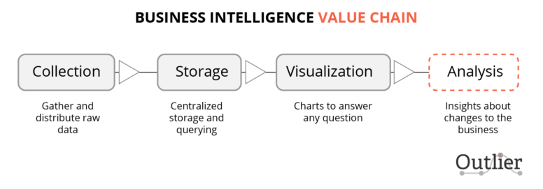

Application Areas:
- Algorithmic trading
- Fraud detection
- Systems monitoring
- Application performance monitoring
- Customer Relationship Management
- Demand sensing
- Dynamic pricing and yield management
- Data validation
- Operational intelligence and risk management
- Payments & cash monitoring
- Data security monitoring
- Supply chain optimization
- RFID/sensor network data analysis
- Workstreaming
- Call center optimization
- Enterprise Mashups and Mashup Dashboards
- Transportation

- Architecture Business Intelligence:

A business intelligence architecture is a framework for organizing the data, information management and technology components that are used to build business intelligence (BI) systems for reporting and data analytics. The underlying BI architecture plays an important role in business intelligence projects because it affects development and implementation decisions.
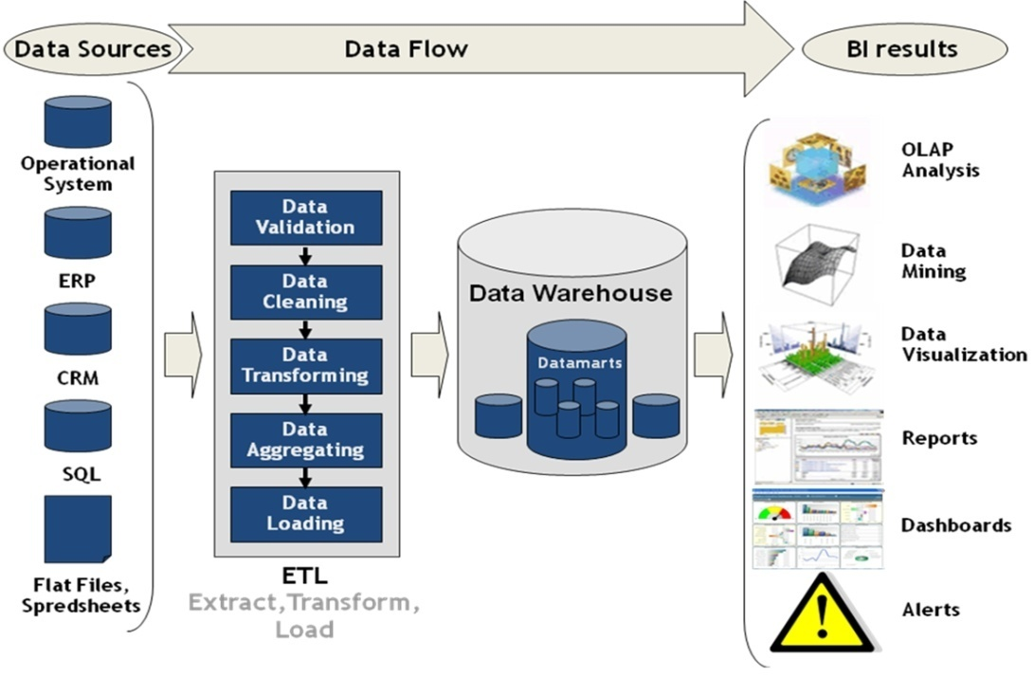

The data components of a BI architecture include the data sources that corporate executives and other end users need to access and analyze to meet their business requirements.

Important criteria in the source selection process include data currency, data quality and the level of detail in the data. Both structured and unstructured data may be required as part of a BI architecture, as well as information from both internal and external sources.

END OF UNIT -- 1

