Swinburne’s Test:
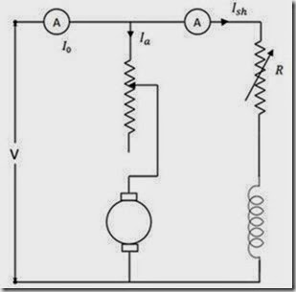
Figure 4.2
This test is a no load test and hence cannot be performed on series motor. The circuit connection is shown in Figure 4.2. The machine is run on no load at rated speed which is adjusted by the shunt field resistance.

ADVANTAGES
1. Economical, because no load input power is sufficient to perform the test
2. Efficiency can be pre-determined
3. As it is a no load test, it cannot be done on a dc series motor

DISADVANTAGES
1. Change in iron loss from no load to full load is not taken into account. (Because of armature reaction, flux is distorted which increases iron losses).
2. Stray load loss cannot be determined by this test and hence efficiency is over estimated.
3. Temperature rise of the machine cannot be determined.
4. The test does not indicate whether commutation would be satisfactory when the machine is loaded.
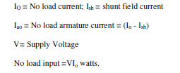

No load power input supplies
(i) Iron losses in the core
(ii) Friction and windings loss and
(iii) Armature copper loss.
Let I = load current at which efficiency is required
Ia = I – Ish if machine is motoring; I + Ish if machine is generating
Efficiency as a motor:

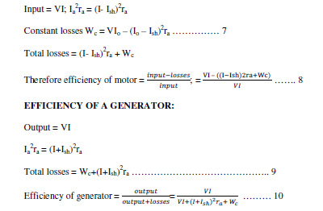
Example Problem:
A 220 V DC shunt motor at No-load takes a current of 2.5 A. the resistance of the armature and shunt field are 0.8Ω and 200Ω respectively. Estimate the efficiency of the motor when the input current is 32 A.
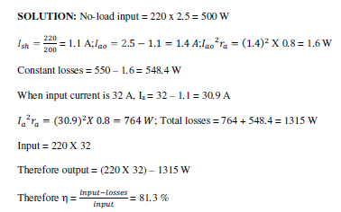

Hopkinson’s Or Regenerative Or Back To Back Test:
This is a regenerative test in which two identical DC shunt machines are coupled mechanically and tested simultaneously. One of the machines is run as a generator while the other as motor supplied by the generator. The set therefore draws only losses in the machines. The circuit connection is shown in Figure 4.3. The machine is started as motor and its shunt field resistance is varied to run the motor at its rated speed. The voltage of the generator is made equal to supply voltage by varying the shunt field resistance of the generator which is indicated by the zero reading of the voltmeter connected across the switch. By adjusting the field currents of the machines, the machines can be made to operate at any desired load with in the rated capacity of the machines

ADVANTAGES:
i. The two machines are tested under loaded conditions so that stray load losses are accounted for.
ii. Power required for the test is small as compared to the full load powers of the two machines. Therefore economical for long duration tests like “Heat run tests”.
iii. Temperature rise and commutation qualities can be observed.
iv. By merely adjusting the field currents of the two machines the two machines can be loaded easily and the load test can be conducted over the complete load range in a short time.

DISADVANTAGES:
i. Availability of two identical machines
ii. Both machines are not loaded equally and this is crucial in smaller machines.
iii. There is no way of separating iron losses of the two machines which are different because of different excitations.
iv. Since field currents are varied widely to get full load, the set speed will be greater than rated values.

The efficiency can be determined as follows:

CIRCUIT DIAGRAM
