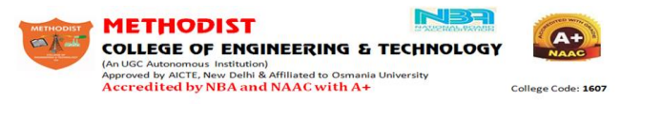
To improve the Central Library and Information Centre Services and the level of User satisfaction your feedback is extremely important to us. Please fill this form and hand it over the library staff.

Have frequently do you visit the library? Daily/Weekly/Monthly/Never
S.NO. | Question | Highly Satisfied | Satisfied | Not Satisfied
1 | Existing library rules and regulations
2 | Availability of books,Journals,Magazines and  News-Papers
3 | Quality of Books and Journals available
4 | Quantity of Books and Journals available
5 | Time taken in transaction of the reading material
6 | Availability of library staff
7 | Co-operation of library Staff
8 | Availability of reprographic facility
9 | Environment in the library
10 | Are you satisfied with network to access e-resources?

Suggestions for improvement: ---------------------------------------------------------------------
------------------------------------------------------------------------------------------------------------------

Name of the Student: -------------------------------------------------BE/ME/MBA: ------------
Year: ---------------- Semester---------------------Roll No:------------------------------------------
Signature of the Student:----------------------------------------------------------------------------

