**SET – A**

**Part - A**

1. **Quality Circles** – It is a small group of employees in the same work area or doing similar type of work who voluntarily meet regularly for about an hour regularly every week to identify, analyze and resolve work related problems, leading to improvement in their total performance and enrichment if their work-life.
2. **Benchmarking** - A process of measuring the performance of an organization against best in class companies, finding out the way in which the best in class companies attain those performance levels and making use of this information as a basis for setting the organizational targets, strategies, policies and implementation.
3. **Tolerance Design** –A process which helps in identifying the statistical tolerance level around the target. The design helps in eliminating excessive variation through selective tightening and upgrading of tolerance s.
4. **PDCA cycle** – PDCA cycle also called “Deming Wheel” is a problem solving process implemented by the companies who aim at continuous improvement. PDCA stands for plan, do ,check and act.
5. **DMAIC** – It stands for define, measure, analyze , improve and control. It is the Last stage of the problem solving approach of six sigma.

**Part – B**

1. **Define TQM and briefly explain the evolution of TQM.**

**Ans**) Total quality is the unyielding and continually improving effort by everyone in an organization to understand ,meet and exceed the expectations of customers.

Evolution

1.**Quality** – 1900 F.W Taylor emphasized on quality by including product inspection and product gauging as two important aspects of manufacturing management.

2. **Quality Control** – The process of quality control begins at the product design phase and ends at the delivery of product/service.

3. **Statistical quality control** – In 1924 Shewhart introduced SPC to monitor production. To measure the extent to which the raw material, processes and products are in accordance with customer specifications.

4. **Total Quality Control** – in mid 1950s, Armand Fiegen Baum proposed TQC which enlarged the focus of quality control.

5. **Quality Assurance** – In 1970s quality assurance methods were used in services.

6. **Total Quality Management** – TQM is a completely new concept wherein quality is considered to be a function of each and every individual in an organization nd efforts are made to improve the quality on continuous basis.

2. **Difference between conventional and total quality management**

**Criteria Traditional TQM**

Organization structure Views enterprise as a collection Views the enterprise as

Of separate highly specialized a system of interdependent

Individuals processes.

Role of People View people as a commodity View people as organization’s

true competitive edge.

Definition of Quality Adherence to internal Products and services that go

Specifications & standards beyond the present needs and

Expectations of customers.

Goals and objectives People do not cooperate Self interests and greater good

Unless it serves their own interests are served simultaneously.

Knowledge Applicable to manufacturing Applicable to all disciplines

and engineering.

Management System Managers oversee dept or functions Oversee interdependent systems

Union & Management Adverse relationship Union becomes a partner and

Stakeholder in the success of org.

Team Work Hierarchical org structure Formal and informal mechanism

Promotes identification with facilitates team work.

functions and creates conflict

Supplier relationship Suppliers are pitted against Suppliers are partners with

Each other to obtain lowest price their customers.

Control Control achieved by pre-established Results from shared values

Rules and procedures. And beliefs etc.

Customers Are always outsiders to the org. Everyone inside the org is a

Customer.

Responsibility Manager’s is a director Manager is a facilitator.

Motivation Motivation is achieved by Managers provide leadership

Aversive control.

3 **a) Explain cause and effect of Ishikawa and its advantages.**

A fishbone diagram is a cause-and-effect discovery tool that helps figure out the reason(s) for defects, variations or failures within a process. In other words, it helps break down, in successive layers, root causes that potentially contribute to an effect.  Sometimes called an Ishikawa diagram or cause-and-effect analysis, a fishbone diagram is one of the main tools used in a [root cause analysis](https://www.reliableplant.com/root-cause-analysis-31548).

A fishbone diagram, as the name suggests, mimics a fish skeleton. The underlying problem is placed as the fish’s head (facing right) and the causes extend to the left as the bones of the skeleton; the ribs branch off the back and denote major causes, while sub-branches branch off of the causes and denote root causes. These causes mimic the bones of the fish skeleton. The construction of the fishbone can branch off to as many levels as is needed to determine the causes of the underlying problem.

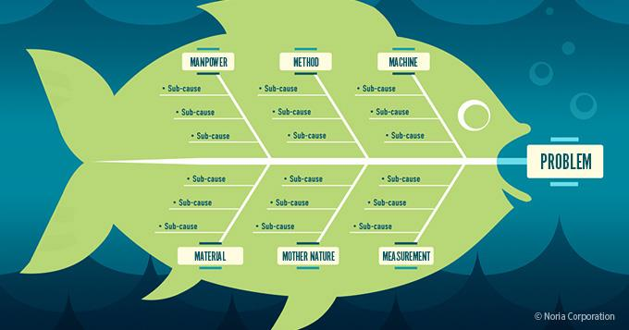

* Help identify cause and effect relationships with underlying problems,
* Help facilitate joint brainstorming discussions,
* The brainstorming process encourages broad thinking, keeping teams from limited thinking patterns that can lead to getting stuck,
* The process of asking why something happened repeatedly at each stage helps drill down to one or more root causes,
* Help prioritize relevant causes, so underlying root causes are addressed first.

b) **What is Just in time and what are the elements of JIT?**

Just-in-time, or JIT, is a method of inventory management in which only as many goods are received from suppliers as they are needed. The main objective of this method is to reduce inventory holding costs and increase total revenue.

Just-in-time (JIT) inventory management, also know as lean manufacturing and sometimes as the Toyota production system (TPS), is an inventory strategy that manufacturers use to increase efficiency. This process involves ordering and receiving inventory for production and customer sales only when it is needed to produce those items, and not before.

**Elements of JIT(Expand)**

1)Waste Elimination 2) Enforced Problem solving 3) Continuous Improvement 4) Employee involvement and empowerment 5) TQM 6) Parallel processing

4 **a)** **Discuss the application of FMEA . What are the benefits and pitfalls of FMEA ?**

**Ans)**

Failure mode effect analysis is defined as the process of determining the potential failures, their effects and suggesting corrective action. It is a detailed study of product design manufacturing operation or distribution network to determine which features are critical to various modes of failure.

Application

Application of FMEA in the five basic areas

1. Concept 2) Design 3) Equipment 4) Process 5) Service.

Benefits

1. Produce products and services without error
2. Good quality and reliability of products
3. Increases satisfaction level of customers
4. Decreases time and cost spent on developing the products
5. Decreases risk
6. Enhances safety and increases usage.

Pitfalls

1. Analysis writing is tedious and tiring
2. Mismatch between size and experience of the teams.
3. It involves uncertainty and ambiguity

**b) Explain the following Taguchi methods**

Quality Loss Function - The quality loss function as defined by Taguchi is **the loss imparted to the society by the product from the time the product is designed to the time it is shipped to the customer**. In fact, he defined quality as the conformity around a target value with a lower standard deviation in the outputs.

Orthogonal arrays - A simple and easier method of placing an experiment together. It is also called as fractional factorial design. They help the users in obtaining the essential information at low cost. They are mostly used in case where there exist several factors and levels.

Signal to noise ratio – Signal to noise ratio was proposed by Taguchi for calculating the target value for the response. It is ratio between mean and the variance. The signal factors are divided by the operator or designers for attaining an intended value of the response variable. The noise factors costly and are difficult to control.

S/N = Amount of energy for intended function = Signal

Amount of energy wasted Noise

Important Signal to noise ratio

* Nominal-the-best
* Smaller-the – better
* Larger-the- better
* Target- the- best
* Classified attribute
* Dynamic

**5 A) State the objectives of Six Sigma.**

**Ans)** (Expnd)

1. To decrease deviations
2. Bring down defects
3. Enhance productivity
4. Improve customer satisfaction
5. Increase profitability and ROI
6. Enhance the top line
7. Business transformation
8. Strategic improvement
9. Problem solving

**B) Benefits and Costs of six sigma.**

**Ans)** Benefits

1. Promotes Consistent Success
2. Sets Individual Goals
3. Enhance value to customers
4. Increases the rate of Quality improvement
5. Promotes learning and cross pollination
6. Executes Strategic change

Costs

1. Improvement costs
2. Training and consultation costs
3. Indirect payroll costs
4. Direct payroll costs
5. Other costs (material, administrative, infrastructure and project costs)

6 **A) Discuss in detail frame work for improving service quality.**

Ans) PZB model or Gaps model of service quality

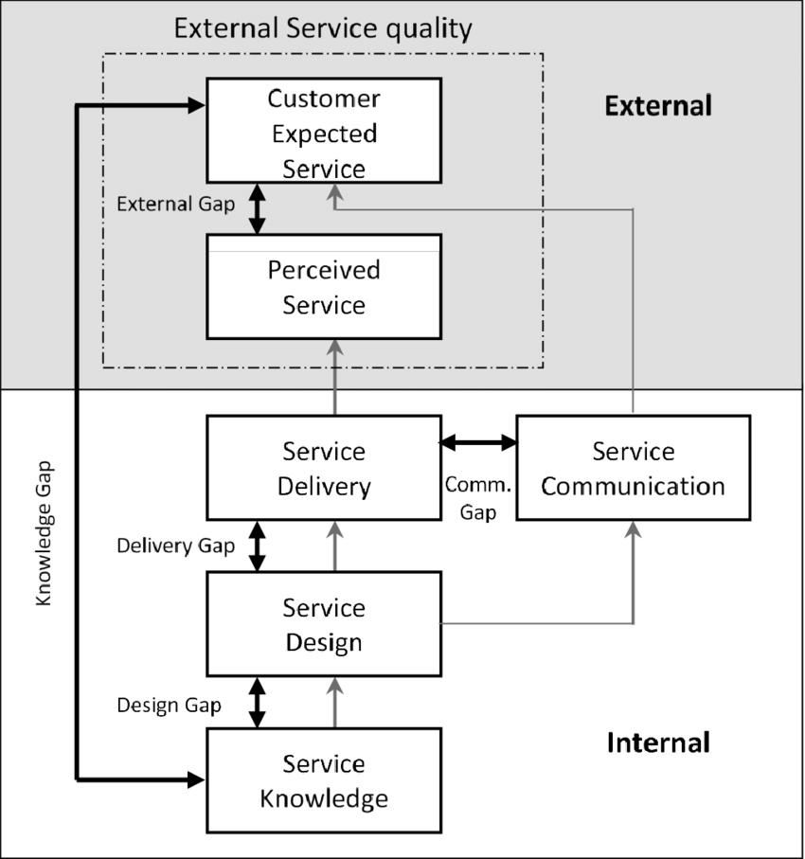

Gap 1

Gap2

Gap3

Gap4

Gap5

**B)** **TQM implementation in Banks**.

Ans) (expand)

1. Reducing processing times of key products and services
2. Promptness in responding to customer enquiries
3. Accuracy and timeliness of statement of accounts and records
4. Customer service quality
5. Banking service product quality
6. E-banking improvement
7. Increasing customer satisfaction and security.

7 **A) Evaluation process of Malcom Baldrige National Quality Award**

**Ans)** (Expand)

1. Application Review – Reviewed independently by group of examiners
2. Consensus Review – Examiners arrive at an agreement on key issues like applicant’s strengths and area of improvement.
3. Site Visit Review – Examiners clarify any doubts with regard to the information provided by applicant.
4. Selection of Award Recipient – Three applicant names are suggested.

**B) What are the steps involved in the implementation of Continuous Improvement**

**approach?**

**Ans)** Steps involved I implementation

1. Define Current Strategies
2. Define the objectives of Continuous improvement
3. Transforming objectives into Action
4. Allotting Teams
5. Define the Process
6. Defining the variability sources
7. Executing change

**8 A) Explain various types and levels of benchmarking.**

**Ans)** Types of Benchmarking

1. Performance Benchmarking – The cost, quality, performance characteristic of products and other features of the product are compared with the benchmarked company.
2. Process Benchmarking – concentrates on the work processeslike billing ,employee training or order entity
3. Strategic Benchmarking – Studies the ways other companied formulate strategies and attain competitive advantage over other firms in the industry and becomes successful in the market.

Levels of Benchmarking

1. Internal Benchmarking – Comparison within organization in different divisions
2. Competitive Benchmarking – Comparison with best-in-class companies
3. Non-Competitive Benchmarking – tries to benchmark processes that need improvement.
4. World-class Benchmarking- benchmark the organization which is recognized in the world.

B) **Discuss in detail about tools used in six sigma**

Ans)

1. Statistical Process Control – Tools included in SPC are graphical analysis, correlation, mean, median mode, histogram etc
2. Process Mapping – It is an important used in DMAIC/MAIC. Process mapping helps in identifying the input and output of the process and effectively minimize variations in the process.
3. Measurement System analysis- It ensures that the measurement tool is statistically accurate. It helps in identifying the problems arising in the process and randomly selecting the samples for verification.
4. Process Capability Tool – It emphasizes on fulfilling the customers CTQ and meeting specifications required to carry out the process effectively.
5. Multivariate Study – It determines how inputs affect the output capability and the factors which are responsible for major variations in the process.
6. Hypothesis Testing – Determines the probability value.
7. Failure Mode Effect Analysis – It predicts, identifies and avoids the problems.
8. Design of Experiment – Tool for testing and optimizing the performance of a process, product, service or solution.
9. Control Panel – It helps in increasing the customer satisfaction by controlling the problems.
10. Control Chart – It helps six sigma in identifying the problem and taking corrective action.

9 A) **Define Service quality and write in detail about service determinants.**

**Ans)** Service Quality is refers to the quality of core services as well as the facilitating services, which assist in increasing the importance of core services to the customer.

The determinants of service quality

1. Reliability –deals with uniformity of performance and dependability.
2. Responsiveness – Deals with the willingness of an employee to offer the service on time.
3. Competence- Refers to knowledge and skills.
4. Access
5. Courtesy
6. Communication
7. Credibility
8. Security
9. Empathy

yTangibility

B) **Explain five dimensions of service quality.**

**Ans) (Expand)**

1. Reliability
2. Responsiveness
3. Assurance
4. Empathy
5. Tangibility