**No.ES103EE**

**METHODIST COLLEGE OF ENGINEERING & TECHNOLOGY (An Autonomous Institution)**

**B.E. (CSE/AI&DS) I-Semester (AICTE) Examination, March-2023**

**Subject: ELEMENTS OF ELECTRICAL AND ELECTRONICS ENGINEERING**

**Time:3hours Max.Marks:60**

**Note: Missing data, if any, maybe suitably assumed.**

**PART-A**

**Answer all the questions**

|  |  |  |  |  |
| --- | --- | --- | --- | --- |
| **Q.No.** | **Questions** | **Marks** |  |  |

**1. a.** Define Kirchhoff’s law 2M

**b.** Find the current in each branch for the circuit shown 2M

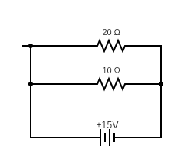

**c.** Define Faraday’s Law 2M

**d.** Draw the circuit diagram of D.C Shunt motor with equations 2M

**e.** Define Transformer 2M

**f**. List the assumptions of an Ideal Transformer 2M

**g.** Define ripple factor & voltage regulation 2M

h. List the applications of CRO 2M

**i**. Draw the symbolic representation of PNP & NPN Transistor. 2M

**j**. Define Oscillator 2M

**PART-B**

**Answer Any Five questions**.

2.a. Find the current in 10 ohm resistor using Thevenin’s Theorem

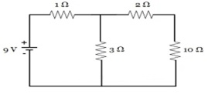 4M

b. Evaluate current flow in 2Ω resistance by using superposition theorem in the circuit of figure.

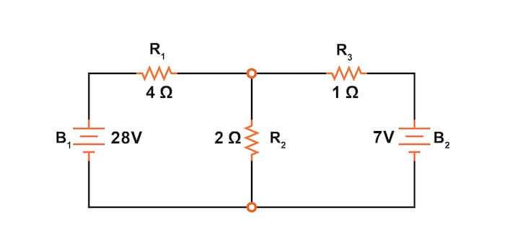 4M

3.a. Derive the EMF Equation of a D.C Machine  4M

b. A 4 pole, 230V DC shunt motor has 888 wave connected conductors. It draws a field current

of 0.6A to give a no-load flux of 5.4mwb.The armature resistance is 0.8 Ω. calculate the

motor speed at a no-load current of 2A. what would be the motor current(line) and speed

when it develops a torque of 29.6Nm. 4M

4.a. Derive the emf equation of Transformer 4M

b. In a 25 kVA, 2000/200V transformer, the iron and copper losses are 350 W and 400 W

respectively. Calculate the efficiency on unity power factor at (a) full load (b) half full load.

4M

5. Explain the construction of half wave type rectifier and calculate the efficiency, TUF, Ripple

Factor & Regulation. 8M

6. Expalin the CB configuration of a transistor & draw its characteristics. 8M

7.a. Find the current in 10 ohm resistor for the circuit shown below

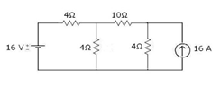 4M

b. A 440V DC Shunt motor takes a armature current of 60A when its speed is 750rpm.

if the armature resistance is 0.25Ω calculate the torque produced 4M

8.a. Explain the constructional features of Three phase Induction motor. 4M

b. Explain the characteristics of Zener diode characteristics. 4M

9. Explain the V-I Characteristics of JFET. 8M

*****