**No.ES103EE**

**METHODIST COLLEGE OF ENGINEERING & TECHNOLOGY (An Autonomous Institution)**

**B.E. (CSE/AI&DS) I-Semester (Supplementary) Examination, September-2023**

**Subject: ELEMENTS OF ELECTRICAL AND ELECTRONICS ENGINEERING**

**Time:3hours Max.Marks:60**

**Note: Missing data, if any, maybe suitably assumed.**

**PART-A**

**Answer all the questions**

|  |  |  |  |  |
| --- | --- | --- | --- | --- |
| **Q.No.** | **Questions** | **Marks** |  |  |

**1. a.** Define Ohm’s law 2M

**b.** Find the equivalent resistance between the terminals a &b for the circuit shown

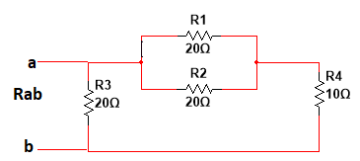 2M

**c.** List the losses in a D.C Machine 2M

**d.** What is the function of commutator in a D.C Machine? 2M

**e.** Draw the no load phasor diagram of a transformer 2M

**f**. Define slip 2M

**g.** Define ripple factor & voltage regulation 2M

**h**. List the applications of CRO 2M

**i.** Draw the symbolic representation of PNP & NPN Transistor. 2M

**j.** Write the h-parameters of a transisitor 2M

**PART-B**

**Answer Any Five questions**.

2. Evaluate current flow in 3Ω resistance by using superposition theorem in the circuit of figure. 8M

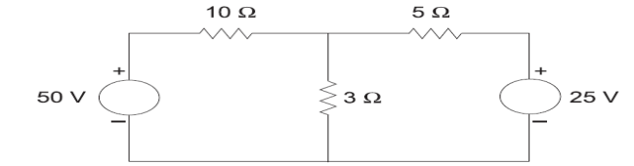

3.a. Explain with a neat sketch the constructional features of a D.C Machine 8M

4.a. Derive the emf equation of Transformer 4M

b. Explain the on load operation of a transformer for lagging power factor with neat phasor

diagram. 4M

5.Explain the construction of bridge type rectifier and calculate the efficiency, TUF, Ripple Factor & Regulation. 8M

6. Expalin the CE configuration of a transistor & draw its characteristics. 8M

7.a. Find the current in each branch for the circuit shown below 4M

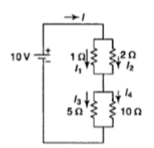

b. A 220V dc shunt motor takes a 3A at no-load .If the armature & shunt field resistances are 0.2

Ω and 110 Ω respectively. Find the output power and efficiency when the motor takes a

current of 30A at full load. 4M

8.a Explain 3-phase transformer connections. 4M

b. Explain the characteristics of P-N Junction diode characteristics. 4M

9. Explain the V-I Characteristics of JFET. 8M

*****