^{Code No.ES101CE}
METHODIST COLLEGE OF ENGINEERING & TECHNOLOGY
_{(An Autonomous Institution)}
B.E. (CIVIL/MECH) I-Semester Supplementary Examination, September-2023
Subject: ENGINEERING MECHANICS-1
Time: 3 hours Max.Marks:60
Note: Missing data, if any, maybe suitably assumed.
^{PART-A}
^{Answer All the questions.}
Q.No. | Questions | Marks | CO | BTL
1. a | Define the parallelogram law of forces. | 2 | 1 | 2
b | Recall the moment of force. | 2 | 1 | 1
c | Tell the Lami’s theorem. | 2 | 2 | 2
d | Point A as shown in fig is in equilibrium under the action of applied forces. Find tensions T _{ab} and T_{ac}  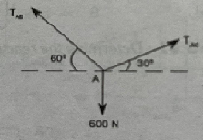 | 2 | 2 | 2
e | What is cone friction | 2 | 3 | 1
f | A Body weighing 250 N is laying on a rough horizontal plane. A horizontal effort of 50 N is required to cause the body to slide. Determine the coefficient of friction. | 2 | 3 | 1
g | Define the term Centre of Gravity. | 2 | 4 | 2
h | Find the y coordinate of the semi-circular lamina of radius 20mm. | 2 | 4 | 2
i | Define Radius of gyration. | 2 | 5 | 1
j | What are the assumptions in when frames are subjected to external load. | 2 | 5 | 2

^{PTO}

^{PART-B}
^{Answer Any Five questions.}
Q.No. |  | Questions | Marks | CO | BTL
2. |  | A Horizontal line PQRS is 12 m long, where PQ=QR=RS=4m. Forces of 1000, 1500, 1000 and 500 N act at P,Q, R and S respectively and action of these forces make angles 90⁰ , 60⁰ , 45⁰ and 30⁰ respectively with PS. Find the magnitude, direction and position of the resultant force. | 8 | 1 | 3
3. |  | Three identical cylinders, each weighing W, are stacked as shown in fig. on smooth inclined surfaces, each inclined at an angle ϴ with the horizontal. Determine the smallest an angle ϴ to prevent the stack from collapsing.  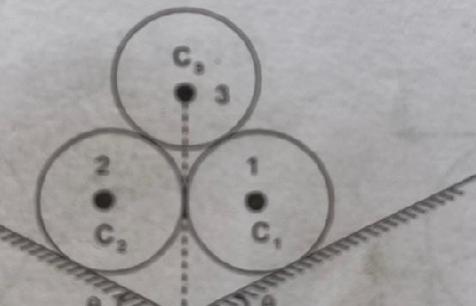 | 8 | 2 | 3
4. |  | Two blocks of equal weights W rests on two surfaces of same coefficient of static friction (µ=0.25). The blocks are connected by a rope passing over a frictionless pulley. Determine for what value of α, the motion of two blocks will impend. | 8 | 3 | 3
 |  | 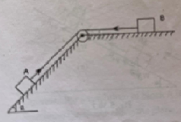
5. |  | Find the coordinates of the centroid of the area obtained after removing a semi-circle of radius 10 cm from a quadrant of a circle of radius 20 cm as shown in fig | 8 | 4 | 4
 |  | 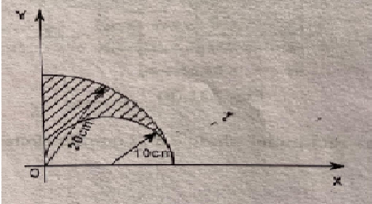
6. |  | Find the magnitude and nature of the forces in all members of the truss with the loading as shown in fig.  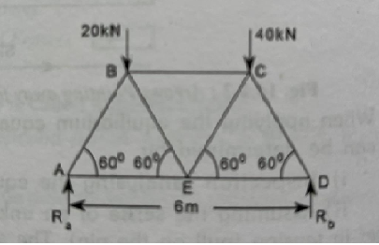 | 8 | 5 | 3
7. | a. | A body is subjected to the three forces as shown in fig If possible determine the direction of force F so that the resultant is in x- direction, when  - F= 10000N ii) F=6000N  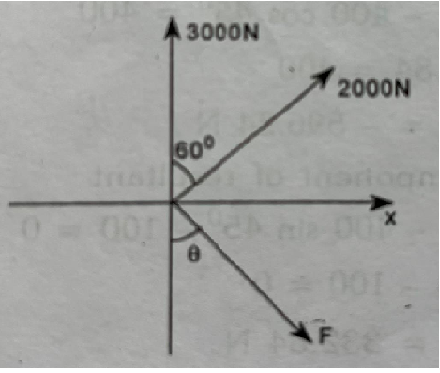 | 4 | 1 | 2
 | b | A ball of weight Q= 12 N rests in a right angled through, as shown in Fig. Determine the forces exerted in the sides of the through at D and E if all surfaces are perfectly smooth  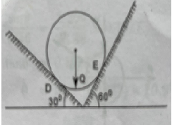 | 4 | 2 | 1
8. | a | Define the terms Coefficient of Friction and Angle of Friction | 4 | 3 | 2
 | b | State and prove the parallel axis theorem. | 4 | 4 | 3
9. | a | A cube of side 400mm has a mass density of 2000kg/m³. Find out the mass moment of inertia of the cube about its centroidal axis parallel to one of its sides and one of its edges. | 4 | 4 | 3
 | b | State and prove Pappus Theorem-1& 2. | 4 | 5 | 3

******

