^{Code No.ES103CE}
METHODIST COLLEGE OF ENGINEERING & TECHNOLOGY(An Autonomous Institution)
B.E. (EEE) I-Semester (Supplementary) Examination, September-2023
^{Subject: ENGINEERING MECHANICS}
Time: 3 hours Max.Marks:60
Note: Missing data, if any, maybe suitably assumed.
^{PART-A}
^{Answer All the questions.}
Q.No. | Questions | Marks | CO | BTL
1. a | State Varignon’s theorem. | 2 | 1 | 1
b | Explain Lami’s theorem.. | 2 | 1 | 1
c | Define of angle of friction . | 2 | 2 | 1
d | State laws of friction. | 2 | 2 | 1
e | Write coordinates of centroid for right angled triangle with a neat sketch. | 2 | 3 | 1
f | Explain polar of moment of inertia. | 2 | 3 | 1
g | Differentiate between rectilinear and curvilinear translation. | 2 | 4 | 1
h | A lift of weight 30kN moving upward with an acceleration of 2m/sec.Find the tension in the cable. | 2 | 4 | 2
i | Explain types of impacts. | 2 | 5 | 1
j | State work energy principle in translation. | 2 | 5 | 1

^{PART-B}
^{Answer Any Five questions.}
Q.No. |  | Questions | Marks | CO | BTL
2. |  | Three forces are shown in figure (1). Determine the resultant and its position w.r.t X and Y axis.  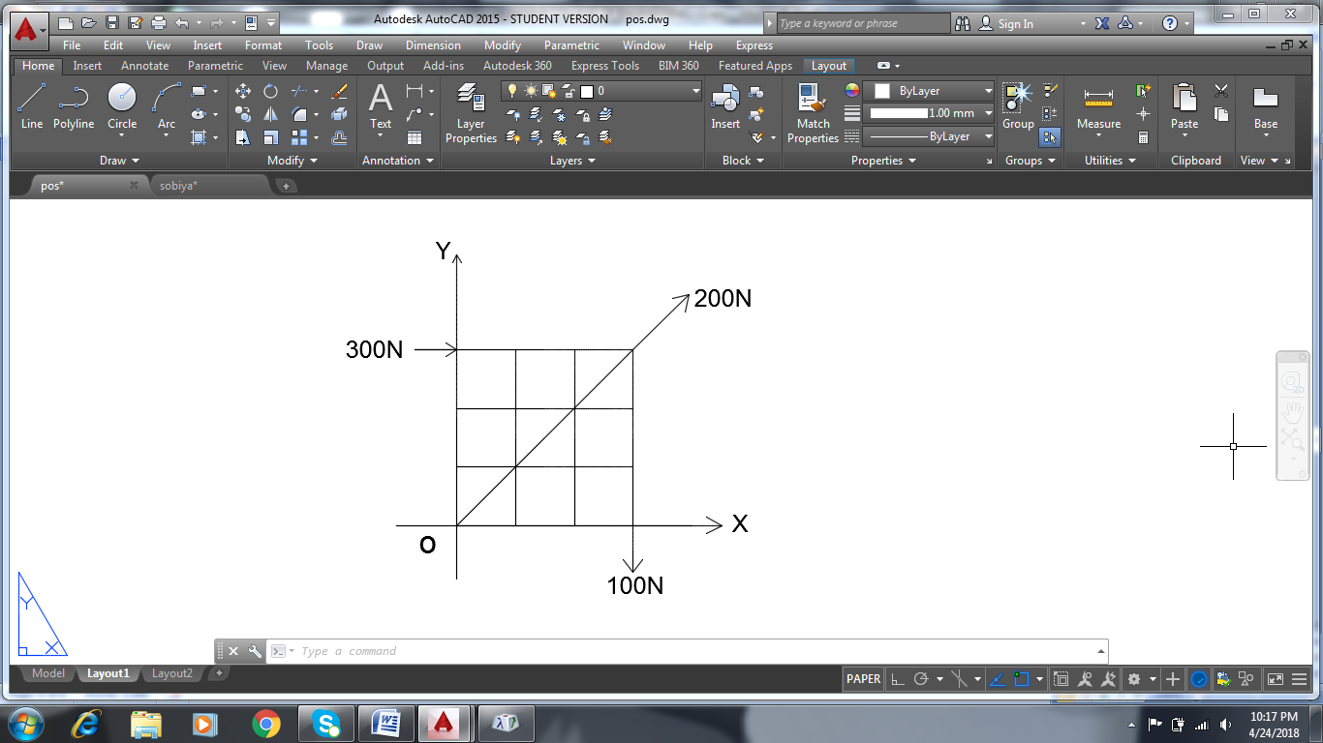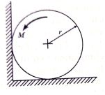 | 8 | 1 | 2
 |  | Figure (1) Figure (2)
3. |  | A homogeneous cylinder of weight 100N and diameter 2m rests on a horizontal floor in contact with a vertical wall as shown in figure (2). If the coefficient of friction at all contact surfaces is 0.3, determine the couple ‘M’ acting on the cylinder which will start anticlockwise rotation. | 8 | 2 | 4
4. |  | Find the centroid of semicircular area of radius ‘R’ | 8 | 3 | 2
5. |  | A bullet is fired from a height of 100m at a velocity of 300kmph at an angle of 40º to the horizontal. Calculate the maximum height reached by the bullet and time of flight. | 8 | 4 | 3
6. |  | The block ‘A’ and ‘B’ shown in Figure (3) have a mass of 12kg and 90kg respectively. Determine the distance ‘B’ travels from the rest to attain a velocity of 1.9m/s.  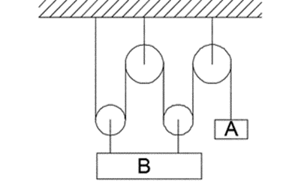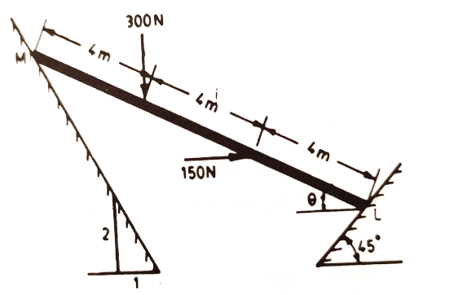  Figure (3) Figure (4) | 8 | 5 | 3
7. |  | A bar LM is subjected to vertical and horizontal forces as shown in figure (4). Find the “Ɵ” at which equilibrium exists. | 8 | 1 | 4
8. |  | Find the moment of inertia of a T section of flange300 x 20mm with centrally placed web of 15 x 200mm about its both centroidal axes. | 8 | 3 | 3
9. |  | Three balls A, B and C of masses 12.5kg, 26kg and 55kg moving along the same straight line in the same direction with velocities 16m/s, 4m/s and 3m/s. If A collides with B and subsequently B collides with C, find the final velocities. Assume perfect elastic collision. | 8 | 5 | 3

******

