^{Code No.ES103CE}
METHODIST COLLEGE OF ENGINEERING & TECHNOLOGY
_{(An Autonomous Institution)}
B.E. (EEE) I-Semester (AICTE) Examination, March-2023
^{Subject: ENGINEERING MECHANICS}
Time: 3 hours Max.Marks:60
Note: Missing data, if any, maybe suitably assumed.
^{PART-A}
^{Answer All the questions.}
Q.No. | Questions | Marks | CO | BTL
1. a | State law of transmissibility of forces. | 2 | 1 | 1
b | Explain conditions of equilibrium. | 2 | 1 | 1
c | Define of cone of friction. | 2 | 2 | 1
d | At the impending motion show that angle of repose is equal to angle of friction. | 2 | 2 | 2
e | Differentiate between centroid and centre of gravity. | 2 | 3 | 1
f | Find polar of moment of inertia of a circular section of diameter 30mm. | 2 | 3 | 2
g | A stone is thrown vertically upward and return to earth in 5 seconds. How high it has travelled. | 2 | 4 | 2
h | State D Alembert’s principle. | 2 | 4 | 1
i | Explain coefficient of restitution. | 2 | 5 | 1
j | A body of mass 20kg moving with a speed of 10m/sec. Find its kinetic energy. | 2 | 5 | 2

^{PART-B}
^{Answer Any Five questions.}
Q.No. |  | Questions | Marks | CO | BTL
2. |  | The force system shown in figure (1) has a resultant of 300N acting up to the right with 3H:4V. Find the values of ‘F’ and ‘θ’ required to give this resultant.  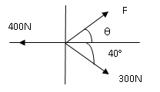  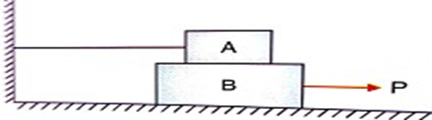 | 8 | 1 | 2
 |  | Figure (1) Figure (2)
3. |  | Blocks A and B weighing 1100 N and 2200 N are resting on each as shown in figure (2) and block A is resisted by cable. Find the value of P to maintain the equilibrium. Take coefficient of friction for all contact surfaces as 0.3 | 8 | 2 | 3
4. |  | Locate the centroid of the hatched plate about the axes as shown in figure (3)  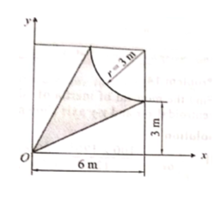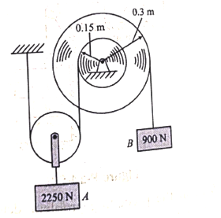  Figure (3) Figure (4) | 8 | 3 | 4
5. |  | Assuming the pulleys to be frictionless and weightless find the acceleration of body B as shown in figure (4). | 8 | 4 | 3
6. |  | A bullet weighing 0.25N and moving at 800m/sec penetrates a body of 100N which is resting on a horizontal surface with µ_{k}= 0.2 and bullet emerges with a velocity of 90m/sec. How far and how long does the body then move? | 8 | 5 | 5
7. |  | Determine the resultant of a system of concurrent forces having the following magnitudes and passing through the origin and indicated points P = 28 N (12,6,-4),T = 52 N (-3,-4,12) and F = 27 N (6,-3,-6). | 8 | 1 | 2
8. |  | Find the moment of inertia of a symmetrical I section of flanges 200 x 12mm with centrally placed web of 10 x 150mm about its both centroidal axes. | 8 | 3 | 3
9. |  | The rectilinear motion of a particle is governed by a= -8S⁻²where ‘a’ is in m/s² and ‘S’ is in m, when t = 1s, s= 4m and v =2 m/s. Determine the acceleration of the particle at t= 2 sec. | 8 | 4 | 3

******

