^{Code No. PC5101ME}
METHODIST COLLEGE OF ENGINEERING & TECHNOLOGY (An Autonomous Institution)
M.E I-Semester (Make-Up) Examination, May -2023
Subject: FINITE ELEMENTS TECHNIQUES
Time: 3 hours Max.Marks:60
Note: Missing data, if any, maybe suitably assumed.
^{PART-A}
^{Answer All the questions.}
Q.No | Questions | Marks | CO | BTL
1. a | Distinguish between local coordinates and global coordinates | 2 | 1 | 2
b | Formulate transformation matrix of a 1D truss element from first principles | 2 | 2 | 2
c | Summarize Jacobian matrix. Recall Jacobian for a 2D CST element | 2 | 3 | 1
d | Enlist the advantages of Lumped mass matrix over consistent mass matrix | 2 | 4 | 1
e | When fluid is considered as potential flow and state the boundary conditions in terms of stream function Ѱ | 2 | 5 | 2
^{PART-B}
^{Answer Any Five questions.}
Q.No. |  | Questions | Marks | CO | BTL
2. | a | Distinguish between the Rayleigh Ritz method and Galerkin Method | 5 | 1 | 2
 | b | Formulate the element stiffness matrix for a Quadratic Bar element | 5 | 1 | 3
3. | a | (i) Why transformation is required while solving truss problems? State transformation matrix for the truss element  (ii) Sketch the Hermite shape functions of a beam element | 5 | 2 | 3
 | b | Formulate the element stiffness matrix for a plane truss element | 5 | 2 | 2
4. | a | Formulate the finite element equations for constant strain triangle element shown in Fig.1 Plane stress E= 200 GPa; v =0.25; Thickness=5 mm. Nodal coordinates in mm  x_{i} = 1; x_{j} = 5; x_{k} = 3  y_{i} = 2; y_{j} = 4; y_{k} = 6  Pressure p = 5 N/mm² on side ij.  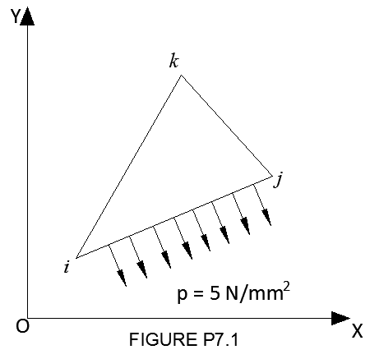  Fig.1 | 7 | 3 | 3
 | b | Distinguish between plane stress and plane strain conditions | 3 | 3 | 3
5. | a | Determine the nodal temperature and rate of heat transfer through a composite wall show in Fig.2  Thermal conductivities  k₁ = 45 W/m ^{O}C;  k₂ = 0.5 W/m ^{O}C;  Convective heat transfer coefficient h = 20W/m ^{O}C;  Temperature of left face of the wall = 80 ^{O}C;  Ambient temperature Ф ͚ = 25 ^{O}C  Assume the area normal to the direction of heat flow A = 1 cm² use linear elements.  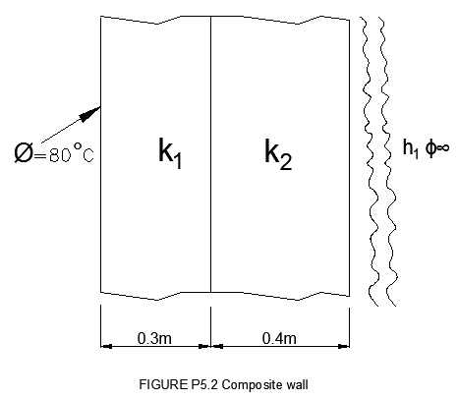  Fig.2 | 10 | 4 | 3
6. | a | Determine the natural frequencies and corresponding eigenvectors for the transverse vibration of beam shown in Fig.3 Use three beam elements with consistent mass matrices. The cross section of the beam is 25 mm × 10 mm, ρ = 7500 kg/m³; E= 200 GPa  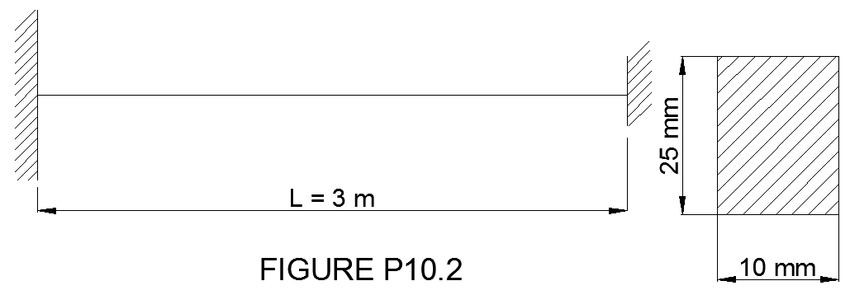  Fig.3 | 10 | 4 | 3
7. | a | Derive the element equation for irrotational, inviscid fluid flow using velocity function formulation | 10 | 5 | 3
8. | a | Distinguish between lagrangian elements and axisymmetric elements | 5 | 3 | 3
 | b | Distinguish between essential and natural boundary conditions. Recall the essential and natural boundary conditions in heat transfer for FE analysis. | 5 | 4 | 3
9. | a | A metallic fin with thermal conductivity K=360 W/m⁰C, 0.1cm thick and 10cm long extends from a plane wall whose temperature is 253⁰c. Determine the temperature distribution and amount of heat transferred from the fin to the air at 20⁰C with h= 9w/m²⁰C. Take the width of the fin to be 1m. let the tip of the fin be insulated. | 10 | 3 | 2

