^{Code No.PC5101ME}
METHODIST COLLEGE OF ENGINEERING & TECHNOLOGY (An Autonomous Institution)
M.E I-Semester (Regular & Supplementary) Examination, March -2023
Subject: FINITE ELEMENTS TECHNIQUES
Time: 3 hours Max.Marks:60
Note: Missing data, if any, maybe suitably assumed.
^{PART-A}
^{Answer All the questions.}
Q.No | Questions | Marks | CO | BTL
1. a | Enlist the equilibrium equations on three dimensional cartesian co-ordinates for elasticity problem | 2 | 1 | 2
b | Illustrate by sketch the hermite shape functions of a beam element | 2 | 2 | 2
c | Summarize the conditions to be satisfied for application of axi-symmetric elements | 2 | 3 | 2
d | Rephrase the physical significance of a capacitance matrix in heat transfer analysis | 2 | 4 | 2
e | Reproduce the consistent mass matrix for a beam element with 2 dof/node | 2 | 5 | 1
^{PART-B}
^{Answer Any Five questions.}
Q.No. |  | Questions | Marks | CO | BTL
2. | a | (i) State the equilibrium equations on three dimensional Cartesian co-ordinates for elasticity problem  (ii) Distinguish between error and residual. | 5 | 1 | 2
 | b | (i) Write the K Matrix for Frame, Beam and Quadratic bar element  (ii) Illustrate 2D Truss and 2D beam element and show the dof. | 5 | 1 | 2
3. | a | Find nodal displacements and element stress in the truss shown in Fig.1  E= 80 GPa ; A₁ = 600 mm²; L₁ = 500 mm; A₂ = 600 mm² ; L₂ = 600 mm; A₃ = 600 mm²; L₃ = 500 mm;  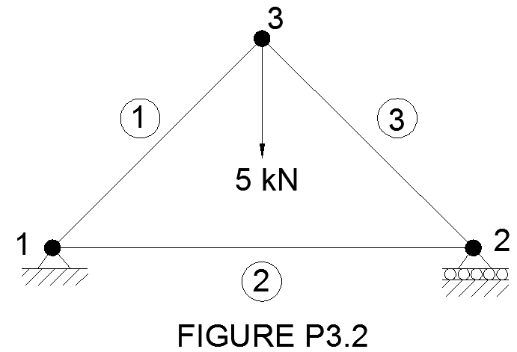  Fig.1 | 10 | 2 | 3
4. | a | Formulate element equations for the axi-symmetric element shown in Fig.2 E= 100 GPa; v =0.3; α = 5×10⁻⁶ per ⁰C ; ∆T = 60 ^{O}C; p = 8 N/mm² acting perpendicular to the side jk.  Nodal coordinates in mm  _{ri} = 5; r_{j} = 1; r_{k} = 3;  z_{i} = 5; z_{j} = 6; z_{k} = 2;  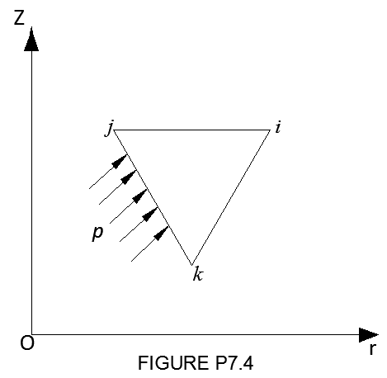  Fig.2 | 7 | 3 | 3
 | b | Distinguish between sub-parametric, iso-parametric and super-parametric elements | 3 | 3 | 2
5. | a | Calculate the nodal temperatures of the composite wall shown in Fig.3 There is a uniformly distributed heat source Q = 50 W/m³ present in the composite layered wall. Thermal conductivities: k₁ = 60 W/m ^{O}C; k₂ = 0.5 W/m ^{O}C; Heat flux q” on the surface = 100W/m²; Right face is maintained at 25 ^{O}C;  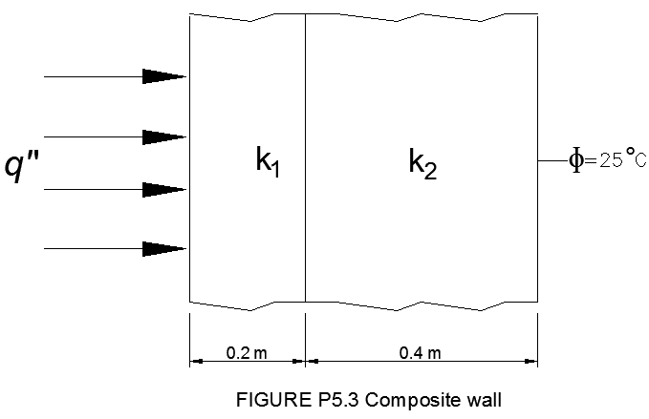  Fig.3 | 10 | 4 | 3
6. | a | Determine the natural frequencies of a simply supported beam shown in Fig.4 Use 2 beam elements with consistent mass matrix. ρ = 5000 kg/m³; E= 100 GPa ; I = 2000 mm⁴; A = 250 mm²  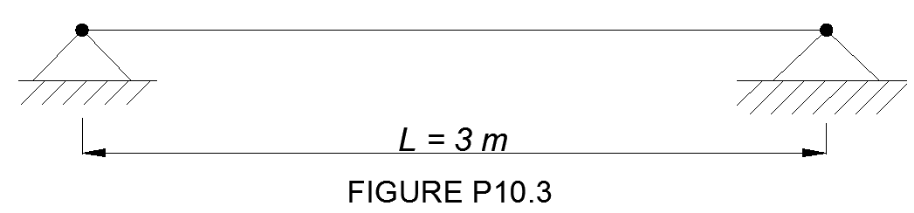  Fig.4 | 10 | 4 | 3
7. | a | Recall and reproduce the process of finite element method to solve a fluid flow problem in detail, with suitable illustrations | 5 | 5 | 2
 | b | The stream function corresponding to a fluid flow is given by Ψ(x,y) = 4x³ – 5y². Check whether the flow is rotational or irrotational. | 5 | 5 | 3
8. | a | Determine the nodal displacement and element stress by finite element formulation for the following figure.  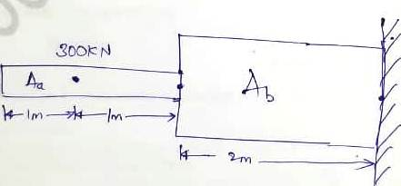  Use: P=300KN, A_{a}= 0.5m², A_{b}= 1m², E=200GPa | 10 | 3 | 2
9. | a | Distinguish between essential and natural boundary conditions. Recall the essential and natural boundary conditions of a cantilever beam for FE analysis | 5 | 4 | 2
 | b | Determine the deflection and slope at 2 m from the left end of the shaft mounted in bearings. A load of 1 kN and a moment of 2 kN m act on the shaft. Model the bearings as fixed supports. | 5 | 2 | 3

******

