^{Code No.:} ^{ES202EE}
METHODIST COLLEGE OF ENGINEERING & TECHNOLOGY (An Autonomous Institution)
B.E. (EEE) II-Semester (Supplementary) Examination, FEB - 2024
Subject: PRINCIPLES OF ELECTRICAL AND ELECTRONICS ENGINEERING
Time: 3 hours Max.Marks:60
Note: Missing data, if any, maybe suitably assumed.
^{PART-A}
^{Answer all the questions.}
Q.No. | Questions | Marks | CO | BTL
1. a | What is the basic property of a capacitance? | 2 | 1 | 1
b | Relate Voltage and Current of inductance. | 2 | 1 | 2
c | Outline the procedure of mesh analysis. | 2 | 2 | 1
d | Find the current flowing through each resistor of a series circuit consisting of four 20 Ω and one 10 Ω resistors all in series supplied with a battery voltage of 90 V. | 2 | 2 | 1
e | List the limitations of the maximum power transfer theorem. | 2 | 3 | 2
f | Summarize the reciprocity theorem. | 2 | 3 | 2
g | How is PN junction formed? | 2 | 4 | 1
h | Show the diode symbol and label the electrodes. | 2 | 4 | 2
i | Classify BJT. | 2 | 5 | 2
j | Where is a MOSFET used? | 2 | 5 | 3

^{PTO}

^{PART-B}
^{Answer Any Five questions.}
Q.No. |  | Questions | Marks | CO | BTL
2. | a | Determine the voltage V_{O} in the circuit shown below using source transformation?  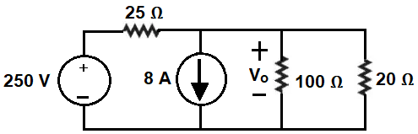 | 4 | 1 | 4
 | b | Classify the circuit elements. State Ohm’s law and list its limitations? | 3 | 1 | 2
3. | a | Derive condition for STAR-DELTA and DELTA - STAR transformations | 4 | 2 | 2
 | b | List the characteristics of a parallel resistances circuit. | 3 | 2 | 2
4. |  | Determine the current in resistor 6 Ω by superposition theorem in the circuit shown below?  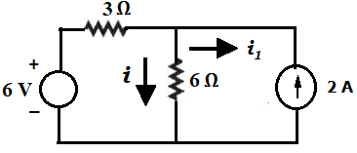 | 8 | 3 | 4
5. | a | With a neat circuit explain the operation of full wave bridge rectifier? | 5 | 4 | 2
 | b | Show the Zener diode characteristics. | 3 | 4 | 2
6. | a | Discuss the operation of transistor as an amplifier. | 5 | 5 | 6
 | b | List the BJT Specifications | 3 | 5 | 4
7. | a | Discuss about dependent sources. | 3 | 1 | 6
 | b | Determine I in the 2 ohms resistor shown below using mesh analysis? | 5 | 2 | 5
8. | a | Derive the condition for the Maximum power Transfer theorem ? | 4 | 3 | 5
 | b | Outline transition and diffusion capacitances. | 4 | 3 | 2
9. | a | Illustrate Thevenin’s theorem. | 4 | 3 | 2
 | b | Show the common base configuration of npn and pnp transistors. | 4 | 5 | 2
******

