^{Code No.ES202ME}
METHODIST COLLEGE OF ENGINEERING & TECHNOLOGY
_{(An Autonomous Institution)}
B.E. (MECH) II-Semester (Regular) Examination, SEPTEMBER-2023
Subject: ENGINEERING MECHANICS-II
Time: 3 hours Max.Marks:60
Note: Missing data, if any, maybe suitably assumed.
^{PART-A}
Answer All the questions.(10X2M=20M)
Q.No. | Questions | Marks | CO | BTL
1. a | Define the term time of flight. | 2 | 1 | 2
b | Define the term trajectory? | 2 | 1 | 2
c | Write laws of motion? | 2 | 2 | 1
d | A motorist travelling at a speed of 70 kmph suddenly applies brakes and halts after skidding 50 m. Determine the time required to stop the car. | 2 | 2 | 2
e | Define the terms (i) Work (ii) Energy. | 2 | 3 | 2
f | If a stone falls past a window of 2.45 m height in half a second, find the height from which the stone fell. | 2 | 3 | 2
g | What are the virtual work approaches? | 2 | 4 | 2
h | The amplitude of a particle in simple harmonic motion is 0.75 m and the period is 1.2 sec. Determine the maximum velocity and the maximum acceleration. | 2 | 4 | 2
i  j | Differentiate between Natural vibrations and forced vibrations.  What is simple and compound pendulums? | 2  2 | 5  5 | 1  2

^{PART-B}
Answer Any Five questions.(5X8M=40M)
Q.No. |  | Questions | Marks | CO | BTL
2.
 |  | In what distance will body A of Fig. attain a velocity of 3 m/sec. starting from rest?  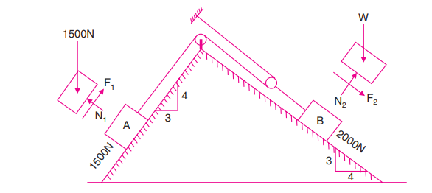 | 8 | 1 | 3
3. |  | Determine the tension in the string and accelerations of blocks A and B weighing 1500 N and 500 N connected by an inextensible string as shown in Fig. Assume pulleys as frictionless and weightless  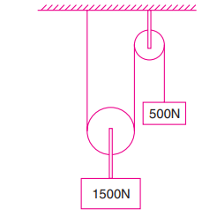 | 8 | 2 | 4
4. |  | A 3000 N block starting from rest as shown in Fig. 16.17 slides down a 50° incline. After moving 2 m it strikes a spring whose modulus is 20 N/mm. If the coefficient of friction between the block and the incline is 0.2, determine the maximum deformation of the spring and the maximum velocity of the block.  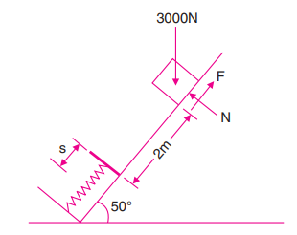 | 8 | 3 | 3
5. |  | A 1500 N block is in contact with a level plane, the coefficient of friction between two contact surfaces being 0.1. If the block is acted upon by a horizontal force of 300 N, what time will elapse before the block reaches a velocity of 16 m/sec starting from rest? If 300 N force is then removed, how much longer will the block continue to move? Solve the problem using impulse momentum equation. | 8 | 4 | 3
6. |  | A particle moves along a straight line and its motion is represented by equation S=6t + 4t² - 3t³ . Where t is in seconds and S is in meters. Determine  a)Displacement, velocity and acceleration 3 sec after start.  b) Displacement and acceleration when velocity equal to zero.  c) Displacement and velocity when acceleration equal to zero | 8 | 5 | 4
7. | a | A ball is dropped from the top of a tower 30 m high. At the same instant a second ball is thrown upward from the ground with an initial velocity of 15 m/sec. When and where do they cross and with what relative velocity? | 4 | 1 | 3
 | b | A curve in the road is in the form of an arc of a circle of radius 400 m. At what angle should the surface of the road be laid inclined to the horizontal so that the resultant reaction of the surface acting on a car running at 120 km/h is normal to the surface of the road? | 4 | 2 | 3
8. |  | A particle in SHM has an amplitude of 15 cm and a period of $π$/2 sec. Find the velocity and acceleration of the particle, when it has travelled 9 cm to the right of the center of its path. What time is required for this displacement. | 8 | 3 | 3
9. |  | For the system of connected bodies as shown in Fig. Determine the force P required to make the motion impending to the left. Coefficient of friction for all contacting surfaces is 0.25. Pulleys are smooth. | 8 | 4 | 3
******

