^{Code No.ES202ME}
METHODIST COLLEGE OF ENGINEERING & TECHNOLOGY
_{(An Autonomous Institution)}
B.E. (MECH) II-Semester (Regular) Examination, SEPTEMBER-2023
Subject: ENGINEERING MECHANICS-II
Time: 3 hours Max.Marks:60
Note: Missing data, if any, maybe suitably assumed.
^{PART-A}
Answer All the questions.(10X2M=20M)
Q.No. | Questions | Marks | CO | BTL
1. a | Define Maximum Height and time of flight | 2 | 1 | 1
b | Can you write about Projectile? | 2 | 1 | 2
c | Define D Alembert’s Principle? | 2 | 2 | 1
d | Write about angle of banking? | 2 | 2 | 2
e | What is Work -Energy Principle? | 2 | 3 | 1
f | What is work-energy principle for rotation bodies? | 2 | 3 | 2
g | Mention the forces which are generally omitted while applying the principle of virtual work | 2 | 4 | 2
h | Write the impulse-momentum equation and mention its application | 2 | 4 | 2
i  j | Explain the difference between simple pendulum and compound pendulum with a neat sketch?  Define the following terms (i) Amplitude (2) Period of Time | 2  2 | 5  5 | 2  2
^{PART-B}
Answer Any Five questions.(5X8M=40M)
Q.No. |  | Questions | Marks | CO | BTL
2. | a | A ball is dropped from the top of a tower 30 m high. At the same instant a second ball is thrown upward from the ground with an initial velocity of 15 m/sec. When and where do they cross and with what relative velocity? | 4 | 1 | 3
 | b | A projectile is aimed at a target on the horizontal plane and falls 12 m short when the angle of projection is 15°, while it overshoots by 24 m when the angle is 45°. Find the, angle of projection to hit the target. | 4 | 1 | 3
3. |  | A body weighing 1200 N rests on a rough plane inclined at 12° to the horizontal. It is pulled up the plane by means of a light flexible rope running parallel to the plane and passing over a light frictionless pulley at the top of the plane as shown in Fig. The portion of the rope beyond the pulley hangs vertically down and carries a weight of 800 N at its end. If the coefficient of friction for the plane and the body is 0.2,  find: (a) tension in the rope (b) acceleration with which the body moves up the plane, and (c) the distance moved by the body in 3 seconds after starting from rest. | 8 | 2 | 3
4. |  | Two bodies weighing 300 N and 450 N are hung to the ends of a rope passing over an ideal pulley as shown in Fig. How much distance the blocks will move in increasing the velocity of system from 2 m/sec to 4 m/sec? How much is the tension in the string? Use work energy method.  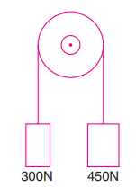 | 8 | 3 | 3
5. |  | A stone is dropped into a well and sound of splash is heard after 4 seconds. Assuming velocity of sound to be 350 m/s, make calculations for the depth of the well. Assume g=9.81 m/s² | 8 | 4 | 3
6. |  | A particle is in simple harmonic motion. It has a velocity of 0.5 m/sec when it is 0.2 m from its static equilibrium position and has a velocity of 0.35 m/sec when it is 0.3 m from the equilibrium position. Determine the maximum velocity, maximum acceleration and the frequency of vibration. | 8 | 5 | 3
7. |  | Find the least initial velocity with which a projectile is to be projected so that it clears a wall 4 m heigh located at a distance of 5m, and strikes the ground at a distance 4 m beyond the wall as shown in Fig. The point of projection is at the same level as the foot of the wall.  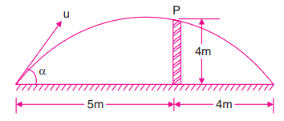 | 8 | 3 | 4
8. |  | Determine the reactions R_{A} and R_{B} developed in the simply supported beam shown in Fig. using virtual work.  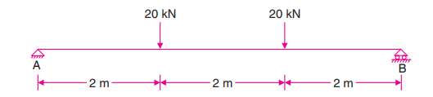 | 8 | 4 | 3
9. |  | A body weighing 300 N is pushed up a 30° plane by a 400 N force acting parallel to the plane. If the initial velocity of the body is 1.5 m/sec and coefficient of kinetic friction is µ = 0.2, what velocity will the body have after moving 6 m?  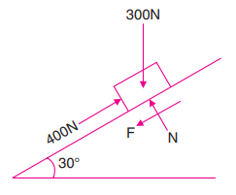 | 8 | 5 | 3

******

