^{Code No.MB203C}
METHODIST COLLEGE OF ENGINEERING & TECHNOLOGY
^{(An Autonomous Institution)}
M.B.A II-Semester (Regular) Examination, september-2023
^{Subject: OPERATIONS RESEARCH}
Time: 3 hours Max.Marks:60
Note: Missing data, if any, maybe suitably assumed.
^{PART-A}
Answer All the questions.(05X2M=10M)
Q.No | Questions | Marks | CO | BTL
1 a | Limitations of Operations Research | 2 | I | BL3
b | Relationship between Primal and Dual Problem | 2 | II | BL2
c | What is meant by balanced and unbalanced transportation problems? | 2 | III | BL1
d | Steps in the CPM process | 2 | IV | BL3
e | Elements of the queuing system | 2 | V | BL3

^{PART-B}
Answer Any Five questions.(5X10M=50M)
Q.No. |  | Questions | Marks | CO | BTL
2 | a | A company manufactures two products A and B. The resources are the capacities Machine-1, Machine-2, and Machine-3. The available capacities are 50,25,and 15 hours respectively. Product A requires 1 hour of Machine-2 and 1 hour of Machine-3. Product B requires 2 hours of Machine-1, 2 hours of Machine-2 and 1 hour of Machine-3. The profit contribution of products A and B are Rs 5 and Rs 4 respectively. Formulate the linear programming model | 10 | I | BL5
 | b | Solve the given linear programming problems graphically:  Minimize: Z = 20x + 10y  and the constraints are:  x + 2y ≤ 40,  3x + y ≥ 30,  4x + 3y ≥ 60,  x ≥ 0, y ≥ 0 |  | I | BL6
3 | a | Find solution using Simplex method  MAX Z = 3x1 + 9x2  subject to  x1 + 4x2 <= 8  x1 + 2x2 <= 4  and x1,x2 >= 0 | 10 | II | BL6
 | b | Find solution using Two-Phase method  MIN Z = 5x1 + 2x2 + 10x3  subject to  x1 - x3 <= 10  x2 + x3 >= 10  and x1,x2,x3 >= 0 |  | II | BL6
4 | a | Solve the given transportation problem using Vogel’s approximation method.  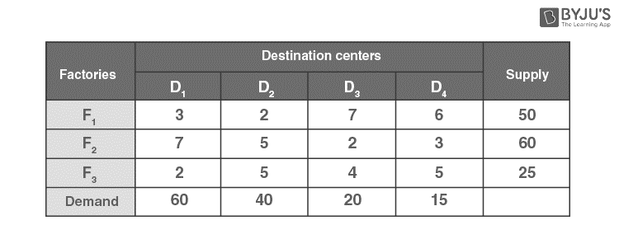 | 10 | III | BL5
 | b | Explain Hungarian Method Steps |  | III | BL3
5 | a | Find out the completion time and the critical activities for the following project:  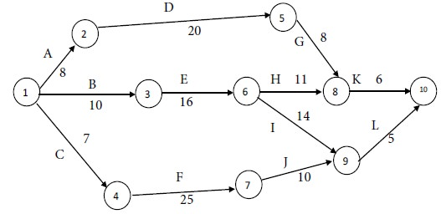 | 10 | IV | BL6
 | b | Critical path, Total float, Free float, Independent float  A - 2  B - 4  C - 3  D A 1  E B 6  F C 5  G D,E 7  H F,G 2 |  | IV | BL6
6 | a | Find Solution of game theory  _{Player A}\^{Player B} B1 B2  A1 1 3  A2 5 2 | 10 | V | BL5
 | b | Give a general structure of queuing system |  | V | BL5
7 | a | Scope and Application of Operations Research | 10 | I | BL4
 | b | Find solution using Simplex(BigM) method  MAX Z = 3x1 + 5x2  subject to  x1 - 2x2 <= 6  x1 <= 10  x2 >= 1  and x1,x2 >= 0 |  | II | BL5
8 | a | Vogel’s Approximation Method Vogel’s Approximation Method Steps | 10 | III
 | b | Difference Between PERT and CPM |  | IV
9 | a | What is Simulation? Scope of Simulation Techniques | 10 | V
 | b | Find solution using Simplex method  MAX Z = 22x1 + 6x2 + 2x3  subject to  10x1 + 2x2 + x3 <= 100  7x1 + 3x2 + 2x3 <= 72  2x1 + 4x2 + x3 <= 80  and x1,x2,x3 >= 0 |  | II

******

