# MASTER OF BUSINESS ADMINISTRATION (MBA) SYLLABUS

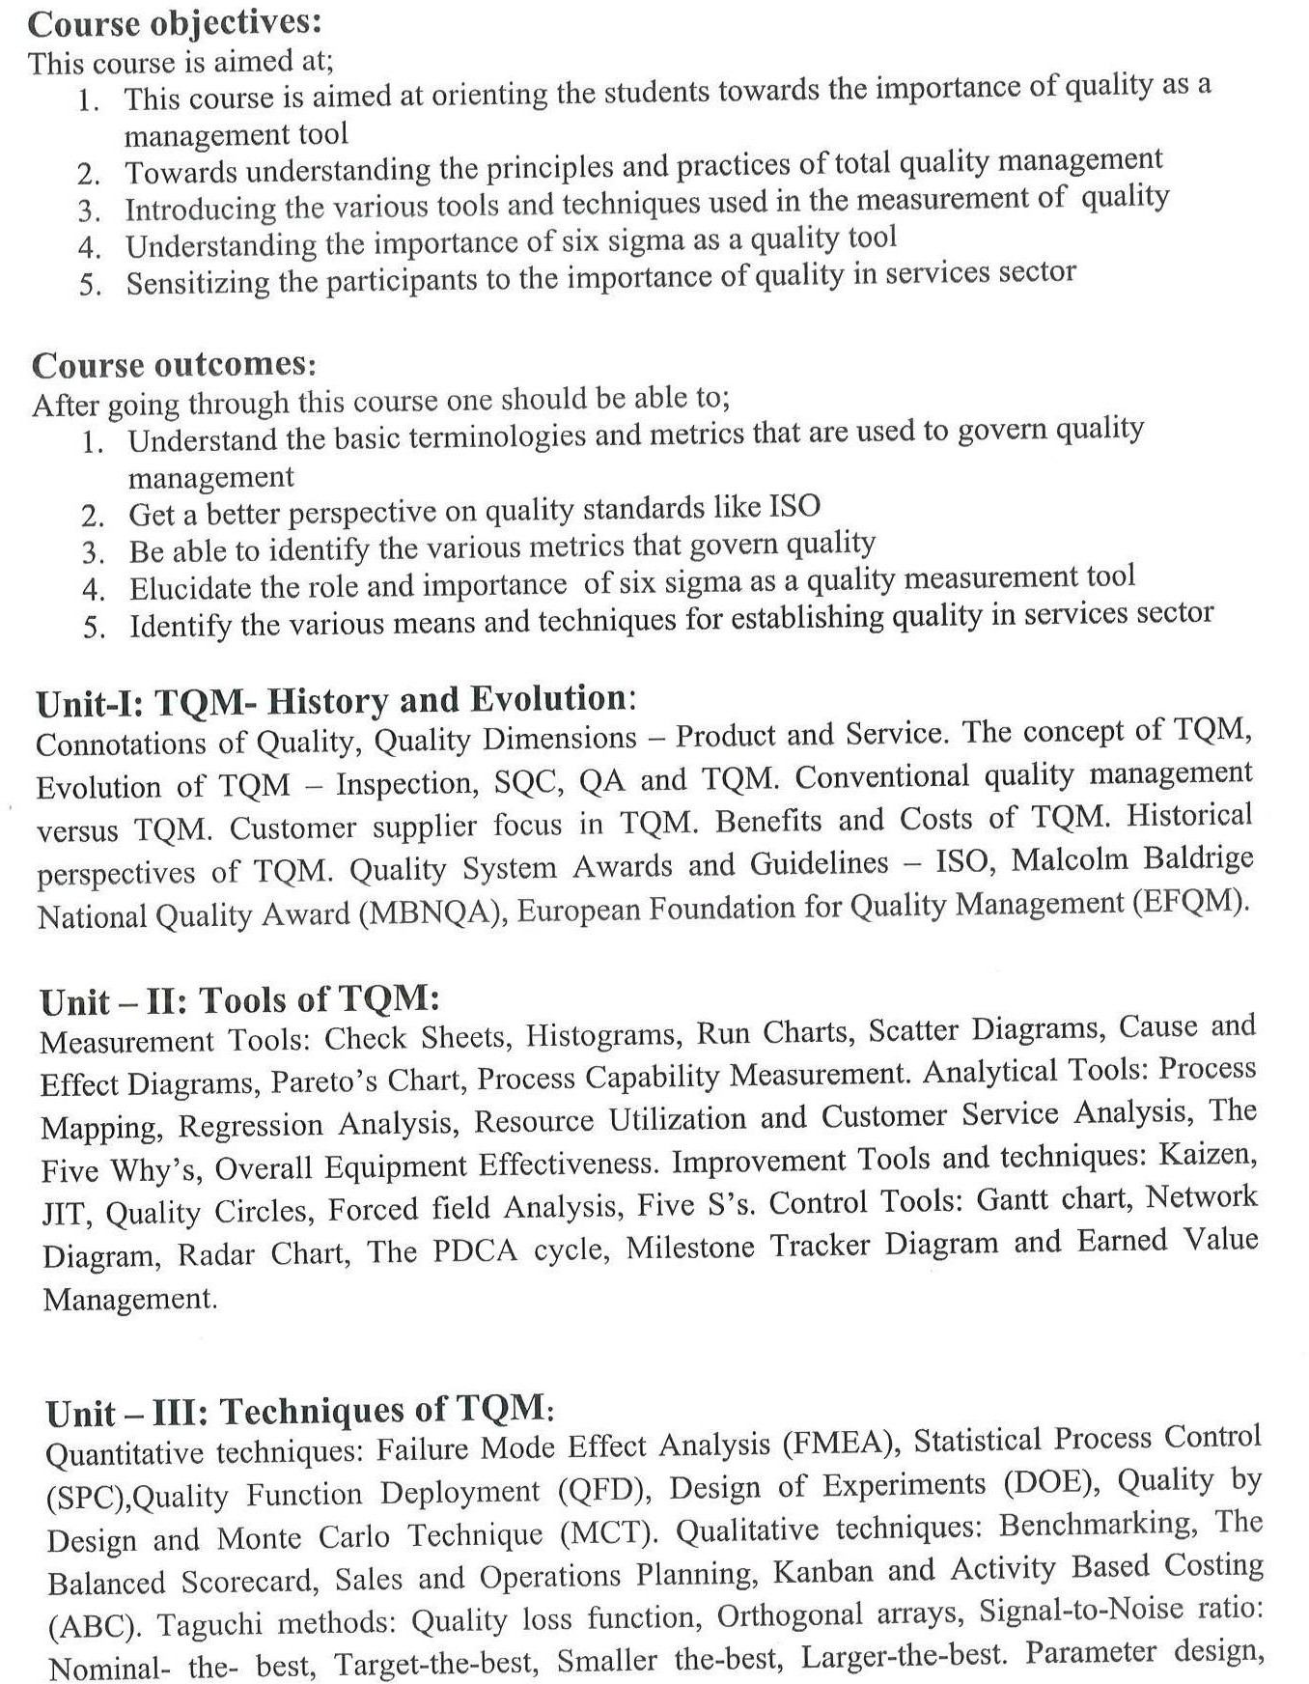

**SEMESTER-II COURSE CODE –MB204C**

# Course: TOTAL QUALITY MANAGEMENT

