^{Code No.6PE5205ME}
METHODIST COLLEGE OF ENGINEERING & TECHNOLOGY
^{(An Autonomous Institution)}
M.E II-Semester (Regular) Examination, September-2023
Subject: ADVANCED MACHINE DESIGN
Time: 3 hours Max.Marks:60
Note: Missing data, if any, maybe suitably assumed.
^{PART-A}
Answer All the questions. (05X2M=10M)
Q.No | Questions | Marks | CO | BTL
1 a | Enlist the factors to be considered for material selection in design | 2 | 1 | 1
b | Reproduce a S-N curve for steel with endurance limit σ_{e} | 2 | 2 | 1
c | Recall Griffith theory | 2 | 3 | 1
d | Give three applications each of constant amplitude fatigue load and variable amplitude fatigue load. | 2 | 4 | 2
e | Enlist modes of surface failures and their causes | 2 | 5 | 1

^{PART-B}
Answer Any Five questions. (05X10M=50M)
Q.No. |  | Questions | Marks | CO | BTL
2 | a | Summarize in detail the various steps involved in systematic design process of a product. | 5 | 1 | 2
 | b | What are process selection charts? Summarize the uses of process selection charts | 5 | 1 | 2
3 | a | Compare various theories of failures in machine design | 5 | 2 | 3
 | b | Paraphrase different factors influencing S-N behavior | 5 | 2 | 2
4 | a | Determine the energy release rate of a DCB specimen through change in strain energy approach for constant load. | 7 | 3 | 3
 | b | Stress field is the same for plane stress and plane strain problems. Why is it not so for displacement fields? | 3 | 3 | 3
5 | a | Determine nucleation life if a slot is made in a large plate (HY-130 steel) having a tipradius of 2 mm and a length of 40 mm from one edge to another. The plate is subjected to a fatigue load of σ_{max} = 140 MPa and σ_{min} = 0.0 MPa | 7 | 4 | 3
 | b | Recall Miners Rule and explain | 3 | 4 | 2
6 | a | Illustrate Pressure Distributions and Contact Zones of Spherical, Cylindrical, and General Hertzian Contact | 3 | 5 | 2
 | b | Determine the size of the contact patch and the maximum contact stresses for a 20-mmdia steel ball rolled against a 40-mm-dia steel cylinder, 25 cm long, with 10 kN. | 7 | 5 | 3
7 | a | Discuss the design guidelines for sand casting | 5 | 1 | 2
 | b | Explain in detail S-N curve representation and approximation | 5 | 2 | 2
8 | a | Determine the energy release rate, using elementary beam analysis, for the configurations given in Fig.  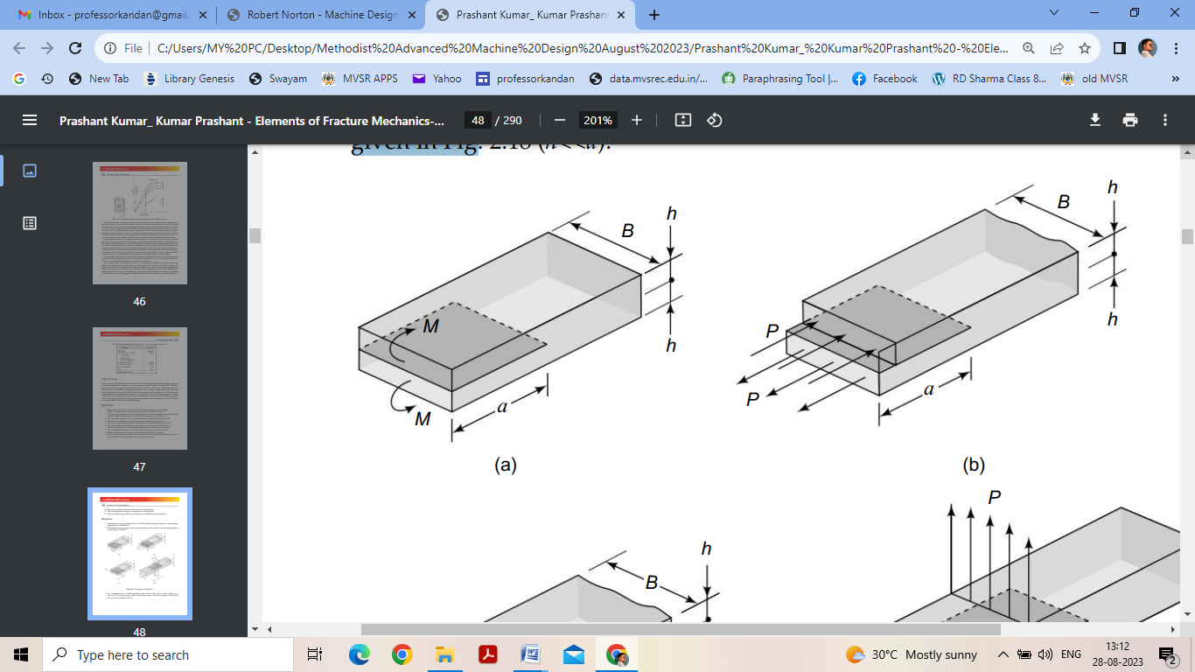 | 5 | 3 | 3
 | b | It is difficult to design components which would not fail due to fatigue loads or stress induced environment-cracking or both. Therefore a crucial component should be routinely checked to identify whether cracks, which have potential to grow and cause the failure of the component, have developed since the last check-up. Comment on these statements. | 5 | 4 | 3
9 | a | Summarize the effect of a sliding component on contact stresses | 5 | 5 | 2
 | b | Explain Design for Reliability in detail | 5 | 1 | 2

******

