^{Code No.6PE5205ME}
METHODIST COLLEGE OF ENGINEERING & TECHNOLOGY
^{(An Autonomous Institution)}
M.E II-Semester (Supplementary) Examination, November-2023
Subject: ADVANCED MACHINE DESIGN
Time: 3 hours Max.Marks:60
Note: Missing data, if any, maybe suitably assumed.
^{PART-A}
Answer All the questions. (05X2M=10M)
Q.No | Questions | Marks | CO | BTL
1 a | Enlist the design considerations for machining processes | 2 | 1 | 1
b | Reproduce a S-N curve for non-ferrous metals with σ_{a} | 2 | 2 | 1
c | Enlist crack opening modes and Illustrate with sketches | 2 | 3 | 1
d | Recall anodic dissolution with reference to fatigue | 2 | 4 | 2
e | Enlist types of surface wears and explain in one brief | 2 | 5 | 1

^{PART-B}
Answer Any Five questions. (05X10M=50M)
Q.No. |  | Questions | Marks | CO | BTL
2 | a | How the selection of materials effect on the quality and productivity | 5 | 1 | 2
 | b | What are material selection charts? Enlist the uses of material selection charts | 5 | 1 | 2
3 | a | Summarize fatigue life estimation using S-N approach. | 5 | 2 | 2
 | b | Paraphrase General S-N behavior | 5 | 2 | 2
4 | a | What is a singularity? What kind of singularity describes a stress field near the vicinity of a crack tip in LEFM? Is it expected to be different for elastic-plastic fracture mechanics? | 7 | 3 | 3
 | b | How does the rate of change of strain energy give G for constant load case or constant deflection case? Is this approach valid for non-linear elastic materials? | 3 | 3 | 3
5 | a | Fluctuating load on a critical component of an offshore structure is shown by a histogram in Fig. During a routine check-up, an edge crack of length 1.5 mm is detected. If the crack length is not allowed to exceed 25 mm, determine the remaining life of the component. Use Paris law with material constants as C = 6.0 × 10^{–12} (MPa)^{–3.2} m^{–0.6} and m = 3.2.  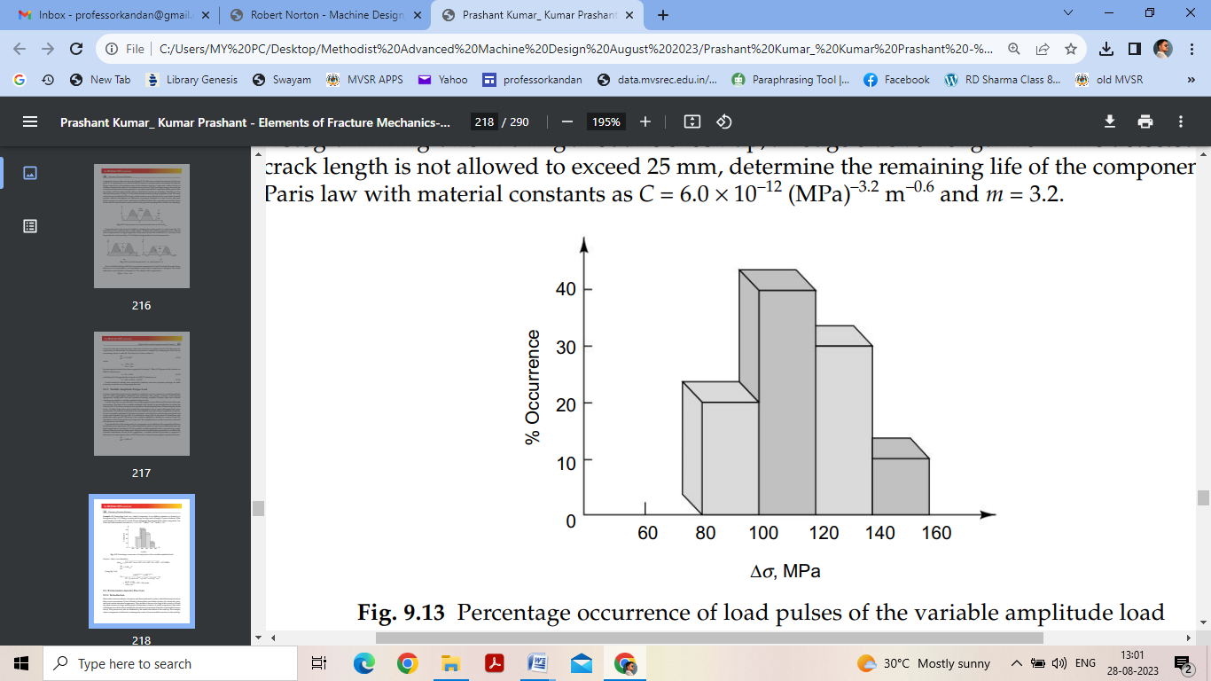 | 7 | 4 | 4
 | b | Recall Manson’s method and explain | 3 | 4 | 1
6 | a | Determine the size of the contact patch and the maximum contact stresses for a 40-mmdia steel cylinder, 25 cm long, rolled against a parallel 50-mm-dia steel cylinder with 10 kN of radial force | 7 | 5 | 3
 | b | Enlist and summarize various precautions a designer has to take while designing to avoid surface failure. | 3 | 5 | 2
7 | a | Discuss the design recommendations for metal forming | 5 | 1 | 2
 | b | Reproduce 3D state of stress on Octahedral plane. List the relevant equations | 5 | 2 | 2
8 | a | Determine the energy release rate, using elementary beam analysis, for the configurations given in Fig.  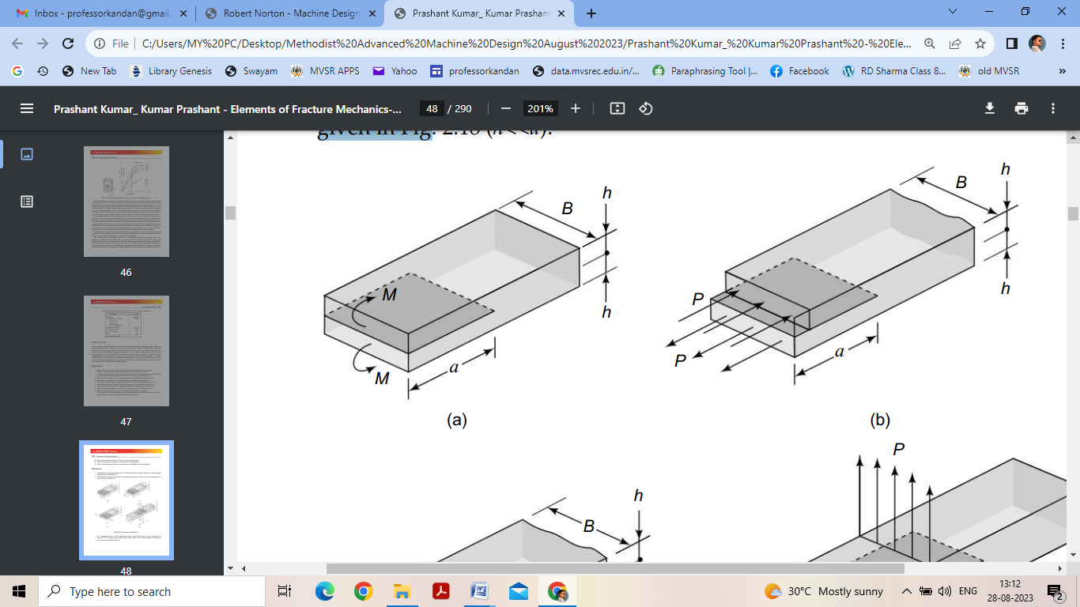 | 5 | 3 | 4
 | b | How do we account for retardation of a fatigue crack growth owing to overloads in variable amplitude fatigue load? | 5 | 4 | 3
9 | a | Recall (i) Point Surface origin (ii) Peeling (iii) Sub case fatigue | 5 | 5 | 2
 | b | Explain Concurrent Engineering in detail with relevant sketches | 5 | 1 | 2

******

