^{Code No.PC302CS}
METHODIST COLLEGE OF ENGINEERING & TECHNOLOGY (An Autonomous Institution)
B.E. (CSE/AI&DS) III-Semester (AICTE) (Supplementary) Examination, AUGUST-2023
^{Subject: DISCRETE MATHEMATICS}
Time: 3 hours Max.Marks:60
Note: Missing data, if any, maybe suitably assumed.
^{PART-A}
^{Answer All the questions.}
Q.No. | Questions | Marks | CO | BTL
1. a | Define universal quantifier and existential quantifier? | 2 | 1 | L1
b | Distinguish between Tautology contradiction and contingency? | 2 | 1 | L2
c | What is meant by cardinality of a set?give example? | 2 | 2 | L1
d | Find the inverse function of f(x)=(3x+2)/(x-1) | 2 | 2 | L2
e | Find the difference between Isomorphism and Homomorphism? | 2 | 3 | L2
f | State the definition of group with example? | 2 | 3 | L1
g | Give the Applications of Inclusion and Exclusion in recurrence relation? | 2 | 4 | L2
h | Determine the value of a₂ for the recurrence relation a_{n}=17a_{n-1}+30n with a₀=3? | 2 | 4 | L3
i | Illustrate about spanning tree with an example? | 2 | 5 | L2
j | Define cut vertex cut edge and cut set? | 2 | 5 | L1

^{PTO}

^{PART-B}
^{Answer Any Five questions.}
Q.No. |  | Questions | Marks | CO | BTL
2. | a | Find the Conjunctive normal form of ~(p->q)∨(r->p) | 4 | 1 | L3
2. | b | Construct the truth table of  i)(p↔q) ⊕ (p↔q)  ii)(pv~t)∧(pv~s) | 4 | 1 | L3
3. | a | Let A={0,1,2,3}.Determine the nature of the following relations on A  i) {(0,0),(1,1),(2,2),(3,3)}  ii) {(0,0),(0,2),(2,2),(3,3),(2,0),(2,3),(3,2)}  iii) {(0,0),(1,1),(1,2),(3,3),(2,1),(2,2)}  iv) {(0,0),(1,1),(2,2),(3,3),(1,3),(3,1),(3,2),(2,3)} | 4 | 2 | L2
3. | b | Construct the Hasse diagram of ({1,2,3,4,6,8,12},/) and find out the maximal elements and minimal elements of Hasse diagram? | 4 | 2 | L4
4. | a | How many ways to construct sequence of 5letters in which first 3letters are English letters and the next two are single digit number if no letter or digit can be repeated? | 4 | 3 | L4
4. | b | There are 30 married couple in a party find the no of ways choosing one man and one women for the game in party such that the two are not married to each other? | 4 | 3 | L4
5. | a | Solve the recurrence relation a_{n}=7.a_{n-1} for n≥1 given that a₂=98? | 3 | 4 | L1
5. | b | Find out the recurrence relation for the following sequence  i)2,6,18,54,162…….. ii)20,17,14,11,8………iii)1,3,6,10,15,21……… | 5 | 4 | L4
6. | a | Find the tree traversal methods of following graph  i)Inorder ii) Preorder iii) Postorder  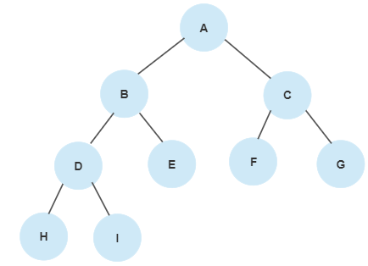 | 4 | 5 | L4
6. | b | Construct a binary tree from Preorder and Inorder  Preorder: A B C D E F G H I  Inorder: B C A E D G H F I | 4 | 5 | L3

7. | a | LetR1={(1,2),(2,3),(3,4)}R2={(1,1),(1,2),(2,1),(2,2),(2,3),(3,1),(3,2),(3,3),(3,4)} be the relations from {1,2,3} to {1,2,3,4} find i)R1∪R2 ii)R1∩R2 iii)R1-R2 iv)R2-R1 | 4 | 2 | L1
7. | b | Prove that if m and n are both perfect squares then nm is also a perfect square? | 4 | 1 | L3
8. | a | Find the 13th term in the expansion [9x-(1)/(3√x) ]¹⁸ x≠0? | 4 | 3 | L4
8. | b | Solve the following recurrence relation using generating functions a_{n+1}-a_{n}=3^{n}, n≥0 with a₀=1? | 4 | 4 | L3
9 | a | Check whether the following graph G is Euler graph and Hamilton graph? Define the terms Euler graph and Hamilton graph?  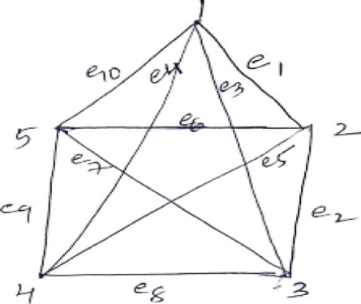 | 4 | 5 | L2
9 | b |  | 4 | 3 | L4
  Find the coefficient of x³y³z² in the expansion of (2x-3y+5z)⁸ ? | 4 | 3 | L3

******

