^{Code No.PC302CS}
METHODIST COLLEGE OF ENGINEERING & TECHNOLOGY (An Autonomous Institution)
B.E. (CSE/AI&DS) III-Semester (AICTE) (Regular) Examination, Feb -2023
^{Subject: DISCRETE MATHEMATICS}
Time: 3 hours Max.Marks:60
Note: Missing data, if any, maybe suitably assumed.
^{PART-A}
^{Answer All the questions.}
Q.No. | Questions | Marks | CO | BTL
1. a | State Demorgans law and write truth table for any one law? | 2 | 1 | L1
b | Compare free variable and bound variable? | 2 | 1 | L2
c | Distinguish between equivalence relation and compatability relation? | 2 | 2 | L3
d | Define partial order set with an example? | 2 | 2 | L1
e | Find the no of permutations of the letters using the word EXAMINATION? | 2 | 3 | L1
f | State the definition of pigeon hole principle with an example? | 2 | 3 | L1
g | Find the value of a₄ for the recurrence relation a_{n}=2a_{n-1}+3 with a₀=6? | 2 | 4 | L1
h | Determine the value of a₂ for the recurrence relation a_{n}=17a_{n-1}+30n with a₀=3? | 2 | 4 | L3
i | Illustrate the applications of the trees in discrete mathematics? | 2 | 5 | L1
j | What is meant by Degree vertex for directed graph? | 2 | 5 | L1

^{PTO}

^{PART-B}
^{Answer Any Five questions.}
Q.No. |  | Questions | Marks |  | CO | BTL
2. | a | Find the Disjunctive normal form of (p∧q)∨~r | 4 |  | 1 | L3
2. | b | Show that P↔Q and (P∧Q) ∨ (~P∧~Q) are logically equivalent? | 4 |  | 1 | L3
3. | a | Consider the functions f and g defined by f(x)=x³ and g(x)=x²+1, x€ R. Find g○f, f○g, f², g² ? | 4 |  | 2 | L3
3. | b | Draw the Hasse diagrams for  a)({1,3,6,9,12}, /) (b) ({1,5,25,125}, /) (c) (Z, ≥)  (d) ({2,3,5,10,11,15,25}, /) ? | 4 |  | 2 | L3
4. | a | Consider the all set of integers from 0to499 find out  i)no of integers are divisible by 3or5  ii) no of integers are divisible by 5or11  iii) no of integers are divisible by 3or11  iv) no of integers are divisible by 3or5or11  v) no of integers are divisible by 3or5 but not 11  vi) no of integers are divisible by 5or11 but not 3  vii) no of integers are divisible by 3or11 but not 5  viii) no of integers are not divisible by 3or5or11 | 5 |  | 3 | L3
 | b | Find the coefficient of x³y³z² in the expansion of (2x-3y+5z)⁸ ? | 3 |  | 3 | L2
5. | a | Solve the following recurrence relation using generating functions a_{n+1}-a_{n}=3^{n}, n≥0 with a₀=1? | 5 |  | 4 | L3
 | b | Solve the recurrence relation a_{n}=7.a_{n-1} for n≥1 given that a₂=98? | 3 |  | 4 | L2
6. | a | Construct a binary tree from Preorder and Inorder  Preorder: A B C D E F G H I  Inorder: B C A E D G H F I | 4 |  | 5 | L3
6. | b | Find the shortest path in the given graph from vertex by kruskals algorithm:  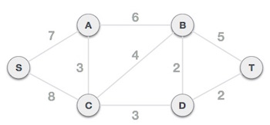 | 4 |  | 5 | L3
7. | a | Give a proof by contradiction of the theorem “if 3n+2 is odd then n is odd”? | 4 |  | 1 | L3
7. | b | If R is a relation on the set A= {1, 2, 3, 4} defined by x R y if x exactly divides y .Prove that (A, R) is a poset. | 4 |  | 2 | L2
8. | a | Find the middle term of (4x²+5x³)⁷ and (3x-2y) ¹⁰? | 4 |  | 3 | L2
 | b | Find the generating functions for the sequences  i) 1, 2, 3, 4,….. ii) 1²,2²,3², 4²,….. iii)0,1,-2,3,-4…. iv)1,1,0,1,1,1,….. | 4 |  | 4 | L2
9. | a | Find the shortest path in the given weighted graph from the vertex by using Dijstras algorithm?  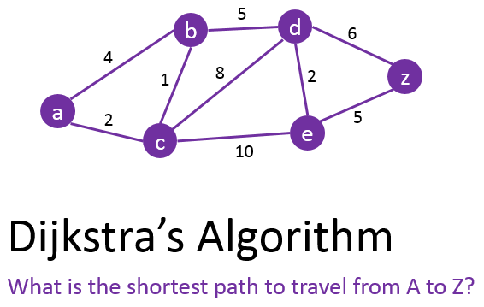 | 4 |  | 5 | L2
9. | b | LetR1={(1,2),(2,3),(3,4)}R2={(1,1),(1,2),(2,1),(2,2),(2,3),(3,1),(3,2),(3,3), (3,4)} be the relations from {1,2,3} to {1,2,3,4} find i)R1∪R2 ii)R1∩ R2 iii)R1-R2 iv)R2-R1 |  | 4 | 2 | L2

******

