^{Code No.}
METHODIST COLLEGE OF ENGINEERING & TECHNOLOGY (An Autonomous Institution)
B.E. (ECE) III-Semester (AICTE) (Regular) Examination, Feb/March -2023
^{Subject: SIGNALS AND SYSTEMS}
^{Time: 3 hoursMax.Marks:60}
Note: Missing data, if any, maybe suitably assumed.
^{PART-A}
^{Answer All the questions.}
Q.No. | Questions | Marks | CO | BTL
1. a | Check whether the given signal is an energy or power signal x(t) = e^{-3t}.u(t)  Sol:  A signal is said to be energy signal when it has finite energy.  Energy $E=\int_{-∞}^{∞}{x^{2}(t)dt}$  A signal is said to be power signal when it has finite power.  Power $P=\lim_{T→∞}\frac{1}{T}\int_{-∞}^{∞}{x^{2}(t)dt}$  NOTE: A signal cannot be both, energy and power simultaneously. Also, a signal may be neither energy nor power signal.  Power of energy signal = 0  Energy of power signal = ∞  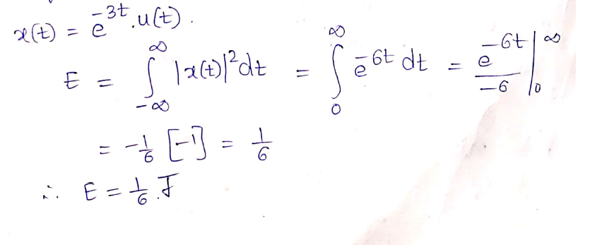  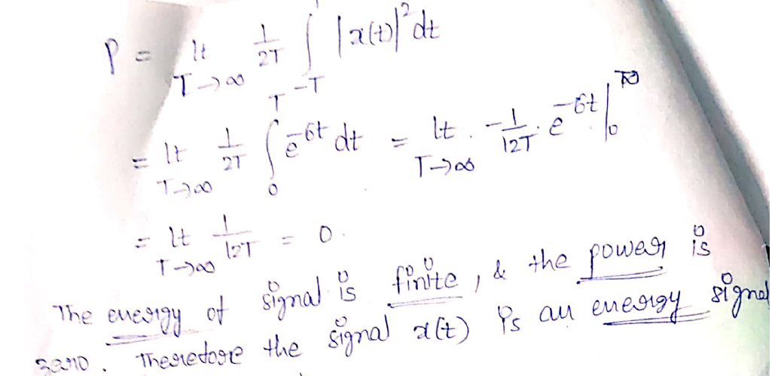 | 2 | 1 | L2
b | Define Causal system with example.  Ans: causal and non-causal systems  A system is said to be causal if its output depends upon present and past inputs, and does not depend upon future input.  For non causal system, the output depends upon future inputs also.  Example 1: y(n) = 2 x(t) + 3 x(t-3)  For present value t=1, the system output is y(1) = 2x(1) + 3x(-2).  Here, the system output only depends upon present and past inputs. Hence, the system is causal.  Example 2: y(n) = 2 x(t) + 3 x(t-3) + 6x(t + 3)  For present value t=1, the system output is y(1) = 2x(1) + 3x(-2) + 6x(4) Here, the system output depends upon future input. Hence the system is non-causal system. | 2 | 1 | L1
c | Define exponential Fourier series.  Ans: The complex Exponential Fourier Series representation of a periodic signal x(t) with fundamental period T_{o} is given by  $$x\left(t\right)= \sum_{k=-∞}^{∞}{C_{k}e^{jkw_{0 }t}}, w_{0}= \frac{2π}{T_{0}}…….(2)$$Where, C_{k} is known as the Complex Fourier Coefficient and is given by,  $$C_{k}= \frac{1}{T_{0}}\int_{T_{0}}{x(t)e^{-jkw_{0}t}} dt…….(3)$$ | 2 | 2 | L1
d | State the condition for orthogonality between the signals x(t) and y(t).  Ans: If $C_{12}= \frac{\int_{t1}^{t2}{x(t)y(t)dt}}{\int_{t1}^{t2}{{y(t)}^{2}dt}}$ component is zero, then two signals are said to be orthogonal.  Put C₁₂ = 0 to get condition for orthogonality.  0 = $\frac{\int_{t1}^{t2}{x(t)y(t)dt}}{\int_{t1}^{t2}{{y(t)}^{2}dt}}$⇒$\int_{t1}^{t2}{x(t)y(t)dt}=0$ | 2 | 2 | L1
e | Find the Fourier Transform of e^{-2t} u(t).  Solution:  X(w)=F{x(t)}=$\int_{-∞}^{∞}{x\left(t\right).e^{-jwt}}$ dt  X(w)=$\int_{-∞}^{∞}{e^{-at}.u(t).e^{-jwt}}$ dt  X(w)=$\int_{0}^{∞}{e^{-at}.1.e^{-jwt}}$ dt  X(w)=$\int_{0}^{∞}{e^{-(a+jw)t}}$ dt  X(w)=${\frac{e^{-(a+jw)t}}{-(a+jw)}}_{ 0}^{ ∞}$  X(w)=$\frac{e^{-\left(a+jw\right)∞}-e^{0}}{-(a+jw)}$  X(w)= $\frac{ 0-1}{-(a+jw)}$  X(w)= $\frac{ 1}{(a+jw)}$=> since a=2  Substitute a and w value to get magnitude and phase plot  Magnitude function $\left|X(w)\right|$=$\frac{1}{\sqrt{a^{2}+w^{2}}}$  Phase function $〈X(w)〉$= -tan⁻¹($\frac{w }{a}$) | 2 | 3 | L2
f | Find the Laplace transform and ROC of the signal x(t)=$e^{-at}.u\left(t\right)$  Solution:  L{x(t)}=X(s)=$\int_{-∞}^{∞}{x\left(t\right). e^{-st}dt}$  L{x(t)}=X(s)=$\int_{-∞}^{∞}{e^{-at}.u\left(t\right). e^{-st}dt}$  L{x(t)}=X(s)=$\int_{0}^{∞}{e^{-at}.1. e^{-st}dt}$  L{x(t)}=X(s)=$\int_{0}^{∞}{e^{-(s+a)t} dt}$  L{x(t)}=X(s)=${\frac{e^{-(s+a)t}}{-(s+a)}}_{ 0}^{ ∞}$  L{x(t)}=X(s)=$\frac{(0-1)}{-(s+a)}$  L{x(t)}=X(s)=$\frac{1}{ s+a}$  ROC: Re(s+a)$>0$ , i.e. Re(s), $σ>-a$ | 2 | 3 | L2
g | Determine whether the system y(n)=$x^{2}(n-2)$ is linear or non-linear system?  Solution:  y(n)=${R\left\{x\left(n\right)\right\}=x}^{2}(n-2)$  For a linear system, R{$a_{1}x_{1}\left(n\right)+a_{2}x_{2}(n)$}=$a_{1}y_{1}\left(n\right)+a_{2}y_{2}(n)$  $y_{1}$(n)=$R\left\{x_{1}\left(n\right)\right\}$=$x_{1}^{2}$(n-2)  $y_{2}$(n)=$R\left\{x_{2}\left(n\right)\right\}$=$x_{2}^{2}$(n-2)  $a_{1}y_{1}\left(n\right)+a_{2}y_{2}\left(n\right)= a_{1}x_{1}^{2}$(n-2)+$a_{2}x_{2}^{2}$(n-2)---------(1)  R{$a_{1}x_{1}\left(n\right)+a_{2}x_{2}(n)$}=${[a_{1}x_{1}\left(n-2\right)+a_{2}x_{2}(n-2)]}^{2}$-------(2)  By comparing the above two equations, R{$a_{1}x_{1}\left(n\right)+a_{2}x_{2}(n)$}$≠ a_{1}y_{1}\left(n\right)+a_{2}y_{2}(n)$  So, the given system is non-linear system. | 2 | 4 | L2
h | Find the DTFT of the unit step function?  Solution:  x(n)=$u(n)$  DTFT{x(n)}=X(w)=$\sum_{n=-∞}^{∞}{x\left(n\right). e^{-jwn}}$  DTFT{x(n)}=X(w)=$\sum_{n=-∞}^{∞}{u\left(n\right). e^{-jwn}}$  DTFT{x(n)}=X(w)=$\sum_{n=0}^{∞}{1. e^{-jwn}}$  DTFT{x(n)}=X(w)=${(e^{-jw})}^{0}+{(e^{-jw})}^{1}+{(e^{-jw})}^{2}+{(e^{-jw})}^{3}+…$  DTFT{x(n)}=X(w)=$\frac{1}{1-e^{-jw}}$ | 2 | 4 | L2
i | Find the transfer function of the system given by  y(n-2)+2y(n-1)+3y(n)=x(n-1)+4x(n) using Z-Transform.  Solution: H(Z)=(Z⁻²+2Z⁻¹+3)/(Z⁻¹+1) | 2 | 5 | L2
j | Using initial value theorem, find x($0$), if X(z) =$\frac{z+3}{\left(z+1\right)(z+2)}$  Solution:  X(z) =$\frac{z+3}{\left(z+1\right)(z+2)}$  X(z) =$\frac{z(1+\frac{3}{z})}{z^{2}\left(1+\frac{1}{z}\right)(1+\frac{2}{z})}$  X(z) =$\frac{(1+\frac{3}{z})}{z\left(1+\frac{1}{z}\right)(1+\frac{2}{z})}$  By using initial value theorem, x(0)=$\lim_{z→∞}{X(z)}$  x(0)=$\lim_{z→∞}{\frac{(1+\frac{3}{z})}{z\left(1+\frac{1}{z}\right)(1+\frac{2}{z})}}$ =0 | 2 | 5 | L2

^{PTO}

^{PART-B}
^{Answer Any Five questions.}
Q.No. |  | Questions | Marks | CO | BTL
2. | a | For the signal x(t)illustrated in Fig. 1, sketch the following signals.  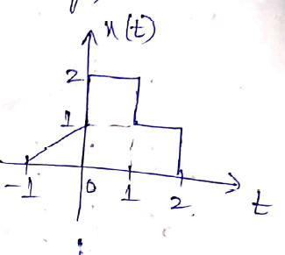  Figure: 1  i. x(t -2)  ii. x(2t+3)  iii. x(3/2t)  iv. x(1 - t)  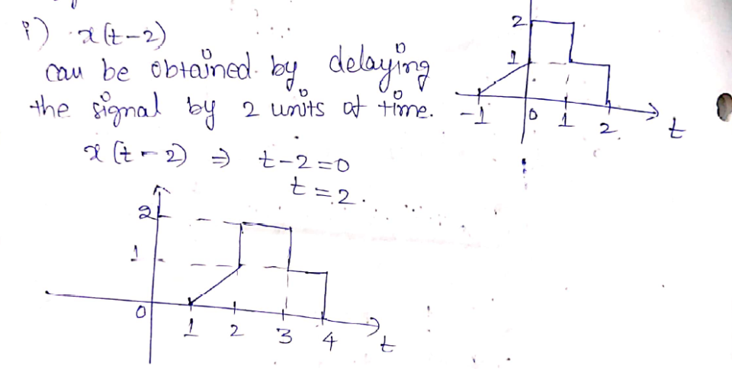  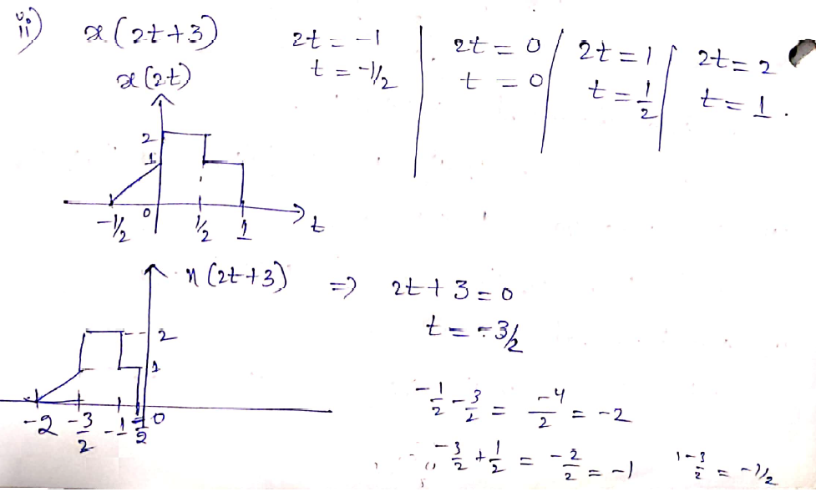  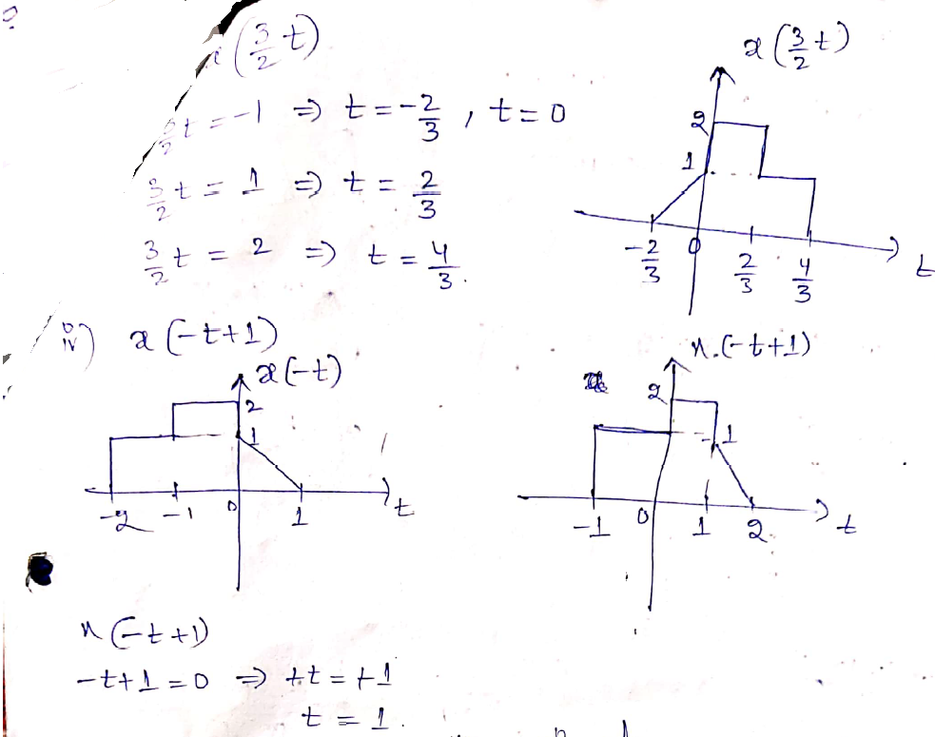 | 5 | 1 | L2
 | b | Explain the continuous elementary signals.  Ans: Unit Step Function:  Unit step function is denoted by u(t). It is defined as u(t)  $$u\left(t\right)=\left\{\begin{aligned}1, t≥0 \\ 0, &t≤0\end{aligned}\right.$$  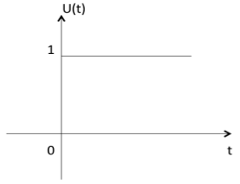  Unit Impulse Function:  Impulse function is denoted by δ(t) and it is defined as δ(t)  $$δ(t)=\left\{\begin{aligned}1, t=0 \\ 0, &t≠0\end{aligned}\right.$$  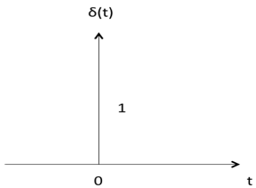  Ramp Signal:  Ramp signal is denoted by r(t), and it is defined as r(t)  $$r(t)=\left\{\begin{aligned}t, t≥0 \\ 0, &t⋖0\end{aligned}\right.$$  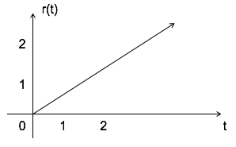  Parabolic Signal:  Parabolic signal can be defined as x(t)  $$x(t)=\left\{\begin{aligned}(t^2)/2, t≥0 \\ 0, &t⋖0\end{aligned}\right.$$  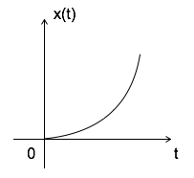  Signum Function:  Signum function is denoted as sgn(t). It is defined as sgn(t)  $$sgn(t)=\left\{\begin{aligned} 1, t>0 \\ -1, &t⋖0 \\ 0, t=0\end{aligned}\right.$$  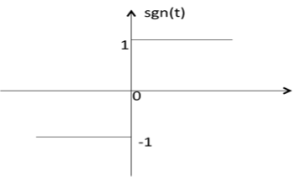  Exponential Signal:  Exponential signal is in the form of x(t) = eαteαt.  The shape of exponential can be defined by α  Case i: if αα = 0 →→ x(t) = e⁰= 1  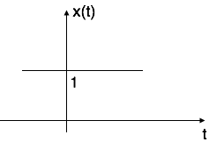  Case ii: if α < 0 i.e. -ve  then x(t) = e^{−αt}. The shape is called decaying exponential.  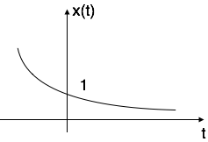  Case iii: if α> 0 i.e. +ve  then x(t) = e^{αt}. The shape is called raising exponential.  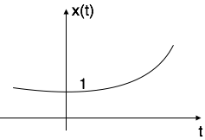  Sinusoidal Signal:  Sinusoidal signal is in the form of x(t) = A cos(w0 ±ϕ) or A sin(w0 ±ϕ)  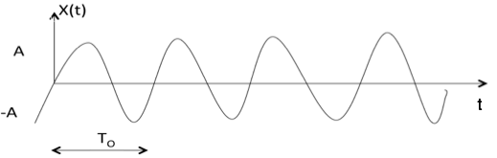  T_{o}=2π/w0 | 3 | 1 | L1
3. | a | Determine the trigonometric form of Fourier series representation of the signal x(t) as shown in figure.  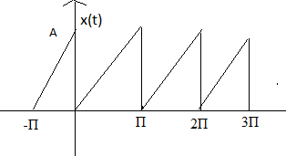  Sol: First represent the signal in point slope form then apply fourier series  ; 0<t<Π  T=Πwo=2  The trigonometric fourier series representation of a periodic signal x (t) with fundamental period T,  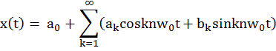  where a_{k} and b_{k} are fourier coefficients given by, a₀ is the dc component of the signal and is given by  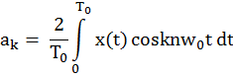  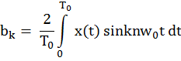  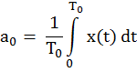  The coefficients are Ao=A/2  An=0 Bn=-A/n  Then substitute Ao,An,Bn in the x(t) trigonometric fourier series representation equation | 5 | 2 | L3
 | b | Check whether the following signals are orthogonal or not?X₁(t)=Sinnw_{o}t and X₂(t)=Cosmw_{o}t[t_{o}, t_{o}+(2π/w_{o})]  Sol: x(t)=sinnw₀t, y(t)=cosmw₀t  the condition for orthogonality is  The integral product is zero hence the signals are orthogonal | 3 | 2 | L2
4. | a | State & prove the Fourier Transform properties. a) Time shifting property b) Convolution in time domain  - Time shifting property  Proof: Let  , i.e., , we have  - Convolution in time domain Convolution Theorems  The convolution theorem states that convolution in time domain corresponds to multiplication in frequency domain and vice versa:  Proof of (a): | 4 | 3 | L2
 | b | Find the inverse Fourier transform of the function X(w)=$\frac{4jw+6}{{(jw)}^{2}+6jw+8}$  Solution:  X(w)=$\frac{4jw+6}{{(jw)}^{2}+6jw+8}$  By applying partial fractions,    X(w)=$\frac{4jw+6}{{(jw)}^{2}+6jw+8}$ =$\frac{4jw+6}{(jw+2)(jw+4)}$ = $\frac{A}{jw+2}+ \frac{B}{jw+4}$  Where A=$[\frac{4jw+6}{jw+4}]_{jw=-2}$⇒A=-1  B=$[\frac{4jw+6}{jw+2}]_{jw=-4}$⇒B=5  X(w) = $\frac{-1}{jw+2}+ \frac{5}{jw+4}$  Apply inverse fourier transform on both sides  x(t)=-$e^{-2t}$u(t)+5$e^{-4t}$u(t) | 4 | 3 | L3
5. | a | State and prove Sampling Theorem with neat Sketch?  Consider a continuous time signal x(t). The spectrum of x(t) is a band limited to f_{m} Hz i.e. the spectrum of x(t) is zero for |ω|>ω_{m}.  Sampling of input signal x(t) can be obtained by multiplying x(t) with an impulse train δ(t) of period T_{s}. The output of multiplier is a discrete signal called sampled signal which is represented with y(t) in the following diagrams:  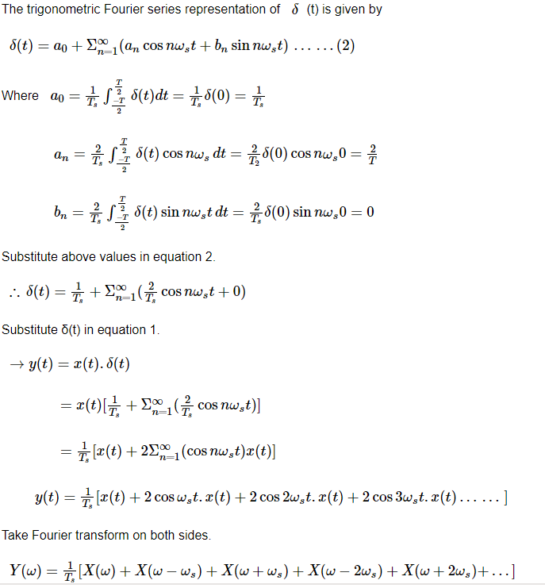  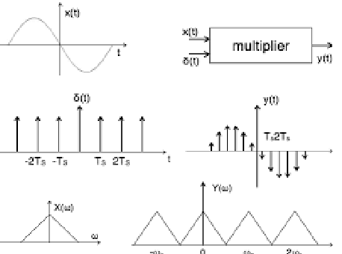 | 5 | 4 | L2
 | b | Find the DTFS of the given periodic sequence  $$x\left(n\right)=\{ 1,2,3,4\}$$  $x\left(n\right)=\{ 1,2,3,4\}$; N=4; n = -1 to 2; k = -1 to 2;  $$a_{k}=\frac{1}{4}\sum_{n=-1}^{2}{x(n)}e^{-j(\frac{2π}{4})nk}$$  $a_{-1}=\frac{1}{4}\sum_{n=-1}^{2}{x(n)}e^{-j(\frac{2π}{4})n(-1)}$ = $\frac{-1}{2}+\frac{j}{2}$  $a_{0}=\frac{1}{4}\sum_{n=-1}^{2}{x(n)}e^{-j(\frac{2π}{4})n(0)}$ = $\frac{5}{2}$  $a_{1}=\frac{1}{4}\sum_{n=-1}^{2}{x(n)}e^{-j(\frac{2π}{4})n(1)}$ = $\frac{-1}{2}-\frac{j}{2}$  $a_{2}=\frac{1}{4}\sum_{n=-1}^{2}{x(n)}e^{-j(\frac{2π}{4})n(2)}$= $\frac{1}{2}$  $$a_{k}=\left\{\frac{-1}{2}+\frac{j}{2}, \frac{5}{2}, \frac{-1}{2}-\frac{j}{2}, \frac{1}{2}\right\}$$ | 3 | 4 | L2
6. | a | State and Prove Initial value theorem and final value theorem of Z-Transform?  Initial value theorem  Statement:  If Z{x(n)}= X(z) then $\lim_{n→0}{x(n)}=x\left(0\right)=\lim_{z→∞}{X(z)}$  Proof:  From the definition of Z-Transform, Z{x(n)} =X(z)=$\sum_{n=0}^{∞}{x\left(n\right). z^{-n}}$  X(z)=$\sum_{n=0}^{∞}{x\left(n\right). z^{-n}}$=$x\left(0\right). z^{0}+x\left(1\right). z^{-1}+x\left(2\right). z^{-2}+…$  Apply the limit $z→∞$ on both sides, we get  $$\lim_{z→∞}{X(z)}=\lim_{z→∞}{[x\left(0\right). z^{0}+x\left(1\right). z^{-1}+x\left(2\right). z^{-2}+…]}$$  $$\lim_{z→∞}{X(z)}= x\left(0\right)+0+0+0+…x\left(0\right)=\lim_{z→∞}{X(z)}$$  Final value theorem  Statement:  If Z{x(n)}= X(z) then $\lim_{n→∞}{x(n)}=x\left(∞\right)=\lim_{z→1}{(z-1)X(z)}$, if (z-1).X(z) has no poles on or outside the unit circle.  Proof:  From the definition of Z-Transform, Z{x(n)} =X(z)=$\sum_{n=0}^{∞}{x\left(n\right). z^{-n}}$  Z{x(n+1)} =z.X(z)-z.x(0)=$\sum_{n=0}^{∞}{x\left(n+1\right). z^{-n}}$  Z{x(n+1)}- Z{x(n)} =z.X(z)-z.x(0)- X(z)=$\sum_{n=0}^{∞}{x\left(n+1\right). z^{-n}}$-$\sum_{n=0}^{∞}{x\left(n\right). z^{-n}}$  $(z-1)X(z$)-z.x(0)=$\sum_{n=0}^{∞}{[x\left(n+1\right)-x\left(n\right)]. z^{-n}}$  Apply the limit $z→1$ on both sides, we get  $\lim_{z→1}{(z-1)X(z)-x(0)}=$ x($∞$)-x(0)  $$x\left(∞\right)=\lim_{z→1}{(z-1)X(z)}$$ | 4 | 5 | L2
 | b | Find the inverse Z-Transform of the signal X(z)= $\frac{3z}{\left(z-1\right)(z-2)}$ by using partial fractions method, if  - ROC: $\left|Z\right|>2$  - ROC: $\left|Z\right|<1$  Solution:  X(z)= $\frac{3z^{-1}}{\left[1-z^{-1}\right][1-2z^{-1}]}$  X(z)= $\frac{3z^{-1}}{\left[1-z^{-1}\right][1-2z^{-1}]}$ = $\frac{3z}{\left(z-1\right)(z-2)}$  The above equation can be expressed in partial fractions form as:  $\frac{X(z)}{Z}$=$\frac{3}{\left(z-1\right)(z-2)}$=$\frac{A}{\left[Z-1\right]}$ + $\frac{B}{[Z-2]}$  A= (z -$1$)${\left.\frac{X(z)}{z}\right|}_{z=1}$  A= ${\left.\frac{3}{z-2}\right|}_{z=1}$=-3  B= (z -$2$)${\left.\frac{X(z)}{z}\right|}_{z=2}$  B= ${\left.\frac{3}{z-1}\right|}_{z=2}$=3  $\frac{X(z)}{Z}$=$\frac{3}{\left(z-1\right)(z-2)}$=$\frac{-3}{\left[Z-1\right]}$ + $\frac{3}{[Z-2]}$  X(z)=-3. $\frac{z}{\left[Z-1\right]}$ + $3.\frac{z}{[Z-2]}$  Apply inverse Z-Transform on both sides, we get  - If ROC: $\left|Z\right|>2$  x(n)=$-3.$u(n)+$3.{(2)}^{n}$.u(n)  - If ROC: $\left|Z\right|<1$  x(n)=$3.$u(-n-1)-$3.{(2)}^{n}$.u(-n-1) | 4 | 5 | L3
7. | a | Check whether the following system is static or dynamic, causal or non-causal? y(t)=x(t)+x(t-2)  Solution:  Here, the present output y(t) depends on present input x(t) and past input x(t-2).  So, the given system is dynamic system.  Here, the present output y(t) depends on present input x(t) and past input x(t-2) but not on future inputs.  So, the given system is causal system. | 4 | 1 | L2
 | b | State and prove properties of Fourier series.  Linearity property and Time shifting property  Linearity property  Statement:  If FS{x₁(t)}=C_{n} and FS{x₂(t)}=D_{n} then FS{a₁ x₁(t)+a₂ x₂(t)}= a₁C_{n} +a₂D_{n}  Proof:  FS{a₁ x₁(t)+a₂ x₂(t)} =$\frac{1}{T}\int_{t_{0}}^{t_{0}+T}{[a_{1}x_{1}(t)+a_{2}x_{2}(t)]}$. $e^{-jnw_{0}t}$dt  =$\frac{1}{T}\int_{t_{0}}^{t_{0}+T}{[a_{1}x_{1}(t)]}$. $e^{-jnw_{0}t}$dt+$\frac{1}{T}\int_{t_{0}}^{t_{0}+T}{[a_{2}x_{2}(t)]}$. $e^{-jnw_{0}t}$dt  =$a_{1}\frac{1}{T}\int_{t_{0}}^{t_{0}+T}{x_{1}(t)}$. $e^{-jnw_{0}t}$dt+$a_{2}\frac{1}{T}\int_{t_{0}}^{t_{0}+T}{x_{2}(t)}$. $e^{-jnw_{0}t}$dt  = a₁C_{n} +a₂D_{n}  Therefore FS{a₁ x₁(t)+a₂ x₂(t)}= a₁C_{n} +a₂D_{n}  Time shifting property:  Statement:  If FS{x(t)}=$c_{n } then$FS{x(t-$t_{0}$)}=$c_{n }$.$e^{-jnw_{0}t_{0}}$  Proof:  From the definition of Fourier series, x(t)=$\sum_{n=-∞}^{∞}{c_{n}}e^{jnw_{0}t}$  [x(t-$t_{0}$)]= $\sum_{n=-∞}^{∞}{c_{n}}e^{jnw_{0}(t-t_{0})}$  [x(t-$t_{0}$)]= $\sum_{n=-∞}^{∞}{{[c}_{n}}e^{-jnw_{0}t_{0}}]$.$e^{jnw_{0}t}$  [x(t-$t_{0}$)]=FS⁻¹[${C_{n}.e}^{-jnw_{0}t_{0}}$]  FS [x(t-$t_{0}$)]= ${C_{n}.e}^{-jnw_{0}t_{0}}$ | 4 | 2 | L2
8. | a | Find the unilateral Laplace transform and ROC of the signal x(t)=$sinw_{0}t$  Solution:  L{x(t)}=X(s)=$\int_{0}^{∞}{x\left(t\right). e^{-st}dt}$  L{x(t)}=X(s)=$\int_{0}^{∞}{sinw_{0}t . e^{-st}dt}$  L{x(t)}=X(s)=$\int_{0}^{∞}{(\frac{e^{jw_{0}t}-e^{-jw_{0}t}}{2j}) . e^{-st}dt}$  L{x(t)}=X(s)=$\int_{0}^{∞}{(\frac{e^{jw_{0}t}}{2j}) . e^{-st}dt}$- $\int_{-∞}^{∞}{(\frac{e^{-jw_{0}t}}{2j}) . e^{-st}dt}$  L{x(t)}=X(s)=$\frac{1}{2j}\int_{0}^{∞}{e^{-(s-jw_{0})t} dt }$-$\frac{1}{2j}\int_{0}^{∞}{e^{-(s+jw_{0})t} dt}$  L{x(t)}=X(s)= $\frac{1}{2j}$ [ ${\frac{e^{-(s-jw_{0})t}}{-(s-jw_{0})}}_{ 0}^{ ∞}- {\frac{e^{-(s+jw_{0})t}}{-(s+jw_{0})}}_{ 0}^{ ∞}$]  L{x(t)}=X(s)=$\frac{1}{2j}[\frac{\left(0-1\right)}{ –\left(s-jw_{0}\right)}$ - $\frac{(0-1)}{-(s+jw_{0})}$ ]  L{x(t)}=X(s)=$\frac{1}{2j}[\frac{1}{ (s-jw_{0})}$ - $\frac{1}{(s+jw_{0})}$ ]  L{x(t)}=X(s)=$\frac{1}{2j}[\frac{2jw_{0}}{ (s^{2}+{w_{0}}^{2})}$ ]  L{x(t)}=X(s)=$\frac{w_{0}}{ (s^{2}+{w_{0}}^{2})}$  ROC: Re($s-jw_{0})>0$ and Re($s+jw_{0})>0$  Common ROC: Re($s)>0$ | 4 | 3 | L3
 | b | Find the DTFT of the signal x(n)=cos$w_{0}$n.u(n)  Solution:  x(n)=cos$w_{0}$n.u(n)  DTFT{x(n)}=X(w)=$\sum_{n=-∞}^{∞}{x\left(n\right). e^{-jwn}}$  DTFT{x(n)}=X(w)=$\sum_{n=-∞}^{∞}{cosw_{0}n.u(n). e^{-jwn}}$  DTFT{x(n)}=X(w)=$\sum_{n=-∞}^{∞}{(\frac{e^{jw_{0}n}+e^{-jw_{0}n}}{2}).u(n). e^{-jwn}}$  DTFT{x(n)}=X(w)=$\frac{1}{2}.(\sum_{n=0}^{∞}{{[e^{j\left(w_{0}-w\right)}]}^{n}}$+$\sum_{n=0}^{∞}{{[e^{-j\left(w_{0}+w\right)}]}^{n}}$)  DTFT{x(n)}=X(w)=$\frac{1}{2}.$($\frac{1}{1-e^{j(w_{0}-w)}}$+$\frac{1}{1-e^{-j(w_{0}+w)}}$)  DTFT{x(n)}=X(w)=$\frac{1}{2}.$($\frac{1-e^{-j(w_{0}+w)}+1-e^{j(w_{0}-w)}}{\left(1-e^{-j\left(w_{0}+w\right)}\right)(1-e^{j(w_{0}-w)}}$)  DTFT{x(n)}=X(w)=$\frac{1-e^{-jw}cosw_{0}}{1-2e^{-jw}cosw_{0}+e^{-j2w}}$ | 4 | 4 | L2
9. | a | Find the Z-transform and ROC of the signal x(n)=${-a}^{n}.u\left(-n-1\right)$  Solution:  Z{x(n)}=X(Z)=$\sum_{n=-∞}^{∞}{x\left(n\right). z^{-n}}$  Z{x(n)}=X(Z)=$\sum_{n=-∞}^{∞}{{-a}^{n}.u\left(-n-1\right). z^{-n}}$  Z{x(n)}=X(Z)=$-\sum_{n=-∞}^{-1}{a^{n}.1. z^{-n}}$  Z{x(n)}=X(Z)=$-\sum_{n=1}^{∞}{a^{-n}.1. z^{n}}$  Z{x(n)}=X(Z)=$-\sum_{n=1}^{∞}{{(a^{-1}z)}^{n}}$  Z{x(n)}=X(Z)=$-(\sum_{n=0}^{∞}{{(a^{-1}z)}^{n}-1)}$  Z{x(n)}=X(Z)=$-(-1+\sum_{n=0}^{∞}{{(a^{-1}z)}^{n})}$  Z{x(n)}=X(Z)=$1-(\sum_{n=0}^{∞}{{(a^{-1}z)}^{n})}$  Z{x(n)}=X(Z)=$1-\{{(a^{-1}z)}^{0}$+${(a^{-1}z)}^{1}$+${(a^{-1}z)}^{2}+{(a^{-1}z)}^{3}+{(a^{-1}z)}^{4}+…$}  Z{x(n)}=X(Z)=$1- \frac{1}{ 1-a^{-1}z}$  Z{x(n)}=X(Z)=$\frac{-a^{-1}z}{ 1-a^{-1}z}$  Z{x(n)}=X(Z)=$\frac{-z}{ a-z}$  Z{x(n)}=X(Z)=$\frac{z}{ z-a}$  ROC:$\left|a^{-1}z\right|<1$  $\left|\frac{z}{a}\right|<1$  $\left|z\right|<a$ | 4 | 5 | L3
 | b | Find the inverse Laplace transform of the signal X(s) =$\frac{s+4}{s^{2}+5s+6}$ by using partial fractions method?  Solution:  X(s)=$\frac{s+4}{s^{2}+5s+6}$  X(s)=$\frac{s+4}{s^{2}+5s+6}=\frac{s+4}{\left(s+2\right)(s+3)}$  X(s)=$\frac{s+4}{\left(s+2\right)(s+3)}$ =$\frac{A}{\left(s+2\right)}+ \frac{B}{(s+3)}$  A= ${\left.\left(s+2\right)X(s)\right|}_{s=-2}$  A=${\left.\frac{s+4}{s+3}\right|}_{s=-2}$=2  B= ${\left.\left(s+3\right)X(s)\right|}_{s=-3}$  B=${\left.\frac{s+4}{s+2}\right|}_{s=-3}$= -1  X(s)=$\frac{s+4}{\left(s+2\right)(s+3)}$ =$\frac{2}{\left(s+2\right)}- \frac{1}{(s+3)}$  Taking the inverse Laplace transform on both sides, we get  x(t)= ${2 e^{-2t}.u(t)-e}^{-3t}.u(t)$ | 4 | 3 | L3

******

