^{Code No.PC302EC}
METHODIST COLLEGE OF ENGINEERING & TECHNOLOGY (An Autonomous Institution)
B.E. (ECE) III-Semester (AICTE) (Supplementary) Examination, Aug -2023
^{Subject: SIGNALS AND SYSTEMS}
Time: 3 hours Max.Marks:60
Note: Missing data, if any, maybe suitably assumed.
^{PART-A}
^{Answer all the questions.}
Q.No. | Questions | Marks | CO | BTL
1. a | Check whether the given signal is an energy or power signal x(t) = e^{-3t}.u(t) | 2 | 1 | L2
b | Define Causal system with example. | 2 | 1 | L1
c | Define exponential Fourier series. | 2 | 2 | L1
d | State the condition for orthogonality between the signals x(t) and y(t). | 2 | 2 | L1
e | Find the Fourier Transform of e^{-2t} u(t). | 2 | 3 | L2
f | Find the Laplace transform and ROC of the signal x(t)=$e^{-at}.u\left(t\right)$ | 2 | 3 | L2
g | Determine whether the system y(n)=$x^{2}(n-2)$ is linear or non-linear system? | 2 | 4 | L2
h | Find the DTFT of the unit step function? | 2 | 4 | L2
i | Find the transfer function of the system given by  y(n-2)+2y(n-1)+3y(n)=x(n-1)+4x(n) using Z-Transform. | 2 | 5 | L2
j | Using initial value theorem, find x($0$), if X(z) =$\frac{z+3}{\left(z+1\right)(z+2)}$ | 2 | 5 | L2

^{PTO}

^{PART-B}
^{Answer Any Five questions.}
Q.No. |  | Questions | Marks | CO | BTL
2. | a | For the signal x(t) given below, sketch the following signals.  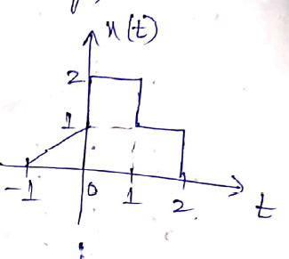  i. x(t -2)  ii. x(2t+3)  iii. x($\frac{ 3}{2}$ t)  iv. x(1 - t) | 5 | 1 | L2
 | b | Explain the continuous elementary signals. | 3 | 1 | L1
3. | a | Determine the trigonometric form of Fourier series representation of the signal x(t) as shown in figure.  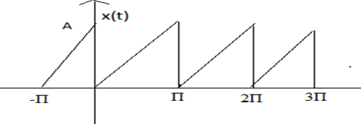 | 5 | 2 | L3
 | b | Check whether the following signals are orthogonal or not?X₁(t)=Sinnw_{o}t and X₂(t)=Cosmw_{o}t[t_{o}, t_{o}+(2π/w_{o})] | 3 | 2 | L2
4. | a | State & prove the Fourier Transform properties.  a) Time shifting property b) Convolution in time domain | 4 | 3 | L2
 | b | Find the inverse Fourier transform of the function X(w)=$\frac{4jw+6}{{(jw)}^{2}+6jw+8}$ | 4 | 3 | L3
5. | a | State and prove Sampling Theorem with neat Sketch? | 5 | 4 | L2
 | b | Find the DFT of the given periodic sequence  $$x\left(n\right)=\{ 1,2,3,4\}$$ | 3 | 4 | L2
6. | a | State and Prove Initial value theorem and final value theorem of Z-Transform? | 4 | 5 | L2
 | b | Find the inverse Z-Transform of the signal X(z)= $\frac{3z}{\left(z-1\right)(z-2)}$ by using partial fractions method, if  - ROC: $\left|Z\right|>2$  - ROC: $\left|Z\right|<1$ | 4 | 5 | L3
7. | a | Check whether the following system is static or dynamic, causal or non-causal? y(t)=x(t)+x(t-2) | 4 | 1 | L2
 | b | State and prove properties of Laplace transform.  (i)Linearity property (ii) Time shifting property | 4 | 2 | L2
8. | a | Find the unilateral Laplace transform and ROC of the signal x(t)=$sinw_{0}t$ | 4 | 3 | L3
 | b | Find the DTFT of the signal x(n)=cos$w_{0}$n.u(n) | 3 | 4 | L2
9. | a | Find the Z-transform and ROC of the signal x(n)=${-a}^{n}.u\left(-n-1\right)$ | 4 | 5 | L3
 | b | Find the inverse Laplace transform of the signal X(s) =$\frac{s+4}{s^{2}+5s+6}$ by using partial fractions method? | 4 | 3 | L3

******

