^{Code No.PC406AD}
METHODIST COLLEGE OF ENGINEERING & TECHNOLOGY
_{(An Autonomous Institution)}
B.E. (AI & DS) IV-Semester (Supplementary) Examination, FEB-2024
Subject: FOUNDATIONS OF ARTIFICAL INTELLIGENCE
Time: 3 hours Max.Marks:60
Note: Missing data, if any, maybe suitably assumed.
^{PART-A}
Answer All the questions.(10X2M=20M)
Q.No. | Questions | Marks | CO | BTL
1. a | Define Artificial Intelligence | 2 | CO1 | I
b | List the types of agents and define them. | 2 | CO1 | I
c | Outline the ways of knowledge representation. | 2 | CO2 | II
d | What is declarative knowledge? Give example | 2 | CO2 | I
e | What is non monotonic logic? | 2 | CO3 | I
f | Recall and write Bayes’ Theorem with example | 2 | CO3 | I
g | List different forms of learning | 2 | CO4 | I
h | Define learning agents. | 2 | CO4 | I
i | Define Expert systems. | 2 | CO5 | I
j | Identify some examples of expert systems | 2 | CO5 | III

^{P.T.O}

^{Code No.1PC406AD}
^{PART-B}
Answer Any Five questions.(5X8M=40M)
Q.No. |  | Questions | Marks | CO | BTL
2. | a | Distinguish A* and AO* search algorithms with suitable examples | 4 | CO1 | IV
 | b | Identify and explain the sequence of nodes that will be visited using breadth-first and depth-first search by considering the below data structure.  A  / | \  B C D  / \ /  E F G  / \  H I | 4 | CO1 | III
3. | a | Illustrate forward reasoning with example. | 4 | CO2 | II
 | b | Compare and contrast forward and backward reasoning | 4 | CO2 | IV
4. | a | Elaborate on Bayesian network and Hidden Markov Models | 4 | CO3 | VI
 | b | Machines A and B produce 10% and 90% respectively of the production of a component intended for the motor industry. From experience, it is known that the probability that machine A produces a defective component is 0.01 while the probability that machine B produces a defective component is 0.05. If a component is selected at random from a day’s production and is found to be defective, find the probability that it was made by (a) machine A; (b) machine B. | 4 | CO3 | III
5. | a | Explain briefly about general model of learning agents | 4 | CO4 | V
 | b | Discuss partial order planning with example. | 4 | CO4 | VI
6. | a | Explain how Rule based expert system works? | 4 | CO5 | V
 | b | Explain Decision tree based expert system with an example. | 4 | CO5 | V
7. | a | In the following two-ply game tree, the terminal nodes show the utility values computed by the utility function. Utilize the Minimax algorithm to identify the utility values for other nodes in the given game tree.  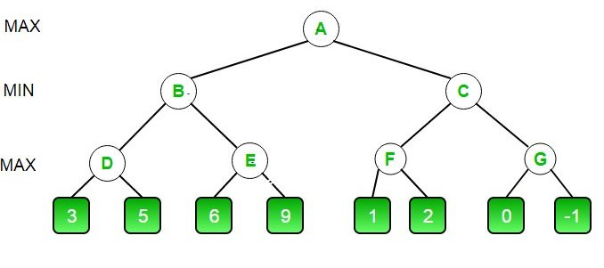 | 4 | CO1 | III
 | b | Explain various ways in which AI can resolve the conflicts. | 4 | CO2 | V
8. | a | Explain the architecture of fuzzy logic system. | 4 | CO3 | V
 | b | Differentiate supervised and un supervised learning. | 4 | CO4 | IV
9. | a | Explain non-monotonic expert system with suitable example. | 4 | CO5 | V
 | b | Illustrate AO* algorithm with an example | 4 | CO1 | II

******

