^{Code No.PC404CE}
METHODIST COLLEGE OF ENGINEERING & TECHNOLOGY
_{(An Autonomous Institution)}
B.E. (CIVIL) IV-Semester (AICTE) Regular Examination, AUGUST-2023
Subject: MECHANICS OF MATERIALS AND STRUCTURES
Time: 3 hours Max.Marks:60
Note: Missing data, if any, maybe suitably assumed.
^{PART-A}
Answer All the questions.(10X2M=20M)
Q.No. | Questions | Marks | CO | BTL
1.a | List the various methods for computing deflection of beams ? | 2 | 1 | 1
b | Define Conjugate beam ? | 2 | 1 | 1
c | Write the equivalent lengths for the four standard cases for columns | 2 | 2 | 2
d | Define unsymmetrical bending. | 2 | 2 | 1
e | Explain the position of shear centre in various sections | 2 | 3 | 2
f | Define Staticindeterminacy. | 2 | 3 | 1
g | What are the advantages of fixed beams. | 2 | 4 | 1
h | What is meant by Prop? | 2 | 4 | 2
i | StateCastigliano'sTheorem-I | 2 | 5 | 1
j | What is the significance of unit load method. | 2 | 5 | 2

^{PART-B}
Answer Any Five questions.(5X8M=40M)
Q.No. |  | Questions | Marks | CO | BTL
2. | a | Derive an expression for slope and deflection for a simply supported beam of span ‘L’ subjected to uniformly distributed load of ‘w/m’ over its entire span. | 8 | 1 | 2
3. | a | Determine the Euler's critical load for a hollow cylinder cast iron of 160mm external diameter and 140mm internal diameter if it is 6m long and hinged at both ends. Compare this load with that given by Rankine's formula. Take E=0.7X10⁵ N/mm², f_{c}= 550N/mm²and α= 1/ 1600. | 8 | 2 | 3
4. | a | Find the Shear Centre of I- Section as shown below. Both flanges are of same dimensions.  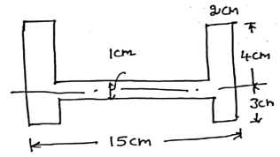 | 8 | 3 | 3
5. | a | Draw SFD and BMD for a propped cantilever beam fixed at A and prop at B of length 5m subjected to point load of 20kN at a distance of 3m from fixed end. | 8 | 4 | 3
6. | a | Draw BMD and SFD for the continuous beam as shown below. During loading B sinks by 30mm. Take EI = 40,000kN-m2. Span AB and BC are 12m each.  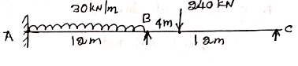 | 8 | 4 | 4
7. | a | Find the vertical deflection at C for the cantilever truss shown below. The cross sectional areas of CD and DE are 2500mm² and others are 1250mm². Take E= 200GPa. Triangle ADE is equilateral. Load at C is 40kN.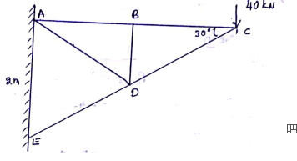 | 8 | 5 | 4
8. | a | Determine Static and Kinematic indeterminacy of the following structures  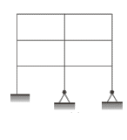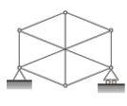 | 8 | 3 | 3
9. | a | Derive Euler’s formula for a long column with both ends hinged. Also mention assumptionsinvolved in the derivation of this formula. | 8 | 2 | 2

*****

