^{Code No.PC406EC}
METHODIST COLLEGE OF ENGINEERING & TECHNOLOGY
_{(An Autonomous Institution)}
B.E. (ECE) IV-Semester (Supplementary) Examination, FEB-2024
Subject: AUTOMATIC CONTROL SYSTEMS
Time: 3 hours Max.Marks:60
Note: Missing data, if any, maybe suitably assumed.
^{PART-A}
Answer All the questions.(10X2M=20M)
Q.No. | Questions | Marks | CO | BTL
1. a | What are the advantages of open loop system? | 2M | 1 | 1
b | Write the analogous electrical and mechanical quantities based on force-voltage analogy. | 2M | 1 | 2
c | State the limitations of RH criterion of stability. | 2M | 2 | 2
d | Examine the stability of the system whose Characteristic Equation is  s⁴+4s³+s²+8s+1=0. | 2M | 2 | 4
e | Define Gain Margin and Phase Margin. | 2M | 3 | 1
f | What is the effect of PID Controllers? | 2M | 3 | 2
g | State the advantages of state variable analysis. | 2M | 4 | 2
h | Define Observability of a system. | 2M | 4 | 1
i  j | Draw the block diagram of Digital Control System.  List the merits and demerits of digital control systems over analog systems. | 2M  2M | 5  5 | 3  3

^{P.T.O}
^{Code No.PC406EC}
^{PART-B}
Answer Any Five questions.(5X8M=40M)
Q.No. |  | Questions | Marks | CO | BTL
2. | a | Obtain the Transfer Function of the following using Mason’s Gain Formula: | 5M | 1 | 4
 | b | Determine the overall Transfer Function of the block diagram given below: | 3M | 1 | 4
3. | a | Sketch the root locus of a unity feedback control system whose loop transfer function is G(s).H(s) = k/[s(s+5)(s+10)]. | 6M | 2 | 4
 | b | Define break in and breakaway point with respect to root locus. | 2M | 2 | 1
4. | a | Draw a Bode plot and obtain Gain and Phase Margins for G(s) = $\frac{400(s+2)}{s^{2}(s+5)(s+10)}$ | 6M | 3 | 4
 | b | List the various types of compensators. | 2M | 3 | 1
5. | a | A Linear Time-Invariant system is given by the homogeneous state equation:  $\left[\begin{matrix}\frac{dx_{1}}{dt} \\ \frac{dx_{2}}{dt}\end{matrix}\right]$ = $\left[\begin{matrix}0 & 1 \\ -1 & -2\end{matrix}\right]\left[\begin{matrix}x_{1} \\ x_{2}\end{matrix}\right]$. Find its State Transition Matrix. | 4M | 4 | 4
 | b | State the properties of State Transition Matrix. | 4M | 4 | 1
6. | a | For the sampled data control system shown below, find the response to unit step input when G(s) = 1/ (s+1).  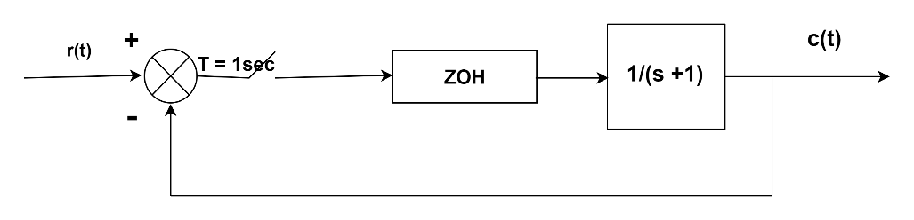 | 5M | 5 | 4
 | b | Explain the architecture of Digital Control System. | 3M | 5 | 3
7. | a | Write the differential equations governing mechanical systems. | 4M | 1 | 2
 | b | The Transfer Function of forward path and feedback element is G(s) = $\frac{s+4}{s(s+2)}$and H(s) =$\frac{s^{3}+2s^{2}+s}{s^{2}(s^{2}+5s+4)}$  Then determine the type and order of the system. | 4M | 2 | 4
8. | a | Write short notes on Nyquist Plots. | 3M | 3 | 4
 | b | Obtain state variable model for a closed loop Transfer Function given by Y(s) / U(s) = $\frac{160\left(s+4\right)}{{s^{3}+8s^{2}+192s+640}^{}}$ | 5M | 4 | 3
9. | a | Obtain the expression for C(z) in terms of R(z) of a basic closed loop discrete control system. | 5M | 5 | 4
 | b | Define time-domain specifications. | 3M | 2 | 1

******

