^{Code No.PC406EC}
METHODIST COLLEGE OF ENGINEERING & TECHNOLOGY
_{(An Autonomous Institution)}
B.E. (ECE) IV-Semester (AICTE) Regular Examination, AUGUST-2023
Subject: AUTOMATIC CONTROL SYSTEMS
Time: 3 hours Max.Marks:60
Note: Missing data, if any, maybe suitably assumed.
^{PART-A}
Answer All the questions.(10X2M=20M)
Q.No. | Questions | Marks | CO | BTL
1. a | Define Transfer Function for a system. | 2M | 1 | 1
b | Write the Mason’s Gain formula. | 2M | 1 | 1
c | Explain RH criterion of stability. | 2M | 2 | 2
d | Given r(t)=(1-t²)u(t) and G(s) = $\frac{2}{s^{2}(s+3)}$. find steady state error. | 2M | 2 | 3
e | State the Principle of Argument. | 2M | 3 | 1
f | What isNyquist Criterion for stability? | 2M | 3 | 1
g | List any two properties of state transition matrix. | 2M | 4 | 1
h | Define Controllability and Observability of a system | 2M | 4 | 1
i  j | What is the transfer function of Zero order hold circuit?  Identify the advantages of Digital Control Systems. | 2M  2M | 5  5 | 1  2

^{P.T.O}

^{Code No.PC406EC}
^{PART-B}
Answer Any Five questions.(5X8M=40M)
Q.No. |  | Questions | Marks | CO | BTL
2. | a | What is the open loop DC gain of a unity negative feedback sys having closedloop transfer function as $\frac{(s+4)}{(s^{2}+7s+13)}$. | 3M | 1 | 3
 | b | Derive the Transfer Function for the Mechanical System shown below. Also draw the Force-Voltage analogous circuit.  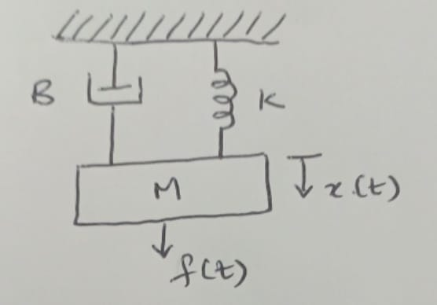 | 5M | 1 | 4
3. | a | Construct Root Locus for the following Open Loop Transfer Function: G(s) =$\frac{k}{[s\left(s+4\right)\left(s^{2}+s+20\right)]}$. | 8M | 2 | 4
4. | a | What are the merits of Bode Plots over Nyquist Plot? | 3M | 3 | 1
 | b | Illustrate the need for a compensator.For a Lead-compensator network, draw pole-zero plot, Bode plot and list the Transfer Function expression. | 5M | 3 | 3
5. | a | Obtain the state space representation of the following systems described by the differential equation  $$\frac{d^{3}x}{{dt}^{3}}+3\frac{d^{2}x}{{dt}^{2}}+4\frac{dx}{dt}+4x=u_{1}\left(t\right)+3u_{2}\left(t\right)+4u_{3}(t)$$  Output equations:$y_{1}=4\frac{dx}{dt}+3u_{1}(t)$ ;  $$y_{2}=\frac{d^{2}x}{{dt}^{2}}+ 4u_{2}(t)+ u_{3}(t)$$ | 5M | 4 | 4
 | b | Specify the need for state variables. | 3M | 4 | 2
6. | a | Illustrate the block diagram of digital control systems. | 5M | 5 | 4
 | b | Draw the circuit of Sample and Hold circuit and obtain its Transfer Function. | 3M | 5 | 4
7. | a | Discuss about the Block Diagram representation and its components of a control system. | 3M | 1 | 3
 | b | Write the standard form of a second order system whose closed loop poles are located at s= (-3$)±$j4. Then calculate the rise time. | 5M | 2 | 4
8. | a | Given the characteristic Equation is 2s³ + 3s² + 2s + k =0, find the condition for k for the system to be stable. | 4M | 3 | 4
 | b | Compute the observability matrix of the system matrix: A=$\left[\begin{matrix}1 & 2 \\ 3 & 4\end{matrix}\right]$ ,  B = $\left[\frac{2}{5}\right]$, C= $\left[3 4\right]$ | 4M | 4 | 4
9. | a | For the system, find response at sampling instants to unit step input for T = 1 sec, k=1.  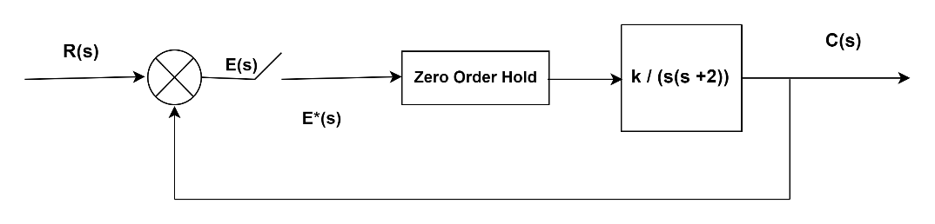 | 5M | 5 | 4
 | b | Write short notes on frequency domain specifications. | 3M | 3 | 3

******

