^{Code No.PC406EE}
METHODIST COLLEGE OF ENGINEERING & TECHNOLOGY
_{(An Autonomous Institution)}
B.E. (EEE) IV-Semester (AICTE) Regular Examination, AUGUST-2023
^{Subject: CONTROL SYSTEMS}
Time: 3 hours Max.Marks:60
Note: Missing data, if any, maybe suitably assumed.
^{PART-A}
Answer All the questions.(10X2M=20M)
Q.No. | Questions | Marks | CO | BTL
1.a | Compare open loop and closed loop control systems. | 2 | 1 | 2
b | State and explain the Mason’s gain formula. | 2 | 1 | 1
c | Distinguish between type and order of a system. | 2 | 2 | 2
d | A unity feedback system has an open loop transfer function G(s)=10/(s+1)(s+2). Determine the steady state error for unit step input. | 2 | 2 | 3
e | What is Nyquist stability criterion? | 2 | 3 | 2
f | Write the necessary condition for stability. | 2 | 3 | 2
g | What are frequency domain specifications? | 2 | 4 | 2
h | Draw the locations of poles and zeroes in the s-plane for a leadcompensator. | 2 | 4 | 3
i  j | Define the controllability & observability of the system.  List the advantages of state variable analysis. | 2  2 | 5  5 1 | 2
^{P.T.O}
^{Code No.4PC406EE}
^{PART-B}
Answer Any Five questions.(5X8M=40M)
Q.No. |  | Questions | Marks | CO | BTL
2. | a | Using block diagram reduction techniques, determine transfer function  C/Rof thesystem shown in figure.  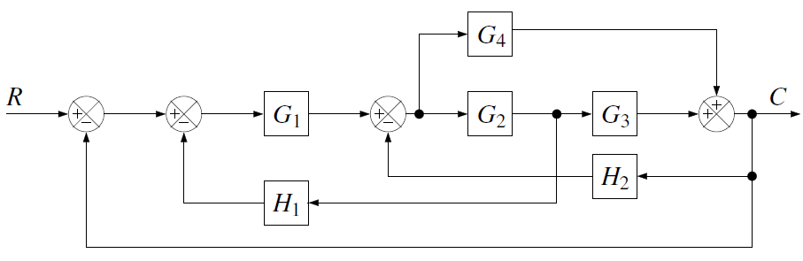 | 6 | 1 | 3
 | b | Why negative feedback is preferred over positive feedback? | 2 | 1 | 1
3. | a | Considering the response of a second order under damped system to a step input,derive the following: (i) Peak time (t_{p}) (ii) Rise time (t_{r}). | 5 | 2 | 1
 | b | For a unity feedback system whose open loop transfer function is  G(s) = 4/s(s+5).Find ω_{n} and ξ. | 3 | 2 | 2
4. | a | Using Routh’s stability criterion, determine the stability of the system represented by characteristic equation s⁴+8s³+18s²+16s+5=0. | 6 | 3 | 3
 | b | What are break away and break in point? How to determine them? | 2 | 3 | 2
5. |  | Sketch the Bode plot for the following transfer function and obtain the gain and cross over frequencies.  G(s) = 10/s(1+0.4s)(1+0.1s) | 8 | 4 | 3
6. | a | Obtain the state model for the system represented by  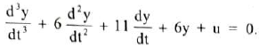 | 5 | 5 | 3
 | b | What are the properties of state transition matrix? | 3 | 5 | 2
7. | a | With neat diagram, explain the operation of synchro transmitter-receiver pair. | 6 | 1 | 2
 | b | Sketch the response of a second order under damped system. | 2 | 2 | 2
8. | a | Sketch the root locus of the system whose open loop transfer function is 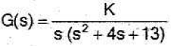 | 5 | 3 | 3
 | b | Sketch the polar plot of G(s) = 1/(1+sT₁)(1+sT₂). | 3 | 4 | 2
9. |  | Determine the transfer function for following system given below:  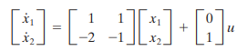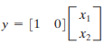 | 8 | 5 | 3
 |  | ******

