**ADDITIVE MANUFACTURING TECHNOLOGY**

**UNIT 4**

**ADDITIVE MANUFACTURING DATA FORMATS**

**STL Format**

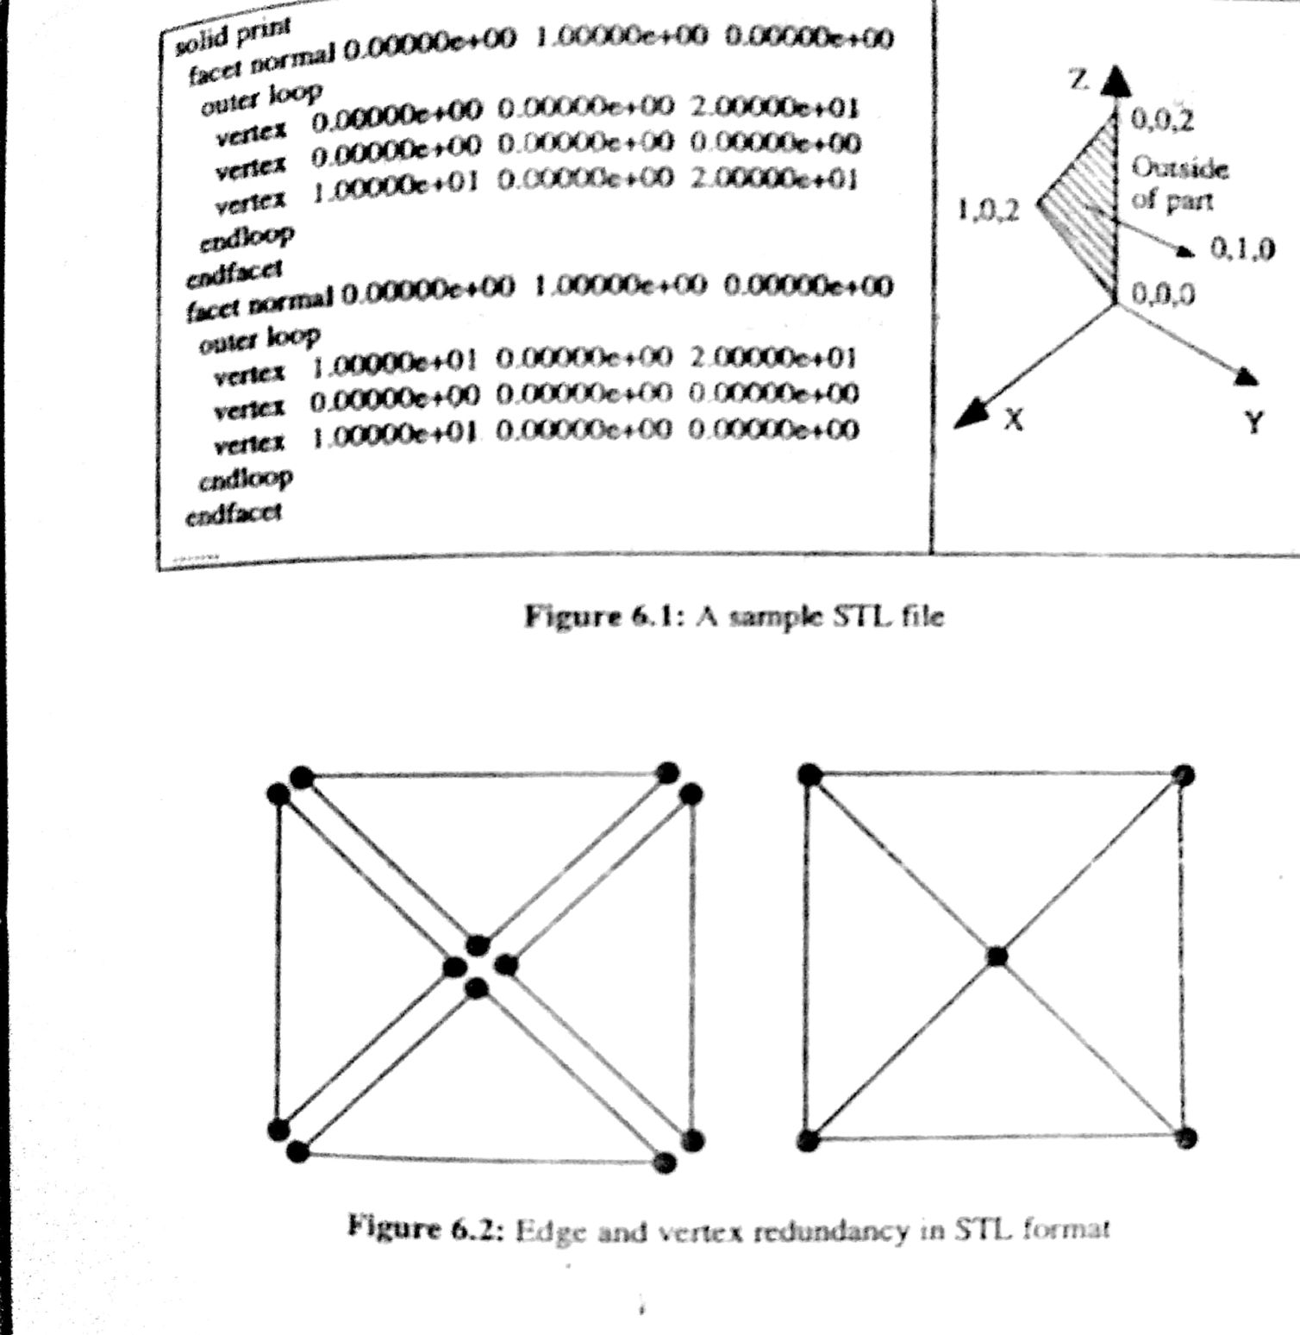Representation methods used to describe CAD geometry vary from one system to another. A standard interface is needed to convey geometric descriptions from various CAD packages to rapid prototyping systems. The STL file as the de facto standard has been used in almost all rapid prototyping systems. The STL file is created from the CAD database via an interface on the CAD system. This file consists of an unordered list of triangular facets representing the outside skin of an object.

STL file can be specified in two formats.

1. ASCII format and
2. Binary format.

The size of the ASCII STL file is larger than that of the binary format but is human readable. In a STL file, triangular facets are described by a set of X, Y and Z coordinates for each of the three vertices and a unit normal vector with X, Y and Z to indicate which side of facet is an object. An example is shown in figure.

**Advantages of the STL file**

* It provides a simple method of representing 3D CAD data.
* It is already a de facto standard and has been used by most CAD systems and rapid prototyping systems.
* It can provide small and accurate files for data transfer for certain shapes.

**Disadvantages**

* The STL file is many times larger than the original CAD data file.
* The STL file carries much redundancy information such as duplicate vertices and edges shown in figure.
* The geometry flaws exist in the STL file because many commercial tessellation algorithms used by CAD vendor today are not robust.
* This gives rise to the need for a repair software which slows down the production cycle time.
* The slicing of large STL files can take many hours. However some RP processes can slice while they are building the previous layer and this will avoid this disadvantage.

**STL File Problems**

* Several problems exist in STL files as they contain no topological data.
* Many commercial tessellation algorithms used by CAD vendors today are not robust and as a result they tend to create polygonal approximation models which exhibit the following types of errors.

1. Gaps (Cracks, holes, punctures) that is, missing facets

2. Degenerate facets (where all its edges are collinear)

3. Overlapping facets.

4. Non manifold topology conditions.

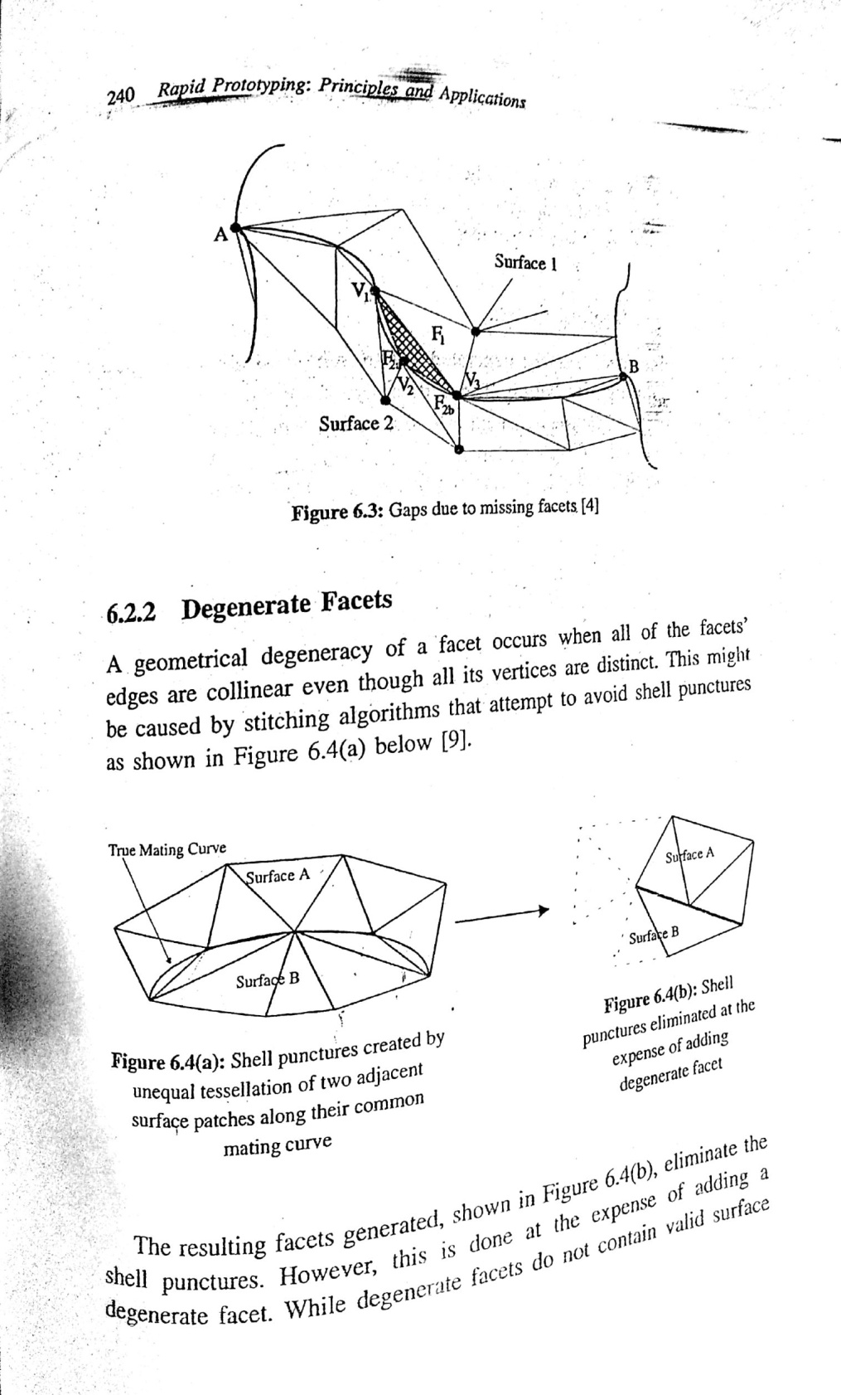**Reasons:** Due to the difficulties encountered in tessellating surfaces, surface intersections, and controlling numerical errors. Hence it is necessary to perform model validity checks before the tessellated model is sent to the rapid prototyping equipment for manufacturing. If the tessellated model is invalid, specific problems are to be determined (whether they are due to gaps, degenerate facets or overlapping facets etc.)

**Missing facets or gaps**

Tessellation of surfaces with large curvature can result in errors at the intersection between such surfaces, leaving gaps or holes along edges of the part model. A surface intersection anomaly which results in a gap is shown in figure.

**Degenerate Facets**

A geometrical degeneracy of a facet occurs when all of the facets’ edges are collinear even though all its vertices are distinct. This might be caused by stitching algorithms that attempt to avoid cell punctures as shown in figure 6.4 a below. The resulting facets generated shown in figure 6.4 b eliminate the cell punctures.

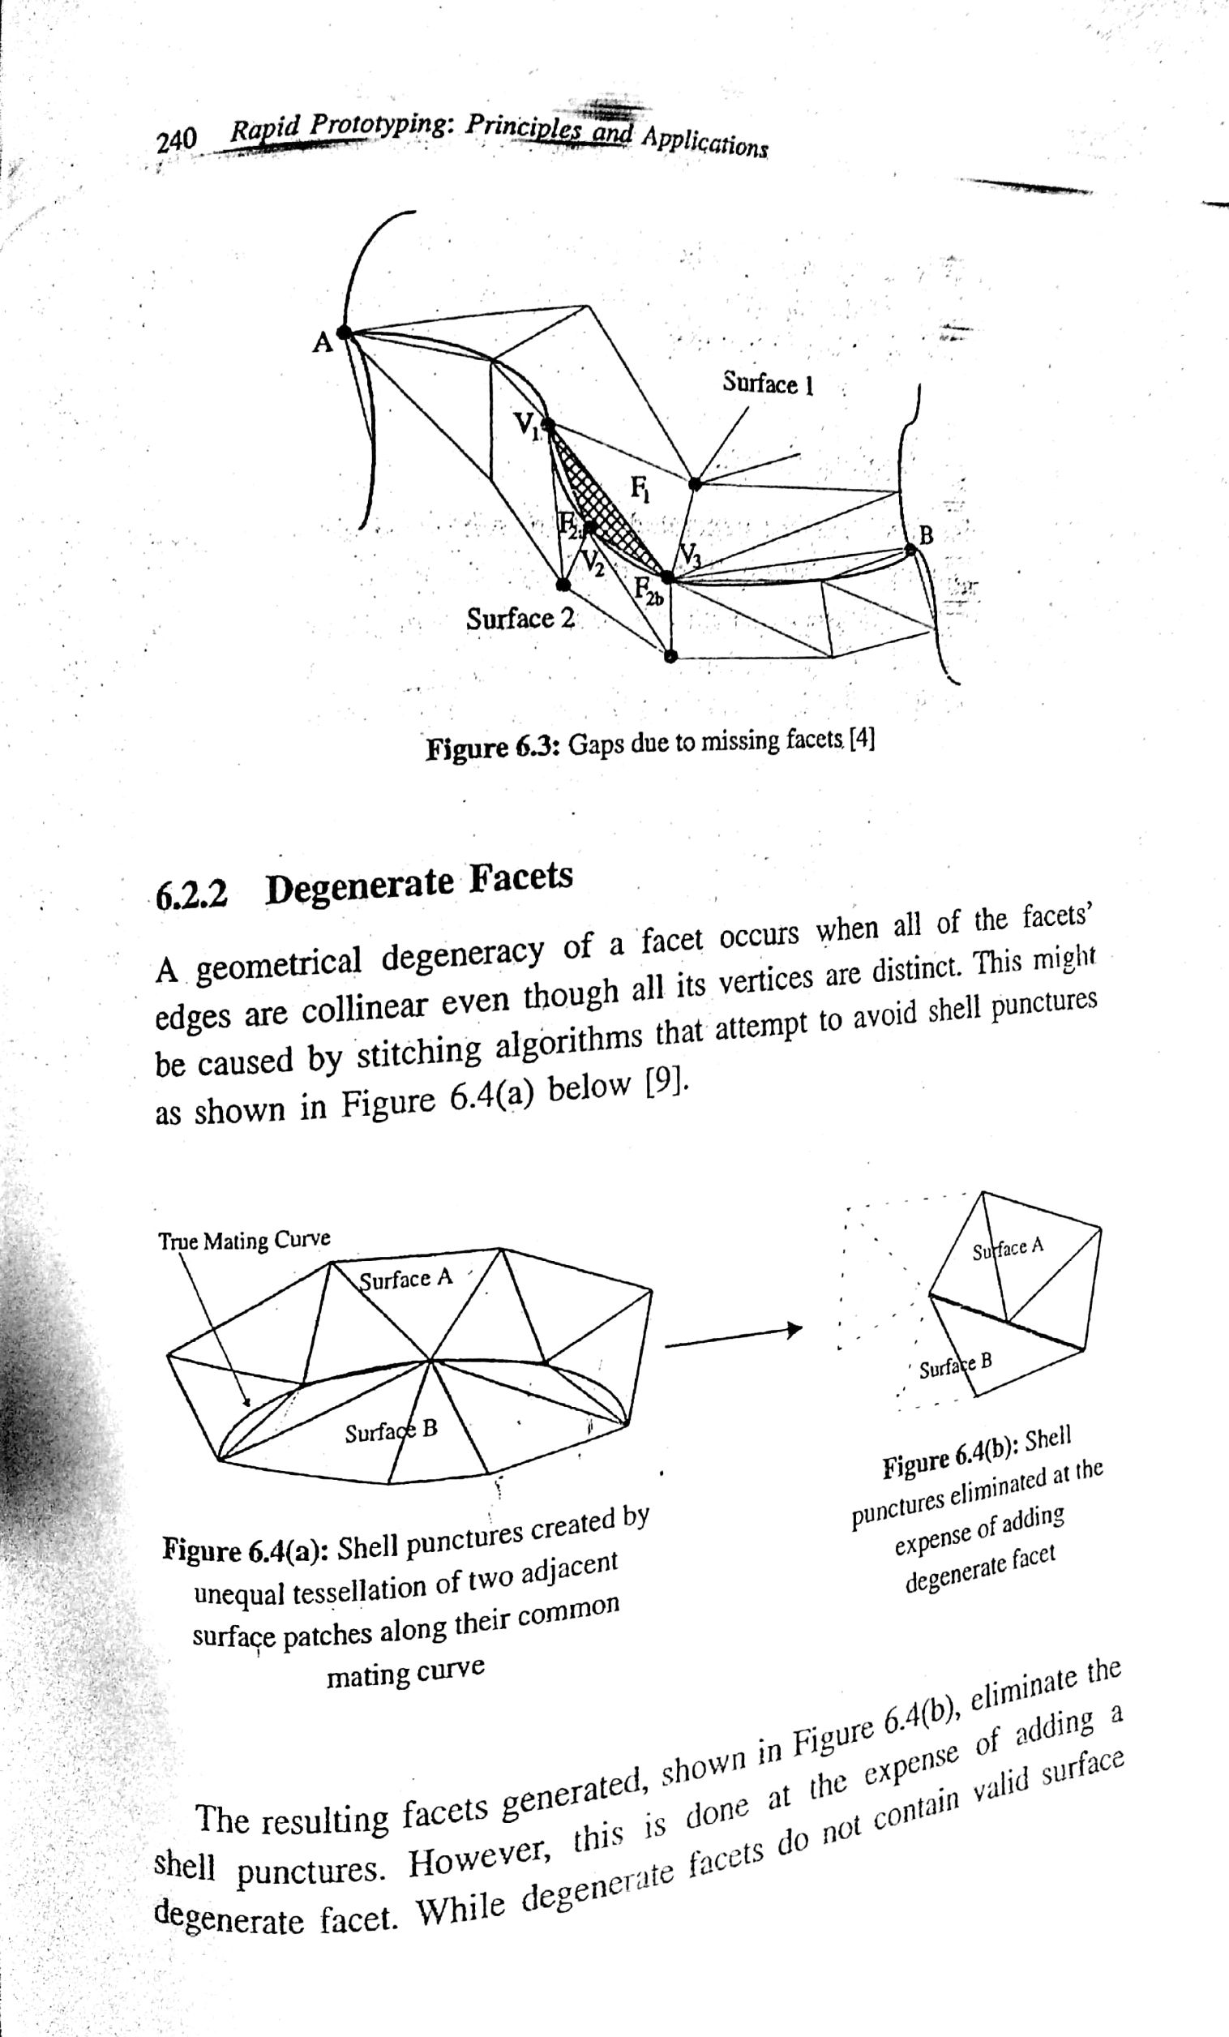

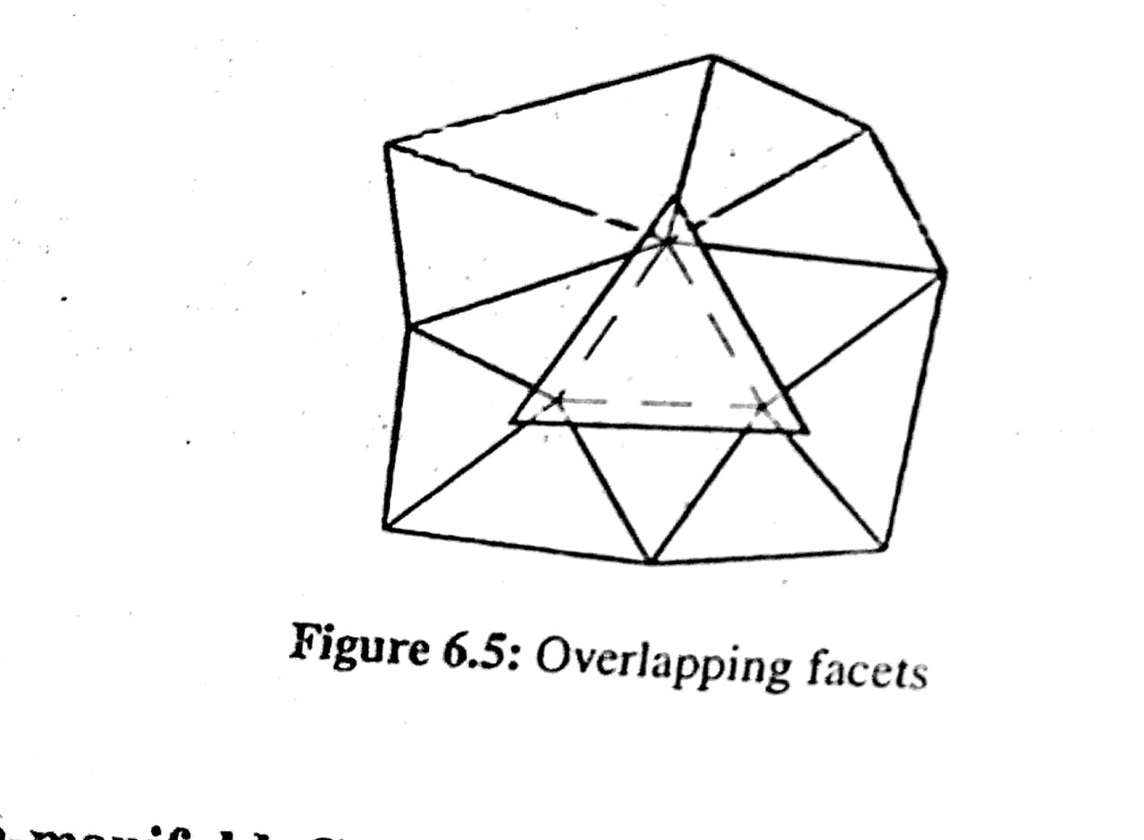However this is done at the expense of adding a degenerate facet. While degenerate facets do not contain valid surface normals, they do represent implicit topological information on how two surfaces mated. This important information is consequently stored prior to discarding the degenerate facet.

**Overlapping facets**

Overlapping facets may be generated due to numerical round-off error occurring during tessellation. The vertices are represented in 3D space as floating point numbers instead of integers. Numerical round-off can cause facets to overlap if tolerances are set too liberally. Example of an overlapping facet is shown in figure 6.5.

**Non-manifold conditions**

There are three types of non manifold conditions.

1. A non-manifold edge
2. A non-manifold point.
3. Non-manifold face.

These may be generated because tessellations of the fine features are susceptible to round off errors. Example of a non manifold edge is shown in Figure 6.6 a. Hear the non manifold edge is actually shared by four different facets as shown in figure 6.6 b.

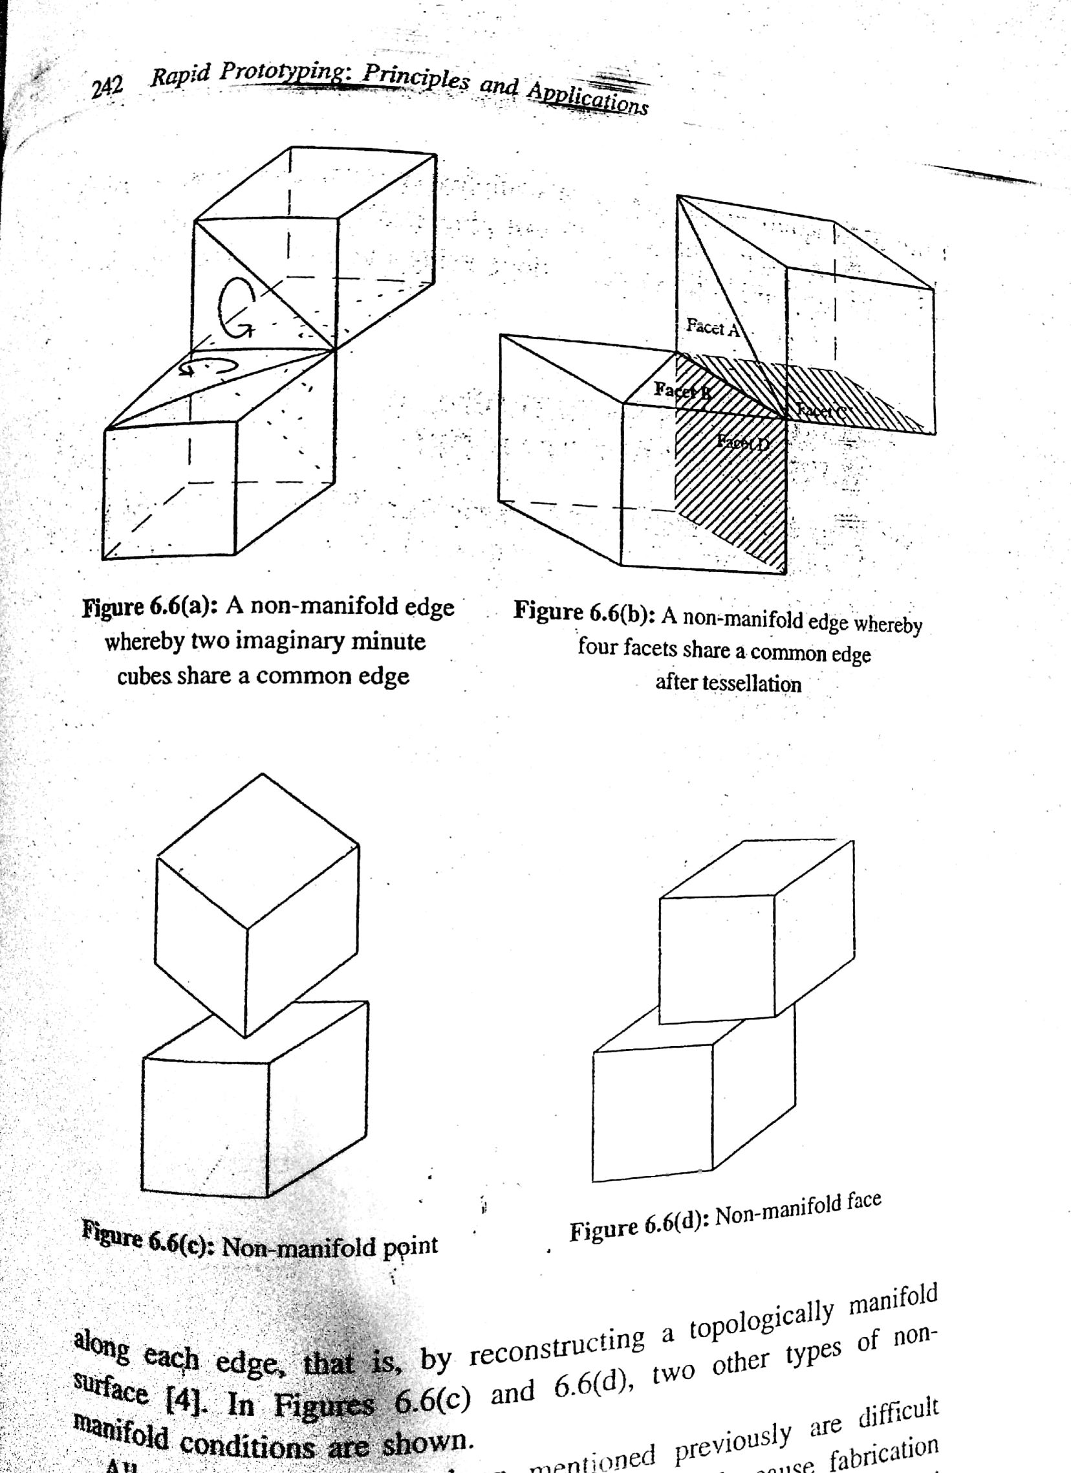

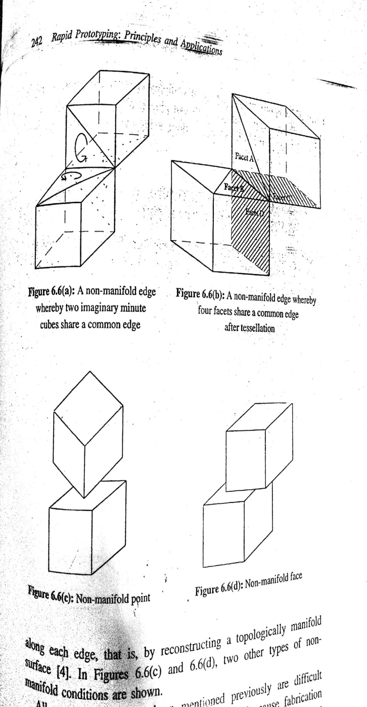

A valid model would be one whose facets have only an adjacent facet each, i.e., one edge is shared by two facets only. Hence the non manifold edges must be resolved such that each facet has only one neighboring facet along each edge, that is, by reconstructing a topologically manifold surface.

In figures 6.6 c and 6.6 d, two other types of non manifold conditions are shown.

All these problems are difficult to handle by most slicing algorithms. They also cause fabrication problems for RP processes which essentially require valid tessellated solids as input. Thus such problems have become almost inevitable as long as the representation of the solid model is done using the STL format which inherently has these limitations.

**Consequences of building a valid and invalid tessellated model.**

**A Valid Model**

A tessellated model is said to be valid if there are no missing facets, degenerate facets, overlapping facets or any other abnormalities. When a valid tessellated model as in figure 6.7 a is used as an input, it will first be sliced into 2D layers as shown in figure 6.7 b.

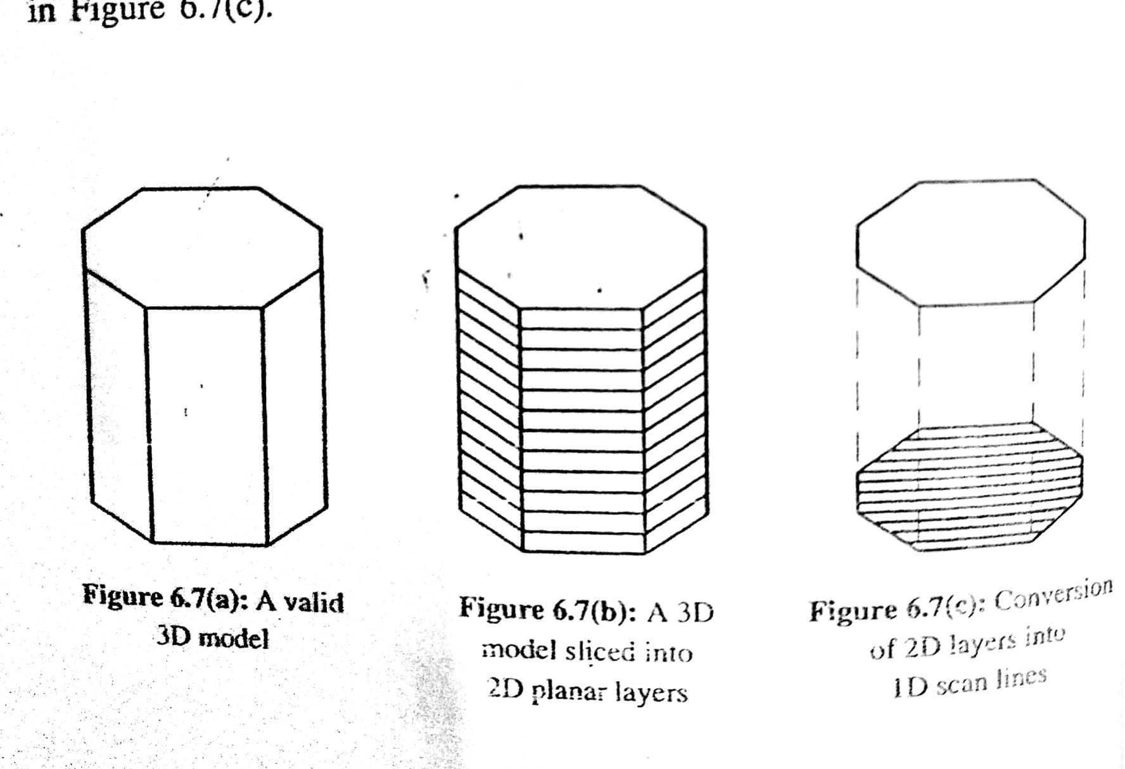

Each layer would then be converted into unidirectional or 1D scan lines for the laser or other RP techniques to commence building the model as shown in figure 6.7c. The scan lines would act as on/off points for the laser beam controller so that the part model can be built accordingly without any problems. Each layer would then be converted into unidirectional (or 1D) scan lines to commence building the model using laser or other RP techniques as shown in figure 6.7c. The scan lines would act as on/off points for the laser beam controller so that the part model can be built accordingly without any problems

**An invalid model**

If the tessellated model is invalid, a situation may develop as shown in figure 6.8. A solid model is tessellated non robustly and results in a gap as shown in figure 6.8 a. If this error is not corrected and the model is subsequently sliced as shown in figure 6.8 b, in preparation for it to be built layer-by-layer, the missing facets in the geometrical model would cause the system to have no predefined stopping boundary on the particular slice, thus the building process would continue right to the physical limit of the RP machine, creating a stray physical solid line and ruining the part being produced as shown in figure 6.8 c.

Therefore it is of paramount importance that the model must be repaired before it is sent for building.

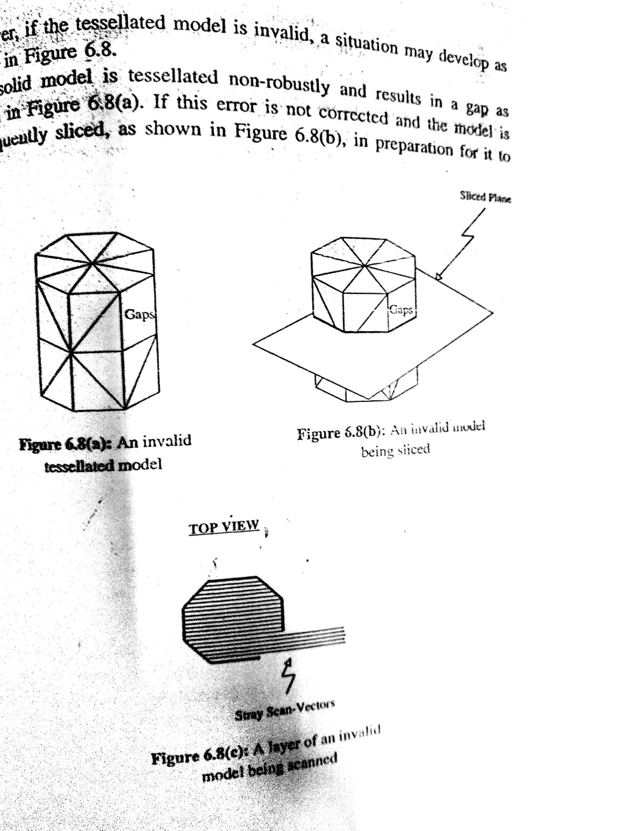

**STL File Repair**

The STL file repair can be implemented using:

1. A generic solution and

2. Dedicated solutions for special cases.

**Generic Solution**

In order to ensure that the model is valid and can be robustly tessellated, one solution is to check the validity of all the tessellated triangles in the model. In existing RP systems, when a punctured shell is encountered, the course of action taken is only requires a skilled technician to manually repair the shell. This manual cell repair is frequently done without any knowledge of the designer’s intent. The work can be very time consuming and tedious, thus negative the advantages of rapid prototyping as the cost would increase and the time taken might be longer than that taken if traditional prototyping process is used.

The main problem of repairing the invalid tessellated model would be that of matching the solution to the designer’s intent. The generic algorithm aims to match the quality of repair done manually by a skill technician when information of the designer’s intent is not available.

The basic approach of the algorithm to solve the missing facets problem would be to detect and identify the boundaries of all the gaps in the model. Once the boundaries of the gaps are identified, suitable facets would then be generated to repair and patch up these  
gaps.

The size of the generated facets would be restricted by the gap’s boundaries while the orientation of its normal would be controlled by comparing it with the rest of the shell. This is to ensure that the generated facets’ orientation is correct and consistent throughout the gap closer process. The orientation of the shell’s facets can be obtained from the STL file which lists its vertices in an ordered manner. The algorithm exploits this feature so that the repair carried out on the invalid model using suitably created facets would have the correct orientation.

Thus, this generic algorithm can be said to have the ability to make an inference from the information contained in the STL file so that the following two conditions can be ensured.

1. The orientation of the generated facet is correct and compatible with the rest of the model.
2. Any contoured surface of the model would be followed closely by the generated facets due to the smaller facet generated.

Finally the basis for the working of the algorithm is due to the fact that in a valid tessellated model there must only be two facets sharing every edge. If this condition is not fulfilled then this indicates that there are some missing facets.

With the detection and subsequent repair of these missing facets, the problems associated with the invalid model can then be eliminated.

**Special Algorithms**

The generic solution presented only caters to gaps that are isolated from one another. However, should any of the gaps were to meet at a common vertex; the algorithm may not be able to work properly. Special algorithms are used to address the following special cases.

1. Two are more gaps formed from a coincidental vertex.

2. Degenerate facets

3. Overlapping facets

The special cases are classified as such because these errors are not commonly encountered in the tessellated model. When there are still problems in the tessellated model after the generic solution’s repair, the expanded algorithm could then be used to detect and solve the special case problems.

**Other Translators**

**IGES File**

IGES (Initial Graphics Exchange Specification) is a standard used to exchange graphics information between commercial CAD systems. It was set up as an American National Standard in 1981. The IGES file can precisely represent CAD models. It includes not only the geometry information, but also topological information.

In IGES, surface modeling, constructive solid geometry and boundary representation are introduced. Especially the ways of representing the regularized operations for union, intersection and difference have also been defined.

**Advantages:**

* Wide adoption and comprehensive coverage.
* Since IGES was set up as American National Standard, virtually every commercial CAD-CAM system has adopted IGES implementations.
* It provides the entities of points, lines, arcs, splines, NURBS surfaces and solid elements. Therefore it can precisely represent CAD model.

**Advantages** of using IGES over current approximate methods include:

* Precise geometry representations,
* Few data conversions,
* Smaller data files and
* Simpler control strategies.

**Disadvantages**

* Because IGES is the standard format to exchange data between CAD systems, it also includes much redundant information that is not needed for rapid prototyping systems.
* The algorithms for slicing an IGES file are more complex than the algorithms slicing a STL file.
* The support structures needed in RP systems such as SLA cannot be created according to the IGES format.
* Lack of transfer standards for a variety of cad  systems and system complexities.

**HP/GL File**

HP/GL (Hewlett Packard Graphics Language) is a standard data format for graphic plotters. Data types are all two-dimensional including lines, circles, splines, texts etc.

**Advantages:**

* Lot of commercial CAD systems have the interface to output the HP/GL format.
* It is a 2D geometry data format which does not need to be sliced.

**Disadvantages:**

* + Because HP/GL is a 2D data format, the files would not be appended, potentially leaving hundreds of small files needing to be given logical names and then transferred.
  + All the support structures required must be generated in the system and sliced in the same way.

**CT Data**

CT (Computerized Tomography) scan data is a particular approach for medical imaging. This is not a standardized data. Formats are proprietary and somewhat unique from one CT scan machine to another. The scan generates data as a grid of three-dimensional points where each point has a varying shade of grey indicating the density of the body tissue found at that particular point.

Data from CT scans have been used to build skull, femur, knee and other bone models on stereolithography systems. Some of the reproductions were used to generate in-plants which have been successfully installed in patients.

The CT data consists essentially of raster images of the physical objects being imaged. It is used to produce models of human temporal bones. There are 3 approaches of making models from CT scan data.

* Via CAD systems
* STL interfacing
* Direct interfacing.

**Advantage** of CT data as an interface of rapid prototyping is that it is possible to produce structures of the human body by the rapid prototyping systems.

**Disadvantages:**

1. Increased difficulty in dealing with image data as compared with STL.

2. Need for a special interpreter to process CT data.

**Newly Proposed Formats**

The STL file ----a collection of co-ordinate values of triangles----- is not ideal and has inherent problems in this format. As a result, researchers have in recent years proposed several new formats and these are discussed below.

**SLC File**

The SLC (Stereolithography) file format is developed by 3D systems. It addresses a number of problems associated with the STL format. An STL file is a triangular surface presentation of a CAD model.

Since the CAD data must be translated to this faceted representation, the surface of the STL file is only an approximation of the real surface of an object. The facets created by STL translation are sometimes noticeable on rapid prototyping parts.

When the number of STL triangles is increased to produce smoother part surfaces, STL files become very large and the time required for a rapid prototyping system to calculate the slices can increase. SLC attempts to solve these problems by taking two dimensional slices directly from a CAD model instead of using an intermediate tessellated STL model.

According to 3D systems, these slices eliminate the facets associated with STL files because they approximate the contours of the actual geometry.

**Problems with SLC:**

1. In slicing a CAD model, it is not always necessary more accurate as the control of each slice is still approximations of the geometry.
2. Slicing in this manner requires much more complicated calculations and therefore is very time consuming when compared to the STL file.
3. A feature of a CAD model which falls between two slices but is just under the tolerances set for inclusion on either of the adjacent slicers may simply disappear.

**CLI File**

The CLI (Common Layer Interface) format is meant as a vendor independent format for layer by layer manufacturing technologies. In this format, a part is built by a succession of layer descriptions. The CLI file can be in binary or ASCII format. The geometry part of the file is organized in layers in the ascending order. Every layer is started by a layer command, giving the height of the layer. The layers consist of series of geometric commands. The CLI format has two kinds of entities.

One is the polyline------ The polylines are closed, which means that they have a unique sense, either clockwise or anti-clockwise. This directional sense is used in the CLI format to state whether a polyline is in the outside of the part or surrounding a hole in the part. Counter-clockwise polylines surround the part, whereas clockwise polylines surround holes. This allows correct directions for beam offset.

The other is the hatching to distinguish between the inside and outside of the part. As this information is already present in the direction of polyline, and hatching takes up considerable file space, hatches have not been included into output files.

**Advantages of the CLI format:**

* + Since the CLI format only supports polyline entitles, it is a simpler format compared to the HP/GL format.
  + The slicing step can be avoided in some applications.
  + The error in the layer information is much easier to be correct than that in the 3D information. Automated recovery procedures can be used and if required, editing is also not difficult.

**Disadvantages:**

* + The CLI format only has the capability of producing polylines of the outline of the slice.
  + Although the real outline of the part is obtained by reducing the curve to segments of straight lines, the advantage over the STL format is lost.

The CLI format also includes the layer information like the HP/GL format. But, the CLI format only has polyline entities, while HP/GL supports arcs and lines. The CLI format is simpler than the HP/GL format and has been used by several rapid prototyping systems.

**RPI File**

The RPI (Rapid Prototyping Interface) format is derived from STL format data. It is capable of representing facet solids, but it includes additional information about the facet topology. Topological information is maintained by representing each facet solid entity with indexed lists of vertices, edges, and faces. Instead of explicitly specifying the vertex coordinates for each facet, a facet can refer to them by index numbers. This contributes to the goal of overall redundant information reduction.

The format is developed in ASCII to facilitate cross-platform data exchange and debugging. A RPI format file is composed of the collection of entities, each of which internally defines the data it contains. Each entity is composed of an entity name, a record count, a schema definition, schema termination symbol, and the corresponding data. The data is logically subdivided into records which are made up of fields. Each record corresponds to one variable type in the type definition.

**Advantages:**

* + Topological information is added to the RPI format. As the result, flexibility is achieved. It allows users to balance storage and processing costs.
  + Redundancy in the STL is removed and the size of file is compacted.
  + Format extensibility is made possible by interleaving the format schema with data.
  + Representation of CSG primitives is provided, as capabilities to represent multiple instances of both facet and CSG solids.

**Disadvantages**:

* + An interpreter which processes a format as flexible and extensible as the RPI format is more complex than that for the STL format.
  + Surface patches suitable for solid approximation cannot be identified in the RPI format.

The RPI format offers a number of features unavailable in the STL format. The format can represent CSG primitive models as well as facet models. Both can be operated by the Boolean union, intersection, and difference operators. Provisions for solid translation and multiple instancing are also provided.

Process parameters, such as process types, scan methods, materials, and even machine operator instructions, can be included in the file. Facet models are more efficiently represented as redundancy is reduced. The flexible format definition allows storage and processing cost to be balanced.

**LEAF File**

The LEAF or Layer Exchange AASCII Format is generated by Helsinki University of Technology. To describe this data model, concepts from the object-oriented paradigm are borrowed. At the top level, there is an object called LMT-file that can contain parts which in turn are composed of other parts or by layers. Ultimately, layers are composed of 2D primitive and currently the only ones which are planned for implementation are polylines.