ATM SYSTEM

**1.PROBLEM STATEMENT:**

The project on ATM is based on the processing of debit cards in ATM.

There are two main sections- Customer and the Administrator sections.

In **Withdraw** module the requested amount is deducted from the user’s account, if sufficient balance is available.If the balance in the user’s account is insufficient the service is denied.

In **Deposit** module the deposited amount is added to the user’s balance.

In **Balance Enquiry** module ,the amount that is present in the user’s account is displayed. The user must enter his pin and account number to perform any of the transactions.

**2.OVERALL DESCRIPTION:**

**2.1 MODULES**:

* Login
* Deposit
* Withdraw
* Changing pin number
* Balance enquiry

**2.1MODULE DELIVERABLES**:

**2.1.1 LOGIN:**

**Basic Flow :**

User enters correct pin and logs into the machine

**Alternative Flow :**

User enters wrong pin and the card gets rejected

**Pre-condition :**

User must know the correct pin number.

**2.1.2 DEPOSIT AMOUNT:**

**Basic Flow:**

User enters the amount and feds cash to machine.

**Alternative Flow:**

User cancels transaction.

**Pre condition:**

User should know the amount to be deposited.

**Post condition:**

User balance gets updated in the account.

**2.1.3 WITHDRAWAL:**

**Basic Flow:**

User enters amount and gets cash from machine.

**Alternative Flow:**

Not enough cash in account and so the card gets rejected.

**Pre condition:**

User knows the amount to withdraw.

**Post condition:**

Balance is updated in account.

**2.1.4 BALANCE ENQUIRY:**

**Basic Flow:**

User enquires about balance and the balance is displayed.

**Alternative Flow:**

User cancels transaction.

**2.1.5 DELETE ACCOUNT:**

**Basic Flow:**

User confirms deletion and account gets deleted.

**Alternative Flow:**

User doesn’t confirm and resumes transaction.

**3. DESIGN**

**3.1 USECASE DIAGRAM**

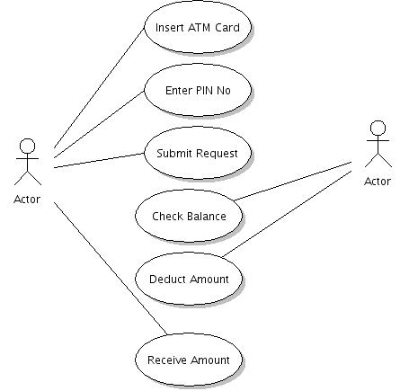

**3.2 CLASS DIAGRAM**



**3.3 ACTIVITY DIAGRAM**



**3.1.4 COLLABORATION DIAGRAM**



**3.1.5 SEQUENCE DIAGRAM**

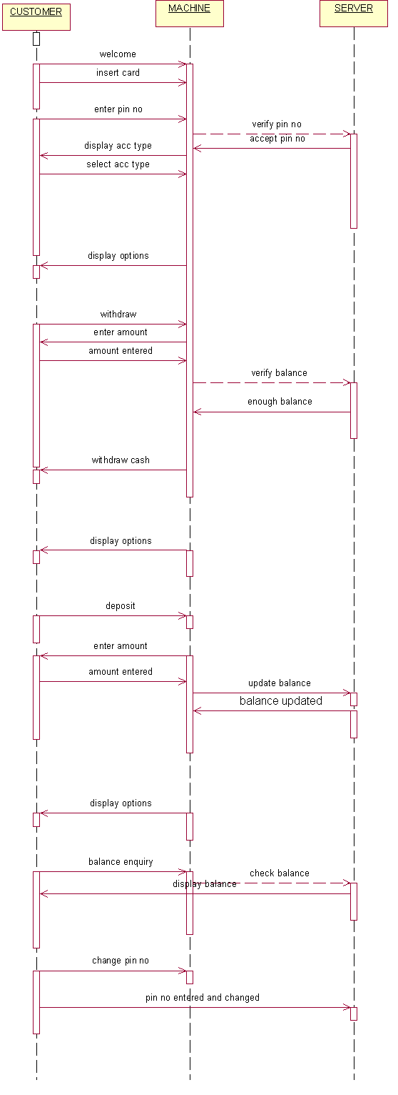

**3.1.7 COMPONENT DIAGRAM**



**3.1.5 DEPLOYMENT DIAGRAM**



**6.TESTING:**

|  |  |  |  |  |  |
| --- | --- | --- | --- | --- | --- |
| **Test case ID: Test_01** | | | | | |
| Test priority  (Low/Medium/High):Medium | | | | | |
| Module name: login | | | | | |
| Test title :verify login with valid username and password | | | | | |
| Precondition: user has invalid username and password | | | | | |
| S.NO | TEST STEPS | EXPECTED  RESULTS | ACTUAL  RESULTS | STATUS | NOTES |
| 1 | Provide valid  User name | User should  Be able to  login | The user is able to move to next  Entry | Success | - |
| 2 | Provide valid password | User should be  Able to  Login | The user is able  To login  Successfully | Success | Incase of wrong  Password was given an error  Message box was  displayed |
| 3 | Click login | User should be able to navigate to next page after validation | User name and password is validated and next page is displayed | Success | Incase user gives wrong entry the sign in page remains active |
| 4 | Click signup | User should be able to navigate to next page where user enters his credentials | User navigates to the signup page where his user name and password is validated | success | - |

**RESULT:**