DBMS RECORD
Page No: 1
INTRODUCTION
Database Management System
This model is like a hierarchical tree structure, used to construct a hierarchy of
records in the form of nodes and branches. The data elements present in the structure have
Parent-Child relationship. Closely related information in the parent-child structure is stored
together as a logical unit. A parent unit may have many child units, but a child is restricted
to have only one parent.
The drawbacks of this model are:
•
The hierarchical structure is not flexible to represent all the relationship proportions,
which occur in the real world.
•
It cannot demonstrate the overall data model for the enterprise because of the non-
availability of actual data at the time of designing the data model.
•
It cannot represent the Many-to-Many relationship.
Network Model
It supports the One-To-One and One-To-Many types only. The basic objects in this
model are Data Items, Data Aggregates, Records and Sets.
It is an improvement on the Hierarchical Model. Here multiple parent-child relationships
are used. Rapid and easy access to data is possible in this model due to multiple access paths
to the data elements.
Relational Model
•
•
•
•
Does not maintain physical connection between relations
Data is organized in terms of rows and columns in a table
The position of a row and/or column in a table is of no importance
The intersection of a row and column must give a single value
Features of an RDBMS
•
•
•
•
The ability to create multiple relations and enter data into them
An attractive query language
Retrieval of information stored in more than one table
An RDBMS product has to satisfy at least Seven of the 12 rules of Codd to be
accepted as a full- fledged RDBMS.

DBMS RECORD
Page No: 2
Relational Database Management System
RDBMS is acronym for Relation Database Management System. Dr. E. F. Codd first
introduced the Relational Database Model in 1970. The Relational model allows data to be
represented in a simple row- column. Each data field is considered as a column and each
record is considered as a row. Relational Database is more or less similar to Database
Management System. In relational model there is relation between their data elements. Data
is stored in tables. Tables have columns, rows and names. Tables can be related to each
other if each has a column with a common type of information. The most famous RDBMS
packages are Oracle, Sybase and Informix.
Simple example of Relational model is as follows :
Student Details Table
Roll_no
1
2
3
Sname
Rahul
Sachin
Saurav
S_Address
Satelite
Ambawadi
Naranpura
Student Marksheet Table
Rollno
1
2
3
Sub1
78
54
23
Sub2
89
65
78
Sub3
94
77
46
Here, both tables are based on students details. Common field in both tables is Rollno. So
we can say both tables are related with each other through Rollno column.
Degree of Relationship
•
•
•
One to One (1:1)
One to Many or Many to One (1:M / M: 1)
Many to Many (M: M)
The Degree of Relationship indicates the link between two entities for a specified
occurrence of each.

DBMS RECORD
Page No: 3
One to One Relationship : (1:1)
11
Student Has Roll No.
One student has only one Rollno. For one occurrence of the first entity, there can be, at the
most one related occurrence of the second entity, and vice-versa.
One to Many or Many to One Relationship: (1:M/M: 1)
1M
Course Contains Students
As per the Institutions Norm, One student can enroll in one course at a time however, in one
course, there can be more than one student.
For one occurrence of the first entity there can exist many related occurrences of the second
entity and for every occurrence of the second entity there exists only one associated
occurrence of the first.
Many to Many Relationship: (M:M)
MM
Students Appears Tests
The major disadvantage of the relational model is that a clear-cut interface cannot be
determined. Reusability of a structure is not possible. The Relational Database now accepted
model on which major database system are built.
Oracle has introduced added functionality to this by incorporated object-oriented
capabilities. Now it is known is as Object Relational Database Management System
(ORDBMS). Object- oriented concept is added in Oracle8.
Some basic rules have to be followed for a DBMS to be relational. They are known as
Codd’s rules, designed in such a way that when the database is ready for use it encapsulates
the relational theory to its full potential. These twelve rules are as follows.

DBMS RECORD
Page No: 4
E. F. Codd Rules
1. The Information Rule
All information must be store in table as data values.
2. The Rule of Guaranteed Access
Every item in a table must be logically addressable with the help of a table name.
3. The Systematic Treatment of Null Values
The RDBMS must be taken care of null values
inapplicable information.
4. The Database Description Rule
A description of database is maintained using the same logical structures with
which data was defined by the RDBMS.
5. Comprehensive Data Sub Language
According to the rule the system must support data definition, view definition,
data
manipulation,
integrity
constraints,
authorization
and
transaction
to represent missing or
management operations.
6. The View Updating Rule
All views that are theoretically updateable are also updateable by the system.
7. The Insert and Update Rule
This rule indicates that all the data manipulation commands must be
on sets of rows having a relation rather than on a single row.
8. The Physical Independence Rule
Application programs must remain unimpaired when any changes are
storage representation or access methods.
9. The Logical Data Independence Rule
The changes that are made should not affect the user’s ability to work with the
data.The change can be splitting table into many more tables.
10. The Integrity Independence Rule
The integrity constraints should store in the system catalog or in the database.
11. The Distribution Rule
The system must be access or manipulate the data that is distributed in other

operational
made in

DBMS RECORD
Page No: 5
systems.
12. The Non-subversion Rule
If a RDBMS supports a lower level language then it should not bypass any
integrity constraints defined in the higher level.
Object Relational Database Management System
Oracle8 and later versions are supported object-oriented concepts. A structure once created
can be reused is the fundamental of the OOP’s concept. So we can say Oracle8 is supported
Object Relational model, Object – oriented model both. Oracle products are based on a
concept known as a client-server technology. This concept involves segregating the
processing of an application between two systems. One performs all activities related to the
database (server) and the other performs activities that help the user to interact with the
application (client). A client or front-end database application also interacts with the
database by requesting and receiving information from database server. It acts as an
interface between the user and the database.
The database server or back end is used to manage the database tables and also respond to
client requests.
Introduction to ORACLE
ORACLE is a powerful RDBMS product that provides efficient and effective solutions for
major database features. This includes:
•
•
•
•
•
•
•
•
•
•
•
Large databases and space management control
Many concurrent database users
High transaction processing performance
High availability
Controlled availability
Industry accepted standards
Manageable security
Database enforced integrity
Client/Server environment
Distributed database systems
Portability

DBMS RECORD
Page No: 6
•
•
Compatibility
Connectivity
An ORACLE database system can easily take advantage of distributed processing by using
its Client/ Server architecture. In this architecture, the database system is divided into two
parts:
A front-end or a client portion
The client executes the database application that accesses database information and interacts
with the user.
A back-end or a server portion
The server executes the ORACLE software and handles the functions required for
concurrent, shared data access to ORACLE database.

DBMS RECORD
Page No: 7
ROADWAY TRAVELS
“Roadway Travels” is in business since 1977 with several buses connecting different
places in India. Its main office is located in Hyderabad.
The company wants to computerize its operations in the following areas:
•
•
•
Reservations
Ticketing
Cancellations
Reservations :
Reservations are directly handeled by booking office.reservations can be made 60
days in advance in either cash or credit. In case the ticket is not available,a wait listed ticket
is issued to the customer. This ticket is confirmed against the cancellation.
Cancellation and modification:
Cancellations are also directly handed at the booking office. Cancellation charges
will be charged.
Wait listed tickets that do not get confirmed are fully refunded.

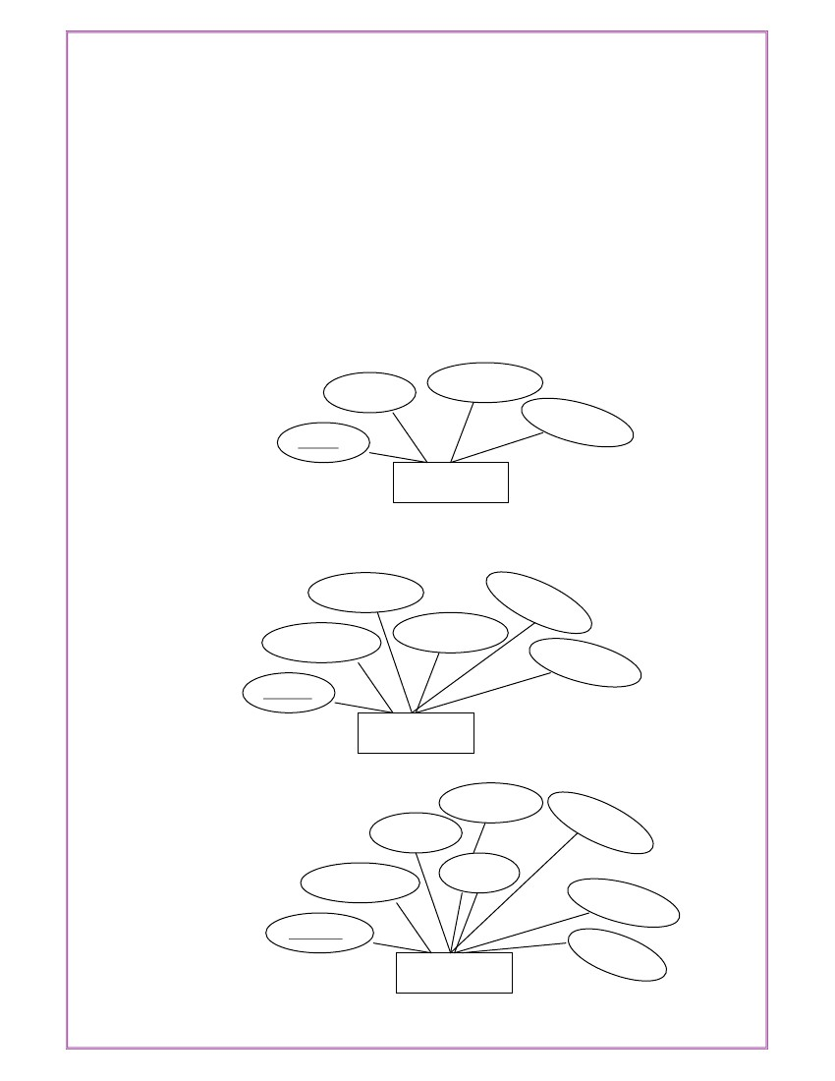
DBMS RECORD
Page No: 8
Exp No: 1
Date: _ _/_ _/ _ _
AIM: Analyze the problem and come with the entities in it. Identify what Data has to be
persisted in the databases.
The Following are the entities:
1 .Bus
2. Reservation
3. Ticket
4. Passenger
5. Cancellation
The attributes in the Entities:
Bus:( Entity)
Source
Destination
Couch Type
Bus No
Bus
Reservation (Entity)
Contact No
No-of-Seats
Address
PNR NO
Bus No
Journey date
Reservation
Ticket :(Entity)
Dep- Time
Age
Sex
Destination
Ticket No
Bus No
Source
Journey date
Ticket

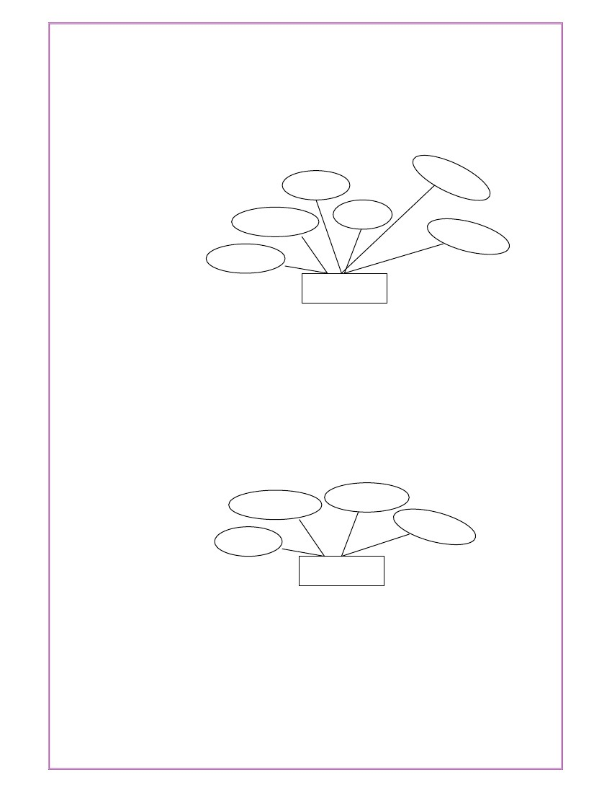
DBMS RECORD
Page No: 9
Passenger:
Age
Sex
Contact NO
PNR NO
Name
Ticket No
Passenger
Cancellation (Entity)
Journey date
Seat No
Contact No
PNR NO
Cancellation

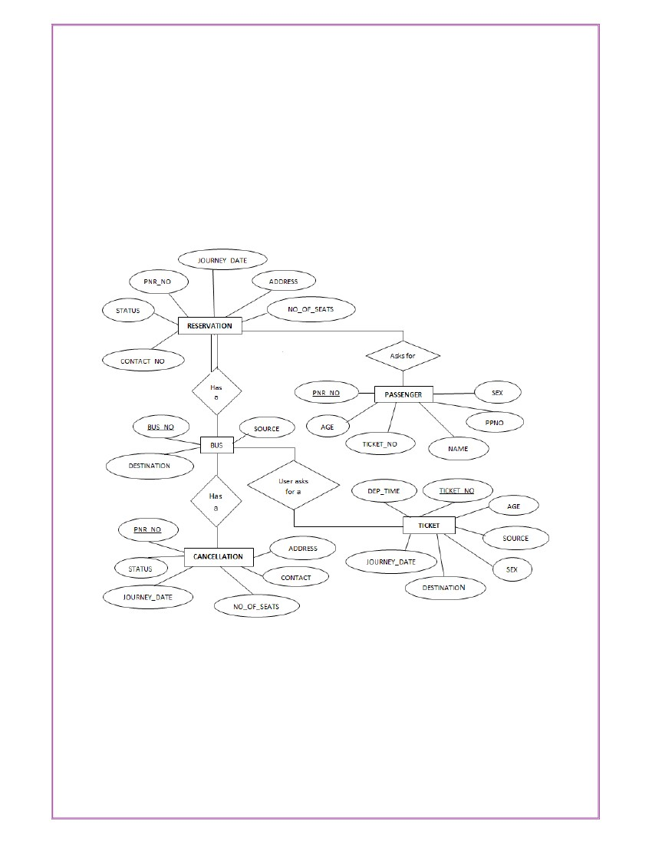
DBMS RECORD
Page No: 10
Concept design with E-R Model:

DBMS RECORD
Page No: 11
Exp No: 2
Date: _ _/_ _/ _ _
AIM: Represent all entities in a tabular fashion. Represent all relationships in a tabular
fashion.
What is SQL and SQL*Plus
Oracle was the first company to release a product that used the English-based Structured
Query Language or SQL. This language allows end users to manipulate information of
table(primary database object). To use SQL you need not to require any programming
experience. SQL is a standard language common to all relational databases. SQL is database
language used for storing and retrieving data from the database. Most Relational Database
Management Systems provide extension to SQL to make it easier for application developer.
A table is a primary object of database used to store data. It stores data in form of rows and
columns.
SQL*Plus is an Oracle tool (specific program ) which accepts SQL commands and PL/SQL
blocks and executes them. SQL *Plus enables manipulations of SQL commands and
PL/SQL blocks. It also performs additional tasks such as calculations, store and print query
results in the form of reports, list column definitions of any table, access and copy data
between SQL databases and send messages to and accept responses from the user. SQL
*Plus is a character based interactive tool, that runs in a GUI environment. It is loaded on
the client machine.
To communicate with Oracle, SQL supports the following categories of commands:
1. Data Definition Language
Create, Alter, Drop and Truncate
2. Data Manipulation Language
Insert, Update, Delete and Select
3. Transaction Control Language
Commit, Rollback and Save point
4. Data Control Language
Grant and Revoke

DBMS RECORD
Page No: 12
Before we take a look on above-mentioned commands we will see the data types available in
Oracle.
Oracle Internal Data types
When you create a table in Oracle, a few items should be important, not only do you have to
give each table a name(e.g. employee, customer), you must also list all the columns or fields
(e.g. First_name, Mname, Last_name) associated with the table. You also have to specify
what type of information thattable will hold to the database. For example, the column
Empno holds numeric information. An Oracle database can hold many different types of
data.
Data type Description
Char(Size) Stores fixed-length character data to store alphanumeric values, with a
maximum size of 2000 bytes. Default and minimum size is 1 byte.
Varchar2(Size) Stores variable-length character data to store alphanumeric values,
with maximum size of 4000 bytes.
char(Size) Stores fixed-length character data of length size characters or bytes,
depending on the choice of national character set. Maximum size if determined by the
number of bytes required storing each character with an upper limit of 2000 bytes. Default
and minimum size is 1 character or 1 byte, depending on the character set.
Nvarchar2(Size) Stores variable-length character string having maximum length size
characters or bytes, depending on the choice of national character set. Maximum size is
determined by the number of bytes required to store each character, with an upper
limit of 4000 bytes.
Long Stores variable-length character data up to 2GB(Gigabytes). Its lenth would be
restricted based on memory space available in the computer.
Number [p,s] Number having precision p and scale s. The precision p indicates total
number of digit varies from 1 to 38. The scale s indicates number of digit in fraction part
varies from –84 to 127.
Date Stores dates from January 1, 4712 B.C. to December 31, 4712 A.D. Oracle
predefine format of Date data type is DD-MON-YYYY.

DBMS RECORD
Page No: 13
Raw(Size) Stores binary data of length size. Maximum size is 2000 bytes. One must
have to specify size with RAW type data, because by default it does not specify any size.
Long Raw Store binary data of variable length up to 2GB(Gigabytes).
LOBS – LARGE OBJECTS
LOB is use to store unstructured information such as sound and video clips, pictures upto 4
GB size.
CLOB A Character Large Object containing fixed-width multi-byte characters.
Varying-
width character sets are not supported. Maximum size is 4GB.
NCLOB A National Character Large Object containing fixed-width multi-byte
characters.
Varying-width character sets are not supported. Maximum size is 4GB. Stores
national character set data.
BLOB To store a Binary Large Object such a graphics, video clips and sound files.
Maximum size is 4GB.
BFILE Contains a locator to a large Binary File stored outside the database. Enables
byte stream I/O access to external LOBs residing on the database server. Maximum
size is 4GB.Apart from oracle internal data types, user can create their own data type, which
is used in database and other database object. We will discuss it in the later part.

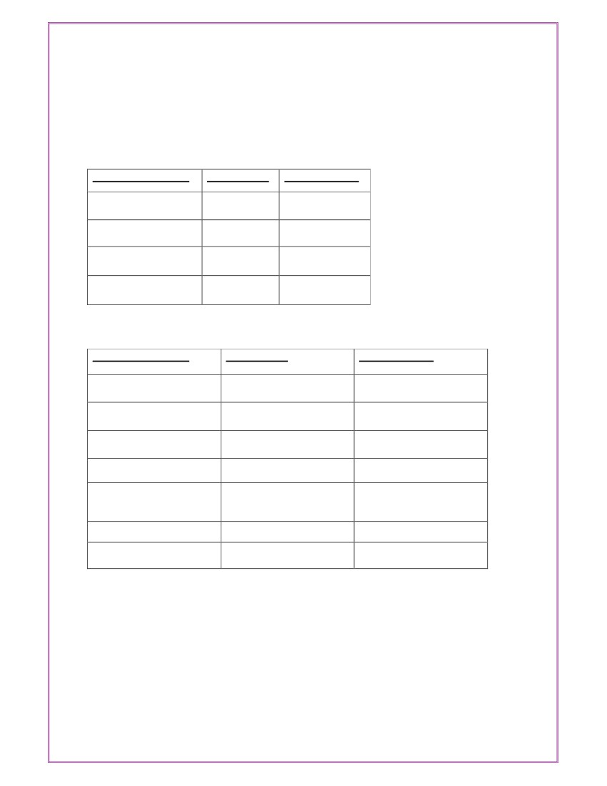
DBMS RECORD
Page No: 14
The following are tabular representation of the above entities and relationships
BUS:
COLOUMN NAME
Bus No
Source
Destination
Couch Type
DATA TYPE
varchar2(10)
varchar2(20)
varchar2(20)
varchar2(20)
CONSTRAINT
Primary Key
Reservation:
COLOUMN NAME
PNRNo
Journey date
No-of-seats
Address
Contact No
DATA TYPE
number(9)
Date
integer(8)
varchar2(50)
Number(9)
CONSTRAINT
Primary Key
BusNo
Seat no
varchar2(10)
Number
Should be equal to 10
numbers and not allow
other than numeric
Foreign key

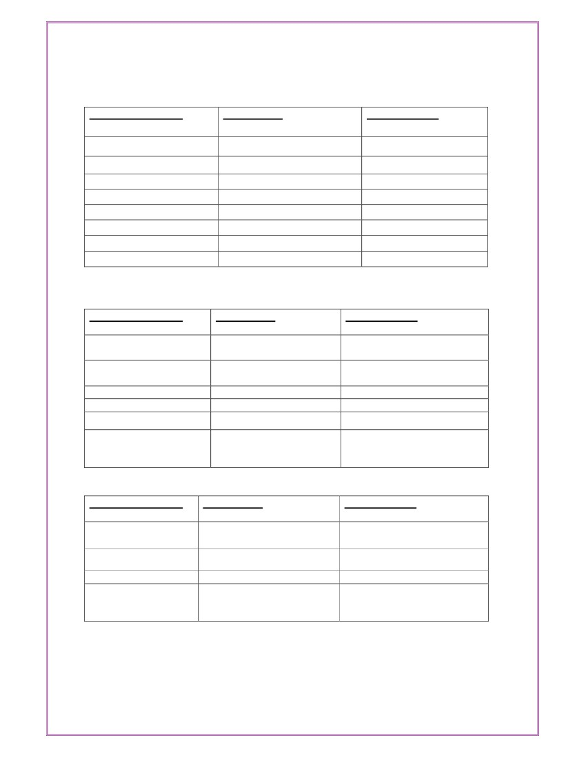
DBMS RECORD
Page No: 15
Ticket:
COLOUMN NAME
Ticket_No
Journey date
Age
Sex
Source
Destination
Dep-time
Bus No
DATA TYPE
number(9)
Date
int(4)
Char(10)
varchar2(10)
varchar2(10)
varchar2(10)
Number2(10)
CONSTRAINT
Primary Key
Passenger:
COLOUMN NAME
PNR No
Ticket No
Name
Age
Sex
Contact no
DATA TYPE
Number(9)
Number(9)
varchar2(15)
integer(4)
char(10)
Number(9)
CONSTRAINT
Primary Key
Foreign key
(Male/Female)
Should be equal to 10 numbers
and not allow other than
numeric
Cancellation:
COLOUMN NAME
PNR No
Journey-date
Seat no
Contact_No
DATA TYPE
Number(9)
Date
Integer(9)
Number(9)
CONSTRAINT
Foriegn-key
Should be equal to 10 numbers
and not allow other than
numeric

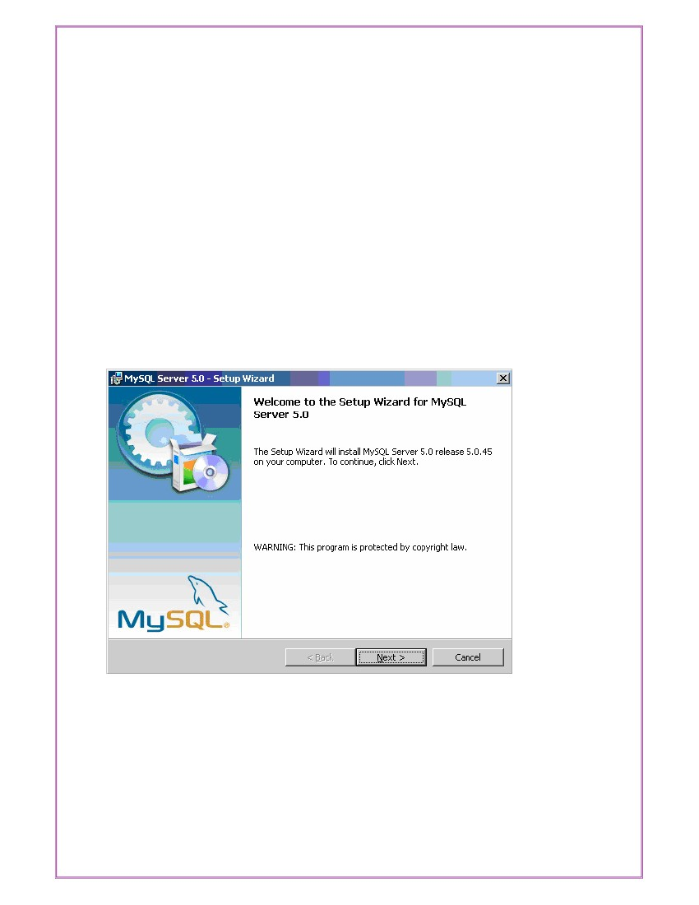
DBMS RECORD
Page No: 16
Exp No: 3
Date: _ _/_ _/ _ _
AIM: Installation of MySQL and practicing DDL & DML commands.
1. Steps for installing MySQL
Step11
Make sure you already downloaded the MySQL essential 5.0.45 win32.msi file. Double
click on the .msi file.
Step22
This is MySQL Server 5.0 setup wizard. The setup wizard will install MySQL Server 5.0
release 5.0.45 on your computer. To continue, click next.
Step33
Choose the setup type that best suits your needs. For common program features select Typical
and it’s recommended for general use. To continue, click next.

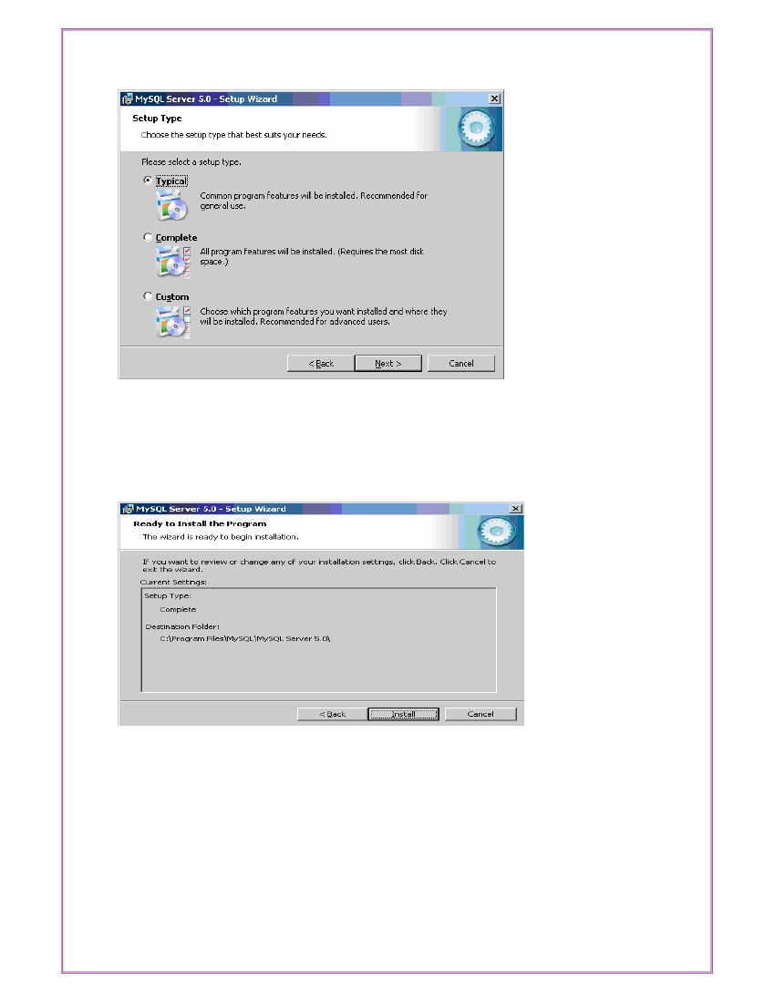
DBMS RECORD
Page No: 17
Step4
4
This wizard is ready to begin installation. Destination folder will be in C:\Program
Files\MySQL\MySQL Server 5.0\. To continue, click next.
Step55
The program features you selected are being installed. Please wait while the setup wizard
installs MySQL 5.0. This may take several minutes.

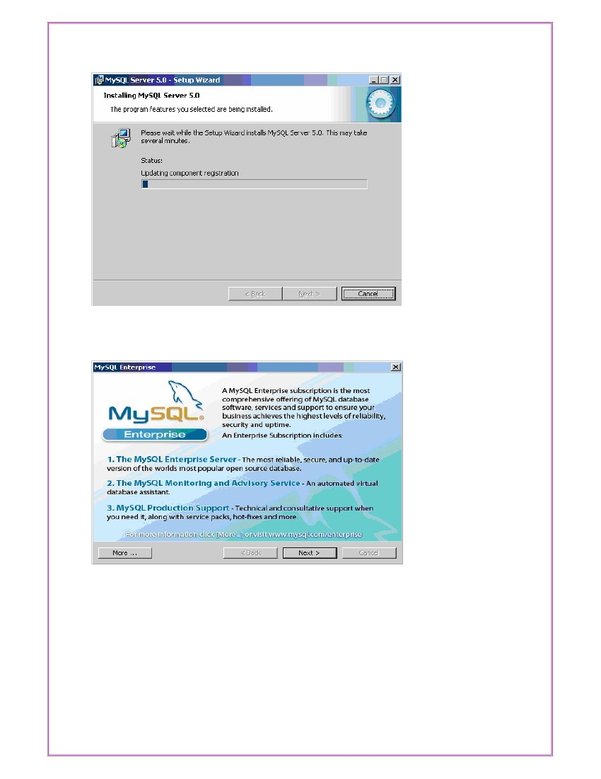
DBMS RECORD
Page No: 18
Step6
To continue, click next.
6
Step7
To continue, click next.

7

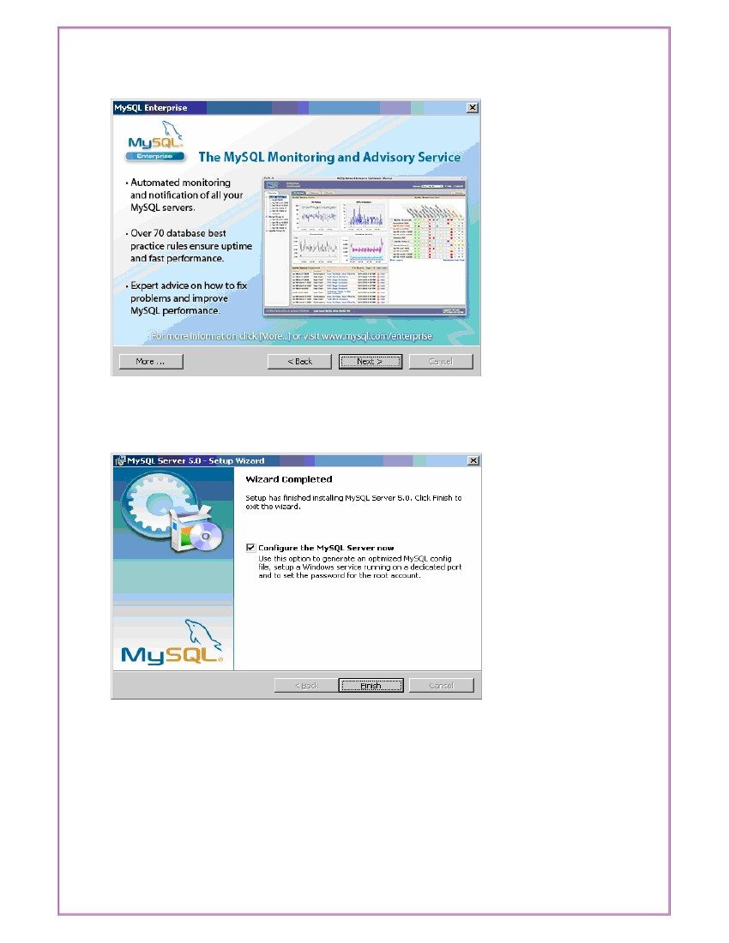
DBMS RECORD
Page No: 19
Step88
Wizard Completed. Setup has finished installing MySQL 5.0. Check the configure the
MySQL server now to continue. Click Finish to exit the wizard
d.
Step99
The configuration wizard will allow you to configure the MySQL Server 5.0 server instance.

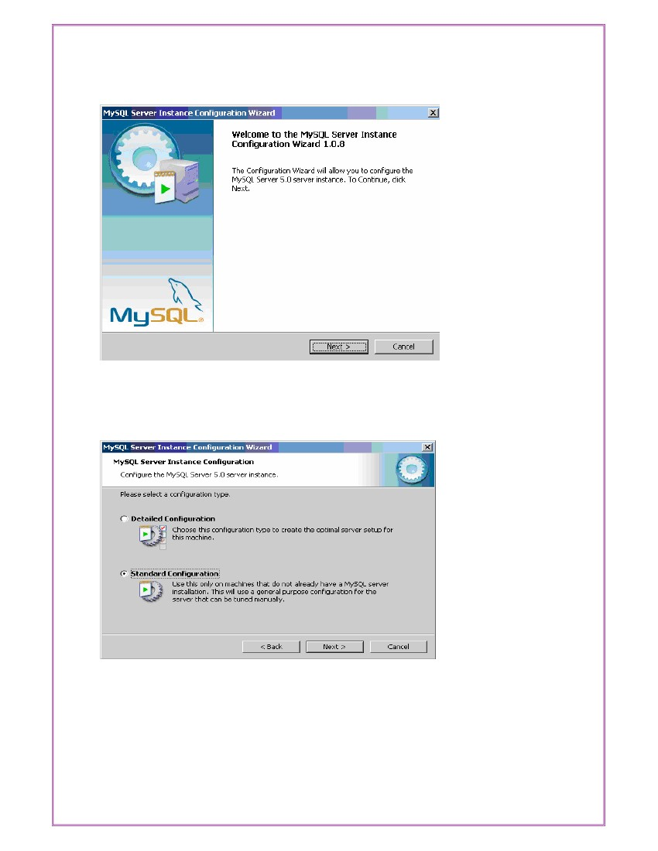
DBMS RECORD
Page No: 20
To continue, click next.
Step1010
Select a standard configuration and this will use a general purpose configuration for the
serverthatcanbetunedmanually.Tocontinue,clicknext.
Step11

11

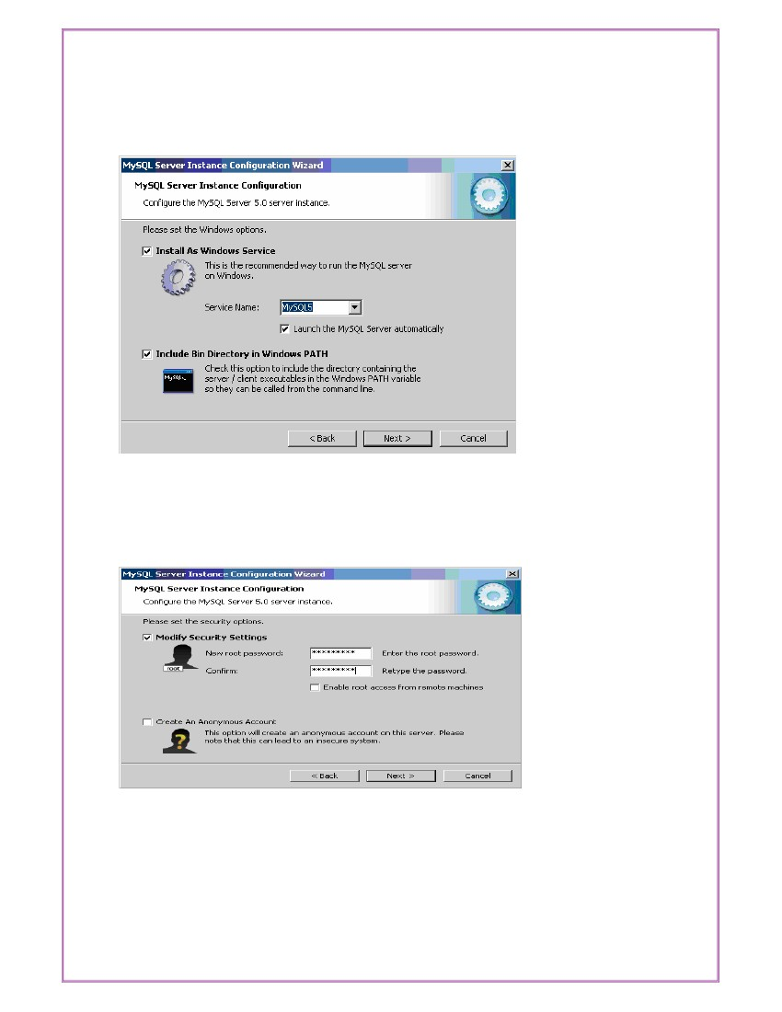
DBMS RECORD
Page No: 21
Check on the install as windows service and include bin directory in windows path. To
continue, click next.
Step1212
Please set the security options by entering the root password and confirm retype the
password. To continue, click next.
Step13

13

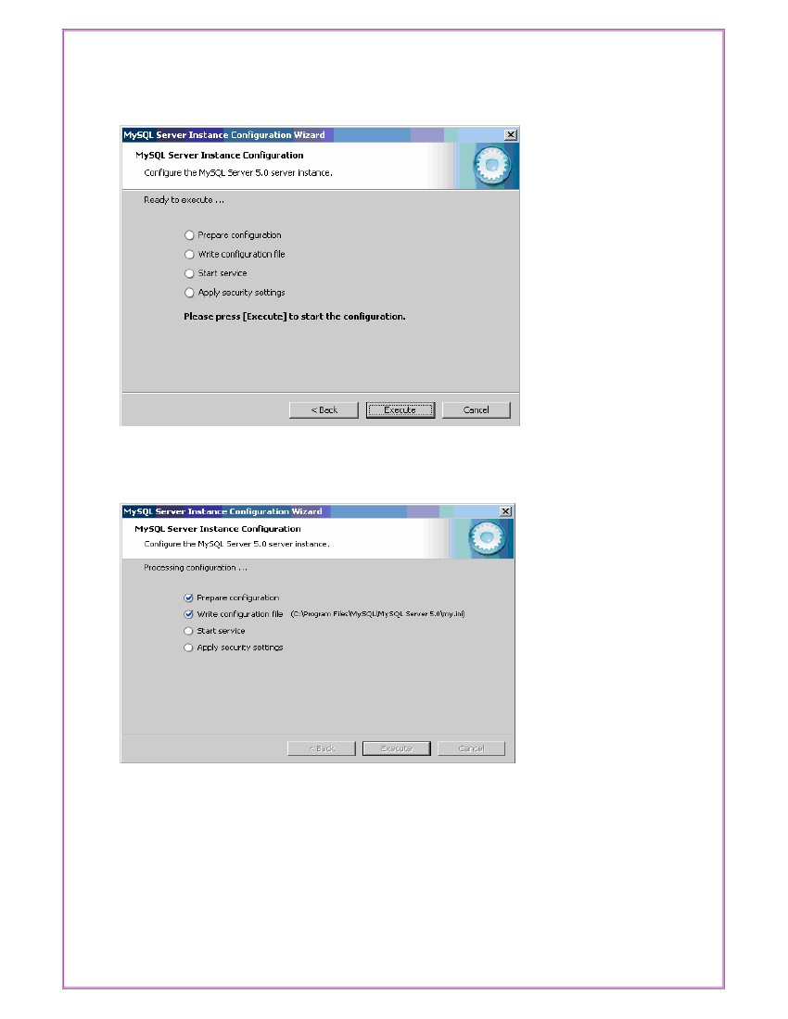
DBMS RECORD
Page No: 22
Ready to execute? Clicks execute to continue.
Step14
Processing configuration in progress.
14

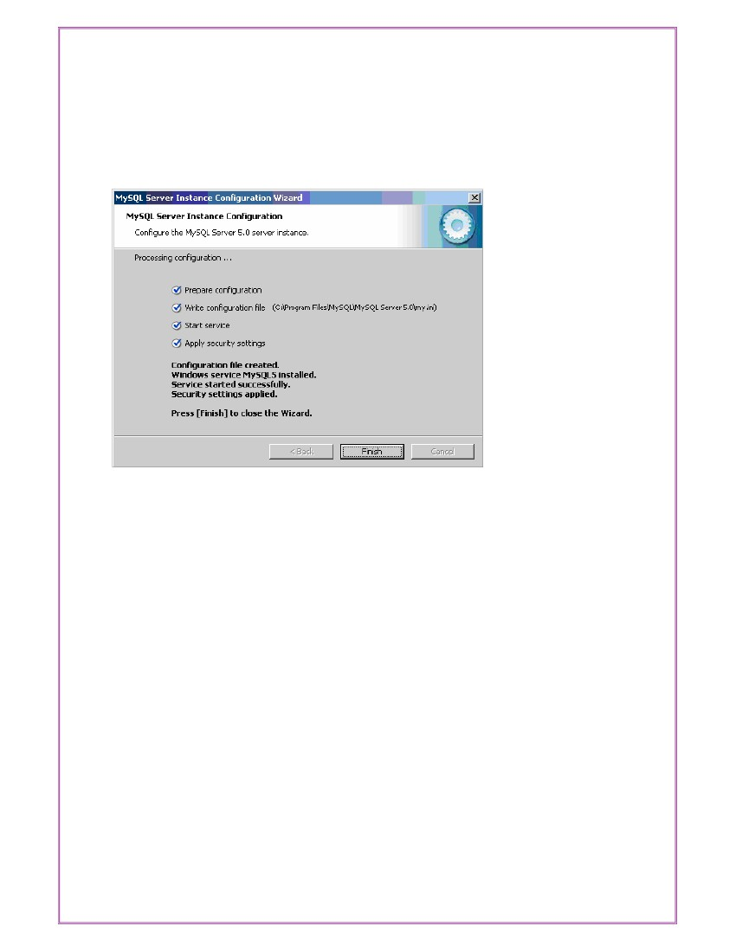
DBMS RECORD
Page No: 23
Step15
15
Configuration file created. Windows service MySQL5 installed. Press finish to close the
wizard.

DBMS RECORD
Page No: 24
2. Practicing DDL & DML Commands
Data Definition Language
The data definition language is used to create an object, alter the structure of an object and
also drop already created object. The Data Definition Languages used for table definition
can be classified into following:
❖ Create table command
❖ Alter table command
❖ Truncate table command
❖ Drop table command
Creating of Tables on ROAD WAY TRAVELS:
Table is a primary object of database, used to store data in form of rows and columns. It is
created using following command:
Create Table <table_name> (column1 datatype(size), column2 datatype(size),
・_,column(n) datatype(size));
Where, table_name is a name of the table and coulumn1, column2 _ column n is a name of
the column available in table_name table.
R Each column is separated by comma.
Pointes to be remember while creating a table.
❖ Table Name must be start with an alphabet.
❖ Table name and column name should be of maximum 30 character long.
❖ Column name should not be repeated in same table.
❖ Reserve words of Oracle cannot be used as a table and column name.
❖ Two different tables should not have the same name.
❖ Underscores, numerals and letters are allowed but not blank space or single quotes.
Example:
SQL> create table Bus(Bus_No varchar(5),
varchar(20),CouchType varchar2(10),fair number);
Table Created.
Above definition will create simple table. Still there are more additional option related with

source
varchar(20),
destination

DBMS RECORD
Page No: 25
create table for the object-relation feature we will discuss it afterwards.
Desc command
Describe command is external command of Oracle. The describe command is used to view
the structure of a table as follows.
Desc <table name>
SQL> desc bus;
NameNull?
----------------------------------------- --------
BUS_NONOT NULL
SOURCE
DESTINATION
CouchType
FAIR
Reservation Table:
SQL> create table Reservation(PNR_NO Numeric(9), No_of_seats Number(8), Address
varchar(50), Contact_No Numeric(9), Status char(3));
Table created.
SQL> desc Reservation
NameNull?Type
----------------------------------------- -------- ----------------------------
PNR_NONUMBER(9)
NO_OF_SEATSNUMBER(8)
ADDRESSVARCHAR2(50)
CONTACT_NONUMBER(9)
STATUSCHAR(3)
Type
----------------------------
INTEGER2(5)
VARCHAR2(20)
VARCHAR2(20)
VARCHAR2(10)
NUMBER
Cancellation Table:
SQL> create table Cancellation(PNR_NO Numeric(9), No_of_seats Number(8), Address
varchar(50), Contact_No Numeric(9), Status char(3));
Table created.
SQL> desc Cancellation
NameNull? Type
----------------------------------------- -------- ----------------------------
PNR_NONUMBER(9)
NO_OF_SEATSNUMBER(8)
ADDRESSVARCHAR2(50)
CONTACT_NONUMBER(9)
STATUSCHAR(3)

DBMS RECORD
Page No: 26
Ticket Table:
SQL> create table Ticket(Ticket_No Numeric(9) primary key, age number(4), sex char(4)
Not null, source varchar(2), destination varchar(20), dep_time varchar(4));
Table created.
SQL> desc Ticket
NameNull?Type
----------------------------------------- ------------------------------------
TICKET_NONOT NULL NUMBER(9)
AGENUMBER(4)
SEXNOT NULL CHAR(4)
SOURCEVARCHAR2(2)
DESTINATIONVARCHAR2(20)
DEP_TIMEVARCHAR2(4)
Alteration of Table
Once Simple Table is created, if there is a need to change the structure of a table at that time
alter command is used. It is used when a user want to add a new column or change the width
of datatype or datatype itself or to add or drop integrity constraints or column. (we will see
about constraints very soon.).i.e. table can be altered in one of three way : by adding
column, by changing column definition or by dropping column.
Addition of Column(s)
Addition of column in table is done using:
Alter table <table_name> add(column1 datatype, column2 datatype ・_);
Add option is used with alter table_ when you want to add a new column in existing
table. If you want to Add more than one column then just write column name, data type and
size in brackets. As usual Comma sign separates each column. For Example, suppose you
want to add column comm in emp_master, then you have to perform the following
command.
SQL> ALTER TABLE Passenger ADD FOREIGN KEY (PNR_NO) REFERENCES
Reservation(PNR_NO);
Table altered.
SQL> ALTER TABLE Cancellation ADD FOREIGN KEY (PNR_NO) REFERENCES
Reservation(PNR_NO);
Table altered.

DBMS RECORD
Page No: 27
SQL> alter table Ticket modify tiketnonumber(10);
Table altered.
Deletion of Column
Till Oracle8 it is not possible to remove columns from a table but in Oracle8i, drop option is
used withAlter table_ when you want to drop any existing column.
Alter table <table_name> drop column <column name>;
Using above command you cannot drop more than one column at a time.
For Example, suppose you want to delete just before created column comm from the
emp_master, then you have to apply following command.
SQL>Alter Table Emp_master drop column comm;
Table altered.
Dropping column is more complicated than adding or modifying a column, because of the
additional work that Oracle has to do. Just removing the column from the list of columns in
the table actually recover the space that was actually taken up by the column values that is
more complex, and potentially very time- consuming for the database. For this reason, you
can drop a column using unused clause. Column can be immediately remove column by
drop clause, the action may impact on performance or one make marked column as unused
using unused caluse, there will be no impact on performance. When unused caluse is used
the column can actually be dropped at a later time when the database is less heavily used.
One can marked column as a unused using :
Alter table <table_name> set unused column <column name>;
For Example,
SQL>Alter Table Emp_master set unused column comm;
Table altered.
Making a column as Unused_ does not release the spcace previously used by the colum,
until you drop the unused columns. It can be possible using:
Alter table <table_name> drop unused columns;
Once you have marked column as unused_ you cannot access that column
You can drop multiple columns at a time using single command as per follows

DBMS RECORD
Page No: 28
Alter table <table_name> drop (Column1, Column2,_);
The multiple columns name must be enclosed in parentheses.
Modification in Column
Modify option is used with Alter table_ when you want to modify any existing column.
If you want to
modify data type or size of more than one column then just write column name, data type
and size in brackets and each column is separated by comma sign as per follows:
Alter table <table name> modify (column1 datatype,・_);
For Example, if you want to change size of salary column of emp_master the following
command is performed.
SQL> Alter table emp_master modify salary number(9,2);
Table altered.
It will change size of salary column from 7 to (9,2).
When you want to decrease the size of column, table must be empty. If table has any rows
then it will not allow decrement in the column width.
Truncate Table
If there is no further use of records stored in a table and the structure is required then only
data can be deleted using Truncate command. Truncate command will delete all the records
permanently of specified table as follows.
Truncate table <table name> [Reuse Storage];
Example
Following command will delete all the records permanently from the table.
SQL>Truncate Table Emp_master;
Or
SQL>Truncate Table Emp_master Reuse Storage;
Table truncated.

DBMS RECORD
Page No: 29
Exp No: 4
AIM: Applying Constraints on Road Way Travels Tables.
Constraints
Date: _ _/_ _/ _ _
Maintaining security and integrity of a database is the most important factor. Such
limitations have to be enforced on the data, and only that data which satisfies the conditions
will actually be stored for analysis.
If the data gathered fails to satisfy the conditions set, it is rejected. This technique ensures
that the data that is stored in the database will be valid, and has integrity. Rules, which are
enforced on data being entered and prevents user from entering invalid data into tables are
called constraints.
permanent storage.
Oracle permits data constraints to be attached to table columns via SQL syntax that will
check data for integrity. Once data constraints are part of a table column construction, the
Oracle engine checks the data being entered into a table column against the data constraints.
If the data passes this check, it is stored in the table, else the data is rejected. Even if a single
column of the record being entered into the table fails a constraint, the entire record is
rejected and not stored in the table. Both the Create table_ and Alter table_ SQL verbs can
be used to write SQL sentences that attach constraints to a table column.
Until now we have created table without using any constraint, Hence the tables have not
been given any instructions to filter what is being stored in the table.
The following are the types of integrity constraints
❖ Domain Integrity constraints
❖ Entity Integrity constraints
❖ Referential Integrity constraint
Oracle allows programmers to define constraints
❖ Column Level
❖ Table Level
Thus, constraints are super control data being entered in tables for

DBMS RECORD
Page No: 30
Column Level constraints
If data constraints are defined along with the column definition when creating or altering
a table structure, they are column level constraints. Column level constraints are applied to
the current column. The current column is the column that immediately precedes the
constraints i.e. they are local to a specific column.Column level constraints cannot be
applied if the data constraints span across the multiple columns in a table.
Table Level Constraint
If the data constraints are defined after defining all the table columns when creating or
altering a table structure, it is a table level constraint. Table Level constraints mostly used
when data constraints spans across multiple columns in a table.
Domain Integrity Constraints
These constraints set a range and any violations that take place will prevent the user from
performing the manipulations that caused the breached.
Domain integrity constraints are classified into two types
• Not Null constraint
• Check constraint
Not Null Constraint
Often there may be records in a table that do not have values for every field, either because
the information is not available at the time of data entry or because field is not applicable in
every case. Oracle will place a null value in the column in the absence of a user-defined
value. By default every column will accept null values.A Null values is different from a
blank or a zero. We can say that Null means undefined. Null are treated specially by Oracle.
When a column is defined as not null, then that column becomes mandatory column. It
implies that a value must be entered into the column. Remember that not null constraints can
be applied on column level only.
Example
SQL> create table Ticket(Ticket_No Numeric(9) , age number(4), sex char(4) Not null,
source varchar(2), destination varchar(20), dep_time varchar(4));

DBMS RECORD
Page No: 31
Table created.
Check Constraint
Business rule validations can be applied on a column using Check constraint. Check
constraint must be specified by logical or boolean expressions.
Create a client_master table with following check constraints.
❖ Data values being inserted into the column client_no must starts with the capital
letter ‘C’
❖ Data values being inserted into the column name should be in upper case only.
❖ Only allow Mumbai_ or Ahmedabad_ values for the city column.
Check constraint defined at column level as per follows:
SQL> create table Reservation(PNR_NO Numeric(9), No_of_seats Number(8), Address
varchar(50), Contact_No Numeric(10) constraint ck check(length(contact_no)=10), Status
char(3));
Table created.
Check constraint with alter command
SQL> alter table Ticket add constraint check_age check(age>18);
Table altered.
Entity Integrity Constraints
This type of constraints are further classified into
❖ Unique Constraint
❖ Primary Key Constraint
Unique Constraint
The purpose of unique key is to ensure that information in the column(s) is unique i.e. the
value entered in column(s) defined in the unique constraint must not be repeated across the
column. A table may have many unique keys. If unique constraint is defined in more than
one column (combination of columns), it is said to be composite unique key. Maximum
combination of columns that a composite unique key can contain is 16.
Example:
SQL> create table Ticket(Ticket_No Numeric(9) unique, age number(4), sex char(4) l,
source varchar(2), destination varchar(20), dep_time varchar(4));

DBMS RECORD
Page No: 32
Table created.
Unique constraint with alter command
Example:
SQL> Alter table ticket add constraint uni1 Unique (ticket_no);
Primary Key Constraint
A primary key is one or on more columns(s) in a table to uniquely identify each row in the
table. A primary key column in a table has a special attribute. It defines the column, as a
mandatory column i.e. the column cannot be left blank and should have a unique value. Here
by default not null constraint is attached with the column.A multicolumn primary key is
called a Composite primary key. The only function of a primary key in a table is to uniquely
identify a row. A table can have only one primary key.
Primary key constraint at the column level
Example:
SQL> create table Ticket(Ticket_No Numeric(9) constraint pk primary key, age number(4),
sex char(4) l, source varchar(2), destination varchar(20), dep_time varchar(4));
Table created.
SQL> insert into ticket values (1001,26, ‘M’, ‘KPHB’,’MTM’,’20:00’);
1 row created.
SQL> insert into ticket values (1001,26, ‘M’, ‘KPHB’,’MTM’,’20:00’);
18
ERROR at line 1:
ORA-00001: unique constraint (SCOTT.PR_ONO) violated
If we insert already inserted ticket_no the above mentioned error will generate.
SQL> insert into ticket values (null,26, ‘M’, ‘KPHB’,’MTM’,’20:00’);
ERROR at line 1:
ORA-01400 :cannot insert NULL into (SCOTT_.ORDER_MASTER_ .ORDER_NO”)
If we try to insert null values it will generate error message.
Composite Primary key defined at the table level: Composite Primary key is a primary key
created with the combination of more than one key and combination values of both the fields
should be unique

DBMS RECORD
Page No: 33
Example:
SQL> create table vendor_master (ven_code varchar(5), ven_name varchar(20), venadd1
varchar(15), venadd2 varchar(15),vencity varchar(15), constraint pr_com primary key
(ven_code,ven_name));
Table created.
Primary key with alter command:
SQL> alter table bus add constraint pr primary key (busno);
Table altered.
Referential Integrity Constraint
In this category there is only one constraint and it is Foreign Key & References
To establish a Parent-child_ or a Master-detail_ relationship between two tables having a
common column, we make use of referential integrity constraint.Foreign key represent
relationships between tables. A foreign key is a column whose values are derived from the
primary key or unique key. The table in which the foreign key is defined is called a foreign
table or Detail table. The table that defines the primary or unique keys and is referenced by
the foreign key is called the Primary table or Master table.The master table can be
referenced in the foreign key definition by using references keyword. If the column name is
not specified, by default, Oracle references the primary key in the master table.
The existence of a foreign key implies that the table with the foreign key is related to the
master table from which the foreign key is derived. A foreign key must have a
corresponding primary key or a unique key value in a master table.
Principles of Foreign Key Constraint
❖ Rejects an insert or update of a value in a particular column, if a corresponding
value does not exist in the master table.
❖ Deletion of rows from the Master table is not possible if detail table having
corresponding values.
❖ Primary key or unique key must in Master table.
❖ Requires that the Foreign key column(s) and reference column(s) have same data
type

DBMS RECORD
Page No: 34
References constraint defined at column level
Example:
SQL> create table Passenger(PNR_NO Numeric(9) references reservation , Ticket_NO
Numeric(9) references ticket, Name varchar(20), Age Number(4), Sex char(10), PPNO
varchar(15));
Table created.
Foreign Key Constraint with alter command
SQL> alter table reservation add constraint fk_icode foreign key (busno) references
bus(bus_no);
Table altered.
Remember that when we add constraint at table level foreign key keyword is must.
SQL> delete from bus where bus_no = 2011;
ERROR at line 1:
ORA-02292: integrity constraint (SCOTT.FK_ONO) violated - child record found

DBMS RECORD
Page No: 35
Exp No: 5
AIM : Applying DML commands on Road Way Travels Tables.
Data Manipulation Command
Date: _ _/_ _/ _ _
Data Manipulation commands are most widely used SQL commands and they are
❖ Insert
❖ Update
❖ Delete
❖ Select
a) Insert command
After creation of table, it is necessary it should have data in it. The insert command is used
to add data in form of one or more rows to a table as per follows:
Insert into <table name> values(a list of data values);
In a list of data values you have to specify values for each and every column in the same
order as they are defined. A value of each column is separated by comma in the list.
The value of char, nchar, varchar2, nvarchar2, raw, long and date data types are enclosed in
single quotes.
Using insert command one can insert values in specific columns as follows:
Insert into <table name>(column list) values(a list of data);
Here number of column and a list of data should be same and list of data should be in order
to column list.
SQL> insert into emp_master (empno,ename,salary) values (1122,‘Smith’,8000);
1 row created.
Above command insert one row but values are inserted in only three columns. Remaining
four columns have null values.If you have define not null constraint in any of remaining
columns it want allow you to insert data in a table.
Adding values in a table using Variable method
Till now we have seen static method to insert data. One can add data in a table using

DBMS RECORD
Page No: 36
variable method with & (ampersand) sign. It will prompt user to enter data of mention field.
Generally It is used to add more than one row in a table without typing whole command
repetitively using / sign.
SQL> insert into Passenger values(&PNR_NO,&TICKET_NO, '&Name', &Age, '&Sex',
'&PPNO');
Enter value for pnr_no: 1
Enter value for ticket_no: 1
Enter value for name: SACHIN
Enter value for age: 12
Enter value for sex: m
Enter value for ppno: sd1234
old
1: insert into Passenger values(&PNR_NO,&TICKET_NO, '&Name', &Age, '&Sex',
'&PPNO')
new 1: insert into Passenger values(1,1,'SACHIN',12,'m','sd1234')
1 row created.
SQL> /
Enter value for pnr_no: 2
Enter value for ticket_no: 2
Enter value for name: rahul
Enter value for age: 34
Enter value for sex: m
Enter value for ppno: sd3456
old 1: insert into Passenger values(&PNR_NO,&TICKET_NO, '&Name', &Age, '&Sex',
'&PPNO')
new 1: insert into Passenger values(2,2,'rahul',34,'m','sd3456')
1 row created.
SQL> /
Enter value for pnr_no: 3
Enter value for ticket_no: 3
Enter value for name: swetha
Enter value for age: 24
Enter value for sex: f
Enter value for ppno: sdqw34
old 1: insert into Passenger values(&PNR_NO,&TICKET_NO, '&Name', &Age, '&Sex',
'&PPNO')
new 1: insert into Passenger values(3,3,'swetha',24,'f','sdqw34')
1 row created.
SQL> /
Enter value for pnr_no: 4
Enter value for ticket_no: 4
Enter value for name: ravi

DBMS RECORD
Page No: 37
Enter value for age: 56
Enter value for sex: m
Enter value for ppno: sdqazx
old 1: insert into Passenger values(&PNR_NO,&TICKET_NO, '&Name', &Age, '&Sex',
'&PPNO')
new 1: insert into Passenger values(4,4,'ravi',56,'m','sdqazx')
1 row created.
SQL> /
Enter value for pnr_no: 4
Enter value for ticket_no: 5
Enter value for name: asif
Enter value for age: 33
Enter value for sex: m
Enter value for ppno: iuyhjk
old 1: insert into Passenger values(&PNR_NO,&TICKET_NO, '&Name', &Age, '&Sex',
'&PPNO')
new 1: insert into Passenger values(4,5,'asif',33,'m','iuyhjk')
insert into Passenger values(4,5,'asif',33,'m','iuyhjk')
*
ERROR at line 1: ORA-00001: unique constraint (SYSTEM.SYS_C004023) violated
SQL> insert into Bus values('&Bus_No','&source','&destination');
Enter value for bus_no: 1
Enter value for source: hyd
Enter value for destination: ban
old 1: insert into Bus values('&Bus_No','&source','&destination')
new 1: insert into Bus values('1','hyd','ban')
1 row created.
SQL> /
Enter value for bus_no: 2
Enter value for source: hyd
Enter value for destination: chn
old 1: insert into Bus values('&Bus_No','&source','&destination')
new 1: insert into Bus values('2','hyd','chn')
1 row created.
SQL> /
Enter value for bus_no: 4
Enter value for source: hyd
Enter value for destination: mum
old 1: insert into Bus values('&Bus_No','&source','&destination')
new 1: insert into Bus values('4','hyd','mum')
1 row created.

DBMS RECORD
Page No: 38
SQL> /
Enter value for bus_no: 5
Enter value for source: hyd
Enter value for destination: kol
old 1: insert into Bus values('&Bus_No','&source','&destination')
new 1: insert into Bus values('5','hyd','kol')
1 row created.
SQL> /
Enter value for bus_no: 5
Enter value for source: sec
Enter value for destination: ban
old 1: insert into Bus values('&Bus_No','&source','&destination')
new 1: insert into Bus values('5','sec','ban')
insert into Bus values('5','sec','ban')
*
ERROR at line 1:
ORA-00001: unique constraint (SYSTEM.SYS_C004025) violated
SQL> insert into Reservation values(&PNR_NO, &No_of_seats, '&Address', &Contact_No ,
'&Status');
Enter value for pnr_no: 1
Enter value for no_of_seats: 2
Enter value for address: masabtank
Enter value for contact_no: 9009897812
Enter value for status: s
old1: insert into Reservation values(&PNR_NO, &No_of_seats, '&Address',
&Contact_No,' &Status')
new 1: insert into Reservation values(1,2,'masabtank',9009897812,'s')
1 row created.
SQL>insertinto
values(&PNR_NO,&No_of_seats,'&Address',&Contact_No,'&Status');
Enter value for pnr_no: 8
Enter value for no_of_seats: 3
Enter value for address: cbt
Enter value for contact_no: 9090887753
Enter value for status: s
Reservation
old 1: insert into Reservation values(&PNR_NO, &No_of_seats, '&Address', &Contact_No,
'&Status')
new 1: insert into Reservation values(8,3,'cbt',9090887753,'s')
insert into Reservation values(8,3,'cbt',9090887753,'s')
*
ERROR at line 1:

DBMS RECORD
Page No: 39
ORA-02291: integrity constraint (SYSTEM.SYS_C004024) violated - parent key not found
b) Simple Select Command
Stored information can be retrieved from the table through select command. Select is the
most frequently used command, as access to information is needed all the time. Syntax of
simple select command is as per follows:
Select <column1>,<column2>,_,<column(n)> from <table name>;
The following command will select all the rows and columns from emp_master.
SQL> select * from emp_master;
EMPNO
1122
1122
1123
1124
1125
ENAME
Allen
Smith
King
Martin
Tanmay
JOB
HIREDATE
SALARY
10000
8000
3400
7000
DEPTNO
10
COMM
1000
Manager 1-JAN-00
1-JAN-00
Clerk
30-JUN-00
20
20
300
1000
Manager 30-AUG-00
16-SEP-00 10
5 rows selected.
The ‘*’ will indicate all the columns. But If you want to retrieve only specific columns from
a table then you have to specify column names with select commands.
SQL> select empno,ename,salary from emp_master;
This query will give information from only three columns.
EMPNO
1122
1122
1123
1124
ENAME
Allen
Smith
King
Martin
SALARY
10000
8000
3400
7000
5 rows selected.
SQL> select * from Passenger;
PNR_NO
TICKET_NO
NAME
AGE
SEX
PPNO

DBMS RECORD
Page No: 40
----------
1
2
3
4
----------
1
2
3
4
--------------------
SACHIN
rahul
swetha
ravi
---------- ---------- ---------------
12msd1234
34msd3456
24fsdqw34
56msdqazx
Select Command
Previously we have seen simple use of select statement to retrieve the data from the table.
Now we have look further use of Select statement.
Distinct Clause
To prevent the selection of distinct rows, we can include distinct clause with select
command.The following command will exclude duplicate empno.
SQL> select distinct deptno from emp_master;
DEPTNO
10
20
2 rows selected.
Select command with where clause:
To list out specific rows from a table we can include where clause. We have to specify
conditions with where clause to filter the records. The where clause is similar which we have
used with delete and update command. It can be done using :
Select <column(s)> from <table name> where [condition(s)];
Example
Suppose you want to view only those rows where HireDate is 1-JAN-00.
SQL> select empno,ename from emp_master where hiredate = ‘1-jan- 00’;
EMPNO
1122
ENAME
Allen
1 row selected.
UPDATE Table
SQL> update Passenger set age='43' where PNR_NO='2';

DBMS RECORD
Page No: 41
1 row updated.
SQL> select * from Passenger;
PNR_NOTICKET_NO
--------------------
11
22
33
44
NAME
--------------------
SACHIN
rahul
swetha
ravi
AGE
----------
12
43
24
56
SEXPPNO
---------- ---------------
msd1234
msd3456
fsdqw34
msdqazx
DELETE
SQL> delete from Passenger where PNR_NO='4';
1 row deleted.
SQL> select * from Passenger;
PNR_NOTICKET_NONAME
---------- ------------------------------
11SACHIN
22rahul
33swetha
AGE SEXPPNO
---------- ---------- ---------------
12msd1234
43msd3456
24fsdqw34
DROP Table
SQL> drop table Cancellation;
Table dropped.
Select command with DDL and DML command.
Select command is used to provide information of the table. But apart from retrieving data it
is used with some DDL and DML commands.
Table Creation with select statement
One can create table using select statement as per follows :
create table <table name> as select <columnname(s)> from <existing table name>;
Example
Using following command we can copy emp_master table into emp_master_copy.
SQL>create table emp_master_copy as select * from emp_master;
It will create emp_master_copy table with the same Structure and data of emp_master
table. Suppose if you want to create new table with some specific columns only, then you
have to specify column name in select statement as per follows:

DBMS RECORD
Page No: 42
SQL>create table emp_master_copy1 (eno,nm) as select empno,ename from emp_master;
This command will create a new table emp_master_copy1 with only two columns eno and
nm similar to empno and ename available in emp_master If you want to make a copy of
table without any data i.e. only structure of table, one have to specifywrong condition (like
1=2, 2=3,11=13).SQL>create table emp_copy as select * from emp_master where 1=2;
The condition 1=2 will never satisfy so select statement will retrieve none row and only
structure will copy.
Insert data using Select statement
Inserting records from one table to another table can also possible through select statement.
Syntax:
Inert into <tablename> (select <columns> from <tablename>);
Example
SQL> insert into emp_copy (select * from emp_master);
This will insert all the rows of emp_master.
R When you insert data into one table from another table data structure should be same of
both the table.
If you want to make copy of selected columns data from one table to another table the data
structure of both the columns should be same.
Example
SQL> insert into emp_copy(nm) (select name from emp_master);
Change Table Name
One can change the existing table name with a new name.
Syntax
Rename <OldName> To <NewName>;
Example:
SQL> Rename emp_master_copy1 To emp_master1;
Table Renamed.

DBMS RECORD
Page No: 43
Exp No: 6
Date: _ _/_ _/ _ _
Aim: Practice Queries using ANY, ALL, IN, EXISTS, UNION, INTERSECT
Set Operators
Set operators combine the results of two queries into a single one. The following set
operators are availablein SQL.
❖ Union
❖ Union All
❖ Intersect
❖ Minus
While we are using set operators the following points must be keep in mind The queries,
which are related by a set operator should have the same number of column and the
corresponding columns, must be of the data types.Such a query should not contain any
columns of long data type.The label under which the rows are displayed are those from the
first select statement.
Union: The union operator returns all distinct rows selected by two or more queries.
The following example
combines the result of two queries with the union operator, which eliminates duplicate rows.
SQL> select order_no from order_master;
ORDER_NO
O001
O002
O003
O004
SQL> select order_no from order_detail;
ORDER_NO
O003
O004

DBMS RECORD
Page No: 44
O005
O006
O007
Now we check output using union operator.
Example:
SQL>select order_no from order_master union select order_no from
order_detail;
ORDER_NO
O001
O002
O003
O004
O005
O006
O007
Union All : The union all operators returns all rows selected by either query including
duplicates. The following example combines the result with the aid of union all operator,
which does not eliminates duplicate rows.
Example:
SQL> select order_no from order_master union all select order_no from
order_detail
ORDER_NO
O001
O002
O003
O004
O003
O004
O005
O006

DBMS RECORD
Page No: 45
O007
Intersect : The intersect operator outputs only rows produced by both the queries
intersected i.e. the output in an intersect clause will include only those rows that are
retrieved by both the queries.
Example:
SQL> select order_no from order_master intersect select order_no from
order_detail;
ORDER_NO
O003
O004
Minus : The Minus operator outputs the rows produced by the first query, after filtering the
rows retrieved by the second query.
Example:
SQL> select order_no from order_master minus select order_no from order_detail;
ORDER_NO
O001
O002
EXAMPLE QUERIES:
1. Display Unique PNR_NO of all Passengers
SQL> select PNR_NO from Passenger;
PNR_NO
----------
1
2
3
4
5
6
7
7 rows selected.
2. Display all the names of male Passengers

DBMS RECORD
Page No: 46
SQL> select Name from Passenger where Sex='m';
NAME
--------------------
SACHIN
rahul
rafi
salim
riyaz
3. Display Ticket numbers and names of all Passengers
SQL> select Ticket_NO,Name from Passenger;
TICKET_NONAME
------------------------------
1SACHIN
2rahul
3swetha
23rafi
12salim
34riyaz
21neha
7 rows selected.
4. Display the source and destination having journey time more than 10 hours.
SQL> select source, destination from Ticket where Journey_Dur>10;
SOURCEDESTINATION
------------------------------
HYDBAN
SECBAN
HYDMUM
5. Find the ticket number of passenger whose name starts with ‘S’ and ends with ‘H’
SQL> select Ticket_NO from Passenger where Name like'S%'and name like'%N';
TICKET_NO
----------
1
6. Find the names of the passenger whose age is between 20 and 40
SQL> select Name from Passenger where age between 20 and 40;
NAME
--------------------
swetha
rafi
riyaz
neha

DBMS RECORD
Page No: 47
7. Display all the name of the passengers beginning with ‘r’
SQL> select Name from Passenger where Name like 'r%';
NAME
--------------------
rahul
rafi
riyaz
8. Display the sorted list of Passenger Names
SQL> select Name from Passenger ORDER BY Name;
NAME
--------------------
SACHIN
neha
rafi
rahul
riyaz
salim
swetha
7 rows selected.

DBMS RECORD
Page No: 48
Exp No: 7
Date: _ _/_ _/ _ _
AIM: Practice Queries using Aggregate functions, Group By, Having
Order Clause.
Group Functions:
Clause and
A group functions returns a result based on a group of rows. Some of these are just purely
mathematical functions. The group functions supported by Oracle are summarized below:
1) Avg (Average): This function will return the average of values of the column specified in
the argument of the column.
Example:
SQL> select avg(comm) from emp_master;
AVG(COMM)
————-
766.66667
2) Min (Minimum): The function will give the least of all values of the column present in
the argument.
Example:
SQL>Select min(salary) from emp_master;
MIN(SALARY)
—————-
3400
3) Max (Maximum): To perform an operation, which gives the maximum of a set of values
the max, function can be made use of.
Example:
SQL>select max(salary) from emp_master;
This query will return the maximum value of the column specified as the argument.
MAX(SALARY)
—————-

DBMS RECORD
Page No: 49
10000
4) Sum: The sum function can be used to obtain the sum of a range of values of a record set.
Example:
SQL>Select sum(comm) from emp_master;
SUM(COMM)
————-
2300
5) Count: This function is used to count number rows. It can take three different arguments,
which mentioned below.
Syntax:
Count(*)
Count(column name)
Count(distinct column name)
Count (*): This will count all the rows, including duplicates and nulls.
Example:
SQL>Select count(*) from emp_master;
COUNT(*)
————
4
Count (Column name) : It counts the number of values present in the column without
including nulls.
Example:
SQL> select count(comm) from emp_master;
COUNT(comm)
3
Count (distinct column name) : It is similar to count(column name) but eliminates duplicate
values while counting.
Example:

DBMS RECORD
Page No: 50
SQL>Select count(distinct deptno) from emp_master;
COUNT(DEPTNO)
2
Group By Clause
Group by clause is used with group functions only. Normally group functions returns
only one row. But group by clause will group on that column. The group by clause tells
Oracle to group rows based on distinct values for specified columns, i.e. it creates a data set,
containing several sets of records grouped together based on a condition.
Select group function from table name group by column name
Example:
SQL>select deptno,count(*) from emp_master group by deptno;
DEPTNO COUNT(*)
10
20
2
2
Having Clause
The having clause is used to satisfy certain conditions on rows, retrieved by using group by
clause.Having clause should be preceding by a group by clause. Having clause further filters
the rows return by group by clause.
Example
SQL> select deptno,count(*) from emp_master group by deptno having Deptno is not null;
DEPTNO
10
20
COUNT(*)
2
2
Order By Clause
Order by clause is used to arrange rows in either ascending or descending order. The order
by clause can also be used to arrange multiple columns. The order by clause should be the

DBMS RECORD
Page No: 51
last clause in select statement.It is used as per follows :
select
<column(s)> from <TableName> where [condition(s)]
[order by <column
name> [asc/]desc];
Example
If you want to view salary in ascending order the following command can performed:
SQL> select empno,ename,salary from emp_master order by salary;
EMPNO
1123
1124
1122
1125
4 rows selected.
If you have not specify any order by default it will consider ascending order and salary will
be displayed in ascending order. To retrieve data in descending order the desc keyword is
used after order by clause.
SQL> select empno,ename,salary from emp_master order by salary desc;
And the output will opposite from above.
ENAME
King
Martin
Allen
Tanmay
SALARY
3400
7000
10000
10000
EMPNO
1122
1125
1124
1123
4 rows selected.
ENAME
Allen
Tanmay
Martin
King
SALARY
10000
10000
7000
3400
SQL *Plus having following operators.
❖ Arithmetic Operators
❖ Comparison Operators
❖ Logical Operator
Arithmetic Operator

DBMS RECORD
Page No: 52
Arithmetic operators are used to perform calculations based on number values. The
arithmetic operators are + (addition), - (subtraction), * (multiplication) and / (division). We
can include them in sql command.
Example
SQL> select salary+comm from emp_master;
Salary+comm
11000
3700
8000
(Null)
4 rows selected.
Example:
SQL> select salary+comm net_sal from emp_master;
NET_S
11000
3700
8000
(Null)
4 rows selected.
In above query, it will give output of salary+comm and net_sal is column alias, which is
used to change column heading. So the output will be displayed under the net_sal heading. If
you calculate any number value with null value, it will always return null value.
In arithmetic operators * and / have equal higher precedence. And + and – have equal lower
precedence.
Check the following illustrates the precedence of operators.
SQL> Select 12*(salary+comm) annual_netsal from emp_master;
ANNUAL_
132000
44400
96000

DBMS RECORD
Page No: 53
(Null)
4 rows selected.
If the parenthesis is omitted then multiplication will be performed first followed by addition.
We can change the order of evaluation by using parenthesis.
Comparison Operators:
Comparison operators are used in condition to compare one expression with other. The
comparison operators are =, >, <, >=, <=, !=, between, like , is null and in operators.
Between operator is used to check between two values.
33
Example:
SQL> select * from emp_master where salary between 5000 and 8000;
EMPNO
1124
ENAME
Martin
JOB
HIREDATE
SALARY
7000
DEPTNO COMM
20
1000
Manager 30-aug-00
1 row selected.
The above select statement will display only those rows where salary of employee is
between 5000 and 8000.
IN Operator:
The in operator can be used to select rows that match one of the values in a list.
SQL>Select * from emp_master where deptno in(10,30);
EMPNO
1122
1125
ENAME
Allen
Tanmay
JOB
HIREDATE
SALARY
10000
10000
DEPTNO COMM
10
10
1000
Manager 1-JAN-00
16-SEP-00
2 rows selected.
The above query will retrieve only those rows where deptno is either in 10 or 30.
LIKE Operator:
Like operator is used to search character pattern, we need not know the exact character
value. The like operator is used with special character % and _ (underscore).
SQL> select * from emp_master where job like ‘M%’;
EMPNO
1122
ENAME
Allen
JOB
HIREDATE
SALARY
10000
DEPTNO
10
COMM
1000
Manager 1-jan-00

DBMS RECORD
Page No: 54
1124
Martin
Manager 30-aug-00
7000
20
1000
2 rows selected.
The above select statement will display only those rows where job is starts with ‘M’
followed by any number of any characters. % sign is used to refer number of characters (it
similar to * asterisk wildcard in DOS), while _ (underscore) is used to refer single
character(it similar to ? question wildcard in DOS).
SQL>Select * from emp_master where job like ‘_lerk’;
EMPNO
1123
1 row selected.
In above query, it will display only those rows where job is start with any single character
but ends with ‘clerk’.
Logical Operators:
Logical operators are used to combine the results of two conditions to produce a single
result. The logical operators are AND, NOT and OR.
AND Operator:
The Oracle engine will process all rows in a table and display the result only when all the
conditions specified using the AND operator are satisfied.
SQL> select * from emp_master where salary > 5000 and comm < 750 ;
No rows selected.
The select statement will return only those rows where salary is greater than 5000 and comm
is less than 750. If both the conditions are true then only it will retrieve rows.
OR Operator:
The Oracle engine will process all rows in a table and display the result only when any of
the conditions specified using the OR operators are satisfied.
SQL>select * from emp_master where salary > 5000 or comm < 750;
EMPNO
1122
1123
1124
ENAME
Allen
King
JOB
Manager
Clerk
HIREDATE
1-jan-00
30-jun-00
30-aug-00
SALARY
10000
3400
7000
10
20
20
DEPTNO
COMM
ENAME
King
JOB
Clerk
HIREDATE
30-jun-00
SALARY
3400
DEPTNO
20
COMM
300
1000
300
1000
Martin Manager

DBMS RECORD
Page No: 55
1125
Tanmay
16-SEP-00
10000
10
4 rows selected.
This select statement will check either salary is greater than 5000 or comm is less than 750.
ie it will return all the records either of any one condition returns true.
NOT Operator:
The Oracle engine will process all rows in a table and display the result only when none of
the conditions specified using the NOT operator are satisfied.
SQL> select * from emp_master where not salary = 10000;
EMPNO
1123
1124
ENAME
King
Martin
JOB
Clerk
HIREDATE
30-jun-00
SALARY
3400
7000
DEPTNO
20
20
COMM
300
1000
Manager 30-aug-00
2 rows selected.
This select statement will return all the records where salary is NOT equal to 10000.
Pre-define Functions
Oracle functions serve the purpose of manipulating data items and returning a result.
Functions are also capable of accepting user-supplied variables or constants and operations
on them. Such variables and constants are called arguments.
Functions are classified into Group Functions and Single Row Functions (Scalar
Functions).Before we check single row function and group function, we will take a look on
Dual table”
The Oracle Table Dual”
Dual is a small oracle worktable, which consists of only one row and one column, and
contains the value x in that column. Besides arithmetic calculations, it also supports date
retrieval and it’s formatting.
SQL> select 2*2 from dual;
2*2
4
Single Row Functions (Scalar Functions):
Functions that act on only one value at a time are called as Single Row Functions. A
Single Row function returns one result for every row of a queried table or view.

DBMS RECORD
Page No: 56
Single Row functions can be further grouped together by the data type of their arguments
and return values. Functions can be classified corresponding to different data types as :
❖ String Functions : Work for String Data type
❖ Numeric Functions : Work for number Data type
❖ Conversion Functions : Work for conversion of one data type to another
❖ Date Functions : Work for Date Data type 36
String Functions:
String functions accept string input and return either string or number values.
1) Initcap (Initial Capital): This String function is used to capitalize first character of the
input string.
Syntax:
initcap(string)
Example:
SQL> select initcap(‘azure’) from dual;
INITC
Azure
2) Lower: This String function will convert input string in to lower case.
Syntax:
Lower(string)
Example:
SQL> select lower(‘AZURE’) from dual;
LOWER
azure
3) Upper: This string function will convert input string in to upper case.
Syntax:
Upper(string)
Example:
SQL> select upper(‘azure’) from dual;
UPPER

DBMS RECORD
Page No: 57
——-
AZURE
4) Ltrim (Left Trim): Ltrim function accepts two string parameters; it will fetch only those
set of characters from the first string from the left side of the first string, and displays only
those characters which are not present in second string. If same set of characters are not
found in first string it will display whole string
Syntax:
Ltrim(string,set)
Example:
SQL>select ltrim(‘azuretech’,’azure’) from dual;
LTRI
tech
5) Rtrim (Right Trim): Rtrim function accepts two string parameters; it will fetch only
those characters from the first string, which is present in set of characters in second string
from the right side of the first string.
Syntax:
Rtrim(string,set)
Example:
SQL>select rtrim(‘azuretrim’,’trim’) from dual;
RTRIM
azure
6) Translate: This function is useful when you want to encrypt string. It will take first
character from string1 and search the same character in string2 if that character is found than
it replaces that character out of string3 on base of position of character found in string2. In
below given example first character of string1 is found at position no 2 in string2, so it will
extract second character from string3. Same way second character is found at position
number 4 in string2, so it will extract fourth character from string3 and so on. If any
character in string1 is not found in string2 then it is kept unchanged.
Syntax:

DBMS RECORD
Page No: 58
Translate(string1, string2, string3)
Example:
SQL>select translate(‘abcde’,’xaybzcxdye’,’tanzmulrye’) from dual;
TRANS
azure
7) Replace: This function is useful when you want to search a specified string and replace it
with particular string form the string provided. For example, you want to search ‘A’ from
the ‘TACHNOLOGIAS’ and replace it with ‘E’ to make it ‘TECHNOLOGIES’. Replace
function accepts three arguments first argument is, from which string you want to search,
second argument is what you want to search from the first argument and third argument is
replace string, value of second argument, if found will be replaced with value passed in third
argument.
Syntax:
Replace(string, searchstring, replacestring)
Example:
SQL> select replace(‘jack and jue’,’j’,’bl’) from dual;
8) Substr: Substring fetches out a piece of the string beginning at start and going for count
characters, if count is not specified, the string is fetched from start and goes till end of the
string.
Syntax:
Substr(string, starts [, count])
Example:
SQL>select substr(‘azuretechnology’,4,6) from dual;
SUBSTR
retech
9) Chr: Character function except character input and return either character or number
values. The first among character function is chr. This returns the character value of given
number within braces.
Syntax:
Chr(number)

DBMS RECORD
Page No: 59
Example:
SQL>select chr(65) from dual;
A
10) Lpad (Left Pad): This function takes three arguments. The first argument is character
string, which has to be displayed with the left padding. Second is a number, which indicates
total length of return value and third is the string with which left padding has to be done
when required.
Syntax:
Lpad(String,length,pattern)
Example:
Sql > select lpad(‘Welcome’,15,’*’) from dual;
LPAD(‘WELCOME’,
———————-
********Welcome
11) Rpad (Right Pad): Rpad does exact opposite then Lpad function.
Syntax:
Lpad(String,length,pattern)
Example:
SQL> select rpad(‘Welcome’,15,’*’) from dual;
RPAD(‘WELCOME’,
———————-
Welcome********
12) Length: When the length function is used in a query. It returns length of the input string.
Syntax:
Length(string)
Example:
SQL>select length(‘auzre’) from dual;
LENGTH(‘AUZRE’)
———————-
5

DBMS RECORD
Page No: 60
13) Decode: Unlike the translate function which performs character-by-character
replacement the decode function does a value-by-value replacement.
Syntax:
Select decode(column name,if,then,if,then_....) from <tablename>;
Example:
SQL> select deptno,decode(deptno,10, ‘Sales’, 20, ‘Purchase’, ‘Account’)
DNAME from emp_master;
DEPTNO DNAME
——— ————
10 Sales
20 Purchase
20 Purchase
10 Sales
4 rows selected.
14) Concatenation ( || ) Operator: This operator is used to merge two or more strings.
Syntax:
Concat(string1,string2)
SQL> select concat(‘Azure’,’ Technology’) from dual;
CONCAT(‘AZURE’,’
————————
Azure Technology
SQL> select ‘ename is ‘||ename from emp_master;
‘ENAME IS’||ENAME
————————-
ename is Allen
ename is King
ename is Martin
ename is Tanmay
4 rows selected.
Numeric Functions:

DBMS RECORD
Page No: 61
1) Abs (Absolute): Abs() function always returns positive number.
Syntax:
Abs(Negetive Number)
Example:
SQL> select Abs(-10) from dual;
ABS(-10)
10
2) Ceil: This function will return ceiling value of input number. i.e. if you enter 20.10 it will
return 21 and if you enter 20.95 then also it will return 21. so if there is any decimal value it
will add value by one and remove decimal value.
Syntax:
Ceil (Number)
Example:
SQL>select Ceil (23.77) from dual;
CEIL(23.77)
24
3) Floor: This function does exactely opposite of the ceil function.
Syntax:
Floor(Number)
Example:
SQL>select Floor(45.3) from dual;
FLOOR(45.3)
45
4) Power: This function will return power of raise value of given number.
Syntax:
Power(Number, Raise)
Example:
SQL>Select power (5,2) from dual;
POWER(5,2)

DBMS RECORD
Page No: 62
25
5) Mod: The function gives the remainder of a value divided by another value.
Syntax:
Mod(Number, DivisionValue)
Example:
SQL>select Mod(10,3) from dual;
MOD(10,3)
1
6) Sign: The sign function gives the sign of a value without it’s magnitude.
SQL>select sign(-45) from dual;
SIGN(-45)
-1
SQL>Select sign(45) from dual;
SIGN(45)
1
Date Function:
1) Add_Months: The add_months data function returns a date after adding a specified data
with the specified number of months. The format is add_months(d,n), where d is the date
and n represents the number of months.
Syntax:
Add_Months(Date,no.of Months)
Example:
SQL> select Add_Months(sysdate,2) from dual;
This will add two months in system date.
ADD_MONTH
———
02-NOV-01
2) Last_day: Returns the last date of month specified with the function.
Syntax:
Last_day(Date)

DBMS RECORD
Page No: 63
Example:
SQL> select sysdate, last_day(sysdate) from dual;
SYSDATE LAST_DAY
———— ————-
02-SEP-01 30-SEP-01
3) Months_Between: Where Date1, Date2 are dates. The output will be a number. If Date1
is later than Date2, result is positive; if earlier, negative. If Date1 and Date2 are either the
same days of the month or both last days of months, the result is always an integer;
otherwise Oracle calculates the fractional portion of the result based on a 31-day month and
considers the difference in time components of Date1 and Date2.
Syntax:
Months_Between(Date1,Date2)
Example:
SQL>select months_between(sysdate,’02-AUG-01’) 溺onths_ from dual;
MONTHS
4
4) Next_Day: Returns the date of the first weekday named by ‘char’ that is after the date
named by‘Date’. ‘Day’ must be the day of the week.
Syntax:
Next_Day(Date,Day)
Example:
SQL>select next_day(sydate, ‘sunday’) 哲ext_ from dual;
This will return date of next sunday.
NEXT_DAY
09-SEP-00
5) Round: This function returns the date, which is rounded to the unit specified by the
format.
Syntax:

DBMS RECORD
Page No: 64
Round (Date, [fmt])
If format is not specified by default date will be rounded to the nearest day.
Example:
SQL>Select round(‘4-sep-01’,’day’) 迭ounded_ from dual;
Rounded
02-SEP-01
The date formats are ‘month’ and ‘year’.
If rounded with ‘month’ format it will round with nearest month.
If rounded with ‘year’ format it will round with nearest year.
6) Trunc (Truncate): This function returns the date, which is truncated to the unit specified
by the format.
Syntax:
Trunc(Date,[fmt])
If format is not specified by default date will be truncated.
Example:
This will display first day of current week.
SQL>Select Trunc(‘4-sep-01’,’day’) 典runcated_ from dual;
Truncated
02-SEP-01
The date formats are ‘month’ and ‘year ’.
If rounded with ‘month’ format it will display first day of the current month.
If rounded with ‘year’ format it will display first day of the current year.
Conversion Functions:
Conversion functions convert a value from one data type to another. The conversion
functions are classified into the following:
❖ To_Number()
❖ To_Char()
❖ To_Date()
1) To_Number: The to_number function allows the conversion of string containing

DBMS RECORD
Page No: 65
numbers into the number data type on which arithmetic operations can be performed.
Example:
SQL>Select to_number(‘50’) from dual;
TO_NUMBER(‘50’)
50
2) To_Char: To_char function converts a value of number data type to a value of char data
type, using the optional format string. It accepts a number (no) and a numeric format (fmt) in
which the number has to appear. If ‘fmt’ is omitted, ‘no’ is converted to a char exactly long
enough to hold significant digits.
Syntax:
To_char(no,[fmt])
Example:
SQL> select to_char(17145,’$099,999’) 鼎har_ from dual;
Char
$017,145
To_char converts a value of date datatype to character value. It accpets a date, as well as
the format(fmt) in which the date has to appear. ‘fmt’ must be the date format. If ‘fmt’ is
omitted, ‘date’ is converted to a character value in the default date format 電d-mon-yy_.
Syntax:
To_char(Date,[fmt])
Example:
SQL>select to_char(hiredate, ‘month dd yyyy’) 滴ireDate_ from emp_master
where salary = 10000;
HireDate
January 01 2000
September 16 2000
3) To_Date: The format is to_date(char [,fmt]). This converts char or varchar datatype to
date datatype. Format model, fmt specifies the form of character. Consider the following

DBMS RECORD
Page No: 66
example which returns date for the string ‘January 27 2000’.
Syntax:
To_date(char,[fmt])
Example:
SQL>select to_date(’27 January 2000’,’dd/mon/yy’) 泥ate_ from dual;
Date
27-JAN-00
Practice queries using Aggregate functions, Group by, having and Order By Clause.
1. Write a query to Display the information present in the Cancellation and Reservation
Tables
SQL> select * from Reservation UNION select * from Cancellation;
PNR_NONO_OF_SEATSADDRESSCONTACT_NOSTATUS
---------- ----------------------------------------- -----------------
12sdfgh1234543s
13msbtnk123456789s
22ldkp234567891s
22wertgfds12212121n
34dskng345678912n
35azxsdcvf13243546s
42ddfdsfsdfdsf3456789s
45abids567891234s
52allbd891234567s
511liopujth43256787s
61koti231456781s
PNR_NONO_OF_SEATSADDRESSCONTACT_NOSTATUS
----------------------------------------- ----------
631swebnht453212345s
72dbdhfdbhf90876543s
73jklhg2345671s
14 rows selected.
2. Find the distinct PNR_NO that are present
SQL> SELECT PNR_NO, COUNT(*) AS NoOccurances FROM Passenger GROUP BY
PNR_NO HAVING COUNT(*)>0;
PNR_NONOOCCURANCES
----------------------
11
21

DBMS RECORD
Page No: 67
31
41
51
61
71
7 rows selected.
3. Find the No of Seats booked for each PNR_NO using GROUP BY Clause.
SQL> select PNR_NO,sum(No_of_seats) from Reservation group by PNR_NO;
PNR_NOSUM(NO_OF_SEATS)
--------------------------
13
61
22
45
52
36
73
7 rows selected.
4. Find the number of seats booked in each class where the number of seats is greater than
1.
SQL> select class,sum(No_of_seats) from Reservation where class='a 'or class='b' or class=
'c' group by class having sum(No_of_seats)>1;
CLASSSUM(NO_OF_SEATS)
-------------------
a13
b7
c2
5. Find the total number of cancelled seats.
SQL> select sum(No_of_seats) from Cancellation;
SUM(NO_OF_SEATS)
----------------
22
6. Creating and dropping views

DBMS RECORD
Page No: 68
Exp No: 8
AIM : Implement Joins
Joins
Date: _ _/_ _/ _ _
Sometimes we require to treat multiple tables as though they were a single entity. Then a
single SQL sentence can manipulate data from all the tables. To achieve this, we have to join
tables. The purpose of join is to combine the data spread across tables. A join is actually
performed by the ‘where’ clause which combines the specified rows of tables.
Syntax for joining tables
select columns from table1, table2, ... where logical expression;
Basically there are three different types of joins:
❖ Simple Join
❖ Self Join
❖ Outer Join
Simple Join : This is the most frequently used join. It retrieves the rows from two tables
having a common column and is further classified into equi-join and non-equi join. Equi join
is based on equality and where clause uses comparison operator equal to (=) to perform a
join. Non-equi join specifies therelationship between columns belonging to different tables
by making use of relational operators( >,<,>=,<=, <>).
Example:
SQL> select * from order_master , order_detail where Order_master.order_no =
order_detail.order_no;
This select statement will join the output of order_master and order_detail and display only
those rows where order_master’s order_no equals to order_detail’s order_no. In the example

DBMS RECORD
Page No: 69
the column name is prefixed by the table name because both the tables have the same
column name i.e. order_no. Therefore to distinguish between them we use table names. If
the column names are unique, then we need not prefix it with the table name.
Example:
SQL> select a.*, b.* from itemfile a, order_detail b where a.max_level< b.qty_ord
and a.itemcode = b.itemcode;
This select statement will retrieve rows from itemfile and order_detail where qty_ord of
order_detail table is less than max_level of itemfile and Itemcode are common in both the
table. Here a and b is indicating table aliases name. To prevent ambiguity in a query we
include table names in the select statements. Table aliases are used to make multiple table
queries shorter and more readable.
Self Join : In some situations, you may find it necessary to join a table to itself, as though
you were joining two separate tables. This is referred to as a self-join. In a self-join, two
rows from the same table combine to form a result row. To join a table to it self, two copies
of the very ame table have to be opened in memory. Hence in the fromclause, the table name
needs to be mentioned twice. Since the table names are same, the second table will overwrite
the first table and in effect, result in only one table being in memory. This is because a table
name is translated into specific memory location. To avoid this, each table to be opened
under an alias. Now these table aliases will cause two identical tables to be opened in
different memory locations. This will result in two identical tables to be physically present
in the computer’s memory.Display employees’salary with their manager’s salary. (Use
default emp table)
Example:
SQL>
select a.ename, a.salary, b.ename, b.salary from emp a, emp b where a.mgr =
b.empno;
This query will return employee name,salary with his manager’s name and salary.
Outer Join : Outer join extends the result of simple join. An outer join returns all the rows
returned by simple join as well as those rows from one table that do not match any row from
the other table. This cannot be with a simple join. The outer join is represented by (+) sign.
Example:

DBMS RECORD
Page No: 70
SQL> select * from order_master a, order_detail b where a.order_no = b.order_no(+);
This select statement will return all the records from order_master and only matching
records from order_detail. If (+) is not specified then it is simple join and it will retrieve
only matching records from both tables.
Exp No: 9
AIM : Implement Sub Queries:
Subquery
Date: _ _/_ _/ _ _
A subquery is a form of an SQL statement that appears inside another SQL statement. It is
also termed as nested query. The statement containing a subquery is called parent query
statement. The parent statement uses the rows returned by the subquery. Subquery is always
enclosed within parenthesis. Subquery will be evaluated first followed by the main query.
Example:
SQL> select * from order_master where order_no = (select order_no from order_detail
where order_no = ‘O001’);
In this case subquery will execute first and the main query’s condition will work on
subquery’s output.Now check the following select statement, what will the output.
Example:
SQL> select * from order_master where order_no = (select order_no from order_detail);
It will return an error, ‘single-row subquery returns more than one row’.
When subquery returns more than one row we have to use operators like any, all, in or not
in.‘=any’ is equivalent to ‘in’ operator and ‘!=all’ is equivalent to not in.
Example:
SQL>Select * from order_master where order_no = any(select order_no from order_detail);
SQL> select * from order_master where order_no in(select order_no from order_detail);
Both select statements are equal. After using ‘any’ operator it display records from
order_master where any order_no is equal to order_no from order_detail.
Example:

DBMS RECORD
Page No: 71
SQL> select * from order_detail where qty_ord =all(select qty_hand from itemfile where
itemrate =250);
In above example the subquery will display area that holds the itemrate that is less than 250.
The main query will display details about orders only if qty_ord is greater than all the values
return by the subquery.
Exp No: 10
Date: _ _/_ _/ _ _
AIM : Implement Views:
Views
After a table is created and populated with data, it may become necessary to prevent all
users from accessing all columns of a table, for data security reasons. This would mean
creating several tables having the appropriate number of columns and assigning specific
users to each table, as required. This will answer data security requirements very well but
will give rise to a great deal of redundant data being resident in tables, in the database.To
reduce redundant data to the minimum possible, Oracle allows the creation of an object
called a View.
A View is mapped, to a SELECT sentence. The table on which the view is
based is described in theFROM clause of the SELECT statement. The SELECT clause
consists of a sub-set of the columns of the table. Thus a View, which is mapped to a table,
will in effect have a sub-set of the actual columns of the table from which it is built. This
technique offers a simple, effective way of hiding columns of a table.Some View’s are used
only for looking at table data. Other View’s can be used to Insert, Update and Delete table
data as well as View data. If a View is used to only look at table data and nothing else, the
View is called a Read-Only view. A View that is used to Look at table data as well as Insert,
Update and
Delete table data is called an Updateable View.
The reasons why views are created are:
❖ When Data security is required
❖ When Data redundancy is to be kept to the minimum while maintaining data securiry

DBMS RECORD
Page No: 72
Lets spend some time in learning how a View is Created
❖ Used for only viewing and/or manipulating table data
i.e. a read-only or updateable view
❖ Destroyed
Syntax:
Create View <View_Name> As Select statement;
Example:
SQL>Create View EmpView As Select * from Employee;
View created.
Once a view has been created, it can be queried exactly like a base table.
Syntax:
Select columnname,columnname from <View_Name>;
Example:
SQL>Select Empno,Ename,Salary from EmpView where Deptno in(10,30);
EMPNO
1122
1125
ENAME
Allen
Tanmay
SALARY
10000
10000
2 rows selected.
Updateable Views:
Views can also be used for data manipulation (i.e. the user can perform the Insert, Update
and Delete operations). Views on which data manipulation can be done are called
Updateable Views. When you give an updateable view name in the Update, Insert or Delete
SQL statement, modifications to data will be passed to the underlying table.
For a view to be updateable, it should meet the following criteria:
Views defined from Single Table:
If the user wants to INSERT records with the help of a view, then the PRIMARY KEY
column/s and all the NOT NULL columns must be included in the view.The user can
UPDATE, DELETE records with the help of a view even if the PRIMARY KEY column
and NOT NULL column/s are excluded from the view definition.
Example:

DBMS RECORD
Page No: 73
Table Name: Employee
Column Name Data Type Size Attributes
Empno Number 3 Primary Key
Ename Varchar2 30 Not Null
Salary Number 8,2 Not Null
Deptno Number 3
Syntax for creating an Updateable View:
Create View Emp_vw As
Select Empno,Ename,Deptno from Employee;
View created.
When an INSERT operation is performed using the view:
SQL>Insert into Emp_vw values(1126,’Brijesh’,20);
1 row created.
_ When an MODIFY operation is performed using the view:
SQL>Update Emp_vw set Deptno=30 where Empno=1125;
1 row updated.
_ When an DELETE operation is performed using the view:
SQL>Delete from Emp_vw where Empno=1122;
1 row deleted.
A view can be created from more than one table. For the purpose of creating the View
these tables will be linked by a join condition specified in the where clause of the View’s
definition. The behavior of the View will vary for Insert, Update, Delete and Select table
operations depending upon the following:
❖ Whether the tables were created using a Referencing clause
❖ Whether the tables were created without any Referencing clause and are actually
standalone tables not related in any way.
View defined from Multiple tables (Which have no Referencing clause):
If a view is created from multiple tables, which were not created using a ‘Referencing
clause’ (i.e. No logical linkage exists between the tables), then though the PRIMARY KEY
column/s as well as the NOT NULL columns are included in the View definition the view’s

DBMS RECORD
Page No: 74
behavior will be as follows:
The INSERT, UPDATE or DELETE operation is not allowed. If attempted Oracle displays
the followingerror message:
For insert/modify:
ORA-01779: cannot modify a column, which maps to a non-preserved table.
For delete:
ORA-01752: cannot delete from view without exactly one key-preservedtable.
View defined from Multiple tables (Which have been created with a Referencing
clause):
If a view is created from multiple tables, which were created using a ‘Referencing clause’
(i.e. a logicallinkage exists between the tables), then though the PRIMARY KEY Column/s
as well as the NOT NULL columns are included in the View definition the view’s behavior
will be as follows:
❖ An INSERT operation is not allowed.
❖ The DELETE or MODIFY operations do not affect the Master table.
❖ The view can be used to MODIFY the columns of the detail table included in the
view.
❖ If a DELETE operation is executed on the view, the corresponding records from the
detail table will be deleted.
Syntax for creating a Master/Detail View (Join View):
SQL>Create View EmpDept_Vw As
Select a.Empno,a.Ename,a.Salary,a.Deptno,b.Dname From Employee a,DeptDet b
Where a.Deptno=b.Deptno;
View created.
When an INSERT operation is performed using the view
SQL>Insert into EmpDept_Vw values(1127,’AbhayShah’,10000,10,’Technical’);
ORA-01776:cannot modify more than one base table through a join view When an
MODIFY operation is performed using the view
SQL>Update EmpDept_Vw set salary=4300 where Empno=1125;

DBMS RECORD
Page No: 75
1 row updated.
When an DELETE operation is performed using the view
SQL>Delete From EmpDept_Vw where Empno=1123;
1 row deleted.
Common restrictions on updateable views:
The following condition holds true irrespective of the view being created from a single table
or multiple tables.For the view to be updateable the view definition must not include:
❖ Aggregate functions.
❖ DISTINCT, GROUP BY or HAVING clause.
❖ Sub-queries.
❖ Constants, Strings or Value Expressions like Salary * 2.25.
❖ UNION, INTERSECT or MINUS clause.
❖ If a view is defined from another view, the second view should be updateable.
If the user tries to perform any of INSERT, UPDATE, DELETE operation, on a view which
is created from a non-updateable view Oracle returns the following error message:
For insert/modify/delete:
ORA-01776:data manipulation operation not legal on this view
To Create Read-only View:
In this view, you cannot manipulate the records. Because of this view is created with read
only.
SQL>Create View EmpRO As select * from Employee with Read Only;
View created.
To Create View With Check option:
In this view, you cannot change value of deptno column. Because of this view is created
with checkoption.
SQL>Create View EmpCk As Select * from Employee Where Deptno=10 WithCheck
Option;
View created.
Destroying a view:

DBMS RECORD
Page No: 76
The DROP VIEW command is used to remove a view from the database.
Syntax:
Drop View <View_Name>;
Example:
Remove the view Emp_Vw from the database.
SQL>Drop View Emp_Vw;
View dropped.
SQL> create view v1 as select * from Passenger full natural join Reservation;
View created.
a) INSERT
SQL> insert into male_pass values(&PNR_NO,&age);
Enter value for pnr_no: 12
Enter value for age: 22
old 1: insert into male_pass values(&PNR_NO,&age)
new 1: insert into male_pass values(12,22)
1 row created.
b) DROP VIEW
SQL> drop view male_pass;
View dropped.

DBMS RECORD
Page No: 77
Exp No: 11
AIM : Implement Indexes:
Indexes
Date: _ _/_ _/ _ _
When the user fires a SELECT statement to search for a particular record, the Oracle
engine must first locate the table on the hard disk. The Oracle engine reads system
information and locates the starting location of a table’s records on the current storage
media. The Oracle engine then performs a sequential search to locate records that match
user-defined criteria.
For example, to locate all the orders placed by client ‘C00001’ held in the sales_order
table the Oracle engine must first locate the sales_order table and then perform a sequential
search on the client_no column seeking a value equal too ‘C00001’. The records in the
sales_order table are stored in the order in which they are keyed in and thus to get all orders
where client_no is equal to ‘C00001’ the Oracle engine must search the entire table
column.Indexing a table is an ‘access strategy’, that is, a way to sort and search records in
the table. Indexes are essential to improve the speed with which the record/s can be located
and retrieved from a table.
An index is an ordered list of the contents of a column, (or a group of columns) of a
table.
Indexing involves forming a two dimensional matrix completely independent of the
table on which the index is being created.A column, which will hold sorted data, extracted
from the table on which the index is being created.An address field that identifies the
location of the record in the Oracle database. This address field is called Rowid.
When data is inserted in the table, the Oracle engine inserts the data value in the index. For

DBMS RECORD
Page No: 78
every data value held in the index the Oracle engine inserts a unique rowid value. This is
done for every data value inserted into the index, without exception. This rowid indicates
exactly where the record is stored in the table.Hence once the appropriate index data values
have been located, the Oracle engine locates an associated record in the table using the
rowid found in the table.The records in the index are sorted in the ascending order of the
index column/s.
If the SELECT statement has a where clause for the table column that is indexed, the Oracle
engine will scan the index sequentially looking for a match of the search criteria rather than
the table column itself. The sequential search is done using an ASCII compare routine to
scan the columns of an index. Since the data is sorted on the indexed column/s, the
sequential search ends as soon as the Oracle engine reads an index data value that does not
meet the search criteria.
22245001111111
Example:
Select order_no,order_date,client_no From Sales_order Where client_no=’C00001’;
When the above select statement is executed, since an index is created on client_no column,
the Oracle engine will scan the index to search for a specific data value i.e. client_no equal
to ‘C00001’. The Oracle engine will then perform a sequential search to retrieve records that
match the search criteria i.e. client_no=‘C00001’. When ‘C00002’ is read, the Oracle engine
stops further retrieval from the index. For the three records retrieved, the Oracle engine
locates the address of the table records from the address of the table records from the
ROWID field and retrieves records stored at the specified address.
Client_no ROWID
C00001 00000240.0000.00004
C00001 00000240.0002.00004
C00001 00000241.0002.00004
The Rowid in the current example indicates that the record with client_no ‘C00001’ is
located in data file0004. Two records are stored in block 00000240 with record number 0000
and 0002. The third record is stored in block 00000241 with record number 0002.Thus, data
retrieval from a table by using an index is faster then data retrieval from the table

DBMS RECORD
Page No: 79
whereindexes are not defined.
Duplicate/Unique Index:
Oracle allows the creation of two types of indexes. These are:
Indexes that allow duplicate values for the indexed columns i.e. Duplicate Index
Indexes that deny duplicate values for the indexed columns i.e. Unique Index
Creation of Index:
An index can be created on one or more columns. Based on the number of columns included
in the index, an index can be:
simple Index
Composite Index
Creating Simple Index:
An index created on a single column of a table it is called Simple Index. The syntax for
creating simple index that allows duplicate values is:
Syntax:
Create Index <Index Name> On <Table Name>(ColumnName);
Example:
Create a simple index on client_no column of the Client_master table
SQL>Create Index idx_client_no On Client_master (Client_no) ;
Index Created.
Creating Composite Index:
An index created on a more than one column it is called Composite Index. The syntax for
creating a composite index that allows duplicate values is:
Syntax:
Create Index <Index Name> On <Table Name>(ColumnName, ColumnName);
Example:
Create a composite index on the sales_order tables on column order_no and product_no.
SQL>Create Index idx_sales_order On Sales_order (Order_no,product_no) ;
Index Created.
Note: The indexes in the above examples do not enforce uniqueness i.e. the columns
included in the index can have duplicate values. To create unique index, the keyword

DBMS RECORD
Page No: 80
UNIQUE should be included in the Create
Index command.
Creation of Unique Index:
A unique index can also be created on one or more columns. If an index is created on a
single column, it is called Simple Unique Index. The syntax for creating a simple unique
index is:
Syntax:
Create Unique Index <Index Name> On <Table Name> (Column Name);
If an index is created on more than one column it is called Composite Unique Index. The
syntax for creating a composite unique index is:
Syntax:
Create Unique Index <Index Name> On <Table Name> (ColumnName,ColumnName);
Example:
Create a unique index on client_no column of the client_master table.
SQL>Create Unique Index idx_client_no On Client_master (Client_no);
Index Created.
Note: When the user defines a primary key or a unique key constraint, the Oracle
engine automatically
creates a unique index on the primary key or unique key column/s.
Dropping Indexes:
Indexes associated with the tables can be removed by using the DROP INDEX command.
Syntax:
Drop Index <Index Name>;
Example:
Remove index idx_client_no created for the table client_master.
SQL>Drop Index idx_client_no;
Index dropped.
Note: When a table, which has associated indexes (unique or non-unique) is dropped,

DBMS RECORD
Page No: 81
the Oracle engine automatically drops all the associated indexes as well.
Exp No: 12
Date: _ _/_ _/ _ _
Aim : Implementing Operations on relations using PL / SQL.
Basics of PL/SQL
About PL/SQL
PL/SQL is a Oracle’s Procedural Language (PL) extension to Structured Query Language
(SQL), that Oracle developed as an extension to standard SQL in order to provide a way to
execute proce- dural logic on the database. PL/SQL provides a mechanism for developers to
add a procedural component at the server level. It has been enhanced to the point where
developers now have access to all the features of a full-featured procedural language at the
server level. It also forms the basis for programming in Oracle’s continually evolving set of
client/server development tools, most nota- bly Developer/2000.
Use of PL/SQL
You can use PL/SQL to perform processing on the server rather than the client. You can use
PL/SQL to encapsulate business rules and other complicated logic. It provides for
modularity and ab- straction. Finally, it provides you with a level of platform independence.
Oracle is implemented on many platforms, but PL/SQL is the same on all of them. It makes
no difference whether you are running Personal Oracle on a laptop or Oracle 8 Server on
Windows NT In a nutshell, With PL/SQL you have the power to make your applications
more robust, more effi- cient, and most secure
Advantages of PL/SQL
PL/SQL is a block-structured language offered by Oracle to facilitate the use of the Oracle
RDBMS.It has the following properties and features that can be used to aid in application
development:PL/SQL is completely portable, high performance transaction processing,

DBMS RECORD
Page No: 82
which offers the follow- ing advantages.
• Without PL/SQL, Oracle must process SQL statements one at a time. With PL/SQL, an
entire block of statements can process in a single command line statement. This reduces the
time taken to communicate the application and the Oracle server. PL/SQL blocks are
portable to any operating system or platform.
• PL/SQL allows us to use of all SQL data manipulation commands, transactions control
commands, SQL functions (except group functions), operators and pseudo columns.
• Any DDL Statements are not allowed in PL/SQL Block.
• PL/SQL supports all the SQL data types and as well as it has its own.
These features make PL/SQL a powerful SQL processing language. Using PL/SQL has
several major advantages over using standard SQL statements (in addition to allowing the
use of stored procedures and functions). Among these are ease of use, portability, and higher
performance.
PL/SQL Block
PL/SQL code is grouped into structures called blocks. A Block contains three sections, as
de- scribed below.
declare
<declaration of variables, constants, function, procedure,
cursor etc.>;
begin
<executable statement(s)>;
exception
<exception handling>;
end;
/
Within a PL/SQL block, the first section is the Declaration section. Using Declaration
section, you can define variables and cursors that the block will use. The declaration section
starts with the keyword declare and ends when the Executable commands section starts. (as
indicated by the keyword begin). The executable commands section is followed by
exception handling section; the exception keyword signals the start of the exception

DBMS RECORD
Page No: 83
handling section. The PL/SQL block is termi- nated by the end keyword.
In PL/SQL Block only the executable section is required, the declarative and exception
handling sections are optional.
A Simple Block
Example
Begin
Insert into emp(empno,ename) values(100,’Shruti’);
Insert into emp(empno,ename) values(101,’Yesha’);
End;
/
/ forward slash executes the PL/SQL block.
When the PL/SQL block is executed it will inserted two rows in emp table.
dbms_output.put_line()
dbms_output.put_line() is used to displays the value of variable or any message on the
next line of the console. You might wonder, that, though the block is successfully completed
with dbms_output.put_line() it is not showing any output. For that we have to check out that
the serveroutput is on or not? If not, write the following line on the SQL prompt, and
execute the block again, now you get the output on the console.
SQL>Set Serveroutput On
R It is not necessary to write the above statement for the execution of each and every
block. This statement is written only once per session
You can omit line word from dbms_output.put_line().
dbms_output.put()is used to displays the value of variable or any message on the same line
on the console.
Example
Begin
dbms_output.put_line(‘Starting of PL/SQL’);
dbms_output.put_line(‘Welcome to’)
dbms_output.put(‘AZURE’);
End;

DBMS RECORD
Page No: 84
/
When the above PL/SQL block is executed, you will receive the following response from
Oracle.
SQL> PL/SQL Procedure successfully completed.
Starting of PL/SQL
Welcome to AZURE
R before executing above block make sure that Serveroutput must be on.
Datatypes
PL/SQL datatypes can be classified into two types.
• Scalar datatypes
• Composite datatypes
All SQL data types like number, char, varchar2, raw, long raw, lob, date and ANSI Standard
data type such as boolean, binary_integer and number are categorized as a scalar datatype.
Boolean
Boolean data types can be used to store the values TRUE, FALSE or NULL.
Binary_Integer
Binary_integer is used to store signed integers. The range of binary_integer value is ｱ 231
i.e. the range of binary_integer is –2147483647 to 21474483647
Number
It is same as SQL number data types. In addition to this it includes ANSI standard types
which includes following datatypes
❖ Dec / Decimal
❖ Int / Integer
❖ Real
Identifiers
Identifiers are names, which the programmer used within the program. They can refer to
one of the following.
• Variable
• Constant

DBMS RECORD
Page No: 85
Some data are predetermined before a block is used, and its value remains unchanged during
the execution of block, these are constant. Other data may change or be assigned values, as
the block executed is known as variable.
Variables
Communication with the database takes place via variables in the PL/SQL block. Variables
are memory locations, which can store data values. As the program runs, the contents of
variables can and do change. Information from the database can be assigned to a variable, or
the contents of a variable can be inserted into the database. These variables are declared in
the declarative sections of the block. Every variable has a specific type as well, which
describes what kind of information can be stored in it.
Variables are declared in the declarative section of the block.
The general syntax for declaring a variable is
variable_name type [:= value/expression];
where variable_name is the name of the identifier, type is the any valid data type and value
is the value of the variable.
For example, the following are the legal variable declarations:
salary number(5);
Declares variable called salary to store maximum 5-digit number.
Assigning values to a variable
We can assign a value to the variable using followings.
• Assignment operator (:=)
• Default keyword
• By fetching method
Declare variable name to store maximum 10 characters and assign AZURE value through
assign- ment operator
name varchar2(10):=‘AZURE’;
Declared variable called salary to store maximum 5-digit number and assign value 3999 to it
using default keyword.
Salary number(5) default 3999;
Store an employee name in nm variable whose employee number is 2 using fetching method.

DBMS RECORD
Page No: 86
Select ename into nm from emp where empno = 2;
Constants
We can declare variable as a constant and use them in executable part. One cannot change
the value of constant throughout the program.
variable_name CONSTANT type := value/expression;
where variable_name is the name of the identifier, type is the any valid data type and value
is the value of the variable.
For example,
pi constant number(9,7):=3.1415926;
Here value of variable pi can’t be change throughout the program execution.
Example
Insert value into dept table using variables.
Declare
v_deptno number := 10;
v_dname varchar2(10) := ‘sales’;
v_loc varchar2(10) := ‘bombay’;
Begin
insert into dept values(v_deptno, v_dname, v_loc);
End;
/
Example
To get the area of the circle provided the radius is given.
Declare
pi constant NUMBER(9,7) := 3.1415926;
radius INTEGER(5);
area NUMBER(13,2);
Begin
radius := 3;
area := pi * power(radius,2);
dbms_output.put_line(‘Area of the circle is ’,area);

DBMS RECORD
Page No: 87
End;
/
In the above example, Declaration section having constant identifier (the value of which can
not be reinitialized) named pi, which stores a constant value 3.1415926 and another two
variables of type Integer and Number respectively. In Executable Section, radius is initialize
with value 3 and then area is initialize with the calculated result according to the
mathematical formula for finding area of the Circle.
Example
To get the name and salary of specified employee.
Declare
nm varchar2(20);
sal number(9,2);
Begin
Select ename,salary into nm, sal from emp where empno=2;
dbms_output.put_line(‘Name : ’ || nm);
dbms_output.put_line(‘Salary : ’ || sal);
End;
/
In the above example we have use concatenation operator (||). Concatenation operator
attaches two or more strings together.
‘hello ’||‘world’ gives you ‘hello world’ output.
Comments in PL/SQL Block
As we know from very beginning of programming, Comment improves readability and
makes your program more understandable. The PL/SQL engine ignores them at the
compilation and execution time.
There are two kinds of comments:
Single-line comments
It is starts with two dashes and continues until the end of the line.
Example
Begin — — declaration section is ignored

DBMS RECORD
Page No: 88
Insert into emp(ename, empno) values(‘Tejas’,1234);
End;
/
Multiline comments
It is starts with /* delimiter and end with the */ delimiter. This is the same style of comments
used in the C language.
Example
Begin /* declaration section and exception
section is also neglected*/
Insert into emp(ename, empno) values(‘Tanmay’,1234);
End;
/
R One can utilize multiline comments in Single line.
Example
To get the name and salary of specified employee.
Declare
nm varchar2(20);
sal number(9,2);
Begin
/* Get employee name and Salary */
Select ename,salary into nm, sal from emp where empno=2;
/* Display Employee name and Salry */
dbms_output.put_line(‘Name : ’ || nm);
dbms_output.put_line(‘Salary : ’ || sal);
End;
/
%type Attribute
In many cases, variable will be used to manipulate data stored in a database table. In such
case, the variable should have the same type as the table column.

DBMS RECORD
Page No: 89
For example, the ename column of emp table has type varchar2(20). Based on this, we have
to declare a variable as follows as discussed in above program.
nm varchar2(20);
This is fine, but what happens if the definition of ename column is changed? Say the table is
altered and ename now has type varchar2(25). Any PL/SQL code that uses this column
would have to be changed, as shown here:
nm varchar2(25);
If you have a large amount of PL/SQL code based on ename column of emp table, this can
be a time consuming and error prone process. Rather than hardcode the type of a variable in
this way, you can use the %type attribute.
This attribute is used to declare a variable’s data type as being equivalent to the specified
column’s datatype. So, you need not know the exact data type and size of a database
column.
For example:
nm emp.ename%type;
By using %type, nm will have whatever type and size the ename column of the emp table
has. If the database definition changes, the datatype in PL/SQL block is also changed
according to changes made in database.
Example
To get the name and salary of specified employee using %type attribute.
Declare
nm emp.ename%type;
sal emp.salary%type;
Begin
Select ename,salary into nm, sal from emp where empno=2;
dbms_output.put_line(‘Name : ’ || nm);
dbms_output.put_line(‘Salary : ’ || sal);
End;
/
%rowtype Attribute
%type attribute is used to declare a variable’s data type as being equivalent to the

DBMS RECORD
Page No: 90
specified column’s datatype , while %rowtype attribute is used to declare composite
variable that is equivalent to a row in the specified table. The composite variable is consist
of the column names and datatypes in the referenced table i.e. in the declaration of
%rowtype attribute with variable, variable inherits column and its datatype information for
all the columns of a table.
For example:
erec emp%rowtype;
By using %rowtype, erec will have all the columns with it of emp table.
To, access value of the particular column is done as follows.
erec.ename;
Where, erec is a composite variable, while ename is a column of emp table.
Example
To get the name and salary of specified employee using %type attribute.
Declare
emprec emp%rowtype;
Begin
Select * into emprec from emp where empno=10;
dbms_output.put_line(‘Name : ’ || emprec.ename);
dbms_output.put_line(‘Salary : ’ || emprec.salary);
End;
/
%rowtype attribute specially used with Cursor, which will be discussed later.
PL/SQL Control Structures
Control structure is the most important in PL/SQL to change the logical flow of statements
within PL/SQL Block. PL/SQL has a variety of control structures that allow you to control
the behavior of the block as it runs. These structures include conditional statements and
iterative controls i.e. PL/SQL supports basic programming control structures.
• Sequence
• Selection / Condition
• Iteration

DBMS RECORD
Page No: 91
These structures combined with variables, gives PL/SQL its power and flexibility.
R dbms_standard package provides a language facility to interact with Oracle.
Selection Control
Within PL/SQL block, Selection control is used when the execution of a particular set of
statement is based on a specific condition. Sequence of statements can be executed based on
some condition using the if statement. There are various form of if statement.
If-then form
The simple form of the if statement is the if-then statement as follows.
IF <boolean_expression> THEN
statements;
END IF;
Where boolean_expression is any expression that evaluates to a Boolean value.
Example
Accept Number from a User and display Hello message if the entered number is Positive.
Declare
num number;
Begin
num := &num;
if num > 0 then
dbms_output.put_line(‘Hello’);
end if;
end;
/
Example
Display Salary of a specified employee increasing by 500 if its salary is more than 3000.
Declare
sal number(9,2);
num emp.empno%type;
Begin
num := &num;

DBMS RECORD
Page No: 92
Select salary into sal from emp where empno=num;
If sal > 3000 then
sal := sal + 500;
end if;
dbms_output.put_line(‘Salary : ’ || sal);
End;
/
Above block will display salary of specific employee (as per entered employee number) by
increas- ing 500 if its salary is greater than 3000 otherwise it will display salary as it is.
If-then-else form
So far we have discussed the simplest form of the if statement, which gives us a choice of
executing a statement of block or skipping them. If-then-else form allows us to execute
either or blocks depend on condition using if-then-else form as follows.
IF <boolean_expression> THEN
True block statements;
ELSE
False block statements;
END IF;
True block statements are executed only if the condition is satisfied otherwise the else
portion will be executed.
Example
Accept number from a user and find out whether it is Odd or Even.
Declare
num number;
Begin
num := &num;
if mod(num,2) = 0 then
dbms_output.put_line(no,’is even’);
else
dbms_output.put_line(no,’is Odd’);

DBMS RECORD
Page No: 93
end if;
End;
/
Example
Accept employee number from a user and increase its salary depends on the current salary as
follows.
Salary Increment
>= 5000 12.5%;
<5000 11%
Declare
sal number(9,2);
num emp.empno%type;
pf number(9,2);
Begin
num := &num;
Select salary into sal from emp where empno=num;
If sal >= 5000 then
update emp set salary = salary+(salary*0.125)where empno=num;
else
update emp set salary = salary + (salary*0.11) where empno=num;
end if;
End;
/
If-then-elsif form
This form is used to select one of multiple alternatives.
IF <boolean_expression1> THEN
statements;
ELSIf <boolean_expression2> THEN
statements;

DBMS RECORD
Page No: 94
ELSIf <boolean_expression2> THEN
statements;
——————————
——————————
END IF;
Example
Declare
sal emp.sal%type;
eno emp.empno%type;
Begin
Eno := &eno;
Select salary into sal from emp where empno=eno;
if sal > 10000 then
dbms_output.put_line(‘Salary is more than 10000’);
elsif sal >= 7000 then
dbms_output.put_line(‘salary is between 7000 to 10000’);
else
dbms_output.put_line(‘Salary is less than 7000’);
end if;
End;
/
Iterative Control / Loops
PL/SQL provides a facility for executing statements repeatedly, via loops. In PL/SQL we
have three loops as follows to execute statements repetitively.
• Simple loop
• While loop
• For loop
Simple loop
The most basic kind of loops, simple loop have this Syntax:
LOOP

DBMS RECORD
Page No: 95
Sequence_of_statements;
END LOOP;
Sequence_of_statements will be executed infinitely, since this loop has no stopping
condition. We can exit this loop via EXIT statement. General form of exit statement is as
follows.
EXIT [WHEN condition];
Example
Declare
I number(2):=0;
Begin
Loop
dbms_output.put_line(I);
I:=I+1;
Exit when (I>10);
End loop;
End;
/
WHILE Loop
WHILE <condition>
LOOP
Sequence_of_statements;
END LOOP;
Before each iteration of the loop, condition is evaluated. If it evaluates to TRUE,
sequence_of_statements is executed. If condition evaluates to FALSE or NULL, the loop is
fin- ished and control resumes after the END LOOP statement.
The only difference between simple loop and while loop is simple execute first and then it
will check condition, so simple loop execute at least once and in while loop first it will
check condition and then execute.
Example

DBMS RECORD
Page No: 96
Declare
I number(2):=0;
Begin
While I > 50
loop
dbms_output.put_line(i);
I:=I+5;
End Loop;
End;
/
FOR Loop
The number of iterations for simple loops and while loops is not known in advance; it
depends on the condition. FOR loops, on the other hand, have a defined number of
iterations.
FOR loop_counter IN [REVERSE] LowerBound..UpperBound
LOOP
Sequence_of_statements;
End LOOP;
Where loop_counter is the implicitly declared index variable, lowerbound and upperbound
specify the number of iterations, and sequence_of_Statements is the contents of the loop.
Example
Declare
no number := 5;
Begin
For I in 1..10 loop
dbms_output.put_line(no||‘ * ‘||I||‘ = ‘||no*I);
End loop;
End;
/

DBMS RECORD
Page No: 97
Reverse keyword
If the REVERSE keyword is present in the FOR loop, then the loop index will iterate from
the high value to the low value. Notice that the syntax is the same; the low value is still
referenced first.
Example
Begin
For I in REVERSE 1..5 LOOP
dbms_output.put_line(I);
End LOOP;
End;
/
Goto Statment
The goto statement allows us to branch to a label unconditionally. The label, which is
enclosed within double angular brackets, must precede an executable SQL or a PL/SQL
block. When ex- ecuted, the goto statement transfers control to the labeled statement or a
block.
Example
Declare
no number:=1;
Begin
While no<=10 loop
dbms_output.put_line(no);
no := no+1;
If no = 5 then
goto lbl;
End if;
End loop;
<<lbl>>
dbms_output.put_line(‘Number Printing from lable ‘||no);
End;

DBMS RECORD
Page No: 98
/
In above example, when no is equal to 5 control transfer to label lbl and execute whatever
men- tioned after label and stop execution of for loop.
Exception Handling
Exception
One of the features of PL/SQL is the exception handling mechanism. By using exceptions
and exception handlers, you can make your PL/SQL programs robust and able to deal with
both unex- pected and expected errors during execution. What kind of errors can occur in a
PL/SQL program? Errors can be classified into run-time error and compile-time error.
Exceptions are designed for run-time error handling. Errors that occur during the
compilation time are detected by PL/SQL engine and reported back to the user. The program
cannot handle this, since this had yet to run. Exceptions and exception handlers are how the
program responds to run- time errors. When an error occurs, an exception is raised. When
this happens, control is passed to the exception handler, which is the separate section of the
PL/SQL Block. This separates the error handling from the rest of the block, which makes the
logic of the program easier to understand. In PL/SQL, the user can anticipate and trap for
certain runtime errors. there are two types of exceptions:
❖ Predefined Exceptions
❖ User-defined Exceptions
R Exceptions can be internally defined by Oracle or by the user.
Pre-defined Exceptions
The Pre-defined exception is raised implicitly (automatically) when PL/SQL block or any of
its statement violets Oracle rule. Those errors, which are frequently occur, are assign as a
predefined exception by Oracle.
Then General form Exception Handling is :
Declare
...
Begin
...
Exception

DBMS RECORD
Page No: 99
When Exception_1 then
<Statement(s)>;
When Exception_2 then
<Statement(s)>;
...
End;
/
In this syntax, Exception_1 and Exception_2 are the names of the predefined exceptions.
State- ments are the valid code that will be executed if the exception name is satisfied.
The Oracle server defines several errors with standard names. Although every Oracle error
has a number, the errors must be referenced by name. PL/SQL has predefined some common
Oracle errors and exceptions. Some of these predefined exception names are Sr. Exception
Description
1 No_Data_Found SELECT returned no rows
2 Too_many_rows SELECT into statement returned more than one row.
3 Invalid_cursor This exception is raised when we violet cursor operation.
For example, when we try to close a cursor, which is not opened.
4 Value_error Arithmetic, Conversion, Truncation or Constraint Error occurred. i.e.
Attempt to insert a value with larger precision.
5 Invalid_Number Conversion of a character to a number is failed.
6 Zero_divide Attempted to divide by zero.
7 Dup_val_on_Index Attempted to insert a duplicate value into a column that has a unique
index.
8 Cursor_already_open Attempted to open a cursor that was previously opened.
9 Not_logged_on A database call was made without being logged into Oracle.
10 Transaction_backed_out Usually raised when a remote portion of a transaction is rolled
back
11 Login_denied Login to Oracle failed because of invalid username and password.
12 Program_error Raised if PL/SQL encounters an internal problem.
13 Storage_error Raised if PL/SQL runs out of memory or if memory is corrupted.

DBMS RECORD
Page No: 100
14 Timeout_on_resource Timeout occurred while Oracle was waiting for a resource.
15 Others This is a catchall. If the error was not trapped in the previous
exception traps, this statement will trap the error.
Oracle declares predefined exceptions globally in the package standard. Therefore, you do
not need to declare them yourself.
Example
Write a PL/SQL Block to accept employee name from a user if it is exist display its salary
otherwise display appropriate message using exception handling.
Declare
erec emp%rowtype;
nm emp.ename%type;
Begin
nm:=&nm;
SELECT * into erec from emp where ename=nm;
dbms_output.put_line(‘Employee Salary : ‘ || erec.salary);
Exception
When No_Data_Found then
dbms_output.put_line(‘Entred name is not found’);
When Others then
Null;
End;
/
Example
Write a PL/SQL Block to display the salary of that employee whose age is 45 year otherwise
dis- play appropriate message using exception handling.
Declare
erec emp%rowtype;
yr number;
Begin
yr := &yr;

DBMS RECORD
Page No: 101
SELECT *into erec from emp Where round((SYSDATE-BDATE)/365),0)= 45;
dbms_output.put_line(‘Employee Salary : ‘ || erec.salary);
Exception
When No_Data_Found then
dbms_output.put_line(‘No Employee with 45 years age’);
When Too_many_rows then
dbms_output.put_line(‘More than one Employee with 45 years age’);
When Others then Null;
End;
/
Example
Write a PL/SQL Block to insert add one row in employee table with employee number and
name.Display appropriate message using exception handling on duplication entry of
employee number.
Declare
eno emp.empno%type;
nm emp.ename%type;
Begin
eno := &eno;
nm := ‘&nm’;
insert into emp(empno,ename) values(eno,nm);
Exception
When Dup_val_on_index then
dbms_output.put_line(‘Employee Number already Exist’);
When Others then
Null;
End;
/
As you saw in the earlier examples of exception-handling blocks, the other exception was
used as a catchall exception handler. Others is normally used when the exact nature of the

DBMS RECORD
Page No: 102
exception isn’t important, when the exception is unnamed, or even when it’s unpredictable
User-Defined Exception
Unlike internal exceptions, user-defined exceptions should be explicitly specified. The user-
defined exception must be declared in the declaration part of the PL/SQL Block and it can
explicitly raised with the RAISE Statement. Declaration of user-defined cursor declares a
name for user_defined error that the PL/SQL code block recognizes. The raise exceptions
procedure should only be used when Oracle does not raise its own exception or when
processing is undesirable or impossible to complete
Steps for trapping a user-defined error include the following:
1) Declare the name for the user-defined exception within the declaration section of the
block.
2) Raise the exception explicitly within the executable portion of the block using the RAISE
State- ment.
3) Reference the declared exception with an error-handling routine.
Example
Declare
Invalid_Pay Exception;
Pay Number := &Pay;
Begin
If Pay Not Between 2000 and 5000 Then
RAISE Invalid_Pay;
End If;
Exception
When Invalid_Pay Then
dbms_Output.Put_Line(‘Salary should be between 2000 and 5000’);
End;
/
Example
Accept employee number and salary from a user and store it into the table if salary is greater
than zero otherwise display appropriate message using user-defined exception.

DBMS RECORD
Page No: 103
Declare
sal emp.salary%type;
eno emp.empno%type;
sal_error exception;
Begin
eno := &eno;
sal := &sal;
if sal=0 then
raise sal_error;
else
update emp set salary = sal where empno=eno;
end if;
Exception
when sal_error then
dbms_output.put_line(‘Salary must be >0’);
End; /

DBMS RECORD
Page No: 104
Exp No: 13
Date: _ _/_ _/ _ _
Aim : Writing triggers
Database Triggers:
Trigger defines an action the database should take when some database-related
event occurs. Trig- gers may be used to supplement declarative referential integrity, to
enforce complex business rules, or to audit changes to data. The code within a trigger, called
a trigger body, is made up of PL/SQL blocks. It’s like a stored procedure that is fired when
an insert, update or delete command is issued against associated table.
The execution of triggers is transparent to the user. Triggers are executed by the database
when specific types of data manipulation commands are performed on specific tables. Such
commands may include insert, update, and delete. Updates of specific columns may also be
used as triggering events.Because of their flexibility, triggers may supplement referential
integrity; they should not be used toreplace it. When enforcing the business rules in an
application, you should first rely on the declara- tive referential integrity available with
Oracle; use triggers to enforce rules that cannot be coded through referential integrity.In
other words, a trigger is a PL/SQL block that is associated with a table, stored in a database
and executed in response to a specific data manipulation event. Triggers can be executed, or
fired, in response to the following events:
•
•
•
A row is inserted into a table
A row in a table is updated
A row in a table is deleted
R It is not possible to define a trigger to fire when a row is selected.
A database trigger has three parts namely a trigger statement, a trigger body and a trigger

DBMS RECORD
Page No: 105
restric- Tion Trigger statement specifies the DML statements like insert , update, delete and
it fires the trigger body. It also specifies the table to which the trigger associated.Trigger
body is a PL/SQL bock that is executed when a triggering statement is issued.Restrictions on
a trigger can be achieved using the WHEN clause as shown in the syntax for creat-ing
triggers. They can be included in the definition of a row trigger, wherein, the condition in
the WHEN clause is evaluated for each row that is effected by the trigger.A trigger is a
database object, like a table or an index. When you define a trigger, it becomes a part of the
database and is always executed when the event for which it is defined occurs. It doesn’t
matter if the event is triggered by someone typing in a SQL statement using SQL* Plus,
running a Client/Server program that updates the database, or running a utility like Oracle’s
SQL Loader in order to bulk-load data. Because of this, triggers serves as a choke point,
allowing you to perform critical data validation or computations in response to database
changes, no matter what the source.
Types of Triggers
A trigger ’s type is defined by the type of triggering transaction and by the level at which
the trigger is executed. In the following sections, you will see descriptions of these
classifications, along with relevant restrictions.
Row-Level Triggers
Row-level triggers execute once for each row in a transaction. Row-level triggers are the
most common type of trigger; they are often used in data auditing applications. Row-level
triggers are also useful for keeping distributed data in sync. Row-level triggers are created
using the for each row clause in the create trigger command.
Statement-Level Triggers
Statement-level triggers execute once for each transaction. For example, if a single
transaction inserted 500 rows into a table, then a statement-level trigger on that table would
only be executed once. Statement-level triggers therefore are not often used for data-related
activities; they are nor- mally used to enforce additional security measures on the types of
transactions that may be per- formed on a table.Statement-level triggers are the default type
of trigger created via the create trigger command.
BEFORE and AFTER Triggers

DBMS RECORD
Page No: 106
Because triggers are executed by events, they may be set to occur immediately before or
after those events. Since the events that execute triggers include database transactions,
trigger can be executed immediately before or after insert, update and delete. For database-
level events, addi- tional restrictions apply; you cannot trigger an event to occur before a
logon or startup takes place.
Within the trigger, you can reference the old and new values invoked by the transaction. The
access required for the old and new data may determine which type of trigger you need.
徹ld_ refers to the data, as it existed prior to the transaction; updates and deletes usually
reference old values. New_ values are the data values that the transaction creates (such
as the columns in an inserted record).
If you need to set a column value in an inserted row via your trigger, then you need to
use a BE- FORE INSERT trigger to access the 渡ew_ values. Using an AFTER INSERT
trigger would not allow you to set the inserted value, since the row will already have been
inserted into the table. AFTER row-level triggers are frequently used in auditing
applications, since they do not fire until the row has been modified. The row’s successful
modification implies that it has passed the referen- tial integrity constraints defined for that
table.Together with commonly used four types, it gives a total of 12 possible trigger types,
which are listed in the following Table. Note that the SELECT statement is the only data
manipulation state-ment for which no triggers can be defined.
• Before update row
• Before update statement
• Before insert row
• Before insert statement
• Before delete row
• Before delete statement
• After update row
• After update statement
• After insert row
• After insert statement

DBMS RECORD
Page No: 107
• After delete row
• After delete statement
Also note that one trigger can be defined to fire for more than one SQL statement.
INSTEAD OF Triggers
You can use INSTEAD OF triggers to tell Oracle what to do instead of performing the
actions that invoked the trigger. For example, you could use an INSTEAD OF trigger on a
view to redirect inserts into table or to update multiple tables that are part of a view. You can
use INSTEAD OF triggers on either object views or relational views. For example, if a view
involves a join of two tables, your ability to use the update command on records in the view
is limited. However, if you use an INSTEAD OF trigger, you can tell Oracle how to update,
delete, or insert records in the view’s underlying tables when a user attempts to change
values via the view. The code in the INSTEAD OF trigger is executed in place of the update,
delete,or insert command you enter.
Uses of Triggers
The possible uses for database triggers are varied and are limited only by your imagination.
Some common uses are listed below:• Enforcing business rules
• Maintaining referential integrity
• Enforcing security
• Maintaining a historical log of changes
• Generating column values, including primary key values
• Replicating data
Syntax:
Create [ or replace ] trigger [user.]trigger_name{ before | after | instead of }
{ delete | insert | update [ of column [, column] ・ }
on [user.]{ Table | View }
for each { row | statement }
[ when (condition) ]
PL/SQL Block
Clearly, there is a great deal of flexibility in the design of a trigger. The before and after

DBMS RECORD
Page No: 108
keywords indicate whether the trigger should be executed before or after the triggering
transaction. If the instead of clause is used, the trigger’s code will be executed instead of the
event that caused the trigger to be invoked. The delete, insert, and update keywords (the last
of which may include a column list) indicate the type of data manipulation that will
constitute a trigger event. When the for each row clause is used, the trigger will be a row-
level trigger; otherwise, it will be a statement-level trigger. The when clause is used to
further restrict when the trigger is executed. The restrictions enforced in the when clause
may include checks of old and new data values. For example, suppose we want to monitor
any adjustments to Salary column value that are greater than 10 percent. The following row-
level BEFORE UPDATE trigger will be executed only if the new value of the salary column
is more than 10 percent greater than its old value and add transac- tion details in audit table.
This example also illustrates the use of the new keyword, which refers to the new value of
the column, and the old keyword, which refers to the original value of the column.
Example
Create or replace trigger emp_salary_update_row
before update on emp
for each row
when (:New.Amount / :Old.Amount > 1.1)
usr varchar2(20);
Begin
Select user into usr from dual;
Insert into EMP_AUDIT values (:Old.salary, :New.salary, :Old.eno,
usr, to_char(sysdate,’HH:MI’),sysdate);
Commit;
End;
/
Trigger created.
Breaking the above created trigger command makes it easier to understand. Let’s do it:
Create or replace trigger emp_salary_update_row the emp_salary_update_row is the trigger
name, which indicates table name and it acts upon and the type of trigger. One can define

DBMS RECORD
Page No: 109
trigger with any valid name. before update on emp above statement indicates that this trigger
applies to the Emp table and it will executed before update transactions have been
committed to the database. for each row Because of above statement, the trigger will apply
to each row in the transaction. If this clause is not used, then the trigger will execute at the
statement level. The When clause adds further criteria to the triggering condition. The
triggering event not only must be an update of the Ledger table, but also must reflect an
increase of over 10 percent in the value of the Amount column when (New.Amount /
Old.Amount > 1.1)
The PL/SQL code shown in the following listing is the trigger body. The commands shown
here are to be executed for every update of the emp table that passes the when condition. For
this to suc- ceed, the EMP_AUDIT table must exist, and the owner must have been granted
privileges on that table. This example inserts the old values from the emp record into
EMP_AUDIT table before the employee record is updated in emp table. Structure of
EMP_AUDIT table is as per follows.
EMP_AUDIT
eno number(5)
old_salary number(9,2)
new_salary number(9,2)
user varchar2(20)
tr_time varchar2(10)
tr_date date
Begin
Select user into usr from dual;
Insert into EMP_AUDIT values (:Old.eno, :Old.salary,
:New.salary, usr, to_char(sysdate,’HH:MI’),sysdate);
commit;
End;
/
Above trigger makes the log of the emp table in the EMP_AUDIT table and maintains the
track of updation in the table, the user name, Transaction Date, Transaction Time, All the

DBMS RECORD
Page No: 110
old and new values of columns.R When referencing the New and Old keywords in the
PL/SQL block, they are preceded by the colons(:)
Using :Old and :New Values in Row Level Triggers
When Row level trigger fires once per row processed by the triggering statement. Inside the
trigger, you can access the row that is currently being processed. This is done through
keywords :new and :old. Following describes what values are set to :Old and :New with the
given triggering statement.
Triggering Statement
INSERT
: Old Undefined – all fields are NULL
: New Values that will be inserted when the statement is complete
UPDATE
: Old Original values for the row before the update
: New New values that will be updated when the statement is complete
DELETE
: Old Original values before the row is deleted
: New Undefined – all fields are NULL
They are valid only within row level triggers and not in statement level triggers. :Old values
are not available if the triggering statement is INSERT and :new values are not available if
the triggering statement is DELETE. Each column is referenced by using the expression
:Old.ColumnName or :New.ColumnName. if a column is not updated by the triggering
update statement then :old and :new values remain the same.
An Example of a Trigger with :New
Suppose for a moment that you wanted to be sure that all department names were stored
using uppercase letters. Perhaps you are doing this to facilitate searching on that field.
Following example
shows one way to do this with a trigger.
Example
Create or replace trigger upperdname before insert or update on
dept for each row

DBMS RECORD
Page No: 111
Begin
:new.dname := upper(:new.dname);
End;
/
Trigger created.
Example
Following trigger does not allow the user to delete any row from a Try table.
Create Or Replace Trigger delete_rest_trig Before Delete On Try
Begin
Raise_Application_Error(-20011,’UNABLE TO DELETE’);
End;
/
In the above example, a new Term is used i.e. Raise_Application_Error()
Let’s discuss it in details:
Customizing Error Conditions
Oracle provides a procedure named raise_application_error that allows programmers to issue
user- defined error messages.
Syntax :
Raise_Application_Error(Error_number, Message);
Where Error_number is a negative integer in the range –20000 to –20999. and Message Is a
string up to 2048 bytes in length An application can call 迭aise_Application_Error_ only
from an executing stored subprogram like stored procedures and functions, database
triggers.
Typically
迭aise_Application_Error_
is
used
in
database
triggers.
迭aise_Application_Error_ ends the subprogram, rolls back any database changes it made,
and returns a user-defined error number and message to the application Within a single
trigger, you may establish different error conditions. For each of the error conditions you
define, you may select an error message that appears when the error occurs. The error num
bers and messages that are displayed to the user are set via the Raise_Application_Error

DBMS RECORD
Page No: 112
proce - dure, which may be called from within any trigger. Following example shows a
statement-level BEFORE UPDATE or INSERT trigger on the Emptable. When a user
attempts to Insert, modify or delete a row in the Emp table, this trigger is executed and
checks two system conditions; that the day of the week is neither Saturday nor Sun-day, and
that the Oracle username is other than user ‘ADMIN’.
Example
Create or replace trigger emp_rest before insert or update or delete on Emp
Declare
Weekend_Error Exception;
Invalid_User Exception;
Begin
If to_char(SysDate, ‘DY’) in (‘sat’,’sun’) then
Raise Weekend_Error;
End if;
If upper(User) != ‘ADMIN’ then
Raise Invalid_User;
End if;
Exception
When Weekend_Error then Raise_Application_Error(-20001,’No Insertion or
Updation on Weekends’);
When Invalid_User then
Raise_Application_Error(-20002,’Insertion, Updation or
deletion only allowed to Admin Users’);
End;
/
Trigger created.
Study following code and find out use of following Trigger
Create or replace trigger check_date_time before insert or update
or delete on dept

DBMS RECORD
Page No: 113
Begin
If to_number(to_char(sysdate,’hh24'))>not in(10,18) or
to_char(sysdate, ‘dy’) not in (‘sun’, ‘sat’) then
raise_application_error(-20001,’no manipulations allowed in
table in non-office working hours’);
End if;
End;
Firing Triggers selectively using Trigger Predicates Problem
We have a lot of tables in the database. Instead of writing three different triggers for
INSERT, UPDATE, and DELETE operations, we want to write one trigger for each table in
the system, and that trigger should handle any DML operations on that table individually.
We need to know how to create such triggers and in the trigger body how to recognize the
type of DML operation that caused the trigger to fire. How to fire triggers selectively using
trigger predicates?
Solution
You can write a single trigger to handle multiple DML operations on a table. For
instance, an INSERT,DELETE or UPDATE statement can fire the same trigger with the user
of the ON IN- SERT OR DELETE OR UPDATE OF clause while creating the trigger. The
trigger body can use the conditional predicates INSERTING,DELETING, AND
UPDATING to execute specific blocks of code, depending upon the triggering statement.
Example
Create or replace trigger find_tran before insert or update or
delete on dept for each row
Begin
If Inserting then
raise_application_error(-20001,’Insertion Restricted’);
elsif updating then
raise_application_error(-20002,’Updation Restricted’);
elsif deleting then
raise_application_error(-20003,’Deletion Restricted’);

DBMS RECORD
Page No: 114
end if;
End;
/
Examples:
Create of insert trigger, delete trigger and update trigger.
1. To write a TRIGGER to ensure that Bus table does not contain duplicate of null values in
Bus_No column.
a) CREATE OR RELPLACE TRIGGER trig1 before insert on Bus for each row
DECLARE a number;
BEGIN
if(:new.Bus_No is Null) then
raise_application_error(-20001,'error:: Bus_No cannot be null');
else
select count(*) into a from Bus where Bus_No =:new. Bus_No;
if(a=1) then
raise_application_error(-20002,'error:: cannot have duplicate Bus_No ');
end if;
end if;
END;
RESULT:
SQL> @trigger
Trigger created.
SQL> select * from Bus;
BUS_NO
-----
110
221
412
501
SOURCE
DESTINATION
-------------------- --------------------
hyd
hyd
hyd
hyd
ban
chn
mum
kol
SQL> insert into Bus values(&Bus_No,'&source','&destination');

DBMS RECORD
Page No: 115
Enter value for Bus_No: null
Enter value for source: Chen
Enter value for destination: hyd
old 1: insert into Bus values(&Bus_No, '&source', '&destination')
new 1: insert into Bus values(null,Chen','hyd')
insert into Bus values(null,’Chen','hyd')
*
ERROR at line 1:
ORA-20001: error::Bus_No cannot be null
35
ORA-06512: at "SYSTEM.TRIG1", line 5
ORA-04088: error during execution of trigger 'SYSTEM.TRIG1'
SQL> /
Enter value for Bus_No: 110
Enter value for source:KOL
Enter value for destination: hyd
old 1: insert into Bus values(&Bus_No, '&source', '&destination')
new 1: insert into Bus values(110,KOL','hyd')
insert into Bus values(110,’KOL','hyd')
*
ERROR at line 1:
ORA-20002: error:: cannot have duplicate Bus_No
ORA-06512: at "SYSTEM.TRIG1", line 9
ORA-04088: error during execution of trigger 'SYSTEM.TRIG1'
b) Create Trigger updchek before update on Ticket
For Each Row
Begin
If New.Ticket_No>60 Then
Set New.Ticket_No=Ticket_No;

DBMS RECORD
Page No: 116
Else
Set New.Ticket_No=0;
End If
End.
SQL> @trigger
Trigger created.
c) CREATE OR RELPLACE TRIGGER trig1 before insert on Passenger for each row
DECLARE a number;
BEGIN
if(:new.PNR_NO is Null) then
raise_application_error(-20001,'error:: PNR_NO cannot be null');
else
select count(*) into a from Passenger where PNR_NO =:new. PNR_NO;
if(a=1) then
raise_application_error(-20002,'error:: cannot have duplicate PNR_NO ');
end if;
end if;
END;
SQL> @trigger
Trigger created.

DBMS RECORD
Page No: 117
Exp No: 14
AIM : Implement Cursors:
Date: _ _/_ _/ _ _
Cursors:
In SQL when you submit a query, it returns number of rows depends on query. It may be
zero or may be hundreds. While in PL/SQL if your select statement returns multiple rows
then oracle must return Too_many_rows error message (Exception). In Such circumstances
it is necessary to manipulate multiple rows through PL/SQL Block without raising
Exception. The resource that Oracle provides to accomplish this job is the Cursor. PL/SQL
cursors provide a way for your program to select multiple rows of data from the database
and then to process each row individually. Specifically, a cursor is a name assigned by
Oracle to every SQL statement processed. This is done in order to provide Oracle a means to
direct and control all phases of the SQL processing
Two kinds of cursor are used by Oracle: Implicit and Explicit. PL/SQL implicitly declares a
cursor for every SQL statement. Implicit cursors are declared by Oracle for each UPDATE,
DELETE, and INSERT SQL command. Explicit cursors are declared and used by the user to
process multiple rows returned by a SELECT statement. Explicitly defined cursors are
constructs that enable the user to name an area of memory to hold a specific statement for
access at a later time.
Explicit Cursor
User define cursor are known as Explicit cursor. Explicit cursor is one in which the cursor

DBMS RECORD
Page No: 118
explicitly assigned to the select statement. Processing of explicit cursor involves four steps.
1) Declare the cursor
2) Open the cursor
3) Fetch data from cursor
4) Close the cursor
Declaring the cursor
The first step is to declare cursor in order for PL/SQL to reference the returned data. This
must be done in the declaration portion of your PL/SQL block. Declaring a cursor
accomplishes two goals:
•
•
It names the cursor
It associates a query with a cursor
The name you assign to a cursor is an undeclared identifier, not a PL/SQL variable. You
cannot assign values to a cursor name or use it in an expression. This name is used in the
PL/SQL block to reference the cursor query.
Cursor <cursor_name> is <select statement>;
Where, cursor_name is the name you assign to the cursor. SELECT statement is the query
that returns row to the cursor active set. In the following example, the cursor named
cur_emp is defined with a SELECT statement that queries the employee table.
cursor cur_emp is select * from emp where ename like ‘A%’;
The only constraint that can limit the number of cursors is the availability of memory to
manage the cursors.
Opening the Cursor
Opening the cursor activates the query and identifies the active set. When the OPEN
command is executed, the cursor identifies only the rows that satisfy the query used with
cursor definition. The rows are not actually retrieved until the cursor fetch is issued. OPEN
also initializes the cursor pointer to just before the first row of the active set. Syntax to
opening a cursor is :
Open <cursor_name>;
In this syntax, cursor_name is the name of the cursor that you have previously defined.
R After a cursor is opened, until the moment you close it, all fetched data in the active

DBMS RECORD
Page No: 119
set will remain static This means that the cursor will ignore all SQL DML commands
(INSERT, UPDATE, DELETE and SELECT) performed on that data after the cursor was
opened. Hence, you should open the cursor only when you need it.
Fetching Data from the Cursor
Getting data form the Activ Set is accomplished with FETCH command. The FETCH
command retrieves the rows from the active set one row at a time. The FETCH command is
usually used in conjunction with some type of iterative process. The first FETCH statement
sorts the active set as necessary. In the iterative process, the cursor advances to the next row
in the active set each time the FETCH command is executed. The FETCH command is the
only means to navigate through the active set. Syntax for Fetching Data from the Cursor is :
Fetch <cursor_name> into <record_list>;
In this syntax, cursor_name is the name of the previously defined cursor from which you are
now retrieving rows-one at a time. record_list is a list of variables that will receive the
columns from the active set. The FETCH command places the results of the active set into
these variables. The record_list or Variable list is the structure that receives the data of
fetched row. For each column value retrieved by the cursors’ query must have corresponding
variable in the INTO list. Additionally, their datatypes must be compatible.
If you want to revisit a previously fetched row, you must close and reopen the cursor and
then fetch each row in turn. If you want to change the active set, you must assign new values
to the input variables in the cursor query and reopen the cursor. This re-creates the active set
with the results of the revised query statement.
Closing the Cursor
The CLOSE statement closes or deactivates the previously opened cursor and makes the
active set undefined. Oracle will implicitly close a cursor when the user’s program or session
is termi- nated. After closing the cursor, you cannot perform any operation on it or you will
receive and invalid_cursor exception. Syntax for closing a cursor:
Close <cursor_name>;
where, cursor_name is the name of the previously opened cursor
Example
Declare

DBMS RECORD
Page No: 120
cursor cur_emp is select ename,Salary from emp;
nm emp.ename%type;
sal emp.salary%type;
Begin
open cur_emp;
fetch cur_emp into nm,sal;
dbms_output.put_line(‘Name : ‘ || nm);
dbms_output.put_line(‘Salary : ‘ || sal);
close cur_emp;
End;
/
Above cursor will store all the records of emp table into active set but display only first
employee details. Because no iterative control is used with fetch statement.
To display all the employee details you should aware little about Cursor Attribute.
Explicit Cursor Attributes
Each cursor, whether it is explicitly or implicitly defined, carries with it attributes that
provide useful data of the cursor. The four cursor attributes are %isopen, %rowcount,
%found and %notfound. These attributes can be used in any PL/SQL statement. Cursor
attributes cannot be used against closed cursors, an invalid_cursor exception will be raised if
you attempt this.
The %isopen Attribute
The %isopen attribute indicates whether the cursor is open. If the named cursor is open, then
this attribute equates to true; otherwise, it will be false. The following example uses the
%isopen at- tribute to open a cursor if it is not already open:
Example
Declare
cursor c1 is select * from emp;
Begin
open c1;
if c1%isopen then

DBMS RECORD
Page No: 121
dbms_output.put_line(‘cursor already open’);
else
open c1;
end if;
close c1;
End;
/
The %notfound Attribute
The %notfound attribute is useful in telling you whether a cursor has any rows left in it to be
fetched. The %notfound Attribute equates to true when last fetch statement return no row
(there are no more rows remaining in Active Set), while it equates to false if last fetch
statement retuns row. Prior to the first fetch, this attribute will equate to null. An error will
be returned if you evalu- ate %notfound on a cursor that is not opened.
Following example illustrates use of %notfound attribute.
Example
Declare
cursor cur_emp is select * from emp where ename like ‘A%’;
emp_rec emp%rowtype;
Begin
open cur_emp;
loop
fetch cur_emp into emp_rec;
exit when cur_emp%notfound;
dbms_output.put_line(‘Name : ‘ || emp_rec.ename);
dbms_output.put_line(‘Age : ‘ || round((sysdate-
emp_rec.bdate)/30, 0);
end loop;
close cur_emp;
End;
/

DBMS RECORD
Page No: 122
Above PL/SQL block of cursor will store all the records of employee into active set whose
name start with A and display their name with the age.
The %found Attribute:
The %found attribute equates to true if the last FETCH statement returns row. Therefore, the
%found attribute is a logical opposite of the %notfound attribute. The %found attribute
equates to false when no rows are fetched. Like the %notfound, this attribute also equates to
null prior to the first fetch.
The following example illustrates practical use of %found attribute
Example
Declare
cursor cur_emp is select ename,salary from emp;
nm emp.ename%type;
sal emp.salary%type;
Begin
open cur_emp;
loop
fetch cur_emp into nm,sal;
if cur_emp%found then
dbms_output.put_line(‘Name : ’|| nm);
dbms_output.put_line(‘Salary : ’|| sal);
else
exit;
end if;
end loop;
close cur_emp;
End;
/
The %rowCount Attribute:
The %rowCount attribute returns the number of rows fetched so far for the cursor. Prior to
the first fetch, %rowcount is zero. There are many practical applications of the %rowcount

DBMS RECORD
Page No: 123
attribute. The following example will perform a commit after the first 250 employees’
salaries are processed.
Example
Declare
cursor c1 is select * from emp where salary > 4000;
emp_rec emp%rowtype;
Begin
open c1;
loop
fetch c1 into emp_rec;
exit when c1%rowcount > 5;
dbms_output.put_line(emp_rec.ename);
end loop;
close c1;
End;
/
Above PL/SQL block of cursor will display only first five records whose salary is greater
than 4000.
Automated Explicit Cursors (Cursor For Loop)
The previous section illustrated the basic mechanism of declaring and using cursors. In
many pro- gramming situations, there is more than one way to code your logic. This also
applies to PL/SQL cursors; there are opportunities to streamline or simplify the coding and
usage of them. An alternate way to open, fetch and close the cursor Oracle furnishes another
approach to place the cursor within a FOR Loop. This is known as a CURSOR FOR loop. A
CURSOR FOR loop will implicitly.
•
•
•
•
Declare the Loop Index
Open the Cursor
Fetch the next row from the cursor for each loop iteration
Close the cursor when all rows are processed or when the loop exits
The Syntax for cursor for loop :

DBMS RECORD
Page No: 124
For <record_list> in <cursor_name>
Loop
Statements;
End loop;
CURSOR FOR loops are ideal when you want all the records returned by the cursor. With
CUR- SOR FOR loops, you should not declare the record that controls the loop.
Example
Declare
cursor emp_cursor is select * from emp where deptno in (10,30);
emp_rec emp%rowtype;
Begin
for emp_rec in emp_cursor
loop
update emp set salary = salary + (salary * 0.10) where
empno = emp_rec.empno;
end loop;
End;
/
Aim: To write a Cursor to display the list of Male and Female Passengers.
Analyst.
DECLARE
cursor c(jb varchar2) is select Name from Passenger where Sex=m;
pr Passenger.Sex%type;
BEGIN
open c('m');
dbms_RESULT.put_line(' Name of Male Passenger are:');
loop
fetch c into pr;
exit when c%notfound;

DBMS RECORD
Page No: 125
dbms_RESULT.put_line(pr);
end loop;
close c;
open c('f');
dbms_RESULT.put_line(' Name of female Passengers are:');
loop
fetch c into em;
exit when c%notfound;
dbms_RESULT.put_line(em);
end loop;
close c;
END;
RESULT:
Name of Male Passenger are:
SACHIN
rahul
rafi
salim
riyaz
Name of female Passengers are:
swetha
neha
PL/SQL procedure successfully completed.
b) To write a Cursor to display List of Passengers from Passenger Table.
DECLARE
cursor c is select PNR_NO, Name, Age, Sex from Passenger ;
i Passenger.PNR_NO%type;
j Passenger.Name%type;
k Passenger.Age%type;

DBMS RECORD
Page No: 126
l Passenger.Sex%type;
BEGIN
open c;
dbms_RESULT.put_line('PNR_NO, Name, Age, Sex of Passengers are:= ');
loop
fetch c into i, j, k, l;
exit when c%notfound;
dbms_RESULT.put_line(i||' '||j||' '||k||' '||l);
end loop;
close c;
END;
RESULT:
SQL>@Passenger
PNR_NO
----------
1
2
3
4
NAME
AGE SEX
-------------------- ---------- ----------
SACHIN
rahul
swetha
rafi
12
43
24
22
m
m
f
m
PL/SQL procedure successfully completed.

DBMS RECORD
Page No: 127
Exp No: 15
AIM : Implement SubPrograms in PL/SQL.
SUBPROGRAMS:
Date: _ _/_ _/ _ _
So, far we have seen PL/SQL Block (Anonymous Block) which are executed by
interactively enter- ing the block at the SQL prompt or by writing the PL/SQL statements in
a user_named file and executing the block at SQL prompt using @ command. The block
needed to compile at every time it is run and only the user who created the block can use the
block. Any PL/SQL block consists of some hundreds statements, in such cases it is
necessary to break the entire block into smaller modules depending on your requirements.
So, your block became more easy to understand and efficient to perform operation and
maintenance. Stored procedures / Sub- programs are such kind of named PL/SQL Block.
Basically it is Sophisticated Business rules and application logic.
Stored subprogram are compiled at time of creation and stored in the database itself. The
source code is also stored in the database. Any user with necessary privileges can use the
stored subpro- gram.
Procedures and Functions are subprograms having group of SQL, PL/SQL and Java–
enables
Statements you to move code that enforce the business rules from your application to
database. It takes a set of parameters given to them by the calling program and perform a set
of actions. The only real difference between a procedure and a function is that a function
will include a single return value. Both functions and procedures can modify and return data

DBMS RECORD
Page No: 128
passed to them as a param- eter.
A procedure or function that has been stored in the library cache is referred to as a stored
proce- dure or a stored function. A stored procedure or stored function has the following
characteristics:
• It has a name: This is the name by which the stored procedure or function is called and
referenced.
• It takes parameters: These are the values sent to the stored procedure or function from the
application.
• It returns values: A stored procedure or function can return one or more values based on
the purpose of the procedure or function.
Procedures
A procedure is a one kind of subprogram, which is designed and created to perform a
specific operation on data in your database. A procedure takes zero or more input parameters
and returns 125 zero or more output parameters.
The syntax of a creation of procedure is as follows:
Syntax:
CREATE OR REPLACE PROCEDURE procedure_name
[(argument1 [IN/OUT/IN OUT] datatype,
argument2 [IN/OUT/IN OUT] datatype,_)] IS
[<local variable declarations>]
BEGIN
Executable Statements
[EXCEPTION
Optional Exception Handler(s)
]
END;
The procedure is made up of two parts: the declaration and the body of the procedure. The
declara- tion begins with the keyword PROCEDURE and ends with the last parameter

DBMS RECORD
Page No: 129
declaration. The body begins with the keyword IS and ends with the keyword END. The
procedure body is further divided into three parts : declarative, executable and exception part
same as PL/SQL blcok. The declaration section is used to assign name and define parameter
list, which variables are passed to the procedure and which values are returned from the
procedure back to the calling program.
Parameters can be define in following format
Argument [parameter mode] datatype
There are three types of parameters mode: IN, OUT and IN OUT
IN Mode
• Default parameter mode.
• Used to pass values to the procedure.
• Formal parameter can be a constant, literal, initialized variable or expression.
• Used for reading purpose
OUT Mode
• Used to return values to the caller.
• Formal parameter cannot be used in an expression, but should be assigned a value.
• Used for writing purpose
126 OUT Mode
• Used to pass values to the procedure as well as return values to the caller
• Formal parameter acts like an initialized variable and should be assigned a value.
• Used for both reading and writing purpose
R In a procedure declaration, it is illegal to constrain char and varchar parameter with
length and number parameter with precision and scale.
The body of the procedure is where the real work is done. The body is made up of the
PL/SQL statements that perform the desired task.
The EXCEPTION Section
In both procedures and functions, you can add optional exception handlers. These exception
han- dlers allow you to return additional information based on certain conditions (such as no
data found or some user-specified condition). By using exception handlers and allowing the
stored procedure to notify you of some special conditions, you can minimize the amount of

DBMS RECORD
Page No: 130
return-value checking that must be done in the application code. Because the work to
determine that no data has been selected has already been done by the RDBMS engine, you
can save on resources if you take advantage of this information.
Example
Create a procedure, which receives a number and display whether it is odd or even.
Create or replace procedure oddeven (num in number) is
a number(3);
Begin
a := mod(num,2);
If a = 0 then
dbms_output.put_line( num ||’ is even number’);
Else
dbms_output.put_line( num ||’ is odd number’);
End if;
End;
/
Procedure created.
127
Execution of procedure
Procedure is executed from a SQL prompt as per follows and One can execute procedure
from caller program also.
SQL > execute/exec procedure_name(parameter list)
For example above created procedure is executed as follows
SQL> Exec example1(7)
7 is odd number
Example
Make a procedure, which will accept a number and return it’s Square.
Create or replace procedure square_no(num in number,ans out number)
Is
Begin

DBMS RECORD
Page No: 131
ans:=num*num;
End;
/
Procedure created.
To execute above procedure we make one block, which is known as a Caller Block
Declare
ret number(10);
no number(5) := &no;
Begin
square_no (no, ret);
dbms_output.put_line(‘Square of ‘||no||’ is : ‘|| ret);
End;
/
Output
Enter value for no: 10
old 3: no number(5) := &no;
new 3: no number(5) := 10;
Square of 10 is : 100
128
Procedures Related to Table
Example
Pass employee no and name and store into employee table.
Create or replace procedure emp_add (eno emp.empno%type, enm
emp.ename%type)
Is
Begin
Insert into emp(empno,ename) values(eno,enm);
Exception
When Dup_val_on_index then
dbms_output.put_line(‘Employee Number already Exist’);

DBMS RECORD
Page No: 132
End;
/
To run above procedure
SQL> exec emp_add(1013,’DAXESH’);
Example
Create a Procedure, which receives employee number and display employee name,
Designation and salary.
Create or replace procedure empdata(eno in number)
Is
enm varchar2(20);
jb varchar2(20);
sal number(10,2);
Begin
Select ename, job, salary into enm, jb, sal from emp where
empno= eno;
dbms_output.put_line(‘employee name
: ‘|| enm);
dbms_output.put_line(‘employee designation: ‘|| jb);
dbms_output.put_line(‘employee salary
End;
/
Procedure created.
Output
SQL>exec empdata(1051)
129 employee name
: RISHI
: ‘|| sal);
employee designation: ANALYST
employee salary
Example
Write a PL/SQL block, which will use a user-defined procedure, which accept employee
number and return employee name and department name in a out parameter.
Create or replace procedure emp_data(eno number, enm out varchar2, dnm out varchar2)

: 5000

DBMS RECORD
Page No: 133
Is
Begin
select ename, dname into enm, dnm from emp, dept where emp.deptno
= dept.deptno and empno = eno;
End;
/
Procedure created
Block To execute procedure
Declare
employee varchar2(30);
department varchar2(20);
eno number(4);
Begin
eno :=&employeenumber;
emp_data(eno, employee, department);
dbms_output.put_line(‘Employee Number ‘||eno);
dbms_output.put_line(‘Employee Name ‘||employee);
dbms_output.put_line(‘Department Name ‘||department);
End;
/
Output
Enter value for employeenumber: 1011
old 6: eno :=&EmployeeNumber;
new 6: eno :=1011;
Employee Number 1011
Employee Name TEJAS
Department Name RESEARCH
130
Example
Create a procedure, which receives department number and get total Salary of that

DBMS RECORD
Page No: 134
Department.
Create or replace procedure dept_total(dno in numbe, total out number)
Is
Begin
Select sum(salary) into total from emp where deptno= dno;
dbms_output.put_line(‘Total salary of Department ‘|| dno ||
‘ is ‘ || total);
End;
/
Procedure created.
Block To execute procedure
Declare
dn number(5) := &no;
tot number;
Begin
dept_total(dn,tot);
End;
/
Output
Enter value for dn: 10
old 2: dn number(5) := &dn;
new 2: dn number(5) := 10;
Total salary of Department 10 is 235300
Example
Write procedure to accept Department number and display Name, Designation and Age of
each employee belonging to such Department.
Create or replace procedure dept_list(dno number)
Is
cursor c1 is select * from emp where deptno = dno;
erec emp%rowtype;

DBMS RECORD
Page No: 135
Begin
For erec in c1
loop
131dbms_output.put_line(‘Emp. Name : ‘ || erec.ename);
dbms_output.put_line(‘Designation : ‘|| erec.desg);
dbms_output.put_line(‘Age : ‘|| round((sysdate-erec.bdate)/
365,0);
dbms_output.put_line(‘=============================’);
End loop;
End;
/
Procedure created.
Output
SQL>exec dept_list(20);
Emp. Name : AANSHI
Designation : ANALYST
Age : 21
=========================
Emp. Name : TEJAS
Designation : MANAGER
Age : 27
=========================
Emp. Name : DAXESH
Designation : MANAGER
Age : 24
=========================
Example
Create a procedure, which will accept Deptno and Display no of employee under different
grade.
Create or replace procedure empcount(dno in number)

DBMS RECORD
Page No: 136
Is
Cursor c1 is select grade, count(*) from emp where deptno = dno group by grade;
grd varchar2(3);
noofemp number(3);
Begin
Open c1;
dbms_output.put_line(‘Grade ‘||’No of employee’);
Loop
Fetch c1 into vgrade, noofemp;
132Exit when c1%notfound;
dbms_output.put_line(grd||’
End loop;
Close c1;
End;
/
Procedure created.
Output
SQL>exec empcount(30);
Grade No of employee
A1
B2
C2
D1
‘||noofemp);

DBMS RECORD
Page No: 137
Exp No: 16
AIM : Implement Functions of PL/SQL.
Functions:
Date: _ _/_ _/ _ _
A function, like a procedure, is a set of PL/SQL statements that form a subprogram. The
subpro- gram is designed and created to perform a specific operation on data. A function
takes zero or more input parameters and returns just one output value. If more than one
output value is required, a procedure should be used. The syntax of a function is as follows:
Syntax
CREATE OR REPLACE Function function_name
[(argument1 [IN/OUT/IN OUT] datatype,
argument2 [IN/OUT/IN OUT] datatype,_)] RETURN datatype IS
[<local variable declarations>]
BEGIN
PL/SQL Statements
[EXCEPTION
Optional Exception Handler(s)]
END [function_name];
/
As with a procedure, a function is made up of two parts: the declaration and the body. The
declara- tion begins with the keyword Function and ends with RETURN statement. The
body begins with the keyword IS and ends with the keyword END.

DBMS RECORD
Page No: 138
The difference between a procedure and a function is the return value. A function has the
return declaration as well as a RETURN function within the body of that function that
returns a value. This RETURN function is used to pass a return value to the calling program.
133
R If you do not intend to return a value to the calling program, or you want to return
more than one value, use a procedure.
How Procedures and Functions Operate
Procedures and functions use the same basic syntax in the program body with the exception
of the RETURN keyword, which can only be used by functions. The body itself is made up
of PL/SQL blocks that perform the desired function and return the desired data to the calling
program. The goal of the body of the procedure is both to minimize the amount of data to be
transmitted across the network (to and from the calling program) and to perform the PL/SQL
statements in the most effi- cient manner possible.
Example
Create a function to get cube of passed number
Create or replace function cube(no number) return number
Is
ans number(4);
Begin
ans := no * no * no;
return ans;
End;
/
Function created.
Output
SQL> select cube(5) from dual;
CUBE(5)
———-
125
Example

DBMS RECORD
Page No: 139
Write a Function to find out maximum salary for the passed designation.
Create or replace function maxjob(des varchar2) return number Is
maxsal number(7,2);
Begin
select max(sal) into maxsal from emp where job = des;
return maxsal;
End;
/
134Function created.
Output
SQL> SELECT MAXJOB(‘ANALYST’) FROM DUAL;
MAXJOB(‘ANALYST’)
————————-
6725
Example
Create a Function to find out existence of employee whose name is passed as a parameter
Create or replace function empchk(enm varchar2) return boolean Is
erec emp%rowtype;
Begin
select * into erec from emp where ename = enm;
return true;
Exception
When no_data_found then
return false;
When too_manu_rows then
Return true;
End;
/
Function created.
Block To execute procedure (Caller Program)

DBMS RECORD
Page No: 140
Declare
nm emp.ename%type;
b Boolean;
Begin
nm := &employeename
b :=empchk(nm);
if b = true then
dbms_output.put_line(‘Employee Exist’);
else
dbms_output.put_line(‘Employee not exist’);
end if;
End;
/
135
Example
Write a Function to find out Total salary for the passed department Name.
Create or replace function totsalary(dnm varchar2) return number
Is
totsal emp.sal%type;
Begin
select sum(sal) into totsal from emp,dept where dept.deptno
= emp.deptno and dname = dnm;
return totsal;
End;
/
Function created.
Block To execute procedure
Declare
tot number;
dnm dept.dname%type := &departmentname;

DBMS RECORD
Page No: 141
Begin
tot = totalsalary(dnm);
dbms_output.put_line(‘Total Salary of ‘|| dnm || ‘ is ‘ ||
tot);
End;
/
Example
Write a Function to find out No Of Employee who joined between dates passed.
Create or replace function noofemp(date1 date,date2 date) return
number
Is
noofemp number(7);
Begin
select count(*) into noofemp from emp where hiredate between
date1 and date2;
return noofemp;
End;
/
Function created.
136
Output
SQL> select noofemp(’20-dec-80',’20-dec-81') from dual;
NOOFEMP(’20-DEC-80',’20-DEC-81')
————————————————
11
Example
Write a function to check whether passed number is Odd or Even.
Create or replace function oddeven(no number) return varchar2 is
Begin
If mod(no,2)=0 then

DBMS RECORD
Page No: 142
return
Else
return no || ‘ is odd’;
End if;
End;
/
Function created.
Output
SQL>Select oddeven(10) from dual;
ODDEVEN(10)
—————-
10 is Even
SQL> select oddeven(11) from dual;
ODDEVEN(11)
—————-
11 is Odd
Example
Write a Function to find out total annual income for the employee, who’s number we passed.
Create or replace function ann_income(eno number) return number
Is total number(9,2);
Begin
137Select (salary + nvl(comm,0))*12 into total from emp where
empno = eno;
return total;
End;
/
Function created.
Output
SQL> select ann_income(1010) from dual;
ANN_SAL(1010)

DBMS RECORD
Page No: 143
——————-
60000
Example
Create a function, which receives three arguments, first two as a number and third as a
arithmetic operator and return proper answer, In case of invalid operator display appropriate
message.
Create or replace function calc(a number, b number, c char, x boolean) return number is
d number; invalid_opt exception;
Begin
If c =’+’ then
d := a + b;
Elsif c=’-’ then
d := a-b;
Elsif c=’/’ then
d := a/b;
Elsif c=’*’ then
d := a*b;
Else
Raise invaid_opt;
End if;
x:=true;
Return d;
Exception
When value_error then
dbms_output.put_line(‘cannot perform calculation’);
x:=false;
return 0;
When invalid_opt then
x:=false;

DBMS RECORD
Page No: 144
return 0;
End;
/
Block To execute procedure
Declare
n1 number;
n2 number;
ans number;
op varchar2;
valid Boolean;
Begin
n1 := &firstnumber;
n2 := &secondnumber;
op := &operator
ans = (n1,n2,op,valid);
if valid then
dbms_output.put_line(n1 op n2 || ‘ is ‘ || ans);
end if;
End;
/

