# METHODIST COLLEGE OF ENGINEERING AND TECHNOLOGY

**(affliated to osmania university)**

**King koti road, abids, Hyderabad 500001.**

**DEPARTMENT OF ELECRICAL & ELECTRONICS ENGINEERING**.

**CONTROL SYSTEMS LAB**

**III EEE VI SEM**

**List of experiments**

1. Characteristics of D.C. and AC. Servomotors.

2. Characteristics of synchros.

3. Frequency response of second order system.

4. Step response of second order system.

5. D.C. Position control system.

6. A.C. Position control system

7. Performance of P, PI and PID Controller on system response.

8. Design of lag and lead compensation.

9. ON - OFF temperature control systems.

10. Simulation of control system concepts using MATLAB.

**Additional experiment**

11. Operating characteristics of Stepper motor.

12. PLC (Programmable Logic Controller) applications. (a) Bottle filling

(b) Speed control of Stepper motor (c) Liquid level control.

13. Data acquisition system and applications.

14. Industrial process control trainer.

**1. (a) CHARACTERISTICS OF DC SERVOMOTOR**

**Aim:** To obtain Torque – Speed characteristics of DC Servomotor.

**Apparatus**:

DC Servomotor kit

Patch cards

Multi-meter

**Theory:**

A feedback control system consists of several components in addition to the process being controlled. There are error detectors, power amplifiers, actuators, sensors etc.

A DC servo motor is used as an actuator to drive a load. Due to less rotor inertia, they have a high ratio of starting torque to inertia. Depending upon the speed control technique applied, i.e., due to variable armature supply or field supply, DC servomotors are of two types. They are armature controlled and field controlled DC and servo motors. DC motors are constructed using rare earth permanent magnets which have high residual flux density & high coercivity. As no field winding is used, field copper losses are zero and the efficiency is more. As armature reaction is negligible, speed is directly proportional to armature winding for a given torque and speed torque characteristics of this motor is flat over wide range.Servo motors are used widely in position control systems. A servo mechanism is in which the controlled variable is a mechanical position, or the rate of change of position, i.e., velocity or acceleration.

**Description of the setup:-**

This setup consists of a DC Servomotor whose characteristic is to be studied. A variable DC supply is provided to vary the speed of the DC motor. A speed sensor is attached to the motor shaft. A tachometer is provided to read the motor speed in rpm. A pulley is attached to the shaft of the DC Servomotor for mechanical loading arrangement. Another pulley is attached to the motor assembly to suspend the load.

**Speed variation and speed measurement:-**

A variable DC voltage from 1V to 12V with 1A is generated using LM 317 metal pack voltage regulator. This source of voltage is used to vary the speed of the motor. The speed sensor must be connected from motor assembly to the instrument by the socket provided in the front panel. The speed sensor, sense the speed of the motor and generates AC signal whose frequency is proportional to the rpm. The signal conditioner converts frequency into voltage, corresponding to rpm. The digital panel meter displays the speed in rpm at the front panel of the instrument. The speed of the motor can be suddenly brought to zero by switching off the variable DC power supply through the switch ON provided at the front panel.

**Torque measurement:-**

In order to measure the torque produced by the DC Servomotor, we have an arrangement to have variable load on the DC Servomotor. The shaft of the DC Servomotor is provided with the pulley. Another pulley is provided to suspend the load through it. The motor is loaded by adding the weights through the thread and pulley system.

**Related Formulae:**

**T = K.Ia** K is the torque constant

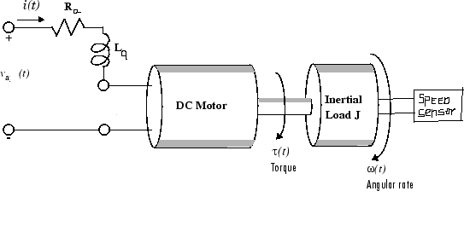

**Procedure:**

**NO LOAD CHARACTERISTICS**

1. Connect the motor to corresponding terminals.
2. Connect the speed sensor to the socket provided.
3. Switch on the power supply.
4. Slowly vary the motor voltage in steps till rated voltage and note the speed.
5. Draw the graph between voltage and speed.

**LOAD CHARACTERISTICS**

1. Connect the motor to corresponding terminals.
2. Connect the speed sensor to the socket provided.
3. Switch on the power supply.
4. Keep the motor voltage to 12V.
5. Now slowly load the motor by adding 50 gms.
6. Tabulate current (I), Speed (N), Weight (W) and calculate the Torque.
7. Repeat steps 5&6 for by increasing the loading up to 250gms in steps of 50gms.
8. Experiment procedure may be repeated for reduced voltage cases.

**Observations and Calculations:**

**NO LOAD CHARACTERISTICS**

|  |  |  |
| --- | --- | --- |
| Sl No | Voltage | speed |
|  |  |  |
|  |  |  |
|  |  |  |
|  |  |  |
|  |  |  |
|  |  |  |

**LOAD CHARACTERISTICS**

**V=--------v**

|  |  |  |  |  |  |
| --- | --- | --- | --- | --- | --- |
| S.No | Voltage(V)  (Volts) | Current (Ia)  Amps | Speed (N)  RPM | Weight (W)  Kgs | Torque (T)  =9.81WR  N-m |
|  |  |  |  |  |  |
|  |  |  |  |  |  |
|  |  |  |  |  |  |
|  |  |  |  |  |  |
|  |  |  |  |  |  |
|  |  |  |  |  |  |

**Specimen Calculation:**

**Expected graph:**

**N**

**(rpm)**

**T(N-m)**

**Results and Discussion:**

**Comments:**

1. How can the torque of a DC Servomotor be controlled?

2. What does the back emf represent?

3. Which type of motor control is best suited for small size motors?

**Short Questions:**

1. Define and explain the term servomechanism.
2. Why are electric motors mostly used as actuators?
3. How kb& KT are equal, if so are prove which can be measured with more accuracy.
4. Give the demerits of field control scheme applied to large and medium sized motors.
5. Write the applications of DC Servomotor?
6. Determine the mathematical model of the DC servo motor and hence its transfer function.

**OUTCOMES**:

Student will be able to:

* determine the torque speed characteristics of a DC servomotor
* Understand the servo mechanism and also as how speed is being maintained constant when torque is changing due to variable load.

**References:**

Control Systems Principles and Design, M.Gopal

Control System Engineering ,I.J.Nagrath and M.Gopal

Modern Control Engineering Katsuhiko Ogata

**1.(b) CHARACTERISTICS OF AC SERVOMOTOR**

**Aim:** To obtain Torque – Speed characteristics of an AC Servo Motor.

## Apparatus:

AC Servomotor kit (25W)

Patch cards

Multimeter

## Theory:

AC Servo motors are two phase induction motors except for certain special design features. The stator of the motor consists of two phases with distributed windings displaced 90 electrical degrees apart. In accordance with the usage, the two phases of such a motor are termed reference and control phase. The voltages applied to the windings of these two phases are not balanced. Generally, voltages of 90 degrees phase difference are applied to each of these stator phases. In the normal mode of operation, a fixed voltage is impressed on reference phase and variable voltage is impressed on control phase. Both the control winding and reference winding are similar and we can interchange them. The rotor of the AC Servomotor is built with high resistance, so that its X/R (Inductive reactance/Resistance) ratio is small which results in linear speed-torque characteristics.

The advantages of AC Servo motors are its compact size, high torque produced, variable speed, easy maintenance and long life. The Servo motors are best suited for low power applications. The power consumed by an AC Servo motor usually varies from fraction of a watt up to only to a few hundred watts.

**Description of the setup:-**

This setup consists of an AC Servomotor whose characteristics are to be studied. The AC Servo motor is coupled to a DC Servo motor. DC Servomotor is used to load the AC Servomotor. A variable DC supply is provided to load the AC Servomotor by the potentiometer P2. A speed sensor is attached to the motor shaft through the coupler. A tachometer is provided to read the motor speed in rpm. An arrangement is made to apply the fixed voltage to the reference winding WR and variable voltage to control winding Wc by potentiometer P1. An ammeter is also provided to read the armature current, Ia of the DC Servomotor.

**Speed variation and speed measurement:-**

A variable AC voltage is applied to the control winding by varying the potentiometer p1. This voltage is used to vary the speed of the motor. The speed sensor is connected from the motor assembly to the control circuit. The speed sensor senses the speed of the motor and generates an ac signal whose frequency is proportional to the rpm. The signal conditioner converts this frequency into a voltage corresponding to the speed(in rpm). The digital panel meter displays the speed in rpm at the front panel of the instrument. The speed of the motor can be suddenly brought to zero by switching off the variable ac power supply through the ‘On’ switch connected to the control winding of the ac servomotor provided at the front panel.

**Torque measurement:-**

In order to measure the torque provided by the Servomotor, we have an arrangement to have variable load on the AC Servomotor. The shaft of the AC Servomotor is coupled to the DC Servomotor. When the servomotor is loaded, the current of DC Servomotor is displayed by the ammeter provided at the front panel, which is proportional to the amount of load applied.

**Related Formulae:**

T = P*60 / (2πN) N-m

Where P = EbIa Watts

Eb is back emf (V),Ia is armature current (A) & N is speed in rpm.

## Circuit diagram:

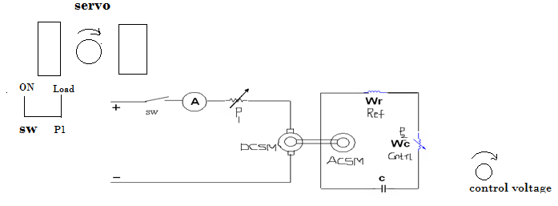

DC servo motor as load with Phase-shifting capacitor,C of

Potentiometer,P1for varying the load AC servo motor, with reference &

andAmmeterfor measuring Control windings Wr&Wc

DC servo motor current.

**Procedure:**

**NO LOAD CHARACTERISTICS**

1. Keep P1& P2 in minimum position.
2. Switch ON the main supply power switch.
3. Measure the reference winding(Wr) voltage by multimeter.
4. Slowly vary the control winding(Wc) voltage and note the speed.
5. Draw the graph between control winding voltage and speed.

**LOAD CHARACTERISTICS**

1. Keep P1& P2 in minimum position.
2. Switch ON the main supply power switch.
3. Measure the reference winding(Wr) voltage by multimeter.
4. Set the control winding voltage to 230V.
5. Now slowly load the motor by switching ON the load and by varying P1 in Steps of RPM.
6. Tabulate the readings in the tabular column.
7. Potentiometer P1 is brought back to minimum position and the load is switched off.
8. Set the control voltage, P2 to 200V value and repeat the steps 5&6.
9. Plot the graphs of Speed Vs Torque for the two control winding voltages set up.
10. Before switching OFF the power supply switch, ensure that the two potentiometers P1&P2 are in minimum position.

**Readings and Calculations:**

**NO LOAD CHARACTERISTICS**

|  |  |  |
| --- | --- | --- |
| Sl No | Voltage | speed |
|  |  |  |
|  |  |  |
|  |  |  |
|  |  |  |
|  |  |  |
|  |  |  |

**LOAD CHARACTERISTICS**

ControlwindingVoltage (V )Volt

|  |  |  |  |  |  |
| --- | --- | --- | --- | --- | --- |
| Sl No | Armature Current (Ia)  Ampere | Speed  (N)  RPM | Back EMF  (Eb)  Volt | Power (P)  = Eb x Ia  Watt | Torque (T)  =60P/2πN  N-m |
|  |  |  |  |  |  |
|  |  |  |  |  |  |
|  |  |  |  |  |  |

**Specimen calculations:**

**Expected graph:**

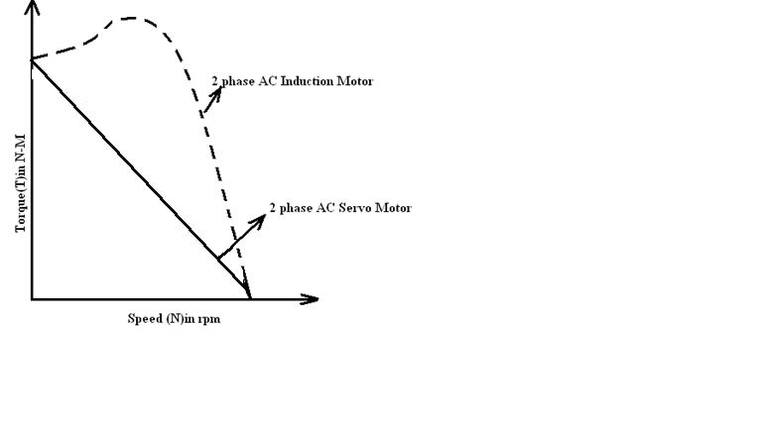

**Results:**

**Comments:**

1**.** What are the desirable characteristics of an AC servo motor for control System applications.

2. What is the reason for positive slope on speed-torque curve of AC induction motor?

**Short Questions:**

1. State the differences in construction of AC induction motor and AC servo motor.
2. What is the use of phase-shifting capacitor.
3. What kind of Slope of torque-speed characteristics is desirable in control systems? Explain.
4. Give the applications of AC servo motor.
5. Determine the mathematical model of an AC servo motor and its transfer function.

**References:**

Control Systems Principles and Design, M.Gopal

**Outcomes:**

Student will able to:

* Understand the working of an AC servo motor
* Understand why servo motors are specially designed for Control Systems.

1. **SYNCHRO TRANSMITTER RECEIVER PAIR**

**AIM:**

1. To study synchro transmitter.
2. To study synchro transmitter and Receiver pair.

**APPARATUS:**

1. Synchro transmitter and Receiver pair trainer kit. 2. Patch chords.

**CIRCUIT DIAGRAM:**

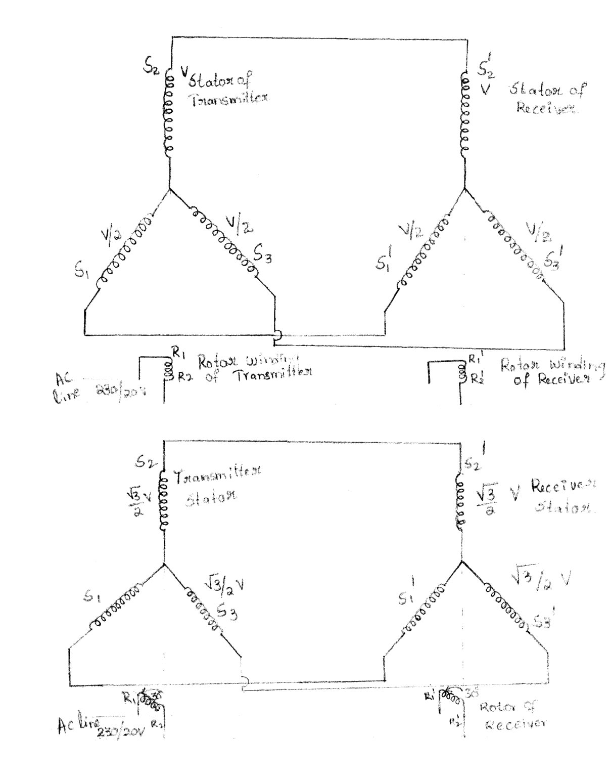

**THEORY:**

**PROCEDURE:**

SYNCHRO TRANSMITTER

1. Connect the main supply to the system with the help of cable provided. Do not interconnect S1, S2 and S3 to S11, S21, and S31.
2. Switch ON main supply for the unit and transmitter rotor supply.
3. Starting from zero position, note down the voltage between stator winding terminals i.e., VS1S2, VS1S3,VS2S3 in a sequential manner. Enter the readings in a tabular form and plot the graph of angular position Vs rotor voltages for all the 3-phases.
4. Note that zero position of the stator coincide with VS3S1, voltage equal to zero voltage. Do not disturb this condition.

**SYNCHRO TRANSMITTER RECEIVER PAIR**

1. Connect the main supply cable
2. Connect S1, S2 and S3 terminals transmitter to S1, S2 and S3 of synchro receiver by patch chords provided respectively.
3. Switch ON rotors supply of both transmitter and receiver and also switch ON the main supply.
4. Move the pointer i.e. rotor position of synchro transmitter in steps of 30o and observe the rotor position. Observe that whenever transmitter rotor is rotated, the receiver rotor follows it for both the directions of rotations and their positions are in good agreement.
5. Enter the input angular position and output angular position in the tabular form and plot graph.

##### TABULAR COLUMN:

|  |  |  |  |  |
| --- | --- | --- | --- | --- |
| S.NO | Rotor position in degrees | VS1S3 | VS1S2 | VS2S3 |
| 1 | 0 | 26.6 | 36 | 63.2 |
| 2 | 30 | 51.6 | 5.7 | 57.4 |
| 3 | 90 | 58.6 | 51 | 7.5 |
| 4 | 150 | 6.1 | 57.0 | 51.5 |
| 5 | 210 | 53 | 3 | 56.6 |
| 6 | 300 | 35 | 62 | 28.2 |

|  |  |  |
| --- | --- | --- |
| S.NO | Rotor position of transmitter in degrees | Rotor position of receiver in degrees |
| 1 | 0 | 0 |
| 2 | 30 | 30 |
| 3 | 90 | 90 |
| 4 | 150 | 150 |
| 5 | 210 | 210 |
| 6 | 300 | 300 |

**GRAPHS:**

1. Synchro transmitter
2. Synchro transmitter and receiver pair.

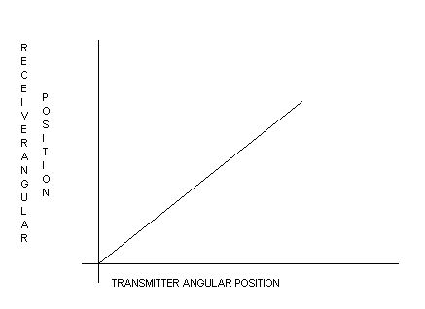

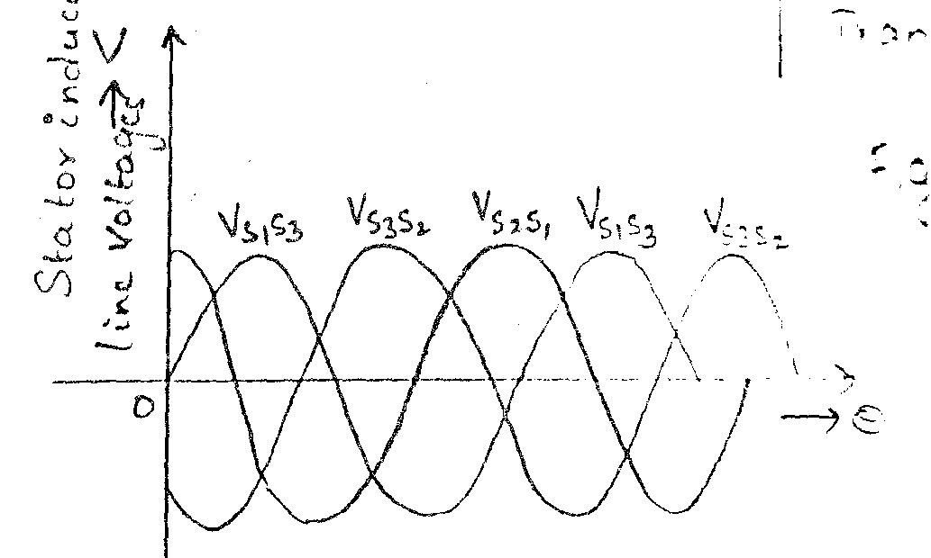

**RESULT:**

**CONCLUSION:**

**3. FREQUENCY RESPONSE OF FIRST ORDER SYSEM**

**Aim:** To plot frequency response for the given first order system.

**Apparatus:**

Frequency response kit

Patch cards

**Theory**:

The frequency response is the steady state response of the system to a Sinusoidal signal. Consider a linear time invariant system, let x(t) is an input sinusoidal signal. Response is also sinusoidal signal of same frequency but with different magnitude phase angle.

**Circuit Diagram:**

**First Order System**

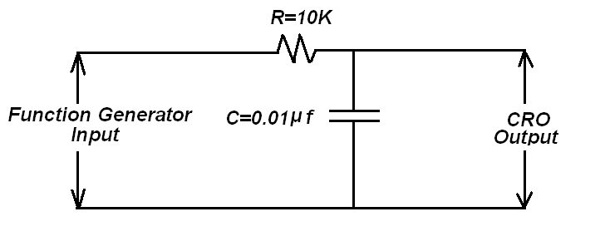

**Second order system**



**Related Formulae:**

For RC filter, Eo(s)/Ei(s) = G(S) = 1/1+Ts

Sinusoidal Transfer Function Magnitude,G (jω) = 1/√1+ ω 2 T2 ,

Phase ∟Tan-1 ω t = M∟θ

Gain in dB = 20 log10 |Vo/Vi| dB

**Procedure:**

1. Connect the circuit as shown.

2. Switch on the apparatus.

3. Set the signal generator to sine wave. Adjust the amplitude of the sine wave signal to suitable voltage.

4. Enter various readings in the table for the frequency from 100Hz to 10 KHz in steps.

5. Plot a graph of Gain in dB Vs frequency, ω in radians.

**Observations:**

**Second Order System**

|  |  |  |  |  |  |  |
| --- | --- | --- | --- | --- | --- | --- |
| S.No | Frequency(Hz) | ω= 2πf  (rad) | Input Voltage(Vi) | Output Voltage(Vo) | Gain  Vo/Vi | Gain in dB =20Log10gain |
|  |  |  |  |  |  |  |
|  |  |  |  |  |  |  |
|  |  |  |  |  |  |  |
|  |  |  |  |  |  |  |
|  |  |  |  |  |  |  |

**Expected graph:**

**Gain in**

**DB**

**Frequency in Hertz**

**Results:**

**Comments:**

1. How are frequency and time response related?

2. Give the various design specifications for a frequency response.

3. What are the main advantages of plotting a Bode plot?

4. Can a nyquist plot be drawn from a given Bode plot?

**Short Questions:**

1. What is the order of a system?
2. What is the type of a system?
3. Analyse the response of first order system for step signal & find the steady state error for the first order system.
4. Define the transient and steady state responses.
5. Define the time response of the system.
6. If s = σ+j ω, then how is s=j ω for frequency response.

**References:**

Modern Control Systems,K.Ogata

**Outcomes:**

Student will able to:

• Know the gain variation with frequency of a first order system

• Understand the transient &steady state response of first order system

**4. TIME RESPONSE OF SECOND ORDER SYSTEM**

**AIM:** To study the time response of second order system.

**APPARATUS:**

1. Second order system kit.
2. Function generator
3. CRO
4. Connecting wires

**CIRCUIT DIAGRAM:**

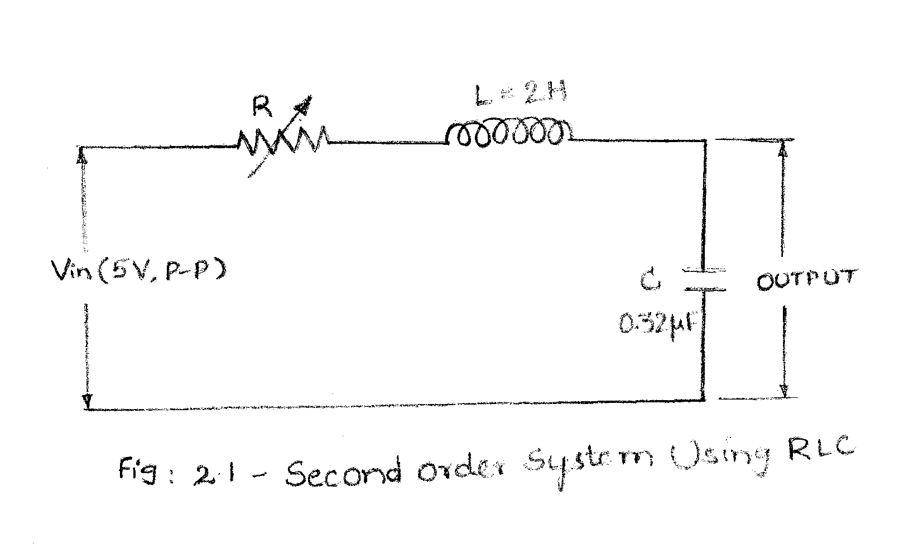

**THEORY:**

**PROCEDURE:**

1. Apply square wave input of magnitude 10V peak to peak.
2. Connect the output to CRO and measure the output voltage for various points.
3. Repeat for various values of ζ=0.3, 0.7,1.

**FORMULAE:**

1. wn= 1/√LC
2. ζ=(R/2) √C/L
3. tp = Π/ (wn(√1- ζ2))
4. tr = (Π- tan-1√1- ζ2/ ζ)/ (wn(√1- ζ2))
5. Mp = e ((-Π ζ)/(√1- ζ2))
6. td= (Π+0.7 ζ)/ wn

**GRAPHS:**

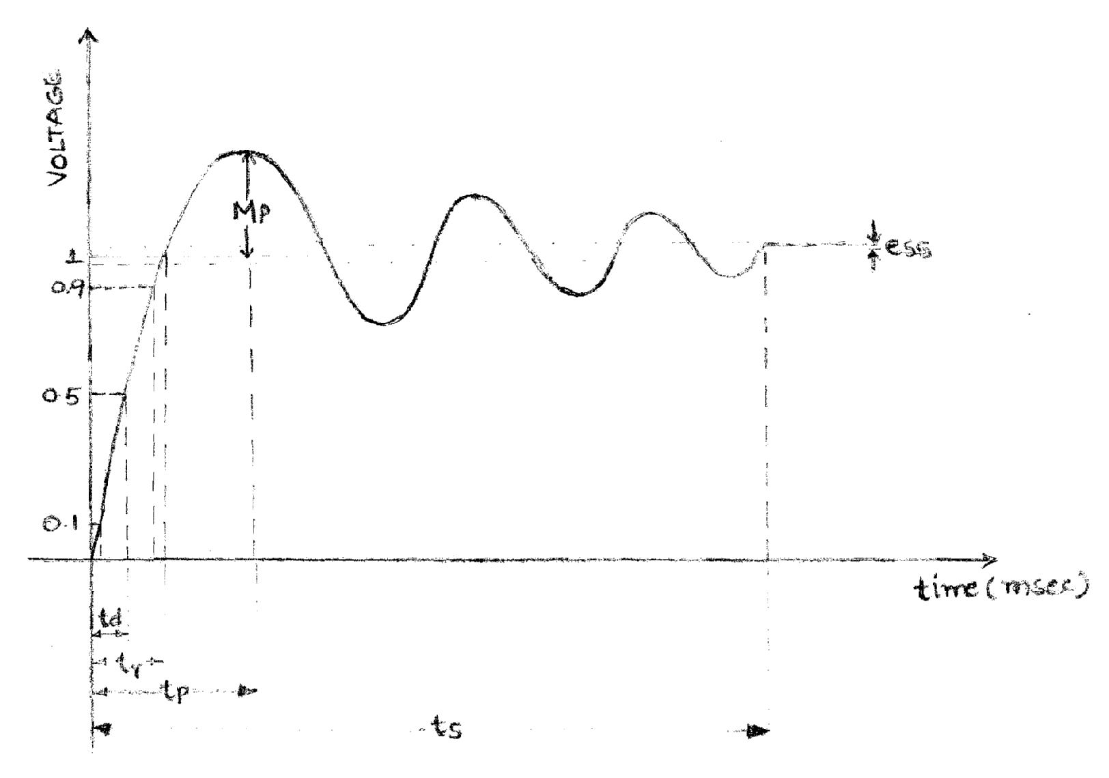

**RESULT:**

**CONCLUSION:**

**5. STUDY OF LEAD LAG COMPENSATION NETWORK**

**AIM:**

1. To study lead compensation.
2. To study lag compensation.
3. To study lead lag compensation.

**APPARATUS:**

1. Trainer kit.
2. Phase angle meter.
3. Function generator.
4. Connecting wires

**CIRCUIT DIAGRAM:**

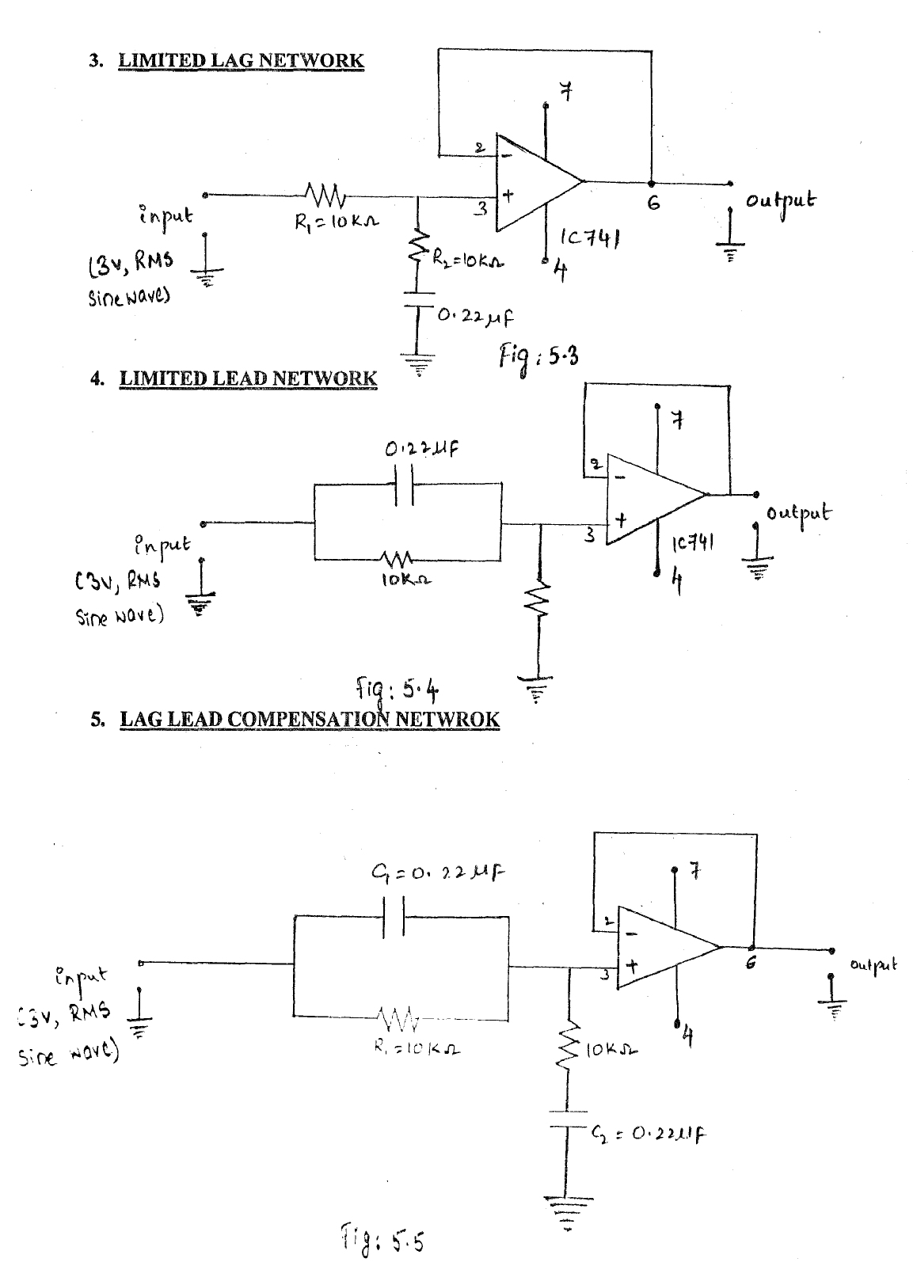

**LAG NETWORK**

**THEORY:**

**PROCEDURE:**

1. Circuit is to be connected as per the circuit diagram.
2. Give a sinusoidal function as input using a function generator with an amplitude of 3V.
3. Select various frequencies and give as input to the lag, lead and lag lead compensating networks.
4. Note phase angle from the phase angle meter and tabulate the input and output voltages for different frequencies.
5. Calculate the phase angle theoretically and verify with the indicated value.
6. Draw the frequency and phase plots.

##### TABULAR COLUMNS:

**LAG NETWORK**

|  |  |  |  |  |  |  |
| --- | --- | --- | --- | --- | --- | --- |
| S.NO. | Freq (Hz) | Indicated T (j ω) θ | V0 (V) | Pratical **V0/(V)** | theoritical**V0/(V)** | Phase angle |
| 1 | 60 | 34 | 2.81 | 0.93 | 0.93 | 20.65 |
| 2 | 80 | 40 | 2.67 | 0.89 | 0.89 | 26.68 |
| 3 | 100 | 45 | 2.52 | 0.84 | 0.84 | 32.14 |
| 4 | 200 | 64 | 1.84 | 0.61 | 0.62 | 51.48 |
| 5 | 300 | 73 | 1.38 | 0.46 | 0.46 | 62.05 |

LEAD NETWORK

|  |  |  |  |  |  |  |
| --- | --- | --- | --- | --- | --- | --- |
| S.NO. | Freq (Hz) | Indicated T (j ω) θ | V0 (V) | Pratical **V0/(V)** | theoritical**V0/(V)** | Phase angle |
| 1 | 60 | 77 | 1.08 | 0.36 | 0.35 | 69.34 |
| 2 | 80 | 72 | 1.37 | 0.45 | 0.44 | 63.31 |
| 3 | 100 | 68 | 1.63 | 0.54 | 0.53 | 75 |
| 4 | 200 | 50 | 2.36 | 0.78 | 0.77 | 38.5 |
| 5 | 300 | 34 | 2.77 | 0.92 | 0.91 | 21.64 |

**GRAPHS:**

1. LAG
2. LEAD

**RESULT**

**CONCLUSION:**

**9. Stability Analysis of Linear Time Invariant Systems**

**Using MATLAB**

**Aim:**

To obtain the **bode plot** for a given transfer function using MATLAB.

**PROGRAM FILE**

%PROGRAM TO OBTAIN THE BODE, ROOT LOCUS & NYQUIST PLOTS for the STABILITY %ANALYSIS of the given Linear Time Invariant System using MATLAB

numf=[10] %numerator of the forward transfer function

denf=[1 4 8 0] %denominator of the forward transfer function

gs=tf(numf,denf) %forward transfer function

numb=[1] %numerator of the backward transfer function

denb=[1] %denominator of the backward transfer function

hs=tf(numb,denb) %backward transfer function

cs=feedback(gs,hs) %closed loop transfer function(of gs and hs)

bode(cs) %bode plot of the closed loop transfer function

margin(cs) %gain and phase margins of the closed loop

%transfer function

Clpoles=pole(cs)

**Theory:**

In any frequency response we plot magnitude M and angle Ø against input frequency ‘ω’. When ω is varied from 0 to ∞, there is a wide range of variations in M and Ø so it becomes difficult to accommodate all such variations with linear scale hence we use logarithmic scale. Thus in bode plot logarithmic values of magnitude are to be plotted against logarithmic values of frequencies.

Bode plot consists of two plots:

1. Magnitude expressed in logarithmic values of frequency called Magnitude plot.
2. Phase angle in degrees against logarithmic values of frequency called Phase angle plot

**OUTPUT FILE**

>> numf=[10]

denf=[1 4 8 0]

gs=tf(numf,denf)

numb=[1]

denb=[1]

hs=tf(numb,denb)

cs=feedback(gs,hs)

numf =

10

denf =

1 4 8 0

Transfer function:

10

-----------------

s^3 + 4 s^2 + 8 s

numb =

1

denb =

1

Transfer function:

1

Transfer function:

10

----------------------

s^3 + 4 s^2 + 8 s + 10

>> clpoles=pole(cs)

clpoles =

-2.4026

-0.7987 + 1.8773i

-0.7987 - 1.8773i

Because the poles are less than zero, the given system is stable.

bode(cs)

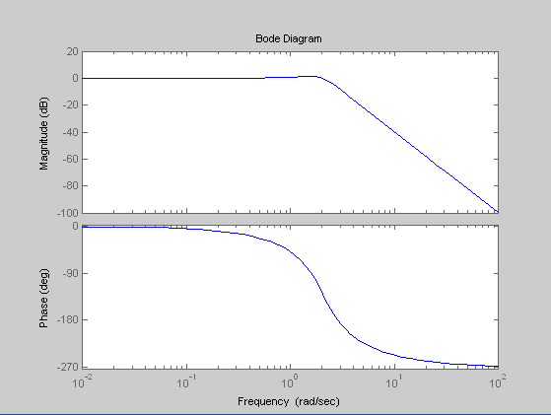

margin(cs)

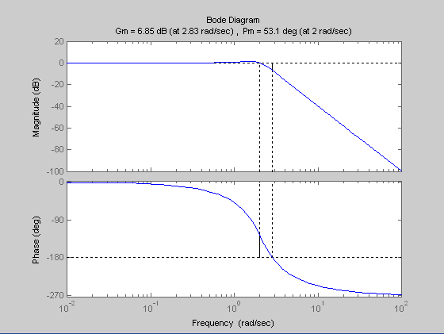

**Result:**

Bode plot are drawn for the given transfer function using MATLAB.

**Stability Analysis of Linear Time Invariant Systems**

**(nyquist plot) using MATLAB**

**Aim:**

To obtain the **nyquist plot** for a given transfer function using MATLAB.

**PROGRAM FILE**

%PROGRAM TO OBTAIN THE BODE, ROOT LOCUS & NYQUIST PLOTS for the STABILITY %ANALYSIS of the given Linear Time Invariant System using MATLAB

numf=[10] %numerator of the forward transfer function

denf=[1 4 8 0] %denominator of the forward transfer function

gs=tf(numf,denf) %forward transfer function

numb=[1] %numerator of the backward transfer function

denb=[1] %denominator of the backward transfer function

hs=tf(numb,denb) %backward transfer function

cs=feedback(gs,hs) %closed loop transfer function(of gs and hs)

nyquist(cs) %nyquist plot of the closed loop transfer

%function

Clpoles=pole(cs)

**Theory:**

The nyquist method handles the system with time delay without the necessity of approximation and hence yields exact results about both absolute and relative stability of the system.

**OUTPUT FILE**

>> numf=[10]

denf=[1 4 8 0]

gs=tf(numf,denf)

numb=[1]

denb=[1]

hs=tf(numb,denb)

cs=feedback(gs,hs)

numf =

10

denf =

1 4 8 0

Transfer function:

10

-----------------

s^3 + 4 s^2 + 8 s

numb =

1

denb =

1

Transfer function:

1

Transfer function:

10

----------------------

s^3 + 4 s^2 + 8 s + 10

>> clpoles=pole(cs)

clpoles =

-2.4026

-0.7987 + 1.8773i

-0.7987 - 1.8773i

Because the poles are less than zero, the given system is stable.

nyquist(cs)

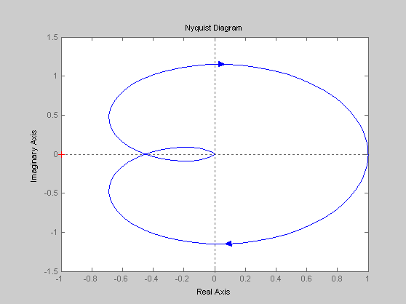

**Result:**

Nyquist plots are drawn for the given transfer function using MATLAB.

**Stability Analysis of Linear Time Invariant Systems**

**(Root locus plot**) using **MATLAB**

**Aim:**

To obtain the **root locus plot** for a given transfer function using MATLAB.

**PROGRAM FILE**

%PROGRAM TO OBTAIN THE BODE, ROOT LOCUS & NYQUIST PLOTS for the STABILITY %ANALYSIS of the given Linear Time Invariant System using MATLAB

numf=[10] %numerator of the forward transfer function

denf=[1 4 8 0] %denominator of the forward transfer function

gs=tf(numf,denf) %forward transfer function

numb=[1] %numerator of the backward transfer function

denb=[1] %denominator of the backward transfer function

hs=tf(numb,denb) %backward transfer function

cs=feedback(gs,hs) %closed loop transfer function(of gs and hs)

rlocus(cs) %root locus of the closed loop transfer function

Clpoles=pole(cs)

**Theory:**

Root locus is a graphical method in which movement of poles in the s-plane is sketched when a particular parameter of system is varied from zero to infinity. The parameter which is usually varied is the gain but any other parameters may be varied.

**.**

**.**

**OUTPUT FILE:**

>> numf=[10]

denf=[1 4 8 0]

gs=tf(numf,denf)

numb=[1]

denb=[1]

hs=tf(numb,denb)

cs=feedback(gs,hs)

numf =

10

denf =

1 4 8 0

Transfer function:

10

-----------------

s^3 + 4 s^2 + 8 s

numb =

1

denb =

1

Transfer function:

1

Transfer function:

10

----------------------

s^3 + 4 s^2 + 8 s + 10

>> clpoles=pole(cs)

clpoles =

-2.4026

-0.7987 + 1.8773i

-0.7987 - 1.8773i

Because the poles are less than zero, the given system is stable.

rlocus(cs)

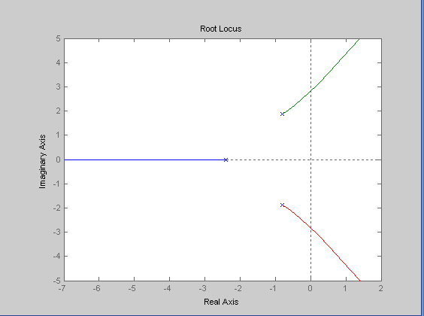

**Result:**

Root locus are drawn for the given transfer function using MATLAB.