The World Wide Web
The World Wide Web (www, W3) is an information space where documents and other web resources are identified by URIs, interlinked by hypertext links, and can be accessed via the Internet.
- It has become known simply as the Web.
- Hypertext documents are commonly called web pages, which are primarily text documents formatted and annotated with the Hypertext Markup Language (HTML).
- Webpages may contain links to images, video, and software components that are rendered to users of a web browser application, running on the user’s computer, as coherent pages of multimedia content.
- Embedded hyperlinks permit users to navigate between web pages. When multiple web pages are published with a common theme or within a common domain name, the collection is usually called a web site.
In the process of weaving the web three essential technologies were developed
- a system of globally unique identifiers for resources on the Web and elsewhere, the universal document identifier (UDI), later known as uniform resource locator (URL) and uniform resource identifier (URI);
- the publishing language HyperText Markup Language (HTML);
- the Hypertext Transfer Protocol (HTTP)

Function
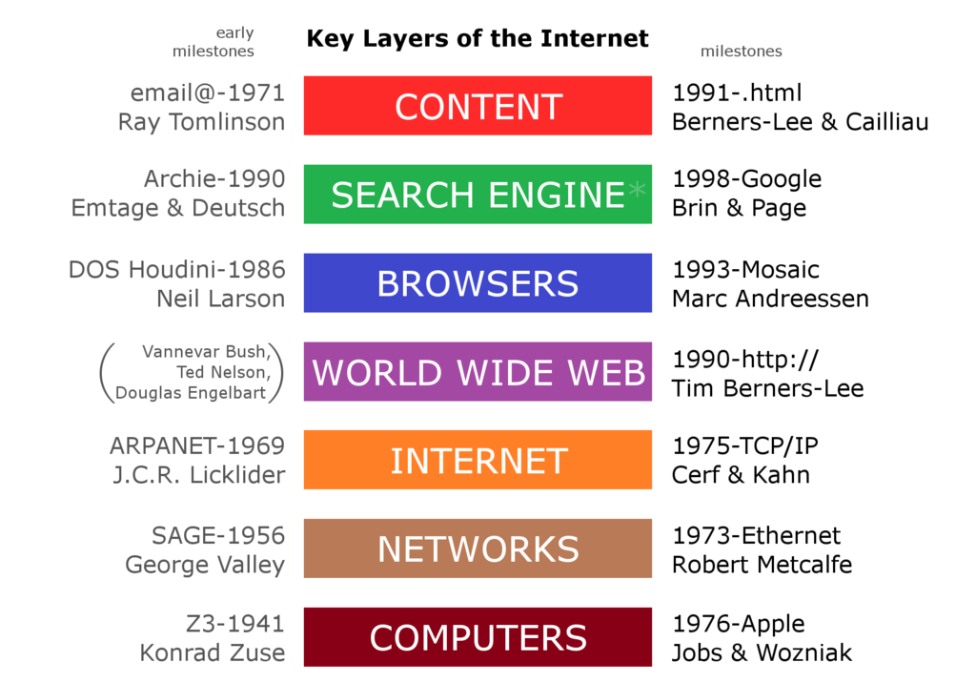
The World Wide Web functions as a layer on top of the Internet, helping to make it more functional. The advent of the Mosaic web browser helped to make the web much more usable.

Whether Web and Internet are same or different?
- The terms Internet and World Wide Web are often used without much distinction. However, the two things are not the same.
  - The Internet is a global system of interconnected computer networks.
  - In contrast, the World Wide Web is one of the services transferred over these networks.
  - It is a collection of text documents and other resources, linked by hyperlinks and URLs, usually accessed by web browsers, from web servers.

Web Browser
A web browser (commonly referred to as a browser) is a software application for retrieving, presenting and traversing information resources on the World Wide Web. An information resource is identified by a Uniform Resource Identifier (URI/URL) and may be a web page, image, video or other piece of content. Hyperlinks present in resources enable users easily to navigate their browsers to related resources.
Although browsers are primarily intended to use the World Wide Web, they can also be used to access information provided by web servers in private networks or files in file systems.
The major web browsers are Firefox, Internet Explorer, Google Chrome, Opera, and Safari.
- The first web browser was invented in 1990 by Sir Tim Berners-Lee.
- Berners-Lee is the director of the World Wide Web Consortium (W3C), which oversees the Web’s continued development, and is also the founder of the World Wide Web Foundation. His browser was called WorldWideWeb and later renamed Nexus.
- The first commonly available web browser with a graphical user interface was Erwise. The development of Erwise was initiated by Robert Cailliau.

- In 1993, browser software was further innovated by Marc Andreessen with the release of Mosaic, “the world’s first popular browser”, which made the World Wide Web system easy to use and more accessible to the average person.
- Andreesen’s browser sparked the internet boom of the 1990s.
- The introduction of Mosaic in 1993 – one of the first graphical web browsers – led to an explosion in web use. Andreessen,
- the leader of the Mosaic team at National Center for Supercomputing Applications (NCSA), soon started his own company, named Netscape, and released the Mosaic-influenced Netscape Navigator in 1994, which quickly became the world’s most popular browser, accounting for 90% of all web use at its peak .

Introduction To Web Server
A Web Server is a Computer or Combination of computers, which is connected through internet or intranet to serve the clients quests, coming from their web browser.
- It is a large repository of web pages which transfer to the client in response to their request.
- The client request to the server through protocol such as FTP, HTTP, SMTP etc for their own specific use.
- Every web server has a unique IP address and domain name which identifies that machine on the network.
- A server contains the server software installed on it, which manages the client request and response them.
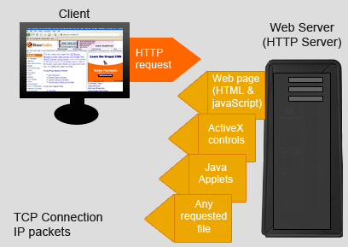
There are many types of web server, Enterprise uses according to their need. Some of the popular category of web servers are -
- HTTP Server - It handles HTTP request coming from clients browser and transfer the static pages to client in response to their request. This pages runs of the client browser. It generally contains the static pages.
- FTP Server - This type of server used for file transfer from one machine (Computer) to another using the internet or intranet. It uses File Transfer Protocols to transfer file from one computer to another. Such type of server uses some file transfer policies, authentication, login validation etc
- Mail Server - A Mail Server store and retrieve mail messages from client mail box.
- Application Server - It is installed database and web servers
Apache Tomcat is popular web server being used today for the implementation of some java technologies. It is a open source software used for implementing web applications.
In the next example of servlet we will use the Apache Tomcat as a web server.

Uniform Resource Locator
- Uniform resource locator (URL) is a reference to a resource that specifies the location of the resource on a computer network and a mechanism for retrieving it. A URL (Uniform Resource Locator) is used to uniquely identify a resource over the web.
- A URL is a specific type of uniform resource identifier (URI), although many people use the two terms interchangeably.
- A URL implies the means to access an indicated resource, which is not true of every URI.
- URLs occur most commonly to reference web pages (http), but are also used for file transfer (ftp), email (mailto), database access (JDBC), and many other applications.
A typical URL has the form http://www.example.com/index.html, which indicates the protocol type (http), the domain name, (www.example.com), and the specific web page (index.html).
URL has the following syntax:
protocol://hostname:port/path-and-file-name

There are 4 parts in a URL:
- Protocol: The application-level protocol used by the client and server, e.g., HTTP, FTP, and telnet.
- Hostname: The DNS domain name (e.g., www.nowhere123.com) or IP address (e.g., 192.128.1.2) of the server.
- Port: The TCP port number that the server is listening for incoming requests from the clients.
- Path-and-file-name: The name and location of the requested resource, under the server document base directory.
For example, in the URL http://www.nowhere123.com/docs/index.html, the communication protocol is HTTP; the hostname is www.nowhere123.com. The port number was not specified in the URL, and takes on the default number, which is TCP port 80 for HTTP. The path and file name for the resource to be located is "/docs/index.html".
Other examples of URL are:
ftp://www.ftp.org/docs/test.txt
mailto:user@test101.com
news:soc.culture.Singapore
telnet://www.nowhere123.com/

HyperText Transfer Protocol (HTTP)
HTTP (Hypertext Transfer Protocol) is perhaps the most popular application protocol used in the Internet (or The WEB).
- HTTP is an asymmetric request-response client-server protocol as illustrated.
- An HTTP client sends a request message to an HTTP server.
- The server, in turn, returns a response message.
- In other words, HTTP is a pull protocol, the client pulls information from the server (instead of server pushes information down to the client).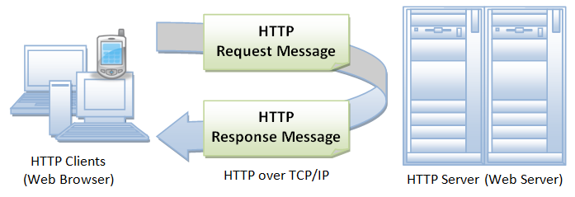
- HTTP is a stateless protocol. In other words, the current request does not know what has been done in the previous requests.
- HTTP permits negotiating of data type and representation, so as to allow systems to be built independently of the data being transferred.
- "The Hypertext Transfer Protocol (HTTP) is an application-level protocol for distributed, collaborative, hypermedia information systems.
  - It is a generic, stateless, protocol which can be used for many tasks beyond its use for hypertext, such as name servers and distributed object management systems, through extension of its request methods, error codes and headers."

Browser
Whenever you issue a URL from your browser to get a web resource using HTTP, e.g. http://www.nowhere123.com/index.html, the browser turns the URL into a request message and sends it to the HTTP server. The HTTP server interprets the request message, and returns you an appropriate response message, which is either the resource you requested or an error message. This process is illustrated below:
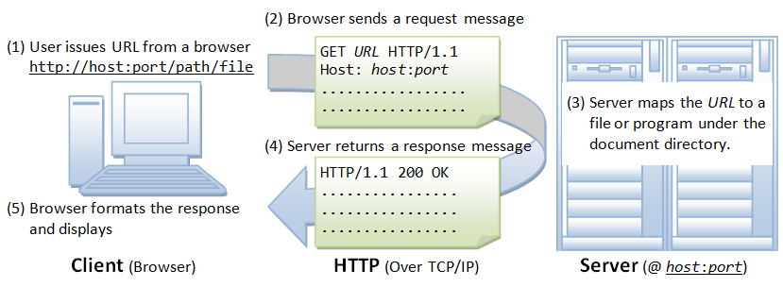

HTML5: Introduction, Links, Images, Multimedia, Lists, Tables, Creating Forms, Styling Forms.

HTML5 introduction
What is HTML5
- This is the latest version of HTML. HTML is not a programming language, it is a markup language.
  - A markup language is a computer language that uses tags to define elements within a document.
  - It is human-readable, meaning markup files contain standard words, rather than typical programming syntax.
  - While several markup languages exist, the two most popular are HTML and XML
- HTML5 stands for Hypertext Markup Language version 5. World Wide Web Consortium (W3C) published it in October 2014. It is the most recent version of the language or code that explains web pages.
- HTML5 was created so as to enable various characteristics that the present day websites need. It is simple to adopt as there are no major alterations to the programming version of HTML.
- HTML stands for Hyper Text Markup Language
- HTML describes the structure of a Web page
- HTML consists of a series of elements
- HTML elements tell the browser how to display the content
- HTML elements are represented by tags
- HTML tags label pieces of content such as "heading", "paragraph", "table", and so on
- Browsers do not display the HTML tags, but use them to render the content of the page
<!DOCTYPE html>
<html>
<head>
<title>Page Title</title>
</head>
<body>
<h1>My First Heading</h1>
<p>My first paragraph.</p>
</body>
</html>

Example Explained
- The <!DOCTYPE html> declaration defines this document to be HTML5
- The <html> element is the root element of an HTML page
- The <head> element contains meta information about the document
- The <title> element specifies a title for the document
- The <body> element contains the visible page content
- The <h1> element defines a large heading
- The <p> element defines a paragraph

HTML Attributes
- All HTML elements can have attributes
- Attributes provide additional information about an element
- Attributes are always specified in the start tag
- Attributes usually come in name/value pairs like: name="value"

The href Attribute
  - HTML links are defined with the <a> tag. The link address is specified in the href attribute:

Example <a href="https://www.w3schools.com">This is a link</a>

The src Attribute
- HTML images are defined with the <img> tag.
- The filename of the image source is specified in the src attribute:

Example <img src="img_girl.jpg">

The width and height Attributes
- HTML images also have width and height attributes, which specifies the width and height of the image:
- Example <img src="img_girl.jpg" width="500" height="600">

HTML Headings
Headings are defined with the <h1> to <h6> tags.
<h1> defines the most important heading. <h6> defines the least important heading.

Example

<!DOCTYPE html>

<html>

<body>

<h1>Heading 1</h1>

<h2>Heading 2</h2>

<h3>Heading 3</h3>

<h4>Heading 4</h4>

<h5>Heading 5</h5>

<h6>Heading 6</h6>

</body>

</html>

Headings Are Important
- Search engines use the headings to index the structure and content of your web pages.
- Users often skim a page by its headings. It is important to use headings to show the document structure.
- <h1> headings should be used for main headings, followed by <h2> headings, then the less important <h3>, and so on.
Note: Use HTML headings for headings only. Don't use headings to make text BIG or bold.

Bigger Headings
Each HTML heading has a default size. However, you can specify the size for any heading with the style attribute, using the CSS font-size property:

Example
<!DOCTYPE html>
<html>
<body>
<h1 style="font-size:60px;">Heading 1</h1>
<p>You can change the size of a heading with the style attribute, using the font-size property.</p>
</body>
</html>

HTML Horizontal Rules
The <hr> tag defines a thematic break in an HTML page, and is most often displayed as a horizontal rule.
The <hr> element is used to separate content (or define a change) in an HTML page:
<!DOCTYPE html>
<html>
<body>

<h1>This is heading 1</h1>
<p>This is some text.</p>
<hr>

<h2>This is heading 2</h2>
<p>This is some other text.</p>
<hr>

<h2>This is heading 2</h2>
<p>This is some other text.</p>

</body>
</html>

HTML Paragraphs
The HTML <p> element defines a paragraph:
<!DOCTYPE html>
<html>
<body>

<p>This is a paragraph.</p>

</body>
</html>

HTML Display
- You cannot be sure how HTML will be displayed.
- Large or small screens, and resized windows will create different results.
- With HTML, you cannot change the output by adding extra spaces or extra lines in your HTML code.
- The browser will remove any extra spaces and extra lines when the page is displayed:
<!DOCTYPE html>
<html>
<body>

<p>
This paragraph
contains a lot of lines
in the source code,
but the browser
ignores it.
</p>

<p>
This paragraph
contains a lot of spaces
in the source code,
but the browser
ignores it.
</p>

<p>
The number of lines in a paragraph depends on the size of the browser window. If you resize the browser window, the number of lines in this paragraph will change.
</p>

</body>
</html>

HTML Line Breaks
The HTML <br> element defines a line break.
Use <br> if you want a line break (a new line) without starting a new paragraph:
<!DOCTYPE html>
<html>
<body>
<p>This is<br>a paragraph<br>with line breaks</p>
</body>
</html>

The HTML <pre> Element
The HTML <pre> element defines preformatted text.
The text inside a <pre> element is displayed in a fixed-width font (usually Courier), and it preserves both spaces and line breaks:
<!DOCTYPE html>
<html>
<body>

<p>The pre tag preserves both spaces and line breaks:</p>

<pre>
My Bonnie lies over the ocean.

My Bonnie lies over the sea.

My Bonnie lies over the ocean.

Oh, bring back my Bonnie to me.
</pre>

</body>
</html>

