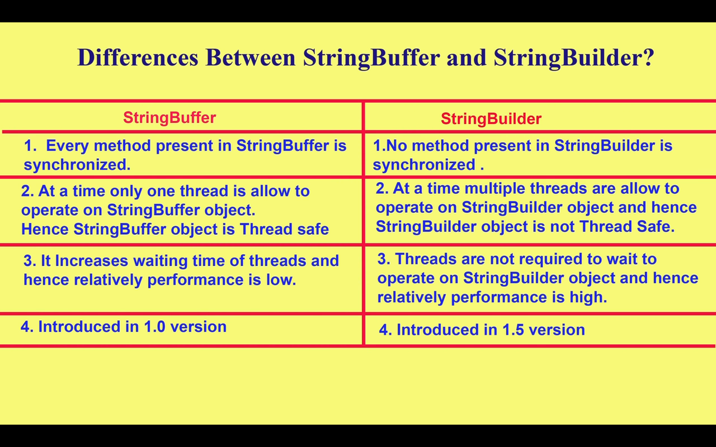

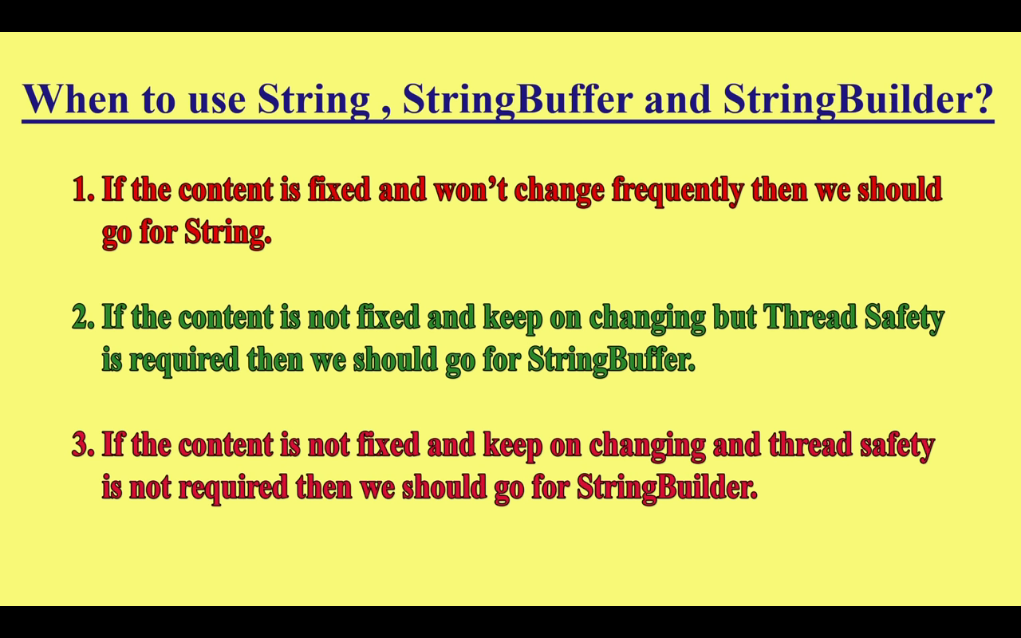

What is String in java
Generally, String is a sequence of characters. But in Java, string is an object that represents a sequence of characters. The java.lang.String class is used to create a string object.

How to create a string object?
There are two ways to create String object:
- By string literal
- By new keyword

1) String Literal
Java String literal is created by using double quotes. For Example:
- String s="welcome";
Each time you create a string literal, the JVM checks the "string constant pool" first. If the string already exists in the pool, a reference to the pooled instance is returned. If the string doesn't exist in the pool, a new string instance is created and placed in the pool. For example:
- String s1="Welcome";
- String s2="Welcome";//It doesn't create a new instance
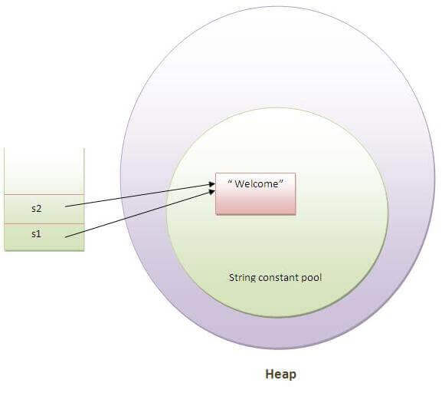
n the above example, only one object will be created. Firstly, JVM will not find any string object with the value "Welcome" in string constant pool, that is why it will create a new object. After that it will find the string with the value "Welcome" in the pool, it will not create a new object but will return the reference to the same instance.

Note: String objects are stored in a special memory area known as the "string constant pool".

Why Java uses the concept of String literal?
To make Java more memory efficient (because no new objects are created if it exists already in the string constant pool).

2) By new keyword
- String s=new String("Welcome");//creates two objects and one reference variable
In such case, JVM will create a new string object in normal (non-pool) heap memory, and the literal "Welcome" will be placed in the string constant pool. The variable s will refer to the object in a heap (non-pool).
- public class StringExample{
- public static void main(String args[]){
- String s1="java";//creating string by java string literal
- char ch[]={'s','t','r','i','n','g','s'};
- String s2=new String(ch);//converting char array to string
- String s3=new String("example");//creating java string by new keyword
- System.out.println(s1);
- System.out.println(s2);
- System.out.println(s3);
- }}

Java String class methods
The java.lang.String class provides many useful methods to perform operations on sequence of char values.
No. | Method | Description
1 | char charAt(int index) | returns char value for the particular index
2 | int length() | returns string length
3 | static String format(String format, Object... args) | returns a formatted string.
4 | static String format(Locale l, String format, Object... args) | returns formatted string with given locale.
5 | String substring(int beginIndex) | returns substring for given begin index.
6 | String substring(int beginIndex, int endIndex) | returns substring for given begin index and end index.
7 | boolean contains(CharSequence s) | returns true or false after matching the sequence of char value.
8 | static String join(CharSequence delimiter, CharSequence... elements) | returns a joined string.
9 | static String join(CharSequence delimiter, Iterable<? extends CharSequence> elements) | returns a joined string.
10 | boolean equals(Object another) | checks the equality of string with the given object.
11 | boolean isEmpty() | checks if string is empty.
12 | String concat(String str) | concatenates the specified string.
13 | String replace(char old, char new) | replaces all occurrences of the specified char value.
14 | String replace(CharSequence old, CharSequence new) | replaces all occurrences of the specified CharSequence.
15 | static String equalsIgnoreCase(String another) | compares another string. It doesn't check case.
16 | String[] split(String regex) | returns a split string matching regex.
17 | String[] split(String regex, int limit) | returns a split string matching regex and limit.
18 | String intern() | returns an interned string.
19 | int indexOf(int ch) | returns the specified char value index.
20 | int indexOf(int ch, int fromIndex) | returns the specified char value index starting with given index.
21 | int indexOf(String substring) | returns the specified substring index.
22 | int indexOf(String substring, int fromIndex) | returns the specified substring index starting with given index.
23 | String toLowerCase() | returns a string in lowercase.
24 | String toLowerCase(Locale l) | returns a string in lowercase using specified locale.
25 | String toUpperCase() | returns a string in uppercase.
26 | String toUpperCase(Locale l) | returns a string in uppercase using specified locale.
27 | String trim() | removes beginning and ending spaces of this string.
28 | static String valueOf(int value) | converts given type into string. It is an overloaded method.

Java String compare
We can compare string in java on the basis of content and reference.
It is used in authentication (by equals() method), sorting (by compareTo() method), reference matching (by == operator) etc.
There are three ways to compare string in java:
- By equals() method
- By = = operator
- By compareTo() method

class Teststringcomparison1{
public static void main(String args[]){
String s1="Sachin";
String s2="Sachin";
String s3=new String("Sachin");
String s4="Saurav";
System.out.println(s1.equals(s2));//true
System.out.println(s1.equals(s3));//true
System.out.println(s1.equals(s4));//false
}
}

equalsIgnoreCase

class Teststringcomparison2{
public static void main(String args[]){
String s1="Sachin";
String s2="SACHIN";

System.out.println(s1.equals(s2));//false
System.out.println(s1.equalsIgnoreCase(s2));//true
}
}

String compare by == operator

class Teststringcomparison3{
public static void main(String args[]){
String s1="Sachin";
String s2="Sachin";
String s3=new String("Sachin");
System.out.println(s1==s2);//true (because both refer to same instance)
System.out.println(s1==s3);//false(because s3 refers to instance created in nonpool)
}
}

String compare by compareTo() method
The String compareTo() method compares values lexicographically and returns an integer value that describes if first string is less than, equal to or greater than second string.
Unicode Range
0-9 --- 48-57
A-Z ----- 65-90
a-z ------ 97-122

Suppose s1 and s2 are two string variables. If:
- s1 == s2 :0
- s1 > s2 :positive value
- s1 < s2 :negative value
class Teststringcomparison4{
public static void main(String args[]){
String s1="Sachin";
String s2="Sachin";
String s3="Ratan";
System.out.println(s1.compareTo(s2));//0
System.out.println(s1.compareTo(s3));//1(because s1>s3)
System.out.println(s3.compareTo(s1));//-1(because s3 < s1 )
}
}

String Concatenation in Java
In java, string concatenation forms a new string that is the combination of multiple strings. There are two ways to concat string in java:
- By + (string concatenation) operator
- By concat() method

1) String Concatenation by + (string concatenation) operator
Java string concatenation operator (+) is used to add strings. For Example:
class TestStringConcatenation1{
public static void main(String args[]){
String s="Sachin"+" Tendulkar";
System.out.println(s);//Sachin Tendulkar
}
}

String Concatenation by concat() method
The String concat() method concatenates the specified string to the end of current string.
class TestStringConcatenation3{
public static void main(String args[]){
String s1="Sachin ";
String s2="Tendulkar";
String s3=s1.concat(s2);
System.out.println(s3);//Sachin Tendulkar
}
}

Java String class methods
The java.lang.String class provides a lot of methods to work on string. By the help of these methods, we can perform operations on string such as trimming, concatenating, converting, comparing, replacing strings etc.
Java String is a powerful concept because everything is treated as a string if you submit any form in window based, web based or mobile application.
Let's see the important methods of String class.

Java String toUpperCase() and toLowerCase() method
The java string toUpperCase() method converts this string into uppercase letter and string toLowerCase() method into lowercase letter.
String s="Sachin";
System.out.println(s.toUpperCase());//SACHIN
System.out.println(s.toLowerCase());//sachin
System.out.println(s);//Sachin(no change in original)

Java String trim() method
The string trim() method eliminates white spaces before and after string.
String s=" Sachin ";
System.out.println(s);// Sachin
System.out.println(s.trim());//Sachin

Java String startsWith() and endsWith() method
String s="Sachin";
System.out.println(s.startsWith("Sa"));//true
System.out.println(s.endsWith("n"));//true

Java String charAt() method
The string charAt() method returns a character at specified index.
String s="Sachin";
System.out.println(s.charAt(0));//S
System.out.println(s.charAt(3));//h

Java String length() method
The string length() method returns length of the string.
String s="Sachin";
System.out.println(s.length());//6

Java String intern() method
A pool of strings, initially empty, is maintained privately by the class String.
When the intern method is invoked, if the pool already contains a string equal to this String object as determined by the equals(Object) method, then the string from the pool is returned. Otherwise, this String object is added to the pool and a reference to this String object is returned.
String s=new String("Sachin");
String s2=s.intern();
System.out.println(s2);//Sachin

Java String valueOf() method
The string valueOf() method coverts given type such as int, long, float, double, boolean, char and char array into string.
int a=10;
String s=String.valueOf(a);
System.out.println(s+10);

Java String replace() method
The string replace() method replaces all occurrence of first sequence of character with second sequence of character.
String s1="Java is a programming language. Java is a platform. Java is an Island.";
String replaceString=s1.replace("Java","Kava");//replaces all occurrences of "Java" to "Kava"
System.out.println(replaceString);

Java StringBuffer class
Java StringBuffer class is used to create mutable (modifiable) string. The StringBuffer class in java is same as String class except it is mutable i.e. it can be changed.

Note: Java StringBuffer class is thread-safe i.e. multiple threads cannot access it simultaneously. So it is safe and will result in an order

Important Constructors of StringBuffer class
Constructor | Description
StringBuffer() | creates an empty string buffer with the initial capacity of 16.
StringBuffer(String str) | creates a string buffer with the specified string.
StringBuffer(int capacity) | creates an empty string buffer with the specified capacity as length.

Important methods of StringBuffer class
Modifier and Type | Method | Description
public synchronized StringBuffer | append(String s) | is used to append the specified string with this string. The append() method is overloaded like append(char), append(boolean), append(int), append(float), append(double) etc.
public synchronized StringBuffer | insert(int offset, String s) | is used to insert the specified string with this string at the specified position. The insert() method is overloaded like insert(int, char), insert(int, boolean), insert(int, int), insert(int, float), insert(int, double) etc.
public synchronized StringBuffer | replace(int startIndex, int endIndex, String str) | is used to replace the string from specified startIndex and endIndex.
public synchronized StringBuffer | delete(int startIndex, int endIndex) | is used to delete the string from specified startIndex and endIndex.
public synchronized StringBuffer | reverse() | is used to reverse the string.
public int | capacity() | is used to return the current capacity.
public void | ensureCapacity(int minimumCapacity) | is used to ensure the capacity at least equal to the given minimum.
public char | charAt(int index) | is used to return the character at the specified position.
public int | length() | is used to return the length of the string i.e. total number of characters.
public String | substring(int beginIndex) | is used to return the substring from the specified beginIndex.
public String | substring(int beginIndex, int endIndex) | is used to return the substring from the specified beginIndex and endIndex.

What is mutable string
A string that can be modified or changed is known as mutable string. StringBuffer and StringBuilder classes are used for creating mutable string.

1) StringBuffer append() method
The append() method concatenates the given argument with this string.
class StringBufferExample{
public static void main(String args[]){
StringBuffer sb=new StringBuffer("Hello ");
sb.append("Java");//now original string is changed
System.out.println(sb);//prints Hello Java
}
}

2) StringBuffer insert() method
The insert() method inserts the given string with this string at the given position.
class StringBufferExample2{
public static void main(String args[]){
StringBuffer sb=new StringBuffer("Hello ");
sb.insert(1,"Java");//now original string is changed
System.out.println(sb);//prints HJavaello
}
}

3) StringBuffer replace() method
The replace() method replaces the given string from the specified beginIndex and endIndex.
class StringBufferExample3{
public static void main(String args[]){
StringBuffer sb=new StringBuffer("Hello");
sb.replace(1,3,"Java");
System.out.println(sb);//prints HJavalo
}
}

4) StringBuffer delete() method
The delete() method of StringBuffer class deletes the string from the specified beginIndex to endIndex.
class StringBufferExample4{
public static void main(String args[]){
StringBuffer sb=new StringBuffer("Hello");
sb.delete(1,3);
System.out.println(sb);//prints Hlo
}
}

5) StringBuffer reverse() method
The reverse() method of StringBuilder class reverses the current string.
class StringBufferExample5{
public static void main(String args[]){
StringBuffer sb=new StringBuffer("Hello");
sb.reverse();
System.out.println(sb);//prints olleH
}
}

Java StringBuilder class
Java StringBuilder class is used to create mutable (modifiable) string. The Java StringBuilder class is same as StringBuffer class except that it is non-synchronized. It is available since JDK 1.5.

Important Constructors of StringBuilder class
Constructor | Description
StringBuilder() | creates an empty string Builder with the initial capacity of 16.
StringBuilder(String str) | creates a string Builder with the specified string.
StringBuilder(int length) | creates an empty string Builder with the specified capacity as length.

Important methods of StringBuilder class
Method | Description
public StringBuilder append(String s) | is used to append the specified string with this string. The append() method is overloaded like append(char), append(boolean), append(int), append(float), append(double) etc.
public StringBuilder insert(int offset, String s) | is used to insert the specified string with this string at the specified position. The insert() method is overloaded like insert(int, char), insert(int, boolean), insert(int, int), insert(int, float), insert(int, double) etc.
public StringBuilder replace(int startIndex, int endIndex, String str) | is used to replace the string from specified startIndex and endIndex.
public StringBuilder delete(int startIndex, int endIndex) | is used to delete the string from specified startIndex and endIndex.
public StringBuilder reverse() | is used to reverse the string.
public int capacity() | is used to return the current capacity.
public void ensureCapacity(int minimumCapacity) | is used to ensure the capacity at least equal to the given minimum.
public char charAt(int index) | is used to return the character at the specified position.
public int length() | is used to return the length of the string i.e. total number of characters.
public String substring(int beginIndex) | is used to return the substring from the specified beginIndex.
public String substring(int beginIndex, int endIndex) | is used to return the substring from the specified beginIndex and endIndex.

Difference between String and StringBuffer
There are many differences between String and StringBuffer. A list of differences between String and StringBuffer are given below:
No. | String | StringBuffer
1) | String class is immutable. | StringBuffer class is mutable.
2) | String is slow and consumes more memory when you concat too many strings because every time it creates new instance. | StringBuffer is fast and consumes less memory when you cancat strings.
3) | String class overrides the equals() method of Object class. So you can compare the contents of two strings by equals() method. | StringBuffer class doesn't override the equals() method of Object class.

Difference between StringBuffer and StringBuilder
Java provides three classes to represent a sequence of characters: String, StringBuffer, and StringBuilder. The String class is an immutable class whereas StringBuffer and StringBuilder classes are mutable. There are many differences between StringBuffer and StringBuilder. The StringBuilder class is introduced since JDK 1.5.
A list of differences between StringBuffer and StringBuilder are given below:
No. | StringBuffer | StringBuilder
1) | StringBuffer is synchronized i.e. thread safe. It means two threads can't call the methods of StringBuffer simultaneously. | StringBuilder is non-synchronized i.e. not thread safe. It means two threads can call the methods of StringBuilder simultaneously.
2) | StringBuffer is less efficient than StringBuilder. | StringBuilder is more efficient than StringBuffer.

