UNIT -I

RANKINE CYCLE:
A Rankine vapour cycle is based on a modified carnot cycle to overcome its limitations. It consists of four steady flow processes as in figure

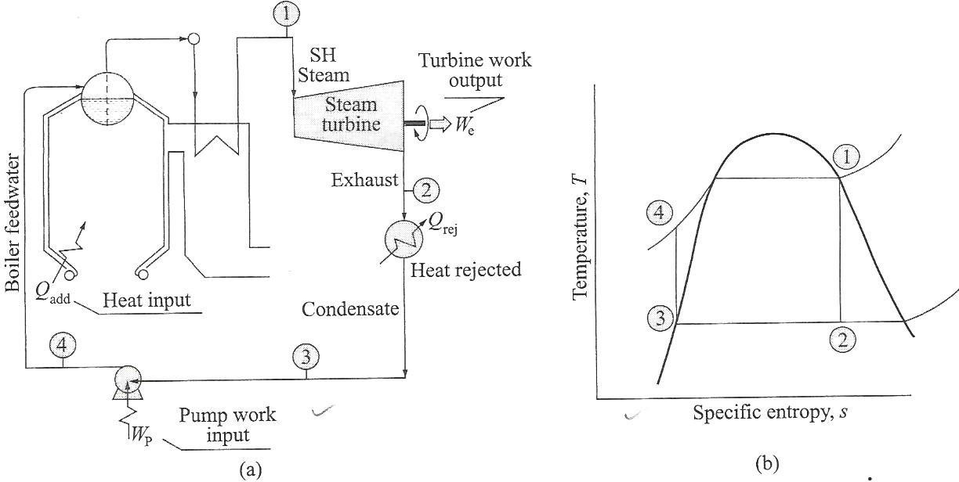

Fig.1 Schematic layout of Rankine cycle

Process 4-1:

Heat is added in the boiler to the BFW, which is a constant pressure process generating a dry, saturated steam at saturation temp. corresponding to the boiler operating pressure,

Q add = m(h₁ - h₄)

Process 1-2:

The steam is reversibly and adiabatically expanded in the turbine.

So, turbine work input = We = m (h₁ - h₂)

Process 2-3:

Constant pressure heat rejection in the condenser. The cooling water extracts the latent heat of condensation from the exit steam exhausted to the condenser. The condensation is complete. The entire vapour is converted into a condensate.
Therefore heat rejection = m (h₂ - h₃)

Process 3-4:

Pump work. This work must be apportioned from the turbine output.
Wp = m(h₄ - h₃)
Net work output, Wnet = We - Wp

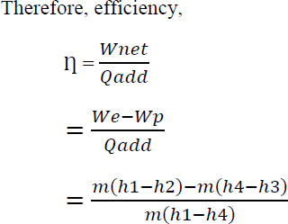

RANKINE CYCLE WITH SUPERHEATED STEAM:
If the heating of the working fluid (BFW) is continued beyond the dry saturation point, i.e well into superheat regime before feeding it to the turbine, i.e; state instead of state 1 , the amount of heat added increase bringing about an incipient increase in the work output
So, superheating begets a higher cycle efficiency.

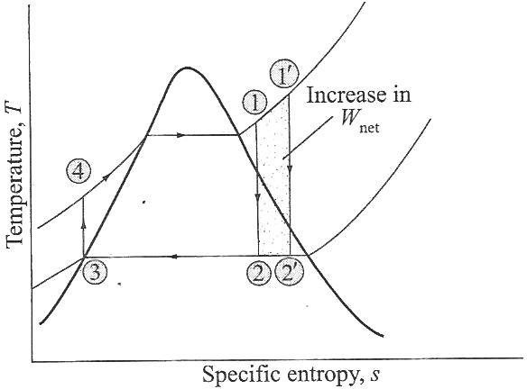

Fig.2 Rankine cycle for Super heated Steam

CONCEPT OF MEAN TEMPERATURE OF HEAT ADDITION:

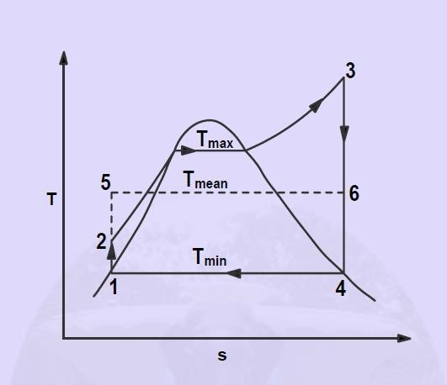

Fig.4 Mean Temperature of Heat Addition

Note:

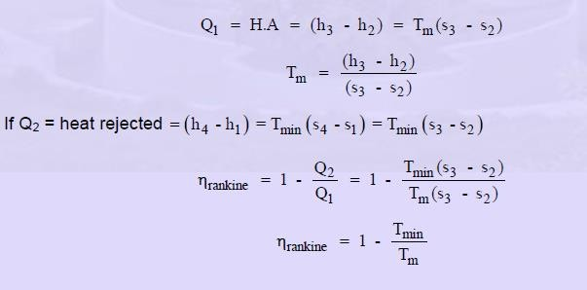

METHODS TO IMPROVE CYCLE PERFORMANCE:
There are three ways to increase the efficiency of the simple ideal Rankine cycle.

Decreasing the condenser pressure:

The effect of lowering the condenser pressure on the Rankine cycle efficiency is illustrated on a T-s diagram on the left. Steam exits as a saturated mixture in the condenser at the saturation temperature corresponding to the pressure in the condenser. So lower the pressure in the condenser, lower the temperature of the steam, which is the heat rejection temperature. The blue area is the net work increases due to the decreasing of the condenser pressure.

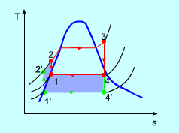

Fig.5 The Effect of Lowing the Condenser Pressure

- Superheating the steam to a high temperature:

The effect of superheating the steam to a high temperature on the Rankine cycle efficiency is illustrated on a T-s diagram on the left. By superheating the stream to a high temperature (from state 3 to state 3'), the average steam temperature during heat addition can be increased. The blue area is the network increased due to superheating the steam to a high temperature.
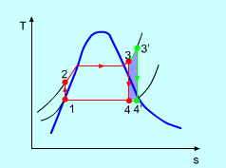

Fig.6 The Effect of Superheating the Steam to a Higher Temperature

- Increasing the boiler pressure:

The effect of increasing the boiler pressure on the Rankine cycle efficiency is illustrated on a T-s diagram on the left. If the operating pressure of the boiler is increased, (process 2-3 to process 2'-3'), then the boiling temperature of the steam raises automatically. For a fixed inlet turbine temperature, the blue area is the network increased and the gray area is the network decreased. Also, the moisture content of the steam

increases from state 4 to state 4', which is an undesirable side effect. This side effect can be corrected by reheating the steam, and results in the reheat Rankine cycle.
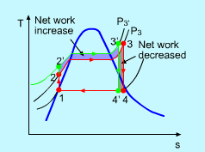

Fig.7 The Effect of Increase the Boiler Pressure

REHEAT CYCLE:
- The efficiency of the Rankine cycle can increase by expanding the steam in the turbine in two stages, and reheat it in between.
- In other words, modify the simple ideal Rankine cycle with reheat process.

- Reheating is a practical solution to the excessive moisture problem in turbines, and it is commonly used in modern steam power plants.

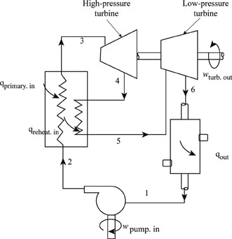

Fig.8 Schematic of Reheat cycle

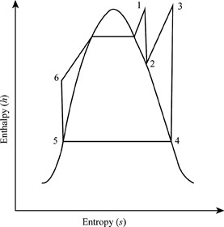
The processes of reheat rankine cycle are explained below using the enthalpy-entropy diagram.

Fig.9 h-s Diagram of Reaheat cycle

Process 1-2
This process is known as high pressure turbine.

Obtain the work-done by turbine using enthalpies of inlet and exit.
Where, h₁ is the enthalpy for inlet state 1 and h₂ is the enthalpy for outlet state 2.
To find the values of h₁ and h₂, use the given values of pressure and temperature at point 1 to calculate first entropy at state 1(S₁) and enthalpy (h₁) from the superheated steam table.
Next to find the variable is dryness fraction to calculate the value of entropy at exit state 2 (S₂) with the given formula.
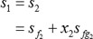
Write the formula for enthalpy at exit state 2.
Process 2-3
This process is known as boiler.
In this process calculate the values of h₃ and S₃. Process 3-4
This process is known as low pressure turbine. In this process calculate the values of h₄ and S₄. Where, S₄ is the entropy at state 4.
Process 4-5
This process is known as condenser.
In this process calculate the heat expelled from condenser.
Process 5-6
This process is known as pump.
In this process work done is calculated by the pump.
Where, h₆ is the enthalpy at state 6. Process 6-1
This process is known as boiler.
In this process obtain the heat supplied.

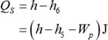
Where, h₅ is the enthalpy at state 5.

RANKINE CYCLE WITH REGENERATION:
Internal heat is exchanged between the expanding fluid (steam) in the turbine and compressed fluid (water) before heat addition. The aim is to increase the cycle efficiency .Heat exchanged in turbine is not practical, hence feed water heating. The compressed water out of the pump is heated in a number of steps rather than continuously, by steam bled from the turbine at selected stage .These heat exchangers are called feed water heaters (F.W.H).
TYPES OF F.W.H:
- Open or direct contact F.W.H.
- Closed with drains cascaded backward.
- Closed with drain pumps forward.
A careful examination of the T-s diagram of the Rankine cycle redrawn in Fig below reveals that heat is transferred to the working fluid during process 2-2' at a relatively low temperature. This lowers the average heat addition temperature and thus the cycle efficiency.
To remedy this shortcoming, we look for ways to raise the temperature of the liquid leaving the pump (called the feedwater) before it enters the boiler. One such possibility is to transfer heat to the feedwater from the expanding steam in a counterflow heat exchanger built into the turbine, that is, to use regeneration. This solution is also impractical because it is difficult to design such a heat exchanger and because it would increase the moisture content of the steam at the final stages of the turbine.
A practical regeneration process in steam power plants is accomplished by extracting, or “bleeding,” steam from the turbine at various points. This steam, which could have produced more work by expanding further in the turbine, is used to heat the feedwater instead. The device where the feedwater is heated by regeneration is called a regenerator, or a feedwater heater (FWH).
Regeneration not only improves cycle efficiency, but also provides a convenient means of deaerating the feedwater (removing the air that leaks in at the condenser) to prevent corrosion in the boiler. It also helps control the large volume flow rate of the steam at the final stages of the turbine (due to the

large specific volumes at low pressures). Therefore, regeneration has been used in all modern steam power plants since its introduction in the early 1920s.
A feedwater heater is basically a heat exchanger where heat is transferred from the steam to the feedwater either by mixing the two fluid streams (open feedwater heaters) or without mixing them (closed feedwater heaters).
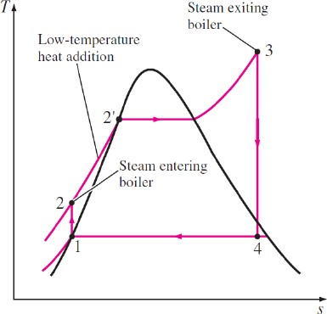
Fig.10 T-S diagram of Regeneration cycle Advantages of Regenerative cycle over Simple Rankine cycle :
- The heating process in the boiler reduced.
- The thermal stresses set up in the boiler are minimized. This is due to the fact that temperature ranges in the boiler are reduced.
- The thermal efficiency is improved because the average temperature of heat addition to the cycle is increased.
- A small size condenser is required.
Disadvantages:
- The plant becomes more complicated.
- Because of addition of heaters greater maintenance is required.
- The heaters are costly and the gain in thermal efficiency is not much in comparison to the heavier costs.
Rankine cycle with Open Feed water Heaters:

An open (or direct-contact) feed water heater is basically a mixing chamber, where the steam extracted from the turbine mixes with the feed water exiting the pump. Ideally, the mixture leaves the heater as a saturated liquid at the heater pressure. The schematic of a steam power plant with one open feed water heater (also called single-stage regenerative cycle) and the T-s diagram of the cycle are shown in Fig. 11. In an ideal regenerative Rankine cycle, steam enters the turbine at the boiler pressure (state 5) and expands isentropically to an intermediate pressure (state 6). Some steam is extracted at this state and routed to the feed water heater, while the remaining steam continues to expand isentropically to the condenser pressure (state 7). This steam leaves the condenser as a saturated liquid at the condenser pressure (state 1). The condensed water, which is also called the feed water, then enters an isentropic pump, where it is compressed to the feed water heater pressure (state 2) and is routed to the feed water heater, where it mixes with the steam extracted from the turbine.
The fraction of the steam extracted is such that the mixture leaves the heater as a saturated liquid at the heater pressure (state 3). A second pump raises the pressure of the water to the boiler pressure (state 4). The cycle is completed by heating the water in the boiler to the turbine inlet state (state 5).
In the analysis of steam power plants, it is more convenient to work with quantities expressed per unit mass of the steam flowing through the boiler. For each 1 kg of steam leaving the boiler, y kg expands partially in the turbine and is extracted at state 6. The remaining (1 - y) kg expands completely to the condenser pressure. Therefore, the mass flow rates are different in different components.
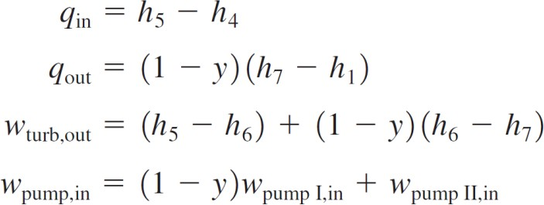
If the mass flow rate through the boiler is m, for example, it is (1 - y)m through the condenser. This aspect of the regenerative Rankine cycle should be considered in the analysis of the cycle as well as in the interpretation of the areas on the T-s diagram. In light of Fig. 11, the heat and work interactions of a regenerative Rankine cycle with one feed water heater can be expressed per unit mass of steam flowing through the boiler as follows:

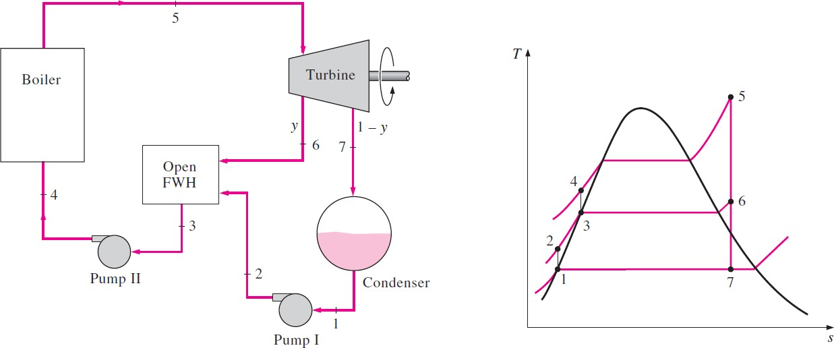

Fig.11 The ideal regenerative Rankine cycle with an open feedwater heater.

Where,
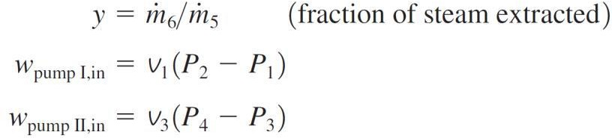

The thermal efficiency of the Rankine cycle increases as a result of regeneration. This is because regeneration raises the average temperature at which heat is transferred to the steam in the boiler by raising the temperature of the water before it enters the boiler. The cycle efficiency increases further as the number of feed water heaters is increased. Many large plants in operation today use as many as eight feed water heaters. The optimum number of feed water heaters is determined from economic considerations. The use of an additional feed water heater cannot be justified unless it saves more from the fuel costs than its own cost.

BOILERS:

- A boiler (or steam generator) is a closed vessel in which water, under pressure, is converted into steam. The heat is transferred to the boiler by all three modes of heat transfer i.e. conduction, convection and radiation.
- Major types of boilers are: (i) fire tube boiler and (ii) water tube boiler
Based on Pressures of operation: (i) High Pressure boiler and (ii) Low Pressure boiler
- Generally water tube boilers are used for electric power stations.

Differences Between Low Pressure boiler, High Pressure boiler:
S.NO | HIGH PRESSURE BOILER | LOW PRESSURE BOILER
1. | In this type of boilers, steam pressure is above 15 psi. | In this type of boilers, steam pressure never exceeds 15 psi.
2. | Hot water pressure always exceeds 260 psi | Water pressure never exceeds 260 psi
3. | Temperature will always be greater than 250oC250oC | Temperature will never be greater than 250oC250oC.
4 | For the safety due to high working pressures, these boilers are required to be monitored all the time. | Since these boilers work on low working pressure, they don’t need continuous monitoring.
5 | Applications involve production of steam in industries and in power plant | These are used for water heating and steam from it used to heat rooms.
6 | For similar size, the output is relatively high. | For similar size, the output is relatively less.
7 | High maintenance is required | Low maintenance required
8 | Operating costs are relatively higher | Operating costs are relatively low.

BOILER MOUNTINGS AND ACCESSORIES:

Boiler Mounting:
Boiler Mountings are the components generally mounted on the surface of the boiler to have safety during operation. These are the essential parts of the boiler, without which the boiler operation is not possible. The following are the important mountings of the boiler:
  - Water level indicator
  - Safety valve
  - Pressure gauge
  - Steam stop valve
  - Feed check valve
  - Main hole
- Water level indicator: this device indicates the exact level of water in the boiler tube.
- Safety valve: it is a mechanical device used to safeguard the boiler, in case the pressure inside the boiler rises above its normal working atmosphere.
- Pressure gauge: the pressure gauge commonly used is the bourdon pressure gauge mounted on the front top of the boiler shell.
- Steam stop valve: the function of the steam stop valve is to stop or open the steam supply from the boiler to the point of application.
- Feed check valve: a valve placed at the boiler end to regulate the flow of water.
- Main hole: it is the opening provided of cleaning or inspection.

Boiler Accessories:
These are those devices which are installed with a boiler and its neighbouring area to increase the efficiency of the boiler. These are not the essential part of the boiler and thus without installing these devices, the boiler operation can be accomplished though at a lower efficiency. The following are the important accessories of the boiler are:
  - Feed water pump
  - Injector
  - Pressure reducing valve
  - Economiser
  - Air pre heater

  - Super heater
  - Steam drier or separator
  - Steam trap
- Feed water pump: the feed water pump is used to feed water to the boiler.
- Injector: function of the injector is the same as that of feed pump i.e.; to deliver feed water to boiler under pressure.
- Pressure reducing valve: the function of the pressure reducing valve is to maintain constant pressure on its delivery side of the valve irrespective of fluctuating demand of steam from the boiler.
- Economiser: a considerable quantity of heat of the plant is carried away by flue gases, so to utilise these waste heat. An economiser is placed in the path of the flue gases to preheat the feed water.
- Air pre – heater: the function of the pre- heater is to heat the air before it enters the combustion chamber.
- Super heater: super pre-heater is used for stationary boiler. The function of the super heater is to convert dry saturated steam into super-heated at the desired temperature.
- Steam drier: the function of the steam drier or separator is to separate water particles from steam before it is supplied to the point of application.

DRAUGHT:
- The combustion in the boiler requires supply of sufficient quality of air and removal of exhaust gases
- The Circulation of air is caused by difference of pressure is known as draught. Thus draught is the differential in pressure between the two points.
A draught tube may be
  - Natural Draught
  - Mechanical Draught

Natural Draught:
- A natural Draught is provided by the chimney or stack.
- Natural draught has its limitation. Modern plants has high rate of heat transfer and Draught losses are very high. In view of this Natural draught is used only for small boilers.

Mechanical Draught:

Modern large size plants use very large size of boilers of capacity above 1000,000 kg per hour. Such boiler needs tremendous volume of air (around 200000 m3) per minute. A Chimney provides this. Therefore mechanical draught is used.
- In a mechanical draught the system the movement air is due to the action of fan. A Mechanical Draught consists of forced Draught or induced draught or both.
- In forced draught system the fan is installed near the boiler .the fan force the air through the furnace, economizer, air preheater and chimney. The pressure of air, throughout the system, is above atmospheric and air is forced to flow through the system.
- In an induced draught system the, the fan is installed near the base of the chimney .The burnt gases are sucked out from the boiler, thus reducing the pressure inside the boiler. To less than atmosphere. This induces fresh air to enter the furnace.
- A mechanical Draught need additional capital investment and maintenance. But it required for proper operation of modern power plant. In super thermal power plant, each boiler may use two forced fans and two induced fan.

STEAM NOZZLES AND TURBINES

Flow of steam through nozzles :
- The flow of steam through nozzles may be regarded as adiabatic expansion.
- The steam has a very high velocity at the end of the expansion, and the enthalpy decreases as expansion takes place.
- Friction exists between the steam and the sides of the nozzle; heat is produced as the result of the resistance to the flow.
- The phenomenon of super saturation occurs in the flow of steam through nozzles. This is due to the time lag in the condensation of the steam during the expansion.

Types of Nozzles:
- Convergent Nozzle
- Divergent Nozzle
- Convergent-Divergent Nozzle

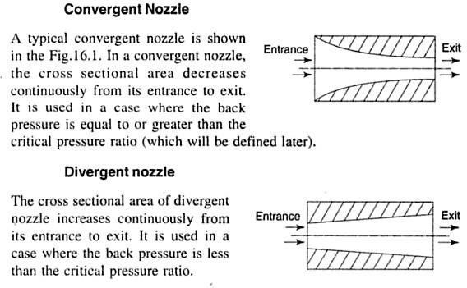

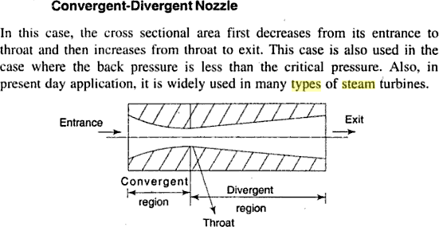
-
Supersaturated flow or Metastable flow in Nozzles :
As steam expands in the nozzle, its pressure and temperature drop, and it is expected that the steam start condensing when it strikes the saturation line. But this is not always the case. Owing to the high velocities, the residence time of the steam in the nozzle is small, and there may not sufficient time for the necessary heat transfer and the formation of liquid droplets. Consequently, the condensation of steam is delayed for a little while. This phenomenon is known as supersaturation, and the steam that exists in the wet region without containing any liquid is known as supersaturated steam.
The locus of points where condensation will take place regardless of the initial temperature and pressure at the nozzle entrance is called the Wilson line. The Wilson line lies between 4 and 5 percent moisture curves in the saturation region on the h-s diagram for steam, and is often approximated by the 4 percent moisture line. The supersaturation phenomenon is shown on the h-s chart below:

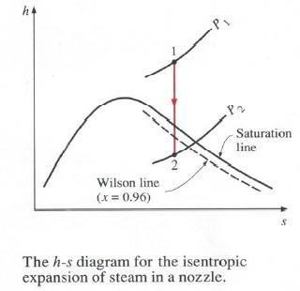

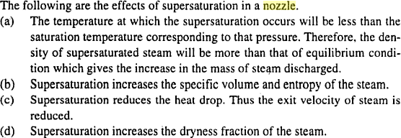
Effects of Supersaturation:

Critical Pressure Ratio:
The critical pressure ratio is the pressure ratio which will accelerate the flow to a velocity equal to the local velocity of sound in the fluid.
Critical flow nozzles are also called sonic chokes. By establishing a shock wave the sonic choke establish a fixed flow rate unaffected by the differential pressure, any fluctuations or changes in downstream pressure. A sonic choke may provide a simple way to regulate a gas flow.
The ratio between the critical pressure and the initial pressure for a nozzle can expressed as pc / p1 = ( 2 / (n + 1) )^{n} / ^{(n} – ¹⁾
where
pc = critical pressure (Pa) p1 = inlet pressure (Pa)

n = index of isentropic expansion or compression – or polytropic constant
For a perfect gas undergoing an adiabatic process the index – n – is the ratio of specific heats – k
= cp / cv. There is no unique value for – n. Values for some common gases are

  - Steam where most of the process occurs in the wet region : n = 1.135
  - Steam superheated : n = 1.30
  - Air : n = 1.4
  - Methane : n = 1.31
  - Helium : n = 1.667

Effect of Friction on Nozzles:
- Entropy is increased.
- Available energy is decreased.
- Velocity of flow at throat is decreased.
- Volume of flowing steam is decreased.
- Throat area necessary to discharge a given mass of steam is increased.
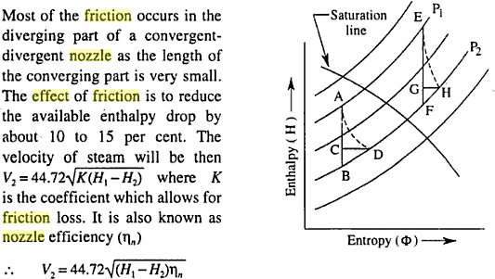

Velocity of steam at nozzle exit:
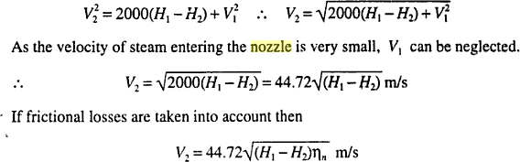

Mass of steam discharged through a nozzle:
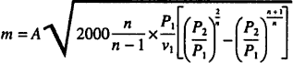

Condition for maximum discharge through nozzle:
The nozzle is always designed for maximum discharge
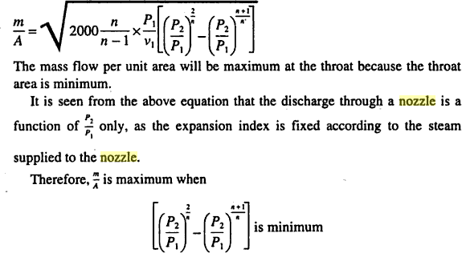

Values for maximum discharge:

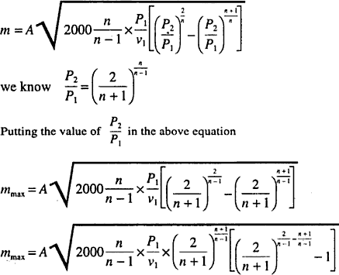

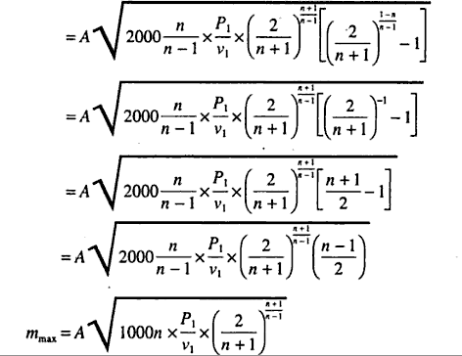

Where P1 is the initial pressure of the steam in kpa and v1 is the specific volume of the steam in m³/kg at the initial pressure.

Sample Problems on Steam Nozzle:

- Steam at pressure of 1.5 Mpa and temperature of 260ºC expands isentropically in a steam nozzle to a pressure 500 kPa with an actual enthalpy drop of 200 Kj/kg. If the nozzle outlet area is approximately 4 cm² and mass flow rate is 10 kg/s, calculate the number of nozzles required and adjust the
outlet dimensions to suit this number.

- Dry saturated steam at 10 bar pressure enters a convergent nozzle which is having 10mm throat diameter and 12 mm divergent portion length. Determine the diameter at the nozzle exit and cone angle of the divergent portion so that the steam may leave at 1 bar pressure. Assume the effects of Friction are negligible.

- Steam at pressure of 22 bar and temperature 300ºC is supplied to a group of five nozzles at the rate of 4.5 kg/s. The exit pressure of steam is 3 bar. Determine the following:

  - The dimensions of the nozzles of rectangular cross section with an aspect ratio of 3:1. Neglect the friction effect and assume the expansion is metastable.
  - Degree of Under cooling and Supersaturation.
  - The loss in available heat drop due to irreversibility
  - Change in entropy

