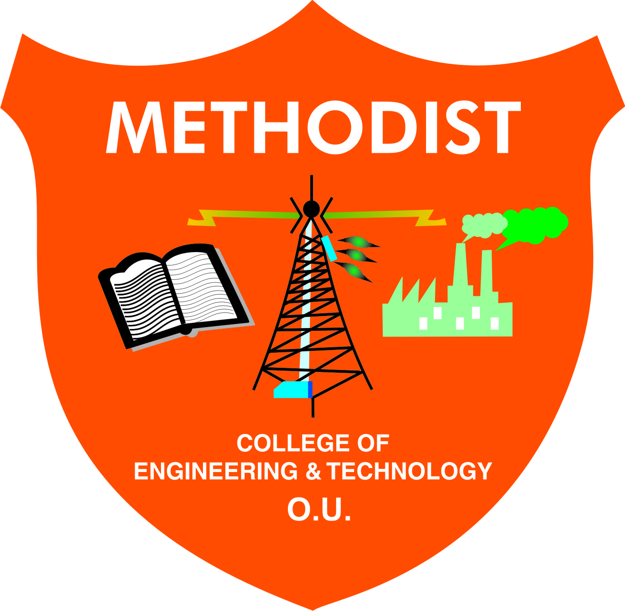
METHODIST COLLEGE OF ENGINEERING & TECHNOLOGY
King Koti, Abids, Hyderabad
Academic Calendar for I SEM of A.Y-2015-16
S. No | Date | Day | Event
 | 20-07-2015 | Monday | Commencement of Class work
 | 08-08-2015 | Saturday | Completion of unit 1
 | 10-08-2015 | Monday | Bonalu - Holiday
 | 26-08-2015 | Wednesday | Completion of unit 2
 | 05-09-2015 | Saturday | Teachers Day Celebrations
 | 07-09-2015 to 09-09-2015 | Monday  To Wednesday | Internal Test I
 | 15-09-2015 | Tuesday | Engineers Day Celebrations
 | 17-09-2015 | Thursday | Vinayaka Chavithi - Holiday
 | 23-09-2015 | Wednesday | Completion of unit 3
 | 24-09-2015 | Thursday | Bakrid - Holiday
 | 02-10-2015 | Friday | Gandhi Jayanthi - Holiday
 | 12-10-2015 | Monday | Bathukamma Festival - Holiday
 | 13-10-2015 | Tuesday | Completion of unit 4
 | 21-10-2015 | Wednesday | Durgastami - Holiday
 | 22-10-2015 | Thursday | Dasara - Holiday
 | 24-10-2015 | Saturday | Muhurram - Holiday
 | 28-10-2015 | Wednesday | Completion of unit 5
 | 29-10-2015 to 31-10-2015 | Thursday  To Saturday | Internal Test - II
 | 06-11-2015 | Friday | Display of Internal Marks on or Before
 | 07-11-2015 | Saturday | Last Day of Instructions
 | 09-11-2015 to 28-11-2015 | Monday  To Saturday | Preparation Holidays & Practical Exams
 | 11-11-2015 | Wednesday | Deepavali - Holiday
 | 30-11-2015 onwards | Monday | Commencement of Theory Examinations
 | 04-01-2016 | Monday | Commencement of II SEM Class Work

Director

METHODIST COLLEGE OF ENGINEERING & TECHNOLOGY
King Koti, Abids, Hyderabad
Academic Calendar for I SEM of A.Y-2016-17
S. No | Date | Day | Event
 | 11-07-2016 | Monday | Commencement of Class work
 | 29-07-2016 | Friday | Completion of Unit 1
 | 16-08-2016 | Tuesday | Completion of Unit 2
 | 25-08-2016 | Thursday | Sree Krishna Asthami - Holiday
 | 29-08-2016 to 31-08-2016 | Monday  To Wednesday | Internal Test - I
 | 05-09-2016 | Monday | Vinayaka Chavithi - Holiday
 | 06-09-2016 | Tuesday | Completion of Unit 3
 | 12-09-2016 | Monday | Bakrid - Holiday
 | 15-09-2016 | Thursday | Engineers Day Celebrations
 | 23-09-2016 | Friday | Completion of Unit 4
 | 30-09-2016 | Friday | Bathukamma Starting Day - Holiday
 | 07-10-2016 | Friday | Completion of Unit 5
 | 11-10-2016 | Tuesday | Dussehra - Holiday
 | 12-10-2016 | Wednesday | Moharam - Holiday
 | 20-10-2016  To 22-10-16 | Thursday  To Saturday | Internal Test - II
 | 28-10-2016 | Friday | Display of Internal Marks on or Before
 | 31-10-2016  To 19-11-2016 | Monday  To Saturday | Preparation Holidays & Practical Examinations
 | 21-11-2016 | Monday | Commencement of Theory Examinations
 | 02-01-2017 | Monday | Commencement of II SEM Class Work

Director

METHODIST COLLEGE OF ENGINEERING & TECHNOLOGY
King Koti, Abids, Hyderabad
Academic Calendar for I SEM of A.Y-2019-20
S. No | Date | Day | Event
 | 08-07-2019 | Monday | Commencement of Class Work
 | 27-07-2019 | Saturday | Completion of Unit 1
 | 29-07-2019 | Monday | Bonalu -Holiday
 | 12-08-2019 | Monday | Bakrid -Holiday
 | 15-08-2019 | Thursday | Independence day
 | 23-08-2019 | Friday | Completion of Unit 2
 | 24-08-2019 | Saturday | Sri Krishna Astami-Holiday
 | 28-08-2019  To 31-08-2019 | Wednesday  To Saturday | Continuous Internal Evaluation - I (CIE)
 | 02-09-2019 | Monday | Vinayaka Chavithi - Holiday
 | 05-09-2019 | Thursday | Teachers Day Celebrations
 | 09-09-2019 | Monday | Completion of Unit 3
 | 10-09-2019 | Tuesday | Moharram -Holiday
 | 15-09-2019 | Sunday | Engineers Day Celebrations
 | 27-09-2019 | Friday | Completion of Unit 4
 | 28-09-2019 | Saturday | Batukamma - Holiday
 | 02-10-2019 | Wednesday | Gandhi Jayanthi - Holiday
 | 07-10-2019  To 13-10-2019 | Monday  To Sunday | Dussara Vacation
 | 19-10-2019 | Saturday | Completion of Unit 5
 | 02-11-2019 | Saturday | Last date of Instruction
 | 06-11-2019  To 09-11-2020 | Wednesday  To Saturday | Continuous Internal Evaluation - II (CIE)
 | 14-11-2019 | Thursday | Display of Sessional Marks
 | 11-11-2019  To 23-11-2019 | Monday  To Saturday | Preparation Holidays & Practical Examinations
 | 25-11-2019 | Monday | Commencement of Theory Examinations
 | 30-12-2019 | Monday | Commencement of II SEM Class Work

Director

METHODIST COLLEGE OF ENGINEERING & TECHNOLOGY
King Koti, Abids, Hyderabad
Academic Calendar for I SEM of A.Y-2017-18
S. No | Date | Day | Event
 | 11-07-2017 | Monday | Commencement of Class Work
 | 01-08-2017 | Tuesday | Completion of Unit 1
 | 15-08-2017 | Tuesday | Independence day
 | 22-08-2017 | Tuesday | Completion of Unit 2
 | 02-09-2017 | Saturday | Eidul - Holiday
 | 05-09-2017 | Tuesday | Teachers Day Celebrations
 | 11-09-2017  To 13-09-2017 | Monday  To Wednesday | Continuous Internal Evaluation - I (CIE)
 | 15-09-2017 | Friday | Engineers Day Celebrations
 | 18-09-2017 | Saturday | Completion of Unit 3
 | 25-09-2017  To 30-09-2017 | Monday  To Saturday | Dussara Vacation
 | 01-10-2017 | Sunday | Sunday- Holiday
 | 02-10-2017 | Monday | Gandhi Jayanthi-Holiday
 | 10-10-2017 | Tuesday | Completion of Unit 4
 | 18-10-2017 | Wednesday | Diwali-holiday
 | 03-11-2017 | Friday | Completion of Unit 5
 | 04-11-2017 | Saturday | Gurunanak Jayanthi-Holiday
 | 08-11-2017  To 10-11-2017 | Wednesday  To Friday | Continuous Internal Evaluation - II (CIE)
 | 10-11-2017 | Saturday | Last date of Instruction
 | 17-11-2017 | Friday | Display of Sessional Marks on or Before
 | 13-11-2017  To 02-12-2017 | Monday  To Saturday | Preparation Holidays & Practical Examinations
 | 08-01-2018 | Monday | Commencement of II SEM Class Work

Drector

METHODIST COLLEGE OF ENGINEERING & TECHNOLOGY
King Koti, Abids, Hyderabad
Academic Calendar for I SEM of A.Y-2018-19
S. No | Date | Day | Event
 | 02-07-2018 | Monday | Commencement of Class work
 | Second Week of July 2018 | Any One Working Day | Guest Lecture
 | 04-08-2018 | Saturday | Completion of Unit I
 | 06-08-2018 | Monday | Bonalu - Holiday
 | 15-08-2018 | Wednesday | Independence day
 | 21-08-2018 | Tuesday | Completion of Unit II
 | 22-08-2018 | Wednesday | Bakrid - Holiday
 | 23-08-2018  To 25-08-2018 | Thursday  To Saturday | Continuous Internal Evaluation – 1 (CIE)
 | 03-09-2018 | Monday | Sri Krishna Astami - Holiday
 | 05-09-2018 | Wednesday | Teachers Day Celebrations
 | Second Week of Sep 2018 | Any One Working Day | 1 Day Seminar
 | 12-09-2018 | Wednesday | Completion of Unit III
 | 13-09-2018 | Thursday | Vinayaka Chavithi - Holiday
 | 15-09-2018 | Saturday | Engineers Day Celebrations
 | 21-09-2018 | Friday | Muharram - Holiday
 | 24-09-2018 | Monday | Completion of Unit IV
 | 02-10-2018 | Tuesday | Gandhi Jayanthi - Holiday
 | 09-10-2018 | Tuesday | Bathukamma Starting Day - Holiday
 | 13-10-2018 | Saturday | Completion of Unit V
 | 15-10-2018  To 20-10-2018 | Monday  To Saturday | Dasara Vacation (short term)
 | 22-10-2018, To 24-10-2018 | Monday  To Thursday | Continuous Internal Evaluation – 2 (CIE)
 | Last Week of Oct 2018 | Any Two Working Days | 2 Days Workshop
 | 27-10-2018 | Saturday | Last date of Instructions
 | 29-10-2018  To 17-11-2018 | Monday  To Saturday | Preparation Holidays & Practical Examinations
 | 05-11-2018 | Monday | Display of Sessional Marks on or before
 | 19-11-2018 | Monday | Commencement of Theory Examinations
 | 24-12-2018 | Monday | Commencement of II SEM Class Work

Director

METHODIST COLLEGE OF ENGINEERING & TECHNOLOGY
King Koti, Abids, Hyderabad
DEPARTMENT OF MECHANICAL ENGINEERING
Academic Calendar for II SEM of A.Y-2015-16
S. No | Date | Day | Event
 | 04-01-2016 | Monday | Commencement of Class work
 | 14-01-2016  To 16-01-2016 | Thursday  To Saturday | Sankranthi - Holiday
 | 26-01-2016 | Tuesday | Republic day
 | 28-01-2016 | Thursday | Completion of Unit 1
 | 13-02-2016 | Saturday | Completion of Unit 2
 | 25-02-2016 To 27-02-2016 | Thursday  To Saturday | Internal Test I
 | 02-03-2016 | Wednesday | Completion of Unit 3
 | 02-03-2016 To 03-03-2016 | Wednesday  To Thursday | International Conference
 | 07-03-2016 | Monday | Maha Shivaratri - Holiday
 | 21-03-2016 | Monday | Completion of Unit 4
 | 23-03-2016 | Wednesday | Holi - Holiday
 | 25-03-2016 | Friday | Good Friday - Holiday
 | Last Week of Mar 2016 | Two Days | Metheric Utsav Followed by Annual Day
 | 05-04-2016 | Tuesday | Babu Jagjivan Ram’s Birthday - Holiday
 | 08-04-2016 | Friday | Ugadi - Holiday
 | 12-04-2016 | Tuesday | Completion of Unit - 5
 | 14-04-2016 | Thursday | Dr. B.R Ambedkar’s Birthday - Holiday
 | 15-04-2016 | Friday | Sri Rama Navami - Holiday
 | 16-04-2016  To 18-04-2016 | Saturday  To Monday | Internal Test II
 | 25-04-2016 to 07-05-2016 | Monday  To Saturday | Preparation Holidays & Practical Examinations
 | 09-05-2016 | Monday | Commencement of Theory Examinations
 | 14-07-2016 | Saturday | Commencement of Next Academic Year 2016-17, I SEM

Director

METHODIST COLLEGE OF ENGINEERING & TECHNOLOGY
King Koti, Abids, Hyderabad
DEPARTMENT OF MECHANICAL ENGINEERING
Academic Calendar for II SEM of A.Y-2016-17
S. No | Date | Day | Event
 | 02-01-2017 | Monday | Commencement of Classes
 | 13-01-2017 | Friday | Bhogi - Holiday
 | 14-01-2017 | Saturday | Pongal -Holiday
 | 26-01-2017 | Thursday | Republic Day
 | 21-01-2017 | Saturday | Completion of Unit 1
 | 11-02-2017 | Wednesday | Completion of Unit 2
 | 24-02-2017 | Friday | Shivaratri-Holiday
 | 21-02-2017  To 23-02-2017 | Monday  To Wednesday | Internal Test - I
 | 01-03-2017 | Wednesday | Completion of Unit 3
 | 22-03-2017 | Wednesday | Completion of Unit 4
 | 29-03-2017 | Wednesday | Ugadi - Holiday
 | Last Week of Mar 2017 | Two Days | Metheric Utsav Followed by Annual Day
 | 05-04-2017 | Wednesday | Sri Rama Navami / Babu Jagjivan Ram Birthday - Holiday
 | 12-04-2017 | Wednesday | Completion of Unit 5
 | 14-04-2017 | Wednesday | Dr Ambedkar Jayanthi/ Good Friday - Holiday
 | 18-04-2017  To 20-04-2017 | Tuesday  To Thursday | Internal Test - II
 | 22-04-2017 | Saturday | Last date of Instruction
 | 24-04-2017  To 16-05-2017 | Monday  To Tuesday | Preparation Holidays & Practical Examinations
 | 26-04-2017 | Wednesday | Display of Internal Marks on or before
 | 08-05-2017 | Monday | Commencement of Theory Examinations
 | 10-07-2017 | Monday | Commencement of Next A.Y-2020-21, I SEM

Director

METHODIST COLLEGE OF ENGINEERING & TECHNOLOGY
King Koti, Abids, Hyderabad
DEPARTMENT OF MECHANICAL ENGINEERING
Academic Calendar for II SEM of A.Y-2017-18
S. No | Date | Day | Event
 | 08-01-2018 | Monday | Commencement of Class work
 | 15-01-2018 | Monday | Bhogi - Holiday
 | 16-01-2018 | Tuesday | Makara Sankranthi - Holiday
 | 25-01-2018 | Thursday | Completion of Unit 1
 | 26-01-2018 | Friday | Republic day - Holiday
 | 13-02-2018 | Tuesday | Maha shivarathri - Holiday
 | 01-03-2018 | Thursday | Holi- Holiday
 | 02-03-2018 | Friday | Completion of Unit 2
 | 05-03-2018  To 07-03-2018 | Monday  To Wednesday | Continuous Internal Evaluation - I (CIE)
 | Third Week of March 2018 | Any Two Working Days | 2 Day Workshop on CAM
 | 26-03-2018 | Monday | Sri Ramanavami- Holiday
 | 27-03-2018 | Tuesday | Completion of Unit 3
 | 30-03-2018 | Friday | Good Friday- Holiday
 | Last Week of Mar 2018 | Two Days | Metheric Utsav Followed by Annual Day
 | 03-04-2018 | Tuesday | Completion of Unit 4
 | 05-04-2018 | Thursday | Babu Jagjeevanram’s Birthday- Holiday
 | 14-04-2018 | Saturday | Dr. B. R. Ambedkar’s Birthday-holiday
 | 18-04-2018 | Wednesday | Completion of Unit 5
 | 25-04-2018  To 27-04-2020 | Wednesday  To Friday | Continuous Internal Evaluation - II (CIE)
 | 28-04-2018 | Saturday | Last date of Instruction
 | 30-04-2018  To 12-05-2018 | Monday  To Saturday | Preparation Holidays & Practical Examinations
 | 04-05-2020 | Friday | Display of Internal Marks on or before
 | 14-05-2018 | Monday | Commencement of Theory Examinations
 | 02-07-2018 | Monday | Commencement of Next Academic Year 2018-19, I SEM

Director

METHODIST COLLEGE OF ENGINEERING & TECHNOLOGY
King Koti, Abids, Hyderabad
DEPARTMENT OF MECHANICAL ENGINEERING
Academic Calendar for II SEM of A.Y-2018-19
S. No | Date | Day | Event
 | 24-12-2018 | Monday | Commencement of Class Work
 | 25-12-2018 | Tuesday | Christmas - Holiday
 | 26-12-2018 | Wednesday | Boxing Day - Holiday
 | 28-12-2018  To 29-12-2018 | Friday To Saturday | ICPET 2018
 | 01-01-2019 | Tuesday | New Year-Holiday
 | 14-01-2019 | Monday | Bhogi - Holiday
 | 15-01-2019 | Tuesday | Pongal -Holiday
 | 26-01-2019 | Friday | Completion of Unit 1
 | 26-01-2019 | Saturday | Republic Day-holiday
 | 13-02-2019 | Wednesday | Completion of Unit 2
 | 14-02-2019  To 16-02-2019 | Thursday To Saturday | Continuous Internal Evaluation - I (CIE)
 | 01-03-2019 | Tuesday | Completion of Unit 3
 | 04-03-2019 | Monday | Shivaratri-Holiday
 | 16-03-2019 | Saturday | Completion of Unit 4
 | Last Week of March 2019 | Two Days | Metheric Utsav Followed by Annual Day
 | 03-04-2019 | Wednesday | Completion of Unit 5
 | 04-04-2019  To 06-04-2019 | Thursday To Saturday | Continuous Internal Evaluation - II (CIE)
 | 12-04-2019 | Friday | Last date of Instruction
 | 15-04-2019 | Monday | Display of Internal Marks on or before
 | 19-04-2019 | Friday | Good Friday- Holiday
 | 22-04-2019  To 04-05-2019 | Monday To Saturday | Preparation Holidays & Practical Examinations
 | 03-05-2019 | Friday | Submission of CIE marks to OU Exam branch
 | 06-05-2019 | Monday | Commencement of Theory Exams
 | 01-07-2019 | Monday | Commencement of Next A.Y-2019-20, I SEM

Director

METHODIST COLLEGE OF ENGINEERING & TECHNOLOGY
King Koti, Abids, Hyderabad
DEPARTMENT OF MECHANICAL ENGINEERING
Academic Calendar for II SEM of A.Y-2019-20
S. No | Date | Day | Event
 | 06-01-2020 | Monday | Commencement of Classes
 | 14-01-2020 | Tuesday | Bhogi - Holiday
 | 15-01-2020 | Wednesday | Pongal -Holiday
 | 26-01-2020 | Sunday | Republic Day
 | 27-01-2020 | Monday | Completion of Unit 1
 | 13-02-2020 | Thursday | Completion of Unit 2
 | 21-02-2020 | Friday | Shivaratri-Holiday
 | 26-02-2020  To 29-02-2020 | Wednesday to Saturday | Continuous Internal Evaluation - I (CIE)
 | 07-03-2020 | Saturday | Completion of Unit 3
 | 21-03-2020 | Saturday | Completion of Unit 4
 | 07-04-2020 | Tuesday | Completion of Unit 5
 | 08-04-2020  To 11-04-2020 | Wednesday to Saturday | Continuous Internal Evaluation - II (CIE)
 | 11-04-2020 | Saturday | Last date of Instruction
 | 13-04-2020  To 25-04-2020 | Monday to Saturday | Preparation Holidays & Practical Exams
 | 18-04-2020 | Saturday | Display of Internal Marks on or before
 | 27-04-2020 | Monday | Commencement of Theory Exams
 | 29-06-2020 | Monday | Commencement of Next A.Y-2020-21, I SEM

Dean

