**UNIT-V**

**INTRODUCTION TO DSP PROCESSORS**

**Common DSP Applications…**

* Communications
* Audio, Video processing
* Graphics, 3-D rendering
* Navigation, radars, GPS
* Controls – Robotics, guidance, Machine Vision
* Filtering
* Frequency-Time transformations (FFT-IFFT)

**Common DSP Tasks…**

* Modulation-Demodulation, Error correction
* Noise reduction, equalization, echo cancellation
* Audio compression
* Vector and Matrix calculations
* Control algorithms

**DSPs Need to Do…**

* Efficient repetitive numerical calculations
* Maintain numeric fidelity
* Provide high memory bandwidth
  + Streaming data
* Real Time processing

**DSPs Need to Minimize…**

* Real Time execution unpredictability
* Memory use
* Power consumption
* Cost
* Development time

**What Do DSPs Have?**

* Specialized memory architecture (Harvard)
* Specialized parallel execution units
* Specialized addressing modes
* Specialized instruction sets for parallelexecution
* Specialized peripherals



**Von Neumann Architecture**

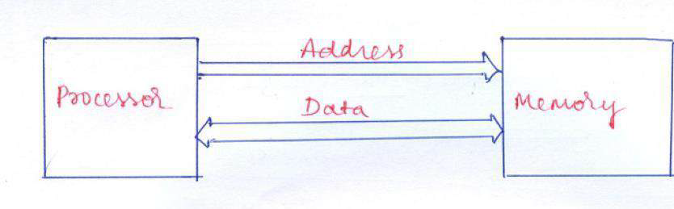

**Harvard Architecture…**

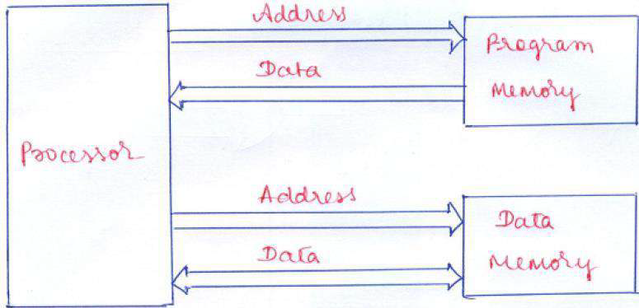

**Harvard Architecture with Dual Data Memory**

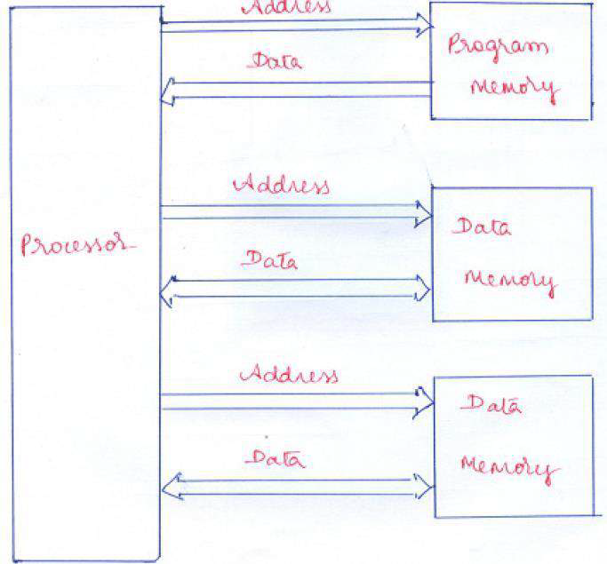





**Summary:**

* **Von Neumann =** Shares the same data bus and the same main memory for transfer storage of instructions and data of the programs.
* Von Neumann is better for desktop computers/high performance computers were cost to performance ratio is important.
* **Harvard =** Uses two separate buses for the transfer of data and instructions and two separate memories for storage of data and instructions.
* Harvard architecture is used primarily for small embedded computers and signal processing. Commonly used within CPUs to handle the cache.

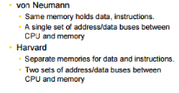

**Main differences**

* Cell sizes used within the main memory are same in Von Neumann. However, Harvard allows for different cell sizes for data/instructions making effective use of resources.
* The programs in Harvard tend to be large.
* Modern computers make use of both Harvard and Von Neumann architecture.
* The main memory is used to store both instructions and data and they are both transferred over the data bus. However, the CPU’s cache has Harvard architecture.
* There is a separate cache memory for instructions and data.
* There is also a separate data bus between these caches.

**Von Neumann Architecture**

**Advantages:**

* Not only data but also instructions of programs are stored within the same memory.
* This makes it easier to re-program the memory.
* Less physical space is required than Harvard
* Handling just one memory block is simpler and easier to achieve
* Cheaper to use than Harvard

**Disadvantages:**

* Shared memory - a defective program can overwrite another in memory, causing it to crash
* Memory leaks - some defective programs fail to release memory when they are finished with it, which could cause the computer to crash due to insufficient memory
* Data bus speed - the CPU is much faster than the data bus, meaning it often sits idle (Von Neumann bottleneck)
* Fetch rate - data and instructions share the same data bus, even though the rate at which each needs to be fetched is often very different
* All memory cell sizes are the same and so can’t be different for instructions/data making it less efficient.

**Harvard Architecture**

**Advantages :**

* There is less chance of corruption since data and instructions are transferred via different buses.
* Data and instructions are accessed in the same way.
* Offers higher performance since Harvard allows for simultaneous fetching of data and instructions - they are kept in separate memory and travel via separate buses
* Both memories can use different cell sizes making effective use of resources.
* Greater memory bandwidth that is more predictable (separate memory for instructions and data)

**Disadvantages:**

* When there is free data memory it cannot be used for instructions and vice versa. Memory dedicated to each must be carefully balanced in manufacture.
* Production of a computer with two buses is more expensive and takes more time to manufacture.
* Harvard architecture has more pins so more complex for main board manufactures to implement.
* Not widely used so more difficult to implement
* Harvard architecture requires a control unit for two buses that is more complicated and development of which is expensive and needs more time.

**VLIW (Very long instruction word)**

* Very long instruction word (VLIW) describes a computer processing architecture  in which a language compiler or pre-processor breaks program instruction down into basic operations that can be performed by the processor in parallel (that is, at the same time).
* Multiple operations per instruction
* Compiler is in control
* Only RISC like operation support
  + Short cycle times
  + Easier to compile for
* Extensible / Scalable
* ***not binary compatible !!***

**What is RISC?**

A reduced instruction set computer is a computer that only uses simple commands that can be divided into several instructions that achieve low-level operation within a single CLK cycle, as its name proposes “Reduced Instruction Set”.

**RISC Architecture**

The term RISC stands for ‘’Reduced Instruction Set Computer’’. It is a CPU design plan based on simple orders and acts fast.

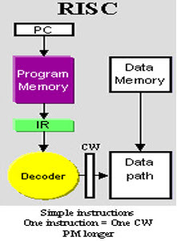

* This is small or reduced set of instructions. Here, every instruction is expected to attain very small jobs.
* In this machine, the instruction sets are modest and simple, which help in comprising more complex commands.
* Each instruction is of a similar length; these are wound together to get compound tasks done in a single operation.
* Most commands are completed in one machine cycle.
* This pipelining is a crucial technique used to speed up RISC machines.

**What is CISC?**

A complex instruction set computer is a computer where single instructions can perform numerous low-level operations like a load from memory, an arithmetic operation, and a memory store or are accomplished by multi-step processes or addressing modes in single instructions, as its name proposes “Complex Instruction Set ”.

**CISC Architecture**

* The term CISC stands for ‘’Complex Instruction Set Computer’’.
* It is a CPU design plan based on single commands, which are skilled in executing multi-step operations.

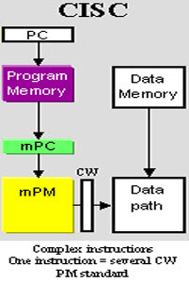

* CISC computers have small programs.
* It has a huge number of compound instructions, which takes a long time to perform.
* Here, a single set of instruction is protected in several steps; each instruction set has additional than 300 separate instructions. Maximum instructions are finished in two to ten machine cycles.
* In CISC, instruction pipelining is not easily implemented.

**Difference between RISC and CISC Architecture**

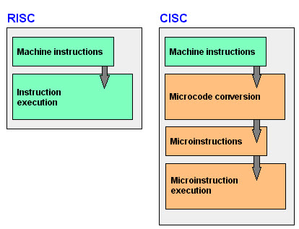

|  |  |
| --- | --- |
| **RISC** | **CISC** |
| 1.  RISC stands for Reduced Instruction Set Computer. | 1. CISC stands for Complex Instruction Set Computer. |
| 2. RISC processors have simple instructions taking about one clock cycle. The average clock cycle per instruction (CPI) is 1.5 | 2. CSIC processor has complex instructions that take up multiple clocks for execution. The average clock cycle per instruction (CPI) is in the range of 2 and 15. |
| 3. Performance is optimized with more focus on software | 3. Performance is optimized with more focus on hardware. |
| 4. It has no memory unit and uses separate hardware to implement instructions.. | 4. It has a memory unit to implement complex instructions. |
| 5. It has a hard-wired unit of programming. | 5. It has a microprogramming unit |
| **6.**The instruction set is reduced i.e. it has only a few instructions in the instruction set. Many of these instructions are very primitive. | **6.**The instruction set has a variety of different instructions that can be used for complex operations. |
| **7.**The instruction set has a variety of different instructions that can be used for complex operations. | **7.**CISC has many different addressing modes and can thus be used to represent higher-level programming language statements more efficiently. |
| 8.Complex addressing modes are synthesized using the software. | 8.CISC already supports complex addressing modes |
| 9.Multiple register sets are present | 9.Only has a single register set |
| 10.RISC processors are highly pipelined | 10.They are normally not pipelined or less pipelined |
| 11. The complexity of RISC lies with the compiler that executes the program | 11. The complexity lies in the microprogram |
| 12. Execution time is very less | 12. Execution time is very high |
| 13. Code expansion can be a problem | 13. Code expansion is not a problem |
| 14. The decoding of instructions is simple. | 14. Decoding of instructions is complex |
| 15. It does not require external memory for calculations | 15. It requires external memory for calculations |
| 16. The most common RISC microprocessors are Alpha, ARC, ARM, AVR, MIPS, PA-RISC, PIC, Power Architecture, and SPARC. | 16. Examples of CISC processors are the System/360, VAX, PDP-11, Motorola 68000 family, AMD, and Intel x86 CPUs. |
| 17. RISC architecture is used in high-end applications such as video processing, telecommunications and image processing. | 17. CISC architecture is used in low-end applications such as security systems, home automation, etc. |

**TMS320C54x Internal Block Diagram**

**Architecture of C54x**

* Fixed Point processor
* Advanced Harvard Architecture, CISC Processor – Separate memory bus structures for program & data.
* High degree of parallelism – Multiply, load/store, add/sub to/from ACC and new address generation can be done simultaneously.
* Powerful Instruction set & most of the operations are of single cycle
* Targeted for portable devices (cellular phones, MP3 players, digital cameras …)

**Bus structure**

Has several address/data buses:

**1. Program Bus (PB):** carries instruction codes & immediate operands from program memory to CPU.

**2. Program Address Bus (PAB):** provides addresses to program memory for both read/write operations.

**3. Data Bus (DB):** carries data between data memory space and CPU.

**4. Data Address Bus (DAB):** provides addresses to access data memory.

**Buses in C54x**

* 8 major 16-bit buses
* 4 program / data buses

1. Program bus, PB

2. Data buses

CB & DB for READ

EB for Write

* 4 address buses • PAB, CAB, DAB & EAB
* All CPU registers, peripheral registers and I/O ports occupy data memory space

**Memory organization**

* Minimum address range of 192K words

– 64K words for program space

– 64K words for data space

– 64K words for I/O space

* ROM, DARAM, SARAM, two way shared RAM
* On-chip Memory Security option
* MMR: 26 CPU regs, peripheral regs and scratch pad RAM block located on data page 0(DP0)

**Central Processing Unit**

* CPU Registers
* 40-bit ALU
* Two 40-bit Acc Regs (AccA & AccB)
* Barrel Shifter Supporting 0-31 bit left shift & 0-16 bit right shift range
* MAC Block
* 16-bit Temp Reg (T)
* 16-bit Transition Reg (TRN)
* Compare, Select and Store Unit (CSSU)
* Exponent Encoder

**Accumulators A & B**

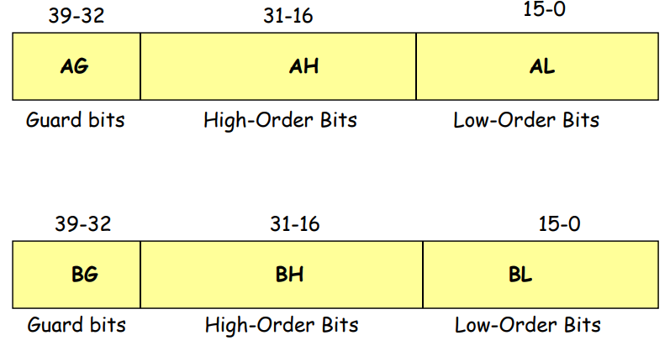

**CPU registers**

* IMR, IFR
* ST0 & ST1
* PMST
* AR0 – AR7(GPRs)
* SP reg
* Circular-Buffer size Register (BK)
* Block-Rep Regs (BRC, RSA and REA)
* PC Extension Reg (XPC)
* ST0,ST1,PMST registers

**Addressing Modes in TMS320C54X Processor**

The method of specifying the operand or the data to be operated by the instruction.

1. Immediate addressing
2. Absolute addressing
3. Accumulator addressing
4. Direct addressing
5. Indirect addressing
6. Memory mapped register addressing
7. Stack addressing

**1) Immediate addressing mode:**

* The data is specified as a part of the instruction.
* Value encoded in the instruction.
* Two types of values:

– Short immediate (3/5/8/9- bit constant)

–Long immediate (16 bits)

* # indicates immediate.

**Example:** • LD #5, ARP; load the immediate 3-bit constant (5h)

• LD #143h, DP; load the immediate 9-bit constant (143h) in DP

• LD #80h, A; 8-bit constant

• LD #1000h, A; 16-bit constant

**2) Absolute Addressing Mode:**

* In this the 16-bit address of the operand is directly
* This addressing can be used to address an operand in all the three address spaces of the processor(i.e. address an operand in program memory, data memory and I/O ports)
* Complete address is specified
* Address is always of 16-bits
* 4 types:

– dmad addressing

– pmad addressing

– PA addressing

– *(lk) addressing

**Example:**

• MVKD SAMPLE,*AR5; dmad addr

• MVDK *AR3, DATA1; dmad addr

• MVPD COEFF, *AR7; pmad addr

• MVPD COEFF, *AR7; pmad addr

• PORTR FIFO, *AR5; PA addr

• LD *(BUFFER), A; *(lk) addr

**3) Accumulator Addressing Mode:**

* In this the contents of accumulator is the address of the operand/data in program memory.
* Use Acc (A/B) contents as address.
* Used to address program memory as data.
* Two instructions:

– READA Smem

– WRITA Smem

**4) Direct Addressing Mode:**

* In this the lower 7 bits of data memory address are specified in the instruction itself.
* The 16-bit data memory address is formed by using either the 9 bits of DP(Data Pointer) in status register-0 or the 16-bit of SP(Stack Pointer)
* When DP is used, the 9 bits of DP is the upper 9 bits of the 16-bit address and the lower 7 bits are the address directly specified by the instruction.
* When SP is used, the 16-bit content of SP is added to 7 bits specified in the instruction to form 16-bit address.

**Example:** ADD 6ch, A; Add the content of memory directly addressed by the

instruction to Accumulator

SUB 57h, B; Subtract the content of memory directly addressed by the

instruction to Accumulator B

**5) Indirect addressing**

* In this the data memory address is specified by the content of one of the eight auxiliary registers, i.e. AR0-AR7
* The AR(Auxiliary Register) currently used for accessing the data is denoted by 3-bit ARP(Auxiliary Register Pointer)
* In this addressing mode, the content of AR can be updated automatically either after or before the operand is fetched.

**Example**: LD *AR3, A ; load the content of memory addressed by AR3 in accumulator A

LD *AR3-, A ; same as above, but after loading decrement AR3

LD *AR3+, A ; same as above, but after loading increment AR3

LD *AR3-0, A ; same as above, but after loading decrement AR3 using AR0

LD *AR3+0, A ; same as above, but after loading increment AR3 using AR0

**6) Memory mapped register addressing**

* In this the address of the memory-mapped register is specified as direct or indirect address in the instruction.

**Example:** LDM 06h, A ; Load the content of MMR directly addressed by the instruction

in accumulator A

STLM A, 1Eh; Store the content of accumulator A in MMR directly addressed

by the instruction

**7) Stack addressing**

* In this the data memory address is the content of Stack Pointer(SP)
* The PUSH and POP instruction access the stack memory using the stack addressing mode.
* The CALL interrupt and RETURN instructions also use stack pointer address for automatic storage/retrieval of information to/from stack.

**Example:** PSHM 1ch; Decrement SP by 2 and push the content of MMR addressed by

the instruction(address=1Ch) to stack memory addressed by SP

POPM 1Ch; POP the top of stack pointed by SP to MMR addressed by the

instruction (address=1Ch), then SP in incremented by 2

**INSTRUCTION SET OF TM320C54X PROCESSORS**

1. Arithmetic instructions
2. Logical instructions
3. Branch/control instructions
4. Load/store instructions
5. Move instructions

**1) Arithmetic instructions**

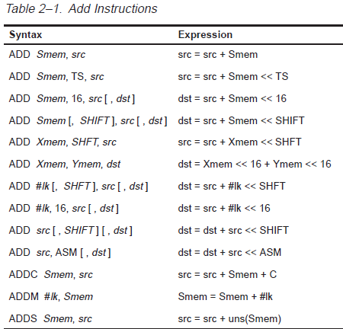

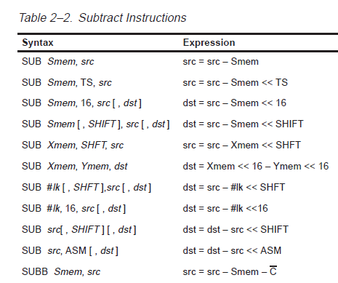

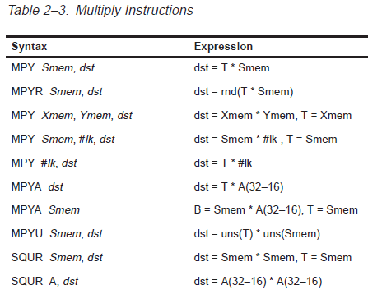

**2) Logical instructions**

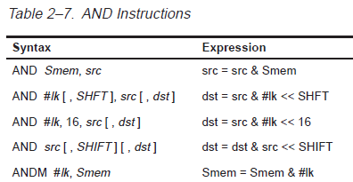

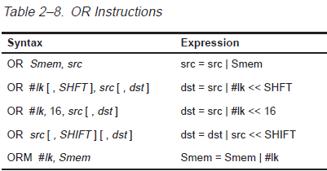

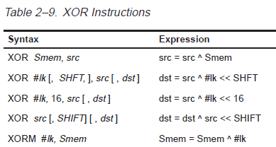

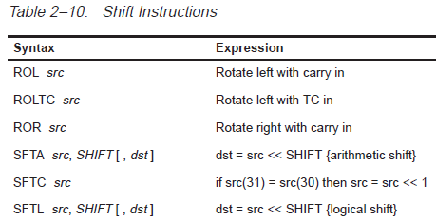

**3) Branch/control instructions**

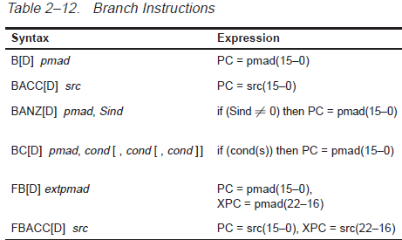

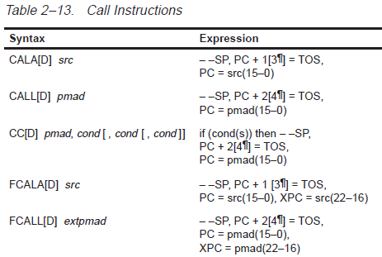

**4) Load/store instructions**

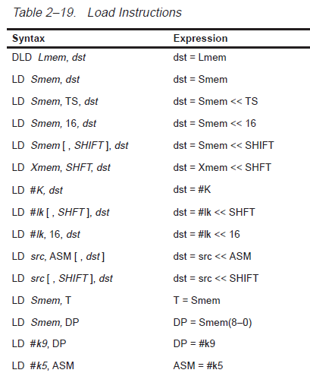

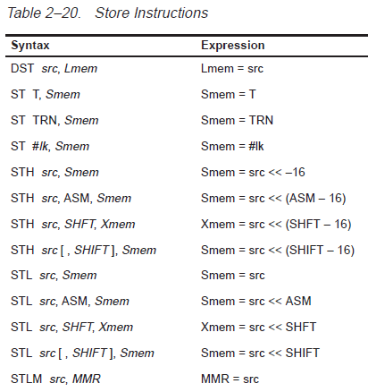

**5) Move instructions**

