UNIT-1

A Horse and Two Goats by R K Narayan: Summary
The short story “A Horse and Two Goats” by R. K. Narayan is set in a fictional small Tamil village named Kritam where the protagonist of the story, Muni, lives. The village consists of less than thirty houses, mostly made of bamboo thatch, straw and mud. Only one house called the Big House, the house of the village chief, is made of brick and cement. Once upon a time, Muni owned a herd of forty sheep and goats. But it is now reduced to just two goats. On the day of the story, Muni takes his usual breakfast of a handful of millet flour and then shakes down drum sticks from the tree in front of his house. When Muni expresses his wish for a drumstick sauce, his wife asks him to bring groceries like dal, spices, oil and potato. He goes to the village shop and makes all efforts to get these things in credit but fails. He comes back home to be humiliated further by his wife and takes the two goats and goes to a place in the outskirts of the village beside the highway to graze his goats. Muni sits under the clay horse statue where he usually sits to protect himself from the sun and watches the trucks. That day he sees a yellow station wagon approaching. The wagon comes and stops in front of the statue. A red faced American, dressed in Khaki, gets out of the wagon and asks in English about the nearest gas station.
As the American notices the horse statue, he gets fascinated by it and starts a discussion with Muni. He offers Muni cigarettes and carries on with the funny conversation where the two of them do not understand each other – Muni speaking in Tamil and the American in English. First Muni assumes the American to be a police man or a soldier and tries to defend himself by saying that he is not involved in the crime that has happened in the nearby village. Then as he finds the American to be friendly by his gestures, he carries on telling his story.Muni ends up telling the stranger how cheetahs or jackals sometimes carry their cattle off. He also tells him that he never went to school, as in those days only Brahmins went to schools. He narrates how the temple priest can see in the camphor flame the face of the thief, and how at the end of the Kali Yuga, the world will be destroyed and the clay horse will come to life and trample down all bad men. Muni also expresses his grudge for the village chief who hasThe American also tells his own story of he being a businessman dealing in coffee and how one day he was forced to work for four hours in his office when there was no electricity or elevators. This incident made him curious to “look at other civilizations”. So, he has come to India to see how people live here. He further adds that his wife has stayed back in Srinagar.
Thinking Muni to be the owner of the horse statue, the American offers a one hundred rupee note to buy it. Realising that some financial element has entered the talk, Muni thinks that the man wants to buy his goats. In fact, he has always dreamt of selling his goats at a good price and setting up a small shop with the money someday. Muni is happy that he has sold his goat for one hundred rupees and the American is happy that he has bought the horse statue.
Muni comes back home to show the money to his wife. She does not believe that he has sold the goats for such a hefty price. She accuses Muni of theft. Her belief of Muni stealing the money gets even stronger when the two goats return home just afterwards.
The title of the story draws attention. By the title “A Horse and Two Goats”, it seems like the horse was also a pet of Muni just like the two goats. But actually it was a clay horse statue. It didn’t even belong to Muni. But due to the miscommunication, it happened so that the American bought the horse statue from Muni thinking him to be the owner. So, the horse statue served Muni more than his goats. Again, it was the horse statue which the man wanted to buy, but Muni thought that he was selling his goats. So the most amusing part of the story lies there in the confusion between the horse and the goats. So, from both the angles the title serves the purpose well.
The greatest themes in the story have been the theme of cultural clash between the East and the West, the theme of poverty and wealth, and finally the theme of knowledge and wisdom. Moreover, it has been a vivid portrayal of rural life in India with hunger and poverty, social classes and caste system, prejudices and superstitions.
USE OF ARTICLES
The English language uses articles to identify nouns. Articles act much like adjectives. Articles clarify whether a noun is specific or general, singular or plural. An article appears before the noun it accompanies.
There are two types of articles Definite article: the, Indefinite article: a, a.
General rules Place the article before the noun. e.g., the house the cat a dog a book Place the article before the adjective when the noun is modified by an adjective.e.g., the purple house the black cat a white dog an open book Correct the house purple or a dog white Incorrect
Do not add an article when the noun has a possessive pronoun (my, his, her, our, their) or a
demonstrative pronoun (this, that). e.g., my house her book that house this book < Correct the my house or the this book Incorrect
DEFINITE ARTICLE: the
Use the to identify specific or definite nouns: nouns that represent things, places, ideas, or persons that can be identified specifically.
Use the with both singular and plural definite nouns.• e.g., the house the houses the business the businesses
Use the to identify things, places, ideas, or persons that represent a specific or definite groupor category.
e.g., The students in Professor Smith’s class should study harder.
The automobile revolutionized travel and industry. (the automobile identifies a specific category of transportation)

INDEFINITE ARTICLE: a or an
Use a or an to identify nouns that are not definite and not specific.
Think of a and an as meaning any or one among many. e.g., a book (any book) a dog (any dog) a cat (one cat) a house (one among many houses)
Use a or an only for singular nouns. Do not use an article for a plural,
indefinite noun.Think of a plural, indefinite noun as meaning all.
e.g., Students should study hard. (All students should study hard.)
When to use a and when to use an
Choose when to use a or an according to the sound of the noun that follows it.
Use a before consonant sounds. e.g., a book a dog
Use a before a sounded h, a long u, and with the sound of w
e.g., a hat a house a union a uniform a one-hour appointment
Use an before vowel sounds (except long u).
e.g., an asset an essay an index an onion an umbrella
Use an when h is not sounded.
e.g., an honor an hour .

Omission of the articles
Before uncountable nouns
We do not use articles before uncountable and abstract nouns used in a general sense.
Honey is sweet. (NOT The honey is sweet.)
Sugar is bad for your teeth.
Wisdom is better than riches.
Virtue is its own reward.
Note that uncountable nouns take the article the when used in a particular sense.
Would you pass the sugar? (= the sugar on the table)
Before plural countable nouns
We do not use articles before plural countable nouns used in a general sense.
Children usually rush about.
Computers are useful machines.
Note that plural nouns take the article the when they are used in a particular sense.
Where are the children? (Which children? Our children)
Before proper nouns
We do not use articles before the names of countries, people, continents, cities, rivers and lakes.
India is a democratic country. (NOT The India …)
Paris is the capital of France. (NOT The Paris …)
Before the names of meals
We do not use articles before the names of meals.
Mother is cooking lunch.
Dinner is ready.
We use a when there is an adjective before breakfast, lunch, dinner etc. We use the when we are talking about a particular meal.
I had a late dinner yesterday.
The lunch we had at the restaurant was very good.
Before languages
We do not use articles before the names of languages.
Can you speak English? (NOT Can you speak the English?)
They speak French at home.
Before school, college, university, church, bed, hospital, prison etc.
His dad is still in hospital.
We learned English at school.
He is at university.
The is used before these words when the reference is to the building or object rather than to the normal activity that goes on there.
I met her at the church. (Here the reference is to the building and not to the activity that is going on there.)
I went to the hospital to see my friend.
PREPOSITIONS
A preposition is a word used to link nouns, pronouns, or phrases to other words within a sentence. They act to connect the people, objects, time and locations of a sentence. Prepositions are usually short words, and they are normally placed directly in front of nouns.

Examples of Prepositions
I prefer to read in the library.
He climbed up the ladder to get onto the roof.
Please sign your name on the dotted line after you read the contract.
Go down the stairs and through the door.
He swam across the pool.
Take your brother with you 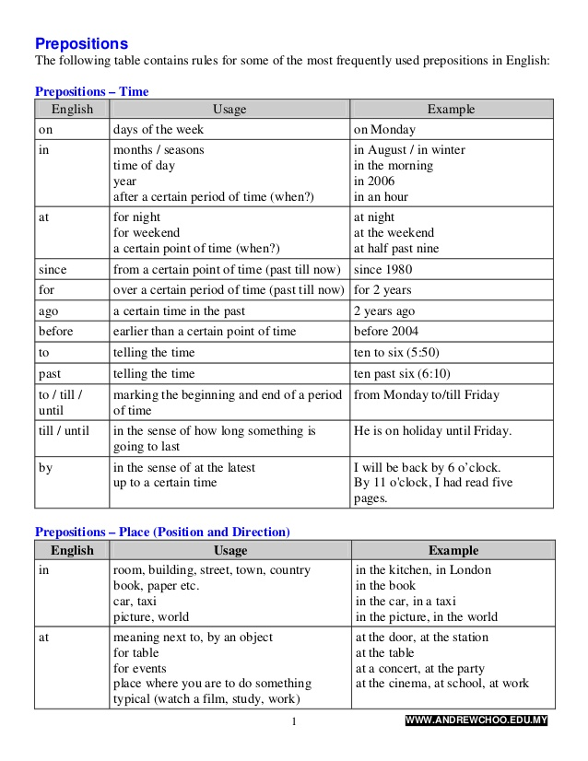
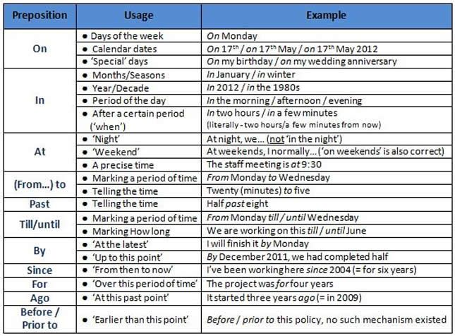
.

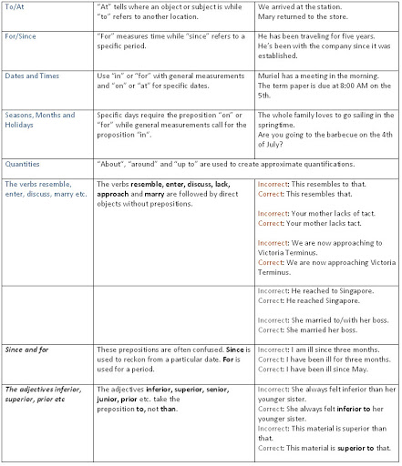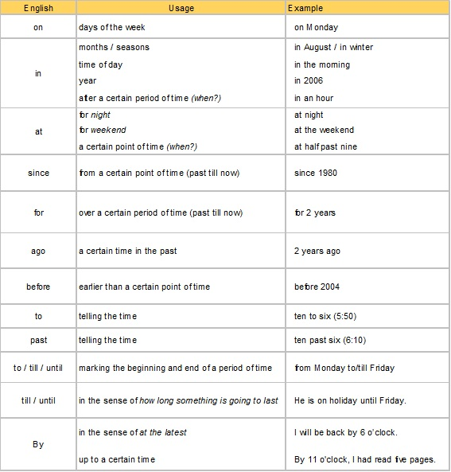

GUIDED WRITING

Write a paragraph on A morning walk using hints given below and your own in 80-100 words.

good for young and old..... refresh mind.... makes us smart and active.... light exercise.... see nature.. birds fly.... flowers lough.... leaves dance... ponds.... canals.... full of water...... running water produces..... sweet music.... regular walk.... enjoy most.

A morning walk is the best exercise. It costs nothing but it is suitable for all. The atmosphere at that time is very cool and refreshing. Everything looks fresh and gay. A cool breeze blows and a walk at that time is really very enjoyable.

I daily go out for a walk. I never miss it and do our without fail. I get up early in the morning. It put on my clothes and go our towards the canal which is at a distance of two kilometers from our house. Atmosphere is very calm and quiet. I pass through the fields. They look charming and fresh.

Developing Hints is developing the phrases into full sentences and not merely filling up dashes.
Develop the following hints into a readable passage and give a suitable title.
A rich farmer - lot of land - cattle and servants - two sons - happy life - After some years younger son unhappy - asked for his share of the property - wouldn't listen to father's advice - got his share - sold them all - went away to another country - fell into bad ways - soon all money gone - poor - no one to help him - understood his mistake.
Answer :
The Disobedient Son
Once there was a rich farmer in a Village. He had a lot of land, cattle and many servants. He had two sons. He led a happy life with them. After some years the younger son became unhappy.
He asked his father for his share of the property. His father advised him not to demand like that. But he would not listen to his father's advice. He got his share and sold them. He had a huge amount with him.
With this amount he travelled to a distant country. He had bad company there and fell into evil ways. All the money was gone. He became poor and no one helped him. Then he understood his mistake and returned to his country. His father and brother took him into their fold and supported him forever. We should obey our parents.

Assignment Questions:

Develop the following hints into a readable passage and give a suitable title.
Dick – actor – brilliant - strange character - insists on realism - headache to the manager - a new drama - first drinking scene - water provided in a cup as usual - Dick insists on liquor - manager has to buy a bottle of liquor - second scene – fight - insists on real swords - refuses to handle wooden swords - steel swords brought - third scene - hero drinks poison - manager has real poison - actor in a fix - promises to be sensible in future.

Develop the following hints into a readable passage and give a suitable title.
Devan - clever thief - robs the rich - gives all to the sick and the needy - other thieves jealous - plan to get rid of him - challenge Devan to steal the King's pyjamas - Devan accepts challenge - finds king sleeping - opens a bottle of red ants on the bed - King badly bitten - cries for help - servants rush in pretends to look for ants - Devan removes King's pyjamas – escapes - other thieves dumbfounded - accept Devan their leader

