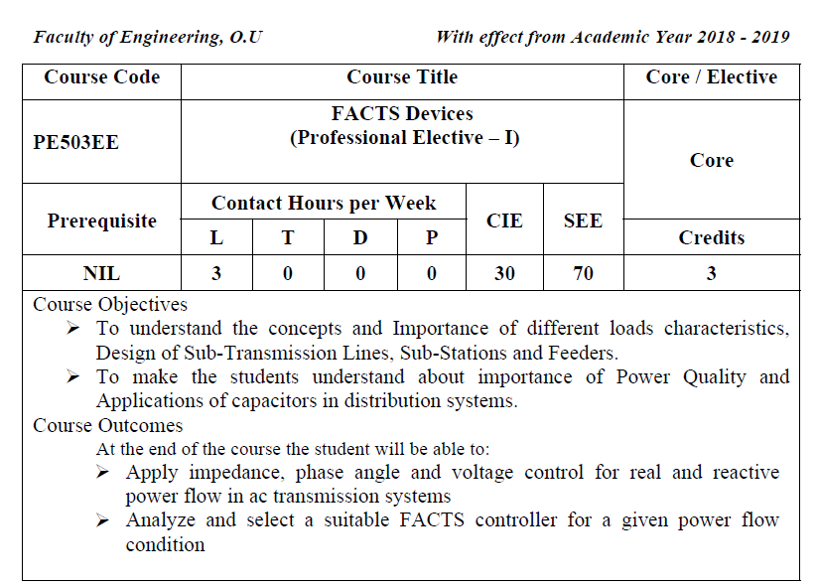

UNIT-I
Flexible AC Transmission Systems (FACTS): FACTS concepts and general system
conditions: Power flow in AC systems, Relative importance of controllable parameters,
Basic types of FACTS controllers, shunt and series controllers, Current source and
Voltage source converters
UNIT-II
Static Shunt Compensators: Objectives of shunt compensation, Methods of controllable
VAR generation, Static Var Compensator, its characteristics, TCR, TSC, FC-TCR
configurations, STATCOM, basic operating principle, control approaches and
characteristics.
UNIT-III
Static Series Compensators: Objectives of series compensator, variable impedance type
of series compensators, TCSC, TSSC-operating principles and control schemes, SSSC,
Power Angle characteristics, Control range and VAR rating, Capability to provide
reactive power compensation, external control .
UNIT-IV
Combined Compensators: Introduction to Unified Power Flow Controller, Basic
operating principles, Conventional control capabilities, Independent control of real and
reactive power
UNIT-V
Application of FACTS : Improvement of system stability limit-enhancement of system
damping- Enhancement of transient stability-Prevention of voltage instability
Suggested Reading
1. Understanding FACTS –Concepts and Technology of Flexible AC Transmission
Systemsǁ Narain G.Honorani, Laszlo Gyugyi

