HUMAN DISEASES:
4.0: Disease; Definition;
4.1: Human diseases- Causes, Symptoms, Diagnosis, Treatment and Prevention of:- Influenza, Acquired Immune Deficiency Syndrome (AIDS), Hepatitis, Diabetes, Cancer, Hypertension.
4.2: Immunity, Immune system-components and types
4.3: Immune response,
4.4: Antigen-antibody reaction
4.0: Disease; Definition:
What is a Disease?
disease (noun)- a disorder of structure or function in a human, animal, or plant, especially one that produces specific symptoms or that affects a specific location and is not simply a direct result of physical injury.
- A disease in an organism, commonly exhibits signs or symptoms indicative of its abnormal state.
- Thus, the normal condition of an organism must be first understood in order to recognize the hallmarks of any disease.
- This nevertheless, does not always make a sharp demarcation between disease and health clearly visible.
- The study of disease is called pathology. It involves the determination of the cause (etiology) of the disease, the understanding of the mechanisms of its development (pathogenesis), the structural changes associated with the disease process (morphological changes), and the functional consequences of those changes.
Correctly identifying the cause of a disease is necessary to identifying the proper course of treatment.

4.1: Human diseases- Causes, Symptoms, Diagnosis, Treatment and Prevention of:- Influenza, Acquired Immune Deficiency Syndrome (AIDS), Hepatitis, Diabetes, Cancer, Hypertension.
Influenza is a viral infection that attacks your respiratory system -our nose, throat and lungs. Influenza is commonly called the flu, but it's not the same as stomach "flu" viruses that cause diarrhoea and vomiting. For most people, influenza resolves on its own. Symptoms: Sneeze
Symptoms: To start with, the flu may seem like a common cold with a runny nose, sneezing and sore throat. However the difference is obvious- colds usually develop slowly, whereas the flu tends to come on suddenly. A cold can be a nuisance, one usually feel much worse with the flu.

Common signs and symptoms of the flu include:
- Fever over 100.4° F (38℃)
- Aching muscles
- Chills and sweats
- Headache
- Dry, persistent cough
- Fatigue and weakness
- Nasal congestion
- Sore throat
Causes:
Flu viruses travel through the air in droplets when someone with the infection coughs, sneezes or talks. One can inhale the droplets directly, or the germs can be picked up from an object -such as a telephone or computer keyboard - and then transfer them to your eyes, nose or mouth.

People with the virus are likely contagious from the day or so before symptoms first appear until about five days after symptoms begin. Children and people with weakened immune systems may be contagious for a slightly longer time.

Influenza viruses are constantly changing, with new strains appearing regularly. If you've had influenza in the past, your body has already made antibodies to fight that particular strain of the virus. If future influenza viruses are similar to those you've encountered before, either by having the disease or by getting vaccinated, those antibodies may prevent infection or lessen its severity.

But antibodies against flu viruses you've encountered in the past can't protect you from new influenza strains that can be very different immunologically from what you had before.

Risk factors:
Factors that may increase your risk of developing influenza or its complications include:

Age:
Seasonal influenza tends to target children younger than 12 months of age and adults 65 years old or older.
Living or working conditions:
People who live or work in facilities with many other residents, such as nursing homes or military barracks, are more likely to develop influenza. People who are hospitalized are also at higher risk.
Weakened immune system:
Cancer treatments, anti-rejection drugs, long-term use of steroids, organ transplant, blood cancer or HIV/AIDS can weaken your immune system. This can make it easier for you to catch influenza and may also increase your risk of developing complications.

Chronic illnesses:
Chronic conditions, including lung diseases such as asthma, diabetes, heart disease, neurological or neuro-developmental disease, an airway abnormality, and kidney, liver or blood disease, may increase your risk of influenza complications.
Aspirin use under age 19. People who are younger than 19 years of age and receiving long-term aspirin therapy are at risk of developing Reye's syndrome if infected with influenza.
Pregnancy:
Pregnant women are more likely to develop influenza complications, particularly in the second and third trimesters. Women who are up to two weeks postpartum also are more likely to develop influenza-related complications.
Obesity:
People with a body mass index (BMI) of 40 or more have an increased risk of complications from the flu.
Complications:
If you're young and healthy, seasonal influenza usually isn't serious. Although you may feel miserable while you have it, the flu usually goes away in a week or two with no lasting effects. But children and adults at high risk may develop complications such as:
- Pneumonia
- Bronchitis
- Asthma flare-ups
- Heart problems
- Ear infections
Pneumonia is the most serious complication. For older adults and people with a chronic illness, pneumonia can be deadly.

Prevention:
The Centres for Disease Control and Prevention (CDC) recommends annual flu vaccination for everyone age 6 months or older.

Each year's seasonal flu vaccine contains protection from the three or four influenza viruses that are expected to be the most common during that year's flu season. This year, the vaccine will be available as an injection and as a nasal spray.

In recent years, there was concern that the nasal spray vaccine wasn't effective enough against certain types of flu. However, the nasal spray vaccine is expected to be effective in the 2019-2020 season. The nasal spray still isn't recommended for some groups, such as pregnant women, children between 2 and 4 years old with asthma or wheezing, and people who have compromised immune systems.

Most types of flu vaccines contain a small amount of egg protein. If you have a mild egg allergy -you get hives only from eating eggs, for example -you can receive the flu shot without any additional precautions. If you have a severe egg allergy, you should be vaccinated in a medical setting and be supervised by a doctor who is able to recognize and manage severe allergic conditions.

Controlling the spread of infection:
The influenza vaccine is not 100 percent effective, so it's also important to take measures such as these to reduce the spread of infection:
Wash hands: Thorough and frequent hand-washing is an effective way to prevent many common infections. Or use alcohol-based hand sanitizers if soap and water are not readily available.
Contain coughs and sneezes: Cover the mouth and nose when you sneeze or cough. To avoid contaminating your hands, cough or sneeze into a tissue or into the inner crook of your elbow.
Avoid crowds: The flu spreads easily wherever people congregate -in child care centres, schools, office buildings, auditoriums and public transportation. By avoiding crowds during peak flu season, you reduce your chances of infection. And if you're sick, stay home for at least 24 hours after your fever subsides so that you lessen your chance of infecting others.

AIDS (Acquired Immune Deficiency Syndrome):
AIDS (Acquired Immune Deficiency Syndrome) is the final and most serious stage of HIV disease, which causes severe damage to the immune system.
Human immunodeficiency virus infection and acquired immune deficiency syndrome (HIV/AIDS) is a spectrum of conditions caused by infection with the human immunodeficiency virus (HIV).[9][10][11] Following initial infection a person may not notice any symptoms, or may experience a brief period of influenza-like illness.[4] Typically, this is followed by a prolonged period with no symptoms.[5] As the infection progresses, it interferes more with the immune system, increasing the risk of developing common infections such as tuberculosis, as well as other opportunistic infections, and tumors that rarely affect people who have uncompromised immune systems.[4] These late symptoms of infection are referred to as acquired immunodeficiency syndrome (AIDS).[5] This stage is often also associated with unintended weight loss.[5]

HIV is spread primarily by unprotected sex (including anal and oral sex), contaminated blood transfusions, hypodermic needles, and from mother to child during pregnancy, delivery, or breastfeeding.[12] Some bodily fluids, such as saliva and tears, do not transmit HIV.[13] Methods of prevention include safe sex, needle exchange programs, treating those who are infected, pre- and post-exposure prophylaxis, and male circumcision.[4] Disease in a baby can often be prevented by giving both the mother and child antiretroviral medication.[4] There is no cure or vaccine; however, antiretroviral treatment can slow the course of the disease and may lead to a near-normal life expectancy.[5][6] Treatment is recommended as soon as the diagnosis is made.[14] Without treatment, the average survival time after infection is 11 years.[7]
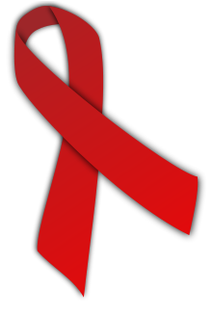
The red ribbon is a symbol for solidarity with HIV-positive people and those living with AIDS.^{[3]}
HIV/AIDS has had a large impact on society, both as an illness and as a source of discrimination.[21] The disease also has large economic impacts.[21] There are many misconceptions about HIV/AIDS, such as the belief that it can be transmitted by casual non-sexual contact.[22] The disease has become subject to many controversies involving religion, including the Catholic Church's position.
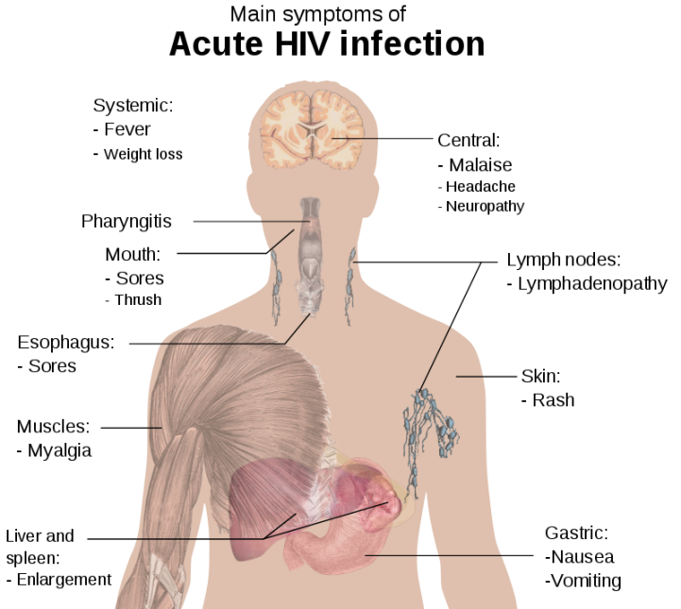

4.2: Immunity, Immune System-Components
What Is the Immune System?
The immune system is the body's defense against infections. The immune system attacks germs and helps keep us healthy.

What Are the Parts of the Immune System?
Many cells and organs work together to protect the body. White blood cells, also called leukocytes, play an important role in the immune system.

Some types of white blood cells, called phagocytes, chew up invading organisms. Others, called lymphocytes, help the body remember the invaders and destroy them.

One type of phagocyte is the neutrophil, which fights bacteria. When someone might have bacterial infection, doctors can order a blood test to see if it caused the body to have lots of neutrophils. Other types of phagocytes do their own jobs to make sure that the body responds to invaders.

The two kinds of lymphocytes are B lymphocytes and T lymphocytes. Lymphocytes start out in the bone marrow and either stay there and mature into B cells, or go to the thymus gland to mature into T cells. B lymphocytes are like the body's military intelligence system — they find their targets and send defenses to lock onto them. T cells are like the soldiers — they destroy the invaders that the intelligence system finds.

How Does the Immune System Work?
When the body senses foreign substances (called antigens), the immune system works to recognize the antigens and get rid of them.
B lymphocytes are triggered to make antibodies. These specialized proteins lock onto specific antigens. The antibodies stay in a person's body. That way, if the immune system encounters that antigen again, the antibodies are ready to do their job. That's why someone who gets sick with a disease, like chickenpox, usually won't get sick from it again.
This is also how immunizations (vaccines) prevent some diseases. An immunization introduces the body to an antigen in a way that doesn't make someone sick. But it does let the body make antibodies that will protect the person from future attack by the germ.
Although antibodies can recognize an antigen and lock onto it, they can't destroy it without help. That's the job of the T cells. They destroy antigens tagged by antibodies or cells that are infected or somehow changed. (Some T cells are actually called "killer cells.") T cells also help signal other cells (like phagocytes) to do their jobs.

Antibodies also can: neutralize toxins (poisonous or damaging substances) produced by different organisms activate a group of proteins called complement that are part of the immune system. Complement helps kill bacteria, viruses, or infected cells.
These specialized cells and parts of the immune system offer the body protection against disease. This protection is called immunity.

Humans have three types of immunity — innate, adaptive, and passive:
- Innate immunity: Everyone is born with innate (or natural) immunity, a type of general protection. For example, the skin acts as a barrier to block germs from entering the body. And the immune system recognizes when certain invaders are foreign and could be dangerous.
- Adaptive immunity: Adaptive (or active) immunity develops throughout our lives. We develop adaptive immunity when we're exposed to diseases or when we're immunized against them with vaccines.
- Passive immunity: Passive immunity is "borrowed" from another source and it lasts for a short time. For example, antibodies in a mother's breast milk give a baby temporary immunity to diseases the mother has been exposed to.
- The immune system takes a while to develop and needs help from vaccines. By getting all your child's recommended vaccines on time, you can help keep your child as healthy as possible.
What is an Immune response?:
- The Immune response is the body's response caused by its immune system being activated by antigens. The immune response can include immunity to pathogenic microorganisms and its products, allergies, graft rejections, as well as autoimmunity to self-antigens.
- The immune system being activated by antigens and in this process the main cells involved are T cells and B cells (sub-types of lymphocytes), and macrophages (a type of leucocyte or white blood cell). These cells produce lymphokines that influence the other host cells' activities.
- B cells, when activated by helper T cells undergo clonal expansion. B cells differentiate into plasma cells, which are short lived and secrete antibodies, and memory B cells, which are long lived and produce a fast, remembered response when exposed to the same infection in the future. B cells mature to produce immunoglobulins (also known as antibodies), that react with antigens.
- At the same time, macrophages process the antigens into immunogenic units which stimulate B lymphocytes to differentiate into antibody-secreting plasma cells, stimulating the T cells to release lymphokines.

Antigen-antibody interaction :
- Antigen-antibody interaction, or antigen-antibody reaction, is a specific chemical interaction between antibodies produced by B cells of the white blood cells and antigens during immune reaction. ... The specificity of the binding is due to specific chemical constitution of each antibody.
- Antigen is a macromolecule that causes an immune response by lymphocytes. Antigen receptor, a surface protein located on B cells and T cells, binds to antigens and initiates acquired immune responses. ... The specific binding between antigen and antibody is similar to that of the lock-and-key binding model.
- When an antigen binds to the B-cell surface, it stimulates the B cell to divide and mature into a group of identical cells called a clone. An activated clones of B-cells will produce the respective neutralizing antibody molecule only , the ma of Types Ig G, IgA, IgM, IgE or Ig D.
- As these antibodies circulate, they attack and neutralize antigens that are identical to the one that triggered the immune response. Antibodies attack antigens by binding to them. Antibody affinity refers to the strength with which the epitope binds to an individual paratope (antigen-binding site) on the antibody. High affinity antibodies bind quickly to the antigen, permit greater sensitivity in assays and maintain this bond more readily under difficult conditions.

