INFLUENZA
Flu a symptom commonly observed in the human populations is caused by two types of pathogens namely, Influenza Virus and Haemophilus influenza-a bacteria.
Infections with influenza virus cause mild to severe respiratory illness and may result in death in vulnerable human populations. On average, influenza causes three to five million cases of severe illness per year worldwide and over 200,000 hospitalizations and 36,000 deaths in the United States alone. While healthy adults typically experience only acute uncomplicated infection, influenza virus predisposes the lungs to bacterial co-infections,5,6,7 which cause significant additional morbidity, particularly in young children, elderly and immune-compromised individuals.8,9,10,11,12 Secondary bacterial infections may also significantly increase mortality in the population as a whole during influenza pandemics.13,14,15,16 majority of deaths appeared to result from secondary bacterial pneumonia.16,17,18,19 The most common bacterial agents mediating such secondary infections in the U.S. are Streptococcus pneumoniae, Staphylococcus aureus, and Haemophilus influenzae.20,21,22,23
H. influenzae is a small Gram-negative coccobacillus that exists in capsulated or non-capsulated forms. H. influenzae is a common cause of otitis media, acute sinusitis, bronchitis, pneumonia and exacerbations of chronic obstructive pulmonary disease.24,25,26,27,28,29. [A Mouse Model of Lethal Synergism Between Influenza Virus and Haemophilus influenza, Lian Ni Lee,* Peter Dias,* Dongun Han,* Sorah Yoon,* Ashley Shea,* Vladislav Zakharov,† David Parham,† and Sally R. Sarawar* Am J Pathol. 2010 Feb; 176(2): 800–811. PMCID: PMC2808086; doi: 10.2353/ajpath.2010.090596 PMID: 20042666]
References
- Simonsen L. The global impact of influenza on morbidity and mortality. Vaccine. 1999;17(Suppl 1):S3–S10. [PubMed] [Google Scholar]
- Thompson WW, Shay DK, Weintraub E, Brammer L, Bridges CB. Cox NJ, Fukuda K: Influenza-associated hospitalizations in the United States. JAMA. 2004;292:1333–1340. [PubMed] [Google Scholar]
- Wong CM, Chan KP, Hedley AJ, Peiris JS. Influenza-associated mortality in Hong Kong. Clin Infect Dis. 2004;39:1611–1617. [PubMed] [Google Scholar]
- Yap FH, Ho PL, Lam KF, Chan PK, Cheng YH, Peiris JS. Excess hospital admissions for pneumonia, chronic obstructive pulmonary disease, and heart failure during influenza seasons in Hong Kong. J Med Virol. 2004;73:617–623. [PubMed] [Google Scholar]
- Sethi S. Bacterial pneumonia. Managing a deadly complication of influenza in older adults with comorbid disease. Geriatrics. 2002;57:56–61. [PubMed] [Google Scholar]
- Hament JM, Kimpen JL, Fleer A, Wolfs TF. Respiratory viral infection predisposing for bacterial disease: a concise review. FEMS Immunol Med Microbiol. 1999;26:189–195. [PubMed] [Google Scholar]
- Wyde PR, Six HR, Ambrose MW, Throop BJ. Influenza virus infection and bacterial clearance in young adult and aged mice. J Gerontol. 1989;44:B118–B124. [PubMed] [Google Scholar]
- Nickerson CL, Jakab GJ. Pulmonary antibacterial defenses during mild and severe influenza virus infection. Infect Immun. 1990;58:2809–2814. [PMC free article] [PubMed] [Google Scholar]
- Gardner ID, Kung TM. Histopathological changes in the lungs of influenza-infected mice superinfected with Staphylococcus aureus. Br J Exp Pathol. 1980;61:415–420. [PMC free article] [PubMed] [Google Scholar]
- Aubrey R, Tang C. The pathogenesis of disease due to Type b Haemophilus influenzae. Herbert M, Hood DW, Moxon ER, editors. Totowa, NJ: Humana Press,; Methods in Molecular Medicine, vol 71Haemophilus influenzae Protocols. 2002:pp 29–50. [Google Scholar]
- Chin CL, Manzel LJ, Lehman EE, Humlicek AL, Shi L, Starner TD, Denning GM, Murphy TF, Sethi S, Look DC. Haemophilus influenzae from patients with chronic obstructive pulmonary disease exacerbation induce more inflammation than colonizers. Am J Respir Crit Care Med. 2005;172:85–91. [PMC free article] [PubMed] [Google Scholar]
- Masuda K, Masuda R, Nishi J, Tokuda K, Yoshinaga M, Miyata K. Incidences of nasopharyngeal colonization of respiratory bacterial pathogens in Japanese children attending day-care centers. Pediatr Int. 2002;44:376–380. [PubMed] [Google Scholar]
- Wilkinson TM, Hurst JR, Perera WR, Wilks M, Donaldson GC, Wedzicha JA. Effect of interactions between lower airway bacterial and rhinoviral infection in exacerbations of COPD. Chest. 2006;129:317–324. [PubMed] [Google Scholar]
- Grant GB, Campbell H, Dowell SF, Graham SM, Klugman KP, Mulholland EK, Steinhoff M, Weber MW, Qazi S. Recommendations for treatment of childhood non-severe pneumonia. Lancet Infect Dis. 2009;9:185–196. [PubMed] [Google Scholar]
- Murphy TF. Respiratory infections caused by non-typeable Haemophilus influenzae. Curr Opin Infect Dis. 2003;16:129–134. [PubMed] [Google Scholar]
- Loosli CG. Influenza and the interaction of viruses and bacteria in respiratory infections. Medicine (Baltimore) 1973;52:369–384. [PubMed] [Google Scholar]
- Seki M, Kosai K, Yanagihara K, Higashiyama Y, Kurihara S, Izumikawa K, Miyazaki Y, Hirakata Y, Tashiro T, Kohno S. Disease severity in patients with simultaneous influenza and bacterial pneumonia. Intern Med. 2007;46:953–958. [PubMed] [Google Scholar]
- McCullers JA, Webster R. A mouse model of dual infection with influenza virus and Streptococcus pneumoniae. Osterhaus A, Cox N, Hampson A, editors. Amsterdam: Elsevier Science,; Options for control of influenza IV. 2001:pp 601–607. [Google Scholar]
- Okamoto S, Kawabata S, Nakagawa I, Okuno Y, Goto T, Sano K, Hamada S. Influenza A virus-infected hosts boost an invasive type of Streptococcus pyogenes infection in mice. J Virol. 2003;77:4104–4112. [PMC free article] [PubMed] [Google Scholar]
- Alonso JM, Guiyoule A, Zarantonelli ML, Ramisse F, Pires R, Antignac A, Deghmane AE, Huerre M, van der Werf S, Taha MK. A model of meningococcal bacteremia after respiratory superinfection in influenza A virus-infected mice. FEMS Microbiol Lett. 2003;222:99–106. [PubMed] [Google Scholar]
- Jarstrand C, Tunevall G. The influence of bacterial superinfection on the clinical course of influenza. Studies from the influenza epidemics in Stockholm during the winters 1969–70 and 1971–72. Scand J Infect Dis. 1975;7:243–247. [PubMed] [Google Scholar]
- Schwarzmann SW, Adler JL, Sullivan RJ, Jr, Marine WM. Bacterial pneumonia during the Hong Kong influenza epidemic of 1968–1969. Arch Intern Med. 1971;127:1037–1041. [PubMed] [Google Scholar]
- Kilbourne ED. New York: Plenum,; Influenza. 1987:pp 220–240. [Google Scholar]
- McCullers JA. Insights into the interaction between influenza virus and pneumococcus. Clin Microbiol Rev. 2006;19:571–582. [PMC free article] [PubMed] [Google Scholar]
- Morens DM, Taubenberger JK, Fauci AS. Predominant role of bacterial pneumonia as a cause of death in pandemic influenza: implications for pandemic influenza preparedness. J Infect Dis. 2008;198:962–970. [PMC free article] [PubMed] [Google Scholar]
- Taubenberger JK, Morens DM. The pathology of influenza virus infections. Annu Rev Pathol. 2008;3:499–522. [PMC free article] [PubMed] [Google Scholar]
- Brundage JF, Shanks GD. Deaths from bacterial pneumonia during 1918–19 influenza pandemic. Emerg Infect Dis. 2008;14:1193–1199. [PMC free article] [PubMed] [Google Scholar]
- Brundage JF, Shanks GD. What really happened during the 1918 influenza pandemic? The importance of bacterial secondary infections. J Infect Dis. 2007;196:1717–1719. [PubMed] [Google Scholar]
- Levine J, Buchman CA, Fregien N. Influenza A virus infection of human Schwann cells in vitro. Acta Otolaryngol. 2003;123:41–45. [PubMed] [Google Scholar]
TO EDIT
Ref:<< https://www.differencebetween.com/difference-between-antigenic-drift-and-vs-antigenic-shift/#cd>>>
Viruses are electron microscopic small infectious particles which can infect all forms of living organisms including bacteria and plants. They are composed of genetic material and glycoprotein capsid. Viral genome codes glycoproteins (antigens) which are important for attaching to the host organism and include viral genome to replicate within the host organism. Influenza virus is one type of virus responsible for the common cold associated diseases among humans and other animals. It exists in different strains and has a segmented RNA genome, and two prominent antigens (receptors) called H and N on the glycoprotein coat.
- 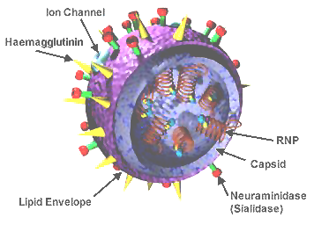
- Figure 01: Influenza Viral Structure
- H and N antigens of the influenza virus bind to the host cell receptors and make a successful infection to cause the disease. H and N antigen structures can be easily recognized by the host defense systems which destroy the viral particles to prevent the disease occurrence. However several genetic variations of influenza viral particles limit the chance of destroying the viral antigens which enter the host body by the host immune system. Antigenic drift is such kind of a genetic variation common in influenza virus. It happens due to gradual development and accumulation of a point mutation in the genes of H and N. As a result of this point mutation, viral particles acquire the capability of changing the H and N antigen structures which cannot be recognized by the host cell antibodies or vaccines. Therefore, the mutations of these H and N coding genes allow the viral particles to escape from the host immune systems and spread the disease.
- Antigenic drift in epidemic flues such as H3N2 and the viral strains are capable of infecting new individuals of the same host species to spread the disease easily. This type of genetic variation is more common and frequently occur among the influenza virus strains A and B.
- 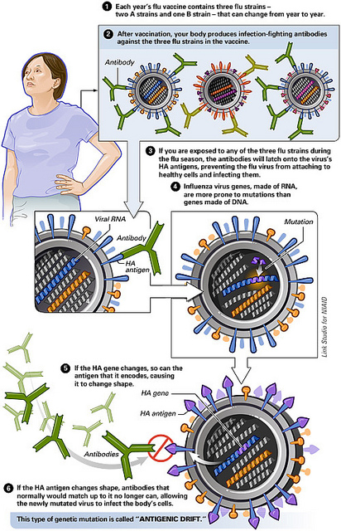
- Figure 02: Antigenic Drift
- What is Antigenic Shift?
- Antigenic shift is another type of genetic variation that occurs in influenza viruses due to the reassortment of genetic materials between two or more similar viral strains. Antigenic shift occurs between closely associated strains. When a host organism is infected with two influenza strains, there is a possibility of exchanging or mixing of genetic materials of the two strains to create a new viral strain with the mixture of genes. This genetic recombination gives the new viral particle a novel capability to escape from the host defense system without recognition. Thus, it is capable of infecting host cells of more than one species and cause a pandemic disease. However, antigenic shift is a rare process which has fewer chances for the occurrence. Influenza virus A can undergo antigenic shift and is capable of infecting a large number of host species, resulting in flu pandemics.
- 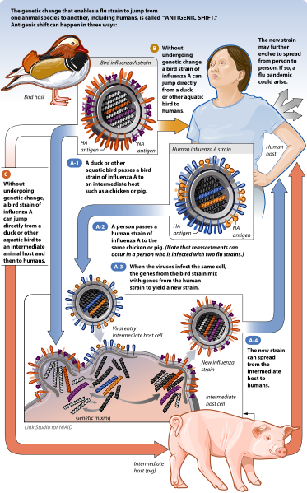
- Figure 03: Antigenic Shift
- What is the difference between Antigenic Drift and Antigenic Shift?

Antigenic Drift vs Antigenic Shift
Antigenetic drift is a genetic variation occurring in the viral genome due a development and accumulation of point mutations in the genes that encode H and N. | Antigenetic shift is a variation occurs in the viral genome due to gene reassortment between two or more viral strains.
Development of the Genetic Change
Antigenic drift is a gradual change over the years. | Antigenic shift is a sudden change.
Genetic Change
It happens due to a point mutation of genes coding for Hemagglutinin and Neuraminidase. | It happens due to the reassortment of genes between two closely related influenza viruses.
Flu Strain
This occurs in both influenza A and B. | This occurs only in Influenza A virus.
Possibility of Infection
Antigenic drift allows the new viral particle to infect more individuals from the same host species. | Antigenic shift creates a new viral particle which is capable of infecting different species.
Occurrence
Antigenic drift is a frequent process in influenza virus. | Antigenic shift is a rare process.
Nature of the Disease
This can lead to an epidemic among the population such as H3N2. | This can lead to a pandemic in the population such as H1N1, Spanish flu, and Hong kong flu.
- Summary – Antigenic Drift vs Antigenic Shift
- Mutations in the segmented RNA genome of the influenza virus give rise to genetic variations in the viral particles and fight against the host defense mechanism. Antigenic drift and antigenic shift are two kinds of genetic variations that occur in influenza (flu) virus. Antigenic drift is a genetic variation which results from the gradual development of point mutations in the genes of H and N of the virus. Antigenic shift is a genetic variation which results from the genetic material exchange between two or more closely related strains of influenza virus. This is the key difference between antigenic drift and antigenic shift. Both these processes create viral particles which are more virulent than preexisting viruses. Therefore, antigenic drifts and shifts make it difficult to develop vaccines and medications against the flu virus.
- References:
1. Bouvier, Nicole M., and Peter Palese. “THE BIOLOGY OF INFLUENZA VIRUSES.” Vaccine. U.S. National Library of Medicine, 12 Sept. 2008. Web. 21 Mar. 2017
2.”Mechanisms of antigenic variation in influenza virus”. Nihon rinsho. Japanese journal of clinical medicine. U.S. National Library of Medicine, n.d. Web. 21 Mar. 2017
3. Boni, Maciej F. “Vaccination and antigenic drift in influenza.” Vaccine. U.S. National Library of Medicine, 18 July 2008. Web. 21 Mar. 2017
- Image Courtesy:
1. “3D Influenza virus”By National Institutes of Health; originally uploaded to en.wikipedia by TimVickers (25 October 2006), transferred to Commons by Quadell using CommonsHelper. – California Department of Health Services (Public Domain) via Commons Wikimedia
2. “Antigenic Drift of the Flu Virus” by NIAID (CC BY 2.0) via Flickr
3. “AntigenicShift HiRes vector” By derivative work: MouagipAntigenicShift_HiRes.png: National Institute of Allergy and Infectious Diseases (NIAID). AntigenicShift_HiRes.png (Public Domain) via Commons Wikimedia

