INTRODUCTION
Theory of Machines
(Study of relative motion between the parts of a machine & the forces acting on those parts)
Kinematics of Machines
(Study of relative motion between the parts of a machine i.e. position, displacement, velocity &
Dynamics of Machines
(Study of forces & their effects on the parts)
Kinetics
(Study of inertia forces which arises from the combined effect of the mass & motion of the
Statics
(Study of forces acting on various parts when those parts are assumed to be without mass or

LINK OR ELEMENT
A link (or element or kinematic link) is a resistance body (or assembly of resistance bodies) that constitute the part (parts) of the machine connecting other parts which have motion relative to it. A link which is stationary and which supports the moving members is called frame. Characteristics of link are:
  - It should have relative motion
  - It need not necessarily be rigid body, but it must be a resistance body (a body capable of transmitting the required forces with negligible deformation).
Ex: Liquids which are resistance to compressive forces, Chains, belts & ropes, which are resistance to tensile forces, Slider crank mechanism which converts the reciprocating motion of the slider into a rotary motion of the crank & vice versa (Fig.1).
It consists of following four links
    - Frame
    - Crank
    - Connecting rod
    - Slider
The slider (i.e. link 4) reciprocates in guide, which is connected to the frame. Hence guide also becomes link 1 (i.e. frame)

Slider
Connecting rod
2
3
4
1
Crank
1
Frame

Fig.1 Slider Crank Mechanism

Classification of links:
- Depending upon the ends on which revolute or turning pairs can be placed
  - Binary link: A link which is connected to two other links, it is called binary link.
  - Ternary link: A link which is connected to three other links, it is called ternary link.
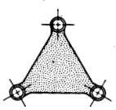
  - Quaternary link: A link which is connected to four other links, it is called quaternary link.
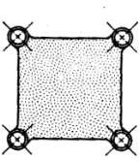
- Depending upon the effect on the link
  - Rigid link: One which does not undergo any deformation while transmitting motion. Ex: connecting rod, crank etc
  - Flexible link: One which partly deforms in a manner not to affect the transmission of motion. Ex: belts, ropes, chains etc
  - Fluid link: One which is formed by having a fluid in a receptacle & motion is transmitted through the fluid by pressure or compression only. Ex: hydraulic presses, jacks, brakes etc
  - Floating link: One which connected to the frame.

KINEMATIC PAIRS
When two elements or links are connected in such a way that their relative motion is completely constrained or successfully constrained, form a kinematic pair.
The three main types of constrained motions are:
- Completely constrained: Motion between a pair of links is limited to a definite direction. Ex: motion of a shaft with collars at each end in a circular hole, motion of a square bar in a square hole, piston & cylinder.
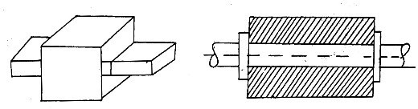

- Incompletely constrained: Motion between a pair of links is not confined to a definite direction. Ex: shaft in a circular hole.
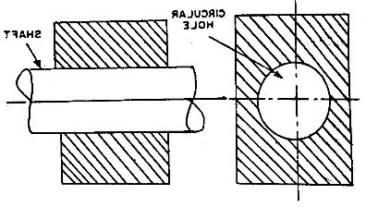
- Successfully constrained: Motion in a definite direction is not brought about by itself, but by some other means. Ex: shaft in foot step bearing.
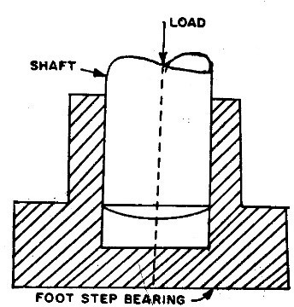

Classification of Kinematic Pair:
- Based on type of contact between the elements
  - Lower pair: Two elements of a pair have a surface contact when relative motion takes place. Ex: sliding pairs, turning pairs & screw pairs
  - Higher pair: Two elements of a pair have a point or line contact when relative motion takes place. Ex: gear drives, cam & follower, belt drives etc
- Based on relative motion between the elements
  - Turning (revolute) pair: Two elements of a pair are connected in such a way that one can only turn or revolve about a fixed axis of another link. Ex: a shaft with collars at both ends fitted in to a circular hole, lathe spindle in head stock etc.
  - Sliding pair: Two elements of a pair are connected in such a way that one can only slide relative to the other. Ex: piston & cylinder, tail stock on lathe bed etc.
  - Rolling pair: Two elements of a pair are connected in such a way that one rolls over another fixed link. Ex: roller bearing, ball bearing etc.
  - Screw (helical) pair: Two elements of a pair are connected in such a way that one element can turn about the other by screw threads. Ex: bolt with nut, lead screw of a lathe with nut etc.
  - Spherical pair: Two elements of a pair are connected in such a way that one element (with spherical shape) turns or swivels about the other fixed element. Ex: ball & socket joint, pen stand etc.
- Based on mechanical constraints between the elements
  - Self-Closed pair: Two elements of a pair are connected mechanically in such a way that only required kind of relative motion occurs. Ex: lower pairs.
  - Force closed (Open) pair: Two elements of a pair are not connected mechanically but are kept in contact by the action of external forces. Ex: cam & follower (kept in contact by the forces exerted by spring & gravity)

KINEMATIC CHAIN
Kinematic Chain is defined as the “combination of kinematic pairs, joined in such a way that each link forms a part of two pairs and the relative motion between the links (elements) is completely or successfully constrained. They are coupled in such a way that the last link is always joined to the first link to transmit definite motion. Ex: slider crank mechanism
- Link 1 is connected to link 2 and to link 4. Therefore links 1 & 2 is a kinematic pair and links 1 & 4 is a kinematic pair. Hence link 1 forms a part of two pairs
- Similarly link 2 forms a part of two pairs (i.e. link 2 – link 3 and link 2 – link 1)
- Similarly, 3 and 4 each forms a part of two pairs
- Hence in this each link forms a part of two pairs and motion of each relative to other is definite.
- Hence the total combination of these links is a kinematic chain.
If each link is assumed to form two pairs with two adjacent links, then the relation between the number of pairs (p) forming a kinematic chain and the number of links (l) may be expressed in the form of an equation:

l  2 p  4
☹☹☹☹(1)

Another relation between the number of links (l) and the number of joints (j) which constitute a kinematic chain is given by the expression:

Note:
j  32l  2
☹☹☹☹(2)

- These two equations are applicable only to kinematic chains, in which lower pairs are used. These equations may also be applied to kinematic chains, in which higher pairs are used. In that case, each higher pair may be taken as equivalent to two lower pairs with an additional element or link.
- If L.H.S > R.H.S. then the chain is locked
- If L.H.S = R.H.S. then the chain is constrained
- If L.H.S < R.H.S. then the chain is unconstrained

MECHANISM
Mechanism is a constrained kinematic chain, with one link fixed, which is used to transmit or transform motion.
Types of mechanism:
- Simple mechanism: has four links.
- Compound mechanism: has more than four links.
- Complex mechanism: formed by the inclusion of ternary or higher order floating link to a simple mechanism.
- Planar mechanism: formed when all links of the mechanism lie in the same plane.
- Spatial mechanism: formed when all links of the mechanism lie in the different plane.
- Equivalent mechanism: formed when one pairs is replaced by other type of pairs and the new mechanism obtained must have the same number of degrees of freedom as the original mechanism. Ex: A turning pair can be replaced by a sliding pair, A spring can be replaced by two binary links, A cam pair can be replaced by one binary link with two turning pairs at each end.

INVERSION:
The exchange of fixedness of an element with its mating element in a kinematic chain is called inversion. Thus, in the Fig. 2 any one of the links may be arbitrary selected as the fixed link, and each arrangement is an inversion of the others.
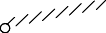Note: Relative motions between the various links is not changed in any manner through the process of inversion, but their absolute motions (those measured with respect to the fixed link) may be changed drastically.
l
q s
q s
l
s
q
l
q
l
s
p p p p

MACHINE:
Fig. 2: Inversions of four bar mechanism

A machine is a mechanism or group of mechanisms used to perform useful work. Its chief function is to adopt a source of power to some specific work requirements.

STRUCTURE:
Structure is an assemblage of several resistance bodies having no relative motion between them. These are meant for taking up loads. There is only straining action due to forces acting on them.

Difference between machine & mechanism:
Sl.  No. | Particulars | Mechanism | Machine
1 | Definition | It is a constrained kinematic chain, with one  link fixed, which is used to transmit or transform motion | A machine is a mechanism or group of  mechanisms used to perform useful work
2 | Purpose | To transmit or transform motion | To transmit energy or to do useful  work
3 | Dependency | No mechanism is necessarily a machine | A machine is a series or train of  mechanism
4 | Relationship | It is a working model of any machine | It is a practical development of any  mechanism
5 | Examples | Clock, mini-drafter etc. | Steam engine, shaper etc.

Difference between machine & structure:
Sl.  No. | Particulars | Machine | Structure
1 | Definition | A machine is a mechanism or group of mechanisms used to perform useful  work | It is an assemblage of several resistance bodies having no relative motion between  them
2 | Work | Modifies or transmit energy to do some  kind of work | Modifies & transmit force only
3 | Relative  motion | Exists between its members | Not exists between its members
4 | Energy | Transmits useful energy | No energy transmission
5 | Examples | Steam engine, shaper etc. | Roof truss,  frames etc. | railway | bridges, | machine

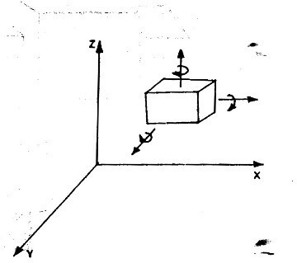
DEGREES OF FREEDOM:
- It is defined as the number of independent relative motions, both translational & rotational, a pair can have.
- An unconstrained rigid body moving in apace can describe the following independent motions.
  - Translation motion along three mutually perpendicular axes x, y & z
  - Rotation motion about these axes.
- Thus, a rigid body possesses 6 degrees of freedom.
- The connection of a link with another imposes certain constraints on their relative motion.
- The number of restraints can never be zero (joint is disconnected) or six (joint becomes solid).
Degrees of freedom = 6 – number of restraints

MOBILITY OF MECHANISM AND GRUBLER’S CRITERION
Mobility of Mechanism defines the number of degrees of freedom. The Grubler’s mobility equation for a planar mechanism is

Where,
F  3l  1  2 j1  j2

F = mobility of number of degrees of freedom
l = number of links including frame
j1 = joints with single (one) degree of freedom (lower pairs or binary joints)
j2 = joints with two degrees of freedom (higher pairs)
If, F > 0, results a mechanism with F degrees of freedom
F = 0, results in a statically determinate structure
F < 0, results in a statically indeterminate structure
Note: A joint connecting l links at a single point must be counted as (l-1) joints.

Example 1: (mechanisms with lower pairs)
Fig. (a) Fig. (b) Fig. (c) Fig. (d) Fig. (e)

Ans:
F  3l 1  2 j1  j2

Fig. | Type | l | j1 | j2 | Calculation | F
a | Three bar | 3 | 3 | 0 | F = 3 (3 - 1) - | 0
 | mechanism |  |  |  | 2 × 3 – 0
b | Four bar | 4 | 4 | 0 | F = 3 (4 - 1) - | 1
 | mechanism |  |  |  | 2 × 4 – 0
c | Five bar | 5 | 5 | 0 | F = 3 (5 - 1) - | 2
 | mechanism |  |  |  | 2 × 5 – 0
d | Five bar | 5 | 6 | 0 | F = 3 (5 - 1) - | 0
 | mechanism |  | (because there are two binary joints at B |  | 2 × 6 – 0
 |  |  | & D will be considered as two, and two
 |  |  | ternary joints at A & C will be considered
 |  |  | as {l-1} i.e. [3-1] × 2)
e | Six bar | 6 | 8 | 0 | F = 3 (6 - 1) - | -1
 | mechanism |  | (because there are four ternary joints at A, |  | 2 × 8 – 0
 |  |  | B, C & D will be considered as {l-1} i.e.
 |  |  | [3-1] × 4)
Conclusion:
  - When F = 0, then the mechanism forms a structure & no relative motion between the links is possible as shown in the fig (a) & (d).
  - When F = 1, then the mechanism can be driven by a single input motion, as shown in the fig (b).
  - When F = 2, then two separate input motions are necessary to produce constrained motion for the mechanism, as shown in the fig (c).
  - When F = -1 or less then there are redundant constrains in the chain and it forms strictly indeterminate structure, as shown in the fig (e).

Example 2: (mechanisms with higher pairs)
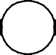
Fig (a) Fig (b)
Fig. | Type | l | j1 | j2 | Calculation | F
a | Cam & follower | 3 | 2 | 1 | F = 3 (3 - 1) - 2 × | 1
 | mechanism |  |  | (there exist a rolling & sliding | 2 – 1
 |  |  |  | between 2 & 3)
b | Roller mechanism | 4 | 3 | 1 | F = 3 (4 - 1) - 2 × | 2
 |  |  |  | (there exist a rolling & sliding | 3 – 1
 |  |  |  | between 4 & 1)
Note: In the second case (fig. b) it has been assumed that the slipping is possible between the links (i.e. between the wheel & the fixed link). However, if the friction at the contact is high enough to prevent slipping, the joint will be counted as one degree of freedom pair, because only one relative motion will be possible between the links.

Problems on Grubler’s Criterion:
(i)
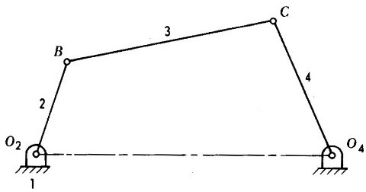
(ii)
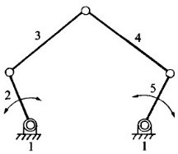
(iii)
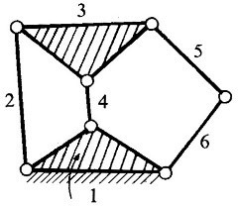

(iv)
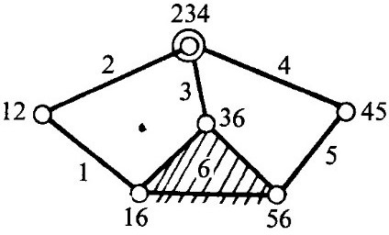
(v)

F = 3(4-1)-2(4) = 1
i.e., one input to any one link will result in definite motion of all the links.

F = 3(5-1)-2(5) = 2
i.e., two inputs to any two links are required to yield definite motions in all the links.

F = 3(6-1)-2(7) = 1
i.e., one input to any one link will result in definite motion of all the links.

F = 3(6-1)-2(7) = 1
i.e., one input to any one link will result in definite motion of all the links.

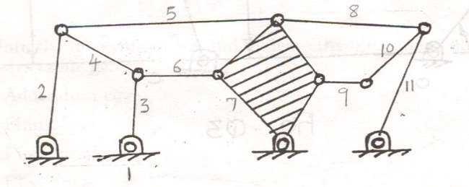
F = 3(11-1)-2(15) = 0
the mechanism forms a structure & no relative motion between the links is possible

(vi)

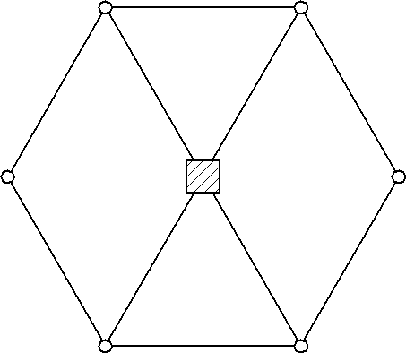Welded

Total number of links n = 7
Joints with one degree of freedom
Joints with two degree of freedom

j1  10
j2  0

F  37 1 2 10  0  2
Hence the linkage is a statically indeterminate structure.

(vii)
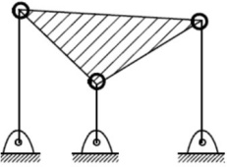
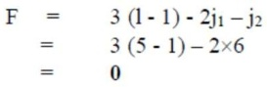

(viii)
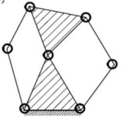
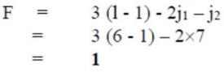
(ix)
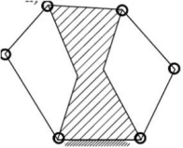
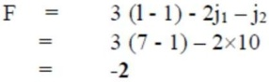
(x)

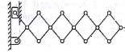
F = 3(12-1)-2(16)-0 = 1

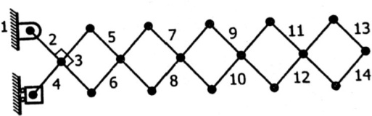
(xi)

F = 3(14-1)-2(18)-1 = 2

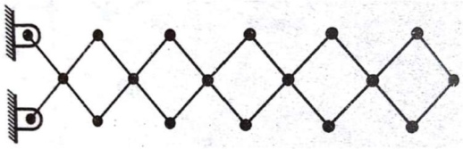
(xii)

F = 3(13-1)-2(18)-0 = 0

(xiii)
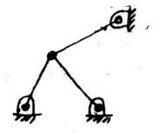
F = 3(4-1)-2(5) = -1
i.e., it is a structure

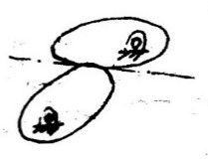
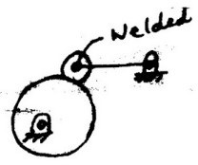
- (xv)
F = 3(3-1)-2(2)-1 = 1 F = 3(3-1)-2(2)-1 = 1

GROSHOFF’S CRITERIA:
For a four-bar mechanism, the sum of the shortest & the longest link lengths should not be greater than the sum of the remaining two link lengths if there is to be continuous relative motion between the two links.
s + l < p + q
where: s = shortest link length, l = longest, p & q = intermediate length links

TYPES OF KINEMATIC CHAINS WITH FOUR LOWER PAIRS:
Kinematic chain with four lower pairs are important, each pair being a sliding pair or a turning pair. The following types of kinematic chains and its inversions are important from practical point of view.

Kinematic chain

Four bar or Quadric cycle chain Slider crank chain Double slider crank chain

  - crank & lever mechanism
  - Double crank mechanism
  - Double lever mechanism
- Reciprocating engine mechanism (1st inversion)
- Oscillating cylinder engine mechanism (2nd inversion)
- Crank & slotted lever mechanism (2nd inversion)
- Whitworth quick return motion mechanism (3rd inversion)
- Rotary engine mechanism (3rd inversion)
- Bull engine mechanism (4th inversion)
- Hand pump (4th inversion)
- Elliptical trammel
- Scotch yoke mechanism
- Oldham’s
coupling

FOUR BAR OR QUADRIC CYCLE CHAIN

D

2(s)

3(l)
C

4(q) s

Note:
s = shortest l = longest
p & q = other two links

A 1(p) B

    - It consists of four binary links, each of them form a turning pair at A, B, C & D.
    - The four links of may be of different lengths.
    - According to the Grashof’s law for a four-bar mechanism, the sum of the shortest & the longest link lengths should not be greater than the sum of the remaining two link lengths if there is to be continuous relative motion between the two links.

    - In this mechanism one of the links, in particular shortest link, will make a complete revolution relative to the other three links, if it satisfies the Grashof’s law, known as crank or driver (AD i.e. link 4).
    - The link BC (link 2) if it makes partial rotation or oscillation, known as lever or rocker or follower, or another crank, if it rotates.
    - The link opposite to the fixed link, link CD (link 3) which connects the crank & lever is called connecting rod or coupler.
    - The fixed link AB (link 1) is known as frame of the mechanism.
    - The four-bar chain with all its pairs as turning pairs is called the Quadric cycle chain.
    - When one of these turning pairs is replaced by a slider pairs, the chain becomes single slider chain.
    - When two turning pairs are replaced by slider pairs, it is called double slider chain or a crossed double slider chain, depending on whether the two slider pairs are adjacent or crossed.

Inversions of Four bar chain: (based on Grashof’s law)

3
D

2
30mm
C 3 C D

4 4
2
30mm

A B A 1 B
1

Fig (a) I inversion Fig (b) II inversion

A 1 B

D
3
C
4
2
A
30mm
1 B
D
3
C

2
4
30mm

Fig (c) III inversion Fig (d) IV inversion

- Let the longest link be l, the shortest link be s and the remaining two p & q.
- Applying Grashof’s law, i.e. l +s < p + q four possibilities exists.
- Fig (a) & (b) show two different crank-rocker mechanisms.
- In each, the shortest link is the crank, the fixed link being either adjacent link.
- Fig (c) shows one double crank (drag link) when the fixed link is the shortest link.
- Fig (d) shows double rocker mechanism when link opposite to the shortest link is the fixed link.

I & II inversions
Crank & rocker mechanism and Beam engine (rotary & oscillatory motion)

B
B1 2
A
B2
C1
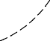C C
3 C2
4
3
D
E
B
2
A
1
1

4
100mm
1 D

Fig. (a) Fig. (b)
- The link 1 is fixed and the lengths 2, 3 & 4 are proportionate in such a way that crank AB is able to rotate completely.
- The follower CD only oscillates from C1 to C2 as shown in the fig (a).
- The initial position of the mechanism is shown by full lines whereas the dotted line show the mechanism for two extreme different positions.
- Since one link rotates & other oscillates, it is known as crank & lever mechanism.
- A part of the mechanism of beam engine , which consists of four links is shown in the fig (b)
- In fig (b), when the crank rotates about the fixed centre A, the lever oscillates about the fixed centre D.
- The end E of the fixed of the lever CDE is connected to a piston rod which reciprocates due to the rotation of the crank.
- In other words purpose of this mechanism is to convert rotary motion into reciprocating motion.

inversions
Coupling rod of locomotive or double crank mechanism (complete rotation of the crank & follower)
- In this mechanism length of link AD = length of link BC.
- Length of link AB = length of link CD.
- When AB rotates about A, the crank DC rotates about D.
- This mechanism is used for coupling locomotive wheels.
- Since links AB & CD works as cranks, this mechanism is also known as double crank mechanism.

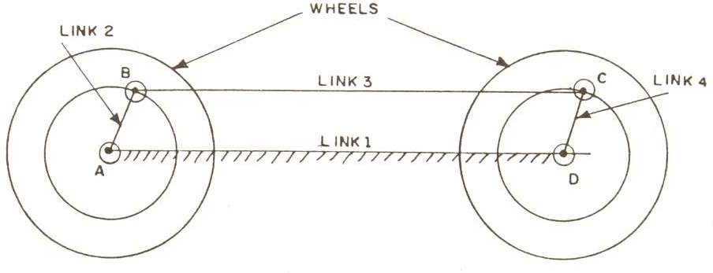

inversions

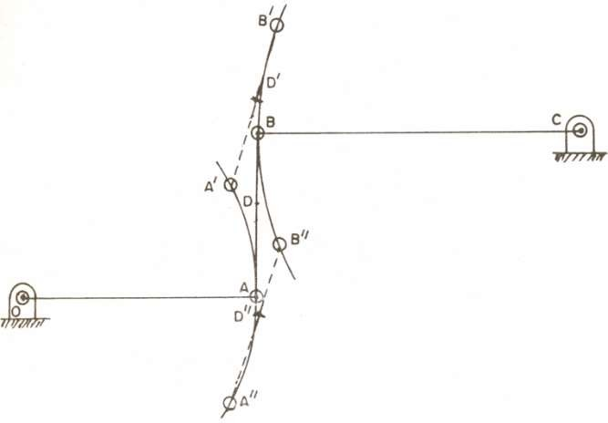
Watt’s straight line mechanism or double lever mechanism (oscillatory motion)
- It is very simple mechanism originally used by James Watt for guiding the motion of the piston of his steam engine to have an approximate straight line motion.
- It has four links OA, AB, BC & CO.
- The link CO is fixed.
- The link AO can oscillate about the centre O whereas the link BC can oscillate about the centre C as shown in the fig.
- In the mean position of the mechanism, the links AO and BC are parallel and link AB is perpendicular to AO and BC.
- It is seen that, if D is the point on link AB such that DA/DB = BC/OA, then for small oscillations of OA and BC, the point D will trace an approximate straight line.
- In fig, approximate straight line is shown when D is in three different positions.

SINGLE SLIDER CRANK CHAIN

Connecting rod
Slider
3
2
4

1

Frame
Crank 1

- It is a modification of basic four bar chain.
- It consists of a one sliding pair & three turning pairs.
- This type of mechanism converts rotary motion into reciprocating motion & vice versa.
- Turning pairs are links 1 & 2, links 2 & 3 and links 3 & 4.
- Sliding pair is links 4 & 1.

Inversions of Single slider crank chain:
- First inversion:

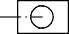Slider
Connecting rod
2
3
4
Crank 1
Frame
2
3
Connecting rod
Piston

4
1
Crank
1
Frame
Cylinder

Fig (a) Fig (b)

- When link 1 is fixed, link 2 is made as crank and link 4 is made as slider, then first inversion of single slider crank is obtained, shown in fig (a).
- This inversion is used in reciprocating engine & reciprocating compressors as shown in the fig (b), where link 1 corresponds to frame which is fixed; link 2 corresponds to crank, link 3 corresponds to connecting rod link 4 corresponds to piston.
- In case of reciprocating engines, the link 4, piston becomes driver where as in case of reciprocating compressors, link 2 (crank) is the driver.

Example: steam engine, compressors, pumps, I.C. engines etc.

- Second inversion:

B
2
3
4
A

1
C
- The second inversion is obtained by fixing the link 3 (connecting rod).
- Link 2 acts as a crank and is rotating about the point B.
- Link 4 oscillates.

Example 1: Oscillating cylinder engine mechanism

A
1
4
2
C
3
B
- It is used to convert reciprocating motion into rotary motion.
- In this mechanism, the link 3 forming the turning pair is fixed which corresponds to connecting rod of a reciprocating steam engine mechanism.
- When the crank (link 2) rotates, the piston attached to the piston rod (link 1) reciprocates and the cylinder (link 4) oscillates about a pin pivoted to the fixed link at C.

Example 2: Crank & slotted lever mechanism
- Fig (a) shows crank & slotted lever mechanism, in which link CB (link 3), corresponds to the connecting rod, is fixed.
- Driving crank AB (link 2) revolves about the centre B in clockwise direction.
- A slider (link 4) is attached to the crank pin at A slides along the slotted lever CD (link 1) and make the slotted lever oscillates about the pivoted point C.
- Link DE (link 5) is attached to the slotted lever (link 1), which in turn is connected to the cutting tool i.e. link 6.
- Link 6 is contained to slide as shown in the fig.
- Fig (b) shows the two extreme positions of the crank.
- First position is when the crank (i.e. link 2) is at right angles to link 1 (or link 1 is tangential to crank radius circle at point A1).
- The remaining corresponding points in this will be D1 & E1.
- Stroke of the cutting tool starts from point E1.
- The crank is rotating in clockwise direction.
- The end of the cutting stroke is marked by E2, when again crank after having rotated through an angle  in clock wise direction is again at right angle to the link 1 at position A2.

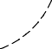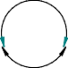6
Stroke
E1
E2
D2

B
A1
b
A2
3
E

5
D1
D
A
2
4 (slider) B

1

3

C

Fig (a)

C
Fig (b)

- Hence the cutting stroke occurs when crank rotates through an angle  and return stroke occurs when crank rotates through an angle b or (3600 - ) in clockwise direction.
- Since the crank has a uniform angular speed, therefore
Time of cutting stroke / time of return stroke =  / b =  / (3600 - )
- Since the angle  is more than angle b as seen from the fig. (b), the cutting time will be more than return time.

Third inversion:

B

A
2
3
4
1
C

- By fixing the link 2 (crank) third inversion is obtained.
- Link 3 along with slider at its end C, becomes a crank.
- Hence link 3 along with slider (link 4) rotates about B.
- By doing so, the link 1 rotates about A along with the slider (link 4) which reciprocates on link 1.

Example 1: Whiteworth Quick-Return Motion mechanism
- Fig (a) shows Whiteworth Quick Return Motion Mechanism, in which link AB (link 2), corresponds to the crank, is fixed.
- Driving crank BC (link 3) revolves about the centre B in counter clockwise direction.
- A slider (link 4) is attached to the crank pin at C slides along the slotted lever CD (link 1) and make the slotted lever oscillates about the pivoted point A.

- Link DE (link 5) is attached to the slotted lever (link 1), which in turn is connected to the cutting tool i.e. link 6.
- 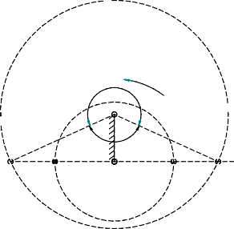Link 6 is contained to slide as shown in the fig.
4
C
3
B
1
2
6
E
A
5
D

B
b
E1
E2
C2
D1
A
D2
C1

STROKE

Fig (a) Fig (b)
- Fig (b) shows the two extreme positions of the crank.
- First position is when the slotted lever CD (link 1) is at right angles to link 2 (or link 5 is collinear to link 1 at point C1).
- The remaining corresponding points in this will be D1 & E1.
- Stroke of the cutting tool starts from point E1.
- The crank is rotating in counter clockwise direction.
- The end of the cutting stroke is marked by E2, when again driving crank after having rotated through an angle  in counter clock wise direction is again at right angle to the link 2 at position C2.
- Hence the cutting stroke occurs when crank rotates through an angle  and return stroke occurs when crank rotates through an angle b or (3600 - ) in counter clockwise direction.
- Since the crank has a uniform angular speed, therefore
Time of cutting stroke / time of return stroke =  / b =  / (3600 - )
- Since the angle  is more than angle b as seen from the fig. (b), the cutting time will be more than return time.
- Used in shaping and slotting machines.

Example 2: Rotary Engine or Gnome Engine
- Fig (a) shows Rotary Engine or Gnome Engine Mechanism, in which link AB (link 2), corresponds to the crank, is fixed.
- Link 1 is made as the piston and link 4 is made as cylinder.
- Here instead of one cylinder, seven or nine cylinders are symmetrically placed at regular intervals in the same plane.
- All the cylinders rotate about the same fixed centre A.
- The fixed link is common to all the cylinders.
- When the piston reciprocates in the cylinders, the whole assembly of cylinders, pistons & connecting rods rotate about the axis A, where entire mechanical power is developed, is obtained in the form of rotation of the crankshaft.

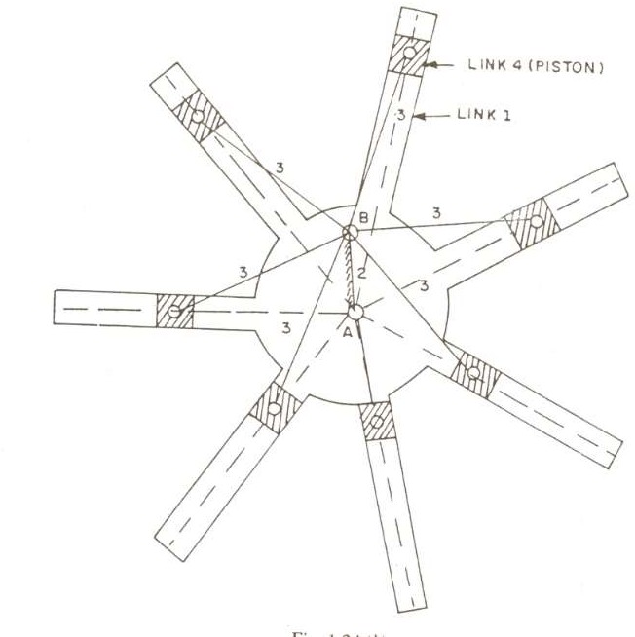
- The only difference between first inversion and this example of third inversion is that, the crank rotates & body is fixed in the first inversion, whereas here the crank is fixed and the body rotates.
- It is a rotary cylinder V type internal combustion engine used as an aero-engine, which now has been replaced by gas turbine.

Fourth inversion:
B

A
2
3
4
1
C

- By fixing the link 4 (sliding pair or cylinder) fourth inversion is obtained.
- Link 3 can oscillate about the fixed-point C on link 4.
- This makes end B of link 2 to oscillate about C and end A reciprocates along the axis of the fixed link 4.

Example: Bull Engine Mechanism or Pendulum Pump and hand pump

A
A
D
C
B
C
D

B
Fig (a) Bull Engine Mechanism or Pendulum Pump Fig (b) Hand pump

Bull Engine Mechanism or Pendulum Pump:
- This inversion is obtained by fixing the die block D as shown in the fig (a).
- As the link BC rotates, the link CD will oscillates about the pin D and the slotted link AB will reciprocates along the vertical straight line.

Hand pump:
- It is obtained by fixing the die block D as shown in the fig (b).
- As the link BC oscillates about bin D, the slotted link AB reciprocates a vertical straight line.

DOUBLE SLIDER CRANK CHAIN

1
3
2
4

1
- It is a four-bar kinematic chain containing two turning pairs and two sliding pairs.
- Link 1 & link 2 is sliding pair, link 2 & link 3 is turning pair, link 3 & link 4 is second turning pair, link 4 & link 1 is second sliding pair.
- Also, the two pairs of the same kind are adjacent (To adjacent pairs 23 & 34 are turning pairs whereas the other two pairs 12 & 14 are sliding pairs)

Inversions of Single slider crank chain:
- First inversion:

1
3
1
2
4
- When link 1 is fixed, the first inversion is obtained as shown in the fig.
- Two adjacent pairs 23 and 34 are turning pairs whereas the other two pairs 12 and 14 are sliding pair.

Example: Elliptical Trammel

Y
C
B 4
q
3
A
2
1
X
1
C
B
q
A q
O
x
y

Fig (a) Fig (b)
- The fixed link 1 has two straight grooves cut in it, at right angle to each other.
- With the movement of the sliders any point C on the link 3 (except the midpoint of AB) will trace an ellipse on a fixed plate.
- The midpoint of AB will trace a circle. Proof:
- Let the coordinates of the point C at any instant are x and y as shown in the fig (b).
- Let q is the angle made by link AC with horizontal at that instant. Then,

cosq  x
BC
and
sin q  y AC

Squaring and adding, we get

x 2
BC2
 y 2
AC2
 cos2 q  sin 2 q

x 2
BC2
y 2
 AC2  1

This is the equation of ellipse. Hence the path traced by the point C is an ellipse whose semi major axis is AC and semi minor axis is BC.
If C is the midpoint of AB, then AC = BC

x 2
AC2
y 2
 AC2  1

x 2  y 2  AC 2

This is the equation of circle whose radius is AC or BC.
Application: Used to draw an ellipse.

Second inversion:
B
3
1
1
2
A
4
- When link 2 or link 4 of the double slider crank chain is fixed, the second inversion is obtained.
- Here link 2 is fixed and end B of the link 3 rotates about the about A and link 4 will reciprocate in the vertical slot.
- Hence, link 1 reciprocates in the horizontal direction.

Example: Scotch Yoke Mechanism
- This mechanism gives simple harmonic motion.
- Here the slider A (link 2) is fixed.
- As AB (link 3) rotates about A, the slider B (link 4) reciprocates in the vertical slot and the link 1 reciprocates in the horizontal direction.
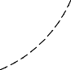
B
3
A
2
2
1
4
Application: Used to convert rotary motion to reciprocating motion. Its early application was on steam pumps, but it is now used as a mechanism on a test machine to produce vibrations.

Third inversion:

1
3
2
A
4
B

1
- When the link 3, of the double slider crank chain is fixed & link 1 is free to move, the third inversion is obtained.
- In this case, each of the slider blocks (i.e. link 2 & link 4) can turn about the pins A & B. if one slide block (say link 2) is turned through an definite angle, the frame (i.e. link 1) and other block (i.e. link 4) must turn through the same angle.

Example: Old Ham’s coupling
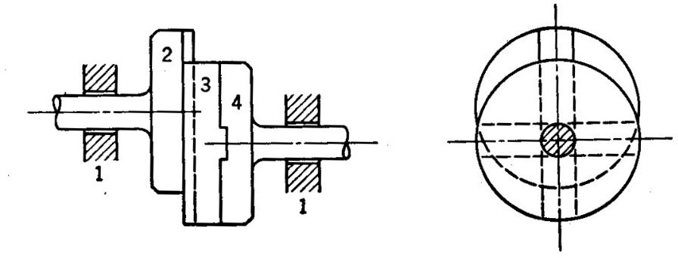
Application: Used for connecting two parallel shafts when the distance between the two shafts is small.
- The two shafts to be connected have flanges at their ends which are rigidly fastened by forging to the shafts.
- These flanges forms link 2 & link 4.
- Each of these links forms a turning pair with link 3.
- There is a diametrical slot cut in the inner faces of these flanges.
- An intermediate piece is a circular disk (link 3) has two tongues T1 & T2 on each face at right angles to each other.
- These tongues can slide fit in the slots in the two flanges (link 2 & 4).
- The link 3 can slide or reciprocate in the slots in the flanges.
- Frame and bearing forms the link 1, which is fixed.
- When the driving shaft is rotated, the flange A (link 2) connected rigidly to the driving shaft also rotates by the same angle, the intermediate piece also rotates by the same angle through which flange A has rotated.
- Due to the rotation of intermediate shaft, the flange B (link 4) connected to the driven shaft, also rotate by the same angle.
- Hence link 2, 4 & 1 have the same angular velocity at every instant.

MECHANISMS

QUICK – RETURN MECHANISMS
- In many applications, mechanisms are used to perform repetitive operations.
- In these repetitive operations, there is usually a part of the cycle, when the mechanism is under load, called working stroke.
- The remaining part of the cycle is called as the return stroke.
- The mechanism simply returns to repeat the operation without load.
- The ratio of the time for the working stroke to the time for return stroke is known as time ratio.
- To produce quick return, the time ration must be greater than unity and as large as possible.
- Quick return mechanisms are used on machine tools to give a slow cutting stroke and a quick return stroke for a constant angular velocity of the driving crank.
- The most commonly used types of quick return mechanisms are
  - Drag link mechanism
  - Whitworth mechanism
  - Crank & Slotted lever Mechanism

Drag link mechanism:
C
B 3
4 5
2 B' 6

C'' 
A D
1
b
C' E''
E E'

Stroke

B''

This is four bar mechanism with double crank in which the shortest link is fixed. If the crank AB rotates at uniform speed, the crank CD will rotate at non-uniform speed. This rotation of link CD transformed to quick return reciprocatory motion of the ram E by the link CE as shown in the figure. When the crank AB’ rotate through an angle α in counter clockwise direction during working stroke, the link CD rotates through 180°. When the crank AB’’ continues to rotate through the angle β during return stroke, the crank CD rotates through another 180°. We
can observe thatˆ  bˆ . Hence time of working stroke is  times more or return stroke is 
b b
times quicker. Shortest link always the stationary link. Sum of the length of shortest and the longest links of the four links 1, 2, 3 and 4 should be less than the sum of the other two links length. It is the necessary condition for drag link quick return mechanism.

Whitworth mechanism:
Refer the third inversion of single slider crank chain mechanism.

Crank & Slotted lever Mechanism:
Refer to the second inversion of single slider crank chain mechanism.

STRAIGHT LINE MOTION MECHANISMS
- These are used to produce straight motions.
- These mechanisms may produce exactly straight line motion or approximate straight line motion.
- In these mechanisms either only turning pairs are connected or one sliding pair is used.
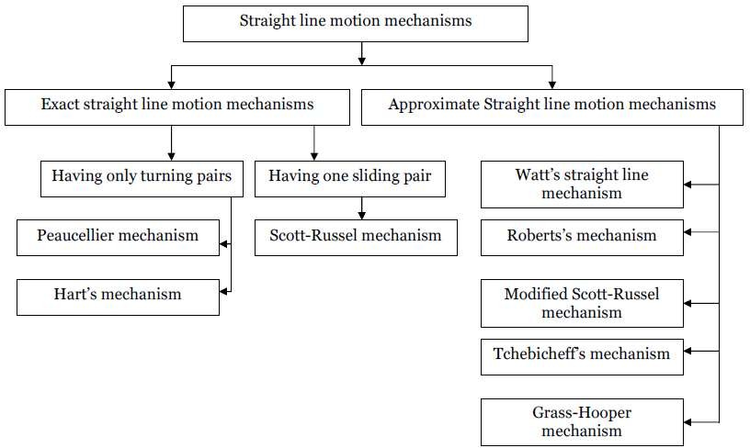

Condition for Exact straight line motion mechanisms:
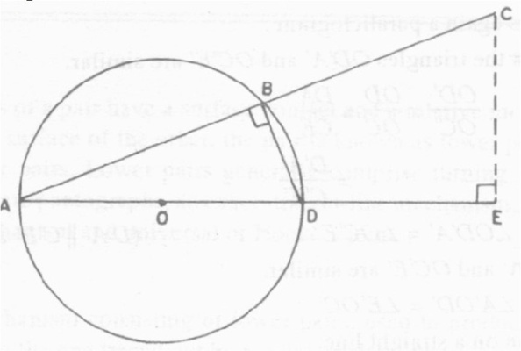
- Let O be the centre of a circle of diameter AD.
- AB is any chord.
- The triangle inscribed on a semi- circle (i.e.Δ ABD) will be right angled triangle.
- The chord produced up to the point C.
- From C, draw a line CE perpendicular to the diameter AD produced.

- Then locus of point C will be straight line, perpendicular to the diameter AD, provided the product of AB×AC is a constant.

Proof: The Δ AEC & Δ ABD are similar as  DAB= EAC (common angle) and
 ABD= AEC = 90°

Hence,
AD  AB

AC AE
Or ABAC = ADAE
But AD is the diameter of the circle and hence it is constant. If AE also constant then ABAC will be a constant when the perpendicular from the point C always coincides with point E. Hence the projection of C should always be at E.

Peaucellier mechanism:
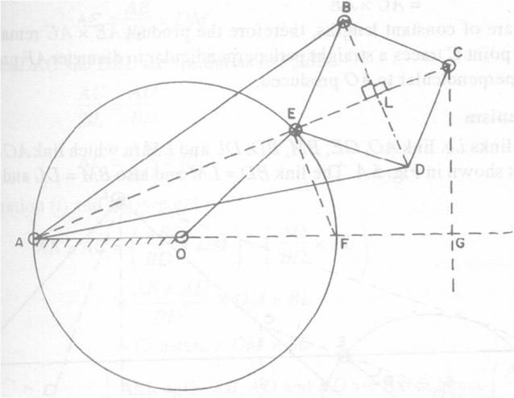
- It consists of eight links i.e. links AO, OE, AB, AD, EB, BC, CD and DE in which link AO is fixed and the link OE is rotating about point O, as shown in the fig.
- Links BC = CD = DE = EB, thus form a rhombus and link AB = AD.
- All the links are connected to pin joints.
- The pin at E is constrained to move along the circumference of a circle of diameter AF by means of link OE, thus OA = OE.
- As the link OE moves around O, the point C moves in the straight line perpendicular to AO produced.

Proof:
- Since BCDE is a rhombus, the diagonals EC & BD will bisect each other at right angles. Hence ELB = CLB = 900 .
- Also, the AEF will be right angle for all positions of E, as it is angle subtended by a diameter of the circle on the circumference of the circle.
- In ∆AEB & ∆ADE, AB=AD, BE=ED & AE is common. Therefore, these two triangles are similar.
- Hence EAB = EAD. Therefore point E lies on the bisector of DAB (1)

- In ∆ACB & ∆ACD, AB=AD, BC=CD & AC is common. Therefore these two triangles are similar.
- Hence CAB=CAD. Therefore, point C lies on the bisector of DAB (2)
- From (1) & (2), it is clear that AEC is a straight line.
- Now in right angled triangle ALB,

AB 2 =AL2+LB 2 (3)
Now in right angled triangle CLB,
BC 2  CL2LB 2 (4)
Subtracting equation (4) from (3), we get
AB 2  BC 2 AL2CL2
 ( ALCL).( ALCL)
 AC ( ALEL)
 ACAE
- But AB & AC are of constant lengths; therefore, the product AE×AC remains constant.
- Hence point C traces a straight path perpendicular to the diameter AF produced.
- Hence point C moves in a straight line perpendicular to AO produced.

Roberts Mechanism:
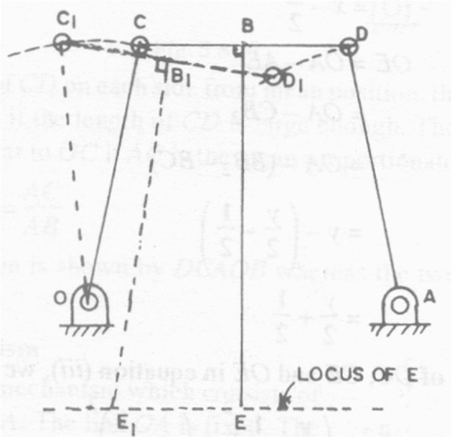
- This is also a four-bar chain mechanism.
- In the mean position, it has the form of trapezium.
- The links OC & AD are of equal lengths and link OA is fixed.
- A bar EB is rigidly attached to the link CD at the midpoint B of the link CD.
- The bar EB is right angle to CD.
- The bar EB is at right angle to CD.
- The point E is the tracing point.
- When the mechanism is displaced as shown in the fig. by the dotted lines, the point E will trace an approximate straight line.

INTERMITTENT MOTION MECHANISM
Intermittent motion means that the motion is not continuous but it is ceased at definite intervals. There are many instances where it is necessary to convert continuous motion into intermittent motion. One of the examples is the indexing of work table on a machine tool.

Ratchet & Pawl mechanism:
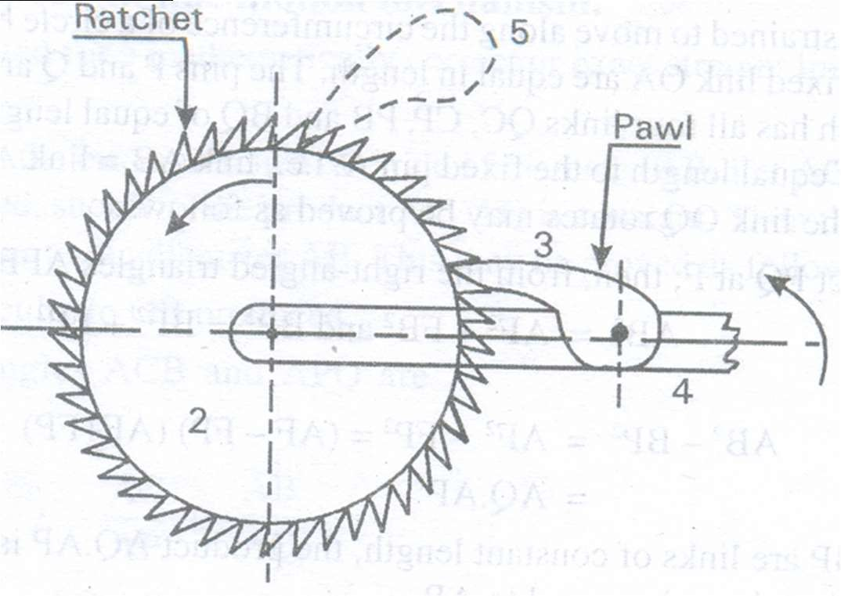
- It consists of a ratchet wheel 2 and a pawl as shown in the fig.
- When the lever 4 carrying, pawl is raised, the ratchet wheel rotates in counter clockwise direction (driven by pawl).
- As the pawl lever is lowered the pawl slides over the ratchet teeth.
- One more pawl 5 is used to prevent the ratchet from reversing.

Application of Ratchet & Pawl mechanism:
- Used to produce intermittent rotary motion from an oscillating or reciprocating member.
- Used in feed mechanisms, lifting jacks, clocks, watches & counting devices.

Geneva mechanism:
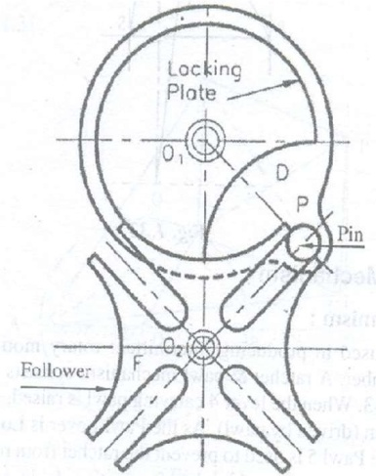
  - It consists of a driving wheel D carrying a pin which engages in a slot of the follower F.
  - The slots are positioned so that the pin enters and leaves them tangentially.

  - Thus, advantage of this mechanism is that it provides indexing without impact loading.
  - During one quarter revolution of the driving plate, the pin & follower remains in contact and hence the follower is turned by one quarter turn.
  - During remaining time of one revolution of driver, the follower remains in at rest, locked in position by circular arc (locking plate).

Applications: (i) Used to prevent over winding of main springs in clock & watches.
  - Feeding the strips of films in a quick advance in early motion pictures.
  - Indexing of a work table on a machine tool.

Toggle Mechanism:
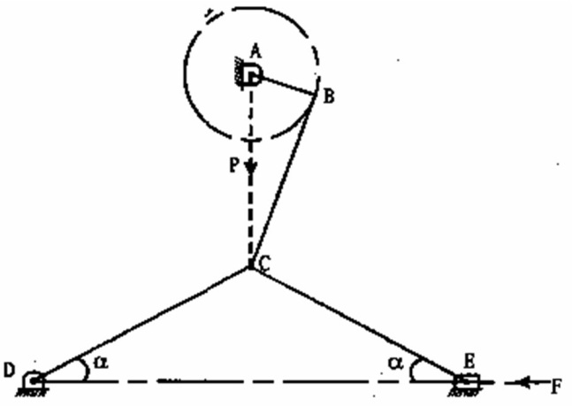
Principle: In slider, crank mechanism, as the crank approaches one of its dead-centre positions, the movement of the slider approaches zero. The ratio of the crank movement to the slider movement approaches infinity, which is proportional to the mechanical advantage. Links CD and CE are of same length.
Resolving the forces at C vertically, we get F sin P

cos 2
Or F  P

2 tan
Thus for a given value of P, as the links CD & CE approaches collinear position (α→0), the force F raises rapidly.
Applications: (i) Used where large force acting through short distance is required.
- Used in toggle clamps, riveting machines, punch presses, stone crushers.
- Used in switches, circuit barkers and other mechanisms where snap action is required.

Pantograph or double lever mechanism (oscillatory motion)
  - It consists of a jointed parallelogram ABCD as shown in the fig.
  - It is made up of bars connected by turning pairs.
  - AB = CD & parallel to each other and also AD = BC & parallel to each other.

  - Extend any two adjacent AB to O and BC to E, such that the points O & E lies in the same straight line through the fourth turning pair D. Thus, ODE lies in a straight line.
  - Make any point O or E as fixed pivot point. Thus, the pantograph mechanism is completed.
  - For all relative positions of the links, the triangles OAD & OBE are similar and points ODE lie on a straight line.
  - It can be proved that the point E traces the same path as described by D.

B

A
C

O E
A' D B'

D' C'

E'

Proof: From the similar triangles OAD & OBE, we find that the
OA  OD  AD
OB OE BE
Since point O is fixed and the points D & E move to some new position D` & E`. Then,
OD  OD'
OE OE'
A little consideration will show that the straight-line DD’ is parallel to the straight-line EE’. Hence,
OD  OD'  DD'
OE OE' EE'
Thus, the ratio of lengths OD:OE from the fixed pivot point O remains same as the links are moved. This is same for all the positions. Hence E traces out the same path as described by point D, but to a reduced scale by a fixed incorporated ratio.
Uses:
- It is used as a geometric instrument to reproduce geometrical figures and plane areas of irregular shapes such as maps, plans & drawings etc. on enlarged or reduced scales.
- Used to guide the cutting tools.
- Used as an indicator rig to reproduce the displacement of the cross head of reciprocating engine mechanism which give the displacement of piston.

Condition for correct steering in motor cars:
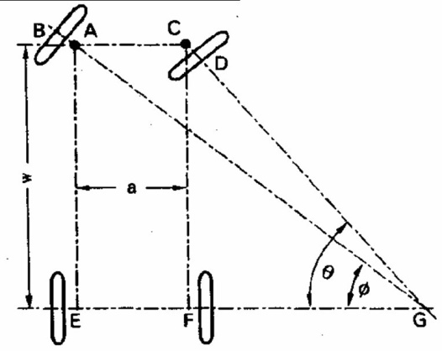
  - It is a mechanism for changing the direction of motion of two or more wheel axels with respect to chassis, in order to move the car in any desired path.
  - The front wheels are mounted on short separate axels which are pivoted to the chassis of the vehicle.
  - The rear wheels have a common axel and this is fixed.
  - Steering is usually effected by turning the axes of rotation of the two front wheels relative to the chassis of the vehicle.
  - If the car is making a right turn as shown in the fig., the axis of the right wheel must swing about pin C through a greater angle than the left wheel about A.

The condition of the good steering is that, the relative motion between the wheels of the vehicle and the road surface must be one of pure rolling.
  - To satisfy above condition, the swing of the two axes would be such that their centre lines extended would always intersect on the centre line of the rear axle at G.
  - Then all parts of the cars would be moving about the vertical axis through G and the tendency of the wheels to skid would be reduced to a minimum.

Let, w = wheel base = AE = CF, a = wheel track = AC = EF From the fig.
AC = EF = EG – FG (1)

From Δ AEG,
tan 

EG 

AE EG AE
tan

 AE cot

Similarly from Δ CFG, FG = CF cotθ
Substituting the value of EG and FG in equation (1), we get AC = AE cot- CF cotθ
a = w cot- w cotθ= w (cot- cotθ)
or

→ Condition for correct steering
cot- cotθ= a/w
So, for correct steering the steering gear must obey this equation whatever may be the radius of curvature of the path followed by the car.

Ackermann Steering gear:
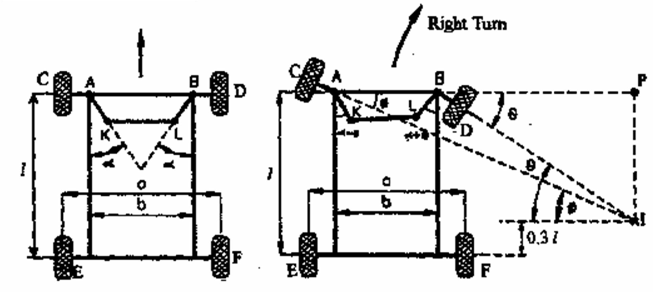
- It consists only of turning pairs and is based on a four bar chain in which two longer links AB & KL are unequal in length, while the two shorter links AK & BL are equal in lengths.
- As is made up of only turning pairs wear & tear of the parts is less & cheaper.
- In the mid position, when the car is moving along the straight path, the link AB & KL are parallel and the links AK & BL each inclined at an angle  to the longitudinal axis of the car.
- When the vehicle steers about the right as shown in the fig., the short link BL turned so as to increase the , whereas the long link LK causes the other short link AK to turn so as to reduce .
- In the above arrangement, it is clear that the angle  through which AK turns is less than the angle θ through which the BL turns and therefore the left front axle turns through a smaller angle than the right front axle.

- Condition for correct steering in motor cars is
cot cotq b .
l

- The value of the  obtained for a given value of θ would depend upon the ratio AK/AB and the angle .
- In this mechanism, the instantaneous centre does not lie on the axis of the rare axel, but on a line parallel to the rear axle axis at an approximate distance of 0.3l above it.
- Three correct steering position will be:
  - when moving straight
  - When moving one correct angle to the right corresponds to the link ratio AK/AB and angle .
  - Similar position when moving to the left.

