What is Photosynthesis By Science and Technology Concepts <https://ssec.si.edu/science-and-technology-concepts-middle-school>>

When plants require food they have no ready source of food except for the earth materials hence plants need sunlight, water, and soil to grow, but where do they get their food? they make it themselves!
Plants are hence called the “autotrophs”(that which can make its own food) because they can use energy from sun light to synthesize, or make, their own food source. Many people believe they are “feeding” a plant when they put it in soil, water it, or place it outside in the Sun, but none of these things are considered food. Rather, plants use sunlight, water, and the gases in the air to make glucose, which is a form of sugar that plants need to survive. This process is called photosynthesis and is performed by all plants, algae, and even some microorganisms. To perform photosynthesis, plants need three things: carbon dioxide, water, and sunlight.
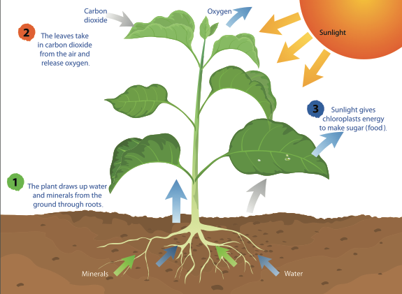
By taking in water (H₂O) through the roots, carbon dioxide (CO₂) from the air, and light energy from the Sun, plants can perform photosynthesis to make glucose (sugars) and oxygen (O₂).
CREDIT: mapichai/Shutterstock.com

Plants need to take in gases in order to live like all animals take in gases through a process called respiration. In animals, during the respiration process, all of the gases in the atmosphere are inhaled, but the only gas that is retained and not immediately exhaled is oxygen. Plants also use the gases the same way, however, during the process of gaseous exchange they take in and use carbon dioxide gas for photosynthesis apart from the oxygen.
Carbon dioxide enters through tiny holes in a plant’s leaves (cells called Stomata), flowers, branches, stems (the pores in the branches of trees are called lenticels), and roots. Plants also require water to make their food. Depending on the environment, a plant’s access to water will vary. For example, desert plants, like a cactus, have less available water than a lilypad in a pond, but every photosynthetic organism has some sort of adaptation, or special structure, designed to collect water. For most plants, roots are responsible for absorbing water.
The last requirement for photosynthesis is an important one because it provides the energy to make sugar.

How does a plant take carbon dioxide and water molecules and make a food molecule?
The Sun! The energy from Sunlight causes a chemical reaction in the Green part of the leaves that breaks down the molecules of carbon dioxide and water and reorganizes them to make the sugar (glucose) and oxygen gas. The Carbon dioxide is condensed into a 6 Carbon compound and that is the sugar that is produced,
To release energy the whole process is reversed by breaking down the Glucose by the mitochondria into energy that can be used for growth and repair. The oxygen that is produced is released from the same tiny holes through which the carbon dioxide entered. Even the oxygen that is released serves another purpose. Other organisms, such as animals, use oxygen to aid in their survival.

If we were to write a formula for photosynthesis, it would look like this:

6CO₂ + 6H₂O + Light energy → C₆H₁₂O₆ (sugar) + 6O₂

The whole process of photosynthesis is a transfer of energy from the Sun to a plant. In each sugar molecule created, there is a little bit of the energy from the Sun, which the plant can either use or store for later.

https://www.livescience.com/51720-photosynthesis.html
Types of photosynthesis:
There are two types of photosynthetic processes: oxygenic photosynthesis and anoxygenic photosynthesis. The general principles of anoxygenic and oxygenic photosynthesis are very similar, but oxygenic photosynthesis is the most common and is seen in plants, algae and cyanobacteria.

During oxygenic photosynthesis, light energy transfers electrons from water (H₂O) to carbon dioxide (CO₂), to produce carbohydrates. In this transfer, the CO₂ is "reduced," or receives electrons, and the water becomes "oxidized," or loses electrons. Ultimately, oxygen is produced along with carbohydrates.Oxygenic photosynthesis functions as a counterbalance to respiration by taking in the carbon dioxide produced by all breathing organisms and reintroducing oxygen to the atmosphere.

On the other hand, anoxygenic photosynthesis uses electron donors other than water. The process typically occurs in bacteria such as purple bacteria and green sulfur bacteria, which are primarily found in various aquatic habitats. "Anoxygenic photosynthesis does not produce oxygen -hence the name,"

Though both types of photosynthesis are complex, multistep affairs, the overall process can be neatly summarized as a chemical equation.

Oxygenic photosynthesis is written as follows:

6CO2 + 12H2O + Light Energy → C6H12O6 + 6O2 + 6H2O

Here, six molecules of carbon dioxide (CO2) combine with 12 molecules of water (H2O) using light energy. The end result is the formation of a single carbohydrate molecule (C6H12O6, or glucose) along with six molecules each of breathable oxygen and water.

Similarly, the various anoxygenic photosynthesis reactions can be represented as a single generalized formula:
CO₂ + 2H₂A + Light Energy → [CH₂O] + 2A + H₂O

The letter A in the equation is a variable and H2A represents the potential electron donor. For example, A may represent sulfur in the electron donor hydrogen sulfide (H₂S), explained Govindjee and John Whitmarsh, plant biologists at the University of Illinois at Urbana-Champaign, in the book "Concepts in Photobiology: Photosynthesis and Photomorphogenesis" (Narosa Publishers and Kluwer Academic, 1999).

The Photosynthetic Apparatus:
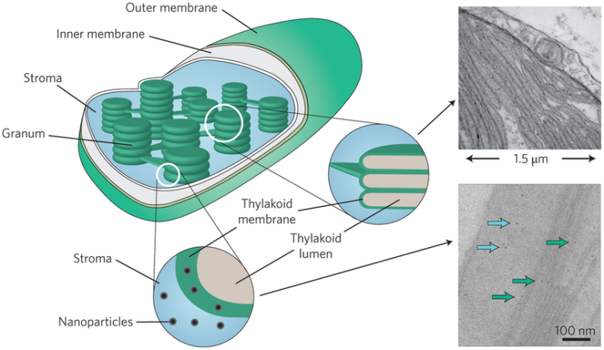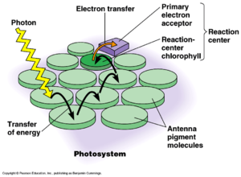
The following are cellular components essential to photosynthesis.

Pigments:
Pigments are molecules that bestow color on plants, algae and bacteria, but they are also responsible for effectively trapping sunlight. Pigments of different colors absorb different wavelengths of light. Below are the three main groups.

Chlorophylls: These green-colored pigments are capable of trapping blue and red light. Chlorophylls have three subtypes, dubbed chlorophyll a, chlorophyll b and chlorophyll c. According to Eugene Rabinowitch and Govindjee in their book "Photosynthesis"(Wiley, 1969), chlorophyll a is found in all photosynthesizing plants. There is also a bacterial variant aptly named bacteriochlorophyll, which absorbs infrared light. This pigment is mainly seen in purple and green bacteria, which perform anoxygenic photosynthesis.
Carotenoids: These red, orange or yellow-colored pigments absorb bluish-green light. Examples of carotenoids are xanthophyll (yellow) and carotene (orange) from which carrots get their color.
Phycobilins: These red or blue pigments absorb wavelengths of light that are not as well absorbed by chlorophylls and carotenoids. They are seen in cyanobacteria and red algae.

Plastids:
Photosynthetic eukaryotic organisms contain organelles called plastids in their cytoplasm. The double-membraned plastids in plants and algae are referred to as primary plastids, while the multiple-membraned variety found in plankton are called secondary plastids, according to an article in the journal Nature Education by Cheong Xin Chan and Debashish Bhattacharya, researchers at Rutgers University in New Jersey.

Plastids generally contain pigments or can store nutrients. Colorless and nonpigmented leucoplasts store fats and starch, while chromoplasts contain carotenoids and chloroplasts contain chlorophyll, as explained in Geoffrey Cooper's book, "The Cell: A Molecular Approach" (Sinauer Associates, 2000).

Photosynthesis occurs in the chloroplasts; specifically, in the grana and stroma regions. The grana is the innermost portion of the organelle; a collection of disc-shaped membranes, stacked into columns like plates. The individual discs are called thylakoids. It is here that the transfer of electrons takes place. The empty spaces between columns of grana constitute the stroma.

Chloroplasts are similar to mitochondria, the energy centers of cells, in that they have their own genome, or collection of genes, contained within circular DNA. These genes encode proteins essential to the organelle and to photosynthesis. Like mitochondria, chloroplasts are also thought to have originated from primitive bacterial cells through the process of endosymbiosis.

"Plastids originated from engulfed photosynthetic bacteria that were acquired by a single-celled eukaryotic cell more than a billion years ago," Baum told Live Science. Baum explained that the analysis of chloroplast genes shows that it was once a member of the group cyanobacteria, "the one group of bacteria that can accomplish oxygenic photosynthesis."

In their 2010 article, Chan and Bhattacharya make the point that the formation of secondary plastids cannot be well explained by endosymbiosis of cyanobacteria, and that the origins of this class of plastids are still a matter of debate.

Antennae:
Pigment molecules are associated with proteins, which allow them the flexibility to move toward light and toward one another. A large collection of 100 to 5,000 pigment molecules constitutes "antennae," according to an article by Wim Vermaas, a professor at Arizona State University. These structures effectively capture light energy from the sun, in the form of photons. 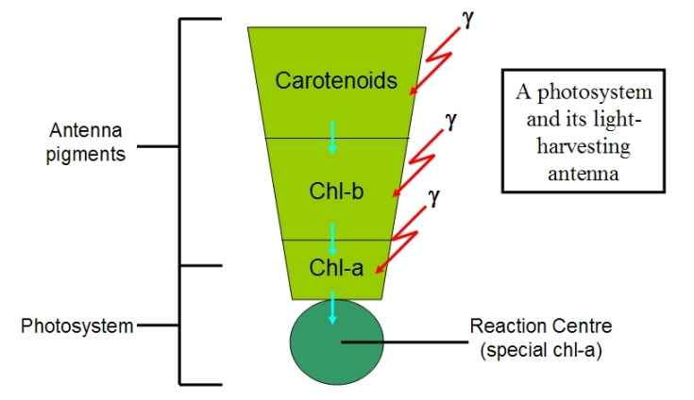

Ultimately, light energy must be transferred to a pigment-protein complex that can convert it to chemical energy, in the form of electrons. In plants, for example, light energy is transferred to chlorophyll pigments. The conversion to chemical energy is accomplished when a chlorophyll pigment expels an electron, which can then move on to an appropriate recipient.

Reaction centers:

The pigments and proteins, which convert light energy to chemical energy and begin the process of electron transfer, are known as reaction centers.

The photosynthetic process:
The reactions of plant photosynthesis are divided into those that require the presence of sunlight and those that do not. Both types of reactions take place in chloroplasts: light-dependent reactions in the thylakoid and light-independent reactions in the stroma.

- Light-dependent reactions (also called light reactions): When a photon of light hits the reaction center, a pigment molecule such as chlorophyll releases an electron. "The trick to do useful work, is to prevent that electron from finding its way back to its original home," Baum told Live Science. "This is not easily avoided, because the chlorophyll now has an 'electron hole' that tends to pull on nearby electrons."

The released electron manages to escape by traveling through an electron transport chain, which generates the energy needed to produce ATP (adenosine triphosphate, a source of chemical energy for cells) and NADPH. The "electron hole" in the original chlorophyll pigment is filled by taking an electron from water. As a result, oxygen is released into the atmosphere.

- Light-independent reactions (also called dark reactions and known as the Calvin cycle): Light reactions produce ATP and NADPH, which are the rich energy sources that drive dark reactions. Three chemical reaction steps make up the Calvin cycle: carbon fixation, reduction and regeneration. These reactions use water and catalysts. The carbon atoms from carbon dioxide are “fixed,” when they are built into organic molecules that ultimately form three-carbon sugars. These sugars are then used to make glucose or are recycled to initiate the Calvin cycle again.

