Department of Electronics and Communication Engineering
SUBJECT: SATT (PC303 EC)
ASSIGNMENT-I
- Show that whether the unit step signal is a power or energy signal.
- Write the relation between exponential and trigonometric Fourier series coefficients.
- Find the trigonometric Fourier series of the following signal x(t)
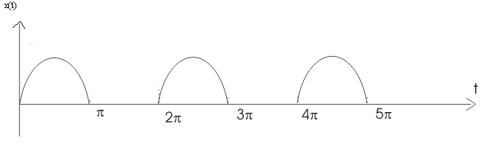
- Determine the even and odd part of the following signal
x(t)= sin(3t)+cos(2t)+sin(t)cos(2t).
- Determine the energy of the signal x(t)=e^{-5t} u(t).
- Find the inverse Laplace transform of X(S) = 1/ (s+1) (s-2) (s+3)?
- ROC>2 b)ROC<-3 c) -1< Roc<2
- Write properties of Fourier transform and Laplace Transforms.

Note: Last date for submission of assignment-I is 25-08-2018

