UNIT II
- Competency Definition
- Any attitude, skill, behaviour, motive, or other personal characteristic that is essential for an individual to perform a job or, more importantly, differentiates ‘solid’ from ‘outstanding’ performance.

- Competencies Required By Employees
Competencies required by an employee for excellent performancce
- Adaptability
- Commitment
- Creativity
- Motivation
- Foresight
- Leadership
- Independence
- Emotional Stability
- Analytical Reasoning and
- Communication Skills

Behavioural Competencies
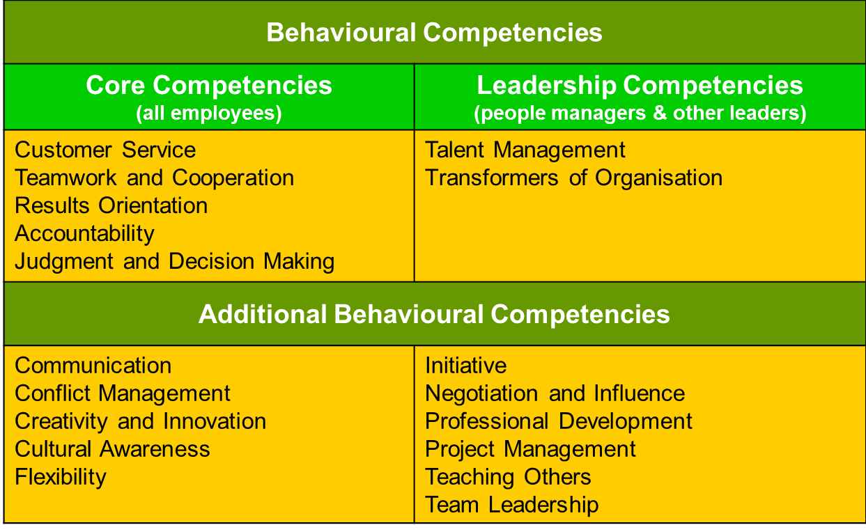

Competency Iceberg Model
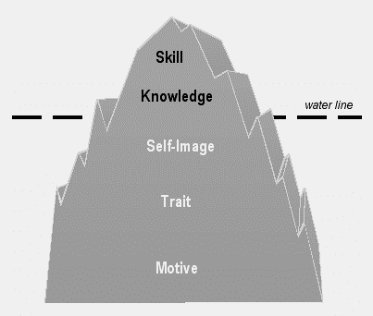
Competency Iceberg Model
- We can think of competencies in terms of an iceberg
- Technical competencies (Knowledge, Skill) are at the tip - above waterline, clearly visible & easier to assess
- Behavioral competencies (Self-image, Trait, Motive) are below the waterline - more difficult to assess & often harder to develop
- Behavioral competencies can be understood as manifestations of:
- how a person views him or herself (self-image)
- how he or she typically behaves (traits) or
- which gives purpose & direction to his behaviour (motives)
Competencies
- Skill - A person's ability to do something well (Excellent in use of Microsoft Word)
- Knowledge - Information that a person uses in a particular area (speaks many languages)
- Self-image - A person's view of him or herself, identity, personality and worth (leader, or developer of people)
- Trait - A typical aspect of a person's behavior (good listener)
- Motive - What drives someone's behavior in a particular area (achievement, affiliation or power)

Types of Competencies
There are five types of competencies:
- Core Competencies
- Technical/Professional/Functional competencies
- Behavioural Competencies
- Threshold competencies
- Differentiating competencies

- Core Competencies - Internal capability that is critical to the success of business, to be possesses by all individuals
- Technical/Professional/Functional Competencies -Specific knowledge & skills required to be effective in a job
- Behavioural competencies - Motives, traits & attributes that shape behaviour & reflect “how” one applies one’s knowledge & skills in order to achieve results
- Threshold competencies - Characteristics required by a jobholder to perform a job effectively
Differentiating competencies - Characteristics which differentiate superior performers from average performers
Main Competency Components
- Definition
• Explains what the competency means
• Provides common language that everyone can understand in the same way
- Scale
• Lays out a behaviour pattern for each level - begins with basic behaviour and gradually increases
• Represents a logical and progressive development sequence
Relationship Building Competency – Definition
Ability to develop contacts & relationships, internal & external to the organization, to facilitate work efforts or to gain support/cooperation
Relationship Building Competency – Five Level Scale
1. Understands the significance of networking
2. Identifies/approaches key stakeholder contacts
3. Actively seeks relationship-building opportunities
4. Organizes involvement of key players
5. Builds a network of contacts
Competency Characteristics
- The various attributes of a specific competency is known as the characteristics of the competency
Leadership competencies – Characteristics
- Decisiveness
- Strategic Orientation
- Development of People
- Team Leadership
- Achievement Orientation
- Self-Confidence and Courage of Conviction
- Impact and Influence
- Relationship Building
Interpersonal Competencies – Characteristics
- Respect for client
- Listening skills
- Oral communication skills
- Written communication skills
- Leadership skills
- Negotiation skills
- Coaching skills
- Presentation skills
- Teamwork skills
- Facilitation skills
- Conflict management skills
- Ability to work in an environment of diversity
- Interviewing skills
- Flexibility
Role of Leaders :
- Leaders, directors and managers run an organization through their leadership
- The competencies acquired by them through formal education & experience help them to improve
- the organization’s productivity & revenues and
- human capital values
- Senior leadership should recognize the importance of the following aspects in talent management:
- Talent
- Competency
- Training, education & on the job experience
- Placement, Rotation, Succession Planning & Performance Management
- Health & Safety
- Motivation & Innovation
- Role of Leaders in Talent Management
- Involvement of top executives in driving or actively participating in the TM strategy is critical to its success
- Proactive role & role modeling and demonstrated commitment of top executives are very important
- - To ensure successful implementation of talent management throughout the organization
- Senior leadership should be aware of economic & intangible benefits of integrated, strategically aligned human capital asset management systems

- They should know the economic benefits of integrated talent management as follows:
- increased revenues
- customer satisfaction
- improved quality
- increased productivity
- reduced cost
- reduced cycle time
- increased return to shareholders and
- Increased market capitalization
- They should know the intangible benefits of TM as follows:
- - employees’ satisfaction
- - motivated work force
- - climate conducive to innovativeness & creativity and
- high individual and team performance
- In Organizations which have not fully exercised TM, role of senior leadership as change agents/sponsors to introduce TM is very crucial
- Senior leadership should look at human resources as source of people power & human capital asset
- Senior leadership should disperse shared vision & strategic intents throughout the organization
- to give clear direction for talent, competency & human capital mgt, in order to achieve common goals
- Senior leadership has many ways to demonstrate & exercise commitment, interest and participation
- - in the fabric of talent, competency & human capital management processes
- A few examples given below:
- Personnel Development Committee/Human Resource Development Forum
- Succession Plan & Leadership Development
- Strategic Business Plan & Deployment
Personnel Development Committee/ Human Resource Development Forum:
- PDC/HRD Forum discusses human resources development throughout the organization
- It involves joint assessment & evaluation of key personnel talent, competency and performance to identify and determine candidates for filling:
- vacant positions
- cross-assignments
- relocations
- promotions and
- successions
- Committee discusses periodically the training & development needs for fast-tracks
- It discusses talent management issues & review human capital development strategy
- The Committee consists of senior leadership of the respective organization as Members/Chairman

- Top leadership takes the lead &
- Human resource professionals can facilitate the meetings
Succession Plan and Leadership Development
- A board led by top executive, takes the responsibility for succession plan of key leadership positions
- based on recommendations and inputs from the PDC or HRD Forum.
- Each candidate is scrutinized for his talent & level of competency against required talent & competency
- Board also discusses leadership development profile conforming to strategic intents & changing business environment
Strategic Business Plan and Deployment
- Strategic planning process constitutes:
- Formulation of shared Vision, Mission, Values and
- Determination of strategy, strategic intents and objectives of the organisation
- Assessment & analysis of company SWOT precedes the business plan process
- The role of senior leadership in the strategic planning & deployment process is to ensure that - investment in & development of human capital becomes an integral part of the company business plan
- The leadership should ensure that
- - there is continuing processes of exploring for new & talented human capital potentials
- - developing them and making them efficient & high performing productive human capital
- - The process must add value to shareholders & to company wealth
- These continuing processes are keys to sustainable company success and growth
Role of CEO’s in Talent Management:
- A recent study shows Chief Executive Officers (CEOs) of top companies are becoming increasingly responsible for and involved in talent management.
- They are spending a large amount of their time often more than 20% on talent management.
Talent management has become more important to them, because of a growing recognition that it helps to drive corporate performance
- Good talent management should be done through comprehensive development programmes.
- The process should identify leadership potential, evaluate performance and carry out targeted development activities
- Many CEOs are mentoring executives in their organisations
- They regard the development of the next generation of leaders as one of the best ways of leaving a strong legacy

