Talent and Knowledge Management
Unit I
Unit – I:
Meaning and importance of talent management. Designing and building a talent reservoir–Segmenting the Talent Reservoir. Talent Management Grid. Creating a talent management system. Institutional strategies for dealing with talent management.
Definition of Talent Management: An organization's attempts to recruit, keep, and train the most gifted and highest quality staff members that they can find, afford and hire. Talent management gives business managers an especially important role to play in recruiting, developing and retaining desirable staff members.
Talent Management, as the name itself suggests is managing the ability, competency and power of employees within an organization. The concept is not restricted to recruiting the right candidate at the right time but it extends to exploring the hidden and unusual qualities of your employees and developing and nurturing them to get the desired results. Hiring the best talent from the industry may be a big concern for the organizations today but retaining them and most importantly, transitioning them according to the culture of the organization and getting the best out of them is a much bigger concern.
Talent Management in organizations is not just limited to attracting the best people from the industry but it is a continuous process that involves sourcing, hiring, developing, retaining and promoting them while meeting the organization’s requirements simultaneously. For instance, if an organization wants the best talent of its competitor to work with it, it needs to attract that person and offer him something that is far beyond his imagination to come and join and then stick to the organization. Only hiring him does not solve the purpose but getting the things done from him is the main task. Therefore, it can be said that talent management is a full-fledged process that not only controls the entry of an employee but also his or her exit.
We all know that it’s people who take the organization to the next level. To achieve success in business, the most important thing is to recognize the talent that can accompany you in achieving your goal. Attracting them to work for you and strategically fitting them at a right place in your organization is the next step. It is to be remembered that placing a candidate at a wrong place can multiply your problems regardless of the qualifications, skills, abilities and competency of that person. How brilliant he or she may be, but placing them at a wrong place defeats your sole purpose. The process of talent management is incomplete if you’re unable to fit the best talent of the industry at the place where he or she should be.
Some organizations may find the whole process very unethical especially who are at the giving end (who loses their high-worth employee). But in this cut-throat competition where survival is a big question mark, the whole concept sounds fair. Every organization requires the best talent to survive and remain ahead in competition. Talent is the most important factor that drives an organization and takes it to a higher level, and therefore, cannot be compromised at all. It won’t be exaggerating saying talent management as a never-ending war for talent!
Need for Talent Management:

There are various factors why organization needs talent development. It is because to compete effectively in a complex and dynamic environment to achieve sustainable growth. The organization needs talent development to develop leaders for tomorrow from within an organization. İt is also to maximize employee performance as a unique source of competitive advantage. Talent development also helps empower employees by cutting down on high turnover rates and reducing the cost of constantly hiring new people to train.

Factors Influencing Talent:
There are many factors which cause instability in an organization’s workforce. Some of these factors are illness, retirement, attrition or finding better jobs. Considering this unstable environment and in order to create stability for the future of the organization, they need to hire capable people for key positions. One of the important tools for attracting, developing, and retaining the talent in the workforce is succession planning. There are many factors influencing the implementation of an effective succession planning system in organizations.
Most organizations found that they must rely on their employees as the only way to become stable in this competitive age. Organizations need to develop their employees’ knowledge, skills, talents and capabilities. Many organizations use succession planning to develop and maintain powerful leadership and other key employees to make sure that they address all the skills and competencies required for the economic environment.
One of the human resource tools which can help the current and future needs of organizations, is succession planning. Succession planning is a helpful approach to find the appropriate people who are needed for leadership positions or other key positions in the organizations .Haraf (2005) states that, the need for effective succession plans is increasing in the organizations, but many companies and organizations do not pay enough attention to such plans and many of them are facing many challenges and barriers in the process of these programs.
In an overall definition, succession planning is a vital structure that takes into account the organization’s resources for the maintenance and development of high potential employees. Over the years, many studies conducted in the field of succession planning. However, some researchers believe that beginning research in succession planning issues is related to the early 20th century with the writings of Henri Fayol about the fourteen points of management but succession planning and management as we know it nowadays arrivedof age in the late 1960’s and early 1970’s, when formal succession planning methods were adopted by organizations. Some methods which were used in succession planning were estimating the performance and potential of the group of talented employees, planning their movement through the organization, and establishing detailed developmental plans.
Historically, organizations only paid attention to replace the employees exactly before they were to leave the organization and the decision about the people who would replace them usually was made by the chief executives or board of directors. The focus was on replacing the employees, not to develop them and in many cases it did cost a lot for the organizations.
In fact, in today’s dynamic world where competition is high, work is fluid, environment is unpredictable, organizations are flatter, and the organizational configuration frequently changes, the old view of succession planning by defining specific people for the specific job does not work . Nowadays, organizations found the alternative way. They discovered that in order to be certain of having proper talents for the future needs, they must train leaders and key employees.
Succession planning is used as an essential and strategic tool for the organizations to attract, develop, and retain talent in the workforce. As a comprehensive definition, succession planning can be defined as an attempt to have a plan for the right number and quality of key position employees, including managers to cover retirements, promotions, serious illnesses, death or any new job, which may be created in the future of the organization’s plans .
Importance Of Talent Management
Like ,Human Capital, Talent Management Is Gaining Increased Attention. Talent Management (TM) Brings Together A Number Of Important Human Resources (HR) And Management Initiatives.
Organizations That Formally Decide To "Manage Their Talent" Undertake A Strategic Analysis Of Their Current HR Processes. This Is To Ensure That A Co-Ordinated, Performance Oriented Approach Is Adopted. Quite Often, Organizations Adopting A TM Approach Will Focus On Co-Coordinating And Integrating:
- Recruitment - Ensuring The Right People Are Attracted To The Organization.
- Retention - Developing And Implementing Practices That Reward And Support Employees.
- Employee Development - Ensuring Continuous Informal and Formal Learning And Development.
- Leadership and "High Potential Employee" Development - Specific Development Programs For Existing and Future Leaders.
- Performance Management - Specific Processes That Nurture And Support Performance, Including Feedback/Measurement.
- Workforce Planning - Planning For Business and General Changes, Including The Older Workforce And Current/Future Skills Shortages.
- Culture - Development of A Positive, Progressive and High Performance "Way Of Operating".
Talent Management vs Knowledge Management: Talent management and knowledge management are two terms that have gained currency in recent terms because of their importance for organizations. Because of the use of the words talent and knowledge that are similar in meaning, people are confused between the two terms but in reality these are different concepts that are applied in different contexts. There are many differences between talent management and knowledge management which will be highlighted in this article.
What is Talent Management?
It is too well known that a team with best talent performs better than other teams. All organizations believe that best performance is possible only when they have the superior talent. It is people who make the difference. Talent management is a strategy, in fact an interconnected HR activity that is designed to attract the best possible talent, and also to retain the talent available to achieve business objectives. Talent management is being referred to as a euphemism, and the new word coined in its place is war for talent. Sometimes talent management is also called Human Capital Management. While in some organizations, talent management is restricted to hiring and retaining best available talent, there are organizations who have a broader perspective and believe that every individual is talented and the need is to identify and capitalize on this talent.
One tool that has emerged as a popular one for searching superior talent is competency mapping. It helps in identifying the competencies of a workforce so as to come up with people who can be assigned tasks with greater responsibilities.
What is Knowledge Management?
Knowledge management is a set of activities designed to identify, create and distribute knowledge among the employees of an organization. It also refers to the process of embedding this knowledge into procedural practices and operations to spread it through various ways. Knowledge management is being taught as a separate field of study since 1991 in various degree courses such as management, information systems and business administration. Today KM has broadened its perspective and fields like public policy, public health and even media are contributing to research in the field of KM. The sole purpose of KM in any organization is to better performance and efficiency of the employees and to have competitive advantage over others.KM encourages sharing of knowledge gained and treats knowledge as a strategic asset of the organization. KM believes that knowledge is not the prerogative of a chosen few and it should be disseminated among all for the common benefit of the organization.
The difference between knowledge management and talent management

Talent management and knowledge management, most of the corporate world swears by these two buzzwords. Of late, the two terms have shifted the dynamics of business operations to the human assets. Companies have finally come up to the terms where they have realized that only the best talent can ensure the growth and development of any businesses both on books and in market. Thus, two business objectives were coined- talent management and knowledge management. There are many differences related to the purpose and objectives of these two terms which can be better understood by this write-up.
Talent is an asset to any company. From an SMB to Fortune 500 company thrives on it. To ensure better compliance between talent and organization, an interconnected HR activity-known as talent management is devised. The purpose of this activity is to attract the best and most appropriate talent to the company. Another role of this business objective is to retain the talent. However, the battle to attract new talents through talent management has reached to new levels and is now fondly called ‘war for talent’. It is also referred to as Human Capital Management. Some organizations also extend their perspective of talent management to the belief that every individual is talented and the need is to recognize the talent and capitalize it. The most important tool in this category is ‘competency mapping’ wherein the competences are traced on an individual basis to identify the superior talent.

Knowledge management (KM) is a business objective to allocate, identify and create knowledge within an organization and among employees. Sharing and embedding of knowledge into the process is indeed a strategic asset to the company. It propels the performance levels and enhances the efficiency of employees. KM is now a part of curriculum of management, information systems and business administration courses since 1991. Now, even media and public policy, public health sectors are adopting the trend to spread the related knowledge to all and not let it restricted among chosen few.

Disadvantages of Talent Management:
Talent management is a human resources system used to hire, manage, train and compensate top talent. Such programs include strategic planning to align HR needs with the goals and vision of the organization, and ensure that top performers are recruited, developed and retained. While proactive planning is valuable, talent management does has some challenges to overcome.

Costs
The time, resources and financial costs to operate a talent management program can be high. This is a burden for small business that don't necessarily have the resources to implement such a system.
Many companies have one or more HR professionals spending much of their time to develop and implement talent management, but a business with few employees may find those labor hours best spent in other ways. Talent management programs also involve the use of software solutions to map out talent needs at all levels or departments, which can be expensive.

Worker Conflicts
Several workplace realities impede the impact of talent management. Many small businesses rely on part-time and temporary workers. Keeping them motivated while trying to focus on the long-term tenure of full-time, permanent employees is difficult. If your business relies on workers who you don't need or expect to be around for long, it may not be worth the effort to install a formal talent management program.
Multi-generational workplaces also present challenges. Companies of all sizes struggle to come up with effective recruiting strategies that don't discriminate by age, and offering rewards for workers at varying ages that may have different motivations can be difficult.

Leadership Limitations
A June 2008 "Bloomberg Businessweek" article pointed out that the leadershippipeline is often not full enough to carry out talent management. HR professionals often map out the leadership needs for the business and the skills required at each level Small businesses may struggle to bring in and develop enough effective store managers or business unit leaders to complete with other small companies as well as larger competitors. To recruit more aggressively, including in other geographic areas, only adds to the costs of talent management.

HR and Management Conflicts
A core drawback of talent management for small companies is that the programs are often developed and coordinated by human resources professionals. Smaller companies may not have full HR staffs. Instead, managers often hire, train, motivate and fire their own workers while also performing critical business duties. This means managers don't have the time in many cases to implement talent management. Even companies that do have HR professionals often get frustrated at the difficulty of getting managers to concentrate on talent management needs instead of focusing entirely on other business concerns.
Talent Reservoir (TR)
- Talent reservoir is a talent management process that takes into account the various aspects of the assessment process to identify competencies required by the organization.
- It identifies key areas of risk management and organizational deficiencies.
- Talent reservoir integrates all components of talent management: selection (both internal and external), competency and performance evaluation, coaching and staff development, and succession planning.
- The goal of Talent Reservoir is to build a reservoir of high-talent people capable of supporting an organization's current and future business requirements.
Acceleration Pool System (APS
- APS is used for grooming executive talent and building a talent reservoir
- APS develops a group of high-potential candidates for undefined jobs at the executive level
- Senior managers can only focus on specific skill and knowledge development of high-potential candidates
- A midsize company may have one acceleration pool aimed at developing people for top management positions
- Nominations are made by management, based on job performance/assessment center results
- Candidates can join the accelerated development pool after knowing the pros and cons of it
How Acceleration Pool Works
- Development of pool members is accelerated through "stretch" assignments
- It offers the best learning and highest-visibility opportunities
- Pool members spend less time in assignments
- Get more training
- Attend special developmental experiences:
- University executive programs
- In-company action learning sessions and
- Get more feedback and coaching
- People might be in the pool for 1 to 15 years, depending on when they enter and their development needs
- Pool members have assigned mentors
- Assessment Centers help define specific individual development needs
- Act as the basis for individual development plans
- A senior management team reviews each participant's job performance, competency development and job-experience growth at least twice a year
- Team makes appropriate assignment & development decisions for good of organization & candidate
- Organizational movement can be horizontal or vertical, with heavy use of task-force assignments to minimize family relocation
- Training focuses on management & interpersonal skills, with training delivered through:
- Action learning assignments,
- Virtual teams,
- Web-based self-study &
- Classroom instruction
- Most people become part of the pool relatively early in their careers but door is always open for late comers
- They can be dropped if they aren't adequately performing in their assigned jobs or not meeting their development goals
- Not everyone promoted to senior positions will come from the pool, but most of the internal promotions will
Segmenting Talent Reservoir
A large organization may have three pools:
- One starting at supervisory level
- One at middle management level and
- One directly below senior level
- Size of a pool depends on number of positions above it and
- Selection ratio that the organization would like to have in filling target positions
- An acceleration pool in a manufacturing firm may fill top plant management positions
- A middle managers pool may fill a range of positions
- Some people might be in 2 or 3 pools as they advance
- Some people may never be out of an acceleration pool
- They may jump from one pool to another as they move up
Factors Around Which Acceleration Pools are Built
- Acceleration pools are built around several factors that define the characteristics of the top managers needed:
- Competencies or dimensions
- Job challenges and
- Organizational knowledge
Competencies or dimensions:
- Clusters of behavior, knowledge, technical skills and motivations, important for success in senior management:
- change leadership
- strategic direction
- global marketing
- entrepreneurial insight and
- building of business partnerships
Job challenges
- A person entering into top management, may need experience or exposure to :
- carrying an assignment from beginning to end
- being heavily involved with merger, acquisition, strategic alliance, or partnership opportunity
- implementing companywide change
- developing and implementing a plan to cut costs or control inventories
- negotiating agreements with external organizations & operating in high-pressure or high-visibility situations
Organizational knowledge
- A senior manager must understand to perform effectively in following areas:
- line and staff
- home office and field offices
- domestic & international and
- management and sales
- Benchmark organizations use a combination of job performance, interview & assessment-center data
- to identify high-potential people and
- to diagnose competency-development needs
Assessment Centers
What is an assessment/development center?
An assessment/development center is a process designed to identify an individual’s strengths, weaknesses, and potential in a current or future role.
The assessment process is characterized by:
  - Multiple participants rated by multiple assessors on several varied exercises
  - Many of these exercises are designed to assess competencies
  - Data integration: a structured evaluation of the participant in which assessors present objective evidence and reach a consensus decision
The outcome of an assessment/development center are:
  - Written reports detailing a participant’s competencies as they relate to job requirements
  - One-to-one sessions examining the reports
Advantages of Assessment Center Method
- A good system for spotting potential
- An excellent tool for diagnosing specific development needs which can be the target of effective training interventions
- Can play an important role in succession and development planning
- Provides insights far beyond those can be obtained by quicker, easier methods, such as, paper-and-pencil tests and interviews
- Use of outside professional assessors provides an accurate and unbiased view of competencies
- Perceived by participants as being fair, job relevant, and accurate
- Allows for an accurate comparison of people throughout the world
- All organizations have more good people than they think, this method can find them
How Acceleration Pool Members Develop
- Acceleration pool members develop through a combination of short, high-impact, targeted training programs
- Short-term learning experiences, such as, attending conferences or hosting a delegation of foreign customers and
- From meaningful, measurable job assignments
- For each development activity, acceleration pool members are prepared for success
- They understand why the learning opportunity is important to their current and future job success
- They define desired outcomes relative to competencies, challenges & organizational knowledge
- Specific measurable learning objectives are established to keep focus on application
- Acceleration pool members are evaluated on how they apply concepts acquired through training on a measurable way back on the job
- By having application targets defined before taking training, pool members can focus their attention on application during training
- They can also tap into instructor's special knowledge or get coaching from other people in the training class, relative to the targeted application
- Pool members develop their learning goals and have a strong sense of ownership of their own development
- After completing a learning event, pool members evaluate their success against their objectives and document their achievements
- Pool members & organization can use the information to gauge their developmental achievements on the road to senior management positions
Acceleration PoolAssumptions
- Everyone has talent
- has the right to be developed
- has the right to be considered for promotion, but only a few people will be accelerated in their development
- Not being selected for an acceleration pool doesn't mean a manager's career development is stifled
- Many high-potential people decide that they don't want to be in an acceleration pool because of the pool's demand on lifestyle and other issues

How Acceleration Pool System Helps An Organization
- Organizational success depends more on having the right people for the right jobs at the right time
- There's a need to develop internal talent
- Acceleration pool system meets these needs
- Pools focus executives' time on developing the competencies of high-potential people
- Acceleration pools are an attractive alternative
- They fit the current culture's young managers by offering intensive self-development, job flexibility & self-management of their careers
- Provides an ongoing supply of constantly developing high-potential candidates
- Emphasizes on competencies, job challenges & organizational knowledge

Talent Management Grid
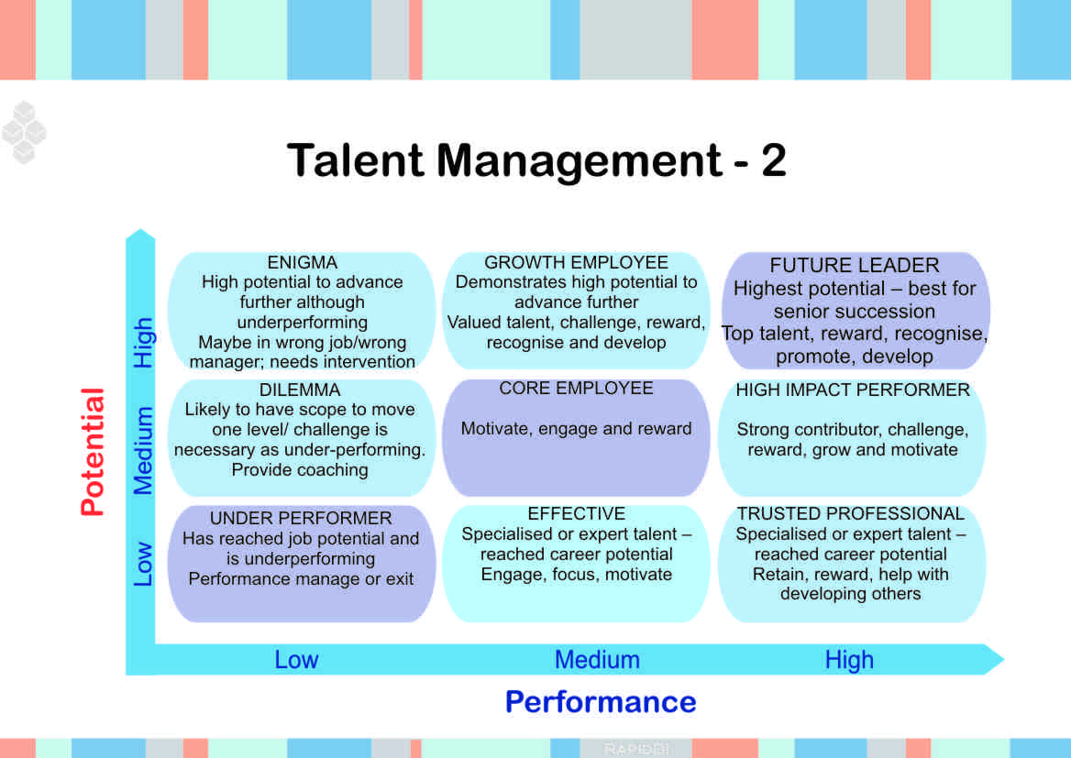

Tool for identifying & retaining key talent in organizations – 9 box grid

Background to the Nine Box Grid
The nine box grid or matrix, is believed to have originated within McKinsey to assess different business units and to priorities the investment in individuals. This was developed for GE in the late 1960s and 1970s to enable them assess the potential of individuals in its business and prioritize their investment and overall strategy. It is claimed that it is based on the Boston Consulting Group and their “Boston Box” of business or product potential, applied to individuals. (The GE-MC Kinsey nine box matrix)

Identify and retain talent
Before we can retain key talent we need to identify who and what key talent is. We also need to understand that not every quality employee is a High Potential, High Performer employee. Just because someone performs well in their current role does not make them a potent performer in the next role. Indeed, many managers and leaders fail as they were promoted on the basis of their technical job performance, not their management or leadership potential.

The concept of the nine boxes
The horizontal of 3 boxes assesses (leadership) performance and the vertical assesses (leadership potential). A combination of these makes up the box within the grid that the leader is placed.

Why use the nine box grid?
- It’s a straight forward way to assess any population of leaders on two important dimensions
- It’s a useful tool to facilitate a dialogue amongst a senior leadership team. Teams can use it to calibrate their expectations and ratings
- With an open debate, the multiple perspectives provide for a much more accurate assessment compared to one person’s opinion
- The process when used by all managers can facilitate a shared sense of ownership for the organizations talent pool
- It’s an effective way to identify the development needs of individuals and explore the transition towards development planning
- Provides a framework for succession planning

Putting the nine box grid to use – Talent Management
Every individual has unique capabilities and talent. An employee of the organization will be able to contribute effectively if the talent he or she possesses suits the job profile otherwise it will be regressive for both the employee and the organization. The company will have to hire new resource or retrain an existing one leading to wastage of resources. That’s why we say that it takes talent to find talent.
Organizations put their best efforts to attract and retain best performing employees and hence talent management is a crucial aspect for them. Talent management is the process of managing the current top performers and attracting the new credible individuals to join the team to attain high professional performance in accordance to company’s goals. It is basically the art of putting right people at the right place and utilizing them to their full potential. Many companies are now realizing the need of the hour by putting up strong teams and incorporating talent management into their business strategies.
From talent management’s point of view, an employee is evaluated on the basis of two aspects: potential and performance. The track record or previous performance of the employee forms the basis for his or her selection for a particular role. But talent management also looks into the potential of the employee to evaluate how an employee will perform if appropriate skills are made available. The nine box model of talent management as illustrated in the figure specifies the categories of employees depending upon the various potential levels plotted against performance levels.
Talent management is a key element to an organization’s succession planning process
Lets have a look at these categories:

Enigma
These are the kind of employees who are completely wasted in an organization. They are the people with high potential but deliver low performance. They are either wrongly placed or are working under wrong managers who have been unable to harness their full potential. This scenario requires external intervention and a heart to heart with the employee and the manager can yield good results.
Dilemma
The employees having average potential but showing low performance fall under this category. The reason could be many: not upgrading as per the job requirement, not falling in line with the changes in the company. They can perform better if given proper opportunities and motivation.
Underperformer
These employees are the individuals with low potential coupled with low performance. They under perform and don’t show any scope for improvement. Here the management has to take a tough decision of either throwing the ball in their court and giving them some time to improve their performance or asking them to leave the organization.

Growth employees
This category has employees that constantly show high potential but the performance is not up to that standard. They may not be getting enough motivation or inspiration to move forward. The company should value the talent and should try to extract the best out of every employee. These kinds of employees can become great assets for the company by giving them enough challenges and by praising them as they achieve goals. It further instills a sense of confidence and the performance is bound to increase.
Core employees
This category has employees that more or less perform up to the job potential but there is always a chance to achieve higher performance by giving them necessary push. They are just like employees in the category dilemma but are more promising.
Effective
These are people with specific talents as they show higher performance as compared to their potential. They may have reached their full career potential so here the talent management team can keep them engaged, focused and motivated to get the desired results.
Future leaders
These employees are the leaders of tomorrow and are the best possible options for succession at senior positions. They depict leadership qualities and yield results. People listen to them and they know how to get the work done. Talent management team should recognize their efforts and should reward them appropriately. Promote them and give them the chance to grow as an individual and also as a part of the organization.
High Impact Performers
High impact performers are those who by some grooming and motivation can become the future leaders. They may have lost pace with the changes in the organization like dilemma and core employees but can be among the top talent.
Trusted professionals
Trusted professionals perform much higher than their potential because of some special talent they may be having. Your effort should be to retain them by rewarding and recognizing their efforts. You can always take their help to develop high performers.
This nine box model shows how you can do effective talent management by recognizing the categories of employees using the appropriate techniques to retain and groom the top talent pool. The talent management system is of even more importance in tough economic times as it helps in optimizing the performance of the employees and achieving profound growth in the organization.

Using the 9-box grid
The grid is used in two ways; to plan individual career development and to plan and manage the talent pool in the organisation. There is development action associated with each of the 9 boxes. In brief these are:
- Ready for a move to the next level within the next 12 months.
- Move to a larger role on the same level within 12-24 months.
- Coach and develop to be exceptional performer.
- Leverage mastery for the benefit of the organisation. Reward and recognise. Use their help to develop high performers.
- Manage /coach to improve performance.
- These can be employees who have moved to a new level. Coach/ develop to continue to have a turn potential.
- Develop to become exceptional performers.
- Assess the reasons for lack of performance. Coach/develop to become fully performing.
- As above or move out in the next 12 months.
Effective organisations have a mix of people in all the boxes. Many organisations just focus on the top talent (boxes 1-3) and forget the needs of the people in other boxes. Employees in the boxes 4, 5 and 7 are valuable employees who can have deep expertise in their areas. The challenge is to keep the skills of these employees up to date as business and technology changes. Over time the market forces and change would push the performance levels up, so staff would need to keep up to maintain full performance. Managers ought to help employees improve performance as well as try and lift growth potential of the team.
Creating a Talent Management System
- Broad process of managing human resources within an organization is called Talent Management
- Just as IT system organizes all computer related technologies within an organization
- A comprehensive Talent Management System manages & integrates all human resource (talent) related components of business
- A well-designed Talent Management System provides infrastructure to optimize investment in people
What is a Talent Management System
- Talent management system incorporates important aspects of building, managing & equipping workforce to achieve strategic mission
- Important components of talent management system:
- Selection
- On-boarding
- Performance management
- Engaging & developing
- Career advancement and
- Succession planning
- An integrated talent management system
- Supports strategic initiatives
- Aligns talent management initiatives &
- Fosters employee/customer satisfaction
Understanding and Identifying Core Competencies
- For creating an integrated TMS, understand & identify core competencies (CC) required for each job
- CC are skills &behaviours required to be effective in specific job & organization culture
- CC also reflect the needs driven from business strategy
- CC are fundamental to success of TMS from the point of hire through succession planning
- After identifying CC, TMS’s objective is to align, engage & develop those CC in job candidates & internal team members
Selection
- While selecting & hiring, ensure that candidates are thoroughly vetted against technical & soft skill requirements of the role
- Analyze the team’s strengths & choose a new hire, based upon team gaps/composition in meeting strategic goals
- Select the “fit” candidates with values & expectations of organizational culture
- Tools to guide interviewing process & assessment instruments help to identify and vet candidates
On-Boarding
- On-boarding refers to mechanism through which new employees acquire necessary knowledge, skills & behaviors to become effective organizational members & insiders
- Tactics used include formal meetings, lectures, videos, printed materials or
- Computer-based orientations to introduce newcomers to their new jobs & organizations
- These socialization techniques lead to positive outcomes for new employees:
- higher job satisfaction
- better job performance
- greater organisational commitment and
- reduction in stress & intent to quit
Performance Management, Engaging and Developing
- Ensure that natural strengths & abilities of each person are leveraged to the highest potential
- Maximize talent, both individually & within the team, predict success in retention, performance & organizational momentum
- Use tools & wisdom to actively identify, utilize & develop the talents of the people
- CC identified for an integrated TMS are used to evaluate &develop employees of the team
- Design proper performance management, 360° feedback & organizational training program for improving CC
Career Advancement and Succession Planning
- Align potential of individuals with future opportunities in career advancement & succession planning
- Most organizations today are concerned about their leadership bench
- Assess leadership competencies necessary for future strategic success against existing talent potential
- Organizations now need to allocate resources to develop high potential internal candidates or
- Put aside fund to recruit outside candidates where internal gaps exist
- Workforce planning tools, assessment tools & high potential programs will be helpful
Integrated TMS provides the organization with:
- High performance organizations are founded upon an integrated and well-managed TMS
- TMS is powered by CC that will fuel achievement of the strategic mission
- Like a thread through fine fabric, a TMS weaves crucial core competencies through:
- selection
- on-boarding
- performance management
- engagement
- development
- career advancement &
- succession planning
- human resource efficiencies
- effectiveness &
- productivity
- Successful implementation of strategy depends upon organization’s ability to deploy the TMS effectively

Institutional Strategies for Dealing with Talent Management
Talent Management is more than just leadership development & succession planning. It is a systematic approach for:
- attracting, retaining & developing, the ‘brightest & best’ people in a business to help organisation to achieve its goals
- Top team is to chalk out a series of actions that will create
- a philosophy for talent management within the organisation &
- establish coherent links with related HR policies &
- develop clear guidelines for developing people who are in talent pool
What business issues are to be solved?
- Review
- the existing systems & processes
- strengths & problems that are inherent to current way of working
- Look into what issues are there to be solved:
- Retention of best performers
- Lack of successors to senior positions
- Over-reliance on external recruitment over internal promotion
- Avoiding shortages in critical skills
Whether There Is An Immediate & Radical Change Requirement
- Whether there are issues which present a genuine business dilemma or risk
- Whether there is a requirement for immediate and radical change
- For whom this is an issue - the CEO / a particular department / only HR
- Note that building & delivering a successful talent management strategy will take time & money
- There should be genuine commitment for the strategy to be created
Define What Success Would Look Like
- Discuss with key parties what success would look like for the organisation & for them
- This should cover both in quantitative measures and in qualitative measures
- These measures should be used to help in building the business case
Talent Management Covers Range of Subjects
- Talent management is not a stand alone activity
- It can not be created & managed effectively in isolation from existing people management activities
- Talent management is an umbrella term covering a range of subjects:
- recruitment and attraction
- performance management
- training and development
- succession planning
Identify Essential Elements of Strategy
- Ask questions to uncover what should be the essential ingredients of talent management strategy
- This is a critical stage which will ensure that strategy delivers integrated talent management processes
Identify Existing HRM Processes
- Identify what people management processes already exist, what could be improved, what are missing?
- Is the recruitment activity successfully attracting talented candidates?
- Does performance management system accurately identify talented individuals?
- Is a fair proportion of training & development budget targeted at talented individuals?
Create Effective Talent Management Strategy
- Pull together talent management strategy
- Outline what needs to be done in the light of existing HR processes and teams
- Ensure that outcome complements, rather than contradicts, the rest of the HR agenda
Gain Acceptance & Commitment
- Define the business case emphasizing the immediate & radical requirement which is driving the issue
- The business case should detail financial cost & benefits of the programme & risks of not taking action
- Organisation may lose talent if immediate action is not taken
- Discuss talent management strategy with ‘allies’ around the business & with HR colleagues
- This will facilitate valuable feedback & help
- to secure acceptance and commitment and
understanding from within the team to ensure HR presents a ‘joined up’ approach to talent management
Present the Strategy & Proceed with Implementation
- Present the talent management strategy & business case to top management to secure
- appropriate resource & budget
- Proceed & implement the integrated talent management process
Conclusion
- Implementation of talent management strategy will result in:
- improved business results
- reduction in business issues for which talent management strategy was designed
- increased ability to attract the very best to join the organisation
- increased retention of high performers
- reduced reliance on external hires to fill critical senior positions

UNIT II
- Competency Definition
- Any attitude, skill, behaviour, motive, or other personal characteristic that is essential for an individual to perform a job or, more importantly, differentiates ‘solid’ from ‘outstanding’ performance.

- Competencies Required By Employees
Competencies required by an employee for excellent performancce
- Adaptability
- Commitment
- Creativity
- Motivation
- Foresight
- Leadership
- Independence
- Emotional Stability
- Analytical Reasoning and
- Communication Skills

Behavioural Competencies
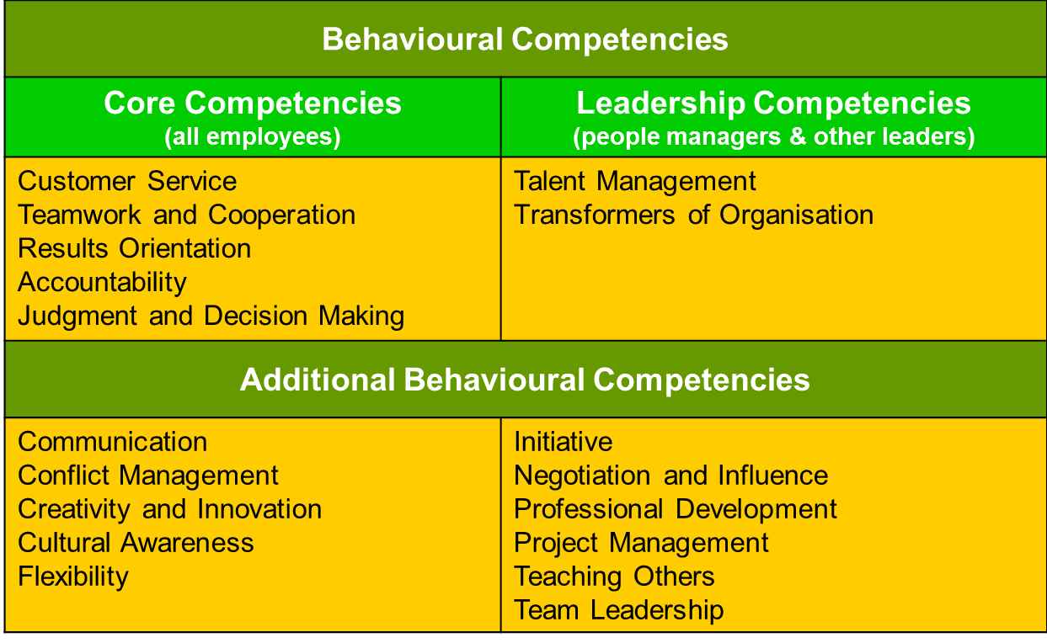

Competency Iceberg Model
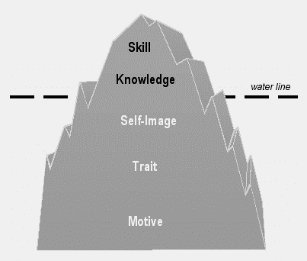
Competency Iceberg Model
- We can think of competencies in terms of an iceberg
- Technical competencies (Knowledge, Skill) are at the tip - above waterline, clearly visible & easier to assess
- Behavioral competencies (Self-image, Trait, Motive) are below the waterline - more difficult to assess & often harder to develop
- Behavioral competencies can be understood as manifestations of:
- how a person views him or herself (self-image)
- how he or she typically behaves (traits) or
- which gives purpose & direction to his behaviour (motives)
Competencies
- Skill - A person's ability to do something well (Excellent in use of Microsoft Word)
- Knowledge - Information that a person uses in a particular area (speaks many languages)
- Self-image - A person's view of him or herself, identity, personality and worth (leader, or developer of people)
- Trait - A typical aspect of a person's behavior (good listener)
- Motive - What drives someone's behavior in a particular area (achievement, affiliation or power)

Types of Competencies
There are five types of competencies:
- Core Competencies
- Technical/Professional/Functional competencies
- Behavioural Competencies
- Threshold competencies
- Differentiating competencies

- Core Competencies - Internal capability that is critical to the success of business, to be possesses by all individuals
- Technical/Professional/Functional Competencies -Specific knowledge & skills required to be effective in a job
- Behavioural competencies - Motives, traits & attributes that shape behaviour & reflect “how” one applies one’s knowledge & skills in order to achieve results
- Threshold competencies - Characteristics required by a jobholder to perform a job effectively
Differentiating competencies - Characteristics which differentiate superior performers from average performers
Main Competency Components
- Definition
• Explains what the competency means
• Provides common language that everyone can understand in the same way
- Scale
• Lays out a behaviour pattern for each level - begins with basic behaviour and gradually increases
• Represents a logical and progressive development sequence
Relationship Building Competency – Definition
Ability to develop contacts & relationships, internal & external to the organization, to facilitate work efforts or to gain support/cooperation
Relationship Building Competency – Five Level Scale
1. Understands the significance of networking
2. Identifies/approaches key stakeholder contacts
3. Actively seeks relationship-building opportunities
4. Organizes involvement of key players
5. Builds a network of contacts
Competency Characteristics
- The various attributes of a specific competency is known as the characteristics of the competency
Leadership competencies – Characteristics
- Decisiveness
- Strategic Orientation
- Development of People
- Team Leadership
- Achievement Orientation
- Self-Confidence and Courage of Conviction
- Impact and Influence
- Relationship Building
Interpersonal Competencies – Characteristics
- Respect for client
- Listening skills
- Oral communication skills
- Written communication skills
- Leadership skills
- Negotiation skills
- Coaching skills
- Presentation skills
- Teamwork skills
- Facilitation skills
- Conflict management skills
- Ability to work in an environment of diversity
- Interviewing skills
- Flexibility
Role of Leaders :
- Leaders, directors and managers run an organization through their leadership
- The competencies acquired by them through formal education & experience help them to improve
- the organization’s productivity & revenues and
- human capital values
- Senior leadership should recognize the importance of the following aspects in talent management:
- Talent
- Competency
- Training, education & on the job experience
- Placement, Rotation, Succession Planning & Performance Management
- Health & Safety
- Motivation & Innovation
- Role of Leaders in Talent Management
- Involvement of top executives in driving or actively participating in the TM strategy is critical to its success
- Proactive role & role modeling and demonstrated commitment of top executives are very important
- - To ensure successful implementation of talent management throughout the organization
- Senior leadership should be aware of economic & intangible benefits of integrated, strategically aligned human capital asset management systems

- They should know the economic benefits of integrated talent management as follows:
- increased revenues
- customer satisfaction
- improved quality
- increased productivity
- reduced cost
- reduced cycle time
- increased return to shareholders and
- Increased market capitalization
- They should know the intangible benefits of TM as follows:
- - employees’ satisfaction
- - motivated work force
- - climate conducive to innovativeness & creativity and
- high individual and team performance
- In Organizations which have not fully exercised TM, role of senior leadership as change agents/sponsors to introduce TM is very crucial
- Senior leadership should look at human resources as source of people power & human capital asset
- Senior leadership should disperse shared vision & strategic intents throughout the organization
- to give clear direction for talent, competency & human capital mgt, in order to achieve common goals
- Senior leadership has many ways to demonstrate & exercise commitment, interest and participation
- - in the fabric of talent, competency & human capital management processes
- A few examples given below:
- Personnel Development Committee/Human Resource Development Forum
- Succession Plan & Leadership Development
- Strategic Business Plan & Deployment
Personnel Development Committee/ Human Resource Development Forum:
- PDC/HRD Forum discusses human resources development throughout the organization
- It involves joint assessment & evaluation of key personnel talent, competency and performance to identify and determine candidates for filling:
- vacant positions
- cross-assignments
- relocations
- promotions and
- successions
- Committee discusses periodically the training & development needs for fast-tracks
- It discusses talent management issues & review human capital development strategy
- The Committee consists of senior leadership of the respective organization as Members/Chairman

- Top leadership takes the lead &
- Human resource professionals can facilitate the meetings
Succession Plan and Leadership Development
- A board led by top executive, takes the responsibility for succession plan of key leadership positions
- based on recommendations and inputs from the PDC or HRD Forum.
- Each candidate is scrutinized for his talent & level of competency against required talent & competency
- Board also discusses leadership development profile conforming to strategic intents & changing business environment
Strategic Business Plan and Deployment
- Strategic planning process constitutes:
- Formulation of shared Vision, Mission, Values and
- Determination of strategy, strategic intents and objectives of the organisation
- Assessment & analysis of company SWOT precedes the business plan process
- The role of senior leadership in the strategic planning & deployment process is to ensure that - investment in & development of human capital becomes an integral part of the company business plan
- The leadership should ensure that
- - there is continuing processes of exploring for new & talented human capital potentials
- - developing them and making them efficient & high performing productive human capital
- - The process must add value to shareholders & to company wealth
- These continuing processes are keys to sustainable company success and growth
Role of CEO’s in Talent Management:
- A recent study shows Chief Executive Officers (CEOs) of top companies are becoming increasingly responsible for and involved in talent management.
- They are spending a large amount of their time often more than 20% on talent management.
Talent management has become more important to them, because of a growing recognition that it helps to drive corporate performance
- Good talent management should be done through comprehensive development programmes.
- The process should identify leadership potential, evaluate performance and carry out targeted development activities
- Many CEOs are mentoring executives in their organisations
- They regard the development of the next generation of leaders as one of the best ways of leaving a strong legacy

UNIT III
The nature of knowledge management
McInerney, Claire. "Knowledge Management and the Dynamic Nature of Knowledge." Journal of the American Society for Information Science and Technology 53 (2002): 1009:1018.
Knowledge Management (KM), once the sole domain of the corporate world, is now necessary to many information disciplines. Information professionals need an understanding of what makes KM effective. This understanding begins with knowledge as an ever-changing entity, made up of human experiences, emotions, and senses. Scholars have identified knowledge to include the tacit (internal) and the explicit (manifestations of the internal). Organizations have developed KM systems to facilitate both tacit and explicit knowledge, and the sharing of the two, through discussion, training, team-building, etc. The author contends that (despite critics’ assessment that KM is incapable of a process so subjective and human) examples abound from the corporate world where KM has maximized profitability, innovation, etc. Based on these examples, the author stresses principles to guide effective KM. These include an environment dedicated to valuing individual experience and open communication as a means to share and learn; using technology to accommodate knowledge (emphasizing currency, accessibility, etc.); and an understanding that KM requires a rooting in both the tacit and explicit forms of knowledge.
The fluidity of knowledge is well-developed. However, how this evolving knowledge affects KM is illustrated by examples solely from the realm of corporate organizations. If KM is increasing in scope beyond the traditional organizations, there is a surprising lack of even anecdotal evidence in new, information-based environments. The implications given for information professionals are a rehashing of the models that have served corporations. It is unclear how KM, armed with a sense of the dynamic and human nature of knowledge, will look different in an information-based environment. This article would be better served if it distinguished how effective KM would look, feel, and operate under the expanding information professions versus the traditional corporate model.

Why Is KM Important Today?
The major business drivers behind today’s increased interest and application of KM lie in four key areas:
1. Globalization of business Organizations today are more global — multisite, multilingual, and multicultural in nature.
2. Leaner organizations We are doing more and we are doing it faster, but we also need to work smarter as knowledge workers — increased pace and workload.
3. Corporate amnesia We are more mobile as a workforce, which creates problems of knowledge continuity for the organization, and places continuous learning demands on the knowledge worker — we no longer expect to work for the same organization for our entire career.
4. Technological advances We are more connected — information technology advances have made connectivity not only ubiquitous but has radically changed expectations: we are expected to be on at all times and the turnaround time in responding is now measured in minutes, not weeks.
Today’s work environment is more complex due to the increase in the number of subjective knowledge items we need to attend to every day. Filtering over two hundred e-mails, faxes, and voice mail messages on a daily basis should be done according to good time management practices and filtering rules, but more often than not, workers tend to exhibit a Pavlovian refl ex to beeps announcing the arrival of new mail or the ringing of the phone that demands immediate attention. Knowledge workers are increasingly being asked to think on their feet with little time to digest and analyze incoming data and information, let alone time to retrieve, access, and apply relevant experiential knowledge. This is due both to the sheer volume of tasks to attend to, as well as the greatly diminished turnaround time. Today ’ s expectation is that everyone is on all the time — as evidenced by the various messages embodying annoyance at not having connected, such as voice mails asking why you have not responded to an e-mail, and e-mails asking why you have not returned a call! Knowledge management represents one response to the challenge of trying to manage this complex, information overloaded work environment. As such, KM is perhaps best categorized as a science of complexity. One of the largest contributors to the complexity is that information overload represents only the tip of the iceberg — only that information that has been rendered explicit. KM must also deal with the yet to be articulated or tacit knowledge. To further complicate matters, we may not even be aware of all the tacit knowledge that exists — we may not know that we don ’ t know. Maynard Keynes (in Wells 1938 , 6) hit upon a truism when he stated “ these . . . directive people who are in authority over us, know scarcely anything about the business they have in hand. Nobody knows very much, but the important thing to realize is that they do not even know what is to be known. ”Though he was addressing politics and the economic consequences of peace, today ’ s organizational leaders have echoed his words countless times. 24 Chapter 1 In fact, we are now entering the third generation of knowledge management, one devoted to content management. In the fi rst generation, the emphasis was placed on containers of knowledge or information technologies in order to help us with the dilemma exemplifi ed by the much quoted phrase “ if only we knew what we know ” ( O ’ Dell and Grayson 1998 ). The early adopters of KM, large consulting companies that realized that their primary product was knowledge and that they needed to inventory their knowledge stock more effectively, exemplifi ed this phase. A great many intranets and internal knowledge management systems were implemented during the fi rst KM generation. This was the generation devoted to fi nding all the information that had up until then been buried in the organization with commonly produced by-products encapsulated as reusable best practices and lessons learned. Reeling from information overload, the second generation swung to the opposite end of the spectrum, to focus on people; this could be phrased as “ if only we knew who knows about. ”There was growing awareness of the importance of human and cultural dimensions of knowledge management as organizations pondered why the new digital libraries were entirely devoid of content (i.e., information junkyards) and why the usage rate was so low. In fact, the information technology approach of the fi rst KM generation leaned heavily toward a top-down, organization-wide monolithic KM system. In the second generation, it became quite apparent that a bottom-up or grassroots adoption of KM led to much greater success and that there were many grassroots movements — which were later dubbed communities of practice. Communities of practice are good vehicles to study knowledge sharing or the movement of knowledge throughout the organization to spark not only reuse for greater effi ciency but knowledge creation for greater innovation. The third stage of KM brought about an awareness of the importance of content — how to describe and organize content so that intended end users are aware it exists, and can easily access and apply this content. This phase is characterized by the advent of metadata to describe the content in addition to the format of content, content management, and knowledge taxonomies. After all, if knowledge is not put to use to benefi t the individual, the community of practice, and/or the organization, then knowledge management has failed. Bright ideas in the form of light bulbs in the pocket are not enough — they must be plugged in and this can only be possible if people know what there is to be known, can fi nd it when they need, can understand it, and, perhaps most important, are convinced that this knowledge should be put to work. A slogan for this phase might be something like: “ taxonomy before technology

Introduction to Knowledge Management
KM for Individuals, Communities, and Organizations
Knowledge management provides benefits to individual employees, to communities of practice, and to the organization itself. This three-tiered view of KM helps emphasize why KM is important today). For the individual, KM:
• Helps people do their jobs and save time through better decision making and problem solving • Builds a sense of community bonds within the organization
• Helps people to keep up to date
• Provides challenges and opportunities to contribute For the community of practice, KM:
• Develops professional skills
• Promotes peer-to-peer mentoring
• Facilitates more effective networking and collaboration
• Develops a professional code of ethics that members can adhere to
• Develops a common language For the organization, KM:
• Helps drive strategy
• Solves problems quickly
• Diffuses best practices
Improves knowledge embedded in products and services
• Cross-fertilizes ideas and increases opportunities for innovation
• Enables organizations to better stay ahead of the competition
• Builds organizational memory Containers Communities

Introducing Knowledge Management
- What is Knowledge Management (KM)?
- What are the driving forces?
- Role of KM in today’s organization
- What is Knowledge Management System (KMS)?
- Classification of Knowledge Management Systems
- Effective Knowledge Management
The 20th anniversary of the landing of an American on the surface of the Moon occasioned many bittersweet reflections. Sweet was the celebration of the historic event itself... Bitter, for those same enthusiasts, was the knowledge that during the twenty intervening years much of the national consensus that launched this country on its first lunar adventure had evaporated...” [Fries,S. 1992
Knowledge has become the key resource, for a nation’s military strength as well as for its economic strength… is fundamentally different from the traditional key resources of the economist – land, labor, and even capital…we need systematic work on the quality of knowledge and the productivity of knowledge … the performance capacity, if not the survival, of any organization in the knowledge society will come increasingly to depend on those two factors” [Drucker,1994
- Knowledge management (KM) may be defined simply as doing what is needed to get the most out of knowledge resources.
- KM focuses on organizing and making available important knowledge, wherever and whenever it is needed.
Related to the concept of intellectual capital (both human and structural
Forces Driving Knowledge Management
- Increasing Domain Complexity
- Accelerating Market Volatility
- Intensified Speed of Responsiveness
- Diminishing Individual Experience

Role of KM in Today’s Organization:
- KM is important for organizations that continually face downsizing or a high turnover percentage due to the nature of the industry.
Facilitate today’s younger manager to make the tough decisions daily needed
What is Knowledge Management “Systems
- Social/Structural mechanisms(e.g., mentoring and retreats, etc.) for promoting knowledge sharing.
- Leading-edge information technologies (e.g., Web-based conferencing) to support KM mechanisms.
- Knowledge management systems (KMS): the synergy between social/structural mechanisms and latest technologies.
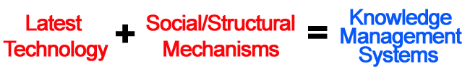
Effective Knowledge Management
- 80% - Organizational processes and human factors
- 20% - Technology
PEOPLE
TECHNOLOGY
ORGANIZATIONAL
PROCESSES
OVERLAPPING FACTORS
Classification of Knowledge Management Systems
  - Knowledge Discovery Systems
  - Knowledge Capture Systems
  - Knowledge Sharing Systems
  - Knowledge Application Systems
- Knowledge is first created in the people’s minds.
KM practices must first identify ways to encourage and stimulate the ability of employees to develop new knowledge
KM methodologies and technologies must enable effective ways to elicit, represent, organize, re-use, and renew this knowledge
KM should not distance itself from the knowledge owners, but instead celebrate and recognize their position as experts in the organization
- Types of Knowledge
In the modern economy, the knowledge that it is able to harness is the organization’s competitive advantage. This competitive advantage is realized through the full utilization of information and data coupled with the harnessing of people’s skills and ideas as well as their commitments and motivations. In the corporate context, knowledge is the product of organization and systematic reasoning applied to data and information. It is the outcome of learning that provides the organization’s only sustainable competitive advantage. As such knowledge is an essential asset that has become more important than land, labor or capital in today’s economy. In general, there are two types of knowledge: tacit knowledge and explicit knowledge. Tacit knowledge is that stored in the brain of a person. Explicit knowledge is that contained in documents or other forms of storage other than the human brain. Explicit knowledge may therefore be stored or imbedded in facilities, products, processes, services and systems. Both types of knowledge can be produced as a result of interactions or innovations. They can be the outcome of relationships or alliances. They permeate the daily functioning of organizations and contribute to the attainment of their objectives. Both tacit and explicit knowledge enable organizations to respond to novel situations and emerging challenges.
Tacit knowledge Tacit knowledge is personal. It is stored in the heads of people. It is accumulated through study and experience. It is developed through the process of interaction with other people. Tacit knowledge grows through the practice of trial and error and the experience of success and failure. Tacit knowledge, therefore, is context-specific. It is difficult to formalize, record, or articulate. It includes subjective insights, intuitions and conjectures. As intuitive knowledge, it is difficult to communicate and articulate. Since tacit knowledge is highly individualized, the degree and facility by which it can be shared depends to a great extent on the ability and willingness of the person possessing it to convey it to others. The sharing of tacit knowledge is a great challenge to many organizations. Tacit knowledge can be shared and communicated through various activities and mechanisms. Activities include conversations, workshops, on-the-job training and the like. Mechanisms include, among others, the use of information technology tools such as email, groupware, instant messaging and related technologies. In managing tacit knowledge, the very first hurdle to most organizations is identifying the tacit knowledge that is useful to the organization. Once relevant tacit knowledge is identified, it becomes extremely valuable to the organization possessing it because it is a unique asset that is difficult for other organizations to replicate. This very characteristic of being unique and hard to replicate is what makes tacit knowledge a basis of the organization’s competitive advantage. Accordingly, it is essential for an organization to discover, propagate and utilize the tacit knowledge of its employees in order to optimize the use of its own intellectual capital. In any organization, tacit knowledge is the essential prerequisite for making good decisions. A new executive not yet familiar with the organization will find it difficult to make good decisions since he or she has yet to acquire tacit knowledge about the workings of the organization. Tacit knowledge istherefore crucial to getting things done and creating value for the organization. This is the essence of the “learning organization”. Management and employees need to learn and internalize relevant knowledge through experience and action. And they need to generate new knowledge through personal and group interactions within the organization. Explicit knowledge Explicit knowledge is codified. It is stored in documents, databases, websites, emails and the like. It is knowledge that can be readily made available to others and transmitted or shared in the form of systematic and formal languages.
Explicit knowledge comprises anything that can be codified, documented and archived. These include knowledge assets such as reports, memos, business plans, drawings, patents, trademarks, customer lists, methodologies, and the like. They represent an accumulation of the organization’s experience kept in a form that can readily be accessed by interested parties and replicated if desired. In many organizations these knowledge assets are stored with the help of computers and information technology. Explicit knowledge is not completely separate from tacit knowledge. On the other hand, the two are mutually complementary. Without tacit knowledge it will be difficult, if not impossible, to understand explicit knowledge. For example, a person without technical, mathematical or scientific knowledge (tacit knowledge) will have great difficulty understanding a highly complex mathematical formulation or chemical process flow diagram, although it may be readily available from the organization’s library or databases (explicit knowledge). And unless we try to convert tacit knowledge to explicit knowledge, we cannot reflect upon it, study and discuss it, and share it within the organization – since it will remain hidden and inaccessible inside the head of the person that has it.
Location of Knowledge
Source/Location of Tacit Knowledge
Intellect
- Mental capacity for thinking & acquiring knowledge, especially of a high or complex order
Experience
- Knowledge or practical wisdom gained from what one has observed, encountered, or undergone
Instinct
- When an ant crawls on the right arm, the left hand automatically moves towards the right arm to drive the ant away
- When we see a scorpion near our leg, we withdraw the leg automatically
- This is called instinctive or automatic movement.
- As we cross a street, how instinctively we move our body to save ourselves from the cars
- There is no thought during such kind of mechanical movement
Intuition
- Intuition is personal experience
- The knowledge obtained through the functioning of the causal body is intuition
- There is direct perception of truth, or immediate knowledge through the super-conscious state
- One knows things in a flash
Reason
- Reason is higher than instinct and is found only in human beings
- It collects facts, generalizes, reasons out from cause to effect, from effect to cause, from premises to conclusions, from propositions to proofs
- It concludes, decides and comes to final judgment
Rise of Knowledge Worker
Knowledge Worker (Peter Drucker 1959)
- A term invented to describe a future trend in the workforce
- These will be professionals that create, modify and/or synthesize information as a fundamental part of their job
- They will require higher education levels and received higher compensation than workers in agriculture or manufacturing
- The term is still generally accepted today (Drucker was right!)
Knowledge Society (Drucker - 1959)
- Term invented to describe the next evolution of society
- This evolution would be a result of the rise in the numbers and importance of knowledge workers in society
- Education was described as the cornerstone of the knowledge society as it is core to the knowledge worker
Drucker was right again!

What is Knowledge Work ?
- Basic task in knowledge work is thinking - it is mental work which adds value to work
- Thinking involved in knowledge work is not a step-by-step linear mental work
- Thinking should be non-linear for creation
- It uses knowledge to produce more knowledge
- It involves activities such as analysing, solving problems, deriving conclusions & applying these conclusions to other situations
Who is Knowledge Worker ?
- One who is a non-manual worker & employed by firms to carry out innovative activities
- He has been schooled to use knowledge, theory & concept, rather than physical force/manual skill
- He creates knowledge, knows how to tap & share it, reuse it whenever necessary & works against a deadline
- He uses his intellect to convert his ideas into products, services or processes
- He possesses un-codified knowledge which is difficult to duplicate
- He does planning, acquiring, searching, analysing, organising, storing, programming, distributing & marketing
Skill Sets Required for Knowledge Workers
- Basic Skills: To read, write, calculate & operate - basic computer applications
- Communication Skills: To use verbal, written & presentation skills for the purposes of negotiation, persuasion, facilitation, coaching & mentoring
- Analytical Skills: ToThink, analyze, solve problems, assess situations, evaluate & implement suggestions
- Human and Behavioral Skills: To cooperate with others, and work in teams.
- Information – Literacy Skills: To locate, gather, analyze and organize information
- Learning Skills: Adapt to a range of situations, take risks, formulate and champion a vision, learn independently, exercise responsibility, innovate , generate knowledge & use knowledge
- Reading for Information: Skill in reading & understanding written work-related instructions & policies
- Locating Information: Skill in interpreting & using workplace graphics, such as, diagrams, floor plans, tables, forms, graphs, charts, and instrument gauges
- Applied Mathematics: Skill in applying mathematical reasoning to a variety of work-related problems.
- Applied Technology: Skills in solving problems of a technological nature, such as, applying principles of mechanics, electricity & electronics, thermodynamics, computer technology, fluid dynamics, networking, integration to machines and systems

Knowledge Intensive Firms (KIF)
In knowledge intensive firms,
- Most of the work is of intellectual nature
- Well-educated, qualified, highly skilled employees form the major part of the work force
- Work processes creating market value, are through knowledge
- Intellectual capital is deployed for innovation, initiative and competence building and to provide custom made services
- Knowledge intensive products and services are produced
In knowledge intensive firms,
- Most of the work is of intellectual nature
- Well-educated, qualified, highly skilled employees form the major part of the work force
- Work processes creating market value, are through knowledge
- Intellectual capital is deployed for innovation, initiative and competence building and to provide custom made services
- Knowledge intensive products and services are produced

Knowledge Intensive Firms: Key Features
- Key resource in KIFs is intellectual capital/intellectual material – knowledge, information, intellectual property, experience
- These can be put to use to create wealth
- In KIFs knowledge has more importance than other inputs and human capital dominates
- A knowledge intensive company makes money through the knowledge of its people
- Application of expertise makes an important contribution in KIFs
- KIF must have capacity to solve complex problems through creative and innovative solutions
- Novel & complex work processes involving problem solving are the indicators of KIFs
- Innovation, initiative & competence building are the important aspects in KIFs
- The tacit knowledge is the prime driver for value creation in KIFs
- KIFs employ highly skilled individuals
- They create market value through application of knowledge to novel, complex client demands
- Knowledge, skills and experience of staff are vital to the development of intellectual capital
- Knowledge is often tacit, difficult to imitate
- Both knowledge stocks & flows are important in KIFs
- KIFS rely on the creation, transfer and integration of knowledge
- KIFs employ highly skilled individuals
- They create market value through application of knowledge to novel, complex client demands
- Knowledge, skills and experience of staff are vital to the development of intellectual capital
- Knowledge is often tacit, difficult to imitate
- Both knowledge stocks & flows are important in KIFs
- KIFS rely on the creation, transfer and integration of knowledge

Key Processes in knowledge Intensive Firms
- HR Strategy
- HR Structure
- HR Delivery
- Resourcing - recruitment, selection & allocation of staff
- Job design and work organisation
- Training and Development
- Performance Management Systems
- Pay and Reward
- Involvement and Participation
HR Strategy
  - Vertical fit – The alignment of HRM practices with the strategic management process of the firm, developing vertical fit with competitive strategy:
  - refining existing knowledge
  - relying on organisational capital
  - exploring new knowledge &
  - reliance on human capital
  - Horizontal fit – a congruence among various HRM practices, fitting HR practices together to support competitive strategy:
  - Refining knowledge,
  - Providing incentives needed to share knowledge,
  - Exploring & emphasising on external recruitment and internal development
HR structure
- Importance of human capital devoted to HR
- Role of the human capital in strategic HR decision making
- Contrasting the strategic role and the operational role
HR delivery
- Delivery of HR is routinely in the hands of line managers
- Key role in how employees actually perceive these HR practices
- Importance of support provided for line managers for their implementation role
- Key messages conveyed regarding the culture and values of the organisation
Resourcing: Recruitment & Selection
- Resourcing – major influence on the performance of the firm – direct impact on human and social capital
- Recruitment: range of methods – elite sources, informal referral (incentivised), drawing on client and network capital plus traditional
- Selection: direct impact on social capital – values driven approaches, selection for potential – e.g., of ‘High Trust’
Allocation of staff
- Difficult and time consuming issue – conflictual – key issue – variations in the extent to which HR issues are considered
- Direct impact on human and social capital – e.g., development opportunities for staff
- Matching the needs of clients (want the best staff), staff (who want interesting & challenging work) and the firm (which want to make a profit)
- Critical role for HR – but often have very limited influence
Job Design and Work Organisation
- Links back to the strategy of the firm – customised solutions – often broad jobs – repetitive solutions – narrower more specialist jobs
- Design of jobs – major impact on development of human capital
- Interacts with selection criteria – e.g., select for potential and broad job design
- Work organisation reflects structural capital – e.g., flat or tall triangles
Training and Development
- Fundamental importance for all knowledge intensive firms – impact on most forms of capital
- Staff often have high interest in developing their knowledge
- Work based learning often key to development – tacit knowledge – e.g., in ‘High Trust’
- Mix of formal programmes and more developmental work
- Places stress on the coaching and feedback skills of line managers
- Learning and development also across organisational boundaries e.g., involving external associates
Performance Management systems
- Key role in stimulating development of human capital
- Staff often very sensitive to these systems – judgements of their own personal worth
- Often difficult to measure outputs
- Wide variations in practices – dependent on HR practices and line manager role
- Conveys powerful messages about what is valued within the firm
- Impact on various behavours
  - Time spent on new business development may not be rewarded
  - Individualistic approach encouraged – unwillingess to collaborate with others
  - can inhibit knowledge sharing
Pay and Reward
- Pay & reward have important influence on employee behaviour – these signals what the firm values
- Bases for reward: job, person or performance
- Seniority based systems – may conflict with reward for current performance
- Team based pay – builds social capital
- Individual based pay – linked to a more fragmented approach – may damage social capital
- These have direct effect on human & social capital
- Ability to become involved in key firm decisions, this generates commitment and loyalty to the firm
- Participation in day-to-day decision making , e.g., allocation of work
- Contribution to the design of HR practices

UNIT IV
Knowledge Management Framework of Hansen
- Hansen identified two strategies for managing knowledge in an organization:
- Codification & Personalization strategies
- Type of knowledge management strategy used by organisations needs to best accommodate
- the way individuals create and transfer knowledge
- Types of relationships/ties between individuals in the organisations, when creating &sharing knowledge
- influences the type of knowledge management strategy used
- In developed social groups - “communities of practice”, where knowledge is created & shared informally:
- use of the personalization strategy would best complement this type of knowledge transfer
- Where social ties are weak & there is little social interaction between individuals:
- technology is the most utilised form of information creation & transfer and
- use of a codification strategy would be most appropriate
- Those implementing a codification strategy will invest heavily into IT
- to codify, store and transfer explicit knowledge to all those within the organisation
- Personalisation strategy will require far less IT investment
- as technology is only required to facilitate social relationships within the organization
- In the study of strategies used by consultancy firms, Hansen found out that
- Best thing is to choose either a personalization or a codification strategy and not both
- The strategy chosen should reflect the company’s competitive strategy
- If a consulting company has a focus on giving tailored and creative advice:
- then a personalization strategy is the best choice
- Codification strategy is more useful when knowledge can be reused often
- General conclusion on KM strategies is that companies should not ‘straddle’ when choosing for a KM strategy
- instead the focus should be on just one of the two strategies - otherwise companies run the risk of getting ‘stuck in the middle’
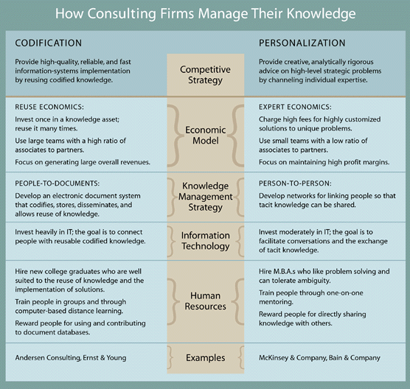

Earl’s Seven School of Knowledge Management
- Instead of using division - personalization/codification,
- Earl proposed seven schools of knowledge management strategy:
- Systems, Cartographic, Engineering, Commercial, Organisational, Spatial and Strategic
- These schools identify the types of knowledge management strategy undertaken by organisations
- Earl categorises these seven schools into three broad types:
- Technocratic, Economic and Behavioural
- Technocratic schools approach knowledge management through:
- information or management technologies
- that support and condition employees in their everyday tasks
- Economic schools aim to explicitly create revenue through:
- exploitation of knowledge as an asset
- The Behavioural schools approach knowledge management from:
- a behavioural perspective
- stimulating and orchestrating managers and managements to proactively create, share & use knowledge resources

- Seven schools of knowledge management strategy proposed by Earl is
- to give managers an idea on where and how to begin with KM
- Each school has a different focus, and companies can have multiple schools represented in their company
- The result of this is that
- companies do not have to choose for a focused view, as proposed by Hansen,
- but instead can pick those schools that fulfill the needs of the company, whether tacit or explicit.
- The result is that companies do not do a little bit of everything
- but instead focus on two or three different schools
- allowing the strategy to remain focused yet also contain both tacit and explicit elements
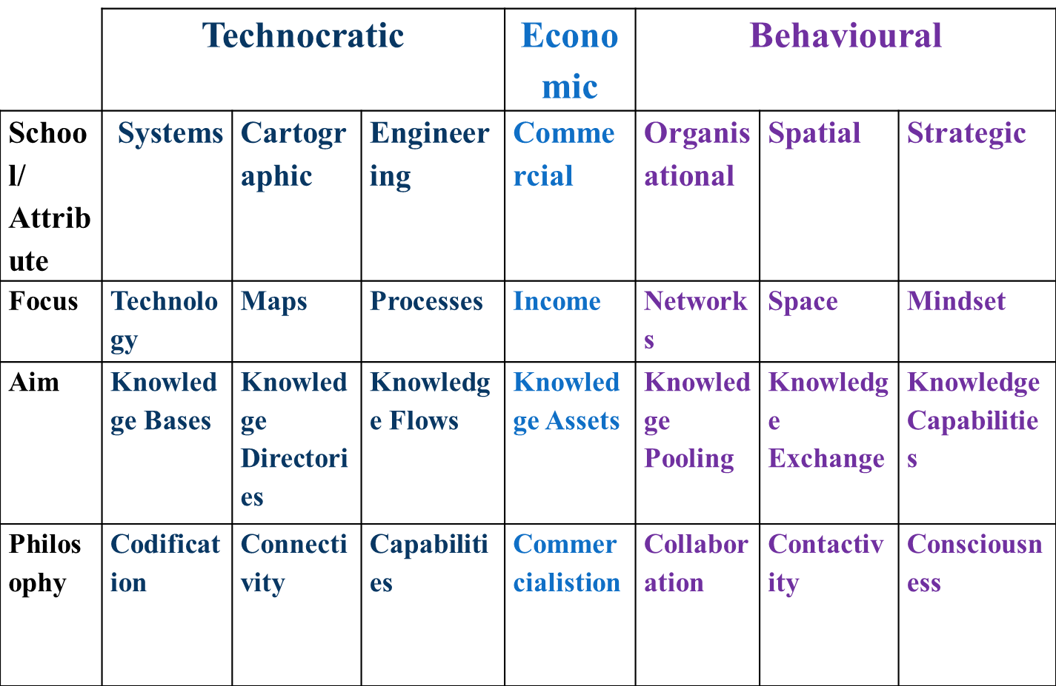

Alvesson and Karreman’s Knowledge Management Approaches
- Alvesson and Karreman used the framework of four management styles
- as the basis for developing four specific approaches to knowledge management
- They make it clear that the distinction between four different approaches to KM are:
- analytical rather than empirical and
- organisations are unlikely to exclusively use one approach to knowledge management.

Mode of Managerial Intervention
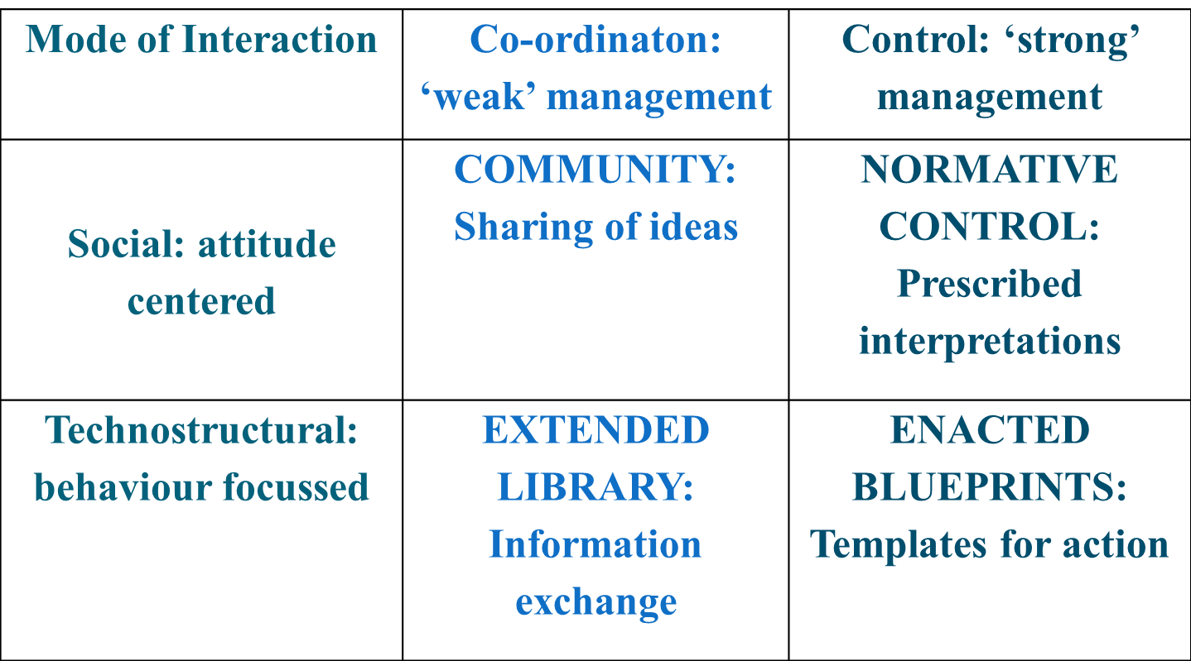

- The Extended Library approach to KM combines -
- behavioural focused controls with a relatively weak form of co-ordinated management and
- represents a relatively bureaucratic, centrally controlled and top down form of KM
- in which IT systems (such as knowledge data bases) play an important role.
- The Community approach to KM combines -
- culture based socially focused controls with a weak form of management
- This approach to KM gives a very limited role to IT systems,
- focusing instead around encouraging the direct sharing of knowledge between people
- Management efforts with this approach are focused on
- creating a climate, culture and context to induce such behaviours
- The Normative Control approach to KM combines –
- socially focused controls with a relatively strong form of management intervention.
- This is KM via culture management, whereby management attempt to create a culture
- that encourages employees to embrace a value system which regards knowledge sharing as a norm
- The fourth approach to KM articulated by Alvesson and Karreman is
- the Enacted Blueprints approach,
- which combines a strong form of managerial intervention with behavioural controls
- This involves managerial efforts being concerned with creating codified data bases of knowledge focused
- around particular roles and tasks
- that provide a mechanism for giving employees access to what are considered a set of best practices
Knowledge Resources
- The term knowledge resources refers not only to the knowledge currently possessed by the individual or the organization but also to the knowledge that can potentially be obtained (at some cost if necessary) from other individuals or organizations
Knowledge Management Solutions
- Knowledge management solutions refer to the variety of ways in which KM can be facilitated
- KM processes
- KM systems
- KM mechanisms and technologies
- KM infrastructure
Knowledge Discovery
- Knowledge discovery may be defined as the development of new tacit or explicit knowledge from data and information or from the synthesis of prior knowledge
- Combination
- Socialization
Knowledge Management Mechanisms
- KM mechanisms are organizational or structural means used to promote KM
- Examples of KM mechanisms include learning by doing, on-the-job training, learning by observation, and face-to-face meetings

Knowledge Management Technologies
- Technologies that support KM include artificial intelligence (AI) technologies encompassing those used for knowledge acquisition and case-based reasoning systems, electronic discussion groups, computer-based simulations, databases, decision support systems, enterprise resource planning systems, expert systems, management information systems, expertise locator systems, videoconferencing, and information repositories encompassing best practices databases and lessons learned systems
Knowledge Management Systems
- KM systems utilize a variety of KM mechanisms and technologies to support the KM processes
- Knowledge Management Discovery Systems
- Knowledge Management Capture Systems
- Knowledge Management Sharing Systems
- Knowledge Application Systems
Knowledge Management Mechanisms
- Mechanisms facilitating direction include traditional hierarchical relationships in organizations, help desks, and support centers
- Mechanisms supporting routines include organizational policies, work practices, and standards
Knowledge Management Infrastructure
- Organizational Culture
- Organizational Structure
- Communities of Practice
- Information Technology Infrastructure
- Common Knowledge
Organizational Culture
- Organizational culture reflects the norms and beliefs that guide the behavior of the organization’s members
- Attributes of an enabling organizational culture include understanding of the value of KM practices, management support for KM at all levels, incentives that reward knowledge sharing, and encouragement of interaction for the creation and sharing of knowledge
Organizational Structure
- Hierarchical structure of the organization affects the people with whom individuals frequently interact, and to or from whom they are consequently likely to transfer knowledge
- Organizational structures can facilitate KM through communities of practice
- Organization structures can facilitate KM through specialized structures and roles that specifically support KM
- Information Technology Infrastructure
- The IT infrastructure includes data processing, storage, and communication technologies and systems
- One way of systematically viewing the IT infrastructure is to consider the capabilities it provides in four important aspects:
  - Reach
  - Depth
  - Richness
  - Aggregation
Common Knowledge
- Common knowledge also refers to the organization’s cumulative experiences in comprehending a category of knowledge and activities, and the organizing principles that support communication and coordination
- Common knowledge helps enhance the value of an individual expert’s knowledge by integrating it with the knowledge of others

UNIT V
Knowledge Management Impacts Organizations
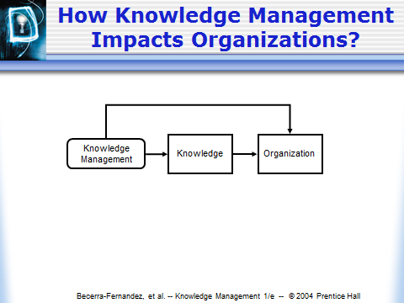
- Retaining expertise of employees
- Enhancing customers’ satisfaction with the company’s products
- Increasing profits or revenues.
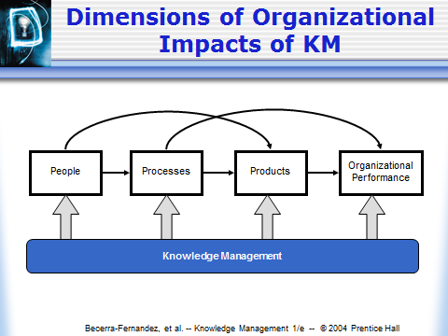
Impact on People
- KM can facilitate employee learning
- KM also causes employees to become more flexible, and enhances their job satisfaction
Impact on Employee Learning
- This can be accomplished through
  - Externalization
  - Internalization
  - Socialization
  - Communities of practice
Impact on Employee Adaptability
- Employees are likely to adapt when they interact with each other
- They are more likely to accept change
- They are more prepared to respond to change
Impact on Employee Job Satisfaction
- Recent study found that in organizations having more employees sharing knowledge with one another, turnover rates were reduced, thereby positively affecting revenue and profit
- KM also provides employees with solutions to problems they face in case those same problems have been encountered earlier, and effectively addressed
How KM Impacts People
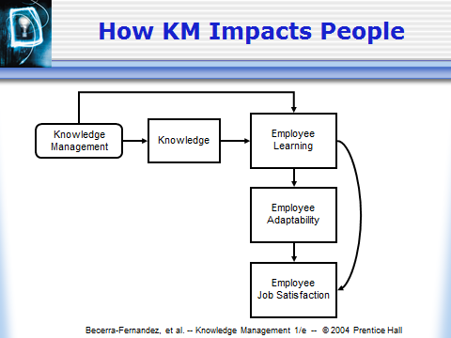
Impact on Processes
- KM enables improvements in organizational processes such as marketing, manufacturing, accounting, engineering, and public relations
- These impacts can be seen along three major dimensions
  - Effectiveness
  - Efficiency
  - Degree of innovation of the processes
Effectiveness, Efficiency and Innovation
- Effectiveness is performing the most suitable processes and making the best possible decisions
- Efficiency is performing the processes quickly and in a low-cost fashion.
- Innovation is performing the processes in a creative and novel fashion, that improves effectiveness and efficiency—or at least marketability.
Impact on Processes
- Impact on Process Effectiveness
  - KM can enable organizations to become more effective by helping them to select and perform the most appropriate processes
  - KM enables organizations to quickly adapt their processes according to the current circumstances, thereby maintaining process effectiveness in changing times
- Impact on Process Efficiency
  - Managing knowledge effectively can also enable organizations to be more productive and efficient
- Impact on Process Innovation
  - Organizations can increasingly rely on knowledge shared across individuals to produce innovative solutions to problems as well as to develop more innovative organizational processes
How KM Impacts Organizational Processes
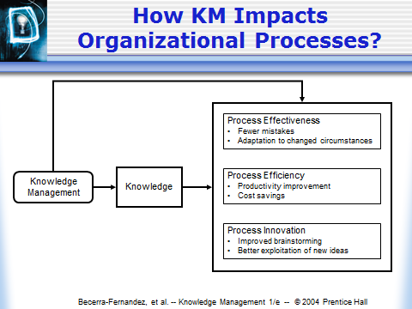
Impact on Products
- Impact on products can be
  - Value added products
  - Knowledge based products
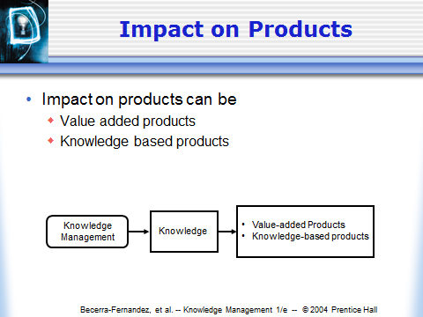
Impact on
Value-Added Products
- KM processes can help organizations offer new products or improved products that provide a significant additional value as compared with earlier products
- Value-added products also benefit from KM due to the effect the latter has on organizational process innovation
Impact on
Knowledge-Based Products
- KM can have a significant impact on product that are knowledge based like those in consulting or software development etc.
- Knowledge based products can sometimes play a significant role in traditional manufacturing firms
Impacts on Organizational Performance
- Direct Impacts
  - Knowledge is used to create innovative products that generate revenue and profit
- Indirect Impacts
  - Use of KM to demonstrate intellectual leadership within the industry, which, in turn, might enhance customer loyalty
  - Use of knowledge to gain an advantageous negotiating position with respect to competitors or partner organizations
How Knowledge Management Impacts Organizational Performance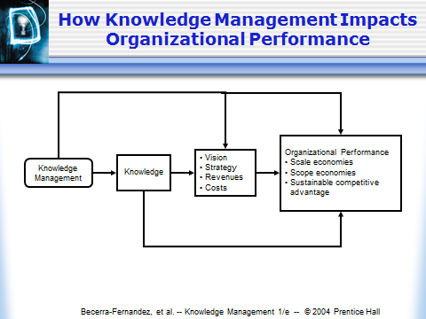

Factors Influencing Knowledge Management
- Factors influencing success of KM initiatives are:
- culture,
- leadership,
- technology,
- organizational adjustments,
- evaluation of knowledge management activities/ knowledge resources,
- governing/administering knowledge activities/ knowledge resources,
- employee motivation and
- external factors
- Factors Influencing KM
- The factors influencing knowledge management can be broadly organised into three categories:
- managerial influences,
- resource influences and
- environmental influences
- Managerial influences
- Managerial influences emanate from organizational participants responsible for administering the management of knowledge
- The framework partitions these influences into four main factors:
- Exhibiting leadership in management of knowledge,
- Coordinating management of knowledge,
- Controlling management of knowledge and
- Measuring management of knowledge
- Exhibiting Leadership in Management of Knowledge
- One crucial reason why organizations are unable to effectively leverage knowledge is :
- lack of commitment of top leadership to sharing organizational knowledge or
- there are too few role models who exhibit the desired behavior
- Of the four managerial influences, leadership is primary
- In alignment with the organization's purpose & strategy, it establishes enabling conditions for fruitful KM
- Coordination, control, and measurement are contributors to establishing these conditions,
- But there is an additional aspect to fulfilling the leadership mission.
- This distinguishing characteristic of leadership is that of being a catalyst through such traits as:
- inspiring,
- mentoring,
- setting examples,
- propagating trust and respect,
- instilling a cohesive and creative culture,
- listening,
- learning,
- teaching, and
- knowledge sharing
- Exhibiting Leadership in Management of Knowledge
- Core competencies for effective leaders of knowledge-intensive organizations are being a catalyst, being a coordinator, exercising control, and being an evaluator.
- KM leader creates conditions allowing participants to readily exercise & cultivate their knowledge manipulation skills to:
- contribute their own individual knowledge resources to the organization's pool of knowledge and
- have easy access to relevant knowledge resources
- For ongoing success of KM initiatives, it is necessary to develop leaders at all levels of functionality/accountability.
- Execution & cultivation of leadership depends on an appreciation of:
- knowledge resources,
- knowledge activities and
- other KM influences.
- Coordinating management of knowledge
- Knowledge development is a primary driver of KM
- The planned approach requires coordination, involving:
- the determination of what knowledge activities to perform
- in what sequence,
- which participants will perform them and
- what knowledge resources will be operated on by each
- Coordination refers to managing dependencies among activities.
- It aims to harmonize activities in an organization by ensuring that proper resources are brought to bear at appropriate times and
- That they adequately relate to each other as activities unfold
- In the management of knowledge, dependencies that need to be managed include:
- those among knowledge resources,
- those among knowledge activities,
- those between knowledge resources and other resources &
- those between resources and knowledge activities
- The management of knowledge in an organization is strongly influenced by how such dependencies are managed.
- Coordination involves not only managing dependencies,
- But marshaling sufficient skills for executing various activities,
- Arrangement of those activities in time, and
- Integrating knowledge processing within organization's operations.
- Coordination approaches suggested and used to manage dependencies in a knowledge-based organization include:
- linking reward structures to knowledge sharing,
- establishing communications for knowledge sharing &
- constructing programs to encourage learning.
- Control is concerned with ensuring that needed knowledge resources and processors are available in sufficient quality & quantity, subject to required security.
- Two critical issues here are protection of and quality of knowledge resources.
- Protecting knowledge resources from loss, obsolescence, unauthorized exposure, unauthorized modification, and erroneous assimilation is crucial for the effective management of knowledge.
- Approaches include legal protection, social protection, and technological protection.
- In establishing sufficient controls to govern the quality of knowledge used in an organization, management needs to consider two dimensions:
- Knowledge validity and
- Knowledge utility
- Validity is concerned with accuracy, consistency, and certainty;
- Utility is concerned with clarity, meaning, relevance, and importance.

Measuring management of knowledge
- In its most basic sense, measurement involves the valuation of knowledge resources and processors.
- It is also a basis for:
- evaluation of leadership, coordination, and control;
- identifying and recognizing value-adding activities and resources;
- assessing and comparing the execution of knowledge activities and
- evaluating the impacts of an organization's KM on bottom-line performance.
- Although it is an under-implemented area, measuring knowledge resources or activities and linking them to financial results is feasible.
- The framework contends that KM initiatives are impacted by:
- whether an organization attempts to measure its knowledge resources /performance of its knowledge activities,
- how it goes about measuring these and
- how effective the measures are.
- Some organizations have already developed and applied indicators of knowledge resources of knowledge activity.
- Resource Influences
- Financial resources put a ceiling on what can be expended on knowledge activities.
- Increasing the financial resources available for a knowledge activity may affect the efficiency of that activity or the quality of its results.
- Moreover, financial resource availability may affect the execution of leadership, coordination, control, and measurement.
- Knowledge manipulation skills of an organization's participants both constrain and facilitate KM.
- These skills are the essential mechanism for performing the knowledge activities that make up KM episodes.
- In the case of human participants, these skills are human resources.
- In case of computer-based participants, these skills are material resources.
- Human resources also influence KM by enabling or restricting the managerial influences.
- Knowledge resources strongly influence KM in an organization.
- As the raw materials for knowledge activities, knowledge resources available in an organization necessarily influence its KM and the resultant learning, projection, and innovation.
- Some knowledge resources also affect KM by serving as the basis for coordination, control, measurement, and leadership.
- Major types of organizational knowledge resources include participants' knowledge, artifacts, culture, and strategy.
- Each can be examined along various attribute dimensions and studied from the standpoint of its influence on KM
- Environmental influences
- Managerial and resource influences on KM are internal to an organization.
- Factors external to an organization also affect its KM.
- The environment influences what knowledge resources should or can be acquired in the course of KM.
- It influences what knowledge manipulation skills are available.
- Environmental influences on KM are
- competition, fashion, markets, technology, time, and the GEPSE (governmental, economic, political, social, and educational) climate.
- Organizations have little control over environmental influences.
- As such, they pose constraints on an organization's KM.
- However, the confluence of environmental influences can also present opportunities for improving KM.
- Knowledge discovery system
- Knowledge discovery system supports the process of developing new tacit or explicit knowledge
- from data & information or
- from the synthesis of prior knowledge
- Two KM sub-processes are associated with KM discovery:
- Combination, enabling the discovery of new explicit knowledge and
- Socialization, enabling the discovery of new tacit knowledge.
- Newly created knowledge could be a better understanding of products or corporate vision.
- KM Mechanisms that facilitate socialization include:
- Apprenticeships,
- Employee rotation across areas,
- Conferences,
- Brain storming retreats,
- Cooperative projects across departments and
- Initiation process for new employees.
- KM Mechanisms that facilitate combination include:
- Collaborative problem solving,
- Joint decision making &
- Collaborative creation of documents
- At senior management level, new explicit knowledge is created by sharing documents & information
- Technologies facilitating combination for knowledge discovery systems are:
- Data bases and
- Web-based access to data
- Reconfiguration of existing information can lead to new knowledge through:
- Sorting,
- Adding,
- Combining and
- Categorizing of explicit knowledge.
- Combination can be facilitated by following technologies:
- Repositories of information,
- Best practice data-bases and learned systems
- Technologies can also facilitate socialization
- Technologies for facilitating socialization are:
- Video conferencing and
- Electronic support for communities of practice.
KM Discovery Processes & Systems and Associated Mechanisms & Technologies
