UNIT-2
“If” POEM SUMMARY
If you can keep your head when all about you
Are losing theirs and blaming it on you,
To be a good human being and to succeed in life, we should keep calm when other people around us are losing their cool. We should not lose our temperament even if others are blaming us for their fault.
Losing the temper does not solve a problem, rather intensifies that. Keeping the head cool makes us think wisely to face those tough situations, and ultimately a solution comes out.
If you can trust yourself when all men doubt you,
But make allowance for their doubting too;
We should have the faith in ourselves, even when others doubt us. But after that, we should give some importance to their doubt too and try to find out what may be the reason for their suspicion. After all, ‘To err is human…’
So, By keeping faith in ourselves we make sure that we don’t get demoralized or disheartened. And, by allowing others’ doubt a little space of thought, we ensure that we are not doing something wrong knowingly or unknowingly.
If you can wait and not be tired by waiting,
We should work hard and wait for the result patiently. We should not get tired by waiting.There are a number of real life examples where people missed big opportunities only by losing their patience
. Moreover, there goes a number of proverbs. “Hurry will bury you.” “Haste makes waste.” “Patience pays off.” So, it’s quite understandable why the poet makes a point for patience here.
Or being lied about, don’t deal in lies,
People may lie about us to others, but we should not indulge ourselves in lies. In other words, we should always remain truthful.If we are misled or tempted to lie, people would ultimately discover the truth and won’t believe us anymore. That’s why it’s important to speak the truth even if that hurts us.
Or being hated, don’t give way to hating,
People may show their hatred towards us, yet we should not hate them. We should show our love and respect to others.No man or woman is perfect in this world. Everyone has his strengths and weaknesses. We have to accept that and respect them for the good qualities in them.
And yet don’t look too good, nor talk too wise:
We should not show us as too good a person or talk too wisely with common people, even after possessing such qualities.Having acquired all these good qualities mentioned above, people generally feel proud and tend to show off how good they are.
But, the poet warns us not to go that way. In that case, others would feel uncomfortable in our company and avoid us. Even others may try to prove us wrong at any cost, leading to an unhealthy competition.

Second stanza
If you can dream—and not make dreams your master;
To do something bigger, we should dream first. But the poet also reminds us not to be guided by unrealistic dreams. If dreams take the driver’s seat, we would get detached from reality and eventually fail.There goes a saying – “You have to dream first before your dream can come true.” So we should dream to reach great heights in life, but keeping the reality in mind.
If you can think—and not make thoughts your aim;
We should be able to think over a matter, but should not make the thoughts our aim. That is to say that we often lose our radar and get detached from the main point. So our thinking should not be scattered misleading us away from the target.
If you can meet with Triumph and Disaster
And treat those two impostors just the same;
Life is a combination of success and failure, joy and sorrow, good times and bad times. We should accept both and face both situations with similar treatment.Here the poet personifies Triumph and Disaster, capitalizing and calling them ‘two impostors’ (pretenders or cheaters). People becomes too happy in success and forgets their duty at hand. We may also get too complacent or proud at a small success, reducing our chances to reach higher goals. Again, at bad times, if we are too grieved, we may lose our faith and confidence. In both cases, our regular course of work is hampered. That is why the poet calls triumph and disaster ‘two impostors’. He asks us to treat those deceivers similarly, with a smiling face. In short, don’t be too happy or too sad under any circumstances.
If you can bear to hear the truth you’ve spoken
Twisted by knaves to make a trap for fools,
We have to bear the tough situations where we see that our speech or statement is distorted by someone to befool others.Very often we see that people misinterpret or even deliberately distort our words to use it in their favour. We should not lose our temper hearing that. Rather we should tolerate that, ensuring we have spoken the truth.
Or watch the things you gave your life to, broken,
And stoop and build ’em up with worn-out tools:
We have to hold our nerves even after seeing that our favourite thing that we built with all our effort and time is broken. Then we have to pick up the scattered parts and build it all over again. This is another key to getting to the top of the world, according to the poet.To keep our cool is not easy in such a situation. But patience and the mental toughness would help us build them again. Indeed, there is a story about Newton that the papers containing his theories were destroyed in fire, and he wrote them again from the beginning.

Third Stanza
If you can make one heap of all your winnings
And risk it on one turn of pitch-and-toss,
And lose, and start again at your beginnings
And never breathe a word about your loss;
We should be able to accumulate all we have and take a risk in one turn of the game of pitch-and-toss. We may lose the game and all our possessions. But we have to stay calm without uttering a word about that loss and rebuild it from the beginning. ere the poet talks about the capability of taking big risks to achieve much greater success and keeping quiet even if we lose the bet. This is yet another aspect of our mental toughness that we need to possess.
If you can force your heart and nerve and sinew
To serve your turn long after they are gone,
And so hold on when there is nothing in you
Except the Will which says to them: “Hold on!”
In the four lines above the poet continues the same theme of mental strength and the power of Will. We have to force our body (heart and nerve and sinew) to serve us even after it has lost the strength due to old age or illness. Thus we should keep on working driven by the power of Will which would ask them (heart and nerve and sinew) to ‘hold on’ compelling them to do their job.
If we want to do something great from our heart, the Will inside us would prevent the body from getting tired. Indeed, there goes a proverb: “When going gets tough, the tough gets going.”

Fourth stanza
If you can talk with crowds and keep your virtue,
Or walk with Kings—nor lose the common touch,
We should stay in touch with people from every class of the society. We should be able to talk with common mass without losing our virtue or moral values. Again, we should be able to walk with kings without going beyond the reach of the common people.
The common touch would help us realize the reality and feel the needs of the society. On the other hand, the noble touch would give us the power and opportunity to reach higher goals.
If neither foes nor loving friends can hurt you,
If all men count with you, but none too much;
We should build ourselves strong enough, mentally and physically, so that neither enemies nor loving friends can hurt us. Moreover, we should develop healthy relationship with everyone around us, and should not allow anyone to harm us.
We have to develop our personality the right way, so that everyone supports us and gives us importance (count with you), but none too much. If we allow someone to give us too much importance, we may be emotionally bound. That may restrict our freedom and prevent us from doing our duty. Or, we may get complacent thinking that we are so much liked by people, thus reducing our effort.
If you can fill the unforgiving minute
With sixty seconds’ worth of distance run,
Time is precious. A minute is filled with sixty seconds. Time (minute) is here called unforgiving , as it waits for none and doesn’t forgive him who wastes it. We should utilize every minute of our life in productive work. Wasting time is not something we can afford in our short lifespan.
Yours is the Earth and everything that’s in it,
And—which is more—you’ll be a Man, my son.
Finally comes the achievement that we can get if we fulfill all the conditions mentioned so far. We can win this earth and everything in it. We can go to top of the world and rule over everything. And what is more, We would be a complete and perfect human being.
We should not forget that Kipling wrote this poem for his son, as it is addressed in the very last line. The poet wanted to show his son the right way to be a future leader. But it has inspired many a man in their journey of life on earth so far.
Compounding and Blending
Compound words are formed when two or more words are put together to form a new word with a new meaning. They can function as different parts of speech, which can dictate what form the compound takes on. For example, the word carry over is an open compound word when it’s used as a verb but it is closed when used as a noun and an a adjective.
There are three different types of compound words:
Closed form: Two words are joined together to create a new meaning (firefly, softball, redhead, keyboard, makeup, notebook).
Hyphenated form: Words are joined together by a hyphen (daughter-in-law, over-the-counter, six-year-old).
Open form: Words are open but when read together, a new meaning is formed (post office, real estate, full moon).

Examples of Compound Words:
Closed compound words are formed when two unique words are joined together. They don’t have a space between them and they are the type that generally comes to mind when we think of compound words. For example:

Cannot | Baseball
Fireworks | Grandmother
Elsewhere | Upside
Together | Sunflower
Crosswalk | Become
Basketball | Moonlight
Football | Railroad
Anybody | Weatherman
Skateboard | Earthquake
Everything | Sometimes
Schoolhouse | Upstream
Fireflies | Grasshopper
Inside | Playthings
Open compound words have a space between the words but when they are read together a new meaning is formed:
Ice cream | Grand jury
Cave in | Post office
Real estate | Middle class
Full moon | Attorney general
Half sister

Hyphenated compound words are connected by a hyphen. To avoid confusion, modifying compounds are often hyphenated, especially when they precede a noun such as in the case of part-time teacher, high-speed chase, and fifty-yard dash. When they come after the noun they are open compounds: a chase that is high speed, a teacher that is part time, etc. Comparative and superlative adjectives are hyphenated when they are compounded with other modifiers: the highest-priced computer, the lower-priced car. Adverbs that end in –ly and compounded with another modifier are not modified: a highly rated restaurant, a publicly held meeting.
Here are more examples of hyphenated compound words.
One-half , Mother-in-law, Eighty-six, One-third, Merry-go-round, Well-being, Mass-produced, Well-being, Over-the-counter, Daughter-in-law.

Blending is one of the many ways new words are made in English. It refers to joining the beginning of one word and the end of another to make a new word with a new meaning. Smog, from smoke and fog, and brunch, from breakfast and lunch, are examples of blends.
Here are is a list of common blended words in English:
blog (web + log) = a regularly updated website, typically one run by an individual or small group, that is written in an informal or conversational style – this is a BLOG!
brunch (breakfast + lunch) = a large meal eaten at a time between breakfast and lunch, replacing the two meals with one instead. (Eating brunch is very common on weekend days in America.)
cyborg (cybernetic + organism) = a hypothetical human being with physical abilities that are beyond a normal human because mechanical elements have been built into the body.
emoticon (emotion + icon) = keyboard symbols used to represent facial expression such as : – ) =
frenemy (friend + enemy) = a person who is a friend even though there is an underlying dislike or rivalry in the relationship
glamping (glamorous + camping) = high class camping, often in cabins or indoor structures, instead of tents, with many modern amenities, such as electricity, running water, cable TV and internet
humongous (huge + monstrous) = very big, both of these words mean large so putting the two words together indicates that something is extremely big
Internet (international + network) = the global communication network that allows computers around the world to connect and share information
mocktail (mock + cocktail) = a cocktail that has no alcohol in it, mock = fake, so this is like a fake cocktail
motel (motor + hotel) = a building with accommodations, meals, and other services for travelers, often (or originally) found along motorways or highways as opposed to in towns
smog (smoke + fog) = air pollutant often found in large cities
Spanglish (Spanish + English) = a mix of words and idioms from both Spanish and English, often used by people who know both languages well
spork (spoon + fork) = an eating utensil that is shaped like both a spoon and fork, often has a rounded spoon shape with short prongs at the end like a fork
staycation (stay + vacation) = a budget-friendly alternative to a vacation in which people stay at home during their time off from work

CONNECTIVES
Connectives connect and relate sentences and paragraphs. They assist in the logical flow of ideas as they signal the relationship between sentences and paragraphs.
Words that connect words, phrases, or clauses are called connectives. The primary connectives are:
1. Conjunctions (as, and, but, if, or, etc.)
2. Prepositions (at, by, in, to, etc.)
3. Relative pronouns (who, which, what, and that)
4. Conjunctive or relative adverbs (hence, when, whence, where, why, etc.)

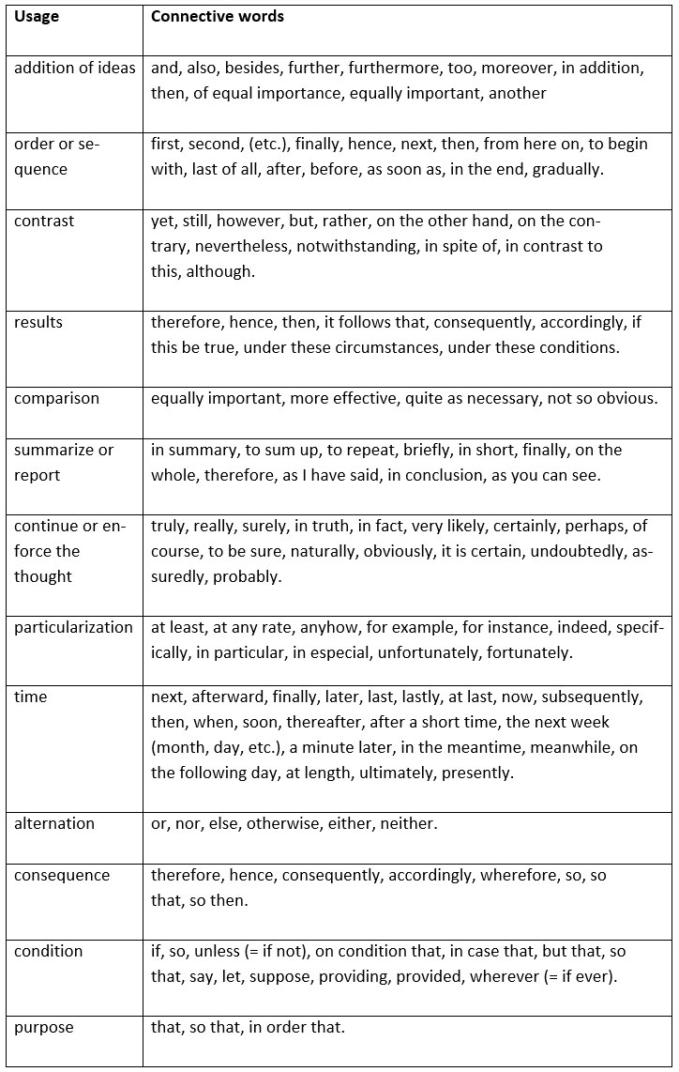Transition Words. As a "part of speech" transition words are used to link words, phrases or sentences. They help the reader to progress from one idea (expressed by the author) to the next idea. Thus, they help to build up coherent relationships withinthe text.

These show addition, introduction, similarity to other ideas, &c.
Addition:

indeed, | further, | as well (as this), | either (neither), | not only (this) but also (that) as well,
also, | moreover, | what is more, | as a matter of fact, | in all honesty,
and, | furthermore, | in addition (to this), | besides (this), | to tell the truth,
or, | in fact, | actually, | to say nothing of,
too, | let alone, | much less | additionally,
nor, | alternatively, | on the other hand, | not to mention (this)

Introduction:
such as, | as, | particularly, | including, | as an illustration,
for example, | like, | in particular, | for one thing, | to illustrate
for instance, | especially, | notably, | by way of example,

Reference:

speaking about (this), | considering (this), | regarding (this), | with regards to (this),
as for (this), | concerning (this), | the fact that | on the subject of (this)

Similarity:
similarly, | in the same way, | by the same token, | in a like manner,
equally | likewise,

Identification
that is (to say), | namely, | specifically, | thus,

that is (to say), | I mean, | (to) put (it) another way | in other words,

These transitions are used to signal conflict, contradiction concession, dismissal, &c.

Conflict:
but, | by way of contrast, | while, | on the other hand,
however, | (and) yet, | whereas, | though (final position),
in contrast, | when in fact, | conversely, | still

Emphasis:
even more, | above all, | indeed, | more importantly, | besides

Concession:
but even so, | nevertheless, | even though, | on the other hand, | admittedly,
however, | nonetheless, | despite (this), | notwithstanding (this), | albeit
(and) still, | although, | in spite of (this), | regardless (of this),
(and) yet, | though, | granted (this), | be that as it may,

Dismissal:
either way, | whichever happens, | in either event, | in any case, | at any rate,
in either case, | whatever happens, | all the same, | in any event,

Replacement:
(or) at least, | (or) rather, | instead

Causal Transitions:
These transitions signal cause/effect and reason/result, etc. . .

Cause/Reason:
for the (simple) reason that, | being that, | for, | in view of (the fact), | inasmuch as,
because (of the fact), | seeing that, | as, | owing to (the fact),
due to (the fact that), | in that | since, | forasmuch as,

Condition:
on (the) condition (that), | granted (that), | if, | provided that, | in case,
in the event that, | as/so long as, | unless | given that,
granting (that), | providing that, | even if, | only if,

Effect/Result:
as a result (of this), | consequently, | hence, | for this reason, | thus,
because (of this), | in consequence, | so that, | accordingly
as a consequence, | so much (so) that, | so, | therefore,

Purpose:
for the purpose of, | in the hope that, | for fear that, | so that,
with this intention, | to the end that, | in order to, | lest
with this in mind, | in order that, | so as to, | so,

Consequence:
under those circumstances, | then, | in that case, | if not,
that being the case, | if so, | otherwise

These transitions are used to signal a chronological or logical sequence.

Numerical:
in the (first, second, etc.) place, | initially, | to start with, | first of all | thirdly, (&c.)
to begin with, | at first, | for a start, | secondly,

Continuation:
subsequently, | previously, | eventually, | next,
before (this), | afterwards, | after (this), | then

Conclusion:
to conclude (with) | as a final point, | eventually, | at last,
last but not least, | in the end, | finally, | lastly,

Digression:
to change the topic | incidentally, | by the way,

Resumption:
to get back to the point, | to resume | anyhow, | anyway, | at any rate,
to return to the subject,

Summation:
as was previously stated, | so, | consequently, | in summary, | all in all,
 | thus, | as I have said, | to sum up, | overall,
as has been mentioned, | then, | to summarize, | to be brief, | briefly,
given these points, | in all, | on the whole, | therefore,
as has been noted, | hence, | in conclusion, | in a word,
to put it briefly, | in sum, | altogether, | in short

Paragraph Writing
A paragraph is a series of sentences that are organized and coherent, and are all related to a single topic. Almost every piece of writing you do that is longer than a few sentences should be organized into paragraphs. This is because paragraphs show a reader where the subdivisions of an essay begin and end, and thus help the reader see the organization of the essay and grasp its main points.
Paragraphs can contain many different kinds of information. A paragraph could contain a series of brief examples or a single long illustration of a general point. It might describe a place, character, or process; narrate a series of events; compare or contrast two or more things; classify items into categories; or describe causes and effects. Regardless of the kind of information they contain, all paragraphs share certain characteristics. One of the most important of these is a topic sentence.

TOPIC SENTENCES
A well-organized paragraph supports or develops a single controlling idea, which is expressed in a sentence called the topic sentence. A topic sentence has several important functions: it substantiates or supports an essay’s thesis statement; it unifies the content of a paragraph and directs the order of the sentences; and it advises the reader of the subject to be discussed and how the paragraph will discuss it. Readers generally look to the first few sentences in a paragraph to determine the subject and perspective of the paragraph. That’s why it’s often best to put the topic sentence at the very beginning of the paragraph. In some cases, however, it’s more effective to place another sentence before the topic sentence—for example, a sentence linking the current paragraph to the previous one, or one providing background information.
Although most paragraphs should have a topic sentence, there are a few situations when a paragraph might not need a topic sentence. For example, you might be able to omit a topic sentence in a paragraph that narrates a series of events, if a paragraph continues developing an idea that you introduced (with a topic sentence) in the previous paragraph, or if all the sentences and details in a paragraph clearly refer—perhaps indirectly—to a main point. The vast majority of your paragraphs, however, should have a topic sentence.

PARAGRAPH STRUCTURE
Most paragraphs in an essay have a three-part structure—introduction, body, and conclusion. You can see this structure in paragraphs whether they are narrating, describing, comparing, contrasting, or analyzing information. Each part of the paragraph plays an important role in communicating your meaning to your reader.
Introduction: the first section of a paragraph; should include the topic sentence and any other sentences at the beginning of the paragraph that give background information or provide a transition.
Body: follows the introduction; discusses the controlling idea, using facts, arguments, analysis, examples, and other information.
Conclusion: the final section; summarizes the connections between the information discussed in the body of the paragraph and the paragraph’s controlling idea.

Assignment Questions
1.Write a Paragraph in about 150 words on Traffic Menace in your city.
2. Write a Paragraph in about 150 words on the benefits of Technology to human kind.

Top of Form

