ENGINE MAINTENANCE – REPAIR AND OVERHAULING

1. What do you mean by engine overhauling and explain its necessity?

Overhauling a machine, strictly speaking, means going over it. When a vehicle engine is being overhauled, it is completely taken apart, every piece is inspected and what ever piece shows appreciable wear is reconditioned to its original shape and dimensions or replaced by a new one. After this the engine is reassembled, put on a test stand, started, tuned up, and carefully tested.

Since it is difficult to keep and accurate maintenance log for a vehicle away from the garage sometimes for days or week and since the operators of these vehicles need not be first class mechanics, and because nobody is concerned how efficiently an engine works as long as it runs and pulls the lead, a general overhauling of the engine is done at regular intervals, every 12 or 18 months as the case may be.

In general, the methods of overhaul do not differ from maintenance procedure, except that in overhauling a more strict examination is in order as the intervals are considerably greater than in maintenance work, a part even slightly worn, if it is not subject to maintenance inspection periodically, should therefore be either reconditioned or replaced.

- What is the precaution to be taken before dismantling engine. Dismantling:

One of the important rule to be adhered in dismantling an engine is to mark all parts and identify them as the engine is dismantled. It is particularly important to mark camshaft gears and valves if manufacturer’s marks cannot be found. Centre and punch markings will serve the purpose.

Changing the tyres around: In order to obtain the greatest mileage from a set of new tyres (including the spare one too) it is necessary to change then round at intervals of about 3000 miles for rear drive vehicles and 2000 miles for front drive vehicles during this useful life.

Cuts in tyre treads: Since water and grit penetrate and destroy the cords, small cuts in tyre has to be plugged with readily available “plastic tyre stopping large cuts should be vulcanized at tree.

Punctures: When a puncture occurs, on the road, the vehicle should be stopped and the when changed Tube less tyres can be driven to a safe distance even though they puncture, because, they lose their air
more slowly. Small punctures can be repaired with rubber patches and rubber solution. Minimum amount of solution is to be applied and it is allowed to dry for 5 to 10 minutes before placing the prepared patch: After this some talc is sprinkled over the patch to prevent sticking to the outer cover major repairs of the tubes are to be done with a professional vulcanizer.

When the vehicle is stored for a long period all the tyres are to be removed and stored an cool dry place, or the vehicle can be jacked off the ground and the tyres can be rubbed with French chalk.

- Write down the step by step procedure for engine removing and dismantling? Removal of Engine from the vehicle

A general procedure for removing the engine from the vehicle can be summed up as follows:

Drain oil from the sump
Drain water from radiator and jackets, opening all taps in the cooling system.
Remove engine bonnet and where filled vertical side members.
Remove radiator
Disconnect cable from battery
Disconnect fuel fed supply line
Remove L.T. cables from ignition system and disconnect wiring to horn.
Disconnect radiator hose from the engine side
Disconnect oil pipe to instrument pressure gage and thermometer pipe
Remove electric horn if liable to obstruct engine removal

- Take off cable connections to dynamo and starting meter (It is better to remove both starting motor (It is better to remove both starting motor and dynamic if readily accessible, as this allows better access to engine mounting nuts)

- Remove exhaust pipe flange nuts

- Take off accelerator and air choke controls

- Take out all foot boards as far back as rear of gear box

- Disconnect clutch pedal operating rod and pull of spring.

- Disconnect foot brake pedal and hand brake, if anchored to engine unit

- As the engine, clutch, and gear box are built as integral unit an most medium vehicles, it is more convenient to remove the complete unit than gear box; these operations can be performed better on the bench than on the chassis and much time save thereby

METHOD OF REMOVING ENGINE FROM VEHICLE

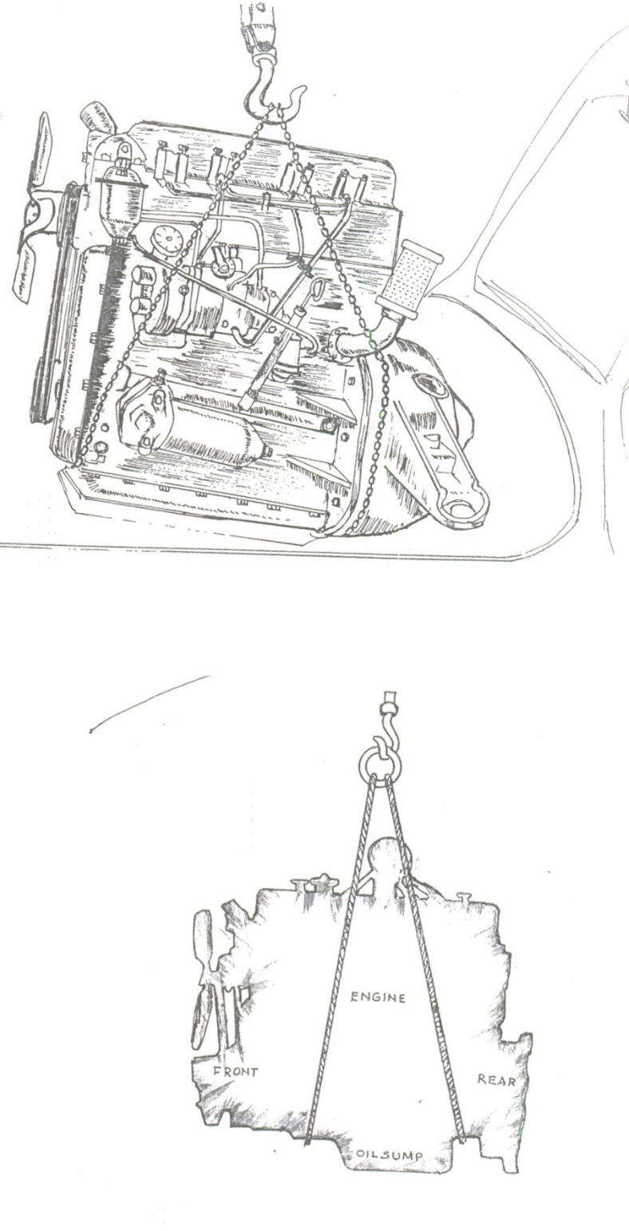
At this stage it is advisable to stop and look around the engine unit to make sure that all connections with the chassis frame, dash board, and body work have been released. The final operation will then connecting the front universal joint (just behind the gear box) and the earthing cable or strip between the engine unit and chassis frame, finally removing the nuts of the holding- down studs or bolts of the engine unit mounting. Usually there are two rubber mountings at the front end of the engine and a single large rear mounting on the gear box.

Once the engine is freed from the chassis a single or double rope or chain sting should be adjusted carefully round it making sure that the sling comes under the strongest part of the unit and does not foul any of the more vulnerable components like, the ignition unit, oil filter or carburettor. Now locate the chain on the lifting hook of the crane, so that when the engine is raised the front will be on a slightly higher level than the rear. Finally, lift the engine slowly and at the same time push the chassis rearwards so that the clutch housing will clear the cab opening.

It is convenient to mount the engine an a suitable engine stand, which will have the following features.

It should take a range of engine sizes
Convenient means for securing the engine
- It should be portable.

- The frame must be capable of rotation about a horizontal axis.

- Design of the frame should allow ready access to all engine parts in any position.
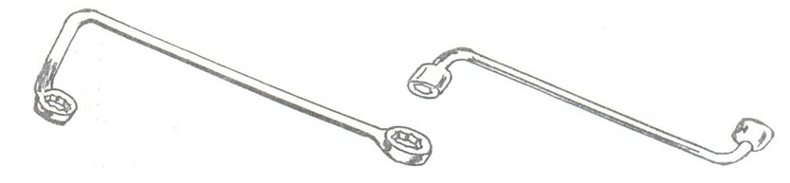

CYLINDER HEAD BOLT WRENCH
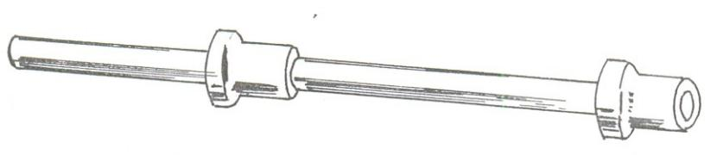

CAMSHAFT BEARING TOOL
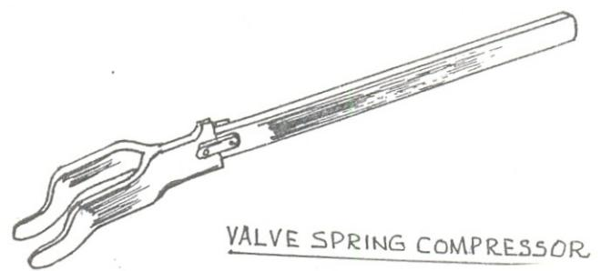

VALVE SPRING COMPRESSOR
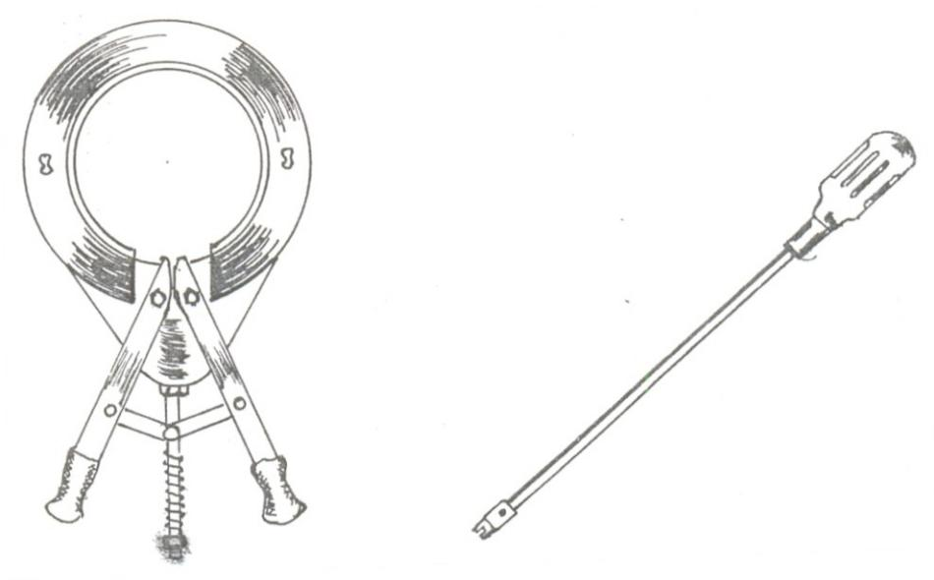

PISTON RING TOOL

3. Explain the Procedure for Decarbonizing the Engine

OIL SLIMP SCREW DRIVER

The intervals at which decarbonizing of the engine becomes necessary, depend upon a number of circumstance being governed by the performance and tendency of the engine to knock under acceleration or hill climbing . It is unwise to post pone decarbonising, since increase engine wear will result and the performance will also continue to fall off.

The hard carbon deposit found on motor vehicle engine consists partly of carbon from lubricating oil and fuel and partly of hard abrasive siliceous matter carried as fine dust particles by the air of the fuel mixture.

The procedure of decarbonising an engine is as follows:

- Remove the cylinder head and clean with paraffin

- Remove the gasket and check for scratches, indentation and other defects. (if necessary use a spare gasket)

- Clean the cylinder block machined faces with paraffin and dry it so as to prevent adherence of carbon dust.

- Plug the water circulation orifice in the cylinder block with cotton waste so as to prevent dust entering.

- Using the starting handle bring a pair of pistons to their top centre position and remove the carbon deposits from their crown with a flat scrapper, leaving a ring of carbon about 1/8” wide around the outer periphery of the crown.

The reason for this is that this carbon which slightly overlaps the edge tends to prevent oil from parsing upwards, tests have shown that the oil consumption in slightly reduced when this carbon ring is left.
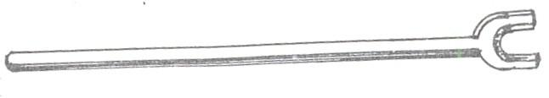

LEVER TYPE VALUE SPRING COMPRESSOR
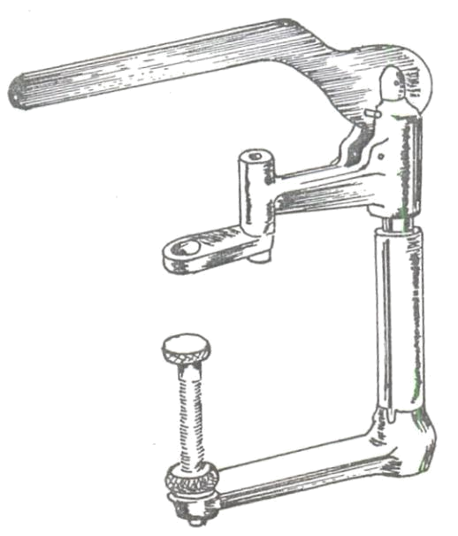

TOOLS FOR COMPRESSIG OVERHEAD VALVE SPRINGS
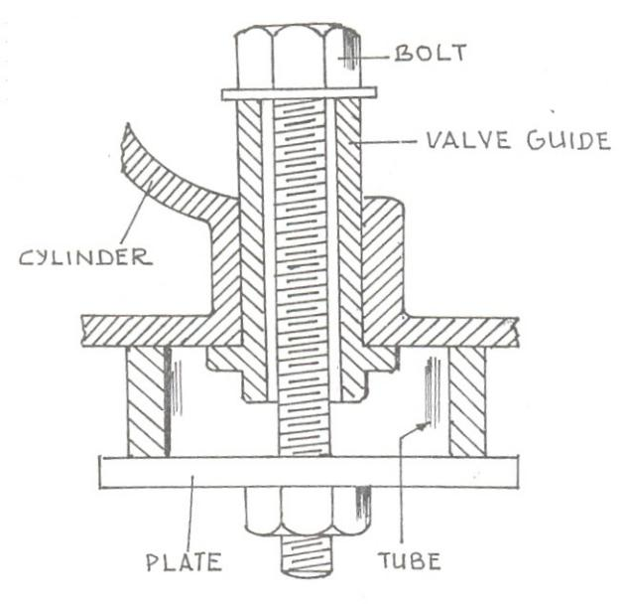

BOLT, NUT AND WASHER- PLATE FOR REMOVING VALVE GUIDES

(6)Having remove the carbon from the two pistons, right the crank shaft until the next pair of pistons come to top.

(7) Wipe the cylinder barrels of the first pair and stuff clean rags or waste in to the top opening, to keep
out carbon scrapped from the second pair of piston.
- Remove the carbon from the second pair as before
- Continue the above proceeding until all the piston are over
- Clean the valves and metal around them
- Scrap the cylinder head off carbon with special scrapper
- Remove carbon from the valve ports and metal around the valve guides

(13) Remove the carbon deposits in the sparking plug holes with a pointed tool such as a bradawl or scriber.

- Remove all plugs (with cotton waste) and give the parts a final cleaning with a suitable cloth.

- Smear each barrel with engine oil and rotate the crankshaft a few times so as to distribute the oil evenly over the surfaces.

- Replace the gasket, (use a new one if necessary and cylinder head and tighter the holding down nuts on finger tight.

- Tighten the cylinder head nut in the order prescribed by the manufacturer, using the appropriate torque by a torque wrench.

- Replace the cylinder head fittings.

The above procedure is for, when the engine requires only decarbonising. When a complete over haul is done, decarbonising also takes part as a routine over haul procedure.

- Explain the procedure for Dismantling an engine? Remove cylinder head

Take off all external accessories, like motor , dynamo ignition unit or injection pump. Remove engine sump

Rake off timing gear cover, after removing pulleys, etc Remove clutch unit

Take out all valves with their tappets, rocker arms, push rods, etc Remove connecting rod caps, pistons and connecting rods Take off timing chain and remove sprockets

Remove crank shaft with flywheel by taking off main bearing caps. Remove camshaft

If necessary, drive out valve guides

(xii) Disconnect oil pump drive and remove oil pump at the most convenient stage in the proceeding operations. The oil filter and cleaner are removed early on, also the disstick or oil level gauge.

As the components are removed they should be grouped conveniently on a bench or table, prior to cleaning. Before taking of any component, make sure that it is marked identically with mating part.

5. Briefly mention the methods used for Cleaning the Engine components?

If relatively few engines are to be reconditioned at appreciable intervals, the paraffin bath
method of cleaning is the most economical. The group of components are immersed in a bath or deep tray containing paraffin and scrubbed with a wire or bristle brush to remove all dirt.

INSERTING LINERS: SCREW AND NUT METHOD
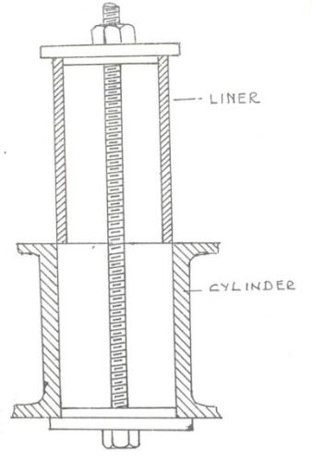
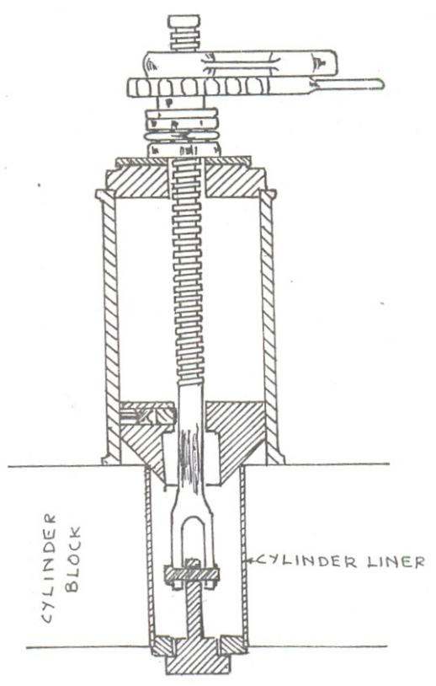

‘BUMA’ TOOL FOR REMOVING CYLINDER LINERS

After cleaning the parts are placed in a metal plate or slab to dry in a warm place.

The motor garages uses a high pressure spray directly by a nozzle on a flexible hose to the parts which are placed on perforated draining tray; small parts dealt with collectively by placing in a special container. The dirt and grease are quickly dislodged and the paraffin is thoroughly filtered through the detachable filter box before it drains into the reservoir at the bottom, thus there is no need to clean any sludge from the tray or reservoir.

Caustic soda made into a solution with hot water, hot saturated, sodium carbonate solutin and trichloro ethelen are other cleansing agents used.

6. Explain the step by step the examination and checking of Components?

Often a careful scribing of the various engine parts will reveal indications of damage excessive wear, surface cracks, and other defects without the need for more elaborate inspection. The simple parts such as studs, bolts and nuts should be examined for signs of damage or stripping. The nuts can be run down the threads as a check. Bolts, nuts and washer faces must be free from edge burrs. The valves, springs , collar’s and retainers, are their examined for wear and shape.

The piston should be carefully inspected for surface damage and for wear effects in the ring grooves, on the skirt portion etc. Blackened areas on the land or skirt denotes areas of gas blow- by , and these are noted. The piston crown should be examined for cracks or distortion and the gudgeon pin holes for signs of hammering effect.

The big end bearings of the connecting rod and the journals of the crank shaft are inspected for signs of cracking, scoring or other surface defects. The can shaft bearings and journals are also checked.

The timing gear teeth will indicate by visual and meshing tests, whether any undue damage or wear has occurred. Similarly the condition of the timing chains rocket teeth are also checked.

When spares are available , they can be employed for comparison purpose with the those under inspection.

Now the cylinder blocks and head are inspected for the following defects.

- Cracks in the water jacket walls
- Damaged machined faces

- Fractured Flanges

- Cracked Valve seatings or loose seating inserts

- Scored cylinder barrels or ridging near the top

- Loose or damaged cylinder head studs.

After the visual inspection the cylinder measurements one taken accurately to find out the wear.

The cylinder, piston, piston rings, crankshaft journals, connecting rod bearings, camshaft ,connecting rods, crank shaft, timing gears, chain wheels and chain are all measured for weak. The valve stem, its seating, guide bushes etc: are also to be checked for wear.

Worn cylinders can be reconditioned by the following methods.

- Machining in the lathe

- Regrinding in the lathe or with special machines designed specifically for this purpose.

- Boring with cutters, using a portable machine that can be clamped to the cylinder block.

- Horning either by portable or fixed machine

- Reaming with portable or fixed machines

When cylinder liners are used, it is easy to remove the work cylinder lines and insert a new one, and the cylinder reboring can be dispensed with.

- Cracks in the piston crown
- Burning of crown.
- Scored lands and skirt
- Blackened areas on land and skirt which are sign of gas leakage from combustion chamber.
- Oil Scrapper ring hole blockage
- Excessive wear of piston lands, skirt, rings grooves and gudgeon pin holes.

The other engine components that are to be examined are the various bearings viz, the crank shaft bearings, the camshaft bearings, the connecting rod big end and small end bearings, the crankpin, the connecting rods, the valves, their seatings, guide bushes, the rocker arm, push rods, cam profile, timing gear, chains of chain drive where used, the ignition system of the S.I. engines, the fuel pump and nozzles of C.I. engines etc.

After all the engine components are inspected and tested for their measurements, shapes and performance the reassembling of the engine begins.
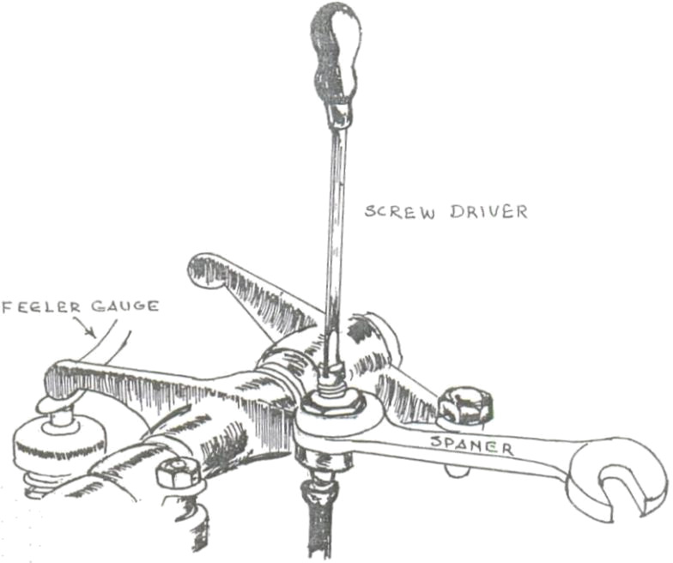

METHOD OF ADJUSTING VALVE STEM CLEARNACE OF OHV ENGINES
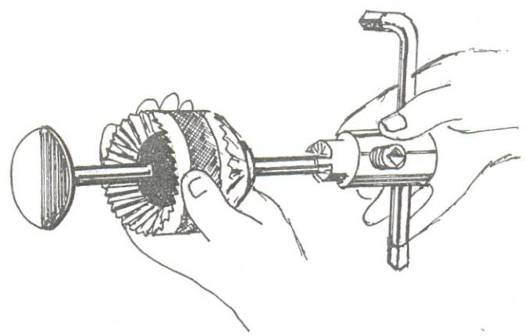

A USEFUL VALVE FACING TOOL

- What are the special tools and basic instruments required for maintenance? Basic Instruments Needed
For Engine:

- Compression Gauge

- Vacuum Gauge

- Tachometer

For Ignition System

- Power Timing Light

- Dwell meter

- Voltmeter

- Ohm meter

For Electric System

- Voltmeter

- Ammeter (0-30 Amps)

- Tachometer

- Hydrometer

- Batter Load Tester

For Fuel System

- Fuel pump Pressure Gauge

For Emission Checking

Exhaust Gas Analyzer

For Cooling System

Coolant Thermometer

- What are the common troubles / Faults that normally occur in an automobile? Cooling System Problems and Causes:

Engine Overheating

  - Loss of coolant
- Defective Thermostat

- Defective water pump

- Collapsed Radiator Hose

- Excessive Rust & Scales

- Obstructed air passage through Radiator

- late Ignition timing

- Combustion leak into cooling system

- Improper coolant mix

- Defective Temperature Gauge

Engine Runs Too Cool

- Defective Thermostat

- Defective Gauge

Fuel System Problems and Causes

Carburetor flooding

- Worn needle and sear

- Leaky float

- Excessive fuel pump pressure

- Improper float adjustment

Rough Idle:

- Improper idle Mixture

- Poor Compression

- Intake manifold leak

- Defective spark plug wires

- Cracked distributor cap

- Stuck PCV valve

Stumbling During Acceleration

- Defective accelerator pump

- Improper adjustment of Acc. Pump

- Ignition Misfire

Sluggish Performance

- Late Ignition Timing

- Too rich or too lean mixture

- Defective advance mechanism

Ignition system Troubles & causes

Engine Misfires at All Speeds

- Defective plug wires

- Cracked distributor cap

- Fouled spark plug

- Burned values

Engine Misfires During Acceleration

- Defective plug wires

- Fouled or worn plugs

- Burned contact points

- partially shorted ignition coil

- Open capacitor

- Poor primary circuit

- Carburetor Problems

Engine Misfires at high speeds

- Insufficient Dwell angle

- Carburetor Problems

Hard Starting

- Burned contact point

- Improper ignition timing

- Low Battery

- Low Battery

- Open Capacitor

- Ignition Timing too much advanced

Starting System Problems & Causes
Battery Not holding charge

- Internal defect of battery

- Dirt on Terminals / Loose Terminals

- Electrical leakage/ shorts

- Excessive Electrical usage with car stopped / idling

- Battery not used for long periods.

Battery Always undercharged

- Defective alternator / Generator

- Low voltage regulator setting

- Infrequent or slow driving with heavy electrical loads

- Excessive charging circuit resistance

- Sulphated Battery

- Too Many Electrical Accessories

Battery Uses Excessive Water

- High voltage regulator setting

- Sulphated Battery

- High temperature

Slow Cranking Speed

- Excessive starter circuit resistance

- Dragging starter armature

- Shorted armature or field

- Excessive engine friction

- Worn starter Bushes

Starter Spins without Engaging

- Defective Bendix drive

- Dirt or Burr on starter shaft

Starter Clicks without Cranking

- Defective solenoid switch

- Open starter cable
- Defective starter

Starter Switch or Solenoid Chatter

- Poor battery connection

- Defective solenoid

- Excessive starter circuit resistance

No Cranking, No Solenoid Click

- Defective starter or ignition switch

- Broken wire, solenoid or switch

- Defective solenoid or switch

Charging System Problems & Causes

No Charge Rate:

- Defective alternator /Generator

- Defective voltage regulator

- Open or grounded field wire

- Open circuit

- Worn or stuck brushes

Low Charge Rate

- Regulator out of adjustment

- Defective regulator

- Excessive field circuit resistance

- Defective alternator/ Regulator

- Worn Brushes

- Sulfated Battery

High Charge Rate

- Regulator out of adjustment

- Defective regulator

- Defective Battery

- High battery temperature
- An accessory drawing excessive current even when the engine is not running.

Problem:

Due to open primary circuit:

- Burned or oxidized ignition points

- Ballast Resistor burned or open

- Ignition points not closing

- Breaker arm binding on pivot post, preventing closing of points

- Breaker arm spring weak or broken

- breaker arm distorted or bent

- Dirty ignition points

- Primary lead connection loose

- Primary winding open

- Open ignition switch circuit

Due to short circuited Primary Circuit

Grounded primary coil winding, grounded ignition switch or a lead will cuase excessive current flow and will usually cause wires to burn.

Possible causes for Grounded primary circuit:

- Ignition points not opening or closing due to improper adjustment.

- Ignition points not opening due to worn rubbing, block on Breaker A.R.M

- Faulty insulating bushing on breaker ARM

- Cracked or faulty insulator at Distributor, Primary Terminal

- Grounded condenser.

- Distributor-To-Coil lead grounded

- Primary coil winding grounded

Due to Faulty secondary ignition circuit

- Corroded spark plug cable terminal

- Cracked insulation on cables (H.T)

- Ignition so weak or ineffective

- Moisture on ignition coil , terminals, distributor ,

- Improper type of spark plugs

- Cracked distributor cap or burned carbon brush in the CAP.
- Improper connection to spark plugs (not correct as per firing order)

- Spark plugs damaged, Dirty or wet porcelain cracked or gaps improperly adjusted.

- Rotor contact spring Bent or Broken

- Distributor rotor grounded

- Distributor cap centre terminal broken or missing

Due to Battery

- Battery run down

- Terminal loose or badly corroded

- Improper ground

- Battery cable undersize.

Due to Excessive fuel supply (flooding)

Accumulation of liquid fuel in the intake manifold as well as cylinder. The engine won’t start until, the rich mixture formed by flooding .

Reason

- Choke not operating properly

- Automatic choke not properly set

- Float level set too high

- Dirty worn or faulty needle valve seat

- Float sticking or rubbing against side of fuel bowl.

- Leak in float allowing fuel inside

- Fuel pump pressure too high

Due to insufficient fuel supply

- Carburetor inlet needle stuck in its seat due to gum in fuel

- Float level too low

- Clogged inlet filter at carburetor

- Faulty or insufficient capacity fuel pump

- fuel pump strainer clogged

- Faulty fuel pump Bowl Gasket

- Fuel line from tank clogged or restricted

When Engine is Hot

Hard starting of engine under hot conduction is mainly due to over supply of fuel (flooding) in rare cases an ignition coil may loose its efficiency when it is hot and cause ignition failure.

When Engine is cold

Apart from the conditions listed under engine won’t start the following conditions are also to be checked.

- Choke setting too lean

- Fuel may have kerosene, water or ice

- Ice in fuel lines

- Engine is cranked too slowly or won’t turn because:

  - Engine oil too thick in sub-zero weather

  - Battery too weak due to very low temp

- Another possibility even though remote is that the water pump is jammed with ice, which will interfere with cranking engine if fan belt is tight.

Due to vapour lock

Flow of fuel to the mixing chamber is stopped (locked) By the formation of vapourrized fuel pockets or bubbles caused by overheating the fuel by hot fuel pump, hot fuel lines or hot carburetor.

High ambient temperature, hard driving defective engine cooling and high altitudes are contributing to vapour lock.

After long period of non usage of vehicle

- More volatile components in the fuel, have evaporated and the remaining ones are not sufficiently volatile to form a combustible mixture.

- Low or run down battery

- Corrosion of engine moving parts

These troubles are more humidity climate and near salt water.

Reasons for the stalling of engine

- Engine idle speed set too low.

- Large air leakage in take manifold
- ignition points need attention

- Vapour lock

- Over supply of fuel (flooding)

- Valves set too tight

- Needle/ seat of carburetor inoperative

- Contaminated fuel

- Choke sticking or improperly adjusted

- Faulty ignition system

- Spark plugs damp/Dirty or incorrect gap

- In operative distributor advance

- Restricted exhaust system

- Burned, warped or sticking valves

- Low compression

- Engine over heating

- Loose or corroded wire connections

- Incorrect idle mixture adjustment

- Incorrect carburetor float setting

- Leaking EGR valve

