UNIT: III STRUCTURAL GEOLOGY

FOLDS: These are one of the most common geological structures found in rocks. These are best displayed by stratified formations such as sedimentary or volcanic rocks or their metamorphosed equivalents.
When a set of horizontal layers are subjected to compressive forces, they bend either upwards or downwards eg: Granitic gneisses, quartzites, Schists, Limestones etc are common rocks in which folds occur.
Explanation:
Tension: A body is said to be under tension when it is subjected to external forces that tend to pull it apart.
Compression: A body is said to be under compression when it is subjected to external forces that tend to compress it.
Torsion: It results from twisting . If the two ends of a rod or plate are turned in opposite directions, the rod or plate is subjected to torsion
TENSION | COMPRESSION | TORSION

STRIKE The strike of a bed is its trend measured on a horizontal surface. Strike refers to the direction in which a geological structure such a bed, a fault plane is present.
When a bed is exposed on the surface , its direction of occurrence, its direction of inclination can be measured by using a clinometre or Brunton compass ( a magnetic compass –like instrument ).
DIP: The dip of a stratum is the angle between the bedding plane and a horizontal plane.

PARTS OF A FOLD:
In nature, folds found in rocks and vary in terms of their length and breadth. However, the bends noticed in rocks are called as folds. Following are the parts of a fold:
CREST & TROUGH: The curved portions of the fold at the top and bottom are called crest and trough respectively. The curved portions are smoothly bent or sharp or angular.
LIMBS / FLANKS: These are the sides of a fold. There are two limbs for every fold and one limb common to the adjacent fold.
AXIAL PLANE: This is the imaginary plane which divides the fold into two equal halves. Depending upon the nature of the fold, the axial plane may be vertical, horizontal or inclined.
WAVE LENGTH: The distance between the successive crests or troughs is called wavelength.
HINGE: The hinge of a fold is the line of maximum curvature in a folded bed.
AXIS: The intersection between the axial plane and the crest or trough of the fold. ( that means the axis is a line parallel to the hinges )

TYPES OF FOLDS : Folds are classified on the basis of (i) Symmetrical character (ii) Upward or down ward bend (iii) occurrence of plunge (iv) Uniformity of bed thickness (v) Behavior of the fold pattern with depth etc
- ANTICLINE & SYNCLINAL FOLDS
- SYMMETRICAL & ASYMMETRICAL FOLDS
- PLUNGING & NON-PLUNGING FOLDS
- OVERTURNED FOLD
- OPEN AND CLOSED FOLDS
- CHEVRON FOLD
- ISOCLINAL & RECUMBENT FOLDS
- BOX FOLD
- FAN FOLD
- ANTICLINORIUM AND SYNCLINORIUM FOLDS
- DRAG FOLD

Anticline: It may be defined as a fold that is convex upward; and the two limbs dip away from each other. In such a fold, the older rocks occur in the centre.
Syncline: It may be defined as a fold that is convex downwards and the two limbs dip toward each other. In this fold, the younger rocks are in the centre.
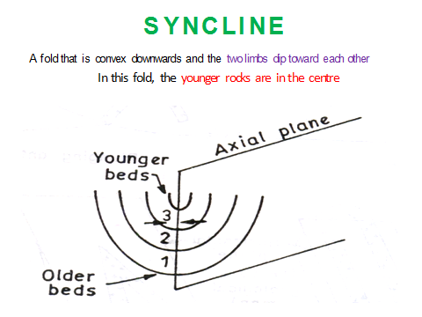

Symmetrical fold: a symmetrical fold is one in which the axial plane is essentially vertical or upright. The axial plane divides a fold into two equal halves in such a way that one half is the mirror image or another.
Asymmetrical fold: A asymmetrical fold is one in which the axial plane is inclined. If the two halves are not mirror images, then the fold is called as asymmetrical fold.
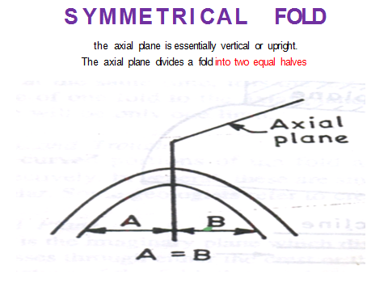

Plunging and Non-Plunging Fold: If the axis of a fold is inclined, then it is called plunging fold. On the other hand, if the axis of the fold is horizontal, then the fold is called Non-plunging fold.
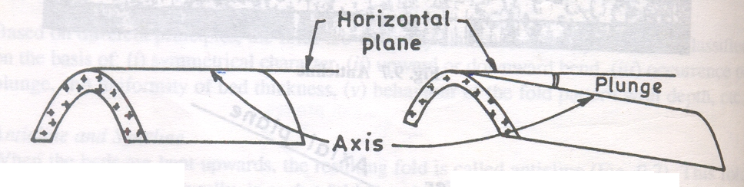

Non-Plunging Anticline Plunging Anticline

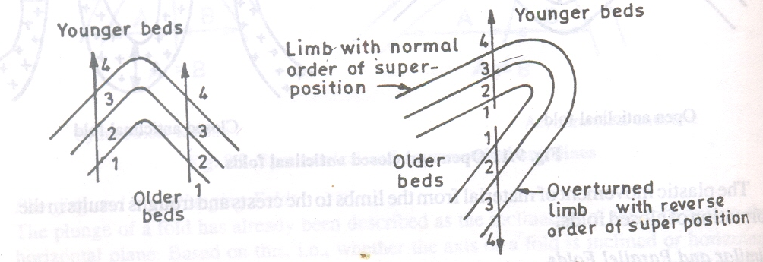
Overturned Fold: In a simple fold, the limbs show the order of superposition of beds. But when one of the limbs is overturned, the order of superposition of beds in that particular limb will be in reverse order, such a fold is called an overturned fold.

Simple fold overturned fold
Open and Closed folds: If the thickness of beds is uniform throughout the fold, it is called an open fold. On the other hand, if the beds are thinner in the limb portions and thicker at the crests and troughs, such fold is called a closed fold.
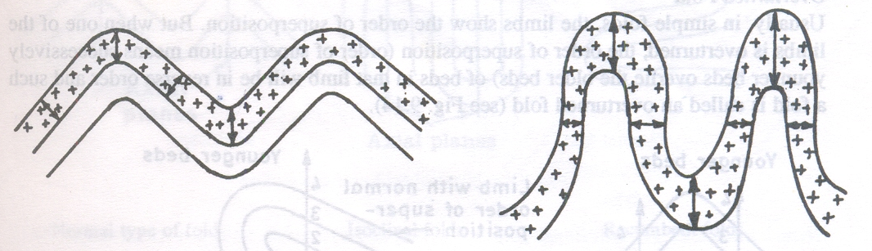
Open Fold Closed Fold

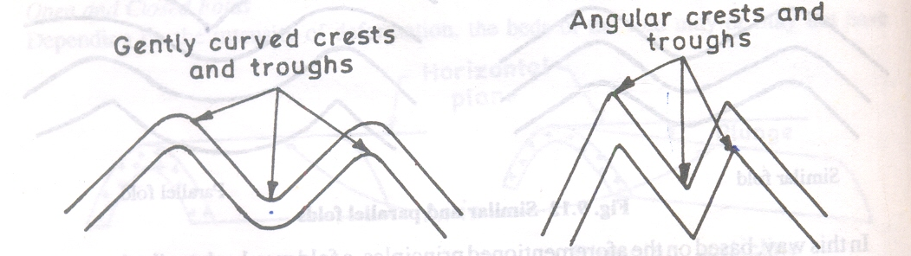
Chevron Fold: A Chevron fold is one in which the hinges are sharp and angular.
Normal type of fold chevron fold

Isoclinal Fold: An Isoclinal Fold in which, the two limbs dip at equal angles in the same direction. These isoclinals folds may be vertical or inclined or horizontal
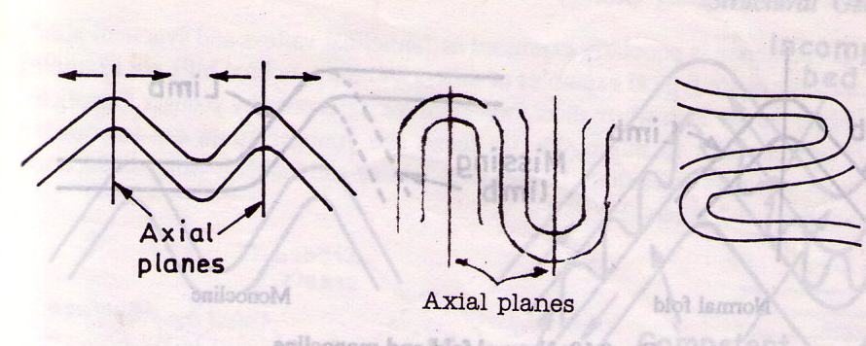
Recumbent Fold: A recumbent fold is one in which, the axial plane is essentially horizontal. All recumbent folds if satisfactory exposures are available, may be traced back to the Root Zone - ie the place on the surface of the earth from which they arise. Also characterized by the presence of digitations (look like great fingers extending from a hand ).
Normal Type of Fold Isoclinal Fold Recumbent Fold
Box Fold: Usually, the crests and troughs of beds are smooth, broad and flat.
Fan Fold: In simple anticline, the limbs dip away from one another and in simple syncline, the limbs dip towards each other. In case of Fan Folds, this is just Opposite.
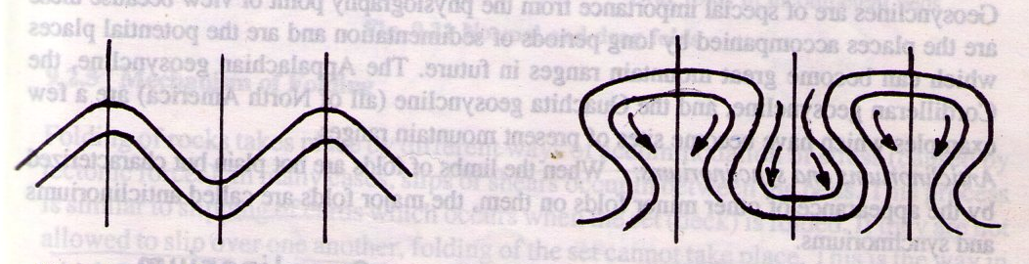
In Fan Fold, the two limbs dip toward each other in case of Anticlinal Fan folds and the two limbs dip away from each other in case of Synclinal Fan Fold.
Normal Type of Fold Fan Fold
Anticlinorium & Synclinorium: A major anticline that is composed of many smaller folds is called an Anticlinorium . Similarly, a Synclinorium is a large syncline also composed of many smaller folds too.
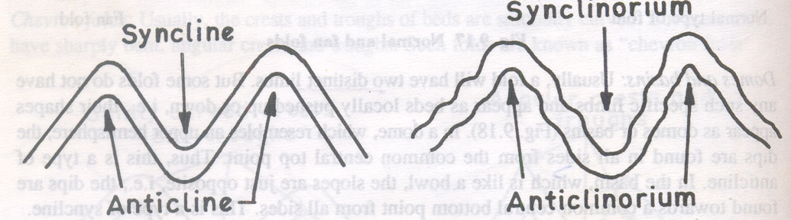
Normal Fold Anticlinorium and Synclinorium Fold
Geo-anticlines and Geosynclines: The Anticline and Synclines with a normal shape but of very large magnitude are called Geo-anticlines ( Giant anticlines ) and Geosynclines. Geosyncline is a large depression, hundreds of miles long and tens of miles wide in which sediments accumulate to greater feet.
Eg: Appalachian ( North America ) Geosyncline was 40,000 feet depth.
The Cordilleran ( North America ) Geosyncline
The Ouachita ( North America ) Geosyncline
The Geosynclines can become great mountain ranges and the examples are mentioned above.
Drag Fold: Drag Folds are those that develop in an incompetent bed ( weaker beds ) lying between two competent beds ( strong beds ).
In the broader sense, drag folds refer to any minor folds genetically associated with major folds. When the competent beds ( stronger beds ) slide past in opposite directions due to shearing effect / dragging effect, the drag folds ( minor folds ) develop in the incompetent beds ( weaker beds ).
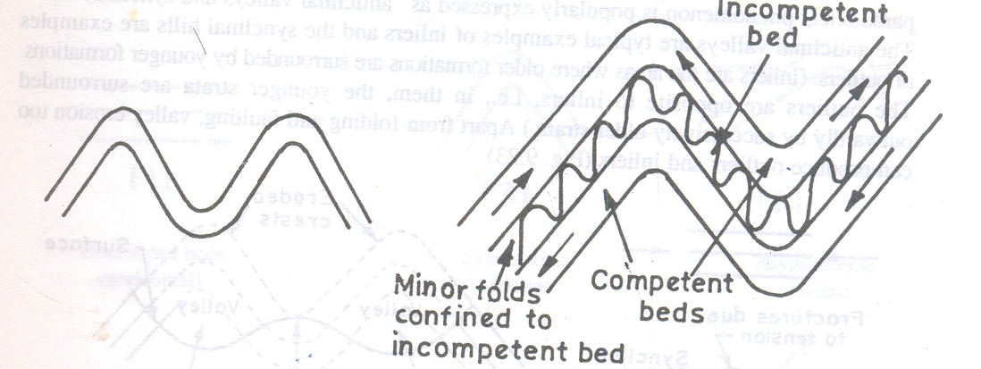

IMPORTANCE OF FOLDS IN CIVIL ENGINEERING POINT OF VIEW:
Folding of rocks takes place by different ways of stress acted upon it. Most of the folds are due to tectonic causes and a few folds are due to non-tectonic causes such as landslides etc…
Due to weathering and erosion, the Anticlines will change over to Valleys while the Synclines change over to Hills. This feature is called as Paradoxical phenomenon is popularly expressed as ANTICLINAL VALLEY & SYNCLINAL HILL.

Folds as a result, the affected rocks get deformed, distorted or disturbed. This results in the occurrence of great strain in rocks which may cause bulging , caving etc.. Because of folding, the affected rocks possess fractures of different types in different parts of folds ie limbs, crest, trough and becomes weak. Such type of locations especially for construction of dams, reservoirs, tunneling, etc.. leads to collapse the civil structures.
For eg: At the dam site, the beds of limb shall be dip in the upstream direction to hold the accumulated water as a load.

FAULTS
Faults may be described as fractures along which relative displacement of adjacent blocks has taken place. The relative displacement caused during faulting may be horizontal, vertical and inclined.

Some faults are only a few inches long, and the total displacement is measured in fractions of an inch while there are faults that are hundreds of miles long. The strike and dip of a fault are measured in the same way as they are for bedding planes. The magnitude of faulting obviously depends on the intensity and the nature of shearing stress ( various tectonic forces ) involved.
Occurrence of faulting is often accompanied by earthquakes and it is an indication of subsurface instability of the region concerned.
PARTS OF A FAULT
Fault plane, foot wall, hanging wall, slip, hade, heave and throw which are important parts of a fault
Fault Plane: This is the plane along which the adjacent blocks were relatively displaced. Like, bedding plane (or axial plane) the fault plane can be expressed by strike and dip. Its intersection with the horizontal plane gives the strike direction. The direction along which the fault plane has the maximum slope is its true dip direction. The amount of inclination of fault plane with reference to the horizontal plane along the true dip direction is called its true dip amount. Hade is the angle between the inclined fault plane and a vertical plane. Dip + Hade = 90⁰
Foot wall and Hanging wall: When the fault plane is inclined, then the faulted block which lies below the fault plane is called the foot wall and the other block which rests above the fault plane is called the hanging wall.
Slip: The displacement that occurs during faulting is called the slip. This may be along strike direction (i.e. Strike slip) or along dip direction (i.e. Dip slip) or along both (Strike and Dip slip). Eg: The fault is an inclined plane that strikes N-S at dips 35° East and has a Hade of 55º East.
Hade: The angle between the fault plane and a vertical plane.
Heave: The horizontal displacement of the blocks is called as heave. Heave can be seen only in vertical faults.
Throw: The vertical displacement of the blocks is called as Throw. Throw can be seen only in vertical faults.
HANGING WALL

FOOT WALL

Classification and types of faults: Faults like folds may be classified on the basis of geometry or their genesis or different principles as follows.

- Type of displacement along the fault plane.
( eg: Translation fault; Rotational Faults )

- Relative movement of FW & HW.
(eg: Normal Fault / Gravity Fault; Thrust / Reverse Fault ).

- Types of slips involved ( classification based on Net Slip )
eg: Strike Slip Fault; Dip Slip Fault ; Oblique Slip Fault )

- Mutual relation of attitudes of the fault plane.
(eg: Strike Fault; Dip Fault; Oblique Fault)

- Inclination of the fault plane.
(eg: High Angle Fault; Low Angle Fault )
- Mode of occurrence of faults.
(eg: Radial Fault; Arcuate Fault; Enehelon Fault )

- Miscellaneous Faults: (eg: Step Fault; Parallel Fault; Horst & Graben Faults )
  - Type of Displacement: Based on the displacement principle, faults are divisible into Translational faults and Rotational faults.
Translational Faults: The displacement of the foot wall with respect to the hanging wall is uniform along the fault plane.
Rotational Faults: In rotational faults, the FW and the HW appears to have been fixed at a place or can be seen the gradual changes in displacement.
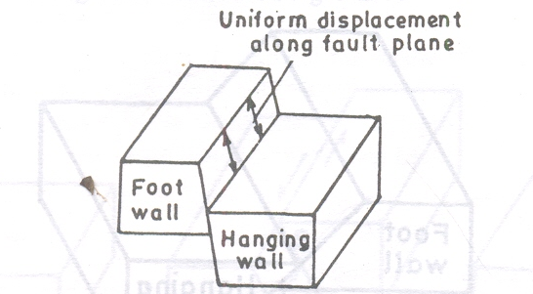 | 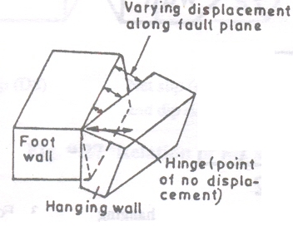
Translational Fault | Rotational Fault

2.Relative Movement of FW/HW: ( In case of inclined faults )
Normal Fault: If the HW goes down with respect to the FW, it is called the Normal Fault. Since the blocks are expected to move or slide down along the influence of gravity, it will be also called as Gravity Fold.
Reverse Fault: If the HW goes up with respect to the FW , it is called as Reverse Fault. This is also called as Thrust Fault
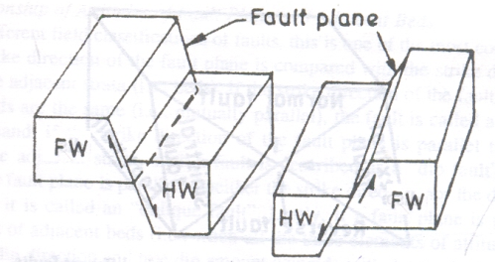 | 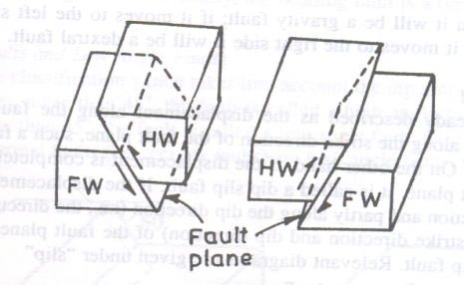
Normal Fault / Gravity Fold | Reverse Fault / Thrust Fault

3.Type of Slips: The displacement that occurs during faulting is called the slip. The total displacement is known as the Net slip. The net slip may be along the strike direction (strike slip) or the dip direction (Dip slip ) or along both
Strike slip fault / Wrench Fault: The displacement is only along the strike direction of the fault plane, such a fault is described as strike slip fault.
Dip Slip Fault: If the displacement is completely along the dip direction of the fault plane it is called a dip slip fault.
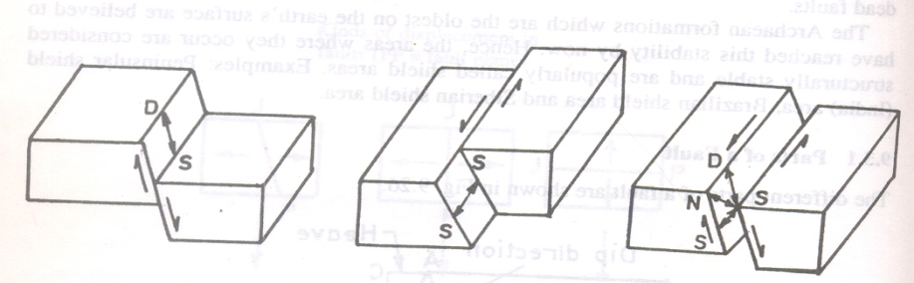
Oblique Slip Fault: If the displacement occurs partly along the strikes direction and partly along the dip direction, such a fault is called as oblique slip fault.

Dip Slip Fault Strike Slip Fault Oblique Fault

4.Mutual relation of attitudes of the fault plane:
If the strike direction of fault plane is parallel to the strike of the beds of adjacent strata, such fault is called as strike fault. On the other hand, if the strike direction of the fault plane is parallel to the true dip direction of adjacent strata, such fault is described as a dip fault. If strike direction of fault plane is neither parallel to strike direction nor parallel to dip direction of adjacent beds, it is called oblique fault.
5. Inclination of the fault plane: This is simple classification which makes account the dip amount of the fault plane. If it is steep i.e. more than 45⁰, the fault is called a high angle fault and if it is gently sloping i.e. less than 45⁰ the fault is called a low angle fault. Generally, normal faults / gravity faults are high angle faults, while Reverse / thrust faults are low angle faults.
High angle Fault: If the dip amount of the fault plane is > 45°, the fault is called a high angle fault.
Low angle Fault: If the dip amount of fault plane is < 45° the fault is called a low angle fault.
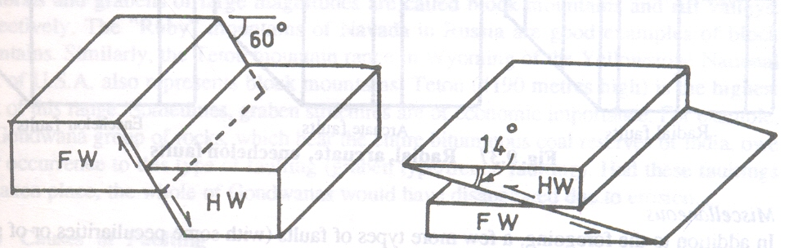
High Angle Faults Low Angle Faults

6. Mode of occurrence of faults: Based on the mode of occurrence or pattern in the field, the following types of faults are examples:
Radial Faults: When a set of faults occur on the surface and appears to be radiating from a common point, they are called radial faults.
Arcuate Faults: A set of faults occur in a peripheral manner, enclosing more or less a circular area.
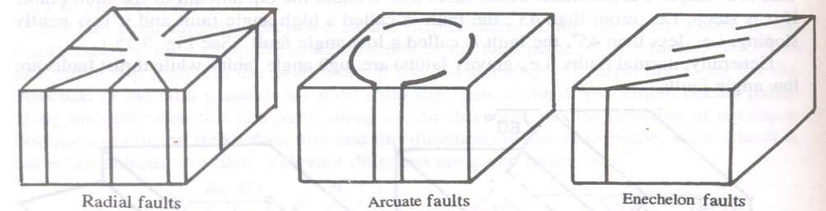
Enechelon Faults: A set of faults which appear to be overlapping one another.

MISCELLANEOUS FAULTS
STEP FAULTS: When a set of parallel normal faults occur at regular intervals, they give a step-like appearance and are called step faults.
PARALLEL FAULTS: When a set of parallel normal faults occur without a regular interval, such type of fault is called as Parallel fault though similar appearance of step faults.

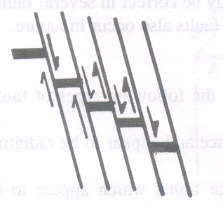 | 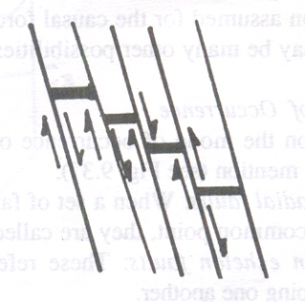
Step faults | Parallel faults

HORST AND GRABENS: When normal faults with mutually diverging or converging fault planes occur, then a few wedge-shaped blocks called “ horsts” are displaced upwards and a few other (alternated with the raised blocks) called “grabens” are displayed downwards.
Horsts and Grabens of large magnitudes are called BLOCK mountains and RIFT valleys, respectively .Eg:(1) Ruby mountains of Navada in Russia (2)Teton Mountain Range in USA are good examples for Horsts.
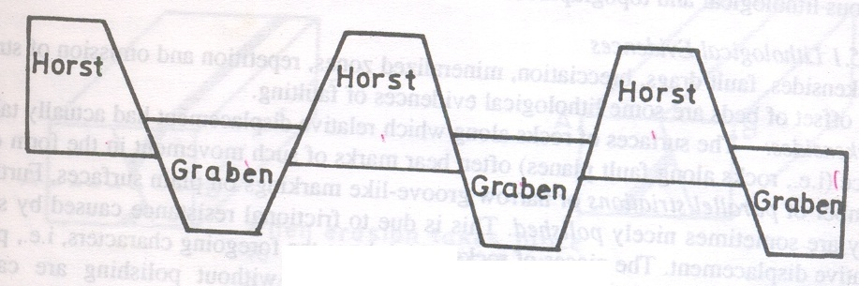

EFFECTS OF FAULTS FROM THE CIVIL ENGG POINT OF VIEW
- Faults are the most unfavorable and desirable geological structures, for any LOCATION OF RESERVOIR
FOUNDATION FOR CONSTRUCTION OF A DAM
BRIDGES / BUILDINGS
TUNNELLING
LAYING ROADS OR RAILWAY TRACKS.

- As long as the faults are active, the site is unstable and susceptible to upward or downward movement along the fault plane. eg; St Francis Dam, California & Austin dam in Texas

JOINTS
Joints are fractures found in all types of rocks. These are cracks or openings formed due to various reasons. Naturally, the presence of joints divides the rock into a number of parts or blocks. Usually, the openings of joints are filled up by secondary minerals such as calcite, quartz etc as veins.
Joints occur in a definite direction and as a set. Some places 2,3,4 or even more sets of joints may occur. Every set of joints shall have their own strike and dip.
Joints may be measured only a few cms in length but some may be large measuring mts. In nature joints may occur as vertical or horizontal or inclined. Most joints are smooth but some display plumose markings ( ridges & depressions a mm ).
CRACKS, ON THE OTHER HAND LIKE FRACTURES ARE RANDOM OR IRREGULAR IN THEIR MODE OF OCCURRENCE.
VARIOUS TYPES OF JOINTS:
Columnar Joints which may occur due to Tensional forces ( pull apart ) eg Basalts.
Shear Joints develop where shearing forces prevail ( due to stress )
Longitudinal / Transverse Joints: These joints are sometimes described whether they are parallel to or across some large scale features such as mountain ranges .
Sheet Joints : A set of joints may develop which are more or less parallel to the surface of the ground. Eg: sandstones; cuddapah slabs, flaggy limestones.
Shrinkage Joints: as a result of cooling, by tensional forces, these joints develop in the rocks.
IMPORTANCE ON CIVIL ENGG POINT OF VIEW:
Joints cause the leakage of water in case of reservoir. Joints may pose groundwater problems in tunneling. The orientation of joints is very significant in engineering projects. Large joint dipping in the construction site cause a landslide. Quarry operations obviously greatly influenced by the joints.
Jointed rocks allow the movement of fluids and may act as AQUIFERS. Bore wells drilled in civil construction areas for water supply will be more productive in highly jointed rocks than in less jointed rocks.

GROUNDWATER
Hydrogeology deals with occurrence, storage and movement of groundwater in the subsurface. All water below the earth surface is referred to as the groundwater or subsurface water.
The surface water percolates or infilters into the ground through the fractures/cracks and its distribution and movement in the subsurface is controlled by the Porosity and Permeability of the geological rock materials such as soils, rocks etc….
Porosity in the rock formations facilitates the storage while permeability contributes to movement of groundwater. Based on the porosity and permeability characteristics all geological formations are named as aquifers, aquiclude, aquitard and aquifuse.
Aquifers: A geological formation that yield significant quantities of water has been defined as an aquifer. A few Sedimentary rocks are permeable considered as good aquifers ( eg: porous Sandstone, gravels, cavernous limestones ) while Igneous and Metamorphic rocks are relatively impermeable and hence serve as poor aquifers
Aquiclude: A rock formation has porosity but no permeability, then it is called aquiclude. That means it can store water and the flow of water does not take place. Eg: clay.
Aquitard: A saturated but poorly permeable strata that impedes groundwater movement and does not yield water freely but may transmit appreciable water to the adjacent aquifers. Eg: Sandy clay with a small quantity of silt.
Aquifuse: A rock neither containing water nor transmitting water. Eg: Solid granite
AQUIFER PARAMETERS: The quantity of water stored by an aquifer and the quantity of water released by the aquifer depend on the nature and composition of the rocks through certain parameters such as Porosity, Permeability etc.
Groundwater can be drawn either from consolidated rocks or unconsolidated sediments. The occurrence of groundwater in a geological formation and scope for its exploitation primarily depend on porosity and permeability properties of that formation.
Porosity (α ): In simple terms, porosity may be described as the amount of openings ( or ) interstices ( or ) empty spaces present in a rock. However, Porosity may be defined as “the ratio of openings or pores or voids ( Vi ) in the soil/rock to the total volume of the soil / rock ( V ) expressed as percentage”.
If α is the porosity, then α = Vi / V where Vi is the volume of interstices and V is the total volume. The average porosity values for some common geological formations are as follows:

Rock Porosity %
Granite, Quartzite 1.5
Shale, Slate 4
Limestone 5 - 10
Sand with gravel 20 - 30
Only Gravel 25
Only Sand 35
Only Clay 45

Prob: A rock sample has ( dry weight ) of 0.655 kg. After saturation with water its weight is 0.732 kg. It is then immersed in water and found to displace 0.301 kg of water. What is the porosity of the sample?
Solution:
Sample ( dry ) weight W1 = 0.655 kg
Wt of saturated sample with water W2 = 0.732 kg
Wt of the water required to saturate the sample ( W2 – W1 ) = 0.732 – 0.655 = 0.077kg
Wt of water displaced by the saturated sample (W3) = 0.0301 kg
Porosity of the sample: (W2 – W1 ) / W3 = 0.077 / 0.301* 100 = 25.58 %
Permeability : The permeability of a rock or soil defines its ability to transmit a fluid or water. Permeability depends on the porosity and interconnected pores character of the rock. Permeability in a rock is measured in darcies ( 1 darcy = 0.987 µ m² )..square micrometer
Eg: 1.Shales are porous but less permeable because of fine grained nature which does not allow water to pass through the rock due to less interconnected pores.
Eg: 2. Vesicular basalts are highly porous but less permeable because the vesicles in them are not interconnected (i.e., the effective porosity is less).
HYDRAULIC CONDUCTIVITY OR COEFFICIENT OF PERMEABILITY ( K): The movement of groundwater depends on the prevailing effects of gravity, velocity and pressure of water. According to DARCY’s law, the flow of water through porous medium is proportional to a factor known as Hydraulic conductivity or coefficient of Permeability (k). It is expressed as Q=KiA where Q= volume of water flowing / unit time through a cross sectional area (A) under a hydraulic gradient ( i ) usually i = 1.
Hence K= Q / iA (K will be called as velocity of flow) .
For some geological formations, the permeability coefficient values are as follows:

Formation | Co-efficient values | Formation | Co-efficient values
Granite- | 0.04 | Quartzite | 0.04
Slate | 4.0 | Shale | 4.0
Sandstone | 400 | Sand | 4000
Sand & gravel | 40000 | Gravel | 400000
Clay | 0.04 | Limestone | 4.0

Hydrologic Cycle: Groundwater is one of the components of the hydrologic cycle in nature. Hydrologic cycle enables a clear understanding of the recharge, storage and movement of water in the subsurface.
The continuous circulation of water from land, water bodies etc., which joins the atmosphere and finally condenses into the form of precipitation. A part of water is lost by evapo-transpiration and certain portion percolates into the ground to form ground water reservoir and the remaining water flows on the ground as runoff and joins the streams, rivers and finally into sea. This cycle is continuously repeated.

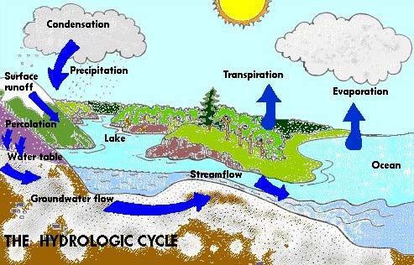
Uses of water: Water is needed for daily use for organisms, for irrigation, industries, electricity production and domestic use. Hence, water is an important resource in all economic activities ranging from agriculture to industry. About 97% of it is salt water in the seas & oceans, 2.6% is trapped in polar ice caps & glaciers. Only 0.4% is available as fresh water.
Fresh water occurs mainly in two forms namely Ground water and Surface water. The distribution of fresh water is geographically uneven varying greatly from country to country & even one region to another region.
- DOMESTIC USE: Water used in the houses for the purposes of drinking, bathing, washing, cooking, sanitary & other needs. The recommended value according to Indian Standard specification for domestic use is 135 liters/ day.
- INDUSTRIAL USE: Water is required for various industries such as cement, mining, textile, leather industries.
- PUBLIC USE: This includes water used for public utility purpose such as watering parks, flushing streets, jails etc.
- FIRE USE: Water is used in case of accidents and to prevent the fire issues.
- IRRIGATION: To grow crops which is the main sources for food.
- OTHER USES: Hydro electric power generation requires water.
Effects of over use of ground water: Over use of groundwater has following ill effects:
- Lowering of water table: Excessive use of ground water for drinking, irrigation and domestic purposes has resulted in rapid depletion of ground water in various regions leading to lowering of water table & drying of wells.
- Ground subsidence: When ground water withdrawal is greater than its recharge rate, the sediments in the aquifer become compacted. This is called ground subsidence which may cause damage of buildings, destroy water supply systems etc.
The reasons for shortage of water are:
- Increase in population,
- Increasing demand of water for various purposes.
- Unequal distribution of fresh water.
- Increasing pollution of existing water sources cause over exploitation.
- People depend on ground water as it is considered to be fresh water.

How we contaminate groundwater ?
Any addition of undesirable substances to groundwater caused by human activities is considered to be contamination. It has often been assumed that contaminants left on or under the ground will stay there. Groundwater often spreads the effects of dumps and spills far beyond the site of the original contamination. Groundwater contamination is extremely difficult, and sometimes impossible, to clean up.
Point sources
- On-site septic systems
- Leaky tanks or pipelines containing petroleum products
- Leaks or spills of industrial chemicals at manufacturing facilities
- industrial waste
- Municipal landfills
- Livestock wastes
- Chemicals used at wood preservation facilities
- Mill tailings in mining areas
- Fly ash from coal-fired power plants
- Sludge disposal areas at petroleum refineries
- Land spreading of sewage or sewage sludge
- Graveyards
- Wells for disposal of liquid wastes
- Runoff of salt and other chemicals from roads and highways
- Spills related to highway or railway accidents
- Coal tar at coal gasification sites
- Asphalt production and equipment cleaning sites

Non-point (distributed) sources
- Fertilizers on agricultural land
- Pesticides on agricultural land and forests
- Contaminants in rain, snow

Water Table: The land surface is covered by loose soil due to natural weathering phenomenon. Since the effect of weathering decreases gradually with depth, a fractured zone of rocks exists below the soil zone. Further, below this zone, occurs the hard formations (bed rock) which are free from fractures.
Groundwater flows slowly through water-bearing formations (aquifers) at different rates. In some places, where groundwater has dissolved limestone to form caverns and large openings, its rate of flow can be relatively fast but this is exceptional.
Many terms are used to describe the nature and extent of the groundwater resource. The level below which all the spaces are filled with water is called the water table. Above the water table lies the unsaturated zone. Here the spaces in the rock and soil contain both air and water. Water in this zone is called soil moisture. The entire region below the water table is called the saturated zone, and water in this saturated zone is called groundwater.
Hence, when rainfall occurs in any region, the rain water moves downwards through fractures under the influence of gravity until it reaches the bed rock. Then, the percolation/infiltration of water leads to the development of a zone above the bed rock which is called as zone of saturation, in which all openings or pores of the rocks are filled with water. Such water is called as groundwater. The upper surface of the zone of saturation is called WATER TABLE. Above the zone of saturation and below the ground surface is the zone of aeration in which water fills only a portion of the pore space.

Surface
Soil soil water
Perched water Perched water table
Vadose water
ZONE OF AERATION impermeable strata
capillary water
W A T E R T A B L E
groundwater
ZONE OF SATURATION
Groundwater fractures

BED ROCK ( HARD ROCK )
Types of groundwater occuring in zone of AERATION:
- Soil Water: Water which occurs in the soil and is available to the roots of plants existing on the surface.
- Vadose Water: (Gravity water): A fraction of rainfall which percolates downwards under the influence of gravity and slowly reaches the water table. In other words, the groundwater recharged this way.
- Perched Water: When a groundwater body is separated from the main groundwater by a relatively impermeable strata of small areal extent within the zone of aeration at a particular place is called as Perched water. Wells tapping ground water from these sources yield only a small quantities of water. .
- Capillary Water: This exists just above and in contact with the water table.
- Meteoric Water: Due to rainfall, water is being soaked into the underlying rock.

Types of groundwater occuring in the zone of SATURATION:
- Free groundwater (unconfined aquifer): The ground water which lies below the water table under atmospheric pressure more freely upwards or downwards within the aquifer.
- Confined water: This waters occur below the water table and is confined between aquicludes or aquifuse under hydrostatic pressure.
- Connate water: Occasionally a sediment or rock may retain some quantity of water from the beginning of their formation.
- Juvenile water: Water which has not previously been a part of the hydrosphere but which forms / rises from a deep, magmatic source.
- Magmatic water: It is the water derived from magma.
Types of Aquifers: Most aquifers are of large areal extent and may be visualized as underground storage reservoirs. Aquifers may be classified as unconfined or confined depending on the presence or absence of water table.
Unconfined Aquifer: An unconfined aquifer is one in which a water table varies depending on recharge and discharge ( pumping form wells ) in a region. Rises and falls in the water table correspond to changes in the volume of water in storage within an aquifer. Wells dug in such an aquifer will have the water level equal to the level of the water table. The water table is under atmospheric pressure only.
Confined Aquifer: These are also called artesian aquifers. In this case, the groundwater should be under pressure more than atmospheric pressure and sandwiched between two aquicludes or two impermeable formations i.e., clay / shally formations. Unlike the unconfined aquifer, the confined aquifer stores less water.
The wells in the confined aquifer are thus artesian wells operating under the piezometric pressure of the aquifer. If the piezometric surface of any well is above the ground surface the water level rises above the ground surface. In such a situation, the well is known as an artesian flowing well.

Confined aquifer diagram
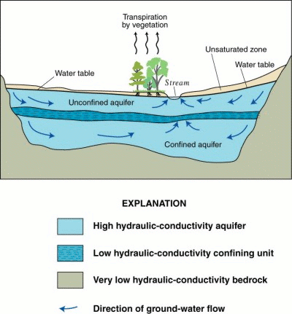
Piezometric surface: A piezometer is a special tool that is used to take measurements within an aquifer. It is submerged within a well beneath the saturated zone, through less porous rock. Many piezometer wells are drilled within a confined aquifer at certain locations. The piezometric surface of water is the level of water within a piezometric well in a confined aquifer. A hydro-geologist can determine recharge and discharge rates and most importantly groundwater-flow direction and rates.

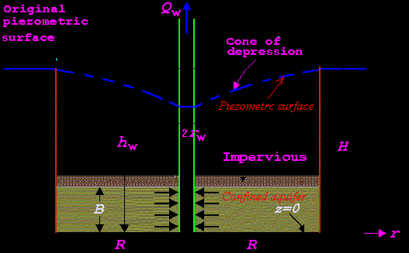
GEOLOGICAL CONTROLS ON GROUNDWATER MOVEMENT: Groundwater movement in the zone of aeration takes place under the influence of gravity while in the zone of saturation are of different kinds based on:
- The permeability character of rocks is one of the most influencing factors of groundwater movement.

- Secondary Porosity associated with the rocks viz. well-developed joints, sheet joints, presence of faults etc also influence the groundwater to move along them.

- The groundwater movement in the zone of saturation also depends on attitude of bedding places ( The percolated water moves along the inclined bedding planes, folded beds etc ). Sometimes, tilted beds, if accompanied by faults, joints, intrusives lead to the occurrence of springs and seepages.

- The buried river channels and conformities also influence the groundwater movement as they are porous and permeable.

- Presence of dolerite dykes, quartz veins in the associated country rocks may act as barriers to the natural flow of groundwater and accumulate on one side part of the dyke.

- Another factor which influences groundwater movement is the hydraulic gradient ( ie., slope or difference in the water table ) .
Fluctuation in the level of the water table in unconfined aquifer is of two different types ie., SEASONAL and CONE OF DEPRESSION.
The water table level rises considerably during rainy seasons because of heavy rainfall and high recharge. In summer, the water is pumped out without any recharge. This leads to a significant fall in the level of water table, thus, this type of fluctuation in the water table is seasonal.
When water is pumped out in a considerable measure from a dug well, the level of water goes down, and leading to the depression in the water table around the dug well in the form of an inverted cone. This phenomenon is called the Cone of depression (or) the cone of exhaustion.
This is a temporary fluctuation in the level of water table because the original position is restored within a short period due to the seepage of ground water from the sides of the dug well
The boundary of the cone of depression is known as the GROUNDWATER DIVIDE. The area enclosed by the Groundwater Divide is known as the AREA OF PUMPING DEPRESSION. The distance between the well and the Groundwater Divide is termed as the RADIUS of INFLUENCE.
When water is pumped out from an open well, immediately the level of water in it goes down, leading to the hydraulic gradient i.e., the difference in the level of the water table of the aquifer and dug well water level.
The difference between the original level of water in the dug well and level after pumping is called DRAWDOWN. If the pumping is continued, the drawdown increases further and the radius of influence of the well also increases. In a good aquifer , the draw down keeps at the same level. It is interesting to know that in all aquifers, the drawdown rate decreases with pumping time. (5’ in 1 hour and further 5’ in 5 hours and still 5’ in another 10 hours).
Springs: A spring is a continuous flow of water on the ground surface. Springs are located at the points of interaction of groundwater table with the surface of ground.

Groundwater and engineering: Groundwater can also have dramatic implications for engineering and geotechnical studies. The study of groundwater is essential for engineers who construct dams, tunnels, water conveyance channels, mines, and other structures. Groundwater must be considered whenever the stability of slopes is important, whether the slope is natural or constructed. Groundwater must also be taken into account when devising measures to control flooding. In all of these situations, groundwater flow and fluid pressure can create serious geotechnical problems.
Groundwater, for example, may create structural weaknesses in dams, or it may flow underground right around the structure. Water flowed so efficiently through the rock formations surrounding the reservoir that the dam would hold no water, even though it was structurally sound.
GROUNDWATER QUESTIONS:
- Origin and occurrence of groundwater
- Short notes on:
- Water table,
- springs,
- cone of depression,
3 Detail the three possible mechanisms of Arsenic release into groundwater?
4. Short notes on :
a) Types of aquifers
b) Geological controls and groundwater movement
5. What are effects of water logging in canal–command areas ? Give Indian examples.
6. What are possible sources of groundwater pollution ?

