https://www.researchgate.net/publication/323551103

UNIT–I Biomolecules

Presentation · March 2018

DOI: 10.13140/RG.2.2.20736.74241
Dr Sumanta Mondal

GITAM (Deemed to be University)

All content following this page was uploaded by Dr Sumanta Mondal on 05 March 2018.

The user has requested enhancement of the downloaded file.

UNIT– I: Biomolecules

UNIT I: Biomolecules: Introduction, classification, chemical nature and biological role of carbohydrate, lipids, nucleic acids, amino acids and proteins.
      - Biomolecules Definition

- Biomolecules are molecules that occur naturally in living organisms. Biomolecules include macromolecules like proteins, carbohydrates, lipids and nucleic acids.

- It also includes small molecules like primary and secondary metabolites and natural products.

- Biomolecules consists mainly of carbon and hydrogen with nitrogen, oxygen, sulphur, and phosphorus. Biomolecules are very large molecules of many atoms, which are covalently bound together.

  - Classes of Biomolecules

- There are four major classes of biomolecules:

    - Carbohydrates

    - Lipids

    - Proteins

    - Nucleic acids

1. Carbohydrates

- Carbohydrates are good source of energy. Carbohydrates (polysaccharides) are long chains of sugars. Monosaccharides are simple sugars that are composed of 3-7 carbon atoms.

- They have a free aldehyde or ketone group, which acts as reducing agents and are known as reducing sugars. Disaccharides are made of two monosaccharides. The bonds shared between two monosaccharides are the glycosidic bonds.

- Monosaccharides and disaccharides are sweet, crystalline and water soluble substances. Polysaccharides are polymers of monosaccharides. They are un-sweet and complex carbohydrates. They are insoluble in water and are not in crystalline form.

- Example: glucose, fructose, sucrose, maltose, starch, cellulose etc.

2. Lipids

- Lipids are composed of long hydrocarbon chains. Lipid molecules hold a large amount of energy and are energy storage molecules. Lipids are generally esters of fatty acids and are building blocks of biological membranes.

- Most of the lipids have a polar head and non-polar tail. Fatty acids can be unsaturated and saturated fatty acids.

- Lipids present in biological membranes are of three classes based on the type of hydrophilic head present:
  - Glycolipids are lipids whose head contains oligosaccharides with 1-15 saccharide residues.

  - Phospholipids contain a positively charged head which are linked to the negatively charged phosphate groups.

  - Sterols, whose head contain a steroid ring. Example steroid.

- Example of lipids: oils, fats, phospholipids, glycolipids, etc.

3. Nucleic Acids

- Nucleic acids are organic compounds with heterocyclic rings. Nucleic acids are made of polymer of nucleotides. Nucleotides consist of nitrogenous base, a pentose sugar and a phosphate group. A nucleoside is made of nitrogenous base attached to a pentose sugar. The nitrogenous bases are adenine, guanine, thyamine, cytosine and uracil. Polymerized nucleotides form DNA and RNA which are genetic material.

Dr. Sumanta Mondal _ Lecture Notes _Biochemistry-II (BP 203T)_B.Pharm-II Sem |  | Page | 1
GITAM (Deemed to be University) | E-mail: logonchemistry@gmail.com

UNIT– I: Biomolecules

4. Proteins

- Proteins are heteropolymers of stings of amino acids. Amino acids are joined together by the peptide bond which is formed in between the carboxyl group and amino group of successive amino acids. Proteins are formed from 20 different amino acids, depending on the number of amino acids and the sequence of amino acids.

- There are four levels of protein structure:

  - Primary structure of Protein - Here protein exist as long chain of amino acids arranged in a particular sequence. They are non-functional proteins.

  - Secondary structure of protein - The long chain of proteins are folded and arranged in a helix shape, where the amino acids interact by the formation of hydrogen bonds. This structure is called the pleated sheet. Example: silk fibres.

  - Tertiary structure of protein - Long polypeptide chains become more stabilizes by folding and coiling, by the formation of ionic or hydrophobic bonds or disulphide bridges, these results in the tertiary structure of protein.

  - Quaternary structure of protein - When a protein is an assembly of more than one polypeptide or subunits of its own, this is said to be the quaternary structure of protein. Example: Haemoglobin, insulin.

    - Functions of Biomolecules

- Carbohydrates provide the body with source of fuel and energy, it aids in proper functioning of our brain, heart and nervous, digestive and immune system. Deficiency of carbohydrates in the diet causes fatigue, poor mental function.

- Each protein in the body has specific functions, some proteins provide structural support, help in body movement, and also defense against germs and infections. Proteins can be antibodies, hormonal, enzymes and contractile proteins.

- Lipids, the primary purpose of lipids in body are energy storage. Structural membranes are composed of lipids which form a barrier and controls flow of material in and out of the cell. Lipid hormones, like sterols, help in mediating communication between cells.

- Nucleic Acids are the DNA and RNA; they carry genetic information in the cell. They also help in synthesis of proteins, through the process of translation and transcription.
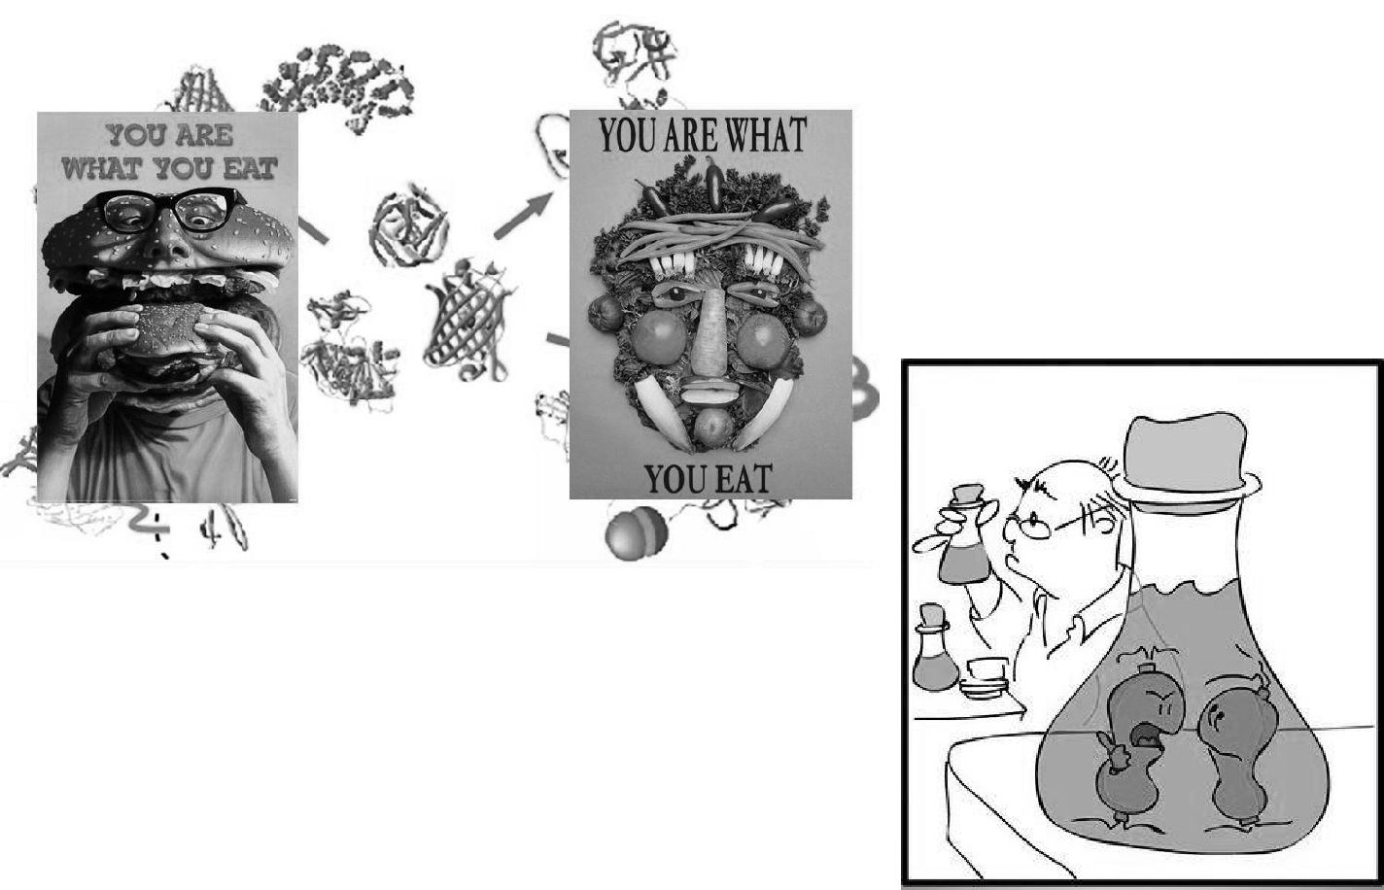

Dr. Sumanta Mondal _ Lecture Notes _Biochemistry-II (BP 203T)_B.Pharm-II Sem |  | Page | 2
GITAM (Deemed to be University) | E-mail: logonchemistry@gmail.com

UNIT– I: Biomolecules

      - Carbohydrates
- Carbohydrate is an organic compound, it comprises of only oxygen, carbon and hydrogen.

- The oxygen: hydrogen ratio is usually is 2:1.
- The empirical formula being C_{n}(H₂O)_{n} .

- Carbohydrates are hydrates of carbon; technically they are polyhydroxy aldehydes and ketones.

- Carbohydrates are also known as saccharides, the word saccharide comes from Greek word sakkron which means sugar.

    - Classification and nomenclature of carbohydrates

- The carbohydrates are divided into three major classes depending upon whether or not they undergo hydrolysis and if they do, on the number of products formed.

  - Monosaccharides: The monosaccharides are polyhydroxy aldehydes or polyhydroxy ketones which cannot be decomposed by hydrolysis to give simpler carbohydrates. e.g. Glucose, fructose, Galactose etc.

  - Oligosaccharides: The oligosaccharides (Oligo: few) are carbohydrates which yield a definite number (2-9) of monosaccharide molecules on hydrolysis.

- Disaccharides - Which yield two monosaccharides molecules on hydrolysis. Which have molecular formula is C₁₂H₂₂O₁₁.e.g. Sucrose, maltose etc

- Trisaccharides - Which yield three monosaccharides molecules on hydrolysis and have molecular formula is

C18H32O16.

- Tetrasaccharides - Which yield four monosaccharides molecules on hydrolysis and have molecular formula is

C₂₂H₄₂O₂₁. eg: Stachyose [gal(α1→6)gal(α1→6)glu(α1↔2β)fru]

  - Polysaccharides: The carbohydrates which have higher molecular weight, which yield many monosaccharide molecules on hydrolysis. E.g. Starch, glycogen, Dextrin, Cellulose etc.

- In general monosaccharides and oligosaccharides are crystalline solids, soluble in water and sweet to taste, they are collectively known as sugars, the polysaccharides on the other hand are amorphous, insoluble in water and tasteless, they are called non-sugars.
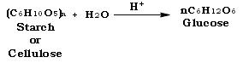
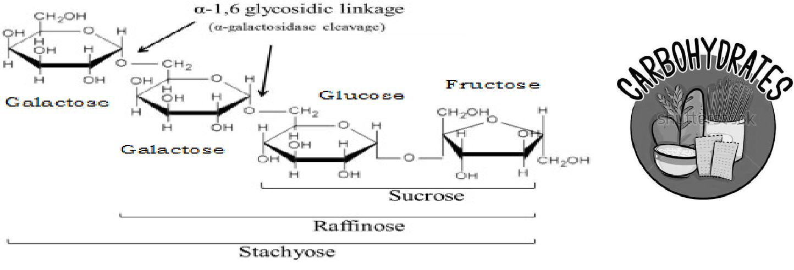

Dr. Sumanta Mondal _ Lecture Notes _Biochemistry-II (BP 203T)_B.Pharm-II Sem |  | Page | 3
GITAM (Deemed to be University) | E-mail: logonchemistry@gmail.com

UNIT– I: Biomolecules

- Different between monosaccharaides, oligosaccharides and Polysaccharides

 |  | Character |  | Monosaccharaides |  | Oligosaccharides |  | Polysaccharides
 |  | No. of sugar molecules | 1 |  | 2-9 |  |  | More than 9
 |  | Glycoside bond |  | Absent |  | Present |  | Present
 |  | Molecular Weight |  | Low |  | Moderate |  | High
 |  | Taste |  | Sweet |  | Minimally sweet taste |  | No taste
 |  | Solubility |  | Soluble |  | Soluble |  | Insoluble
 |  | Nature |  | Always reducing sugar |  | May or may not be |  | Always non reducing sugar
 |  | Example |  | Glucose, fructose, |  | Sucrose, Maltose |  | Starch, Glycogen, Dextrin,
 |  |  |  | Galactose |  |  |  | Cellulose

- Test for carbohydrate:
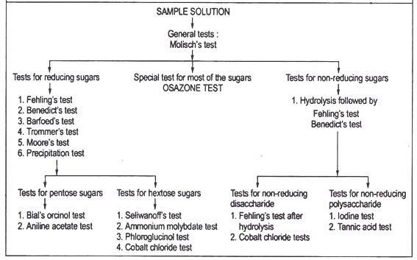

Dr. Sumanta Mondal _ Lecture Notes _Biochemistry-II (BP 203T)_B.Pharm-II Sem |  | Page | 4
GITAM (Deemed to be University) | E-mail: logonchemistry@gmail.com

UNIT– I: Biomolecules

  - Properties of Carbohydrates

- General properties of carbohydrates

Carbohydrates act as energy reserves, also stores fuels, and metabolic intermediates.
    - Ribose and deoxyribose sugars forms the structural frame of the genetic material, RNA and DNA.

    - Polysaccharides like cellulose are the structural elements in the cell walls of bacteria and plants.

    - Carbohydrates are linked to proteins and lipids that play important roles in cell interactions.

    - Carbohydrates are organic compounds; they are aldehydes or ketones with many hydroxyl groups.

- Physical Properties of Carbohydrates

    - Steroisomerism - Compound shaving same structural formula but they differ in spatial configuration. Example: Glucose has two isomers with respect to penultimate carbon atom. They are D-glucose and L-glucose.

    - Optical Activity - It is the rotation of plane polarized light forming (+) glucose and (-) glucose.

    - Diastereo isomeers - It the configurational changes with regard to C2, C3, or C4 in glucose. Example: Mannose, galactose.

    - Annomerism - It is the spatial configuration with respect to the first carbon atom in aldoses and second carbon atom in ketoses.

- Chemical Properties of Carbohydrates
    - Ozazone formation with phenylhydrazine.

    - Benedicts test.

    - Oxidation

    - Reduction to alcohols

  - Structure of Carbohydrates

- There are three types of structural representations of carbohydrates:

      - Open chain structure.

      - Hemi-acetal structure.

      - Haworth structure.
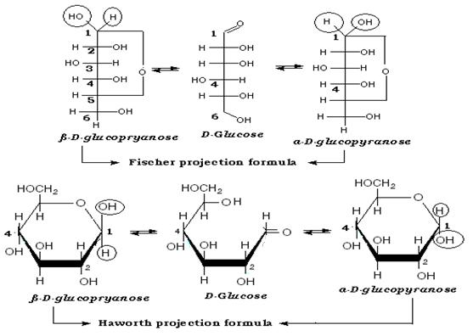

Dr. Sumanta Mondal _ Lecture Notes _Biochemistry-II (BP 203T)_B.Pharm-II Sem |  | Page | 5
GITAM (Deemed to be University) | E-mail: logonchemistry@gmail.com

UNIT– I: Biomolecules

    - Functions of Carbohydrates

  - Carbohydrates are chief energy source, in many animals; they are instant source of energy. Glucose is broken down by glycolysis/ kreb's cycle to yield ATP.

  - Glucose is the source of storage of energy. It is stored as glycogen in animals and starch in plants.

  - Stored carbohydrates act as energy source instead of proteins.

  - Carbohydrates are intermediates in biosynthesis of fats and proteins.

  - Carbohydrates aid in regulation of nerve tissue and are the energy source for brain.

  - Carbohydrates get associated with lipids and proteins to form surface antigens, receptor molecules, vitamins and antibiotics.

  - They form structural and protective components, like in cell wall of plants and microorganisms.

  - In animals they are important constituent of connective tissues.

  - They participate in biological transport, cell-cell communication and activation of growth factors.

  - Carbohydrates those are rich in fibre content help to prevent constipation.

  - Also they help in modulation of immune system.

    - Example of Carbohydrates

- Monosaccharides - Glucose, galactose, glycerose, erythrose, ribose, ribulose, fructose.

- Oligosaccharides - Maltose, lactose, sucrose, raffinose, stachyose.

- Polysaccharides - Starch, glycogen, cellulose, pectin, inulin, hyaluonic acid.

  - Foods rich in carbohydrates are referred to as strachy foods. They are found in legumes, starchy vegetables, whole-grain breads and cereals. They also occur naturally with vitamins and minerals in foods like milk, fruits, and milk products. They are alsdo found in refined and processed products like candy, carbonated beverages, and table sugar.

    - Examples of Polysaccharides

Name of the | Composition | Occurrence | Functions
Polysaccharide
 | Polymer of glucose containing a straight
Starch | chain of glucose molecules (amylose) and a | In several plant species as | storage of reserve food
 | branched chain of glucose molecules | main storage carbohydrate
 | (amylopectin)
Glycogen | Polymer of glucose | Animals (equivalent of | Storage of reserve
 |  | starch) | food
Inulin | Polymer of fructose | In roots and tubers (like | Storage of reserve
 |  | Dahlia) | food
Cellulose | Polymer of glucose | Plant cell wall | Cell wall matrix
Pectin | Polymer of galactose and its derivatives | Plant cell wall | Cell wall matrix
Hemi cellulose | Polymer of pentoses and sugar acids | Plant cell wall | Cell wall matrix
Lignin | Polymer of glucose | Plant cell wall (dead cells | Cell wall matrix
 |  | like sclerenchyma)
Chitin | Polymer of glucose | Bodywall of arthropods. In | Exoskeleton
 |  | some fungi also | Impermeable to water
Murein | Polysaccharide cross linked with amino acids | Cell wall of prokaryotic | Structural protection
 |  | cells
 |  | Connective tissue matrix, | Ground substance,
Hyaluronic acid | Polymer of sugar acids | Outer coat of mammalian
 |  |  | protection
 |  | eggs
Heparin | Closely related to chrondroitin | Connective tissue cells | Anticoagulant
Gums and mucilages | Polymers of sugars and sugar acids | Gums - bark or trees. | Retain water in dry
 |  | Mucilages - flower | seasons

Dr. Sumanta Mondal _ Lecture Notes _Biochemistry-II (BP 203T)_B.Pharm-II Sem |  | Page | 6
GITAM (Deemed to be University) | E-mail: logonchemistry@gmail.com

UNIT– I: Biomolecules
    - Lipids

- Lipids are a heterogeneous group of water-insoluble (hydrophobic) organic molecules that can be extracted from tissues by nonpolar solvents, because of their insolubility in aqueous solutions, body lipids are generally found compartmentalized, as in the case of membrane-associated lipids or droplets of triacylglycerol in adipocytes, or transported in plasma in association with protein, as in lipoprotein particles or on albumin.

- Lipids are a major source of energy for the body, and they provide the hydrophobic barrier.

- Lipids serve additional functions in the body, for example, some fat-soluble vitamins have regulatory or coenzyme functions, and the prostaglandins and steroid hormones play major roles in the control of the body's homeostasis.

  - General characters of lipids

- Lipids are relatively insoluble in water.

- They are soluble in non-polar solvents, like ether, chloroform, and methanol.

- Lipids have high energy content and are metabolized to release calories.

- Lipids also act as electrical insulators, they insulate nerve axons.

- Fats contain saturated fatty acids; they are solid at room temperatures. Example, animal fats.

- Plant fats are unsaturated and are liquid at room temperatures.

- Pure fats are colorless, they have extremely bland taste.

- The fats are sparingly soluble in water and hence are described are hydrophobic substances.

- They are freely soluble in organic solvents like ether, acetone and benzene.

- The melting point of fats depends on the length of the chain of the constituent fatty acid and the degree of unsaturation.

- Geometric isomerism, the presence of double bond in the unsaturated fatty acid of the lipid molecule produces geometric or cis-trans isomerism.

- Fats have insulating capacity, they are bad conductors of heat.

- Emulsification is the process by which a lipid mass is converted to a number of small lipid droplets. The process of emulsification happens before the fats can be absorbed by the intestinal walls.

- The fats are hydrolyzed by the enzyme lipases to yield fatty acids and glycerol.

- The hydrolysis of fats by alkali is called saponification. This reaction results in the formation of glycerol and salts of fatty acids called soaps.

- Hydrolytic rancidity is caused by the growth of microorganisms which secrete enzymes like lipases. These split fats into glycerol and free fatty acids.

  - Classification of lipids

- Simple lipids: Esters of fatty acids with various alcohols.

  - Fats: Esters of fatty acids with glycerol. Oils are fats in the liquid state.

  - Waxes: Esters of fatty acids with higher molecular weight monohydric alcohols.

- Complex lipids: Esters of fatty acids containing groups in addition to an alcohol and a fatty acid.

  - Phospholipids: Lipids containing, in addition to fatty acids and an alcohol, a phosphoric acid residue. They frequently have nitrogen containing bases and other substituents, eg, in glycerophospholipids the alcohol is glycerol and in sphingophospholipids the alcohol is sphingosine.

  - Glycolipids (glycosphingolipids): Lipids containing a fatty acid, sphingosine, and carbohydrate.

  - Other complex lipids: Lipids such as sulfolipids and aminolipids. Lipoproteins may also be placed in this category.

- Precursor and derived lipids: These include fatty acids, glycerol, steroids, other alcohols, fatty aldehydes, and ketone bodies, hydrocarbons, lipid-soluble vitamins and hormones.

Dr. Sumanta Mondal _ Lecture Notes _Biochemistry-II (BP 203T)_B.Pharm-II Sem |  | Page | 7
GITAM (Deemed to be University) | E-mail: logonchemistry@gmail.com

UNIT– I: Biomolecules

• Essential fatty acids

- Two fatty acids are dietary essentials in humans

  - Linoleic acid, which is the precursor of arachidonic acid, the substrate for prostaglandin synthesis.

  - α-linolenic acid is the precursor for growth and development.

- Essential fatty acid deficiency can result in a scaly dermatitis, as well as visual and neurologic abnormalities.
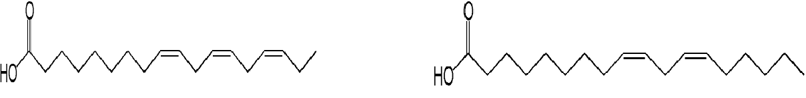

Linolenic acid Linoleic acid

• Regulating Blood Cholesterol Levels

- Fats and cholesterol cannot dissolve in blood and are consequently packaged with proteins (to form lipoproteins) for transport
o Low density lipoproteins (LDL) carry cholesterol from the liver to the rest of the body

o High density lipoproteins (HDL) scavenge excess cholesterol and carry it back to the liver for disposal

- Hence LDLs raise blood cholesterol levels (‘bad’) while HDLs lower blood cholesterol levels (‘good’)

- High intakes of certain types of fats will differentially affect cholesterol levels in the blood

- Saturated fats increase LDL levels within the body, raising blood cholesterol levels

- Trans fats increase LDL levels and decrease HDL levels within the body, significantly raising blood cholesterol levels

- Unsaturated (cis) fats increase HDL levels within the body, lowering blood cholesterol levels
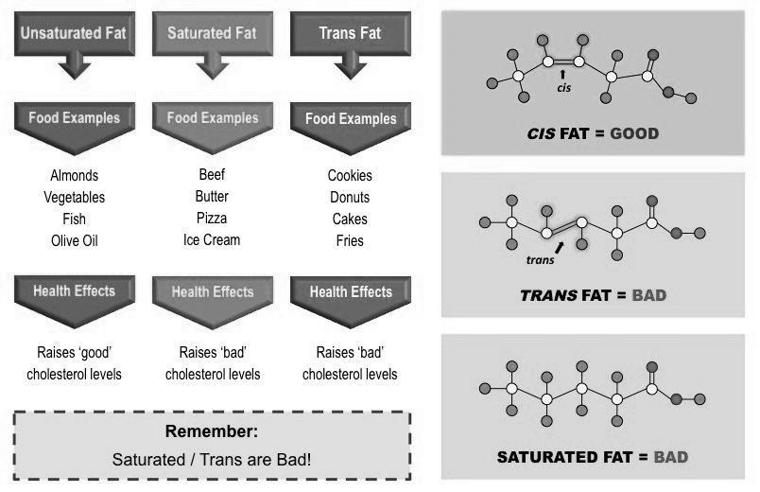

• Lipid Health Claims

- There are two main health claims made about lipids in the diet:

- Diets rich in saturated fats and trans fats increase the risk of CHD

- Diets rich in monounsaturated and polyunsaturated (cis) fats decrease the risk of CHD

Dr. Sumanta Mondal _ Lecture Notes _Biochemistry-II (BP 203T)_B.Pharm-II Sem |  | Page | 8
GITAM (Deemed to be University) | E-mail: logonchemistry@gmail.com

UNIT– I: Biomolecules

• Health Risks of High Cholesterol

- High cholesterol levels in the bloodstream lead to the hardening and narrowing of arteries (atherosclerosis)

- When there are high levels of LDL in the bloodstream, the LDL particles will form deposits in the walls of the arteries

- The accumulation of fat within the arterial walls leads to the development of plaques which restrict blood flow

- If coronary arteries become blocked, Coronary Heart Disease (CHD) will result – this includes heart attacks and strokes
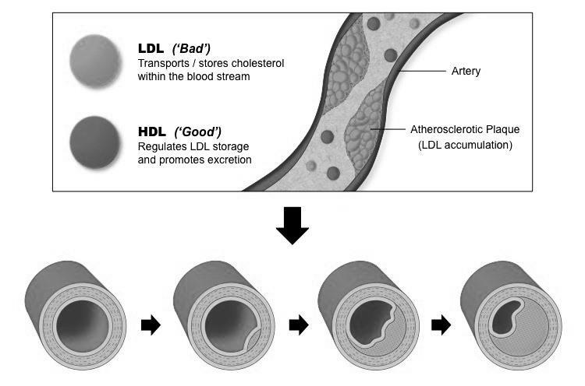

• Examples of Lipids

- Fatty acids - Oleic acid, Linoleic acid, Palmitoleic acid, Arachidonic acid.

- Fats and Oils - Animal fats - Butter, Lard, Human fat, Herring oil.

Plant oils - Coconut oil, Corn, Palm, Peanut, Sunflower oil.

- Waxes - Spermacti, Beeswax, Carnauba wax.

- Phospholipids - Lecithins, Cephalins, Plasmoalogens, Phosphatidyl inositols, Sphingomyelins.

- Glycolipids - Kerasin, Phrenosin, Nervon, Oxynervon.

- Steroids - Cholesterol.

- Terpenes - Monoterpenes, Sesquiterpenes, Diterpenes, Triterpenes.

- Carotenoids - Lycopene, Carotenes, Xanthophylls.
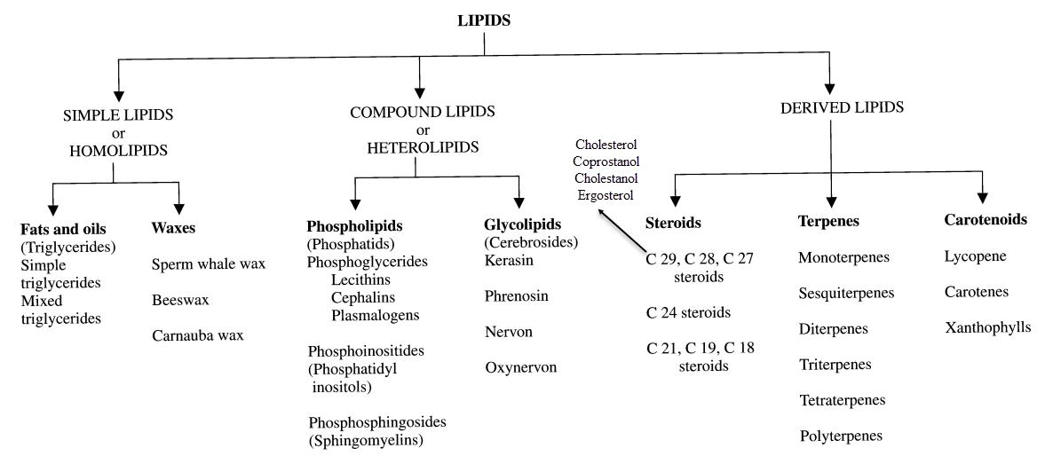

Dr. Sumanta Mondal _ Lecture Notes _Biochemistry-II (BP 203T)_B.Pharm-II Sem |  | Page | 9
GITAM (Deemed to be University) | E-mail: logonchemistry@gmail.com

UNIT– I: Biomolecules

• Biological Role of Lipids

- Food material: Lipids provide food, highly rich in calorific value. One gram lipid produces 9.3 kilocalories of heat.

- Food reserve: Lipids provide are insoluble in aqueous solutions and hence can be stored readily in the body as a food reserve.

- Structural component: Lipids are an important constituent of the cell membrane.

- Heat insulation: The fats are characterized for their high insulating capacity. Great quantities of fat are deposited in the subcutaneous layers in aquatic mammals such as whale and in animals living in cold climates.

- Fatty acid absorption: Phospholipids play an important role in the absorption and transportation of fatty acids.

- Hormone synthesis: The sex hormones, adrenocorticoids, cholic acids and also vitamin D are all synthesized from cholesterol, a steroidal lipid.

- Vitamin carriers: Lipids act as carriers of natural fat-soluble vitamins such as vitamin A, D and E.

- Blood cholesterol lowering: Chocolates and beef, especially the latter one, were believed to cause many heart diseases as they are rich in saturated fatty acids, which boost cholesterol levels in blood and clog the arterial passage. But researches conducted at the University of Texas by Scott Grundy and Andrea Bonanome (1988) suggest that at least one saturated fatty acid stearic acid, a major component of cocoa butter and beef fat, does not raise blood cholesterol level at all. The researchers placed 11 men on three cholesterol poor liquid diets for three weeks each in random order. One formula was rich in palmitic acid, a known cholesterol booster; the second in oleic acid; and the third in stearic acid. When compared with the diet rich in palmitic acid, blood cholesterol levels were 14% lower in subjects put on the stearic acid diet and 10% lower in those on the oleic acid diet.

- Antibiotic agent. Squalamine, a steroid from the blood of sharks, has been shown to be an antibiotic and antifungal agent of intense activity. This seems to explain why sharks rarely contract infections and almost never get cancer.
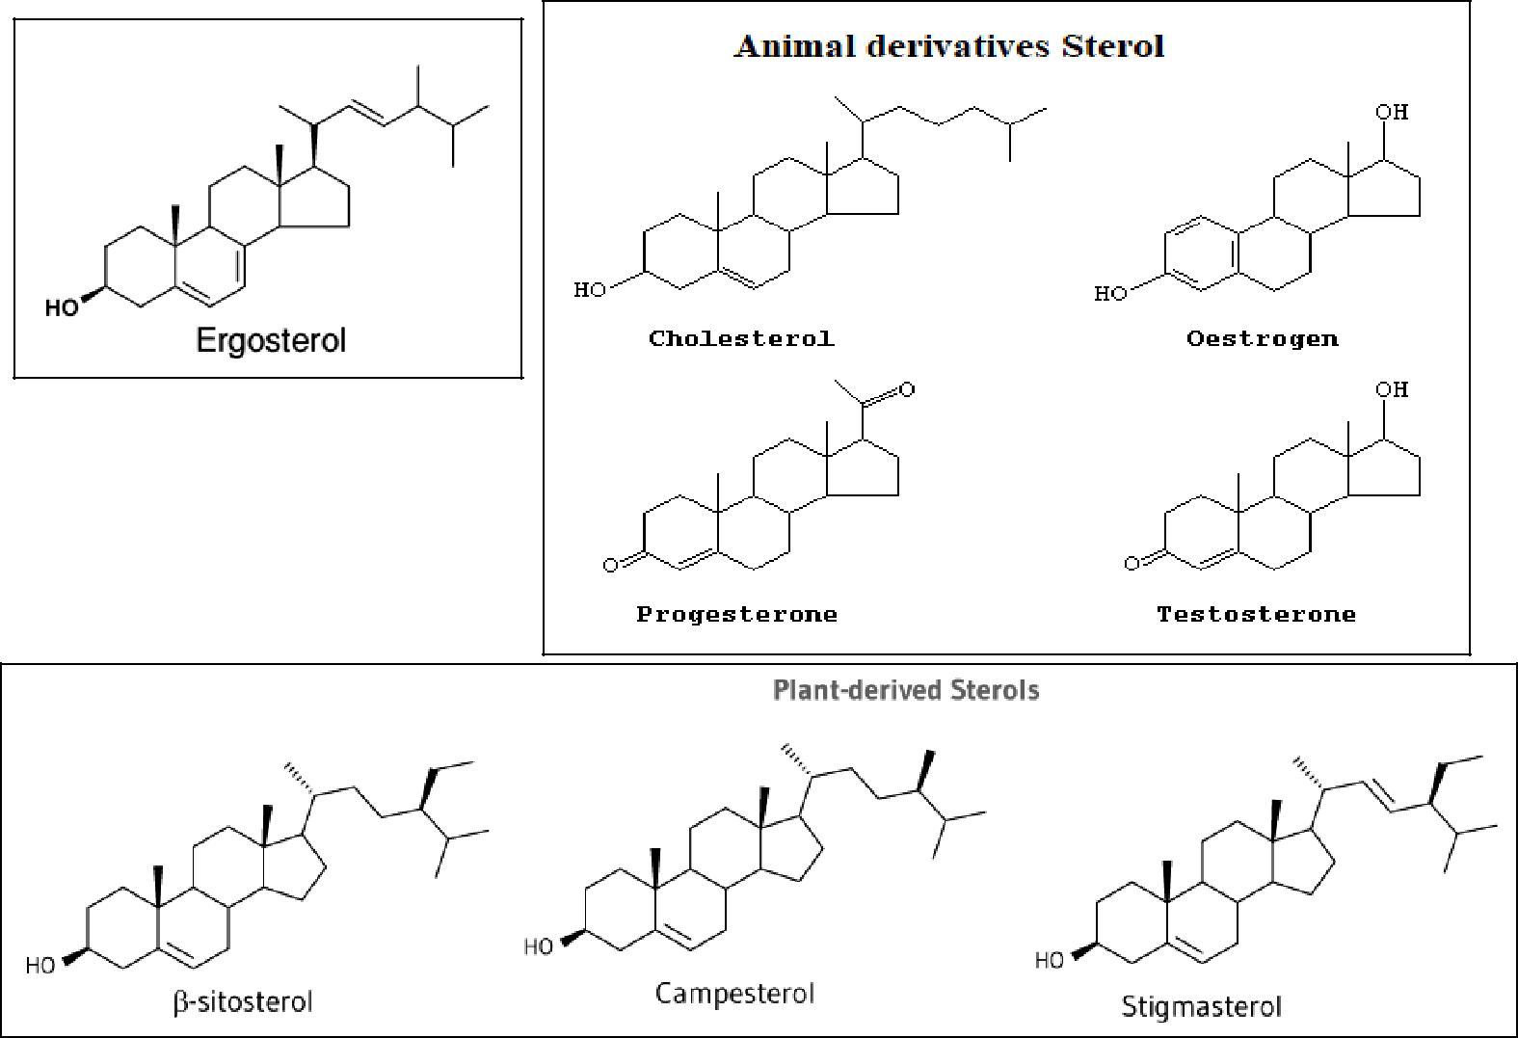

Dr. Sumanta Mondal _ Lecture Notes _Biochemistry-II (BP 203T)_B.Pharm-II Sem |  | Page | 10
GITAM (Deemed to be University) | E-mail: logonchemistry@gmail.com

UNIT– I: Biomolecules

    - Proteins

- Proteins are large biomolecules, or macromolecules, consisting of one or more long chains of amino acid residues.

- Proteins are known as building blocks of life.

- Proteins are the most abundant intracellular macro-molecules. They provide structure, protection to the body of multicellular organism in the form of skin, hair, callus, cartilage, ligaments, muscles, tendons. Proteins regulate and catalyze the body chemistry in the form of hormones, enzymes, immunoglobulin’s etc.

  - General Characteristics of Proteins

- Proteins are organic substances; they are made up of nitrogen and also, oxygen, carbon an d hydrogen.

- Proteins are the most important biomolecules; they are the fundamental constituent of the cytoplasm of the cell.

- Proteins are the structural elements of body tissues.

- Proteins are made up of amino acids.

- Proteins give heat and energy to the body and also aid in building and repair.

- Only small amounts of proteins are stored in the body as they can be used up quickly on demand.

- Proteins are considered as the bricks, they make up bones, muscles, hair and other parts of the body.

- Proteins like enzymes are functional elements that take part in metabolic reactions.

- Antibodies, blood haemoglobin are also made of proteins.

- Proteins have a molecular weight of 5 to 300 kilo-Daltons.

  - Physical Properties of Proteins

- Proteins are colorless and tasteless.

- They are homogeneous and crystalline.

- Proteins vary in shape, they may be simple crystalloid structure to long fibrilar structures.

- Protein structures are of two distinct patterns - Globular proteins and fibrilar proteins.

- Globular proteins are spherical in shape and occur in plants. Fibrilar proteins are thread-like, they occur generally in animals.

- In general proteins have large molecular weights ranging between 5 X 10³ and 1 X 10⁶.

- Due to the huge size, proteins exhibit many colloidal properties.

- The diffusion rates of proteins are extremely slow.

- Proteins exhibit Tyndall effect.

- Proteins tend to change their properties like denaturation. Many a times the process of denaturation is followed by coagulation.

- Denaturation may be a result of either physical or chemical agents. The physical agents include, shaking, freezing, heating etc. Chemical agents are like X-rays, radioactive and ultrasonic radiations.

- Proteins like the amino acids exhibit amphoteric property i.e., they can act as Acids and Alkalies.

- As the proteins are amphoteric in nature, they can form salts with both cations and anions based on the net charge.

- The solubility of proteins depends upon the pH. Lowest solubility is seen at isoelectric point, the solubility increases with increase in acidity or alkalinity.

- All the proteins show the plane of polarized light to the left, i.e., laevorotatory.

  - Chemical Properties of Proteins

- Proteins when hydrolyzed by acidic agents, like conc.HCl yield amino acids in the form of their hydrochlorides.

- Proteins when are hydrolyzed with alkaline agents leads to hydrolysis of certain amino acids like arginine, cysteine, serine, etc., also the optical activity of the amino acids is lost.

- Proteins with reaction with alcohols give its corresponding esters. This process is known as esterification.

- Amino acid reacts with amines to form amides.

- When free amino acids or proteins are said to react with mineral acids like HCl, the acid salts are formed.

- When amino acid in alkaline medium reacts with many acid chlorides, acylation reaction takes place.
- Xanthoproteic test - On boiling proteins with conc. HNO₃, yellow color develops due to presence of benzene ring.

- Folin's test - This is a specific test for tyrosine amino acid, where blue color develops with phosphomolybdotungstic acid in alkaline solution due to presence of phenol group.

Dr. Sumanta Mondal _ Lecture Notes _Biochemistry-II (BP 203T)_B.Pharm-II Sem |  | Page | 11
GITAM (Deemed to be University) | E-mail: logonchemistry@gmail.com

UNIT– I: Biomolecules

  - Structure of Proteins

- Proteins are constructed by polymerization of only 20 different amino acids into linear chains.

- Proteins are the polymers of L-a-amino acids. The structure of proteins is rather complex which can be divided into 4 levels of organization.

    - Primary structure:

  - The linear sequence of amino acids forming the backbone of proteins (polypeptides).

  - Examples of protein with a primary structure are Hexosaminidase, Dystrophin.

- Secondary structure:

  - The spacial arrangement of protein by twisting of the polypeptide chain.

  - Example of protein with a secondary structure is Myoglobin.

- Tertiary structure:

  - The three dimensional structure of a functional protein.

- Number of forces act to hold the polypeptide chain in this final configuration:
  - Polar/Nonpolar Interactions

  - Hydrogen Bonds

  - Van der Waals Forces

  - Ionic Interactions

  - Disulfide Bonds

  - Examples of protein with a Tertiary structure are Globular Proteins (Enzymes) and Fibrous Proteins.

- Quaternary structure:

  - Some of the proteins are composed of two or more polypeptide chains referred to as subunits. The spacial arrangement of these subunits is known as quaternary structure.

- Examples of protein with a Quaternary structure are DNA polymerase, and ion channels.
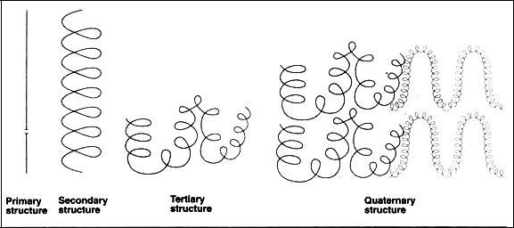

Dr. Sumanta Mondal _ Lecture Notes _Biochemistry-II (BP 203T)_B.Pharm-II Sem |  | Page | 12
GITAM (Deemed to be University) | E-mail: logonchemistry@gmail.com

UNIT– I: Biomolecules

  - Secondary Structure of Proteins

- Shape

  - Alpha Helix: Alpha Helix is a right-handed coiled rod-like structure.

  - Beta Pleated Sheet: Beta sheet is a sheet-like structure.

- Formation

  - Alpha Helix: Hydrogen bonds form within the polypeptide chain in order to create a helical structure.

  - Beta Pleated Sheet: Beta sheets are formed by linking two or more beta strands by H bonds.

- Bonds

  - Alpha Helix: Alpha helix has n + 4 H-bonding scheme. i.e. Hydrogen bonds form between N-H group of one

amino residue with C=O group of another amino acid, which is placed in 4 residues earlier.

  - Beta Pleated Sheet: Hydrogen bonds are formed in between the neighboring N-H and C=O groups of adjacent peptide chain

- -R group

  - Alpha Helix: -R groups of the amino acids are oriented outside of the helix.

  - Beta Pleated Sheet: -R groups are directed to both inside and outside of the sheet.

- Number

  - Alpha Helix: This can be a single chain.

  - Beta Pleated Sheet: This cannot exist as a single beta strand; there are must be two or more.

- Type

  - Alpha Helix: This has only one type.

  - Beta Pleated Sheet: This can be parallel, anti-parallel or mixed.

- Qualities

  - Alpha Helix: 100º rotation, 3.6 residues per turn and 1.5 Aº rise from one alpha carbon to the second

  - Beta Pleated Sheet: 3.5 Aº rise between residues
- Amino Acid

  - Alpha Helix: Alpha helix prefers the amino acid side chains, which can cover and protect the backbone H-

bonds in the core of the helix.

  - Beta Pleated Sheet: The extended structure leaves the maximum space free for the amino acid side chains. Therefore, amino acids with large bulky side chains prefer beta sheet structure.

- Preference

  - Alpha Helix: Alpha helix prefers Ala, Leu, Met, Phe, Glu, Gln, His, Lys, Arg amino acids.

- Beta Pleated Sheet: Beta sheet prefers Tyr, Trp, (Phe, Met), Ile, Val, Thr, Cys.
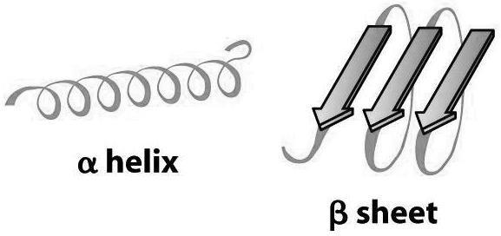

Dr. Sumanta Mondal _ Lecture Notes _Biochemistry-II (BP 203T)_B.Pharm-II Sem |  | Page | 13
GITAM (Deemed to be University) | E-mail: logonchemistry@gmail.com

UNIT– I: Biomolecules
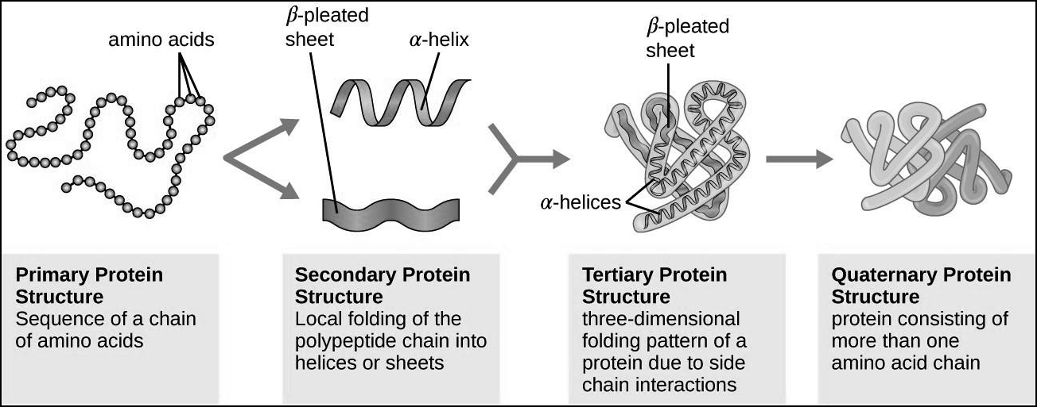

Alpha Helix Secondary Structure | Beta pleate Antiparallel: when |  |  |  | Beta pleate | Parallel: Adjacent
of Proteins | the | adjacent |  | polypeptide | polypeptide | chains running in
 | chains | run | in | opposite | the same direction
 | direction
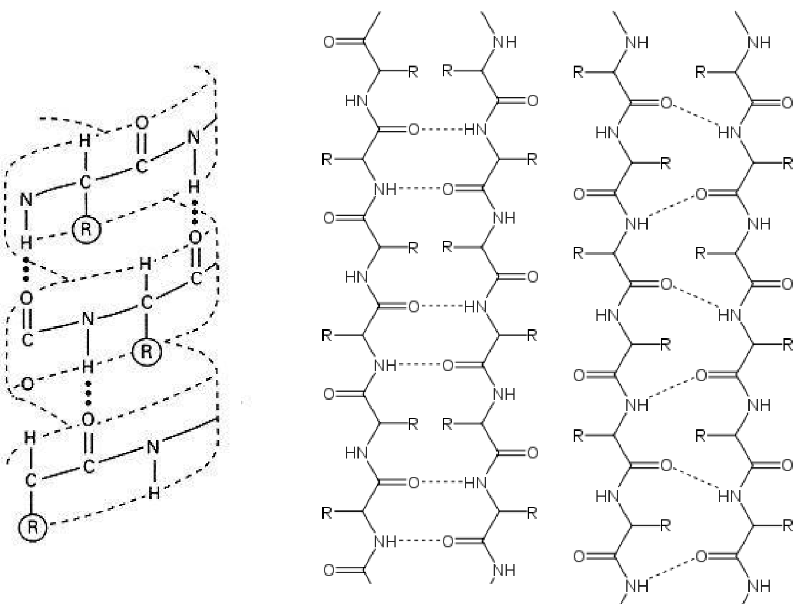

Dr. Sumanta Mondal _ Lecture Notes _Biochemistry-II (BP 203T)_B.Pharm-II Sem |  | Page | 14
GITAM (Deemed to be University) | E-mail: logonchemistry@gmail.com

UNIT– I: Biomolecules

- Protein Classification

        - Classification of Proteins Based on Shape

    - Globular or Corpuscular Proteins

- Globular proteins have axial ratio less than 10 but not below 3 or 4.

- They are compactly folded and coiled and possess a relatively spherical or ovoid shape.

- They are usually soluble in water and in aqueous media.

- Example: Insulin, plasma albumin, globulin enzymes.

Axial ratio, for any structure or shape with two or more axes, is the ratio of the length (or magnitude) of those axes to each other - the longer axis divided by the shorter.

In chemistry or materials science, the axial ratio (symbol P) is used to describe rigid rod-like molecules. It is defined as the length of the rod divided by the rod diameter.

    - Fibrous or Fibrillar Proteins

- These proteins have axial ratio more than 10, hence, they resemble long ribbons or fibres in shape.

- They are mostly found in animals, and are not soluble in water or in solution of dilute acids.

- Fibrous proteins aid in protection and structural support.

- Example: Collagen, Keratin, Elastins, Fibroin

      - Classification of Proteins Based on Composition and Solubility

    - Simple Proteins or Holoproteins:

- These proteins are made of only one type of amino acid, as structural component, on decomposition with acids, they liberate constituent amino acids. They are mostly globular type of proteins except for scleroproteins, which are fibrous in nature.

- Simple proteins are further classified based on their solubility.

  - Protamines and histones

- These proteins occur only in animals and are basic proteins.

  - They possess simple structure and low molecular, are water soluble and are not coagulated by heat.

  - They are strongly basic in character due to the high content of lysine, arginine.

  - Example: Protamines - salmine, clupine, cyprinine; Histones - nucleoshistones, globin.

- Albumins

  - They are widely distributed in nature, mostly seen in seeds.

  - They are soluble in water and dilute solutions of acids, bases and salts.

  - Example: Leucosine, legumeline, serum albumin.

- Globulins

  - They are of two types, pseudoglobulins which are soluble in water,

  - Other is euglobulins which are insoluble in water.

  - They are coagulated by heat.

  - Example: Pseudoglobulin, serum globulin, glycinine. etc.

- Scleroproteins or Albuminoids

  - These occur mostly in animals and are commonly known as animal skeleton proteins.

  - They are insoluble in water, and in dilute solution of acids, based and salts.

Dr. Sumanta Mondal _ Lecture Notes _Biochemistry-II (BP 203T)_B.Pharm-II Sem |  | Page | 15
GITAM (Deemed to be University) | E-mail: logonchemistry@gmail.com

UNIT– I: Biomolecules

    - Conjugated or Complex Proteins or Heteroproteins:

- These are proteins that are made of amino acids and other organic compounds. The non-amino acid group is termed as prosthetic group.

- Complex proteins are further classified based on the type of prosthetic group present.

  - Metalloproteins:

  - These are proteins linked with various metals. o Example: casein, collagen, ceruloplasmin, etc.

- Chromoproteins

- These are proteins that are coupled with a colored pigment.

  - Example: Myoglubin, hemocyanin, cytochromes, flavoproteins, etc.

- Glycoproteins and Mucoproteins

  - These proteins contain carbohydrates as the prosthetic group.

  - Example: Glycoproteins - egg albumin, serum globulins, serum albumins; Mucoproteins - Ovomucoid, mucin etc.

- Phosphoproteins

  - These proteins are linked with phosphoric acid.

  - Example: casein.

- Lipoproteins

  - Proteins forming complexes with lipids are lipoproteins.

  - Example: lipovitellin, lipoproteins of blood.

- Nucleoproteins

  - These are compounds containing nucleic acids and proteins.

  - Example: Nucleoproteins, nucleohistones, nuclein.

- Derived Proteins

  - These are proteins that are derived from the action of heat, enzyme or chemical reagents.

- Derived proteins are of two types, primarily derived proteins and secondary derived proteins. o Primary derived proteins
  - Derivatives of proteins, in which the size of the protein molecule is not altered materially.,.

  - Primary derived proteins are classified into three types - Proteans, Infraproteins and Coagulated proteins.

  - Example: edestan, coagulated egg-white.

- Secondary derived proteins.

  - While in secondary derived proteins, hydrolysis occurs, as a result the molecules are smaller than the original proteins.

  - They are further classified into 3 types - Proteoses, Peptones and Polypeptides

EGG PROTEINS COMPOSITION OF EGG WHITE

Protein |  |  | Percentage
Total protein |  |  | 10-11% (on wet basis); 82.8% (on dry basis)
Ovalbumin |  |  | 70% of total proteins
Conalbumin |  |  | 9%
Ovomucoid |  |  | 13%
 |  | Lysozyme (G₁) | 2.6%
Globulins |  | Lysozyme (G₂) | 7%
 |  | Lysozyme (G₃) | 7%
Mucin |  |  | 2%
Avidin |  |  | 0.06%

Dr. Sumanta Mondal _ Lecture Notes _Biochemistry-II (BP 203T)_B.Pharm-II Sem |  | Page | 16
GITAM (Deemed to be University) | E-mail: logonchemistry@gmail.com

UNIT– I: Biomolecules

3. Classification of Proteins on Biological Function

  - Enzymic Proteins

- They are the most varied and highly specialized proteins with catalytic activity. Enzymes catalyze a variety of reactions.

- Example: Urease, catalase, cytochrome C, etc.

  - Structural Proteins

- These proteins aid in strengthening or protecting biological structures.

- Example: Collagen, elastin, keratin, etc.

  - Transport or Carrier Proteins

- These proteins help in transport of ions or molecules in the body.

- Example: Myoglobin, hemoglobin, etc.

  - Nutrient and Storage Proteins

- These proteins provide nutrition to growing embryos and store ions.

  - Contractile or Motile Proteins

- These proteins function in the contractile system.

- Example: Actin, myosin, tubulin, etc.

  - Defense Proteins

- These proteins defend against other organisms.

- Example: Antibodies, Fibrinogen, thrombin.

  - Regulatory Proteins

- They regulate cellular or metabolic activities.

- Example: Insulin, G proteins, etc.

  - Toxic Proteins

- These proteins hydrolyze or degrade enzymes.

- Example: snake venom, ricin.

MILK PROTEINS

- Milk Protein contains about 0.6–0.7% protein which is not precipitated on acidification to pH 4.7.

- This represents about 20% of the protein contained in skim milk. These whey proteins are separated into 2 fractions : lactalbumin and lactoglobulin.

- The name casein is assigned to the fraction precipitated by acidifying milk to a pH of 4.7. It is present in cow’s milk (3-3.5%) and human milk (0.3-0.6%).

- Casein may be further purified by redissolving and precipitating again. It is of 3 types : α, β and γ.

Dr. Sumanta Mondal _ Lecture Notes _Biochemistry-II (BP 203T)_B.Pharm-II Sem |  | Page | 17
GITAM (Deemed to be University) | E-mail: logonchemistry@gmail.com

UNIT– I: Biomolecules

• Function of Proteins

- Proteins are seen in muscles, hair, skin and other tissues; they constitute the bulk of body's non-skeletal structure. Example: The protein keratin is present in nails and hair.

- Some proteins are hormones and regulate many body functions. Example: Insulin hormone is a protein and it regulated the blood sugar level.

- Some proteins act enzymes, they catalyze or help in biochemical reactions. Example: Pepsin and Tripsin.

- Some proteins act as antibodies; they protect the body from the effect of invading species or substances.

- Proteins transport different substances in blood of different tissues. Example: Haemoglobin is an oxygen transport protein.

- Contractile proteins help in contraction of muscle and cells of our body. Example: Myosin is contractile protein.

- Fibrinogen a glycoprotein helps in healing of wounds. It prevents blood loss and inhibits passage of germs.
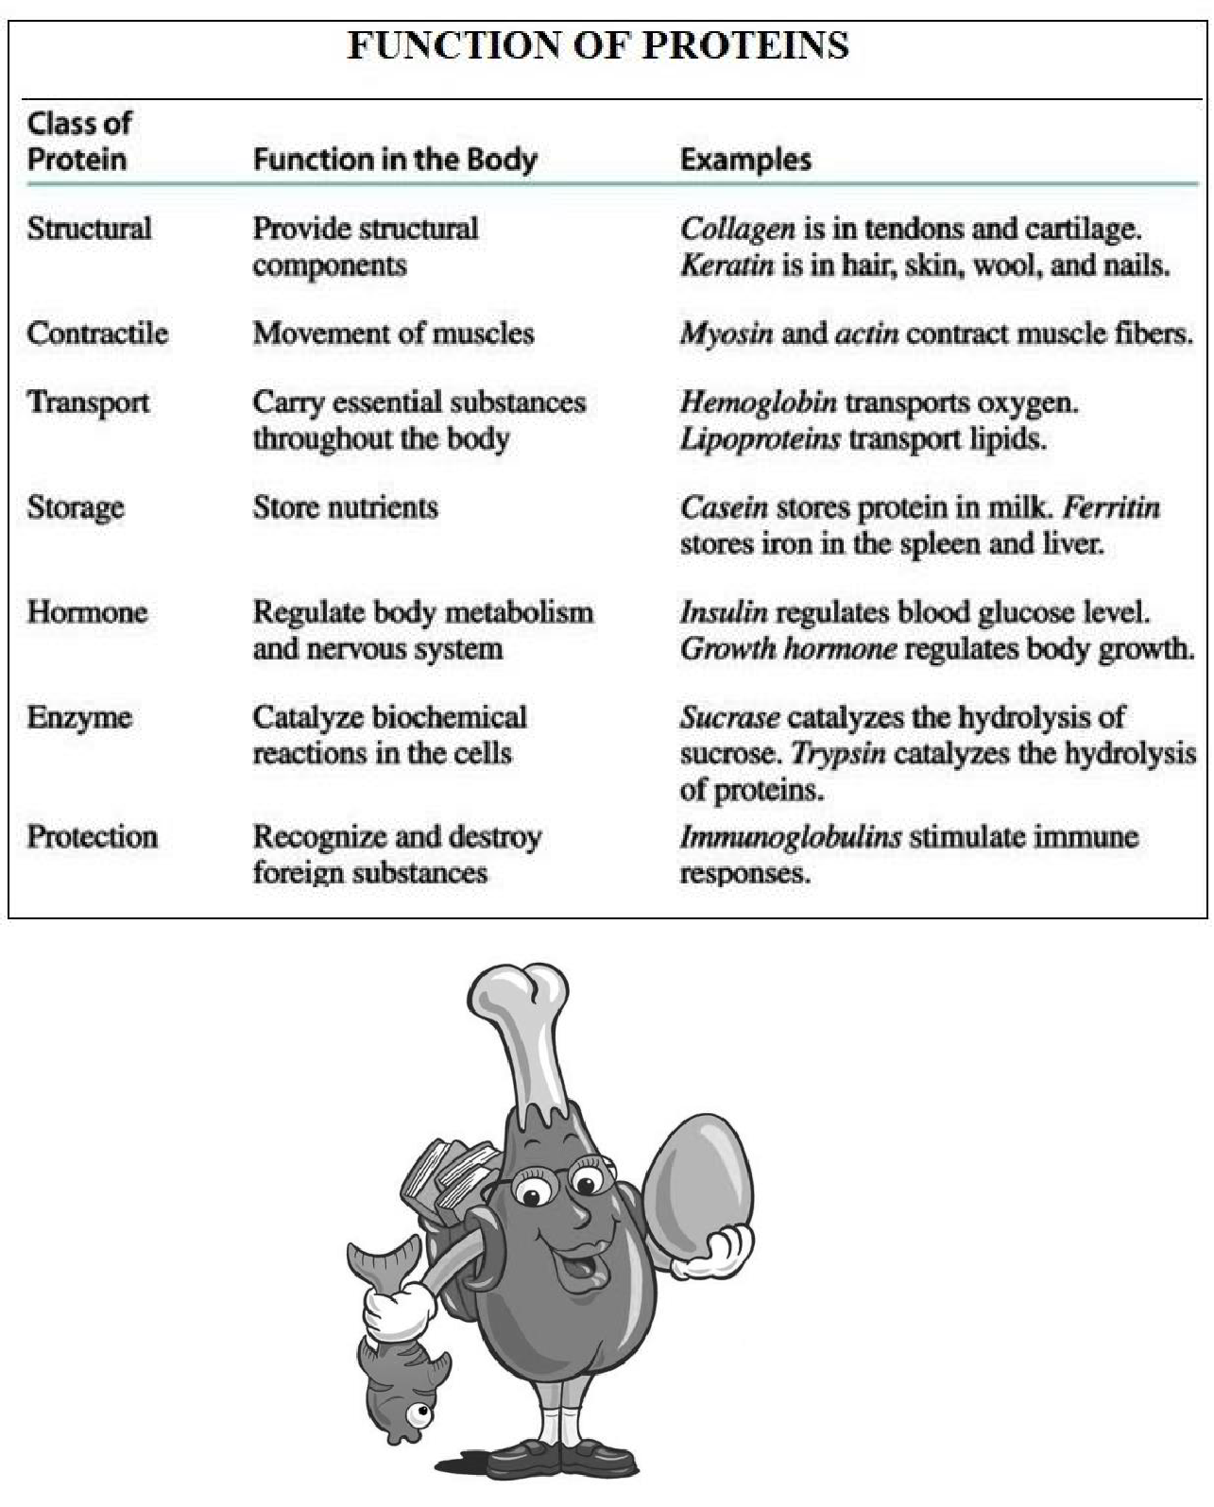

Dr. Sumanta Mondal _ Lecture Notes _Biochemistry-II (BP 203T)_B.Pharm-II Sem |  | Page | 18
GITAM (Deemed to be University) | E-mail: logonchemistry@gmail.com

View publication stats

