UNIT 5

Information Transfer:

Information Transfer is an activity that reproduces either from a full linguistic form into diagrammatic or semi diagrammatic form, or vice versa. During the transfer activity, the information remains the same, but the form of information changes, for instance, from non-linguistic form to linguistic form and so forth.
Information transfer activity is the most enjoyable method to organize thought, it is so suitable for teaching and learning English, because the learners
can develop their language skill. For example, when the learners are provided
with information in the form of table or diagram, they can be motivated or
stimulated to organize ideas or thoughts. It can be basic to produce a good writing, because for some learners it is difficult to find new ideas.
During teaching and learning process of writing, the learners will be
provided with series of activities, such as they are asked to look at the table carefully, find the content of information they get in the tabular form and finally asked to convert it into written form. In transferring the content of information, the learners need to concentrate in arranging and organizing it in order to produce a good writing. Thus, the learning goal can be achieved.

The Advantages of Using Information Transfer Technique:

1) It can give variety of teaching techniques including the four skills of English: Listening, Speaking, Reading, and Writing (LSRW).
2) It can be used from very wide range of texts.
3) It can be arranged or organize easily that develops learners’ ability to
organize information.

Verbal form:

- Sentence Form
- Paragraph form

Non – Verbal Form:

- Table/Chart
- Pie chart
- Flow chart
- Tree diagram
- Bar Diagram

Information Transfer is a writing skill and it is of two types; if a Paragraph is given then we have to convert it into Diagrammatical Table or Graphs. And if it is given in the form of Graph, or pie diagram or any other form, then we have to convert it into small paragraph...
Generally Information transfer must be short and simple.

Examples of Information transfer:

Information Transfer: Non Verbal to Verbal:

The following is the information given in the form of a table. Write two paragraphs of about 70-80 words using the information given below.
 | Maharashtra | Karnataka
Area | 3,07,713 sq. km. | 1,91,791 sq. km.
Population | 7,89,37,187 | 4,49,77,209
Capital | Mumbai | Bangalore
Language | Marathi | Kannada
Rivers | Godavari, Krishna, Bhima, Koyana | Tungabhadra, Kaveri
Crops | Jawar, Bajra, Sugarcane | Jawar, Tea, Rubber
Major Cities | Mumbai, Nagpur, Aurangabad, Nasik | Manglore, Hubli, Dharwad

Ans. ABOUT MAHARASHTRA AND KARNATAKA
Maharashtra and Karnataka are neighbouring countries. Area wise Maharashtra is Larger than Karnataka. 3, 07, 713 sq. m. and 1, 91, 791 sq. km are the area of Maharashtra and Karnataka respectively. Mumbai is the Capital of former and Bangalore is for latter. Marathi is the main language spoken in Maharashtra whereas Kannada is for Karnataka. Godavari, Krishna, Bhima and Koyana are the main rivers running in Maharashtra. In case of Karnataka it is Tungabuadra, Kaveri. Jawar, Bajra and Sugarcane are the main crops in Maharashtra and Jawar, Tea and Rubber are the main crops in Karnataka. Mumbai, Nagpur, Aurangabad and Nasik are some of the major cities in Maharashtra. Mangalore, Hubli and Dharwar are the major cities in Karnataka.

Write a paragraph comparing and contrasting the enrolment of girls and boys in a school from 1998 to 2002.

Year | Boys | Girls
1998 | 5000 | 4911
1999 | 5200 | 5099
2000 | 5100 | 5067
2001 | 5100 | 5190
2002 | 5320 | 5205

Ans. The given table represents the enrolment of girls and boys in a school from 1998 to 2002. In the year 1998 the number of enrolment of boys was more than that of girls. It consists of 5000 in boys and 4911 in case of girls. In 1999, The number of boys were increased about 200 as compared to previous year and in case of girls the total number of enrolment was 5099. In 2000, The number of boys decreased by 100 and it remains the same for the year 2001 also. It accounts for 5100. In case of girls, in 2000 it is 5067 and in 2001 it was 5190. In the last year 2002, number of both boys and girl increased. But the rate of increase in boys were more than that of girls. In that years, the total number of enrolment in boys and girls were 5320 and 5205 respectively.

Transfer the following information into a paragraph:
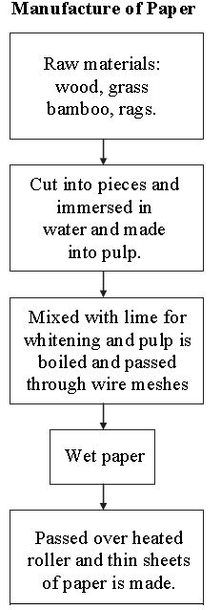

Manufacture of Paper

Paper is chiefly used for writing. The raw material used in the manufacture of paper is wood, grass, bamboo and rags. There are several processes by which the raw material is converted into pulp. Most commonly the raw material is cut into pieces and then immersed in water to convert it into pulp. The pulp is then mixed with lime for whitening it. This pulp and lime mixture is boiled at high pressure. The pulp is next passed through wire meshes. The paper sheets are removed from the mesh while it is still wet. These wet sheets are passed over heated rollers to remove the water and the paper is dried so as to make thin sheets of paper.

A 1. Transfer the information about the Water-cycle given in the flow chart into a paragraph:

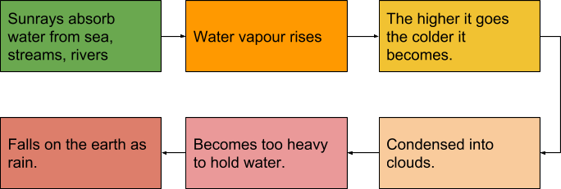
Ans.
Water-Cycle
It is common knowledge that the sunrays absorb water from the surface of the Earth — namely seas, streams, rivers and other such water bodies. This gets converted into water vapour and thus rises. As it goes higher, it becomes cooler and begins to move. Various particles ofvapour collect together and condense to form clouds which when become too heavy are difficult to sustain. The condensed vapour in these clouds then comes down in the form of rains and fills the various water bodies from where once again it evaporates with the heat of the Sun and thus, the cycle of water is maintained.

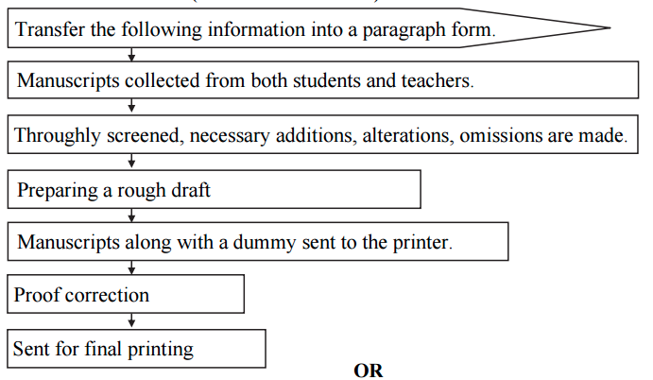

Ans. THE JOURNEY OF MANUSCRIPT

From the given flow chart, it is very evident that the information pertains to the journey of a manuscript from its initial stage to the final printing of a book or a magazine.

Manuscripts are collected from both students and teachers. They are thoroughly screened and edited, where necessary additions, alterations and omissions are made to the copy. A rough draft is then prepared after which the manuscript is sent to the printer along with a dummy. Then comes the stage of proof correction. After the corrections are made and the manuscript is proofread, it is sent for final printing.

Information Transfer: Verbal to Non-Verbal:

Read the following passage and complete the table:

Dialect is a form of a language spoken in one area which may be different from other forms of the same language. Each language has dialects which change every few kilometers. India is a multi-lingual country. Each state follows its own language as official language. For example, Marathi is the official language of Maharashtra, while Ahirani, Wharadi, Konkani and Malwani are its dialects. Several languages in India are spoken but do not have any script. In Karnataka, Kannada is the official language. Tulu is spoken in Karnataka but has no script. In England, English is the official language while Scottish, spoken in Scotland and Welsh spoken in Wales are dialects of English.

State | Official language | Dialects | Spoken /Without script
Maharashtra | Marathi
Karnataka
England

Ans.

State | Official language | Dialects | Spoken /Without script
Maharashtra | Marathi | Ahirani, Wharadi,  Konkani, Malwani | -
Karnataka | Kannada | Tulu | No script
England | English | Scottish, Welsh | -

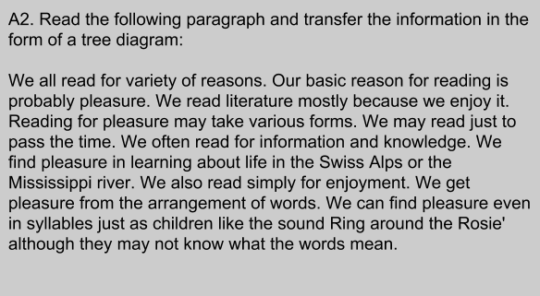
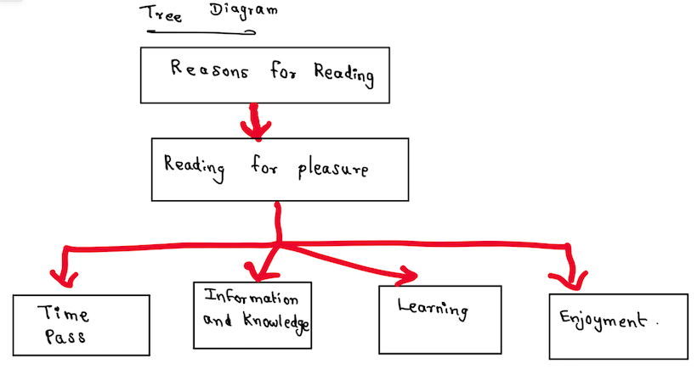
A2. Here are some tips about keeping healthy as given in a science magazine. Read and write in the form of Do’s and Don’ts (table):

You must include vegetables and fruits in your diet and drink a lot of water. You should avoid junk food and aerated water. You shouldn’t sit for long periods of time. Rather you should exercise regularly. You shouldn’t ignore the importance of good breathing habits. Try breathing deeply whenever you think of it. See to it that you sleep for at least 7 hours a day. In fact, you should avoid irregular timings.

Ans.
Do | Don’t
Include vegetables and fruits in your diet. | Consume junk and unhealthy food especially street food.
Drink plenty of water. | Drink aerated water.
Exercise regularly. | Sit for lengthy periods of time.
Try breathing deeply whenever possible | Ignore the importance of good breathing.
Sleep for at least seven hours a day. | Sleep at irregualr times.

https://www.youtube.com/watch?v=fV5JKt7jsP0
This is a link to Information Transfer which is explained very well.

Important aspects of Oral and Visual Presentations:
Presentation Skills:
Presentation skills can be defined as a set of abilities that enable an individual to:
- interact with the audience
- transmit the messages with clarity
- engage the audience in the presentation
- interpret and understand the mindsets of the listeners.
These skills refine the way you put forward your messages and enhance your persuasive powers.
The present era places great emphasis on good presentation skills. This is because they play an important role in convincing the clients and customers. Internally, management with good presentation skills is better able to communicate the mission and vision of the organization to the employees.

Importance of Presentation Skills
Interaction with others is a routine job of businesses in today’s world. The importance of good presentation skills is established on the basis of following points:
- They help an individual in enhancing his own growth opportunities. In addition, it also grooms the personality of the presenter and elevates his levels of confidence.
- In case of striking deals and gaining clients, it is essential for the business professionals to understand the audience. Good presentation skills enable an individual to mould his message according to the traits of the audience. This increases the probability of successful transmission of messages.
- Lastly, business professionals have to arrange seminars and give presentations almost every day. Having good presentation skills not only increases an individual’s chances of success, but also enables him to add greatly to the organization.

How to Improve Presentation Skills
Development of good presentation skills requires efforts and hard work. To improve your presentation skills, you must:
- Research the Audience before Presenting: This will enable you to better understand the traits of the audience. You can then develop messages that can be better understood by your target audience. For instance, in case of an analytical audience, you can add more facts and figures in your presentation.
- Structure your Presentation Effectively: The best way to do this is to start with telling the audience, in the introduction, what you are going to present. Follow this by presenting the idea, and finish off the presentation by repeating the main points.
- Do a lot of Practice: Rehearse but do not go for memorizing the presentation. Rehearsals reduce your anxiety and enable you to look confident on the presentation day. Make sure you practice out loud, as it enables you to identify and eliminate errors more efficiently. Do not memorize anything as it will make your presentation look mechanical. This can reduce the degree of audience engagement.
Almost all students are fearful of presentations. The fear is twofold. One is the content of the presentation and the other is the lack of presentation skills. If the content and skill are found wanting, the grade will be affected. Some may say as long as the content is well prepared, the presentation will not be a problem. But that may not be the case. It will be a pity if all your long hours of research work on the content come to nought due to last minute jittery, anxiety and you fumble during the Q and A session of the presentation.

Guidelines to give good Presentation:

- First and foremost is your content. All your research work should be arranged in a flowing manner.
- The main points are your backbone of your presentation.
- Do not read from your notes.
- Prepare cue cards with key words on them.
- Use visual aids like slides, charts and graphs to illustrate your points. However, do not over use them.
- Dress appropriately for your presentation.
- Speak clearly and loud enough for your audience to hear you. Look at your audience when you speak.
- Vary your pitch and tone to emphasize an important point. Do not speak in monotone.
- You should practice a few times in front of the mirror to check on your posture and gestures.
- End your presentation within the allocated time.
- Summarise your main points before ending your speech. A lucid explanation scores points.
Useful Tips for Effective Presentation Skills:
A Presentation is a purposeful communication i.e. it is the process of presenting a topic to an audience with a specific purpose. For the Presentation to be effective, one needs to plan various aspects of it and make necessary preparations too.

A) The 5 Ps of Effective Presentation:
Making an effective presentation constitutes: Planning, Preparing, Putting in an Order, Practicing, Presenting
Planning
- Choose the right topic
- Have a clear goal
- Have a central idea
- Know your audience
- Know the venue
- Know the time and length of presentation
- Decide on the methodology
Preparing
Preparation is EVERYTHING!
- Gather the relevant material from primary and secondary sources
- Prepare the central idea, the main ideas and the points to substantiate them
Putting in an Order or Organizing
Organize the material into three parts:
- Introduction ( a beginning that introduces/announces the topic),
- Body ( explains the structure of the presentation)
- Conclusion ( summarizes the presentation)
Practicing
Rehearse the presentation to
- Be clear about the content
- Assess strengths and weaknesses
- Learn to pronounce difficult words correctly
- Manage time effectively
- Become confident
- Learn to use technology ( OHP, PPTs)

Presenting
- Overcome stage fear
- Modulate the voice
- Pay attention to appearance and body language
- Maintain eye contact with the audience
- Use the podium effectively
- Be brief. Never exceed the allotted time slot
B) Using Pointers
- Remember to focus pointers that have arrows! Focused arrows are easier and less annoying to follow than a bouncing light blob on the screen.
- Point to things you want the audience to notice at the beginning of your slide exposure.
C) Handouts
- Avoid distributing handouts before or during your talk unless you use them directly in the presentation. If your talk is very technical with too many jargons If you want the audience to walk away with a body of information, hand it out at the end.
- If your talk is very technical with too many jargons, visuals and graphs, prepare handouts for the audience with your overheads or slides reproduced in miniature. The audience can listen to what you are saying and write notes on the handouts, instead of frantically trying to copy everything
D) Expressions used in Presentations
One should come up with effective lines that capture the attention of the audience instantly:
- "Thank you for being here today. I'm here today to talk to you about ____"
Thank you for joining me here this evening/afternoon/morning
- Preparation is essential for an effective presentation.
While making a presentation, certain keywords are used to signpost the different stages. It's a good idea to memorize them and practice using them, so that they come to mind easily during a presentation.
Starting the presentation
• Good morning/good afternoon ladies and gentlemen
•The topic of my presentation today is ...
• What I'm going to talk about today is ...
Stating the purpose of presentation
•The purpose of this presentation is ...
•This is important because ...
• My objective is to ...
Stating the main points
The main points I will be talking about are
firstly ...
secondly...
next, finally... we're going to look at ...
Introducing the first point
• Let's start/begin with ...
Showing graphics, transparencies, slides etc.
• I'd like to illustrate this by showing you...
Moving on to the next point
• Now let's move on to ...
Giving more details
• I'd like to expand on this aspect/problem/point
• Let me elaborate on that
• Would you like me to expand on/elaborate on that?
Changing to a different topic
• I'd like to turn to something completely different
Referring to something which is off the topic
• I'd like to digress here for a moment and just mention that ...
Referring back to an earlier point
• Let me go back to what I said earlier about ...
Summarizing or Repeating the Main Points
  - I'd like to recap the main points of my presentation
    - first I covered
    - then we talked about
    - finally we looked at
    - I'd now like to sum up the main points which were:
Conclusion
  - I'm going to conclude by... saying that/inviting you to/ quoting ...
  - In conclusion, let me... leave you with this thought/invite you to
Questions
  - Finally, I'll be happy to answer your questions.
  - Now I'd like to invite any questions you may have.
  - Do you have any questions?

E) Use of Non-verbal Communication
Eye contact helps and indicates the speaker’s interest in the audience and increases credibility.
Gestures are another important form of non verbal communication. One should focus on making gestures natural and reflective of what is being said.
Posture and body orientation - Standing straight and looking directly at the audience indicates confidence. While using slides, speak to the audience and don’t turn back completely to the audience. It is acceptable to look at a slide -- especially to draw the audience's attention to it, but always turn back to the audience after a few seconds. Learn to modulate your voice. No one appreciates monotonous tone. This helps to improve the impact with the audience.
F) Coping with Stage Fright
The more one worries and thinks about stage fright, the worse it may get. Defuse stage fright with planning and preparation.
One should be optimistic and visualize him/herself successfully presenting before an audience.
How to Overcome This: Since stage fright involves the mind and the body, both components need to be dealt with. Fear begins by allowing ourselves to believe that danger is present, so we must learn to feed our brains more positive, non threatening ideas.
Feeding oneself positive images of the upcoming event counters the mind's image of failure and embarrassment. Prepare the Material-Make sure you understand the topic thoroughly. Know the questions that might come up in a discussion and prepare the answers for them. Rehearse Lines-Rehearsing and practising will enhance your confidence. As your confidence increases your stage fright decreases.

Breathe Deeply- Long, slow breaths will give your brain the oxygen it needs to keep functioning, and to keep yourself calm. If you have stage fright, stop and take three slow, deep breaths.

Practice in front of the mirror-Use mirror to practice. Observe your body language and present it confidently as if you are doing it in front of the audience.

Dress comfortably- Avoid clothing that is new, too tight or uncomfortable.

G) Handling Question and Answer Session
Many presentations today are followed up with a question and answer period. These guidelines help to answer questions confidently:
- Listen to the entire question before answering any questions.
- REPEAT the question aloud so that the entire audience can hear it.
- Credit the person for asking the question by saying, "That was a great question" or, "Glad you asked that question"
- Respond to the question honestly and as well as possible. If you do NOT know an answer to a question be honest, and tell them that you do not know but DO promise to research the answer for them and DO get back to them.

H) Use of Audio-visual Aids
Visual aids include Over Head Projectors, PowerPoint Presentations, Hand Outs, Flip Charts etc. The following are guidelines for effective use of visual aids:
- Keep it simple.
- Check if the computer works properly before the presentation.
- Keep word slides BIG for the audience to read and follow anything. The "Rule of Six" is helpful: Per visual – six lines and six words in each line.
- Text arranged in a few sentences will be easier to read
- Try not to use cursive or unusual font
- Identify the acronyms and abbreviations used
- Use of too many colors distracts the audience from understanding a message.
- Maintain consistency in the title, sub- headings and font size of the words on the slides throughout.
- Keep your visuals simple, bold and graphic
I) Power Point Presentations
PowerPoint presentations are a great way to support a speech, visualize complicated concepts or understand a subject. However, badly designed slides with too much text or bad graphics can distract or worse, irritate the audience
Guidelines to professional presentations:
Design: The first thing that gives a professional touch to any presentation is the design.
1. Compose Slides
- Don’t copy and paste slides from different sources.
- Keep the design very basic and simple. It should not distract.
- Choose a font size that is easily readable.
- Carefully select font sizes for headers and text.
- Leave room for highlights, such as images or take home messages.
- Decorate scarcely but well.
- Don’t ever let the design restrict your messages

2. Maintain Consistency
Consistently use the same font face and sizes on all slides.
3. Match colours
You may use your company logo, highlight headers, create a special frame for figures/images or the whole slide but don’t overload your slides with these elements.
- A poor choice of colours can shatter a presentation.
- Use Contrast-Black text on a white background will always be the best but also the most boring choice.
- Carefully use colour to highlight your message.
- Don’t weaken the colour effect by using too many colors.
- Make a brilliant choice: match colours for design and good contrast to highlight your message
Text
- Keep It Straight and Simple.
- Use Keywords only.
- No sentences!
- Never read your slides, talk freely.
- Remember the slides are only there to support, not to replace the talk!
Images
Images are key elements of every presentation. A good visual cue will help the audience to understand the message much better.
- Have more images in your slides than text.
- But do not use images to decorate!
- Images can reinforce or complement your message.
- Use images to visualize and explain.
- A picture can say more than a thousand words.
Animations & Media
A good animation can not only improve understanding, but can also make the message stay with your audience for long. Use animations and media sparingly to draw attention
Target & Content
The target audience defines the content of the presentation.
Keep the Audience in Mind
- What do they know?
- What do you need to tell them?
- What do they expect?
- What will be interesting to them?
- What can you teach them?
- What will keep them focused?
If one loses the attention of the audience, everything will be lost — it won’t matter how ingenious the design is or how brilliantly one picks colours and keywords.
Practice
A well-prepared and enthusiastic talk will help to convince the audience and maintain their attention. There are some key points that define a good talk:
- One should know the slides inside out.
- Speak freely and with confidence – loud and clear.
- Don’t speak too fast.
- Maintain eye contact with the audience.
https://youtu.be/ADJAcyTq1us
This is the link which describes how to give an Effective Presentation.

